Life Cycle Inventory of collection and repurposing of EV batteries

1.1 Collection and transport phase
Spent batteries are considered hazardous waste by current legislation, so special containers and packaging are required for their safe transport. To facilitate the calculation of the costs related to the collection and transport phase to the plant or storage site of the used batteries, an average total cost of 1.5 € kg⁻¹ battery is considered. This is a very conservative figure because it takes into account the current flows of spent batteries (still quite small). With higher volumes of batteries, a reliable assumption for the next 10 years, the optimization of transport will significantly lower the costs of this phase .
The packaging necessary for transport was also considered, considering a wooden crate for the shipment of batteries labelled "green" and "yellow", which will tend to be the batteries most likely to pass the testing phase and become ESU for a second life. Consequently, batteries labelled as "red", i.e., those damaged or identified as hazardous for transport, are excluded from the study boundary. A wooden crate of 204 kg (with a maximum capacity of 700 kg) at a unit cost of 300 € was considered. It is also conservatively assumed that the crates will be used only twice, with a cost of € 150 per battery for packaging. The inventory for collection and transport phase is shown on Table S1.
Table S1 Inventory for the LCA model of the collection and transport phase
Collection & Transport processes | BEV | PHEV | LCEV
Transport, freight lorry, 3.5-7.5 t, EURO4 (t*km kWh_{nominal}⁻¹) | 5.4 | 14.9 | 6.7
Packaging, wooden box (kg kWh_{nominal}⁻¹) | 1.96 | 9.53 | 2.76

1.2 Testing and disassembly phase
To estimate the costs related to the second phase of repurposing, the data reported in the recent study by (Rallo et al. 2020) were taken. It is assumed that the process is optimized and there is no downtime to minimize the costs of this phase. Consequently, it is assumed that there are several stations with the testing equipment available for each technician.
Regarding the costs related to electricity consumption, the energy required for the testing phase (charging and discharging the batteries for 250 minutes, as shown in Table S2 was calculated, taking an average cost of 0.161 € kWh⁻¹ and a cost of 2.27 € m⁻² per year for lighting. In the calculation of this electrical consumption, an efficiency of 85% was assumed to account the process losses and, in addition, it was considered that during the testing process (250 minutes) the battery is charged continuously. Consequently, the estimated consumption is very conservative and is equal to 4.9 kWh kWh_{nominal}⁻¹. In the European SASLAB project developed by the JRC a consumption for testing of 8.7 kWh is estimated for a PHEV pack of 11.4 kWh (thus 0.76 kWh kWh_{nominal}⁻¹), however the report does not specify which was the assumption with respect to the time spent in testing the battery pack analysed). In any case, and as will be seen in the following chapters, electricity consumption for testing has a marginal impact on the performance of ESU (both economic and environmental).
It was also assumed that only one technician is needed for each battery, unlike what is reported in (Rallo et al. 2020), because there the testing and disassembly takes place in a laboratory with limited equipment (without forklifts or conveyor belt, as instead considered in the plant of this study (Neubauer et al. 2015). In addition, it is assumed that 10% of the batteries are discarded after testing (due to damage, low performance, insufficient SOH, etc.).
Table S2 Man-hours considered for testing, by Rallo et al., 2020. All batteries follow the same procedure (valid times for all three types of batteries considered in the study).
Testing activity | Head | Value
Receiving Inspection & Handling | minutes | 60
Connection to Electrical Test Equipment | minutes | 10
Initial voltage set & balance | minutes | 100
Battery characterization (electrical testing) | minutes | 250
Disconnection from Electrical Test Equipment | minutes | 10
Final Inspection | minutes | 10
Machine Testing time | hours | 5.8
Technician Handling Time | hours | 1.5
TOTAL Battery Testing Time | Hours/battery | 7.3

As for the disassembly of batteries, the timescale presented in the article by Rallo et al., 2020, were used and they consider them to be conservative (Table S3). It is very likely that the timing will be significantly reduced in a plant with optimized procedures, the equipment needed to save man-hours and due to the learning curve. In the future, it is reliable that there will also be regulations that oblige manufacturers to facilitate disassembly for reuse and repurposing.
For the environmental part, no impact related to this phase has been considered because all the work performed is manual.
Table S3 Man-hours considered for the disassembly phase, as presented in Rallo et al., 2020. In this case the times change depending on the battery (it is a function of the number of modules).
Disassembly activity | Head | BEV | PHEV | LCEV
Removal of package top | minutes | 30 | 30 | 30
Extraction of Battery Junction Box | minutes | 45 | 45 | 45
Disconnection of Cell Module Controllers | minutes | 45 | 45 | 45
Disconnection & extraction of BMS | minutes | 30 | 30 | 30
Dismantling of pre-charge circuit | minutes | 30 | 30 | 30
Extraction of modules (20 min/module) | minutes | 240 | 100 | 320
Separation of battery base from HV battery support frame | minutes | 20 | 20 | 20
Removal of humidity buffer | minutes | 20 | 20 | 20
Removal of cooling plates | minutes | 20 | 20 | 20
Total Disassembly | hours/battery | 8.0 | 5.7 | 9.3

1.2.1 Plant size and staff
To calculate the plant size, the parametric model of Neubauer et al. (2015) was followed. This means that the size of the plant is calculated automatically according to the volume of batteries expected, and consequently the same increases over the years, in accordance with the expected expansion of the market for electric vehicles. Another advantage of this model is that by having three different battery streams to disassemble (each of different sizes, different configurations, etc.), the entire plant results from the linear sum of three sub-plants or departments (BEV, PHEV, LCEV) sized separately but summed at the end for common costs (e.g. land purchase, salaries, etc.). For 2026, the reference year considered for the initial sizing of the plant, 2532 BEV, 2058 PHEV and 1418 LCEV batteries are expected. These volumes, together with the times considered, require two work shifts (in 252 working days) to be able to process the volume of batteries, reaching a total of 146,000 kWh of accumulation expected for 2026. The plant area is calculated from the number of offices needed (for managers), the area needed for workstations for testing, assembly and disassembly, the area for the conveyor belt, the storage shelves for batteries and ESU and a space to manoeuvre forklifts. Thus, the size of the plant will be approximately 3000 m², with 44% of the area destinated to the BEV production line, 21% to PHEVs and 35% to LCEVs. The plant has a land cost of 100 €/m² and a cost of 350 € /m² for the construction of the shed. If 2030 is taken as the reference year, and according to the volume of batteries estimated (see Table 1 in the paper) the plant would have a size of 22,500 m² (and a cost of 6.9 M€).
To calculate the required staff we start from the basic technicians for testing, disassembly and assembly, which are estimated according to the volume of batteries expected for each year. The annual volumes are divided between the annual working days (252 in this case) and - taking into account the time needed to carry out each phase, as shown in the previous tables - the number of technicians needed for each type of battery is calculated (Table S4). Then we also consider, in addition to the basic technicians, a supervisor for every 10 technicians, workers to drive the forklifts, electrical engineers, commercial, administrative (1 for every 30 employees), HR manager (1 for every 30 employees), an Operations Manager and a CEO. The salaries for each category and contractual level were taken from ISTAT. The total cost of personnel for 2026 is about 3 M€, as can be seen in Table S4 together with the costs for the following years.
Table S4 Staff and salaries for the repurposing plant (based on the Neubauer et al., 2015 mode l), based on the expected battery flows for 2026 and subsequent years.
Staff members (number) | 2026 | 2027 | 2028 | 2029 | 2030
Technicians | 61 | 95 | 172 | 295 | 506
Others | 29 | 40 | 61 | 101 | 166
TOTAL employees | 90 | 135 | 233 | 396 | 672
Total Labour cost | €2,847.122 | €4,199.922 | €7,533,322 | €12,817,922 | €21.565.322

The required equipment and related unit costs for repurposing are shown in Table S5. For the volume of batteries expected in 2026, the capital costs for the equipment amount to 2.25 M€, with a capital investment of 3.6 M€ to be recovered in 5 years.
Table S5 Number and unit costs of battery repurposing tools
Equipment (year 2026) | No. | Unit Cost (€)
Inspection stations | 3 | 464
Battery Test Channels | 10 | 18,561
Controller area network devices | 10 | 148
Computer | 3 | 2,784
Workstations (testing) | 10 | 464
Storage Racks | 18 | 93
Forklifts | 2 | 6,496
Conveyors (m²) | 25 | 46
Office | 22 | 92,807

In the LCA model, the plant has been included as a "chemical factory, organics" in a similar way to the new battery production plant in the reference system as present in Ecoinvent’s existing lithium battery production process. This component also has virtually no impact on the performance of repurposed batteries, as is often the case in LCA analysis. Consequently, and to simplify, the rest of the equipment ("equipment" such as computers, working stations, etc.) have been neglected in environmental analysis.

1.3 Assembly phase and Quality Control
For the ESU assembly phase, we start from the individual modules of each type of battery. To avoid communication problems between the different modules and the new Battery Management System (BMS), it is considered that the new ESUs are built with the same modules (of one of the BEV, PHEV, LCEV batteries – therefore of the same manufacturer). The repurposed ESU are therefore of three types (BEV, PHEV, LCEV) and have different sizes depending on the number of modules they contain (approximately from 1 to 6), as can be seen in Table S6. Repurposed ESUs have higher nominal capacities due to the reduced SOH of used batteries, as anticipated earlier and in more detail in the next section.
Table S6 Possible configurations of repurposed ESUs. The nominal capacity is a function of the number of connected modules (1 to 6)
TOTAL ESU nameplate capacities (kWh) | BEV | PHEV | LCEV
Assembly ESU 1 module | 4.3 | 2.1 | 2.3
Assembly ESU 2 modules | 8.7 | 4.3 | 4.6
Assembly ESU 3 modules | 13.0 | 6.4 | 6.9
Assembly ESU 4 modules | 17.3 | 8.6 | 9.3
Assembly ESU 5 modules | 21.7 | 10.7 | 11.6
Assembly ESU 6 modules | 26.0 | 12.8 | 13.9

In the absence of data from literature or other sources, the disassembly times reported in Table S7 were taken, thus taking the data from Rallo et al. (2020) but reversing the steps followed for the disassembly of used batteries. A summary of the man-hours required for repurposing batteries (from initial inspection to final assembly) is presented in Table S7.
Table S7 Summary of times (man-hours) required for battery repurposing
TOTAL REPURPOSING TIME |  | BEV | PHEV | LCEV
Battery testing & disassembly | man-hours | 9.5 | 7.2 | 10.8
Total technician time (testing & disassembly) | man-hours module⁻¹ | 0.9 | 1.7 | 0.8
Total technician time (testing & disassembly) | man-hours kWh⁻¹ | 0.2 | 0.8 | 0.3
ESU assembly (1 module) | man-hours | 4.5
Assembly additional modules | man-hours module⁻¹ | 0.5

The cost of assembly is completed by adding several new components that must replace the old ones, for an optimal performance, but also to ensure the operation of the ESUs (the BMS for example is different from that used for electric cars). Current, voltage and temperature sensors, the BMS, a control unit for each module, cables, conduits and terminals, an external case (battery jacket) or container and the frame for containing and connecting the modules (battery junction box) have been considered.
For cooling it is assumed that the work requirements are much easier in a stationary application than in an electric car. Therefore, it is considered that the cooling takes place by natural convection (thus with no additional cost), as reported in the technical specifications of the ESUs of new battery manufacturers, instead of $100 for the liquid cooling system as considered in (Nelson et al. 2011) (see Table S8).
Table S8 Unit costs of the new components for ESUs to be installed with PV systems. Costs taken from the BatPac calculation tool by Nelson et al. (2011)
ESU components | Unit cost (€)
Current, temperature and voltage sensing | 100
Module control | 20
BMS | 100
Battery Jacket (€ kg_{battery}⁻¹) | 2
Battery Junction Box (€ kg_{battery}⁻¹) | 0.5
Busbars and connection wires | 20

Moreover, it was necessary to make further assumptions to estimate the total costs (of the whole plant) related to the purchase of the components shown in Table S9, since the costs vary depending on the size of the ESU (number of modules), and that it is not possible to know a priori the number of each type of ESU that will be manufactured (and sold). Consequently, it was decided to take an average between the worst-case (all ESU sold are small, so the unit costs are higher) and the best-case (all ESU are large, 6-8 modules, with lower unit costs).
As for the modelling of the components for the LCA environmental analysis, it was assumed the production process created ad hoc for the new NMC batteries, but removing from the input the materials and components related to the modules (cathode material, electrolyte and anode inside the cells, separators, etc.) and leaving the rest unchanged (copper and fiberglass cables, BMS, outer cover and steel containment frame). The manufacturing process of new NMC batteries is described in detail below.
Table S9 Inventory to model additional components in the repurposing scenario for LCA analysis. Inputs considered for 1 kg of repurposed battery. The remainder, about 60% of the total weight, concerns the cells and modules recovered from the used batteries
ESU components | Amount | Head
Cable, data cable in infrastructure | 0.37 | m
Cable, three-conductor cable | 0.025 | m
Printed wiring board, surface mounted (BMS) | 0.036 | kg
Reinforcing steel, sheet rolled | 0.32 | kg

1.3.1 Quality Control
Finally, a final quality check was considered to verify that the ESU was assembled correctly (i.e., to verify that it is working correctly) and to ensure that the remaining storage capacity agrees with that drawn according to the assumed DOD and the initial SOC.
For this step, a half – hour technical inspection is assumed for each ESU, during which a technician will do a synthetic check of the main functions, including a test of charge and fast discharge. To account this cost, half an hour of testing has been added, so the sizing of the plant and the number of technicians necessary for the testing (initial and Quality Control) of each ESU has been updated. Additional rejects due to Quality Control were not considered.

1.4 Use phase
The second life duration of repurposed batteries is one of the most critical aspects. As for the performance, and therefore the perceived quality-price ratio, this aspect is probably the one in which the greatest difference between repurposed ESU and new batteries remains. New storage systems usually have a 10-year warranty. Although a reduced DOD of work for ESU (of 50% assumed here, as described in premise iv) can substantially extend the second useful life repurposed batteries have already undergone a few years of degradation due to the passage of time (5 to 10 years of their first useful life in EVs) and the climatic conditions to which they have been subjected. So it is reliable, but not certain, that repurposed battery ESUs will last less than similar storage systems with new batteries. The scientific literature studies analysed report results with wide variability and often based on models developed ad hoc (not validated with long-term empirical studies). The quantification of the difference in performance between new and repurposed batteries is therefore a critical issue of this study (and other similar ones carried out in recent years), which will not be able to solve until we have primary data of case studies or real or pilot projects for residential storage systems in second life.
All the technical characteristics, performance and repurposing operation design features are summarized and presented in Table S10

Table S10 Summary of the characteristics and technical performance of the new and used batteries considered in this study
Repurposed & New ESU characteristics | Nominal capacity (kWh) | K_{eff}  (kWh) | K_{eff} gap  to Ref. | Design DOD | SOH_{initial} | SOH_{final} | c_{max} | c₀ | Weight (kg) | LET (MWh) | LET gap to Ref.
Rep. ESU – BEV 1 | 4.3 | 2.9 | 10% |  |  |  |  |  | 27 | 7.9 | 24%
Rep. ESU – BEV 2 | 8.7 | 5.8 | 9% | 80% | 80% | 60% | 5000 | 1500 | 54 | 15.8 | 23%
Rep. ESU – BEV 3 | 13.0 | 8.6 | 9% |  |  |  |  |  | 82 | 23.8 | 23%
Rep. ESU – BEV 4 | 17.3 | 11.5 | 9% |  |  |  |  |  | 109 | 31.7 | 23%
Rep. ESU – PHEV 2 | 4.3 | 2.8 | 11% |  |  |  |  |  | 38 | 7.8 | 25%
Rep. ESU – PHEV 4 | 8.6 | 5.7 | 10% | 80% | 80% | 60% | 5000 | 1500 | 75 | 15.6 | 24%
Rep. ESU – PHEV 6 | 12.8 | 8.5 | 10% |  |  |  |  |  | 113 | 23.5 | 24%
Rep. ESU – PHEV 8 | 17.1 | 11.4 | 10% |  |  |  |  |  | 150 | 31.3 | 24%
Rep. ESU – LCEV 2 | 4.6 | 3.1 | 4% |  |  |  |  |  | 33 | 8.5 | 19%
Rep. ESU – LCEV 4 | 9.3 | 6.2 | 2% | 80% | 80% | 60% | 5000 | 1500 | 65 | 16.9 | 18%
Rep. ESU – LCEV 6 | 13.9 | 9.2 | 3% |  |  |  |  |  | 98 | 25.4 | 18%
Rep. ESU – LCEV 8 | 18.5 | 12.3 | 2% |  |  |  |  |  | 130 | 33.8 | 18%
New 3.3 | 3.3 | 3.2 | - |  |  |  |  |  | 31 | 10.4 | -
New 6.5 | 6.5 | 6.3 | - | 100% | 97% | 60% | 4000 | 0 | 52 | 20.6 | -
New 9.8 | 9.8 | 9.5 | - |  |  |  |  |  | 75 | 31.0 | -
New 13 | 13.0 | 12.6 | - |  |  |  |  |  | 98 | 41.1 | -

1.5 Manufacturing process of new NMC batteries for LCA model
To model the NMC battery manufacturing process, the existing processes in the Ecoinvent v3.6 database (processes related to the production of LMO chemistry lithium-ion batteries) were combined with the data related to the production of the LiNixCoyMnzO2 cathode (and the upstream processes used to provide the necessary materials, such as CoSO4),the latter coming from the inventories reported in the Supporting Informations of two LCA studies .
Having considered the specific weights of the different configurations of residential accumulators with new NMC batteries (Table S11) and LFP (Sonnen data sheets), the specific contents of each material and component per kilo of battery (kg kg_batteria⁻¹) varies. This means that each configuration will have its own specific impact profile, slightly different from each other. It can be anticipated that the larger accumulators will be the best (lower impact), because they are more efficient (less materials per kWh_{nominal}). Instead, there will be a single environmental profile for all types of repurposed ESU (therefore independent of the number of modules), since the specific weights of each material depending on the configuration of ESU are not available in the literature; for this reason a linear extrapolation has been carried out and, therefore, the quantities of material per kilo of repurposed battery remain constant.
Table S11 Summary of the inventory compiled for the LCA model and the environmental assessment of the study, constructed by combining different sources and databases
Li-ion battery production (1 kg), assembled | Amount | Head
Battery cell, Li-NMC | 0.6 | kg
Reinforcing steel sheet, packaging | 0.32 | kg
Cable, data cable | 0.373 | m
Cable, three conductor cable | 0.025 | m
Printed wiring board, surface mounted | 0.0033 | kg
Electricity, medium voltage | 0.1075 | kWh
Li-NMC battery cell production (1 kg) | Amount | Head
Cathode, LiNi0.4Co0.2Mn0.4O2 | 0.3268 | kg
Anode, graphite | 0.4 | kg
Electrolyte, LiPF6 | 0.019 | kg
Aluminium sheet, wrought alloy | 0.01648 | kg
LDPE film, packaging | 0.0733 | kg
Battery separator | 0.05365 | kg
Ethylene carbonate | 0.8 | kg
Ethylene glycol dimethyl ether | 0.8 | kg
Electricity, medium voltage | 0.105 | kWh
Heat, industrial, natural gas | 0.065 | MJ
Cathode, LiNiCoMnO2 production (1 kg) | Amount | Head
LiNi0.4Co0.2Mn0.4O2 | 0.87 | kg
Carbon black | 0.0263 | kg
Sodium hydroxide (Naoh) | 0.130 | kg
Latex | 0.00989 | kg
Aluminium, sheet, wrought alloy | 0.393 | kg
Water, deionised | 0.2 | kg
Electricity, medium voltage | 0.002 | kWh
Heat, industrial, natural gas | 0.6458 | MJ

Life Cycle Costing results

2.1 Selling prices ESU
The selling prices considered in €/kWh are reported in Table S12 and the market prices for the new battery in Table S13. These are calculated with the battery salvage value method as explained in the manuscript. The reference price is that of 2024, and has been extrapolated to 2026 and 2030 linearly from their reduction respect to 2020 prices (see Table S13). Exponential reductions in prices as predicted or estimated by other sources Bloomberg and others (Logan Goldie-Scot 2019, Steen et al. 2017) have not been realized as for 2024, that’s why a more conservative approach was considered for the selling price estimates of 2026 to 2030.
Table S12 Sales prices considered for revenue calculation, based on reliable prices for new batteries in the study period and the LET performance ratio (repurposed vs. new), as in Neubauer et al. 2012
Stationary battery prices (€ kWh¹) | 2024 | 2026 | 2030
New Small ESU_3.3 kWh | 712 | 693 | 616
New Medium ESU_6.5 kWh | 459 | 440 | 363
New Big ESU_10 kWh | 406 | 387 | 310
New Large ESU_13 kWh | 395 | 376 | 299
Repurposed small ESU_BEV | 526 | 526 | 467
Repurposed Medium ESU_BEV | 339 | 339 | 280
Repurposed Big ESU_BEV | 297 | 297 | 238
Repurposed Large ESU_BEV | 290 | 290 | 231
Repurposed small ESU_PHEV | 519 | 519 | 462
Repurposed Medium ESU_PHEV | 335 | 335 | 276
Repurposed Big ESU_PHEV | 293 | 293 | 235
Repurposed Large ESU_PHEV | 286 | 286 | 228
Repurposed small ESU_LCEV | 561 | 561 | 499
Repurposed Medium ESU_LCEV | 362 | 362 | 298
Repurposed Big ESU_LCEV | 317 | 317 | 254
Repurposed Large ESU_LCEV | 309 | 309 | 246

For comparing the costs of repurposed NMC batteries for second life application, publicly available market prices of new NMC batteries (3 to 13 kWh) produced by a company have been taken. The prices and LET of the new NMC batteries that form the reference system are shown in Table S13.
Table S13. Market 2020 prices and LET for the new battery series for power storage applications in domestic PV systems. Prices are exclusive of the installation and inverter (sources: LET from technical specifications, market prices from a European distributor).
Battery size | 2020 Prices (without VAT, without inverter) | 2024 Prices (without VAT, without inverter) | LET  (MWh) | 2020 Unit price (€ kWh⁻¹ ) | 2024 Unit price (€ kWh⁻¹ )
3.3 kWh | €2.349.00 | € 2,349.00 | 10 | 712 | 712
6.5 kWh | €3.409.00 | € 2,982.00 | 20 | 524 | 459
9.8 kWh | €4,438.00 | € 3,980.00 | 30 | 453 | 406
13.1 kWh | €5,590.00 | € 5,180.00 | 40 | 427 | 395

In the following tables the nameplate capacities, usable energy, unit and total costs, selling prices and LET estimates are presented for all the batteries analysed (BEVs in Table S14, PHEV in Table S15 and LCEV in Table S16. The cost of PHEV batteries with 6-8 modules would remain higher than estimated selling prices for 2026, thus not profitable if we stick to the LET as a “fair” price correction factor, although their prices would still be lower than the prices of batteries with similar nominal capacities currently on the market. As in previous cases, larger ESUs would provide better margins.
Table S14 Comparison of ESU - BEV performance and selling prices with market prices for similar batteries from LG Chem (estimated prices for 2026 of 220 €/kWh). In red are the costs of ESUs that would not be profitable (costs > sales price).
ESU - BEV configurations | Nameplate capacity (kWh) | Usable energy (kWh) | Unit Cost (€/kWh) | Total ESU Cost (€) | 2026 selling price (€) | LET  (MWh) | LET difference
2 modules | 4.3 | 3.5 | 259 | 1124 | 1822 | 7.9 | 76%
4 modules | 8.7 | 6.9 | 232 | 2012 | 2349 | 15.8 | 77%
6 modules | 13.0 | 10.4 | 223 | 2901 | 3085 | 23.8 | 77%
8 modules | 17.3 | 13.9 | 219 | 3790 | 4020 | 31.7 | 77%
New 3.3 | 3.3 | 3.2 | 712 | - | 2286 | 10.4 | -
New 6.5 | 6.5 | 6.3 | 459 | - | 2857 | 20.6 | -
New 9.8 | 9.8 | 9.5 | 406 | - | 3792 | 31.0 | -
New 13 | 13.0 | 12.6 | 395 | - | 4891 | 41.1 | -

Table S15 Comparison of ESU - PHEV performance and selling prices with market prices for similar batteries from. In red are the costs of ESUs that would not be profitable (costs > sales price).
ESU - PHEV configurations | Nameplate capacity (kWh) | Usable energy (kWh) | Unit Cost (€/kWh) | Total ESU Cost (€) | 2026 selling price (€) | LET  (MWh) | LET difference
2 modules | 4.3 | 3.4 | 289 | 1237 | 1778 | 7.8 | 75%
4 modules | 8.6 | 6.8 | 262 | 2240 | 2291 | 15.6 | 76%
6 modules | 12.8 | 10.3 | 253 | 3242 | 3010 | 23.5 | 76%
8 modules | 17.1 | 13.7 | 248 | 4245 | 3922 | 31.3 | 76%
New 3.3 | 3.3 | 3.0 | 712 | - | 2286 | 10.4
New 6.5 | 6.5 | 5.9 | 459 | - | 2857 | 20.6
New 9.8 | 9.8 | 8.8 | 406 | - | 3792 | 31.0
New 13 | 13.0 | 11.7 | 395 | - | 4891 | 41.1

Table S16 Comparison of performance and sales prices of ESU - LCEV with market prices for similar new batteries
ESU - LCEV configurations | Nameplate capacity (kWh) | Residual usable energy (kWh) | Unit Cost (€/kWh) | Total Cost ESU (€) | Selling price (€) | LET  (MWh) | LET difference
2 modules | 4.6 | 3.7 | 261 | 1205 | 2076 | 8.5 | 81%
4 modules | 9.3 | 7.4 | 235 | 2175 | 2676 | 16.9 | 82%
6 modules | 13.9 | 11.1 | 227 | 3145 | 3515 | 25.4 | 82%
7 modules | 16.2 | 13.0 | 222 | 4115 | 4580 | 29.6 | 82%
New 3.3 | 3.3 | 3.2 | 712 | - | 2349 | 10.4
New 6.5 | 6.5 | 6.3 | 459 | - | 2982 | 20.6
New 9.8 | 9.8 | 9.5 | 406 | - | 3980 | 31.0
New 13 | 13.0 | 12.6 | 395 | - | 5180 | 41.1

Sensitivity of repurposing costs
Table S17 Changes in economic performance of BEV battery repurposing plant with lower (more ambitious) price projections for new batteries.
ESU - BEV configurations | Nameplate capacity (kWh) | Usable energy (kWh) | Unit Cost (€/kWh) | Total ESU Cost (€) | 2026 selling price (€) | LET  (MWh) | LET difference
2 modules | 4.3 | 3.5 | 148 | 641 | 635 | 7.9 | 76%
4 modules | 8.7 | 6.9 | 121 | 1047 | 1290 | 15.8 | 77%
6 modules | 13.0 | 10.4 | 112 | 1453 | 1925 | 23.8 | 77%
8 modules | 17.3 | 13.9 | 107 | 1859 | 2580 | 31.7 | 77%
New 3.3 | 3.3 | 3.2 | 712 | - | 726 | 10.4 | -
New 6.5 | 6.5 | 6.3 | 459 | - | 1430 | 20.6 | -
New 9.8 | 9.8 | 9.5 | 406 | - | 2156 | 31.0 | -
New 13 | 13.0 | 12.6 | 395 | - | 2860 | 41.1 | -
ESU - PHEV configurations | Nameplate capacity (kWh) | Usable energy (kWh) | Unit Cost (€/kWh) | Total ESU Cost (€) | 2026 selling price (€) | LET  (MWh) | LET difference
2 modules | 4.3 | 3.4 | 167 | 715 | 620 | 7.8 | 75%
4 modules | 8.6 | 6.8 | 140 | 1195 | 1258 | 15.6 | 76%
6 modules | 12.8 | 10.3 | 130 | 1675 | 1878 | 23.5 | 76%
8 modules | 17.1 | 13.7 | 126 | 2155 | 2517 | 31.3 | 76%
New 3.3 | 3.3 | 3.0 | 712 | - | 726 | 10.4 | -
New 6.5 | 6.5 | 5.9 | 459 | - | 1430 | 20.6 | -
New 9.8 | 9.8 | 8.8 | 406 | - | 2156 | 31.0 | -
New 13 | 13.0 | 11.7 | 395 | - | 2860 | 41.1 | -
ESU - LCEV configurations | Nameplate capacity (kWh) | usable energy (kWh) | Unit Cost (€/kWh) | Total Cost ESU (€) | Selling price (€) | LET  (MWh) | LET difference
2 modules | 4.6 | 3.7 | 148 | 685 | 724 | 8.5 | 81%
4 modules | 9.3 | 7.4 | 123 | 1135 | 1469 | 16.9 | 82%
6 modules | 13.9 | 11.1 | 114 | 1586 | 2193 | 25.4 | 82%
7 modules | 16.2 | 13.0 | 110 | 2036 | 2939 | 29.6 | 82%
New 3.3 | 3.3 | 3.2 | 712 | - | 2349 | 10.4
New 6.5 | 6.5 | 6.3 | 459 | - | 2982 | 20.6
New 9.8 | 9.8 | 9.5 | 406 | - | 3980 | 31.0
New 13 | 13.0 | 12.6 | 395 | - | 5180 | 41.1

Table S18. New battery salvage value estimates based on lower new battery prices.
 | BEV |  | PHEV |  | LCEV
Used battery salvage value (€ kWh⁻¹) | 30 | 0 |  | 20
Buying price, whole battery | € 1,560 | - |  | € 1,480§
NPV | € 4,345,387 | € - 445,704 |  | € 16,622,965
§ Includes 2 battery packs

Summary of repurposing costs

Figure S1 Cost breakdown for ESUs built in relation to number of modules of BEV batteries

Table S19 Summary repurposing costs for the BEV battery and six corresponding ESU types (depending on the number of modules assembled and thus the capacity of the final product)
ESU - BEV costs (€) | Module 1 | Modules 2 | Modules 3 | Modules 4 | Modules 5 | Modules 6
Nameplate capacity (kWh) | 4.3 | 8.7 | 13.0 | 17.3 | 21.7 | 26.0
Transport & collection | 41 | 82 | 123 | 163 | 204 | 245
Used battery packs | 520 | 1040 | 1560 | 2080 | 2600 | 3120
ESU components | 265 | 295 | 326 | 356 | 386 | 416
Labour | 75 | 150 | 225 | 301 | 376 | 451
Consumption | 4 | 8 | 12 | 16 | 20 | 24
Capital | 21 | 43 | 64 | 85 | 106 | 128
Indirect costs | 197 | 395 | 592 | 789 | 986 | 1184
Total | 1124 | 2012 | 2901 | 3790 | 4679 | 5567
Total_kWh (€ kWh_{nominal}⁻¹) | 259 | 232 | 223 | 219 | 216 | 214

Table S20 Summary repurposing costs for the PHEV battery and six corresponding ESU types (depending on the number of modules assembled and thus the capacity of the final product)
ESU - PHEV costs (€) |  | Module 1 | Modules 2 | Modules 3 | Modules 4 | Modules 5 | Modules 6
Nameplate capacity (kWh) |  | 2.1 | 4.3 | 6.4 | 8.6 | 10.7 | 12.8
Transport & collection |  | 28 | 57 | 85 | 114 | 142 | 171
Used battery packs |  | 214 | 428 | 642 | 856 | 1070 | 1284
ESU components |  | 262 | 289 | 316 | 343 | 370 | 397
Labour |  | 82 | 164 | 245 | 327 | 409 | 491
Capital (5y amortization) |  | 49 | 98 | 147 | 196 | 245 | 294
Consumption (electricity) |  | 1 | 1 | 2 | 2 | 3 | 3
Indirect costs |  | 100 | 201 | 301 | 401 | 502 | 602
Total |  | 736 | 1237 | 1739 | 2240 | 2741 | 3242
Total_kWh (€ kWh_{nominal}⁻¹) | 344 |  | 289 | 271 | 262 | 256 | 253

Table S21 Summary repurposing costs for the LCEV battery and six corresponding ESU types (depending on the number of modules assembled and thus the capacity of the final product)
ESU - LCEV costs (€) |  | Module 1 | Modules 2 | Modules 3 | Modules 4 | Modules 5 | Modules 6
Nameplate capacity (kWh) |  | 2.3 | 4.6 | 6.9 | 9.3 | 11.6 | 13.9
Transport & collection |  | 25 | 49 | 74 | 98 | 123 | 147
Used battery packs |  | 254 | 509 | 763 | 1018 | 1272 | 1526
ESU components |  | 261 | 287 | 313 | 339 | 365 | 392
Labour |  | 52 | 105 | 157 | 209 | 262 | 314
Capital (5y amortization) |  | 17 | 33 | 50 | 67 | 83 | 100
Consumption (electricity) |  | 3 | 7 | 10 | 13 | 16 | 20
Indirect costs |  | 108 | 215 | 323 | 431 | 538 | 646
Total |  | 720 | 1205 | 1690 | 2175 | 2660 | 3145
Total_kWh (€ kWh_{nominal}⁻¹) | 311 |  | 261 | 244 | 235 | 230 | 227

A summary of the repurposing costs of the analysed BEV, PHEV and LCEV batteries, in Table S19 Table S20 and Table S21, respectively. In Figure S1, the unit costs of the ESU produced with BEV batteries are graphically presented as a function of the number of modules.
With the assumptions described in paper, the unit costs of ESUs range from 214 to 344 € kWh_{nominal}⁻¹, while the repurposing costs (omitting new components of the ESU and the purchase costs of the used batteries) are calculated to be 78, 122, and 88 € kWh_{nominal}⁻¹, for BEV, PHEV and LCEV batteries, respectively. These costs can be considered in line with other studies in the literature, which report repurposing costs (without new components and used battery costs) ranging from 32 to 114 $ kWh⁻¹ (Eyer et al. 2012, Neubauer et al. 2012, Steen et al. 2017).
As mentioned before, PHEV battery modules are the most expensive due to the small size of the original battery pack (10.7 kWh) and the limited size of its modules (2.1 kWh). As can be seen, the small size of the PHEV pack greatly affects unit costs because the costs related to the transport and collection, testing and disassembly phases are the same for the different batteries, and thus the final cost reported kWh_{nominal} is significantly higher.

Figure S2 Breakdown of consumption costs or for the repurposing of used batteries
Within the consumption costs, the most important item is that of the costs related to the purchase costs of used batteries (77% of consumables, 52% of the total), followed by the components necessary for the construction of the ESU (19% of consumables, 13% of total), as can be seen in Figure S2 above.

Figure S3 Breakdown of labour costs for the repurposing of used batteries
Concerning labour costs, the number of technicians required for disassembly and assembly is also a critical parameter of the analysis (Figure S3). Disassemblers and assemblers account for 49% of the total personnel costs, and thus about 9% of the total cost (comparable to the purchase cost of used batteries). In summary, the main cost is that of new components for ESU (32% of the total), followed by transport costs (19%), labour costs (18%), indirect costs (14%) and purchase costs of used batteries (7%).
Table S22 Summary of indirect costs for the first year (2026)
Indirect Costs (€) | BEV |  | PHEV | LCEV
Insurance | € 429,483 | € 101,670 |  | € 276,043
General & Administrative | € 715,805 | € 169,450 |  | € 460,071
Warranty | € 1,258,412 | € 266,281 |  | € 913,781
R&D | € 755,047 | € 159,768 |  | € 548,269
Total | € 3,158,748 |  | € 697,170 | € 2,198,164

Table S23 presents the summary of the total annual costs of the plant, where the quantities relating to the decomposition presented in Figure 3 in the paper. It shows about 33 M€ costs, given the estimated selling prices of the ESU and taking as a basis the price of new residential battery systems.

Table S23 Summary of total repurposing plant costs for the first year considered (2026)
Annual costs summary (2026) | Full Facility
Capital investment (5y amortization rate) | € 738.444
Labour | € 2,952.122
Consumption (Battery packs, new components) | € 20,971,665
Transportation | € 2,982,755
Indirect costs | € 6,054,366
Total annual costs | € 33,699,898

LCA impact results and sensitivity analysis

We show that the repurposing of batteries (PHEV, the least performing) would be an excellent alternative respect to new batteries (NMC of 13 kWh, the most performing) from an environmental point of view, in particular for the Climate change category. On the other hand, comparing the BEV and the new NMC of 3.3 kWh (the other limit cases) one by one, the potential impact reduction range could range from 50% (for ozone layer thinning) to 90% (for acidification), as shown in the graphic in Figure S4 below. As for the impact of Land Use, the greatest impact for repurposed batteries derives from the use of wooden crates for their transport in safe conditions as required by current legislation.

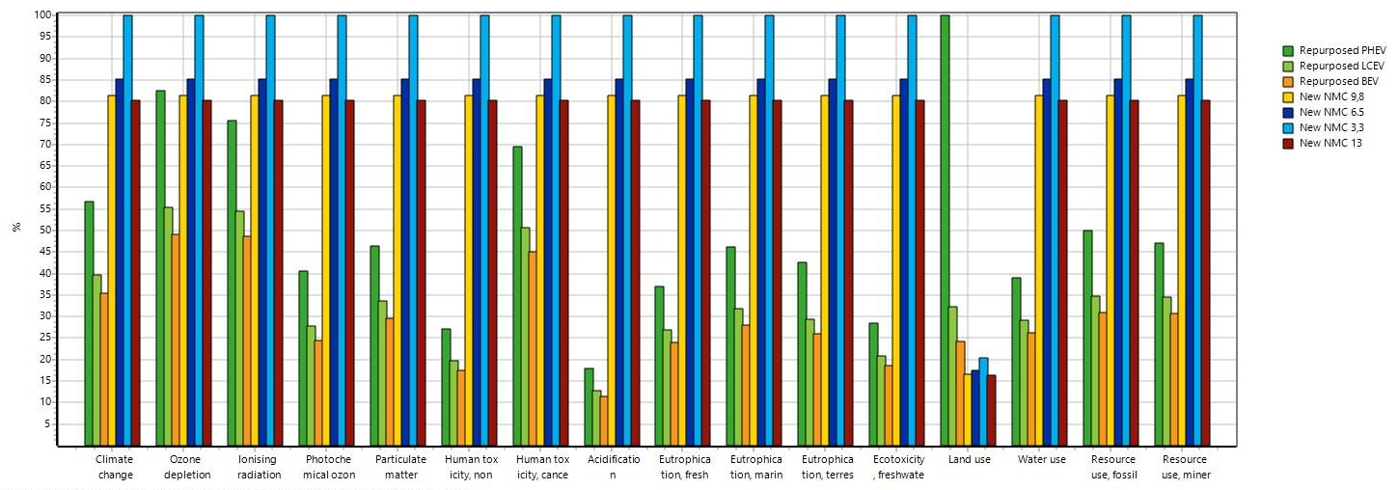
Figure S4 Results of LCA. Dark green, light green and orange represent the results for 1 kWh of storage of repurposing batteries (PHEV, LCEV and BEV respectively), while yellow, dark blue, light blue and dark red represent different configurations of reference system (new NMC batteries of 3.3, 6.5, 9.8 and 13 kWh respectively)

Table S24. Main results characterized for all the scenarios considered in LCA study. Each column represents the environmental footprint (from cradle to gate) of 1 kWh of storage for each battery analysed. The rows show the quantification of each impact considered, reported in the units of measurement of the second column
Impact category | Head | New NMC 3.3 | New NMC 6.5 | New NMC 9.8 | New NMC 13 | Repurposed BEV | Repurposed LCEV | Repurposed PHEV
Climate change | kg CO2 eq | 4.2E-02 | 3.5E-02 | 3.4E-02 | 3.3E-02 | 1.24E-02 | 1.39E-02 | 1.98E-02
Ozone depletion | kg CFC11 eq | 3.3E-09 | 2.8E-09 | 2.7E-09 | 2.7E-09 | 1.39E-09 | 1.57E-09 | 2.34E-09
Ionising radiation | kBq U-235 eq | 2.9E-03 | 2.5E-03 | 2.4E-03 | 2.4E-03 | 1.24E-03 | 1.38E-03 | 1.91E-03
Photochemical ozone formation | kg NMVOC eq | 2.6E-04 | 2.2E-04 | 2.1E-04 | 2.1E-04 | 5.14E-05 | 5.81E-05 | 8.51E-05
Particulate matter | disease inc. | 3.7E-09 | 3.2E-09 | 3.0E-09 | 3.0E-09 | 9.14E-10 | 1.04E-09 | 1.43E-09
Human toxicity, non-cancer | CTUh | 5.1E-09 | 4.4E-09 | 4.2E-09 | 4.1E-09 | 7.22E-10 | 8.11E-10 | 1.12E-09
Human toxicity, cancer | CTUh | 1.5E-10 | 1.3E-10 | 1.2E-10 | 1.2E-10 | 6.09E-11 | 6.84E-11 | 9.37E-11
Acidification | mol H+ eq | 1.2E-03 | 1.0E-03 | 9.9E-04 | 9.8E-04 | 1.09E-04 | 1.22E-04 | 1.70E-04
Eutrophication, freshwater | kg P eq | 6.4E-05 | 5.5E-05 | 5.2E-05 | 5.2E-05 | 1.25E-05 | 1.41E-05 | 1.92E-05
Eutrophication, marine | kg N eq | 7.1E-05 | 6.0E-05 | 5.8E-05 | 5.7E-05 | 1.62E-05 | 1.84E-05 | 2.67E-05
Eutrophication, terrestrial | mol N eq | 8.4E-04 | 7.1E-04 | 6.8E-04 | 6.7E-04 | 1.76E-04 | 1.99E-04 | 2.88E-04
Ecotoxicity, freshwater | CTUe | 6.1 | 5.2 | 4.9 | 4.9 | 0.90 | 1.01 | 1.38
Land use | Pt | 0.3 | 0.3 | 0.3 | 0.2 | 0.30 | 0.40 | 1.23
Water use | m3 depriv. | 2.1E-02 | 1.7E-02 | 1.7E-02 | 1.6E-02 | 4.42E-03 | 4.90E-03 | 6.57E-03
Resource use, fossils | MJ | 0.6 | 0.5 | 0.5 | 0.5 | 0.15 | 0.17 | 0.25
Resource use, minerals and metals | kg Sb eq | 9.1E-06 | 7.7E-06 | 7.4E-06 | 7.3E-06 | 2.29E-06 | 2.57E-06 | 3.50E-06

From Figure S5 you can see the network of processes that conform the BEV repurposed battery system, where the contribution of each process to the overall impact of an ESU is shown (the graphs for the LCEV and PHEV are not shown because they are practically identical). Coincidentally, and similarly to the results of the economic analysis, the main contribution to most impacts comes from the new components to be integrated into the ESU during repurposing, and specifically from the BMS. For new NMC batteries, on the other hand, it is the main material used for the production of the cathode that contributes most to many impact categories (Figure S6), and specifically the extraction of cobalt and the subsequent processes of refining and production of NiCoMn and LiNixCoyMnz Or2.
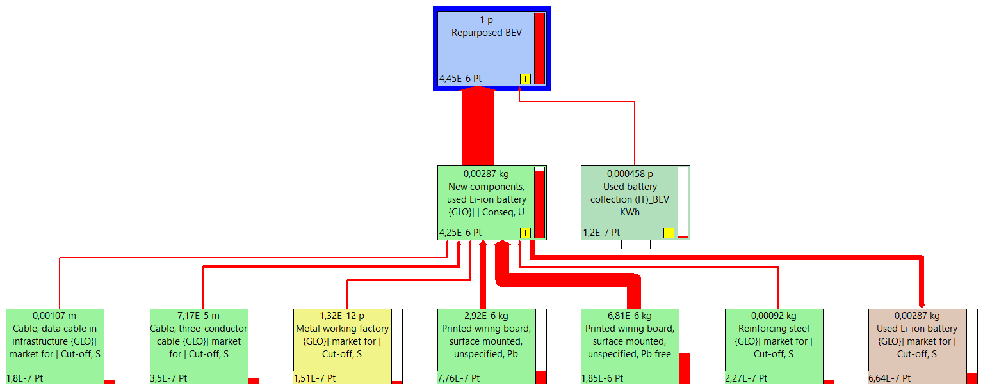
Figure S5 Tree of contribution of the impacts. Here is the tree of aggregate impacts for 1 kWh of the BEV repurposed

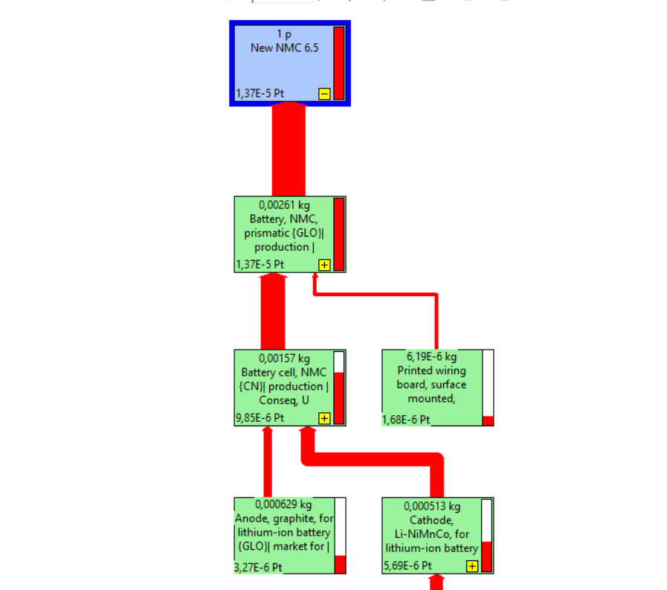
Figure S6 Impact contribution tree. Here is the tree of aggregate impacts for the new NMC of 6.5 kWh.

Table S25 Weighting factors for EF 3.0 methodology used to aggregate previously presented impact results
Impact categories | Weighting factors
Acidification | 6.20
Climate change | 21.06
Ecotoxicity, freshwater | 1.92
Eutrophication, freshwater | 2.80
Eutrophication, marine | 2.96
Eutrophication, terrestrial | 3.71
Human toxicity, cancer | 2.13
Human toxicity, non-cancer | 1.84
Ionising radiation, human health | 5.01
Land use | 7.94
Ozone depletion | 6.31
Particulate matter | 8.96
Photochemical ozone formation - human health | 4.78
Resource use, fossils | 8.32
Resource use, minerals and metals | 7.55
Water use | 8.51

Thanks to this step, it is possible to filter the results presented in Table S24 and in Figure S4 according to their importance and environmental relevance. In the present case, it can be seen in Figure S7 that the impact category related to the consumption of resources (minerals and metals), in turquoise, is the most important for all the analysed systems, that is, the one that contributes the most, in an overall way, to the final impact of the batteries. This derives precisely from the use of minerals and various metals for the production of batteries (e.g. for the cathode material) and the electronics necessary for their control. For new batteries, the second most important impact category would be freshwater ecotoxicity (dark grey), followed by acidification (red), climate change (light green) and freshwater eutrophication (purple). For repurposed batteries, on the other hand, the most relevant impacts after the consumption of mineral resources would be the ecotoxicity of fresh water and Climate Change.

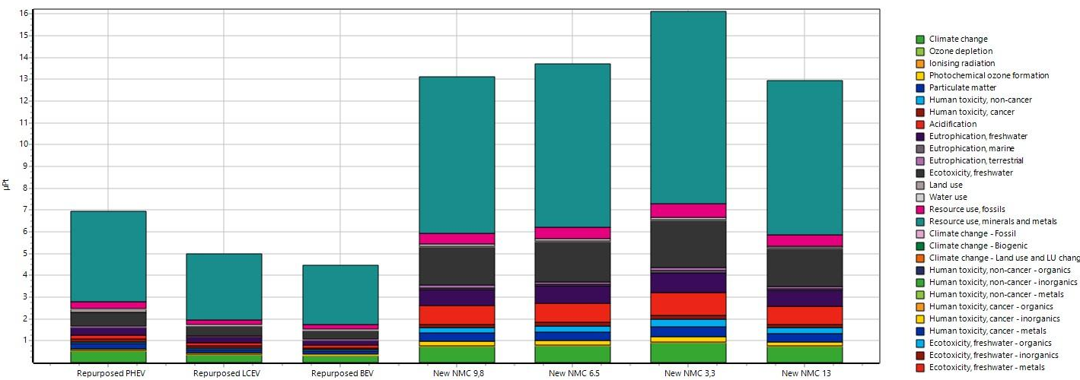
Figure S7 Aggregate environmental impact results for all storage systems analysed

Figure S8 Results of climate changes for all storage systems analysed, presented as overall impacts of the complete battery pack (new or repurposed ESU). The number shown next to the acronyms of repurposed batteries (BEV, PHEV, LCEV) refers to the number of modules used in the configuration of the ESU to achieve an energy performance, or a LET, similar to the new reference batteries (NMC)

The graph in Figure S8 represents the first row in Table S26 and the first group of histograms in Figure S9, showing the new results of the environmental footprint of LFP batteries vs. repurposed batteries (in numerical form in the table, in graphic form in the figure mentioned. Figure S9 presents the relative results (reported in percentages, fixing at 100% the result of the most impacting battery for each category) of the sensitivity analysis carried out and based on the UF of the study (1 kWh of accumulation). To facilitate the understanding of the graph, only the results of the new LFP 6.6 (dark blue bars) and NMC 6.5 (yellow bars) are presented. These storage sizes were chosen based on the average daily residential consumption in Italy, i.e. 5.9 kWh day⁻¹. As can be seen from the graph, the impacts of the new reference system vary depending on the category of impact considered, but remain higher and higher than the repurposed systems under study.
From below it can be seen that the LFP battery has lower impacts than NMC for some impact categories (e.g. acidification and use of mineral resources), while there are higher impacts for other categories (e.g. human toxicity or marine eutrophication), but in general they remain higher than repurposed batteries. To settle these trade-offs, the same normalization and weighing performed previously is applied, to arrive at the single score that allows to aggregate all the impacts and thus compare in an overall way the different storage systems analyzed.

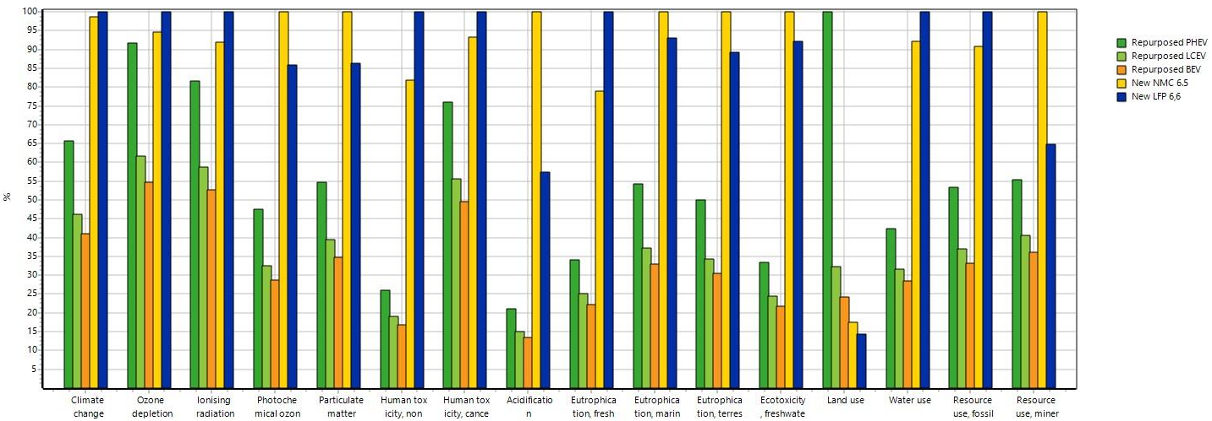
Figure S9 Graphics of results of sensitivity analysis. The comparison of the environmental footprints (different impact categories) of the new scenarios for the reference system (new LFP batteries) is shown here. The first three columns (dark green, light green and orange) represent the results of the repurposed batteries (PHEV, LCEV and BEV, respectively), the yellow columns represent the original reference system (new NMC battery, 6.5 kWh capacity) and the dark blue columns represent the impacts of the new LFP batteries (6.6 kWh capacity)

The results on climate change in Figure S8 are also presented, reported to the entire storage unit or entire ESU instead of the storage energy supplied (1 kWh_{LET}) as in the previous graphic. In this graphic in Figure S10, it can be appreciated that, indeed, the larger ESU have greater impacts as unitary systems. However, when they are reported to the functional unit of the study (1 kWh of actual accumulation), which has been identified as the fundamental service that provides the system under study (the aforementioned LET), the largest ESU are the most efficient and performing in terms of environmental impact for UF (see Figure S10 and Figure S11). The main results in Table S24 are reported at kWh of nominal storage, but presented this way the repurposed batteries have no difference in energy-environmental performance, so we see only one result for all ESU (BEV, PHEV, LCEV) in Figure S10.

Table S26 Numerical results of the scenarios considered for the alternative reference system with LFP batteries in the sensitivity analysis performed. Each column represents the environmental footprint of 1 kWh of storage for each battery analysed along its own life cycle. The rows show the quantification of each impact considered, reported in the units of measurement of the second column
Impact category | Head | New LFP 2.2 | New LFP 4.4 | New LFP 6.6 | New LFP 8.8 | New LFP 11 | Repurposed BEV | Repurposed LCEV | Repurposed PHEV
Climate change | kg CO2 eq | 4.7E-02 | 3.7E-02 | 3.0E-02 | 2.7E-02 | 2.5E-02 | 1.24E-02 | 1.39E-02 | 1.98E-02
Ozone depletion | kg CFC11 eq | 4.0E-09 | 3.1E-09 | 2.5E-09 | 2.3E-09 | 2.1E-09 | 1.39E-09 | 1.57E-09 | 2.34E-09
Ionising radiation | kBq U-235 eq | 3.6E-03 | 2.9E-03 | 2.3E-03 | 2.1E-03 | 1.9E-03 | 1.24E-03 | 1.38E-03 | 1.91E-03
Photochemical ozone formation | kg NMVOC eq | 2.4E-04 | 1.9E-04 | 1.5E-04 | 1.4E-04 | 1.3E-04 | 5.14E-05 | 5.81E-05 | 8.51E-05
Particulate matter | disease inc. | 3.5E-09 | 2.8E-09 | 2.3E-09 | 2.0E-09 | 1.9E-09 | 9.14E-10 | 1.04E-09 | 1.43E-09
Human toxicity, non-cancer | CTUh | 6.6E-09 | 5.2E-09 | 4.3E-09 | 3.8E-09 | 3.5E-09 | 7.22E-10 | 8.11E-10 | 1.12E-09
Human toxicity, cancer | CTUh | 1.9E-10 | 1.5E-10 | 1.2E-10 | 1.1E-10 | 1.0E-10 | 6.09E-11 | 6.84E-11 | 9.37E-11
Acidification | mol H+ eq | 7.2E-04 | 5.7E-04 | 4.6E-04 | 4.1E-04 | 3.8E-04 | 1.09E-04 | 1.22E-04 | 1.70E-04
Eutrophication, freshwater | kg P eq | 8.7E-05 | 6.9E-05 | 5.6E-05 | 5.0E-05 | 4.6E-05 | 1.25E-05 | 1.41E-05 | 1.92E-05
Eutrophication, marine | kg N eq | 7.1E-05 | 5.6E-05 | 4.6E-05 | 4.1E-05 | 3.7E-05 | 1.62E-05 | 1.84E-05 | 2.67E-05
Eutrophication, terrestrial | mol N eq | 8.0E-04 | 6.3E-04 | 5.2E-04 | 4.6E-04 | 4.2E-04 | 1.76E-04 | 1.99E-04 | 2.88E-04
Ecotoxicity, freshwater | CTUe | 5.9 | 4.6 | 3.8 | 3.4 | 3.1 | 0.90 | 1.01 | 1.38
Land use | Pt | 0.3 | 0.2 | 0.2 | 0.2 | 0.1 | 0.30 | 0.40 | 1.23
Water use | m3 depriv. | 2.4E-02 | 1.9E-02 | 1.6E-02 | 1.4E-02 | 1.3E-02 | 4.42E-03 | 4.90E-03 | 6.57E-03
Resource use, fossils | MJ | 0.7 | 0.6 | 0.5 | 0.4 | 0.4 | 0.15 | 0.17 | 0.25
Resource use, minerals and metals | kg Sb eq | 6.4E-06 | 5.0E-06 | 4.1E-06 | 3.6E-06 | 3.4E-06 | 2.29E-06 | 2.57E-06 | 3.50E-06

After weighing and normalizing the results presented above, we arrive at the aggregate results shown in Figure S10. As can be seen here, the new LFP reference batteries would be slightly more performing in this stationary application than the NMC ones, but they would still remain as a worse alternative (from an environmental point of view) than the repurposed one.
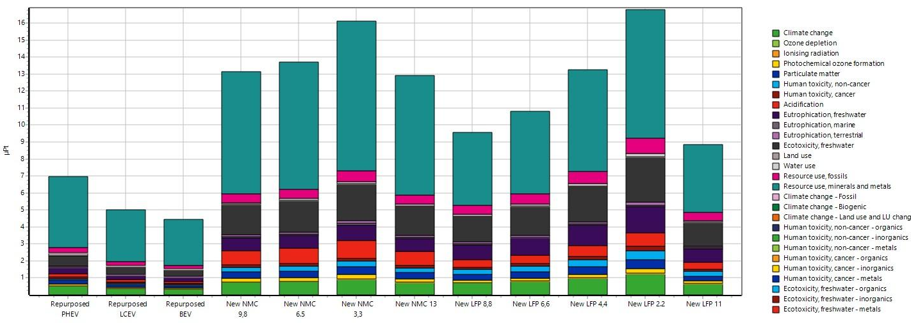
Figure S10 Aggregate environmental impact results for all storage systems analysed

Table S27 Numerical results of the scenarios considered for the alternative circularity allocation criterion used in the sensitivity analysis. Results per kWh of storage energy (LET)
Impact category | Head | BEV-Cutoff | BEV-CFF | LCEV-Cutoff | LCEV-CFF | PHEV-Cutoff | PHEV-CFF | New LFP 6.6 | New NMC 6.5
Climate change | kg CO2 eq | 1.24E-02 | 1.76E-02 | 1.39E-02 | 1.98E-02 | 1.98E-02 | 2.98E-02 | 3.02E-02 | 3.54E-02
Ozone depletion | kg CFC11 eq | 1.39E-09 | 1.68E-09 | 1.57E-09 | 1.89E-09 | 2.34E-09 | 2.88E-09 | 2.55E-09 | 2.82E-09
Ionising radiation | kBq U-235 eq | 1.24E-03 | 1.49E-03 | 1.38E-03 | 1.67E-03 | 1.91E-03 | 2.40E-03 | 2.35E-03 | 2.50E-03
Photochemical ozone formation | kg NMVOC eq | 5.14E-05 | 9.10E-05 | 5.81E-05 | 1.03E-04 | 8.51E-05 | 1.60E-04 | 1.54E-04 | 2.19E-04
Particulate matter | disease inc. | 9.14E-10 | 1.40E-09 | 1.04E-09 | 1.58E-09 | 1.43E-09 | 2.35E-09 | 2.26E-09 | 3.15E-09
Human toxicity, non-cancer | CTUh | 5.55E-09 | 1.17E-08 | 6.23E-09 | 1.31E-08 | 8.55E-09 | 2.02E-08 | 4.27E-09 | 4.38E-09
Human toxicity, cancer | CTUh | 5.72E-10 | 8.07E-10 | 6.42E-10 | 9.06E-10 | 8.84E-10 | 1.33E-09 | 1.23E-10 | 1.29E-10
Acidification | mol H+ eq | 1.09E-04 | 3.22E-04 | 1.22E-04 | 3.61E-04 | 1.70E-04 | 5.76E-04 | 4.62E-04 | 1.04E-03
Eutrophication, freshwater | kg P eq | 1.25E-05 | 2.24E-05 | 1.41E-05 | 2.51E-05 | 1.92E-05 | 3.80E-05 | 5.63E-05 | 5.49E-05
Eutrophication, marine | kg N eq | 1.62E-05 | 2.63E-05 | 1.84E-05 | 2.96E-05 | 2.67E-05 | 4.58E-05 | 4.58E-05 | 6.01E-05
Eutrophication, terrestrial | mol N eq | 1.76E-04 | 3.01E-04 | 1.99E-04 | 3.39E-04 | 2.88E-04 | 5.26E-04 | 5.15E-04 | 7.12E-04
Ecotoxicity, freshwater | CTUe | 0.03 | 0.05 | 0.03 | 0.05 | 0.04 | 0.08 | 3.79 | 5.17
Land use | Pt | 0.62 | 0.70 | 0.84 | 0.93 | 2.67 | 2.82 | 0.18 | 0.26
Water use | m3 depriv. | 4.42E-03 | 7.31E-03 | 4.90E-03 | 8.13E-03 | 6.57E-03 | 1.21E-02 | 1.55E-02 | 1.75E-02
Resource use, fossils | MJ | 0.15 | 0.24 | 0.17 | 0.26 | 0.25 | 0.40 | 0.46 | 0.51
Resource use, minerals and metals | kg Sb eq | 2.29E-06 | 3.54E-06 | 2.57E-06 | 3.97E-06 | 3.50E-06 | 5.88E-06 | 4.10E-06 | 7.74E-06

Finally, in Figure S11 the aggregate results (single score) are presented as before, where it can be observed that even in this case, the repurposed batteries remain, overall, less impactful than the new ones. Except for the PHEV, which has a lower SOH, is penalized under this approach and therefore would remain more impactful than the larger configurations of new LFP batteries.

Figure S11 Aggregated results for all batteries and scenarios analysed

References
Ellingsen LA-W, Majeau-Bettez G, Singh B, et al (2014) Life Cycle Assessment of a Lithium-Ion Battery Vehicle Pack. J Ind Ecol 18:113–124. https://doi.org/https://doi.org/10.1111/jiec.12072
Eyer J, Williams B, Ferry M, et al (2012) A Techno-Economic Analysis of PEV Battery Second Use: Repurposed-Battery Selling Price and Commercial and Industrial End-User Value. In: SAE 2012 World Congress & Exhibition. SAE International
Nelson PAP a., Gallagher KGKG, Bloom ID, Dees DWDW (2011) Modeling the Performance and Cost of Lithium-Ion Batteries for Electric-Drive Vehicles
Neubauer JS, Pesaran A, Williams B, et al (2012) A techno-economic analysis of PEV battery second use: Repurposed-battery selling price and commercial and industrial end-user value. SAE Tech Pap. https://doi.org/10.4271/2012-01-0349
Neubauer J, Smith K, Wood E, Pesaran A (2015) Identifying and Overcoming Critical Barriers to Widespread Second Use of PEV Batteries. Natl Renew Energy Lab 23–62
Logan Goldie-Scot (2019) A Behind the Scenes Take on Lithium-ion Battery Prices. Bloom. New Energy Financ.
Rallo H, Benveniste G, Gestoso I, Amante B (2020) Economic analysis of the disassembling activities to the reuse of electric vehicles Li-ion batteries. Resour Conserv Recycl 159:104785. https://doi.org/10.1016/j.resconrec.2020.104785
Steen M, Lebadeva N, Di Persio F, Boon-Brett L (2017) EU Competitiveness in Advanced Li-ion Batteries for E-Mobility and Stationary Storage Applications – Opportunities and Actions.

This is equivalent to a total transport and collection cost of 9.4 – 13.3 € kWh⁻¹ for Italy and the batteries considered, as indicated by COBAT.
https://www.istat.it/it/archivio/retribuzioni
Available at (accessed on 8/02/2020 and on 22/2/2024): https://www.europe-solarstore.com/batteries/manufacturer/lg-chem.html

