Supplementary Information
DFT study of electron donor-acceptor (EDA) complexes of 1H-indole and benzyl bromide derivatives: mechanism exploration and theoretical prediction
Zhao Liu,‡^{a,b} Shutao Wang,‡ ^{a,b} Zhiqiang Liu,‡ ^{a,b} Yating Ding,ª Yansong Hu,^{b} Runzhang Liu,^{b} Zhengze Zhang,^{b} and Junqiang Lei ^{a*}
ª First Hospital of Lanzhou University, Lanzhou University, 222 South Tianshui Road, Lanzhou 730000 (P. R. China).
^{b} State Key Laboratory of Applied Organic Chemistry, College of Chemistry and Chemical Engineering, Lanzhou University.
*E-mail: leijq2011@126.com

Contents
1. Computation details 3
2. The substituted benzyl bromide molecules selected 3
3. The substituted 1H-indoles molecules selected 5
4. Distance measurement of two molecules in EDA complexes 6
5. The FMO analyses of selected substrates 6
6. References 8
7. Cartesian coordinates 9

- Computation details
All calculations were carried out with the Gaussian 09 programs.¹ The geometries of all the species were fully optimized by using density functional theory (DFT) of the 6-2x method² with the 6-311 G (d, p) basis set for all atoms. Frequency analysis was used to determine the minimum point of the optimized conformation and obtain its energy at the same level of theory. The convergence criteria are used as default and the vibrational analysis has also been carried out at standard conditions (1 atm, 298.15 K). The solvent effects are represented by the implicit solvent model using the SMD-CH₃OH model.³ Analysis of interaction region indicator (IRI) was performed with the Multiwfn program.⁴ The 3D structure of molecules is drawn by CYL-View⁵ and VMD.⁶ The obtained molecular structure is directly used for single point time-dependent density functional (TD-DFT) calculation at the level of CAM-B3LYP /6-311++G (d, p).

- The substituted benzyl bromide molecules selected
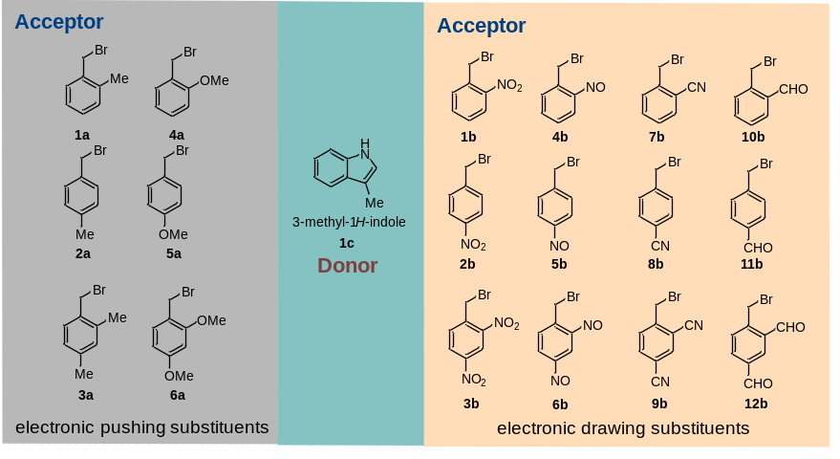
Fig. S1 The substituted benzyl bromide molecules selected in this study.

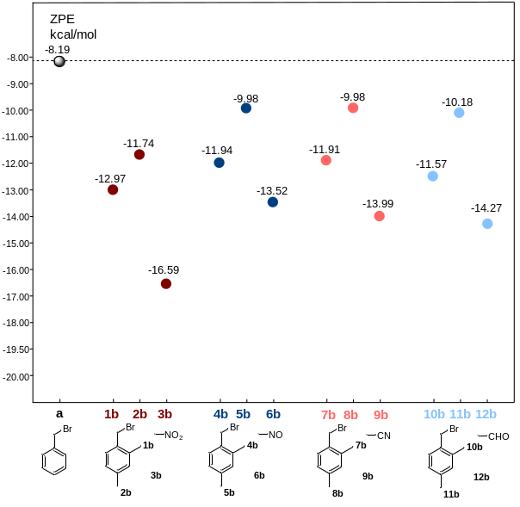
Fig. S2 The formation energy of the selected EDA complex (electron-withdrawing group).

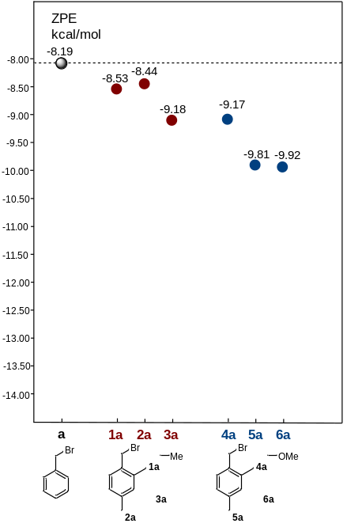
Fig. S3 The formation energy of the selected EDA complex (electron-donating group).

- The substituted 1H-indoles molecules selected
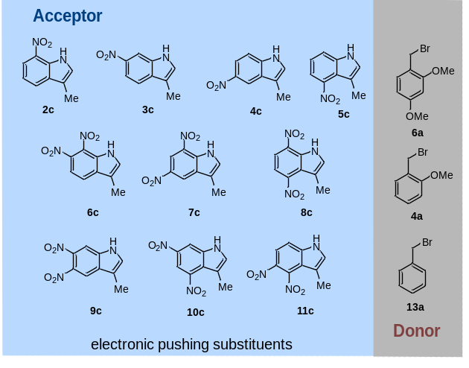
Fig. S4 The substituted 1H-indoles molecules selected in this study.

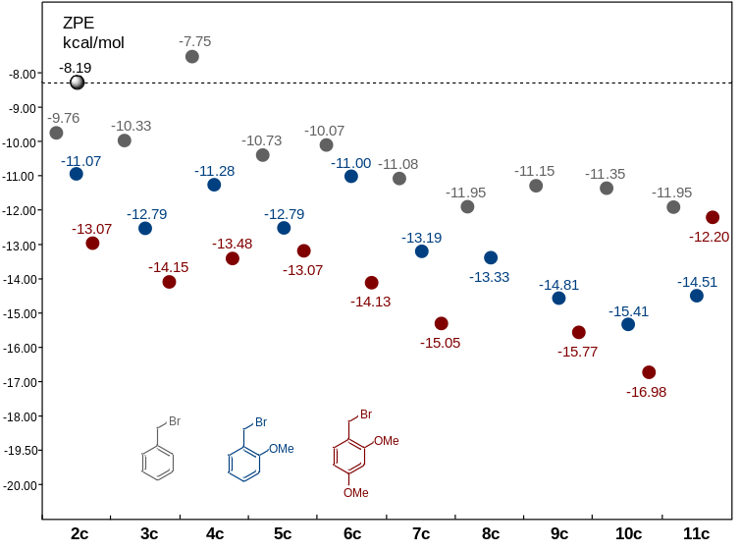
Fig. S5 The formation energy of the selected EDA complex (electron-withdrawing group).

- Distance measurement of two molecules in EDA complexes
Fig. S6 The distance of two molecules in EDA complexes.

- The FMO analyses of selected substrates

Fig. S7 The FMO analyses of substrates.

Table S1 The E_{HOMO}, E_{LUMO} and E_{g} of selected substrates.
EDA Complexes | E_{HOMO}/eV | E_{LUMO}/eV | E_{g}/eV
3b | -9.13 | -2.08 | -7.06
13a | -8.23 | -0.14 | -8.10
6a | -7.36 | 0.06 | -7.42
1c | -6.87 | 0.44 | -7.31
10c | -7.60 | -1.80 | -5.80
Pyr | -7.14 | 2.21 | -9.35

Fig. S8 Structure of EDA complex in excited triplet state.

- References
- M. J. Frisch, G. W. Trucks, H. B. Schlegel, G. E. Scuseria, M. A. Robb, J. R. Cheeseman, G. Scalmani, V. Barone, B. Mennucci, G. A. Petersson, H. Nakatsuji, M. Caricato, X. Li, H. P. Hratchian, A. F. Izmaylov, J. Bloino, G. Zheng, J. L. Sonnenberg, M. Hada, M. Ehara, K. Toyota, R. Fukuda, J. Hasegawa, M. Ishida, T. Nakajima, Y. Honda, O. Kitao, H. Nakai, T. Vreven, J. J. A. Montgomery, J. E. Peralta, F. Ogliaro, M. Bearpark, J. J. Heyd, E. Brothers, K. N. Kudin, V. N. Staroverov, T. Keith, R. Kobayashi, J. Normand, K. Raghavachari, A. Rendell, J. C. Burant, S. S. Iyengar, J. Tomasi, M. Cossi, N. Rega, J. M. Millam, M. Klene, J. E. Knox, J. B. Cross, V. Bakken, C. Adamo, J. Jaramillo, R. Gomperts, R. E. Stratmann, O. Yazyev, A. J. Austin, R. Cammi, C. Pomelli, J. W. Ochterski, R. L. Martin, K. Morokuma, V. G. Zakrzewski, G. A. Voth, P. Salvador, J. J. Dannenberg, S. Dapprich, A. D. Daniels, O. Farkas, J. B. Foresman, J. V. Ortiz, J. Cioslowski and D. J. Fox, Gaussian 09, Revision D.01, Gaussian, Inc., Wallingford, CT, 2013.
- Y. Zhao and D. G. Truhlar, The M06 Suite of Density Functionals for Main Group Thermochemistry, Thermochemical Kinetics, Noncovalent Interactions, Excited States, and Transition Elements: Two New Functionals and Systematic Testing of Four M06-Class Functionals and 12 Other Functionals, Theor. Chem. Acc., 2008, 120, 215-241.
- A. V. Marenich, C. J. Cramer and D. G. Truhlar, Universal Solvation Model Based on Solute Electron Density and on a Continuum Model of the Solvent Defined by the Bulk Dielectric Constant and Atomic Surface Tensions, J. Phys. Chem. B, 2009, 113, 6378-6396.
- T. Lu and F. Chen, Multiwfn: A Multifunctional Wavefunction Analyzer, J. Comput. Chem., 2012, 33, 580-592.
- C. Y. Legault, Cylview, 1.0 b, Universit´e de Sherbrooke, Sherbrooke, Canada, 2009.
- Humphrey W, Dalke A, Schulten K, VMD – Visual.; Molecular Dynamics. J. Molec. Graphics., 1996, 14, 33-38.

- Cartesian coordinates
3b-1c
0 1
Br 3.93393600 -0.97535900 -0.07349900
N -2.62722900 -2.42166700 0.54847600
O -3.16866700 -3.07567500 -0.31734300
O -3.12038500 -2.18223000 1.62947200
C 2.39658100 -0.02951400 -0.86419200
H 2.51046300 1.00815800 -0.58006500
H 2.50018300 -0.15298000 -1.93878900
C 1.11651600 -0.65207300 -0.39756100
C 0.54573700 -1.62815700 -1.22301700
H 1.05818100 -1.89814600 -2.13902200
C -0.65962700 -2.23435100 -0.91980700
H -1.10093800 -2.96709000 -1.58201500
C -1.30203300 -1.86402500 0.25249800
C -0.78249700 -0.92916400 1.11985900
H -1.30415200 -0.64799200 2.02270300
C 0.42065100 -0.32969200 0.77489400
N -0.52113700 1.44338300 -2.24801400
H -0.33106400 1.02152200 -3.14567000
C 0.28183100 2.36306400 -1.61508000
H 1.19288900 2.70628100 -2.08395600
C -0.26394400 2.72463800 -0.41062600
C -1.48913800 1.97610300 -0.29204600
C -2.46978200 1.87109400 0.70797300
H -2.38955300 2.45551500 1.61892300
C -3.53114400 1.00220100 0.51554700
H -4.29205700 0.90417300 1.28166100
C -3.64730000 0.24206900 -0.66662200
H -4.49239800 -0.42767300 -0.78576800
C -2.69427500 0.31935200 -1.66772700
H -2.77146300 -0.27522800 -2.57147500
C -1.61391000 1.18413700 -1.46181600
C 0.27983400 3.73034700 0.55621200
H 0.38815600 3.31481900 1.56244000
H -0.38413600 4.59615900 0.63846600
H 1.25867100 4.08625100 0.22878800
N 0.88960900 0.71175400 1.70197900
O 0.10972700 1.10770200 2.54444100
O 2.02379500 1.12561700 1.59070900

13a-1c
0 1
Br -3.88378200 0.03037300 0.27711500
C -1.99288300 0.63231600 0.13549700
H -1.99351600 1.35259400 -0.67892900
H -1.79003600 1.12550200 1.08223100
C -1.07740100 -0.51796100 -0.11714600
C -0.45189000 -1.16562900 0.94720200
H -0.64615300 -0.83581400 1.96329600
C 0.42605600 -2.21983800 0.70968400
H 0.91545300 -2.71250200 1.54228700
C 0.68119900 -2.63358000 -0.59406000
C 0.05502800 -1.99169100 -1.66202700
H 0.25482100 -2.30882400 -2.67935700
C -0.82137700 -0.94027500 -1.42390700
N 1.36998900 1.73293600 1.50581400
H 1.16800700 1.92754400 2.47559400
C 0.79920600 2.37520100 0.42788100
H 0.05825500 3.14644600 0.58141500
C 1.31163700 1.88529100 -0.74202600
C 2.26415700 0.87362700 -0.36648100
C 3.09933800 0.01227400 -1.09608800
H 3.10347700 0.04066400 -2.18128400
C 3.90875300 -0.87588900 -0.40900700
H 4.55756000 -1.54946000 -0.95748300
C 3.90374000 -0.92150300 1.00024400
H 4.54935500 -1.62815800 1.50965800
C 3.09304000 -0.08359000 1.74695000
H 3.08632700 -0.11964100 2.83068900
C 2.27432900 0.80988400 1.04929100
C 0.94109500 2.28000700 -2.13601000
H 0.55573600 1.42308600 -2.69771900
H 1.80489900 2.66477800 -2.68656100
H 0.17243100 3.05553900 -2.13001100
H -1.30989300 -0.43869000 -2.25369000
H 1.37155800 -3.44853800 -0.77986800
6a-1c
0 1
Br 4.01296500 0.38686300 0.07632700
C 2.31631700 -0.26556400 -0.75771200
H 2.52467900 -0.25982800 -1.82365300
H 2.21780800 -1.28138600 -0.38644700
C 1.15917500 0.59487100 -0.41169800
C 0.49252500 0.43471000 0.82083800
C -0.60138100 1.22554400 1.13801300
H -1.14133800 1.11606300 2.06912900
C -1.06664800 2.16701600 0.21292700
C -0.42134600 2.34931800 -1.00755600
H -0.76800300 3.07355700 -1.73123500
C 0.68769000 1.55479500 -1.29485800
N -1.08162900 -2.88042600 0.76855300
H -0.98999800 -3.34676500 1.65921500
C -0.22056400 -3.02483700 -0.29814400
H 0.60912800 -3.71458000 -0.23948100
C -0.59985200 -2.20805500 -1.32807300
C -1.76392200 -1.49821300 -0.86523400
C -2.58412200 -0.50970800 -1.43221100
H -2.39782600 -0.15335900 -2.44068000
C -3.62361300 0.01106500 -0.67972200
H -4.26279900 0.77944500 -1.10051100
C -3.86684600 -0.44062100 0.63331700
H -4.68667500 -0.01094200 1.19797700
C -3.08177000 -1.42154700 1.21593600
H -3.26805100 -1.77043600 2.22574100
C -2.02840400 -1.93987300 0.45509500
C 0.06175400 -2.05097500 -2.66023100
H 0.32839800 -1.00542300 -2.84583900
H -0.59810700 -2.36573300 -3.47463100
H 0.97355100 -2.64951500 -2.71524000
H 1.19678500 1.68287200 -2.24513400
O 0.97937000 -0.53230400 1.63243500
C 0.37325000 -0.69967000 2.90847300
H 0.89744400 -1.52841200 3.38029000
H 0.49407800 0.20323300 3.51356100
H -0.68809400 -0.94212700 2.81433300
O -2.17926800 2.84440300 0.59616200
C -2.73860100 3.76850000 -0.32993500
H -3.63045100 4.16719500 0.14905100
H -2.04070200 4.58353200 -0.53970200
H -3.01484900 3.26807100 -1.26218600

3b-10c
0 1
Br 2.29708300 3.15744500 -0.39330800
C 1.58498600 1.35372100 -0.72532100
H 1.76562200 1.15787500 -1.77885000
H 2.16695900 0.68751800 -0.09975800
C 0.11220000 1.32131700 -0.44530400
C -0.49174500 1.15861900 0.81107400
C -1.86782100 1.12535300 0.97749700
H -2.30658000 0.98241500 1.95515900
C -2.65500300 1.23251600 -0.14994600
C -2.12153200 1.38302100 -1.42083900
H -2.76828300 1.44741800 -2.28590000
C -0.74350500 1.43920700 -1.54719000
N 1.16448700 -2.08945800 2.51340400
H 0.75614900 -2.09221300 3.43949500
C 2.49040100 -1.97832000 2.23116900
H 3.21764300 -1.92951900 3.02861000
C 2.70899700 -1.92144600 0.87050100
C 1.41152500 -1.99550900 0.27722800
C 0.85994200 -1.91408400 -1.01825800
C -0.49446300 -1.87336900 -1.24832300
C -1.35533800 -1.94762800 -0.14990900
C -0.91229800 -2.06422800 1.15721000
C 0.46085400 -2.08158600 1.34289000
C 4.05466700 -1.72834000 0.24123800
H 4.04283100 -0.90406100 -0.47581200
H 4.39067800 -2.62119200 -0.28883700
H 4.78477000 -1.49327100 1.01753800
H -0.30800400 1.55547800 -2.53278100
H -1.60295900 -2.09919100 1.99064700
N 1.72255300 -1.85652100 -2.19615200
O 2.74547800 -2.50670000 -2.17831000
O 1.36154100 -1.17410800 -3.13580700
H -0.88285300 -1.78000500 -2.25309100
N -2.78594100 -1.80549800 -0.39518500
O -3.17482500 -1.78021300 -1.54536800
O -3.52299900 -1.67312600 0.56528000
N -4.11249900 1.11304000 0.00966200
O -4.57368500 1.23085000 1.12337000
O -4.76625500 0.88712300 -0.98481600
N 0.29586000 0.93845800 2.03991600
O -0.30094000 0.59044600 3.03811900
O 1.49465000 1.10354700 1.99572400

13a-10c
0 1
Br 3.53755100 -1.57901000 -0.20414100
C 1.84709200 -0.55721700 0.00704200
H 1.92140600 -0.11461200 0.99781100
H 1.89039100 0.20951900 -0.76288400
C 0.65569800 -1.44555300 -0.13394400
C 0.05332600 -1.62582400 -1.37889100
C -1.07536100 -2.43126400 -1.50291800
H -1.54570800 -2.55751500 -2.47171800
C -1.60822800 -3.06171500 -0.38197500
C -1.01017300 -2.88432500 0.86480900
H -1.43040900 -3.36440100 1.74126200
C 0.11839400 -2.08243400 0.98738300
N -0.73344300 2.30247000 -2.46622800
H -1.13782500 2.21803800 -3.38947800
C 0.39500800 2.99564600 -2.15432300
H 0.93940500 3.52930400 -2.91976300
C 0.69339500 2.88564900 -0.81303800
C -0.33722000 2.06072600 -0.26319200
C -0.64540300 1.48231600 0.98548700
C -1.67961500 0.59324500 1.15788700
C -2.47379700 0.28039600 0.05243400
C -2.27098600 0.82044800 -1.20548500
C -1.20604800 1.69591100 -1.33744800
C 1.91496200 3.47220900 -0.17361000
H 2.45995200 2.72204300 0.40432100
H 1.67029100 4.29372000 0.50183300
H 2.58097800 3.85218900 -0.95033300
H 0.58030400 -1.93465400 1.95888400
H 0.46391100 -1.12412100 -2.25038600
H -2.49661100 -3.67676700 -0.47505000
H -2.89487100 0.54688200 -2.04648200
N 0.13708600 1.80843600 2.17305300
O 0.55682500 2.94149700 2.28089500
O 0.31405900 0.93467400 3.00092500
H -1.87337700 0.14947100 2.12434300
N -3.53683000 -0.70154900 0.22482100
O -3.74927400 -1.13184900 1.34132600
O -4.15112000 -1.06163500 -0.76068200

6a-10c
0 1
Br 2.44556400 3.01273700 -0.49590200
C 1.54880300 1.23516600 -0.65888100
H 1.74948500 0.92584200 -1.68151200
H 2.08374400 0.61181400 0.05130300
C 0.09428500 1.32453000 -0.37750200
C -0.38071100 1.28513500 0.94911100
C -1.74005400 1.38000800 1.21355000
H -2.13661200 1.35186800 2.21964400
C -2.64853900 1.47708300 0.15308500
C -2.20444500 1.48628900 -1.16744900
H -2.89453000 1.54416600 -1.99778000
C -0.83231700 1.42124600 -1.40560900
N 0.86370300 -2.02562800 2.59445400
H 0.43491600 -1.99989300 3.51029000
C 2.20010100 -1.99251900 2.34493600
H 2.90965600 -1.97437800 3.15958800
C 2.45462600 -1.97905600 0.98983700
C 1.16949200 -1.99764700 0.36383600
C 0.65598700 -1.93283600 -0.94853800
C -0.68778100 -1.81979900 -1.21425500
C -1.57623500 -1.80187400 -0.13748800
C -1.17212100 -1.89895900 1.18348400
C 0.19134500 -1.99663300 1.40574100
C 3.82494400 -1.87389100 0.39318100
H 3.87417700 -1.07318900 -0.34870300
H 4.13034300 -2.79832000 -0.09998700
H 4.54506000 -1.65066000 1.18240800
H -0.47314200 1.43200200 -2.43028800
H -1.88552800 -1.87367400 1.99734300
N 1.54495400 -1.97932200 -2.10431200
O 2.53986900 -2.66923700 -2.02580600
O 1.23566100 -1.34053200 -3.09256400
H -1.04639400 -1.74385300 -2.23111600
N -2.99397700 -1.62001700 -0.42165000
O -3.35517000 -1.62670800 -1.58334100
O -3.75143100 -1.45274000 0.51470000
O 0.56003200 1.12462800 1.90965500
C 0.12253000 1.07204400 3.26223200
H 1.01643300 0.90208500 3.85909000
H -0.34140800 2.01782600 3.55520700
H -0.58534300 0.25249600 3.41486700
O -3.95391400 1.53858600 0.52018000
C -4.93434000 1.46049300 -0.50979000
H -5.89676700 1.45359000 -0.00235600
H -4.87762900 2.32749700 -1.17315600
H -4.81775800 0.53909000 -1.08721700

