Supplementary File
Title: Trends and Factors Affecting the Initiation of Denosumab and Zoledronic Acid among Metastatic Lung, Breast, and Prostate Cancer Patients in the United States
Authors: Kaniz Afroz Tanni, MS¹; Nedret Billor, PhD¹; Surachat Ngorsuraches, PhD¹; Salisa Westrick, PhD¹; Pei Xu, PhD¹; Brandon Johnson, MD²; Jingjing Qian, PhD¹
Affiliation: ¹Auburn University, Auburn, AL, US; ²East Alabama Medical Center, AL, US
Email Address: Kaniz Afroz Tanni (kzt0031@auburn.edu; ORCID ID: 0000-0002-0417-1988), Nedret Billor (billone@auburn.edu), Surachat Ngorsuraches (szn0053@auburn.edu), Salisa Westrick (westrsc@auburn.edu), Brandon Johnson (brandon.johnson@eamc.org), Jingjing Qian (jzq0004@auburn.edu, ORCID ID: 0000-0003-4624-9963)

Table 1: Variables of Interest in SEER-Medicare
Category | Variables | SEER Variable | SEER Files
Demographic and socio-economic characteristics | Age | agedx1-agedx10 | SEER and MBSF ABCD
Demographic and socio-economic characteristics | Sex | s_sex | SEER and MBSF ABCD
Demographic and socio-economic characteristics | race/ethnicity | rac_recy; origrecb | SEER and MBSF ABCD
Demographic and socio-economic characteristics | marital status | marst1-marst10 | SEER and MBSF ABCD
Demographic and socio-economic characteristics | residence in urban/rural area | (ruic10c1-  ruic10c10; | SEER and MBSF ABCD
Demographic and socio-economic characteristics | SEER region (Northeast, Midwest, South, and West) | statecd1-statecd10, cnty1-cnty10 | SEER and MBSF ABCD
Demographic and socio-economic characteristics | Medicare low-income subsidy |  | MEDPAR
Comorbidities | Charlson comorbidity index | diagnosis codes 1-25 (DGN_CD1-DGN_CD25), | MEDPAR
Comorbidities | Charlson comorbidity index | diagnosis codes (dgn_cd1-dgn_cd12) | NCH
Comorbidities | Charlson comorbidity index | diagnosis codes 1-25 (dgn_cd1-dgn_cd25); | OUTPAT
 | history of osteoporosis | ICD-9-CM code 733.0;  ICD-10-CA code M81 | MEDPAR, DME, HHA, Hospice, OUTPAT and NCH
 | hypercalcemia | ICD-9-CM Code 275.42;  ICD-10 code E83. 52 | MEDPAR, DME, HHA, Hospice, OUTPAT and NCH
 | impaired renal function | ICD-9-CM code 585.9;  ICD-10 code N25.9 | MEDPAR, DME, HHA, Hospice, OUTPAT and NCH
Healthcare utilization | Physician office visits | CLM_ID; NCH_CLM_TYPE_CD;  LINE_PLACE_OF_SRVC_CD | NCH, OUTPAT
Healthcare utilization | Emergency department (ED) visits | CLM_ID; NCH_CLM_TYPE_CD;  LINE_PLACE_OF_SRVC_CD | NCH
Healthcare utilization | Hospitalizations | CLM_ID; NCH_CLM_TYPE_CD;  LINE_PLACE_OF_SRVC_CD | NCH
Disease characteristics | Primary Site | site1-site10 | SEER cancer file
Disease characteristics | Histology | ICD-O-3  (hist1-hist10) | SEER cancer file
Disease characteristics | Derived AJCC Stage Group, 6th edition | (dajccstg1- dajccstg10) | SEER cancer file
 | Gleason Score | CSsitespecificfactor620042017va | SEER cancer file
Treatment characteristics | Receipt of DS and/ZA; Receipt of other IV chemotherapy | HCPCS codes (HCPCS_CD)  Administration =  964xx, 96400-96549, Q0083-Q0085;  Specific drugs administered intravenously (IV):  J9000-J9999 | NCH, OUTPAT
Treatment characteristics | Receipt of aromatase inhibitor | NDC codes-  Anastrozole:  00054016413, 00093753656, 00310020130, 00310020137, 00310020150, 00378603405,  00378603477, 00781535631, 00904619546, 00904622961, 16571042103, 16729003510,  16729003515, 16729003516, 21695099030, 35356027030, 38779227406, 38779255503,  38779255504, 38779255506, 42043018003, 42291010530, 51079032301, 51079032306,  51927443500, 51991062010, 51991062033, 54569573100, 54569619800, 54868500000,  54868613000, 54868613001, 55111064730, 55175550503, 60258086603, 62756025013,  62756025083, 63275993001, 63275993002, 63323012930, 66435041530, 67877017110,  67877017130, 68084044811, 68084044821, 68258903501, 68382020906, 42254016130,  60429028630, 60429028690, 60505298503, 63275993003, 63275993004, 63275993005,  68382020910  Exemestane:  00054008013, 49999098630, 54569573200, 54868526100, 59762285801, 00009766304  Letrozole:  00054026913, 00078024915, 00093762056, 00378207105, 00378207193, 00603418016,  16729003410, 35356040930, 51991075910, 51991075933, 54569571400, 54868415100,  54868625200, 55111064630, 62756051183, 63323077230, 42254024330, 60505325503, 60505325508 | NCH, OUTPAT
Treatment characteristics | Receipt of androgen deprivation therapy | ICD and CPT codes= 62.4, 62.41, 62.42, 54520, 54530, 54690, 4164F, C9216, C9430, G0356, G9132, J0128, J1050,  J1051, J1055, J1950, J3315, J9165, J9202, J9217, J9218, J9219, S0165, S0175, S9560 | NCH, OUTPAT
Treatment characteristics | Receipt of radiation | HCPCS codes (HCPCS_CD)  77401-77499, 77520, 77523, 77750-77799, G0256, G0261 | NCH, OUTPAT

Table 2: Bivariate and Multivariable analysis of factors affecting initiation of Denosumab or Zoledronic Acid in MLBPC Patients

Variables | Categories | Bivariate Analysis |  |  | Multivariable Analysis
Variables | Categories | DS (MLBPC)  N=27902 | ZA (MLBPC)  N=26111 | P-value | DS (MLBPC)
Age at Diagnosis |  | 70.22 (1.97)ª | 69.77 (1.78)ª | <0.0001 | 1.07 (1.01-1.12)
Race/ethnicity
 | White | 19771 (70.86) | 18189 (69.66) | 0.002 | REF
 | Black | 6118 (21.93) | 6048 (23.16) | 0.002 | 0.51 (0.44-0.58)
 | Hispanic | 882 (3.16) | 880 (3.37) | 0.002 | 1.52 (1.45-1.68)
 | Other | 876 (3.14) | 742 (2.84) | 0.002 | 0.95 (0.55-1.22)
 | Missing/unknown | 255 (0.91) | 252 (0.97) | 0.002 | 0.94 (0.69-1.32)
Marital Status at diagnosis
 | Single | 5722 (20.51) | 4942 (18.29) | <0.0001 | 1.28 (1.15-1.49)
 | Married | 20035 (71.80) | 18854 (72.21) | <0.0001 | REF
 | Divorced | 1353 (4.85) | 1753 (6.71) | <0.0001 | 0.92 (0.86-1.17)
 | Other | 361 (1.29) | 266 (1.02) | <0.0001 | 1.45 (1.28-1.98)
 | Unknown/Missing | 431 (1.54) | 296 (1.13) | <0.0001 | 0.77 (0.59-0.83)
Low-income subsidy
 | Yes | 2032 (7.28) | 2750 (10.53) | <0.0001 | 0.58 (0.44-0.69)
 | No | 25503 (91.40) | 24149 (88.27) | <0.0001 | REF
 | Unknown/Missing | 367 (1.32) | 312 (1.19) | <0.0001 | 1.02 (0.86-1.18)
Residence
 | Urban | 23064 (82.66) | 20649 (79.08) | <0.0001 | REF
 | Rural | 4701 (16.85) | 5295 (20.28) | <0.0001 | 0.82 (0.68-0.98)
 | Unknown/Missing | 137 (0.49) | 167 (0.64) | <0.0001 | 0.66 (0.45-0.89)
SEER Region
 | West | 8423 (30.19) | 7652 (29.31) | <0.0001 | REF
 | Midwest | 6298 (22.57) | 5174 (19.82) | <0.0001 | 1.13 (1.01-1.45)
 | Northeast | 5883 (21.08) | 6005 (23.00) | <0.0001 | 0.75 (0.59-1.22)
 | South | 7298 (26.16) | 7280 (27.88) | <0.0001 | 0.69 (0.47-1.09)
Hospitalizations |  | 1.95 (0.51)ª | 1.93 (0.58)ª | <0.0001 | 1.07 (1.01-1.64)
ED Visits |  | 1.69 (0.89)ª | 1.71 (0.88)ª | 0.104 | 1.12 (0.82-1.26)
Physician Office Visits |  | 8.55 (3.96)ª | 9.52 (4.13)ª | <0.0001 | 0.86 (0.79-0.94)
Charlson Comorbidity Index
 | 0 | 1769 (6.34) | 1457 (5.58) | <0.0001 | REF
 | 1 | 5717 (20.49) | 5616 (21.51) | <0.0001 | 1.08 (1.03-1.14)
 | 2 | 6582 (23.59) | 5425 (20.78) | <0.0001 | 1.27 (1.16-1.41)
 | ≥3 | 13834 (49.58) | 13613 (52.14) | <0.0001 | 1.45 (1.36-1.71)
History of Osteoporosis
 | No | 25098 (89.95) | 23372 (89.51) | 0.092 | REF
 | Yes | 2804 (10.05) | 2739 (10.49) | 0.092 | 0.88 (0.79-1.06)
History of Hypercalcemia
 | No | 25740 (92.25) | 24078 (92.21) | 0.871 | REF
 | Yes | 2162 (7.75) | 2033 (7.79) | 0.871 | 0.85 (0.69-1.02)
Impaired Renal Function
 | No | 22443 (80.44) | 23635 (90.52) | <0.0001 | REF
 | Yes | 5459 (19.56) | 2476 (9.48) | <0.0001 | 1.22 (1.13-1.36)
Receipt of chemotherapy
 | No | 21330 (76.45) | 20165 (77.23) | 0.032 | REF
 | Yes | 6572 (23.55) | 5946 (23.55) | 0.032 | 1.07 (1.03-1.15)
Receipt of Radiation
 | No | 24284 (87.03) | 22067 (84.03) | <0.0001 | REF
 | Yes | 3618 (12.97) | 4044 (15.49) | <0.0001 | 0.73 (0.67-0.89)
[values in bivariate analysis are presented as N (%); a= Mean (SD); p values are presented from the t-tests for continuous variables and chi-squared tests for the categorical variable. Logistic regression (multivariable analysis) results are presented as OR (95% CI); DS= Denosumab; MLC= Metastatic Lung Cancer; MBC= Metastatic Breast Cancer; MPC= Metastatic Prostate Cancer]

P= <0.0001 (MBC)
P= 0.03 (MPC)
P= 0.13 (MLC)
Figure 1: Trend Analysis of Initiation of Denosumab within 6 months of MLBPC Diagnosis

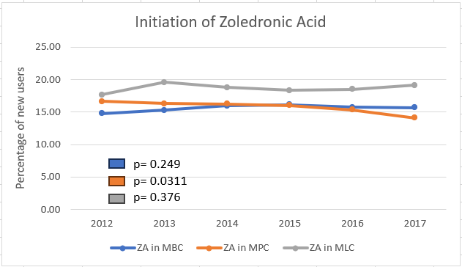
Figure 2: Trend Analysis of Initiation of Zoledronic Acid within 6 months of MLBPC Diagnosis

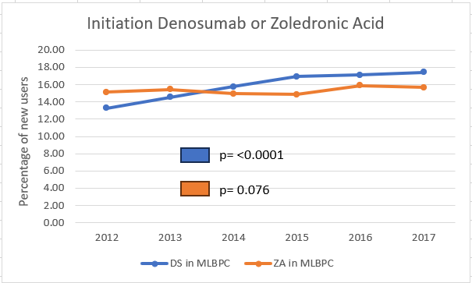
Figure 3: Trend Analysis of Initiation of Denosumab or Zoledronic Acid within 6 months of MLBPC Diagnosis

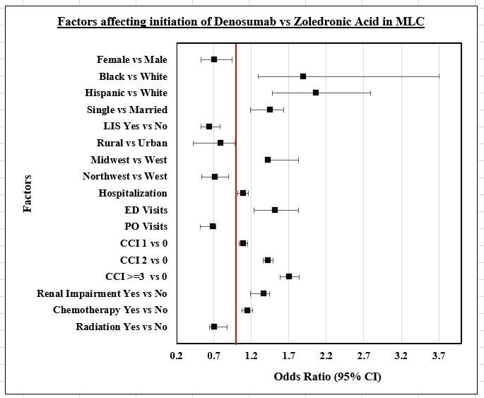
Figure 4: Factors affecting initiation of Denosumab vs Zoledronic acid (Outcome, DS=1) in metastatic lung cancer
[Independent variable in the logistic regression is DS=1; LIS= Low-income subsidy; ED= Emergency department; PO= Physician office; CCI= Charlson comorbidity index]

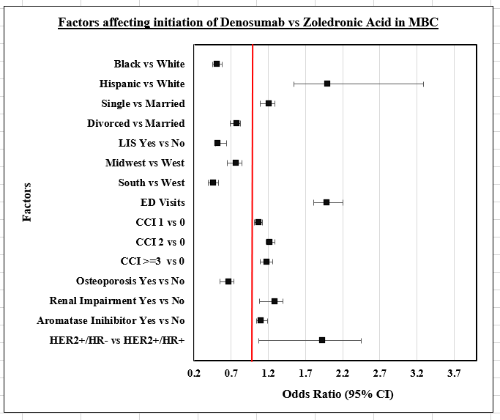
Figure 5: Factors affecting initiation of Denosumab vs Zoledronic acid (Outcome, DS=1) in metastatic breast cancer
[Independent variable in the logistic regression is DS=1; LIS= Low-income subsidy; ED= Emergency department; CCI= Charlson comorbidity index]

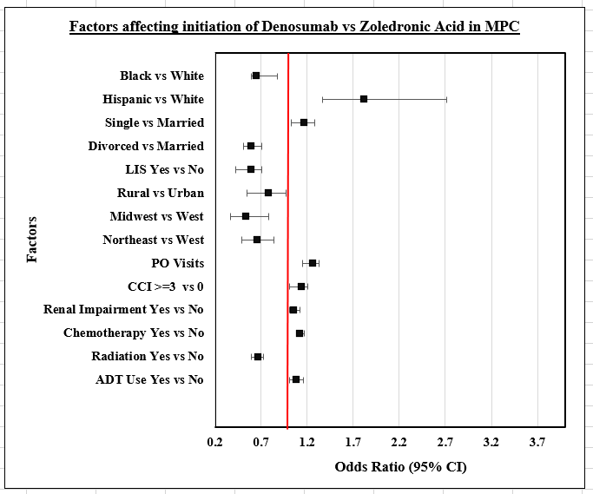
Figure 6: Factors affecting initiation of Denosumab vs Zoledronic acid (Outcome, DS=1) in metastatic prostate cancer
[Independent variable in the logistic regression is DS=1; LIS= Low-income subsidy; PO= Physician office; CCI= Charlson comorbidity index; ADT= Androgen deprivation therapy]

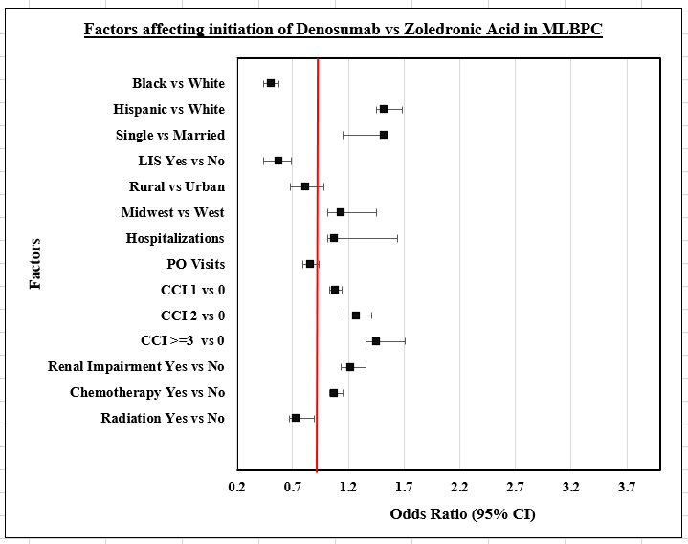
Figure 7: Factors affecting initiation of Denosumab vs Zoledronic acid (Outcome, DS=1) in metastatic lung, breast, and prostate cancer
[Independent variable in the logistic regression is DS=1; LIS= Low-income subsidy; PO= Physician office; CCI= Charlson comorbidity index]

