Cerium oxide nanomaterial regulates endophytic and rhizospheric bacteria of wheat to enhance resistance under simulated microgravity stress
Dengbo Chen^{1#}, Jingjing Cui^{1#}, Liting Zhao¹, Xin Pan¹, Shaocheng Yan¹, Yuming Fu^{1,2,3,4*}, Hong Liu^{1,2,3,4}
¹Institute of Environmental Biology and Life Support Technology, School of Biological Science and Medical Engineering, Beihang University, Beijing, 100083, China
²International Joint Research Center of Aerospace Biotechnology&Medical Engineering, Beihang University, Beijing 100083, China
³Key Laboratory for Biomechanics and Mechanobiology of Ministry of Education, Beijing Advanced Innovation Center for Biomedical Engineering, School of Biological Science and Medical Engineering, Beihang University, Beijing, 100083, China
⁴State Key Laboratory of Virtual Reality Technology and Systems, School of Computer Science and Engineering, Beihang University, Beijing 100083, China
*Corresponding author:
Yuming Fu, E-mail: fuyuming@buaa.edu.cn, Tel: +86-10-82339283, Fax: +86-10-82339283
School of Biological Science and Medical Engineering, Beihang University, No.37 Xueyuan Road, Beijing 100083, China
Figure S1. Rarefaction curves of wheat rhizospheric and endophytic bacteria samples were generated under different gravity conditions, comparing samples treated with and without CeO₂ NP. mμ-g: simulated microgravity without CeO₂ NP; 1-g: normal gravity without CeO₂ NP; m-μg + CeO₂: simulated microgravity culture with CeO₂ NP; 1-g + CeO₂: normal gravity culture with CeO₂ NP.
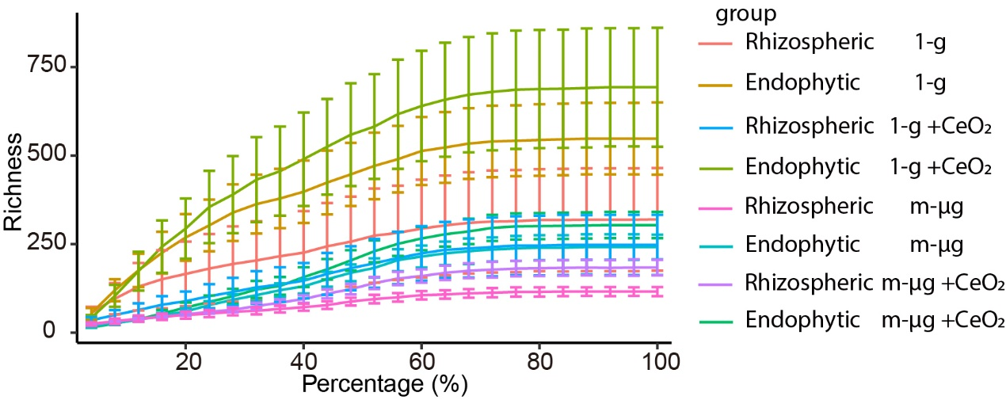

Figure S2. The curve of wheat root-to-shoot ratio in response to CeO₂ NP concentration under different gravity conditions (a); The effects of applying CeO₂ NP at a concentration of 500 mg/L on the root-to-shoot ratio (b), leaf fresh weight (c), and root fresh weight (d) under different gravity conditions mμ-g: simulated microgravity without CeO₂ NP; 1-g: normal gravity without CeO₂ NP; m-μg + CeO₂: simulated microgravity culture with CeO₂ NP; 1-g + CeO₂: normal gravity culture with CeO₂ NP. Kruskal-Wallis tests were used to analyze the difference after adding CeO₂ NP under different gravity conditions. Significant differences were evaluated using a non-parametric multiple comparisons test after conducting the initial analysis. · P < 0.1; * P < 0.05; ** P < 0.01; *** P < 0.001.
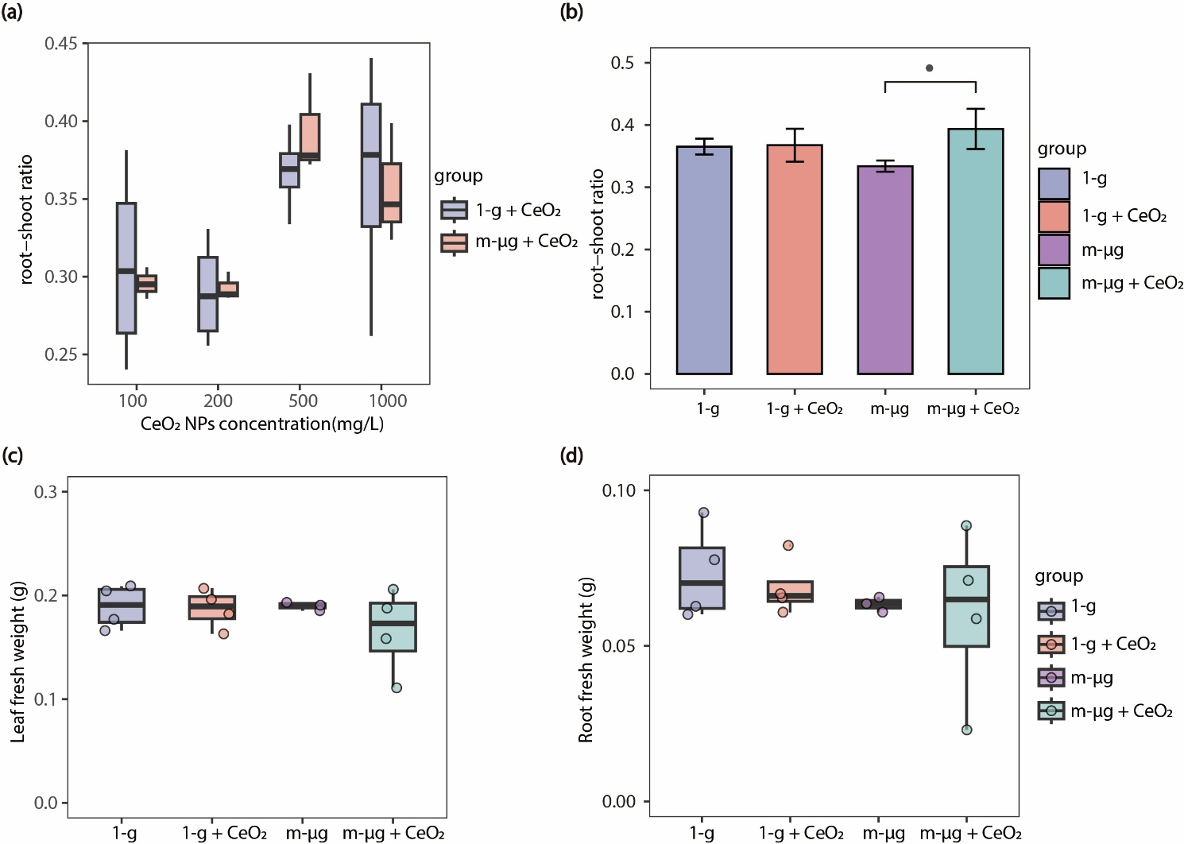
Figure S3. Richness index of rhizospheric (a) and endophytic (b) bacterial communities under different gravity conditions; Evenness index of rhizospheric (c) and endophytic (d) bacterial communities under different gravity conditions. mμ-g: simulated microgravity without CeO₂ NP; 1-g: normal gravity without CeO₂ NP; m-μg + CeO₂: simulated microgravity culture with CeO₂ NP; 1-g + CeO₂: normal gravity culture with CeO₂ NP. Kruskal-Wallis tests were used to analyze the difference after adding CeO₂ NP under different gravity conditions. Significant differences were evaluated using a non-parametric multiple comparisons test after conducting the initial analysis. · P < 0.1; * P < 0.05; ** P < 0.01; *** P < 0.001.
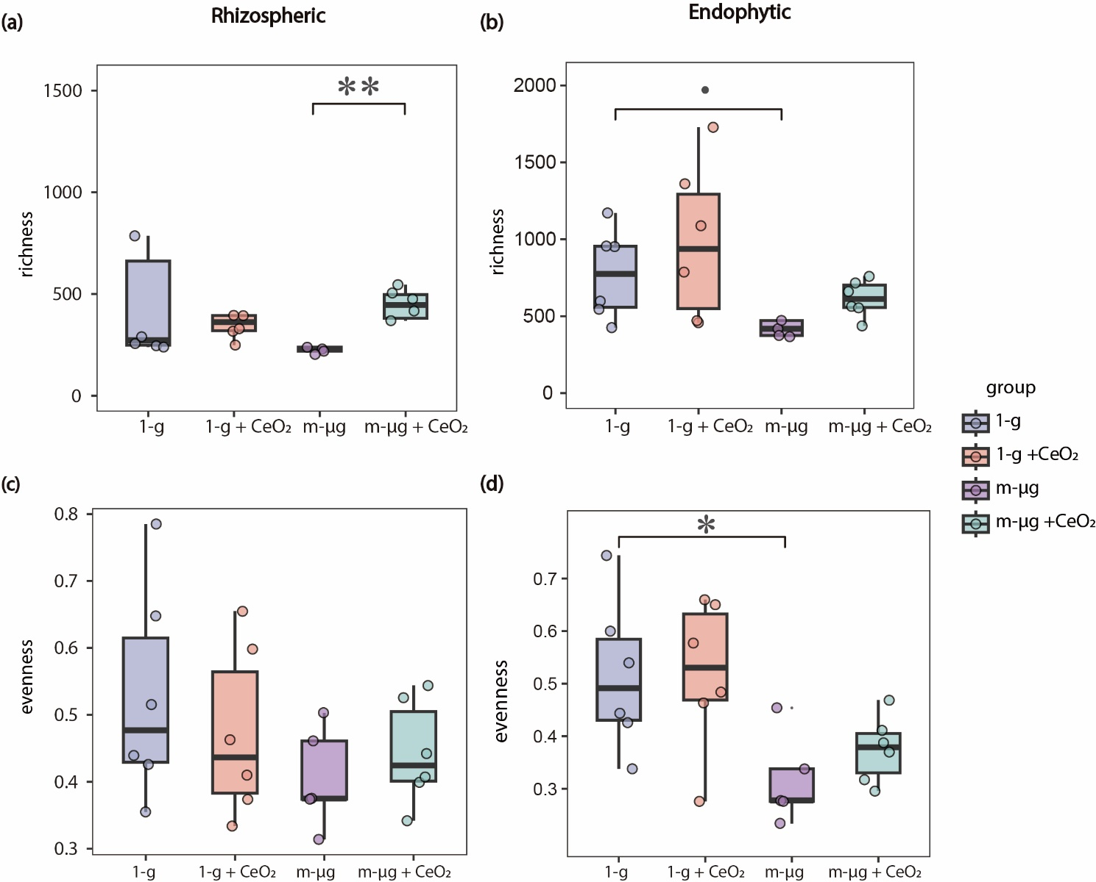
Figure S4. Relative abundance of the top 7 bacterial phyla in wheat rhizospheric (a) and endophytic (b) bacterial communities under different gravity conditions. mμ-g: simulated microgravity without CeO₂ NP; 1-g: normal gravity without CeO₂ NP; m-μg + CeO₂: simulated microgravity culture with CeO₂ NP; 1-g + CeO₂: normal gravity culture with CeO₂ NP. Kruskal-Wallis tests were used to analyze the difference after adding CeO₂ NP under different gravity conditions. Significant differences were evaluated using a non-parametric multiple comparisons test after conducting the initial analysis. · P < 0.1; * P < 0.05; ** P < 0.01; *** P < 0.001.
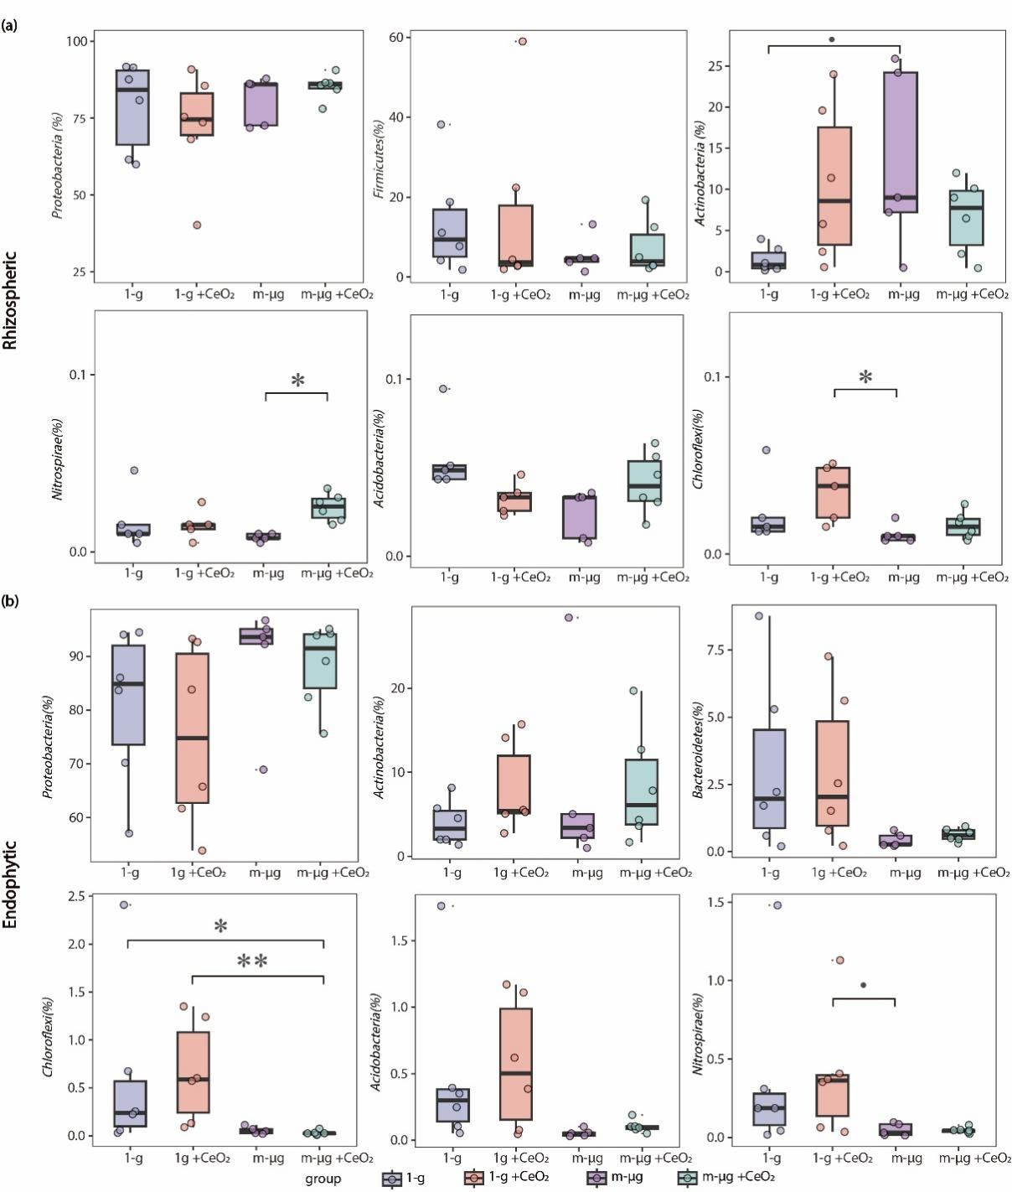
Figure S5. Relative abundance of the top 7 bacterial genus in wheat rhizospheric (a) and endophytic (b) microbial communities under the indicated gravity conditions. mμ-g: simulated microgravity without CeO₂ NP; 1-g: normal gravity without CeO₂ NP; m-μg + CeO₂: simulated microgravity culture with CeO₂ NP; 1-g + CeO₂: normal gravity culture with CeO₂ NP. Kruskal-Wallis tests were used to analyze the difference after adding CeO₂ NP under different gravity conditions. Significant differences were evaluated using a non-parametric multiple comparisons test after conducting the initial analysis. · P < 0.1; * P < 0.05; ** P < 0.01; *** P < 0.001.
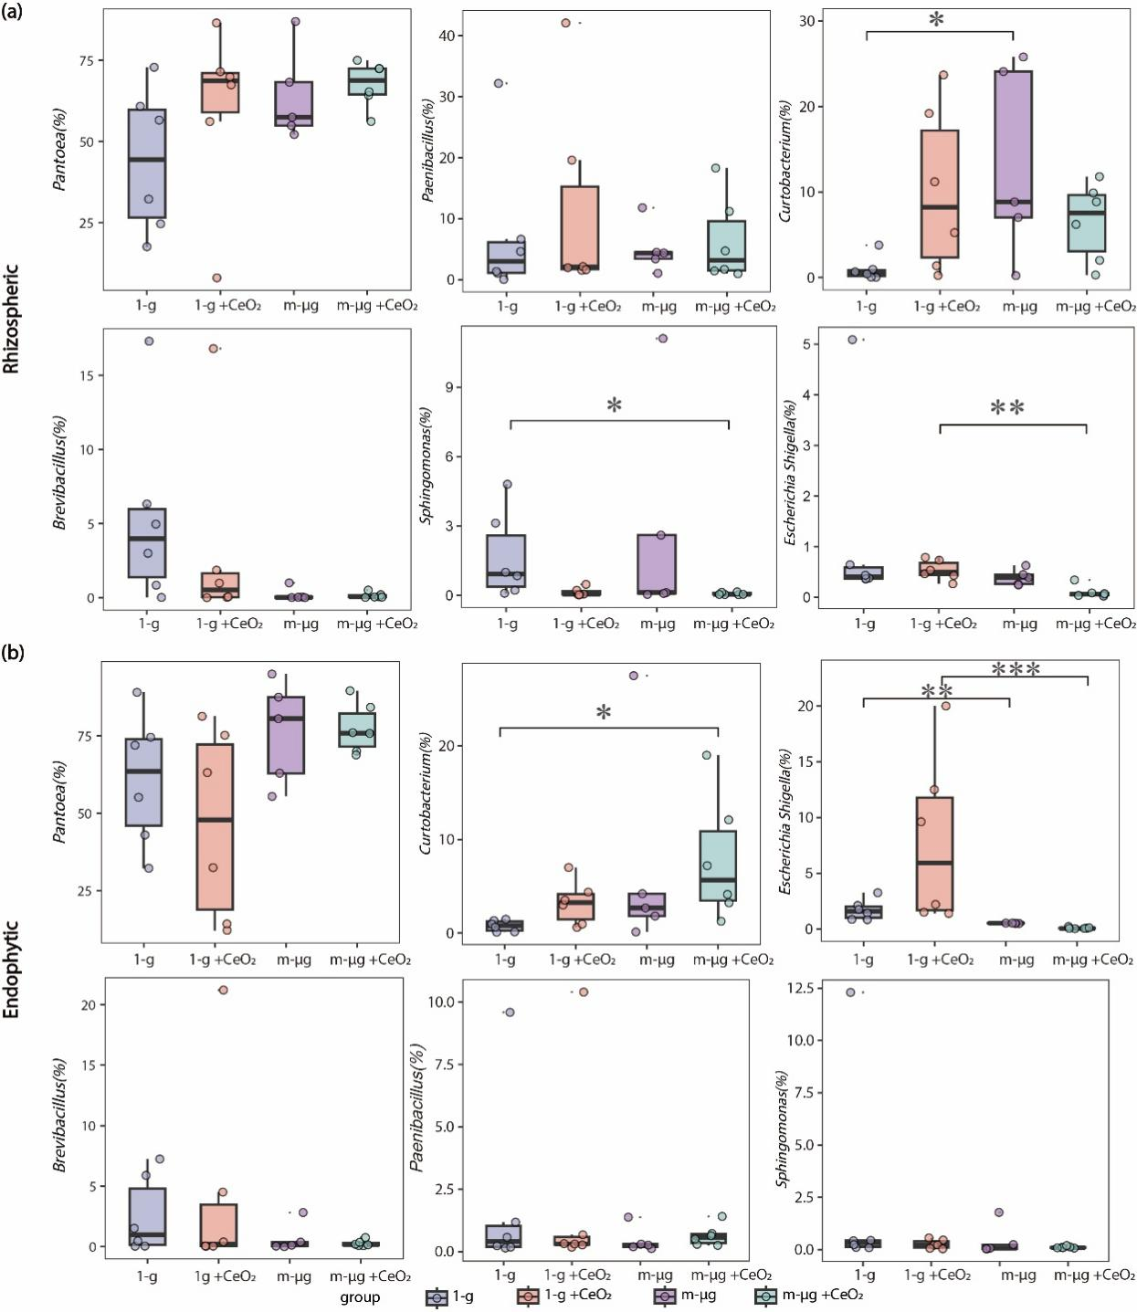
Figure S6. Relative abundance (%) of bacterial pathogens of different origin in rhizospheric (a) and endophytic (b) microbial communities under the indicated gravity conditions. mμ-g: simulated microgravity without CeO₂ NP; 1-g: normal gravity without CeO₂ NP; m-μg + CeO₂: simulated microgravity culture with CeO₂ NP; 1-g + CeO₂: normal gravity culture with CeO₂ NP.
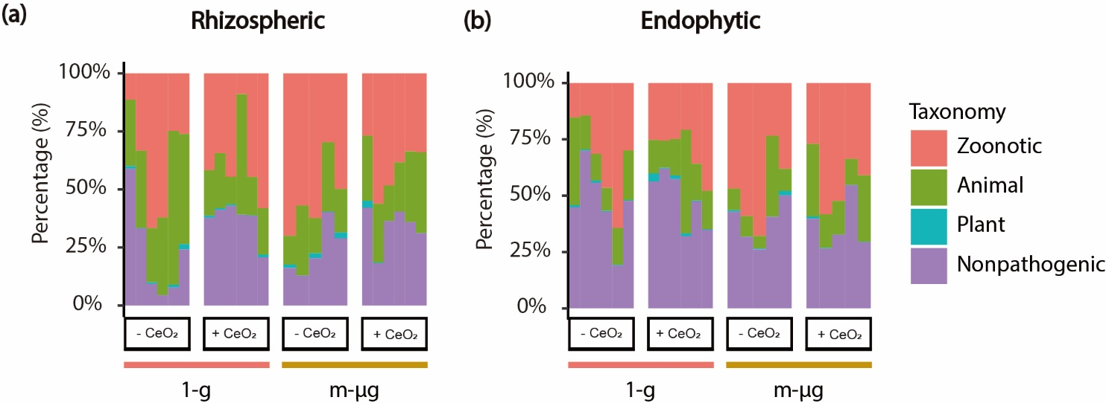
Figure S7. The degree of microbial networks in rhizospheric (a) and endophytic (b) of wheat seedling. mμ-g: simulated microgravity without CeO₂ NP; 1-g: normal gravity without CeO₂ NP; m-μg + CeO₂: simulated microgravity culture with CeO₂ NP; 1-g + CeO₂: normal gravity culture with CeO₂ NP. Kruskal-Wallis tests were used to analyze the difference after adding CeO₂ NP under different gravity conditions. Significant differences were evaluated using a non-parametric multiple comparisons test after conducting the initial analysis. · P < 0.1; * P < 0.05; ** P < 0.01; *** P < 0.001.
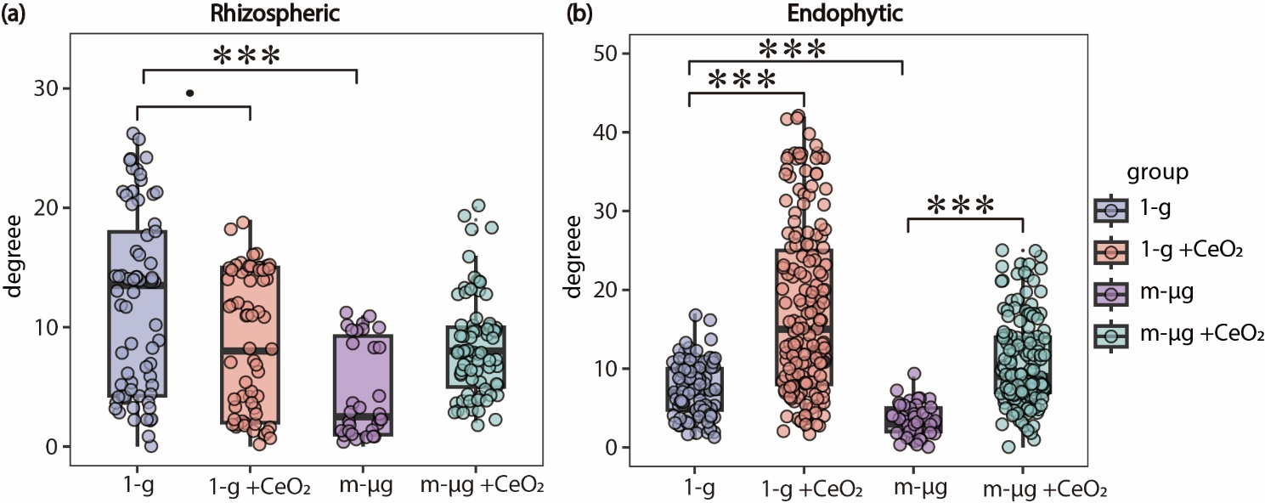

Figure S8. KEGG pathway of rhizospheric and endophytic bacterial flora in wheat seedling stage. The vertical axis shows the KEGG path. The significance was determined using the Wilcoxon rank-sum test. Color indicates significant differences between conditions, with darker red indicating more significant. mμ-g: simulated microgravity without CeO₂ NP; 1-g: normal gravity without CeO₂ NP; m-μg + CeO₂: simulated microgravity culture with CeO₂ NP; $\frac{m-μg }{1-g }$: mμ-g divided by 1-g; $\frac{m-μg + CeO_{2}}{1-g }$: m-μg + CeO₂ divided by 1-g.
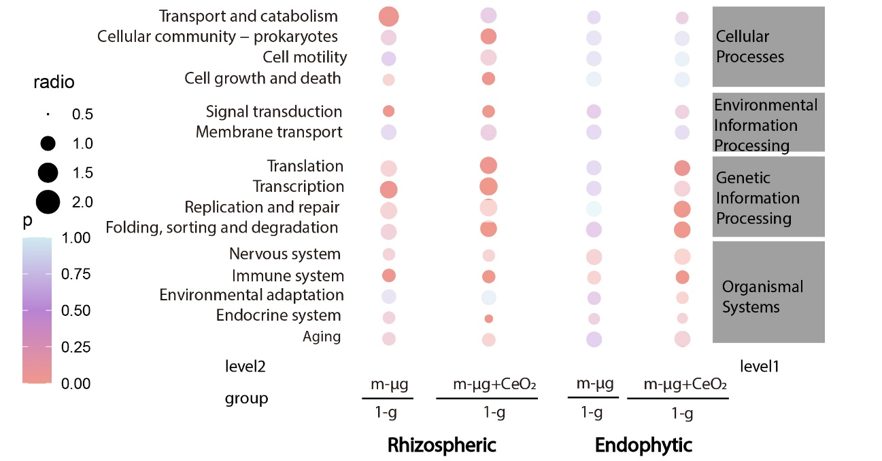
Figure S9. KEGG pathway of rhizospheric and endophytic bacterial flora in wheat seedling stage. The vertical axis shows the KEGG path. mμ-g: simulated microgravity without CeO₂ NP; 1-g: normal gravity without CeO₂ NP; m-μg + CeO₂: simulated microgravity culture with CeO₂ NP; 1-g + CeO₂: normal gravity culture with CeO₂ NP.
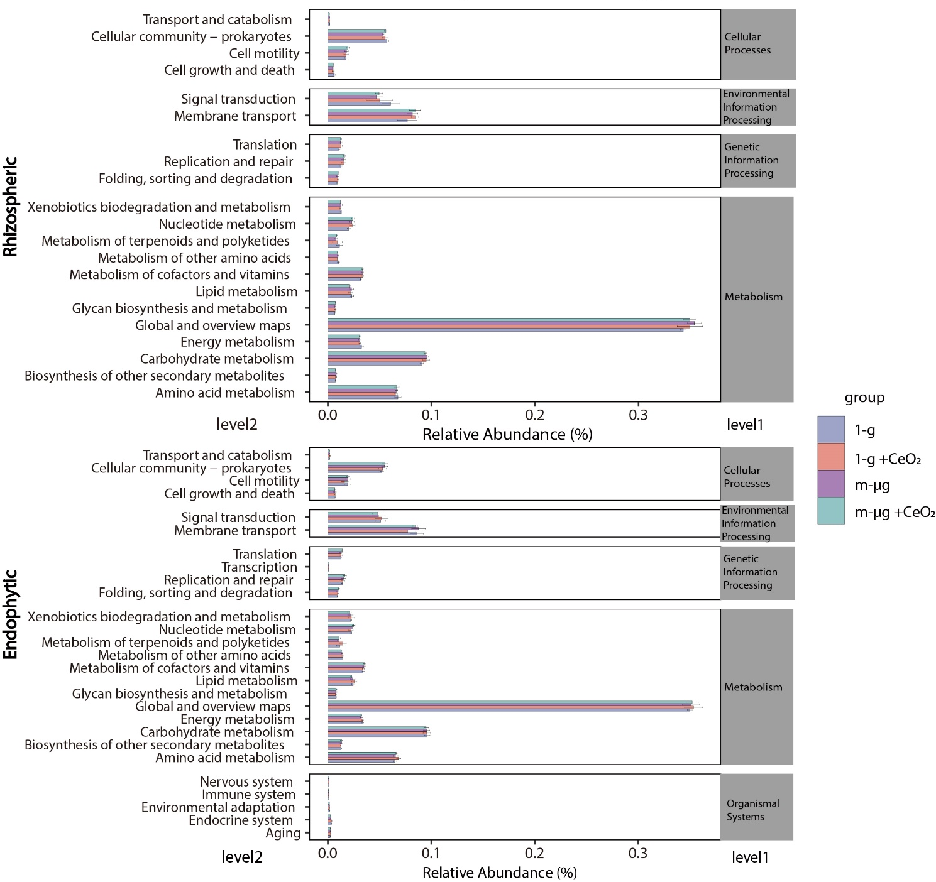

Table S1. Relative fraction of positive and negative correlation within bacterial communities under the indicated gravity conditions. mμ-g: simulated microgravity; 1-g: normal gravity; - CeO₂ NPs: absence of CeO₂ NP; + CeO₂ NP: presence of CeO₂ NP.
 | gravity | nanoparticle | Positive correlation  (%) |  | Negative correlation (%) | Negative correlation / Positive correlation
Rhizospheric | 1-g | - CeO₂ NP | 100% | 0% |  | 0
 | 1-g | + CeO₂ NP | 80.24% | 19.76% |  | 0.25
 | mμ-g | - CeO₂ NP | 80.71% | 19.29% |  | 0.24
 | mμ-g | + CeO₂ NP | 73.33% | 26.67% |  | 0.36
Endophytic | 1-g | - CeO₂ NP | 97.37% | 2.63% |  | 0.03
 | 1-g | + CeO₂ NP | 96.08% | 3.92% |  | 0.04
 | mμ-g | - CeO₂ NP | 68.13% | 31.87% |  | 0.47
 | mμ-g | + CeO₂ NP | 98.11% | 1.89% |  | 0.02

