Atomic mechanism of lithium dendrite penetration in solid electrolytes

Bowen Zhang^{1,2,*}, Botao Yuan^{1,2,*}, Xin Yan³, Xiao Han⁴, Jiawei Zhang^{1,2}, Huifeng Tan^{1,2}, Changuo Wang^{1,2}, Pengfei Yan⁴, Huajian Gao^{5,6,7#}, Yuanpeng Liu^{1,2, #}
¹Center for Composite Materials, Harbin Institute of Technology, Harbin, 150001, China
²National Key Laboratory of Science and Technology on Advanced Composites in Special Environments, Harbin Institute of Technology, Harbin 150080, China
³ School of Mechanical Engineering and Automation, Beihang University, Beijing 100191, China
⁴ Beijing Key Laboratory of Microstructure and Property of Solids, Faculty of Materials and Manufacturing, Beijing University of Technology, Beijing 100124, China
⁵ School of Mechanical and Aerospace Engineering, Nanyang Technological University, Singapore 639798, Singapore
⁶ Institute of High-Performance Computing, A*STAR, Singapore 138632, Singapore
⁷ Mechano-X Institute, Applied Mechanics Laboratory, Department of Engineering Mechanics, Tsinghua University, Beijing 100084, China

*These authors contributed equally to this work.
#Corresponding authors. E-mail: liuyp@hit.edu.cn; gao.huajian@mail.tsinghua.edu.cn

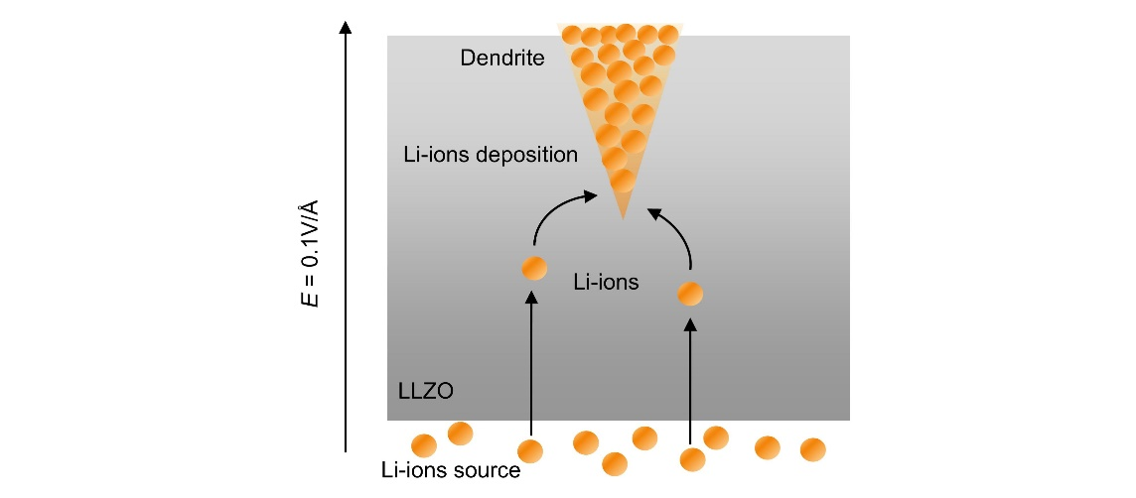Supplementary Fig. 1 | Schematic illustration of the simulation model for the dendrite penetration in solid electrolyte.

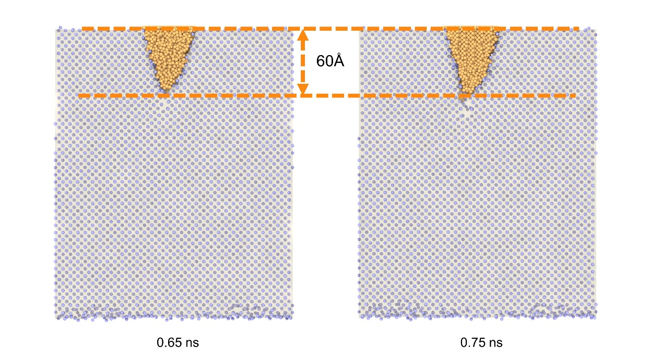Supplementary Fig. 2 | Snapshots from the dendrite/single-crystal LLZO atomistic model at 0.65 and 0.75 ns. Yellow atoms represent lithium metal atoms. Horizontal yellow dashed lines show no change in dendrite lengths between 0.65 and 0.75 ns.

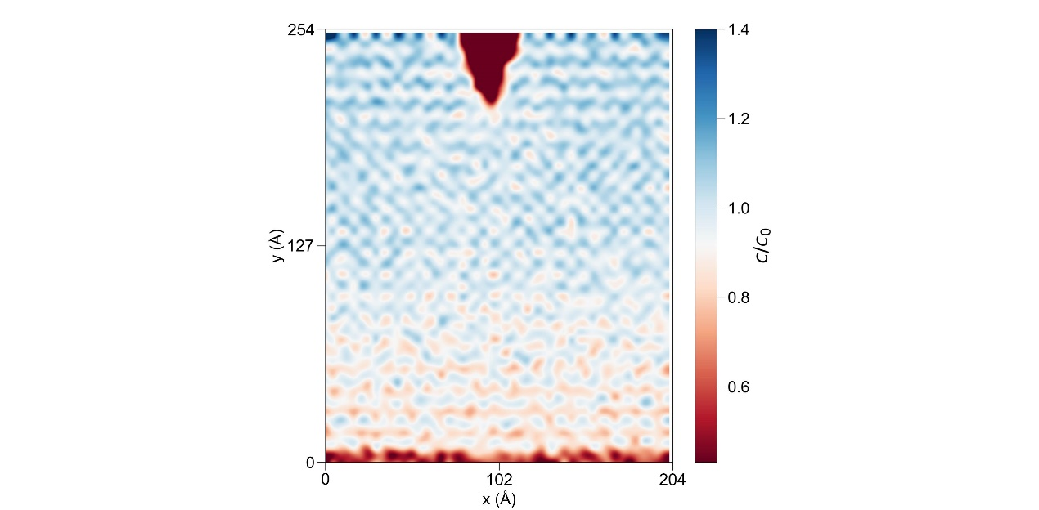Supplementary Fig. 3 | Distribution of Li-ions concentration at 0.4 ns. The concentration distribution is not significantly different from that at 0.1 ns.

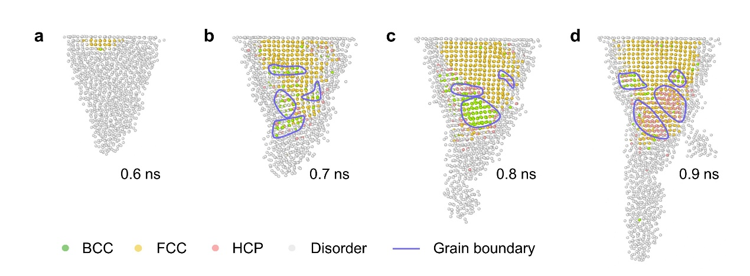Supplementary Fig. 4 | Atomic structure of lithium metal within dendrites during deposition. There are numerous amorphous phases and grain boundaries within the dendrites.

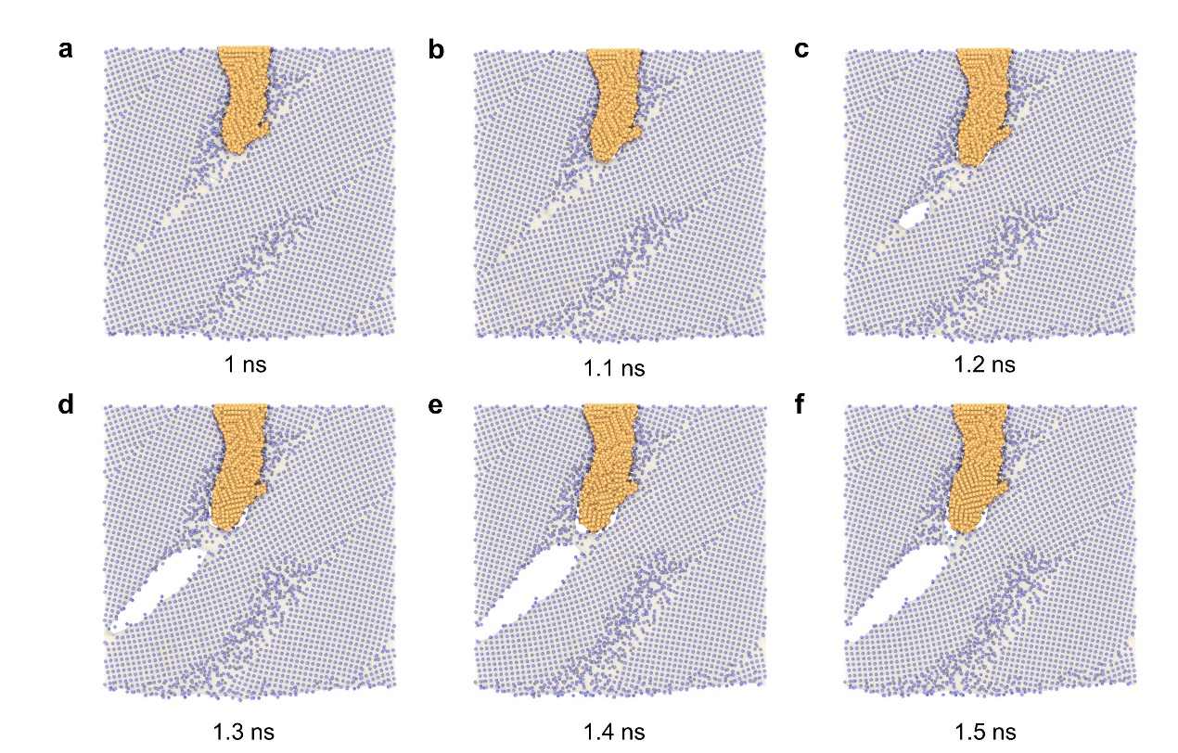Supplementary Fig. 5 | Unstable crack growth along the grain boundary induced by lithium dendrite. The difference in rates between Li-ions deposition and crack growth causes the dendrite to lag behind the crack.

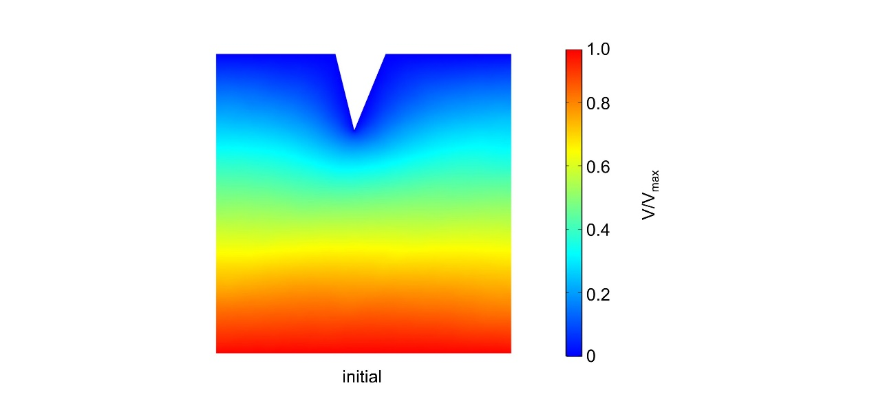Supplementary Fig. 6 | Normalized potential distribution within the solid-state electrolyte at initial time.

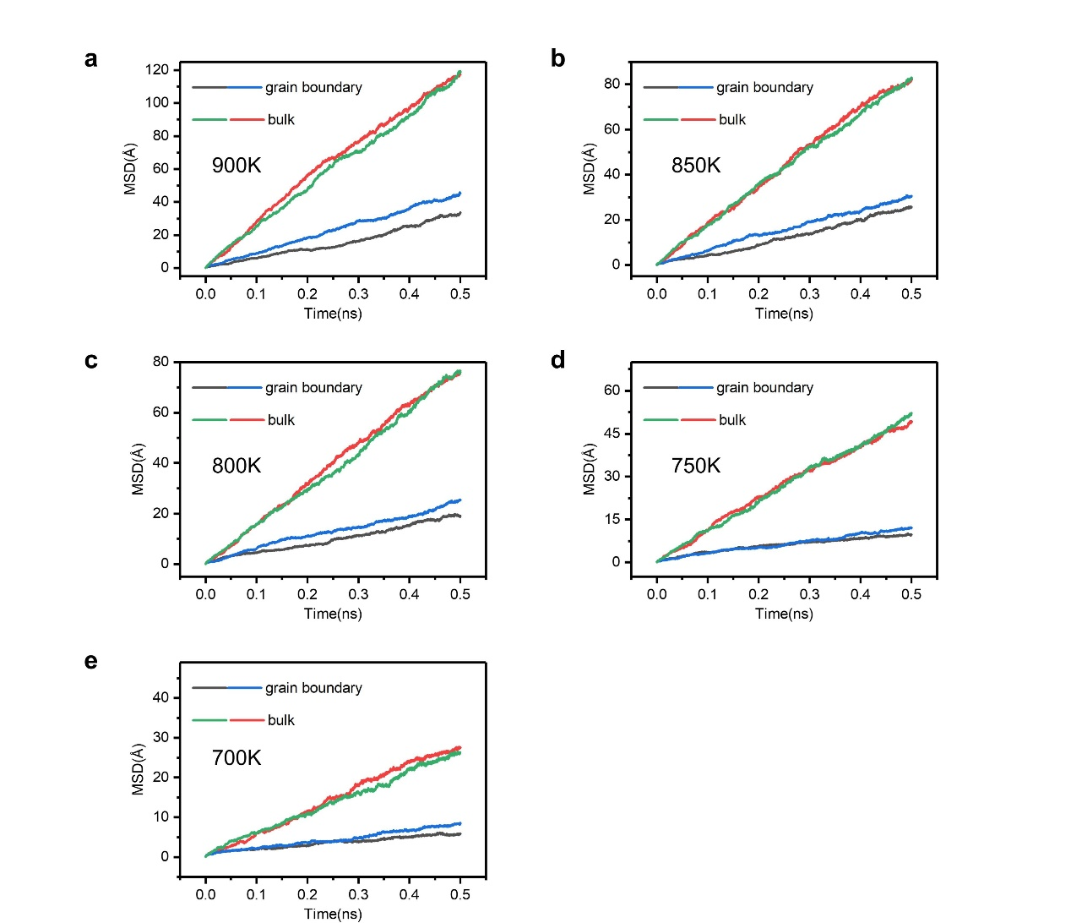Supplementary Fig. 7 | Li-ions MSD at temperatures from 700 to 900 K versus simulation time of grain boundary and bulk

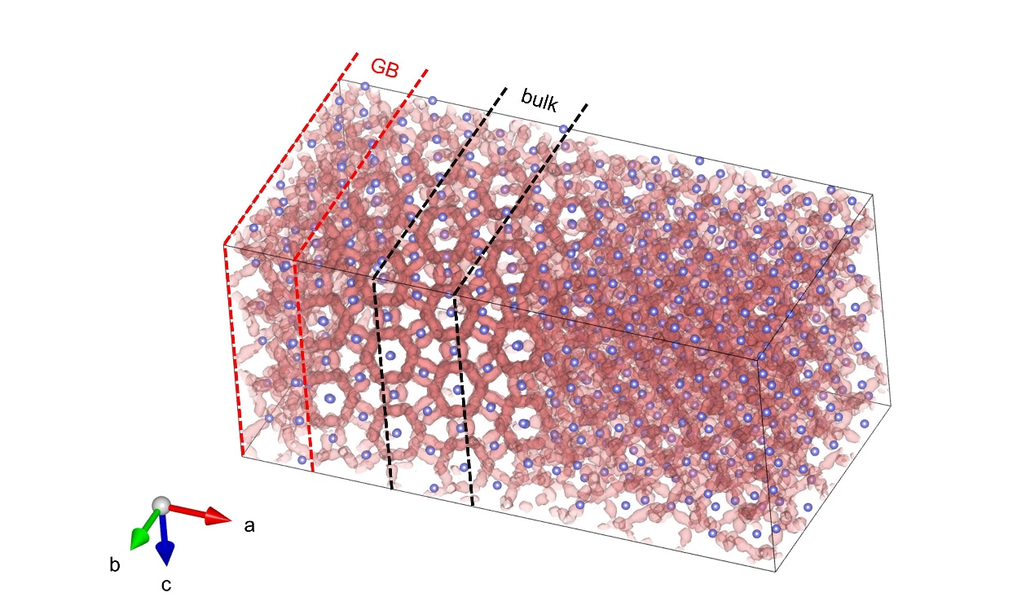Supplementary Fig. 8 | Li-ions trajectory densities accumulated from the MD simulations for diffusion coefficients calculations. The Li-ions in the bulk phase exhibit three-dimensional diffusion behavior, while the Li-ions at the grain boundaries display more pronounced discontinuous diffusion behavior with a higher proportion of immobile Li-ions.

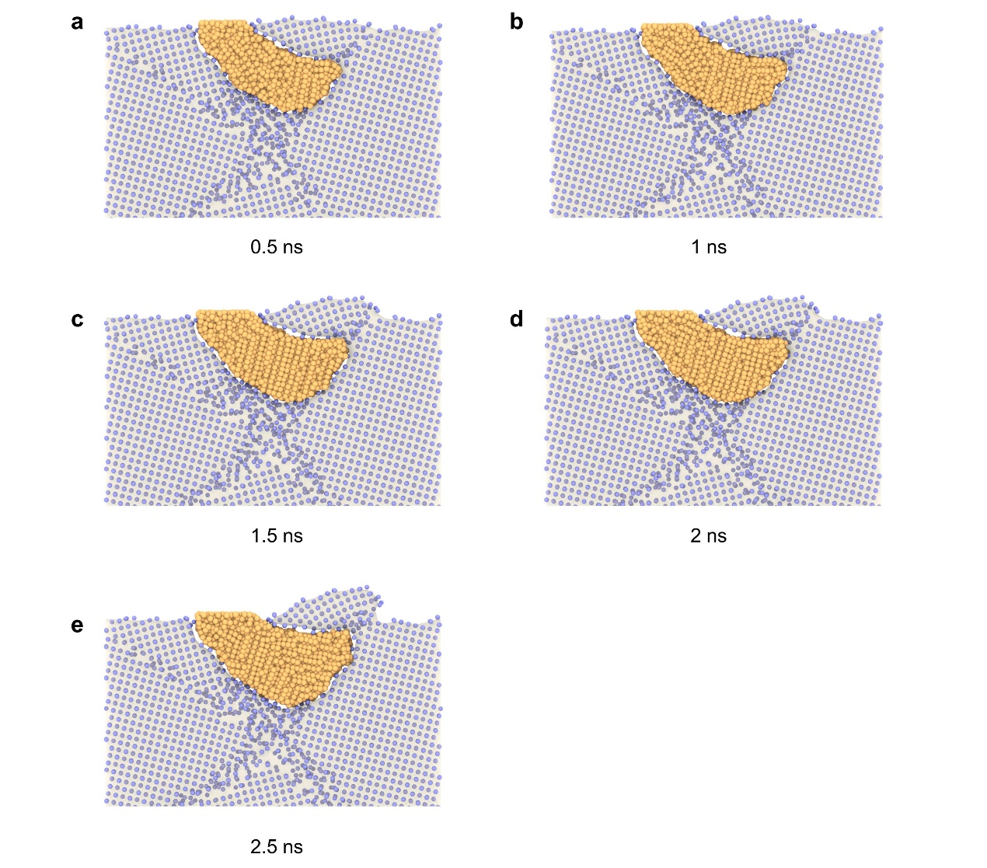Supplementary Fig. 9 | Snapshots from simulations illustrate the atomic structures of the polycrystalline LLZO surface during peeling.

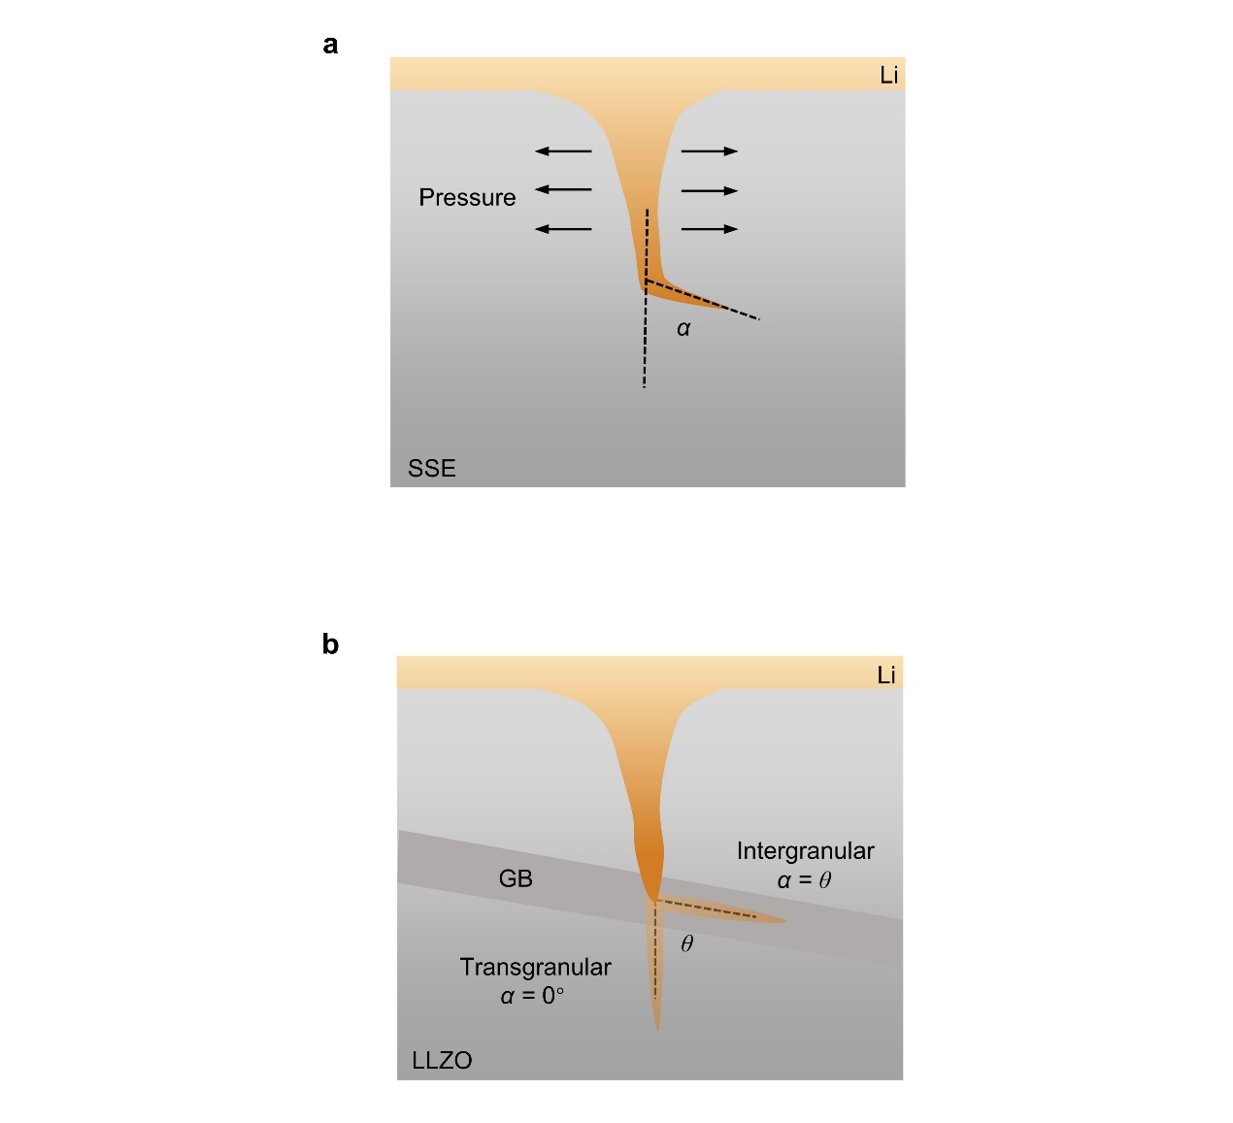Supplementary Fig. 10 | Fracture mechanics model of dendritic penetration in solid electrolyte (a) and schematic diagram of dendrite transgranular/intergranular penetration in solid electrolyte (b).

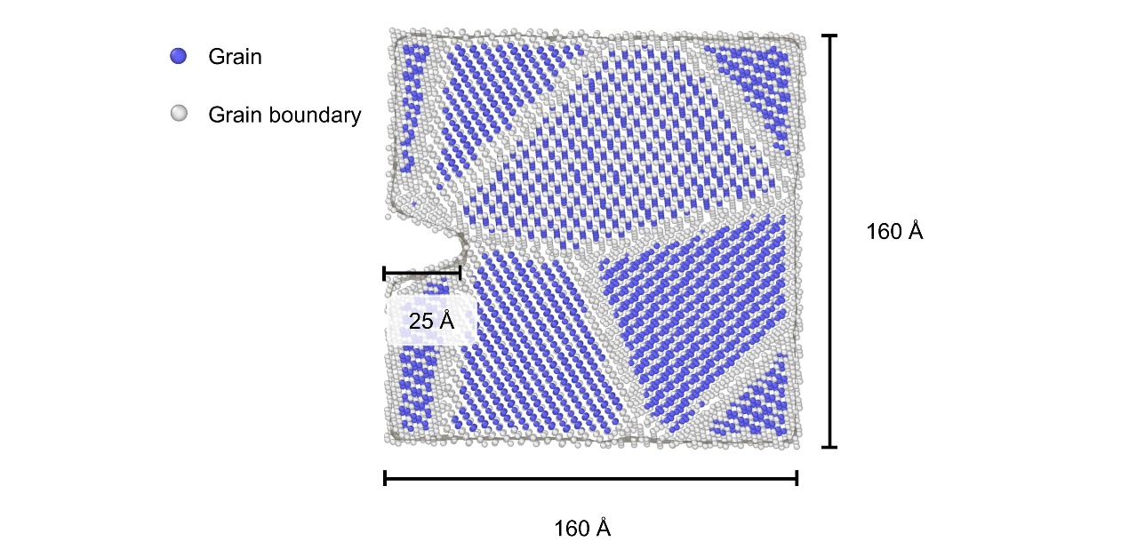Supplementary Fig. 11 | Random grain boundaries model for calculating Mode I fracture toughness 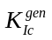of LLZO. This parameter is used to plot Fig. 7d.

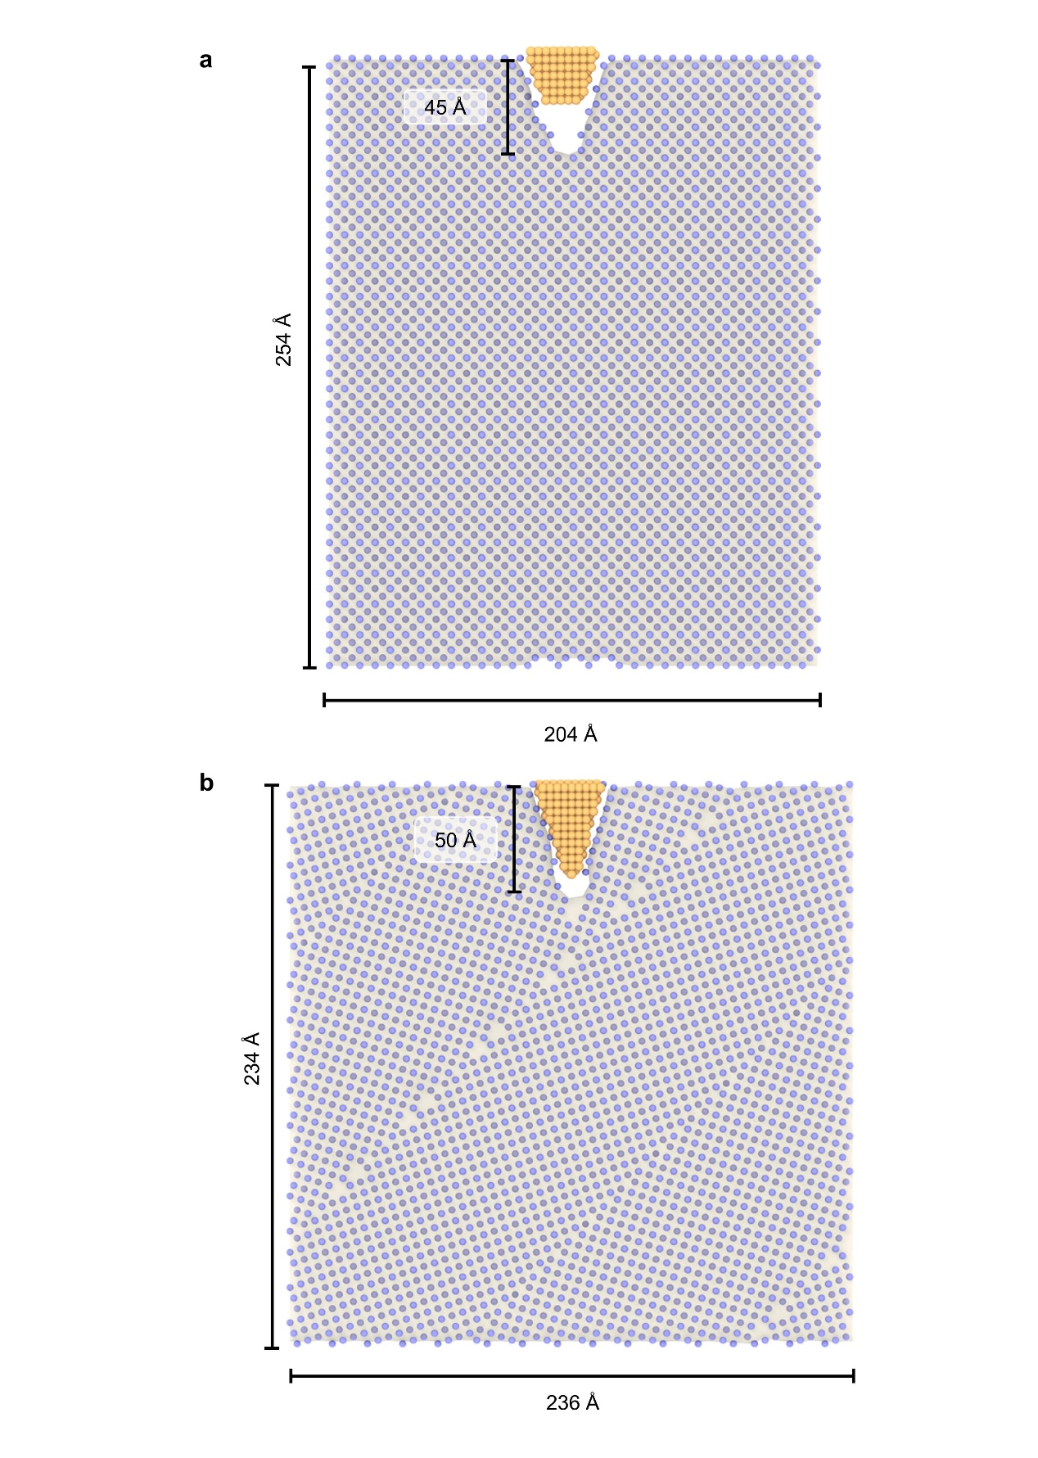Supplementary Fig. 12 | Simulation models for dendrite penetration in single-crystal LLZO (a) and polycrystalline LLZO (b).

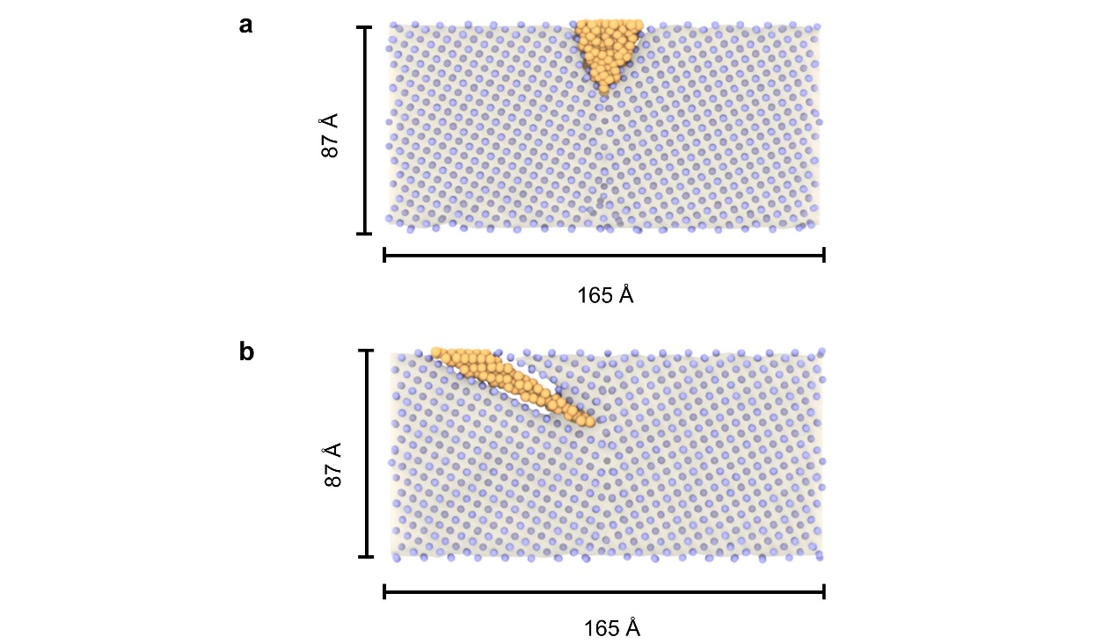Supplementary Fig. 13 | Simulation models with dendrite at angle of incidence 0° (a) and 60° (b) to the grain boundary.

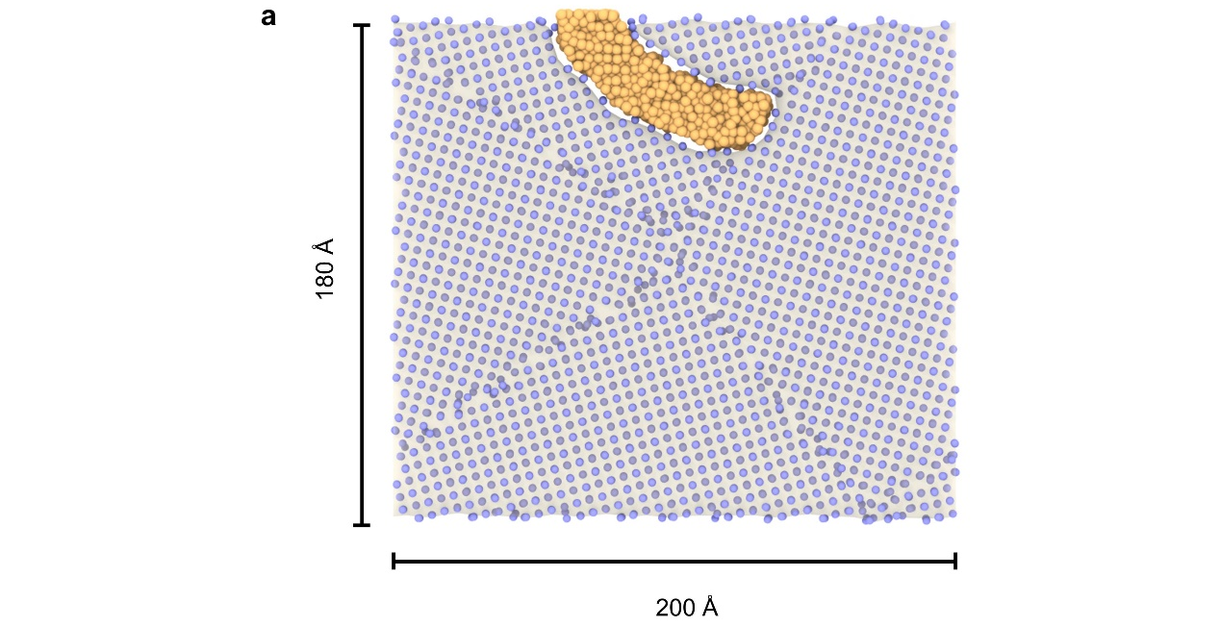Supplementary Fig. 14 | Simulation model for dendrite induced surface peeling. The grain boundaries are random.

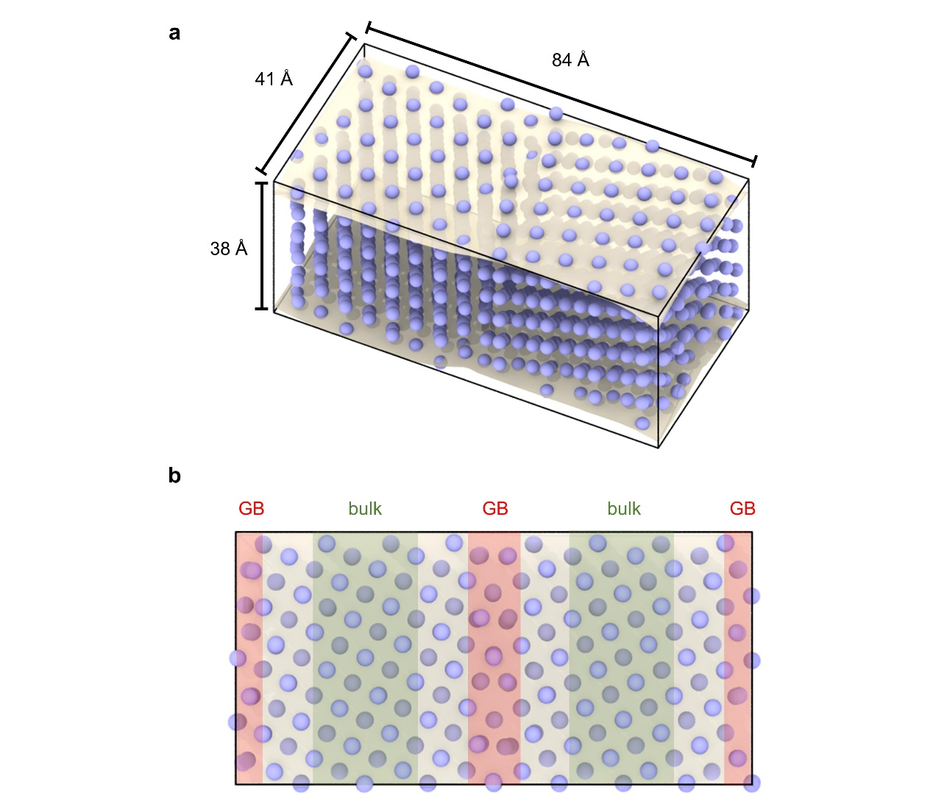Supplementary Fig. 15 | Atomistic model for calculating the diffusion coefficients of bulk and Σ5(310) grain boundary. The region corresponding to the grain boundary accounted for 20% of the solid electrolyte volume.

