Online Suppl. 1. Directed acyclic graph map.

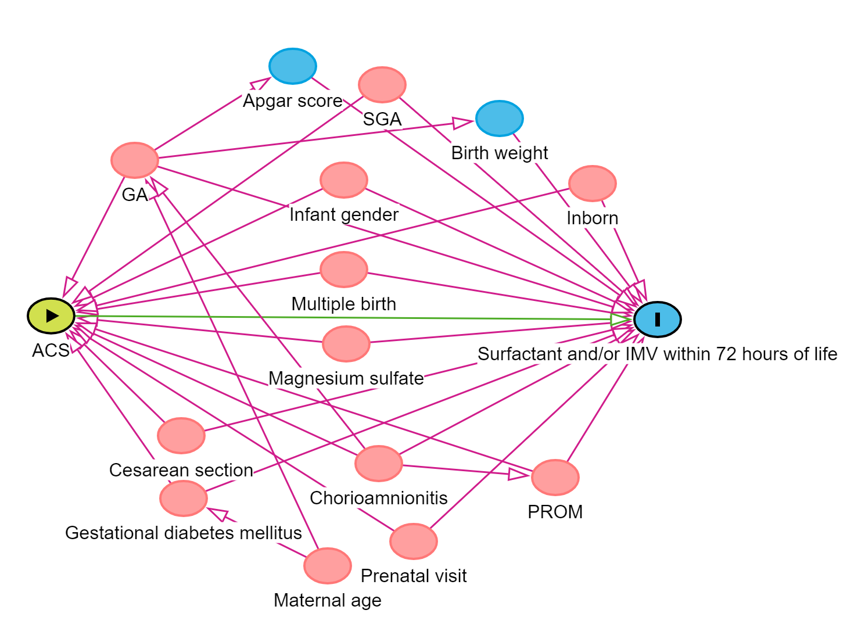

Online Suppl. 2. Sensitivity analysis-propensity score matched analysis.

Infants born to mothers with hypertensive disorders of pregnancy (N = 4582, 20.3%)

Propensity score match
ACS (n = 3806, 83.1%)
No ACS (n = 776, 16.9%)
130 not included in propensity score matched analysis
3160 not included in propensity score matched analysis

646 included in propensity score matched analysisª
646 included in propensity score matched analysis

Online Suppl. 2.1. Flowchart of study population in the propensity score matched sample.
ACS, antenatal corticosteroids. ªCovariables included in propensity score model were GA, infant gender, SGA, multiple birth, gestational diabetes mellitus, premature rupture of membranes, prenatal visit, cesarean section, inborn and magnesium sulfate.

Online Suppl. 2.2. Maternal and infant characteristics of very preterm infants born to mothers with hypertensive disorders of pregnancy by antenatal corticosteroids use in the propensity score matched sample.

 | ACS (n = 646) | No ACS (n = 646) | P-value
Maternal characteristics
Maternal age, years, median (IQR) | 32.0 (29.0-35.0) | 32.0 (29.0-36.0) | 0.826
≥35y, n (%) | 184 (28.5) | 205 (31.7) | 0.203
＜35y, n (%) | 462 (71.5) | 441 (68.3)
Primigravida, n/N (%) | 316/642 (49.2) | 360/642 (56.1) | 0.014
Prenatal visit, n (%) | 645 (99.9) | 641 (99.2) | 0.102
Cesarean section, n (%) | 566 (87.6) | 565 (87.5) | 0.933
PROM (≥24h), n (%) | 19 (2.9) | 19/ (2.9) | 0.940
Antenatal antibiotics, n/N (%) | 210/623 (33.7) | 170/618 (27.5) | 0.018
Magnesium sulfate, n (%) | 332 (51.4) | 332 (51.4) | 1
Pathological chorioamnionitis, n/N (%) | 34/521 (6.5) | 24/533 (4.5) | 0.150
Suspected Chorioamnionitis, n/N (%) | 14/530 (2.6) | 11/558 (2.0) | 0.461
Gestational diabetes mellitus, n (%) | 123 (19.0) | 135 (20.9) | 0.404
Preeclampsia/eclampsia, n/N (%) | 470/639 (73.6) | 442/633 (69.8) | 0.140
Gestational hypertension, n (%) | 568 (87.9) | 552 (85.5) | 0.190
Hypertensive disorders of pregnancy as primary reason for preterm birth, n (%) | 468 (72.5) | 452 (70.0) | 0.326
Infant characteristics
Male, n (%) | 357 (55.3) | 344 53.3 | 0.468
Gestational age, weeks, median (IQR) | 30.3 (29.0-31.1) | 30.1 (29.0-31.0) | 0.053
＜28 weeks, n (%) | 62 (9.2) | 67 (10.4) | 0.643
≥28 weeks, n (%) | 584 (90.4) | 579 (89.6)
Birth weight, grams, median (IQR) | 1192.5 (1000-1410) | 1160 (980-1366) | 0.077
Small for gestational age, n (%) | 142 (22.0) | 143 (22.1) | 0.947
Multiple birth, n (%) | 114 (17.7) | 112 (17.3) | 0.884
Inborn, n (%) | 568 (87.9) | 563 (87.2) | 0.674
Apgar 5min ≤3, n (%) | 3/638 (0.5) | 15/615 (2.4) | 0.0034
Uses of ACS
ACS administration-to-birth interval (n=624), n (%)
≤7d | 333 (53.4) | NA
＞7d | 109 (17.5) | NA
ACS courses (n=615), n (%)
Single complete course | 374 (60.8) | NA
Single partial course | 167 (27.2) | NA
Repeat courses | 69 (11.2) | NA
IQR, interquartile range; n/N, number and total number; PROM, premature rupture of membrane; ACS, antenatal corticosteroids; NA, not available.

Online Suppl. 2.3. Association between antenatal corticosteroids and neonatal outcomes among very preterm infants born to mothers with hypertensive disorders of pregnancy in the propensity score matched sample.
 | ACS (n = 646)  N/(%) | No ACS (n = 646)  N/(%) | P-value | OR (95% CI)
Primary outcome
Surfactant and/or IMV within 72 hours of life | 455 (70.4) | 502 (77.7) | 0.0028 | 0.67 (0.52-0.87)
Secondary outcomes
Death | 58 (9.0) | 102 (15.8) | 0.0002 | 0.48 (0.33-0.70)
Surfactant within 72 hours of life | 420 (65.0) | 440 (68.1) | 0.238 | 0.86 (0.68-1.10)
IMV within 72 hours of life | 231 (35.8) | 328 (50.8) | ＜0.0001 | 0.51 (0.40-0.65)
Combined surfactant and IMV use within 72 hours of life | 196 (30.3) | 266 (41.2) | ＜0.0001 | 0.60 (0.47-0.76)
Moderate or severe BPD | 225/644 (34.9) | 308/645 (47.8) | ＜0.0001 | 0.56 (0.44-0.71)
IVH (Grade III or IV) | 44/583 (7.6) | 39/554 (7.0) | 0.742 | 1.00 (0.61-1.63)
PVL | 18/577 (3.1) | 20/553 (3.6) | 0.643 | 0.68 (0.34-1.39)
NEC (Stage II or above) | 29 (4.5) | 28 (4.3) | 0.892 | 1.04 (0.61-1.78)
Early-onset sepsis | 6 (0.9) | 7 (1.1) | 0.780 | 0.86 (0.29-2.55)
Sepsis | 57 (8.8) | 64 (9.9) | 0.504 | 0.88 (0.60-1.28)
IMV, invasive mechanical ventilation; BPD, bronchopulmonary dysplasia; IVH, intraventricular haemorrhage; PVL, periventricular leukomalacia; NEC, necrotizing enterocolitis; n/N, number and total number; OR, odds ratio; CI, confidence interval.

