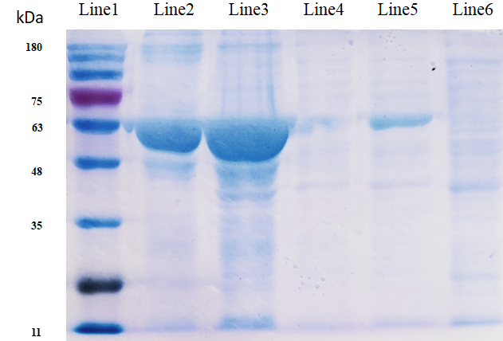

Fig. 1 Expression and purification of HoPGRP-L2. Line1 to Line6 correspond to Marker, purified protein, pellet after cell lysis, supernatant after cell lysis, induced bacterial culture, and pre-induced bacterial culture, respectively. Due to the inclusion of the His tag and partial expression of the pet-30a vector, the depicted protein molecular weight is slightly higher than the actual molecular weight.

