Supplementary Material for

Reporting on the Safety of Dementia Care for 2010-2021 in South Korea

*Corresponding author: science@research.re.kr

Materials and Methods
Supplementary Text
Tables S1 to S30
Figs. S1 to S19

The National Agency approved this study for the Management of Life-sustaining Treatment, which certified that the life-sustaining treatments were managed properly (Korea National Institute for Bioethics Policy (KoNIBP) approval number P01-202007-22-006).
According to the Official Information Disclosure Act in Korea, the Seoul study analyzed AD and anti-Alzheimer's disease drug (AAD) use in Hansen subjects. We searched all medical records of the National Health Insurance Service (NHIS) in Korea and the Sorokdo National Hospital from the time when the International Classification of Diseases (ICD)-10 code and Electronic Data Interchange (EDI) were computerized ¹.
The Sorokdo National Hospital was established in May 1916 to treat leprosy. We connected to the medical record database of the Sorokdo National Hospital and archived it from January 2005 to June 2020. The ICD-10 codes analyzed medical data on the correlation between DDS and AD. In the group of patients diagnosed with Alzheimer's, the average age of death while taking only drugs for dementia treatment (group 1) and the mean age of death with taking psychiatric drugs (group 1 & group 2) ².
According to the Official Information Disclosure Act in Korea, we also requested and analyzed the entire ICD 10 code data (from 2010 to 2021) of AD and AAD from the Health Insurance Review & Assessment system ³. As a result, from 2010 to 2021, the diagnosis of patients with MCI and AD in Korea increased dramatically ⁴.
Tables
Table S1. Mental and Behavioral Disorders, F00-F09, G30 5
Table S2. Symptomatic Relief of Alzheimer’s Disease 5
Table S3. Psychologic Symptoms of Alzheimer’s Disease 5
Table S4. NHIS Masked Code and ICD-10 Code 6
Table S5. The life expectancy of leprosy patients in the Sorokdo National Hospital 7
Table S6. The Friedman Test¹ for Repeated-Measures of the Table S5 life expectancy 8
Table S7. Donepezil code and User and the Death Toll 9
Table S8. Rivastigmine and User and Death Toll 11
Table S9. Galantamine and User and Death Toll 13
Table S10. Memantine and User and the Death Toll 15
Table S11. Nationwide Alzheimer disease (AD) drugs: Number of users and deaths 17
Table S12. The Friedman Test¹ for Repeated-Measures 18
Table S13. Fluoxetine and User and Death Toll 20
Table S14. Sertraline and User and Death Toll 22
Table S15. Escitalopram and User and the Death Toll 24
Table S16. Fluvoxamine and User and the Death Toll 26
Table S17. Aripiprazole and User and Death Toll 28
Table S18. Nationwide Selective serotonin reuptake inhibitors (SSRIs): Number of users and deaths 30
Table S19. The Friedman Test¹ for Repeated-Measures 30
Table S20. Olanzapine and User and Death Toll 33
Table S21. Risperidone and User and Death Toll 35
Table S22. Quetiapine and User and Death Toll 37
Table S23. Haloperidol and User and Death Toll 39
Table S24. Oxcarbazepine and User and Death Toll 41
Table S25. Trazodone and User and Death Toll 43
Table S26. Nationwide Antipsychotic drugs: Number of users and deaths 45
Table S27. The Friedman Test¹ for Repeated-Measures 46
Table S28. 7759328 48
Table S29. Dementia Demography of NHIS from Central Dementia Center. 50
▶ Table S29-1. Extraction criteria : 51
Table S29-2. Current status of long-term care for the elderly with dementia 52
Table S29-3. Dementia Relief Center Registration Status by Subject 53
Table S29-4. Dementia Patient Dementia Relief Center Registration Status 54
Table S29-5. Current status of mild cognitive impairment registered at Dementia Relief Center 55
Table S29-6. AchE + Memantine or Choline alfoscerate 57
Table S30. Total and User and Death Toll 58

Figures
Fig. S1. Donepezil Trend line. 309*x + 12704 R² = 0.861 12
Fig. S2. Rivastigmine Trend line. 490*x + 9446 R² = 0.754 14
Fig. S3. Galantamine Trend line. -403*x + 9350 R² = 0.825 16
Fig. S4. Memantine Trend line. -113*x + 16469 R² = 0.108 18
Fig. S5. The trends of deaths with donepezil, rivastigmine, galantamine, and memantine use. 21
Fig. S6. Fluoxetine Trend line. -32.6*x + 1078 R² = 0.826 23
Fig. S7. Sertraline Trend line. -16.4*x + 1681 R² = 0.274 25
Fig. S8. Escitalopram Trend line. --40*x + 2340 R² = 0.955 27
Fig. S9. Fluvoxamine line. 2.41*x + 1548 R² = 0.001 29
Fig. S10. Aripiprazole Trend line. -30.1*x + 1269 R² = 0.576 31
Fig. S11. The trends of deaths with fluoxetine, sertraline, escitalopram, and fluvoxamine use. 34
Fig. S12. Olanzapine Trend line. -28.1*x + 5082 R² = 0.124 36
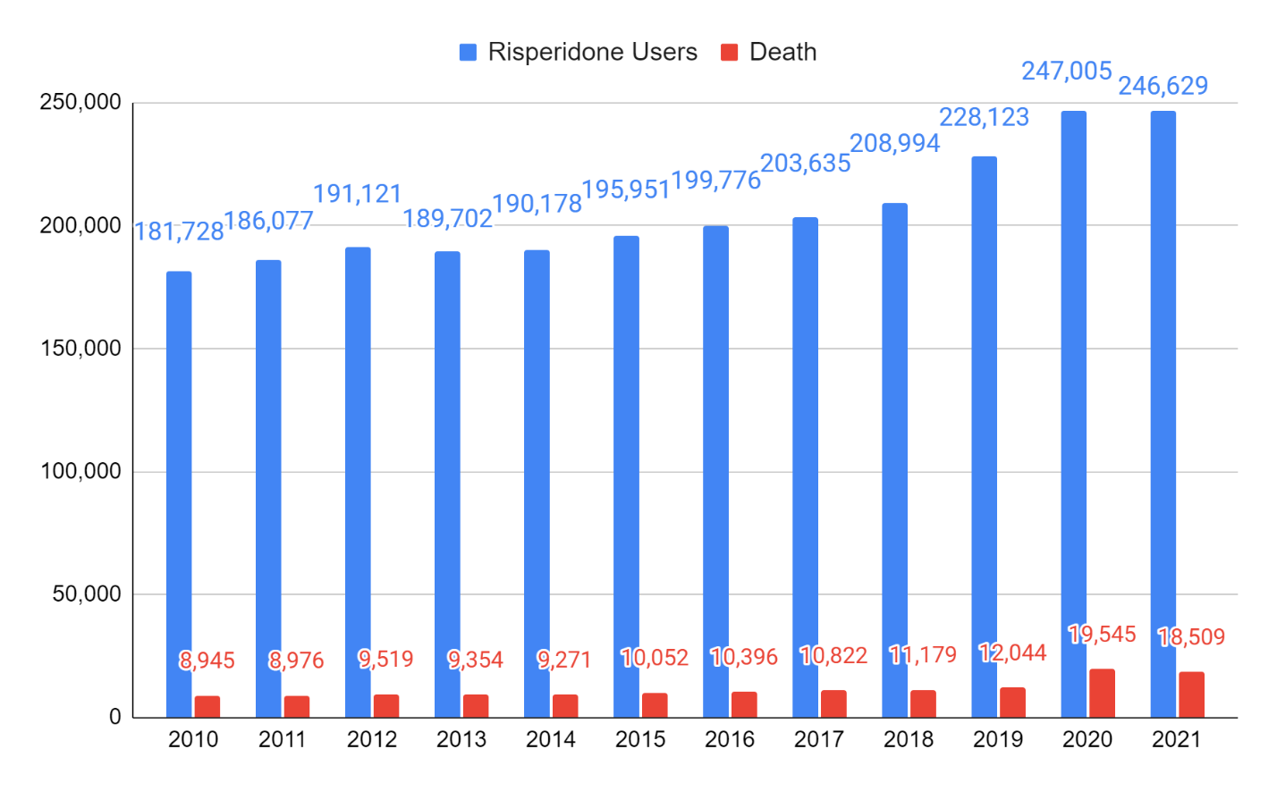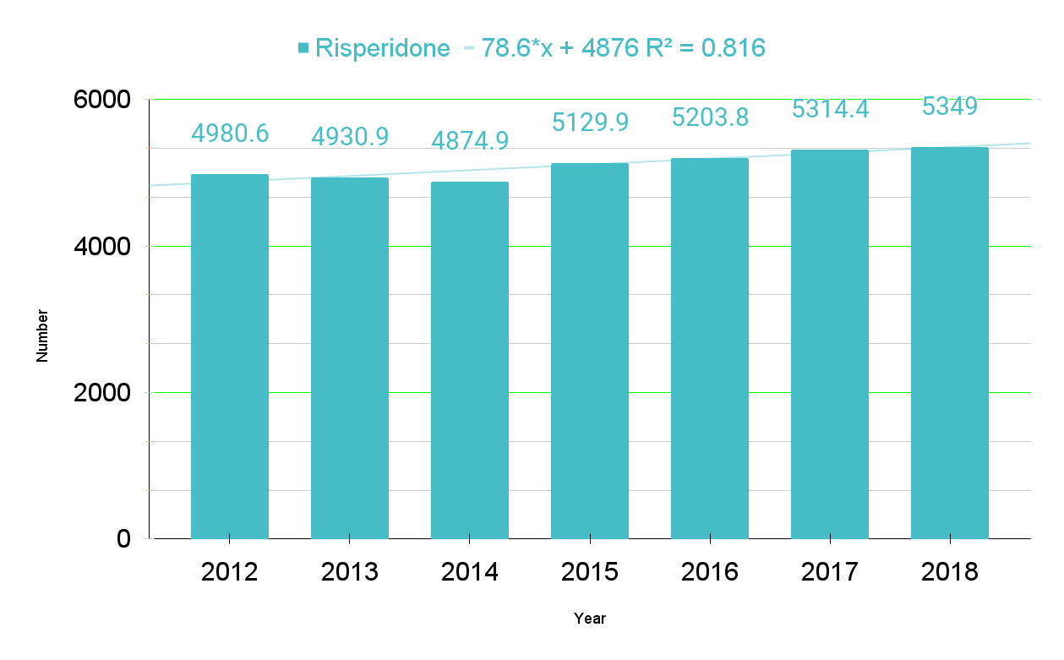Fig. S13. Risperidone Trend line. 78.6*x + 4876 R² = 0.816 38
Fig. S14. Quetiapine Trend line. 293*x + 8825 R² = 0.977 40
Fig. S15. Haloperidol Trend line. 791*x + 11937 R² = 0.993 42
Fig. S16. Oxcarbazepine Trend line. 195*x + 6135 R² = 0.52 44
Fig. S17. Trazodone Trend line. -8.84*x + 2956 R² = 0.331 46
Fig. S18. The trends of deaths with olanzapine, quetiapine, haloperidol, oxcarbazepine and trazodone use. 49
Fig. S19. Total Deaths with AAD Trend line. -247*x + 5018 R² = 0.993 / -244*x + 4955 R² = 0.997 62

The author has provided this supplemental material to give readers additional information about their work.

Supplement Section 1. Korea Drug Code Medicine

Korean Standard Classification of Diseases (KCD) code (ICD-10) for "Alzheimer's disease."
(1) ICD-10 code for Alzheimer's disease.

Table S1. Mental and Behavioral Disorders, F00-F09, G30
F00 code | Dementia in Alzheimer's disease (G30.-+)
F01 code | Vascular dementia
F02 code | Dementia in other diseases classified elsewhere
F03 code | Unspecified dementia
F04 code | Organic amnesic syndrome, not induced by alcohol and other psychoactive substances
F05 code | Delirium, not induced by alcohol and other psychoactive substances
F06 code | Other mental disorders due to brain damage and dysfunction and physical disease
F07 code | Personality and behavioral disorders due to brain disease, damage, and dysfunction
F09 code | Unspecified organic or symptomatic mental disorder
G30 code | Alzheimer's disease

(2) For symptomatic relief of Alzheimer's disease

Table S2. Symptomatic Relief of Alzheimer’s Disease
Donepezil  Rivastigmine  Galantamine  Memantine | 148603ATB 148602ATD 148602ATB 148601ATD 148601ATB 643401ATD 643402ATD
Donepezil  Rivastigmine  Galantamine  Memantine | 224501ACH 224503ACH 224504ACH 224505ACH 224506CPC 224507CPC 224508CPC
Donepezil  Rivastigmine  Galantamine  Memantine | 385203ACR 385203ATR 385204ACR 385204ATR 385205ACR 385205ATR
Donepezil  Rivastigmine  Galantamine  Memantine | 190031ALQ 190001ATB 190003ATD 190004ATB 190004ATD

Table S3. Psychologic Symptoms of Alzheimer’s Disease
Haloperidol  Risperidone  Quetiapine  Olanzapine  Aripiprazole  Oxcarbazepine  Fluvoxamine  Escitalopram  Trazodone  Sertraline  Fluoxetine | 167903ATB 167904ATB 167905ATB 167906ATB 167908ATB 167908ATB 168030BIJ
 | 224201ATB 224201ATD 224202ATB 224202ATD 224203ATB 224204ATB 224205BIJ 224206BIJ
 | 378601ATB 378602ATB 378603ATB 378604ATB 378605ATB 378605ATR 378606ATR 378607ATR 378608ATR 378608ATR 378610ATB
 | 204001ATB 204001ATD 204002ATB 204002ATD 204004ATB 204005ATB
 | 451501ATB 451501ATD 451502ATB 451502ATD 451503ATB 451504ATB 451505ATB 451506BIJ 451507BIJ
 | 206330ASS 206301ATB 206302ATB 206303ATB
 | 162501ATB 162502ATB
 | 474801ATB 474802ATB 474803ATB 474804ATB
 | 242901ACH 242901ATB 242902ATB 242903ATR
 | 227001ATB 227002ATB 227003ATB
 | 161501ACH 161501ATB 161502ACH 161502ATB 161502ATD
(3) The NHIS refused to provide information according to Korea's Official Information Disclosure Act.

Table S4. NHIS Masked Code and ICD-10 Code
Masked code | ICD 10 code | Drug
1486 | 148603ATB 148602ATD 148602ATB 148601ATD 148601ATB 643401ATD 643402ATD | Donepezil
2245 | 224501ACH 224503ACH 224504ACH 224505ACH 224506CPC 224507CPC 224508CPC | Rivastigmine
1900 | 190031ALQ 190001ATB 190003ATD 190004ATB 190004ATD | Memantine
2040 | 204001ATB 204001ATD 204002ATB 204002ATD 204004ATB 204005ATB | Olanzapine
2242 | 224201ATB 224201ATD 224202ATB 224202ATD 224203ATB 224204ATB 224205BIJ 224206BIJ | Risperidone
1615 | 161501ACH 161501ATB 161502ACH 161502ATB 161502ATD | Fluoxetine
2270 | 227001ATB 227002ATB 227003ATB | Sertraline
3786 | 378601ATB 378602ATB 378603ATB 378604ATB 378605ATB 378605ATR 378606ATR 378607ATR 378608ATR 378608ATR 378610ATB | Quetiapine
4515 | 451501ATB 451501ATD 451502ATB 451502ATD 451503ATB 451504ATB 451505ATB 451506BIJ 451507BIJ | Aripiprazole
4748 | 474801ATB 474802ATB 474803ATB 474804ATB | Escitalopram
9999  The previous others | From the decision of the Open Data Mediation Committee (Case number: 2022-015)
9999  The previous others | 242901ACH 242901ATB 242902ATB 242903ATR | Fluvoxamine
9999  The previous others | 385203ACR 385203ATR 385204ACR 385204ATR 385205ACR 385205ATR | Galantamine
9999  The previous others | 167903ATB 167904ATB 167905ATB 167906ATB 167908ATB 167908ATB 168030BIJ | Haloperidol
9999  The previous others | 206330ASS 206301ATB 206302ATB 206303ATB | Oxcarbazepine
9999  The previous others | 162501ATB 162502ATB | Trazodone

Table S5. The life expectancy of leprosy patients in the Sorokdo National Hospital
Population demography of Sorok Island. - Leprosy patients have lived in Sorok Island for a lifetime. According to the request for disclosure of health checkup information from 2005 to 2020 on October 27, 2020, a total of 1321 people (694 males, 627 females) reside there, and the average age is 84.3 years (M 84.3, SD 17.1, 95% CI: 83.6 – 85.0).
year | AD First group¹ | AD First & Second group² | The life expectancy of Korean
2005 | 90.4 | 93.98 | 78.24
2006 | 82.5 | 93.49 | 78.78
2007 | 92.38 | 92.2 | 79.16
2008 | 96.25 | 92.87 | 79.6
2009 | 94.74 | 93.09 | 80.04
2010 | 92.14 | 90.24 | 80.24
2011 | 91.25 | 90.22 | 80.62
2012 | 90.16 | 89.28 | 80.87
2013 | 90.6 | 89.07 | 81.36
2014 | 92.27 | 90.94 | 81.8
2015 | 85.56 | 84.88 | 82.06
2016 | 87.22 | 87.88 | 82.4
2017 | 88.45 | 86.67 | 82.7
2018 | 88.2 | 72.1 | 82.7
2019 | 88.2 | 72.1 | 83.3
Sum | 1350 | 1319 | 1213.87
Mean | 90 | 88 | 81
SD | 4 | 7 | 2
95% CI | 0 | 0 | 0
 | 90 | 88 | 81
 | 90 | 88 | 81
³p-value | 0.97266 | 0.33047 | 0.96806
⁴Kolmogorov-Smirnov Test (D) | 0.11635 | 0.23407 | 0.11840
⁵Skewness  Kurtosis Normality | -0.325353  0.448167  Your data does not differ significantly from that which is normally distributed. | -1.782821  2.432097  Your data does not differ significantly from that which is normally distributed. | -0.172428  -1.120456  Your data does not differ significantly from that which is normally distributed.
¹First Group: Group taking Symptomatic Relief of Alzheimer’s Disease of Table S2, ²Second Group: Group taking both Symptomatic & Psychologic Relief of Alzheimer’s Disease (Table S2 & Table S3). ³The p-value quantifies this probability, with a low probability indicating that your sample diverges from a normal distribution to an extent unlikely to arise merely by chance. ⁴The test statistic (D) provides a measurement of the divergence of your sample distribution from the normal distribution. The higher the value of D, the less probable it is that your data is normally distributed. ⁵The nearer both these are to zero, the more likely it is that your distribution is normal.

Table S6. The Friedman Test¹ for Repeated-Measures of the Table S5 life expectancy

year | AD First group² | AD First & Second group³ | The life expectancy of Korean
2005  2006  2007  2008  2009  2010  2011  2012  2013  2014  2015  2016  2017  2018  2019 | 2  2  3  3  3  3  3  3  3  3  3  2  3  3  3  Sum: 42 | 3  3  2  2  2  2  2  2  2  2  2  3  2  1  1  Sum: 31 | 1  1  1  1  1  1  1  1  1  1  1  1  1  2  2  Sum: 17
Calculation Summary
X²_{r} = (12/(nk(k+1)) * (∑R²) - 3n(k+1)
X²_{r} = 0.067 * 3014 - 180
X²_{r} = 20.9333
The X²_{r} statistic is 20.9333 (2, N = 15).
The p-value is .00003.
The result is significant at p < .01.
¹The Friedman test is the non-parametric alternative to the one-way ANOVA with repeated measures. It is used to test for differences between groups when the dependent variable being measured is ordinal^{. 2}First Group: Group taking Symptomatic Relief of Alzheimer’s Disease of Table S2, ³Second Group: Group taking both Symptomatic & Psychologic Relief of Alzheimer’s Disease (Table S2 & Table S3).

Supplement Section 2. Analysis of AAD and Deaths

Table S7. Donepezil code and User and the Death Toll
Year | Donepezil | Donepezil Users | Death
2010 | 1486 | 96,820 | 12,575
2011 | 1486 | 123,101 | 15,797
2012 | 1486 | 150,128 | 19,604
2013 | 1486 | 176,440 | 22,941
2014 | 1486 | 204,724 | 26,636
2015 | 1486 | 236,834 | 32,084
2016 | 1486 | 267,241 | 36,375
2017 | 1486 | 294,203 | 42,187
2018 | 1486 | 319,751 | 47,487
2019 | 1486 | 336,683 | 48,830
2020 | 1486 | 325,157 | 52,546
2021 | 1486 | 327,531 | 55,294

Year | Donepezil | Donepezil Users | *Death
2012 | 1486 | 100000 | 13058.2
2013 | 1486 | 100000 | 13002.2
2014 | 1486 | 100000 | 13010.7
2015 | 1486 | 100000 | 13547.0
2016 | 1486 | 100000 | 13611.3
2017 | 1486 | 100000 | 14339.4
2018 | 1486 | 100000 | 14851.2
2019 | 1486 | 100000 | 14503.3
(*Deaths per 100,000 population)

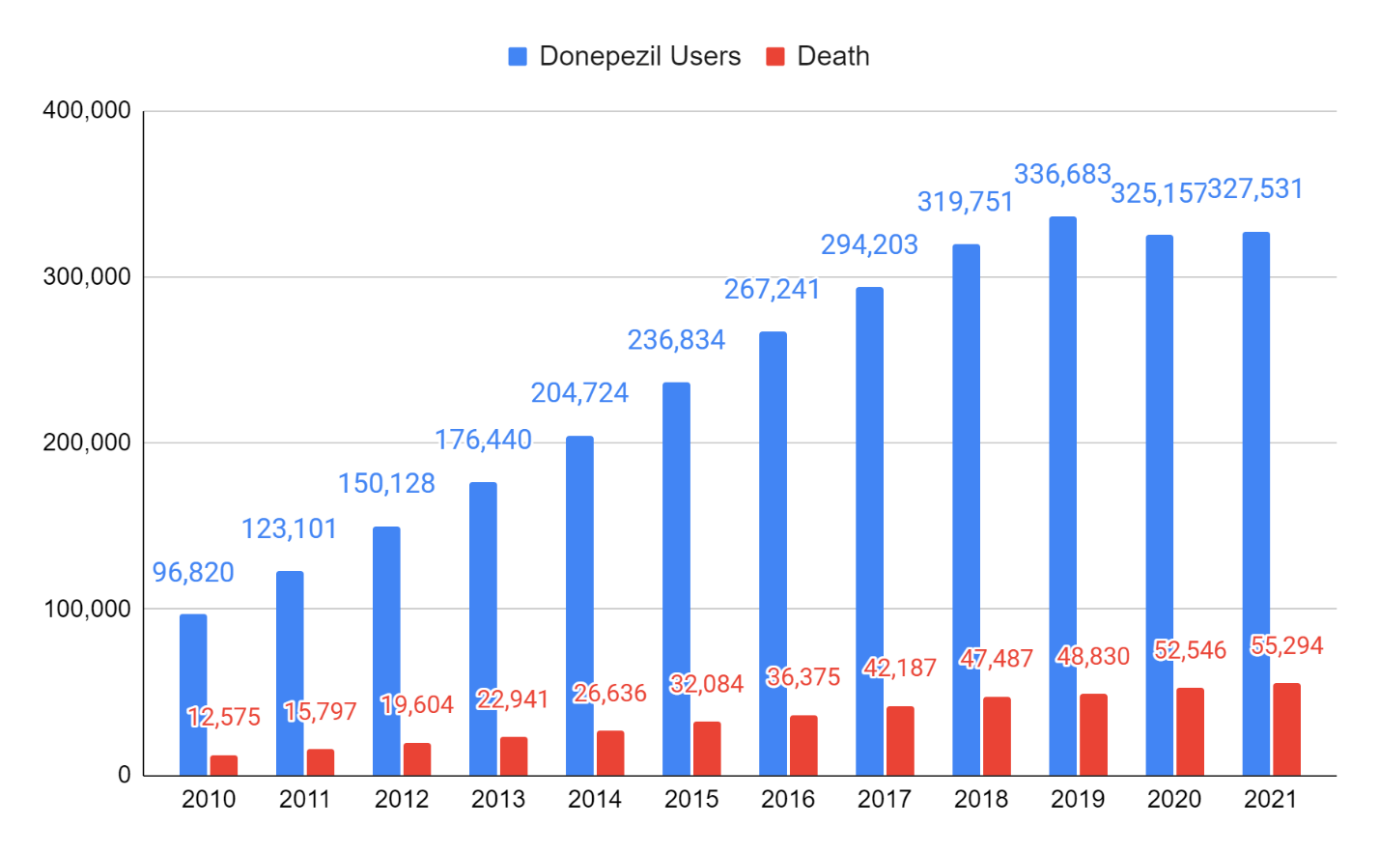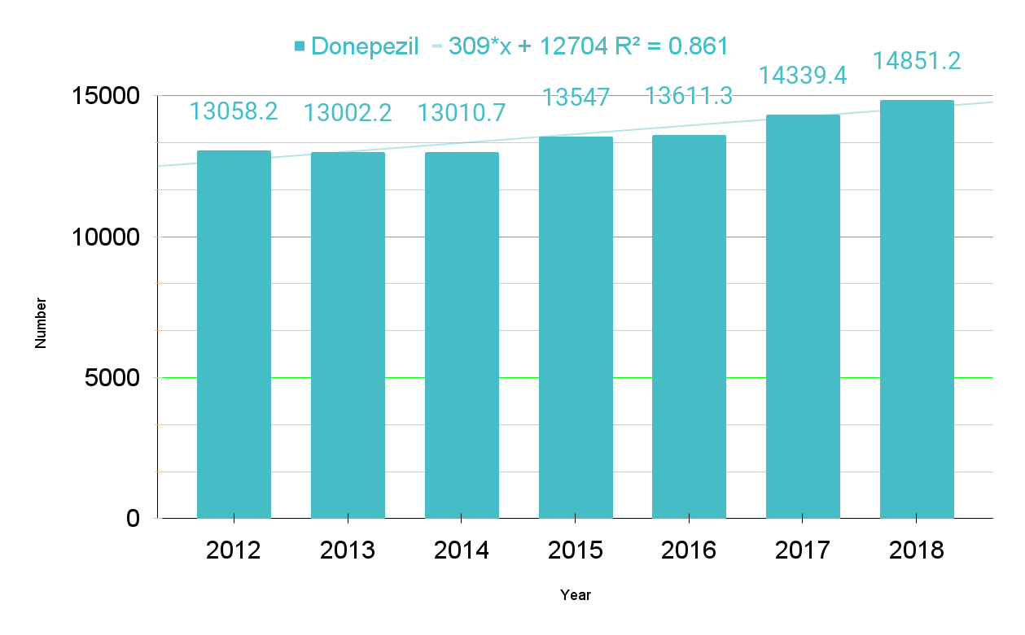

Fig. S1. Donepezil Trend line. 309*x + 12704 R² = 0.861

Table S8. Rivastigmine and User and Death Toll
year | code | Rivastigmine user | death
2010 | 2245 | 8,070 | 780
2011 | 2245 | 9,788 | 850
2012 | 2245 | 11,218 | 1,103
2013 | 2245 | 11,935 | 1,170
2014 | 2245 | 13,705 | 1,291
2015 | 2245 | 15,542 | 1,847
2016 | 2245 | 15,103 | 1,682
2017 | 2245 | 14,443 | 1,716
2018 | 2245 | 14,777 | 1,839
2019 | 2245 | 14,964 | 1,840
2020 | 2245 | 14,684 | 1,843
2021 | 2245 | 16,031 | 2,038

Year | code | Rivastigmine user | *death
2012 | 2245 | 100000 | 9832.4
2013 | 2245 | 100000 | 9803.1
2014 | 2245 | 100000 | 9419.9
2015 | 2245 | 100000 | 11883.9
2016 | 2245 | 100000 | 11136.9
2017 | 2245 | 100000 | 11881.2
2018 | 2245 | 100000 | 12445.0
2019 | 2245 | 100000 | 12296.2
(*Deaths per 100,000 population)
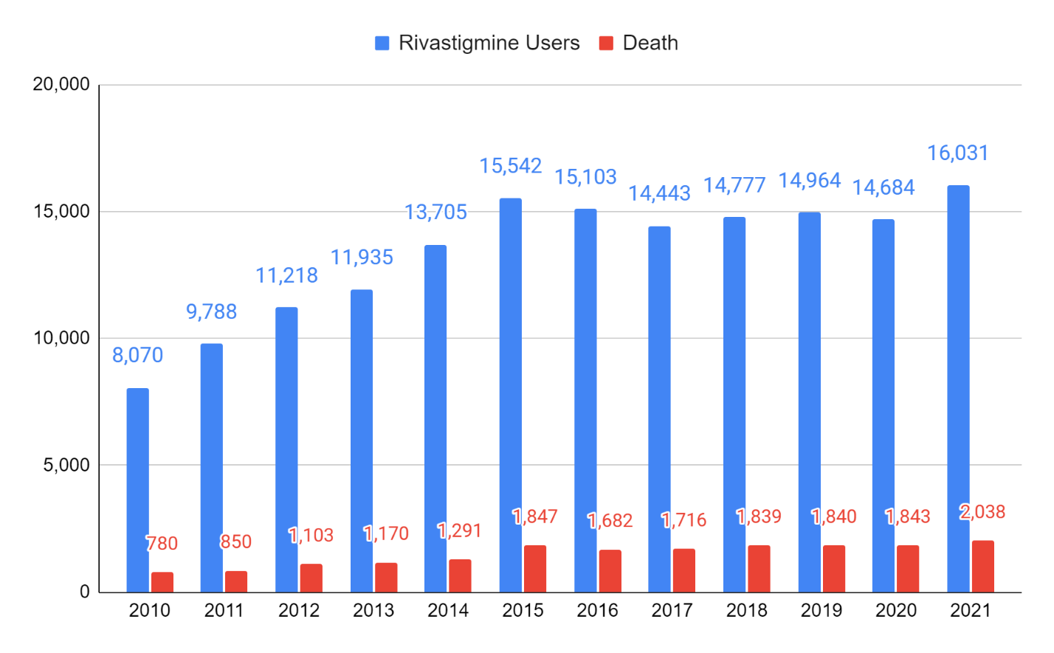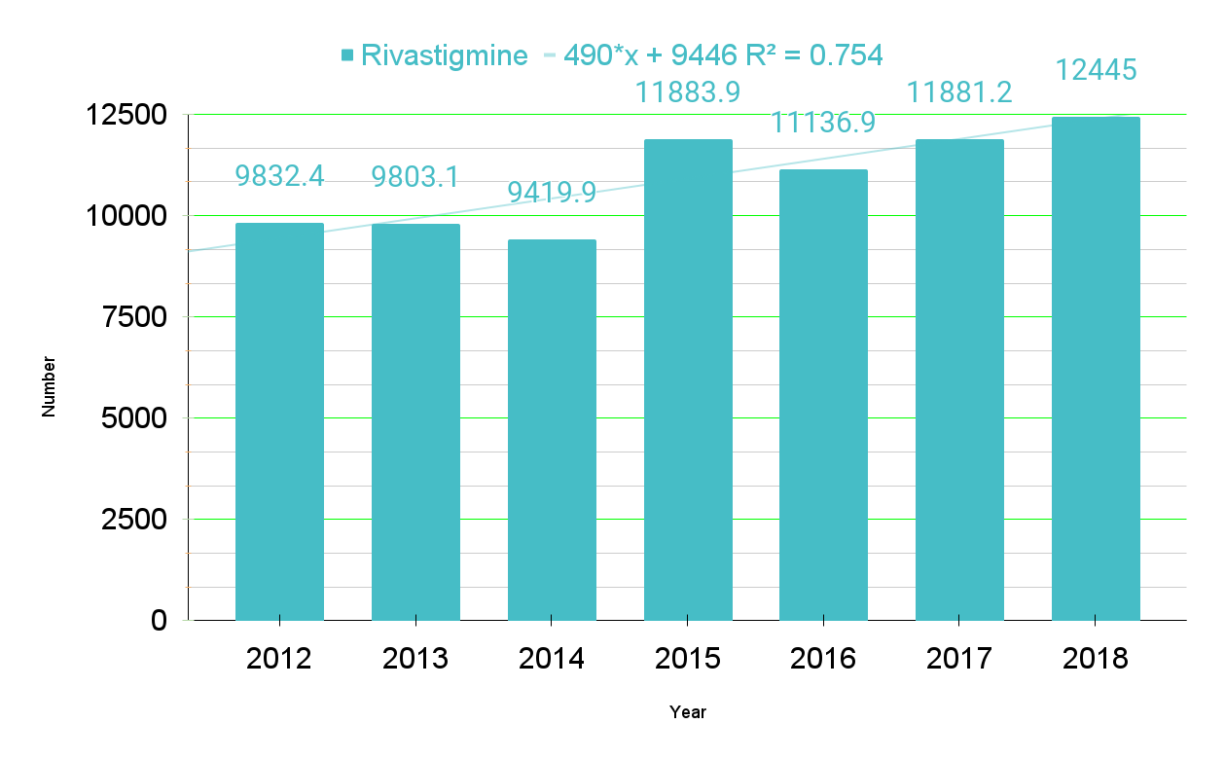

Fig. S2. Rivastigmine Trend line. 490*x + 9446 R² = 0.754

Table S9. Galantamine and User and Death Toll
year | code | Galantamine user | death
2010 | 3852 | 13,061 | 1,199
2011 | 3852 | 12,578 | 1,209
2012 | 3852 | 11,007 | 1,041
2013 | 3852 | 8,960 | 783
2014 | 3852 | 8,334 | 739
2015 | 3852 | 8,080 | 677
2016 | 3852 | 8,406 | 585
2017 | 3852 | 8,610 | 626
2018 | 3852 | 8,184 | 598
2019 | 3852 | 8,905 | 590
2020 | 3852 | 8,541 | 627
2021 | 3852 | 8,474 | 587

Year | code | Galantamine user | *death
2012 | 3852 | 100000 | 9457.6
2013 | 3852 | 100000 | 8738.8
2014 | 3852 | 100000 | 8867.3
2015 | 3852 | 100000 | 8378.7
2016 | 3852 | 100000 | 6959.3
2017 | 3852 | 100000 | 7270.6
2018 | 3852 | 100000 | 7306.9
2019 | 3852 | 100000 | 6625.5
(*Deaths per 100,000 population)
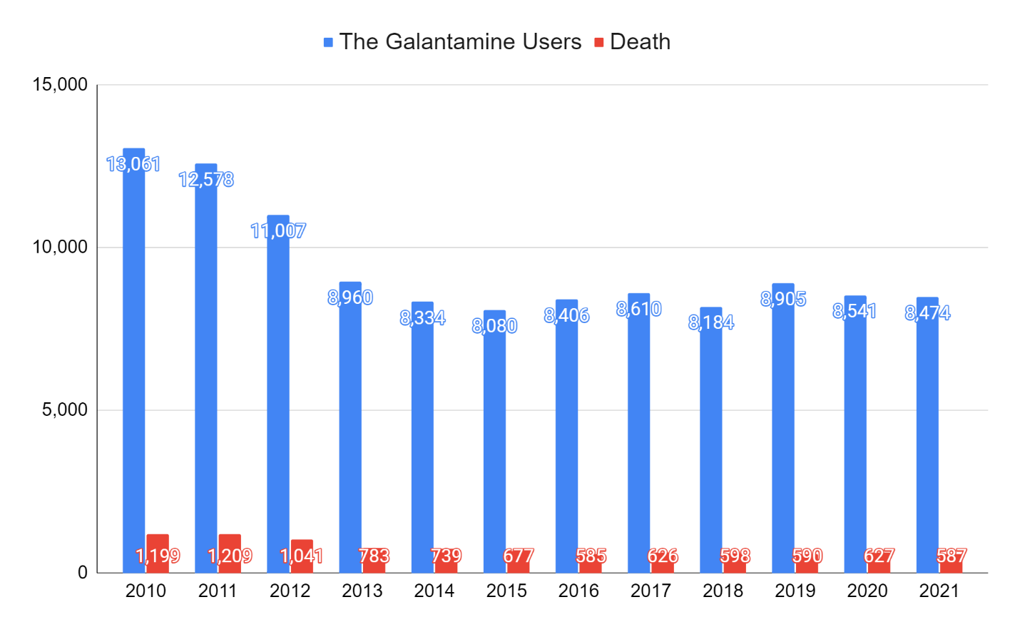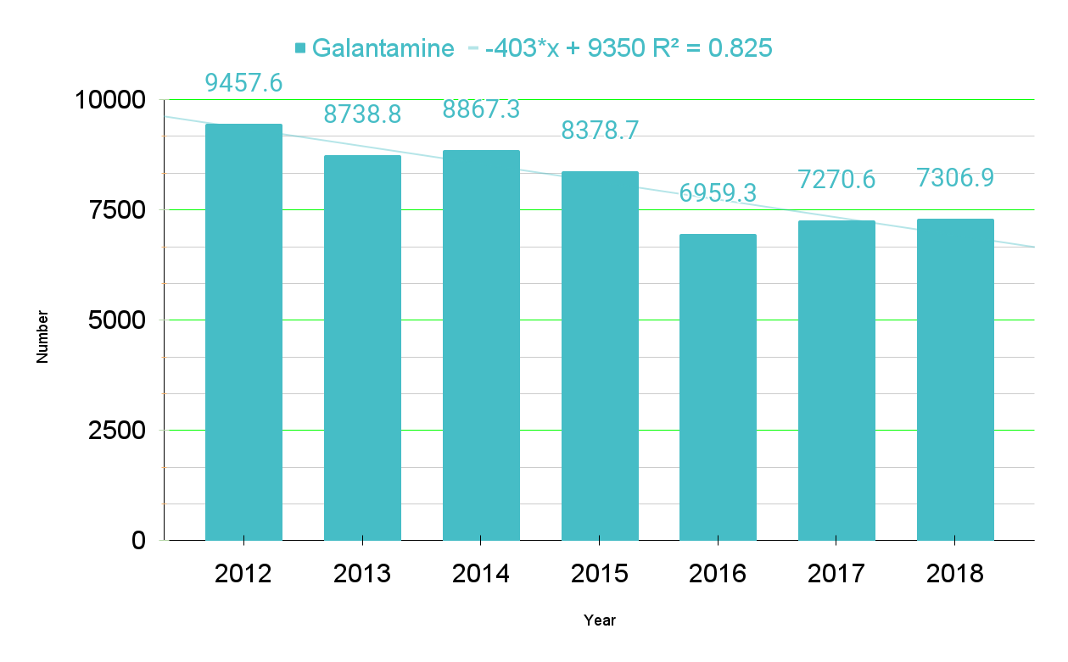

Fig. S3. Galantamine Trend line. -403*x + 9350 R² = 0.825

Table S10. Memantine and User and the Death Toll
year | code | Memantine user | death
2010 | 1900 | 31,965 | 5,559
2011 | 1900 | 35,315 | 5,945
2012 | 1900 | 37,138 | 6,419
2013 | 1900 | 38,391 | 6,403
2014 | 1900 | 43,165 | 6,568
2015 | 1900 | 52,358 | 8,134
2016 | 1900 | 58,626 | 9,080
2017 | 1900 | 65,605 | 10,718
2018 | 1900 | 70,873 | 11,597
2019 | 1900 | 79,770 | 12,714
2020 | 1900 | 83,169 | 14,693
2021` | 1900 | 87,985 | 15,852

year | code | Memantine user | *death
2012 | 1900 | 100000 | 17284.2
2013 | 1900 | 100000 | 16678.4
2014 | 1900 | 100000 | 15216.0
2015 | 1900 | 100000 | 15535.4
2016 | 1900 | 100000 | 15488.0
2017 | 1900 | 100000 | 16337.2
2018 | 1900 | 100000 | 16363.1
(*Deaths per 100,000 population)

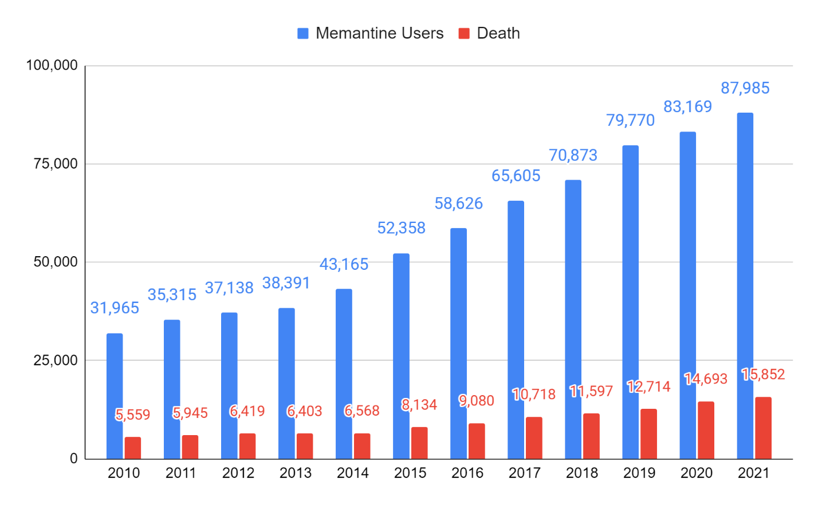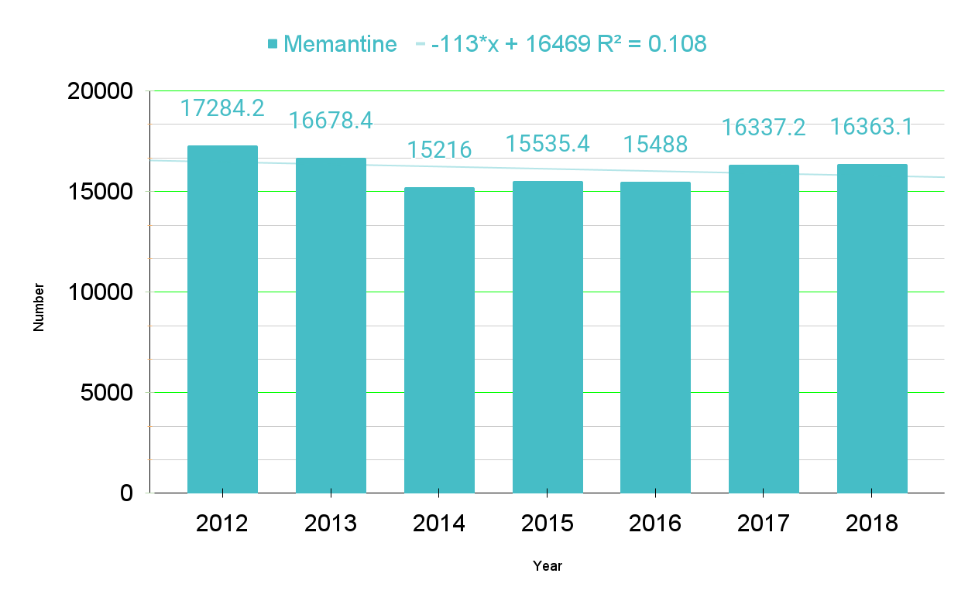

Fig. S4. Memantine Trend line. -113*x + 16469 R² = 0.108

Table S11. Nationwide Alzheimer disease (AD) drugs: Number of users and deaths
year | Donepezil* | Rivastigmine* | Galantamine* | Memantine*
2010 | 12988.0 | 9665.4 | 9180.0 | 17390.9
2011 | 12832.6 | 8684.1 | 9612.0 | 16834.2
2012 | 13058.2 | 9832.4 | 9457.6 | 17284.2
2013 | 13002.2 | 9803.1 | 8738.8 | 16678.4
2014 | 13010.7 | 9419.9 | 8867.3 | 15216.0
2015 | 13547.0 | 11883.9 | 8378.7 | 15535.4
2016 | 13611.3 | 11136.9 | 6959.3 | 15488.0
2017 | 14339.4 | 11881.2 | 7270.6 | 16337.2
2018 | 14851.2 | 12445.0 | 7306.9 | 16363.1
2019 | 14503.3 | 12296.2 | 6625.5 | 15938.3
2020 | 16160.2 | 12551.1 | 7341.1 | 17666.4
2021 | 16882.1 | 12712.9 | 6927.1 | 18016.7
Sum | 168786.20 | 132312.10 | 96664.90 | 198748.80
Mean | 14065.52 | 11026.01 | 8055.41 | 16562.40
SD | 1335.50 | 1449.57 | 1090.88 | 911.06
95% CI | 6.37 | 7.81 | 6.88 | 4.01
( | 14059.15 | 11018.20 | 8048.53 | 16558.39
) | 14071.89 | 11033.82 | 8062.29 | 16566.41
¹p-value | 0.52348 | 0.47369 | 0.36391 | 0.97046
²Kolmogorov-Smirnov Test (D) | 0.22213 | 0.23112 | 0.25299 | 0.13048
³Skewness  Kurtosis Normality | 1.161857  0.421383  significantly from that which is normally distributed. | -0.305275  -1.689647  significantly from that which is normally distributed. | 0.159221  -1.785866  significantly from that which is normally distributed. | 0.052106  -1.152865  significantly from that which is normally distributed.
⁴The Friedman Test between four groups | The X²_{r} statistic is 34.9 (3, N = 12).  The p-value is < .00001. The result is significant at p < .01.
*Deaths per 100,000 population. ¹The p-value quantifies this probability, with a low probability indicating that your sample diverges from a normal distribution to an extent unlikely to arise merely by chance. ²The test statistic (D) provides a measurement of the divergence of your sample distribution from the normal distribution. The higher the value of D, the less probable it is that your data is normally distributed. ³The nearer both these are to zero, the more likely it is that your distribution is normal. ⁴The Friedman test is the non-parametric alternative to the one-way ANOVA with repeated measures.

Table S12. The Friedman Test¹ for Repeated-Measures
year | Donepezil* | Rivastigmine* | Galantamine* | Memantine*
2010  2011  2012  2013  2014  2015  2016  2017  2018  2019  2020  2021 | 3  3  3  3  3  3  3  3  3  3  3  3  Sum: 36 | 2  1  2  2  2  2  2  2  2  2  2  2  Sum: 23 | 1  2  1  1  1  1  1  1  1  1  1  1  Sum: 13 | 4  4  4  4  4  4  4  4  4  4  4  4  Sum: 48
Calculation Summary
X²_{r} = (12/(nk(k+1)) * (∑R²) - 3n(k+1)
X²_{r} = 0.05 * 4298 – 180
X²_{r} = 34.9
The X²_{r} statistic is 34.9 (3, N = 12).
The p-value is < .00001.
The result is significant at p < .01.

¹The Friedman test is the non-parametric alternative to the one-way ANOVA with repeated measures. It is used to test for differences between groups when the dependent variable being measured is ordinal.

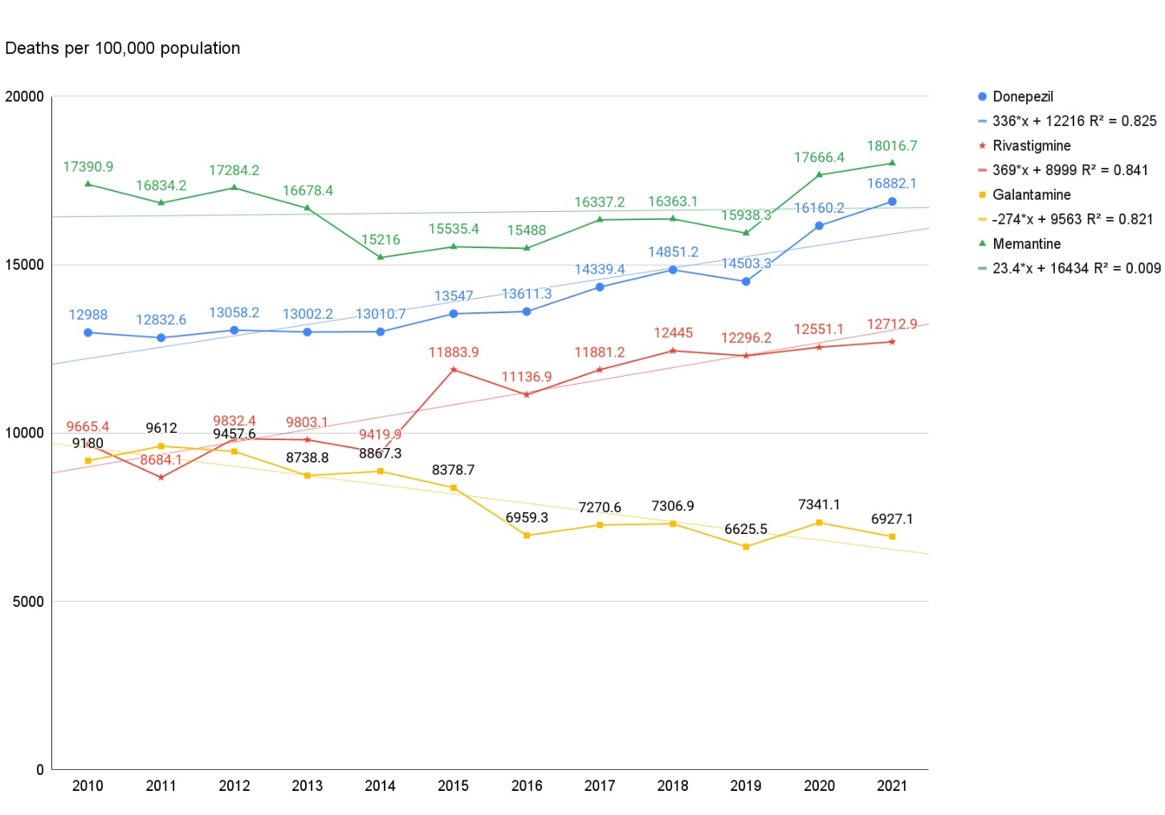

Fig. S5. The trends of deaths with donepezil, rivastigmine, galantamine, and memantine use.
The administration of donepezil (blue) and rivastigmine (red) increased (+) the number of deaths. Galantamine (yellow) reduced (-) the number of deaths, and memantine (green) had no relationship with the increase or decrease in the number of deaths. Memantine is administered to patients with moderate to severe AD and was not associated with an increase or decrease in the number of deaths.

Table S13. Fluoxetine and User and Death Toll
year | code | Fluoxetine user | death
2010 | 1615 | 156,899 | 1,802
2011 | 1615 | 151,252 | 1,580
2012 | 1615 | 150,654 | 1,582
2013 | 1615 | 140,194 | 1,439
2014 | 1615 | 134,013 | 1,395
2015 | 1615 | 133,262 | 1,373
2016 | 1615 | 137,846 | 1,329
2017 | 1615 | 144,496 | 1,268
2018 | 1615 | 157,170 | 1,369
2019 | 1615 | 173,284 | 1,405
2020 | 1615 | 191,492 | 1,908
2021 | 1615 | 225,458 | 1,860

year | code | Fluoxetine user | *death
2012 | 1802 | 100000 | 1050.1
2013 | 1615 | 100000 | 1026.4
2014 | 1615 | 100000 | 1040.9
2015 | 1615 | 100000 | 1030.3
2016 | 1615 | 100000 | 964.1
2017 | 1615 | 100000 | 877.5
2018 | 1615 | 100000 | 871.0
(*Deaths per 100,000 population)

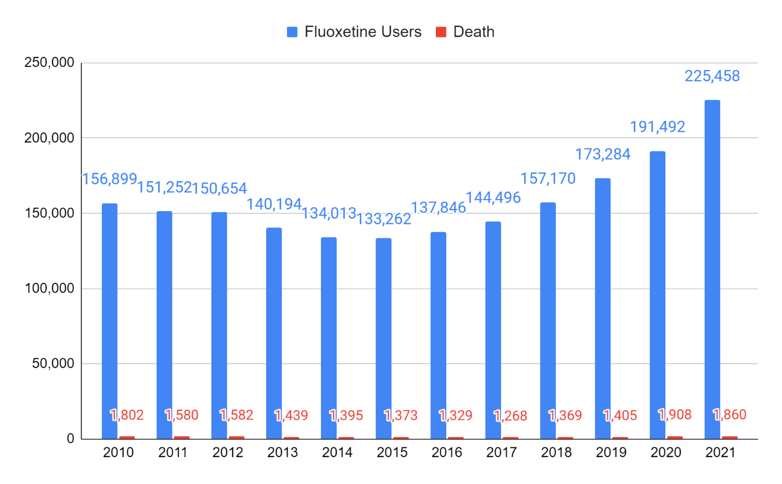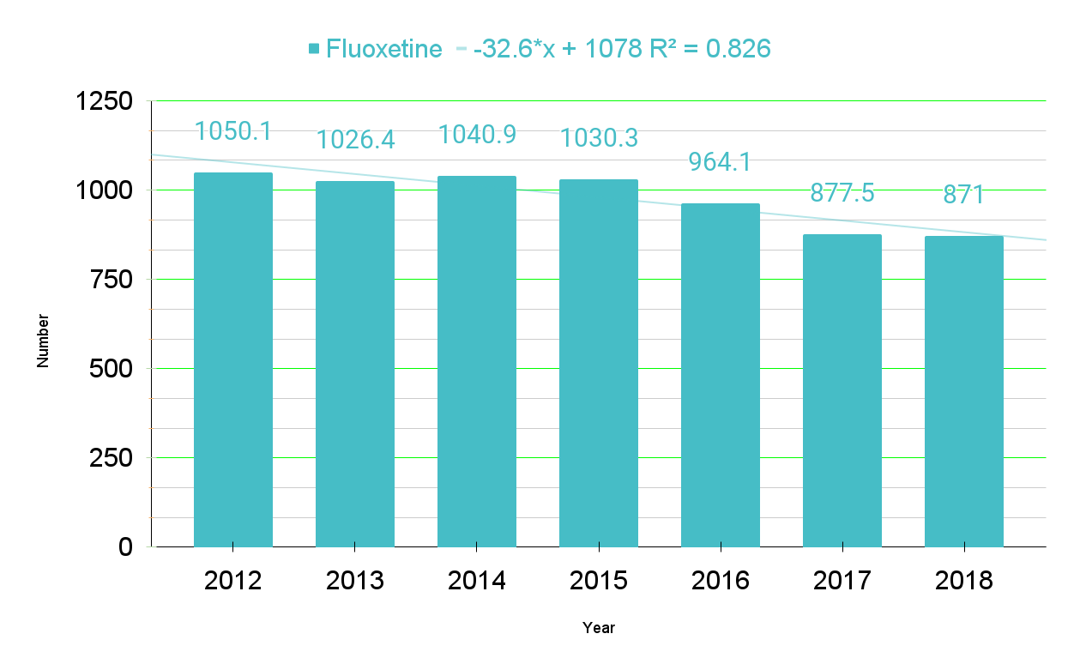

Fig. S6. Fluoxetine Trend line. -32.6*x + 1078 R² = 0.826

Table S14. Sertraline and User and Death Toll
year | code | Sertraline user | death
2010 | 2270 | 71,494 | 1,341
2011 | 2270 | 76,809 | 1,319
2012 | 2270 | 85,193 | 1,377
2013 | 2270 | 86,931 | 1,427
2014 | 2270 | 89,114 | 1,565
2015 | 2270 | 92,676 | 1,522
2016 | 2270 | 103,099 | 1,684
2017 | 2270 | 115,370 | 1,853
2018 | 2270 | 129,710 | 1,982
2019 | 2270 | 142,660 | 2,005
2020 | 2270 | 160,421 | 2,364
2021 | 2270 | 187,294 | 2,612

year | code | Sertraline user | *death
2012 | 2270 | 100000 | 1616.3
2013 | 2270 | 100000 | 1641.5
2014 | 2270 | 100000 | 1756.2
2015 | 2270 | 100000 | 1642.3
2016 | 2270 | 100000 | 1633.4
2017 | 2270 | 100000 | 1606.1
2018 | 2270 | 100000 | 1528.0
(*Deaths per 100,000 population)

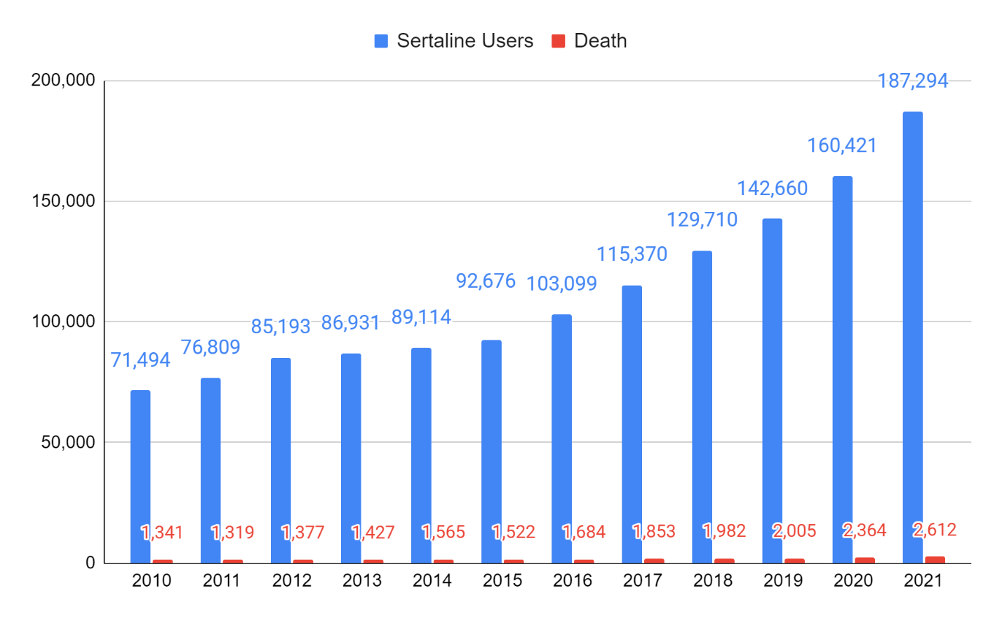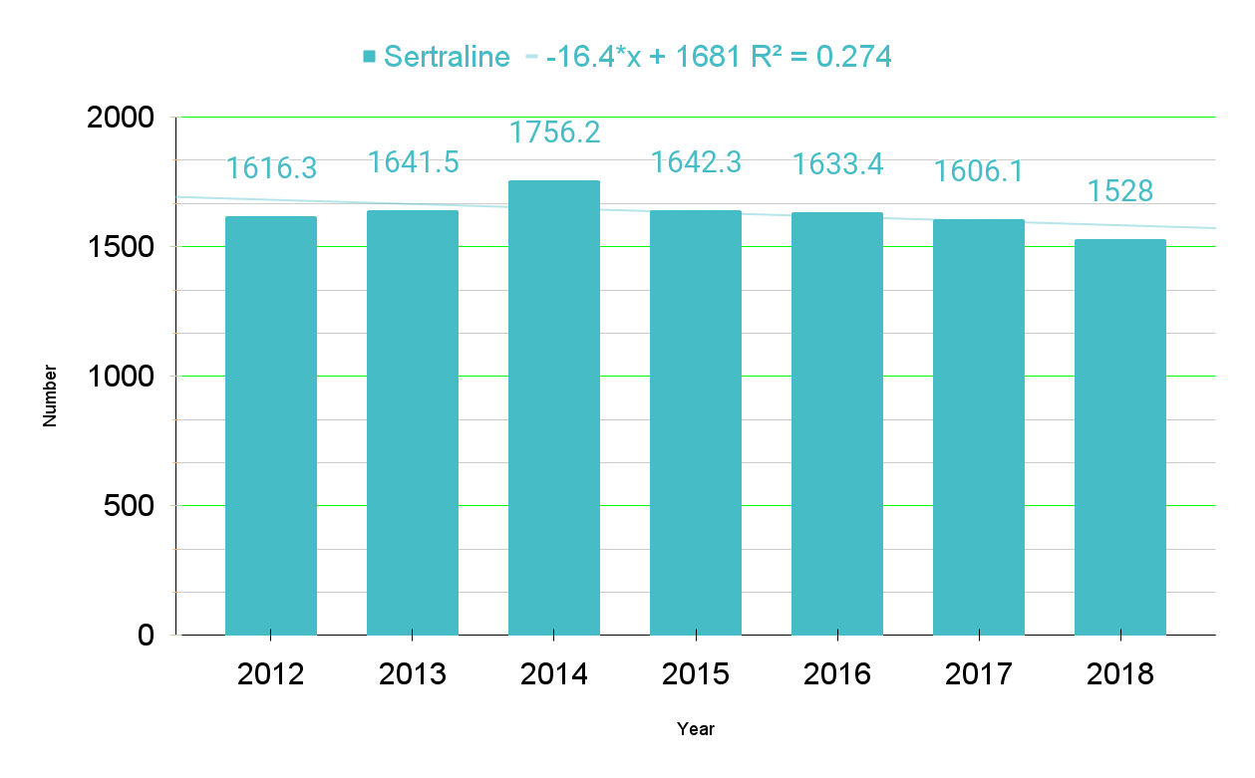

Fig. S7. Sertraline Trend line. -16.4*x + 1681 R² = 0.274

Table S15. Escitalopram and User and the Death Toll
year | code | Escitalopram User | death
2010 | 4748 | 227,186 | 5,093
2011 | 4748 | 258,981 | 5,949
2012 | 4748 | 303,698 | 7,060
2013 | 4748 | 326,645 | 7,585
2014 | 4748 | 359,582 | 8,118
2015 | 4748 | 391,772 | 8,726
2016 | 4748 | 431,465 | 9,298
2017 | 4748 | 478,751 | 10,365
2018 | 4748 | 549,235 | 11,480
2019 | 4748 | 612,579 | 12,472
2020 | 4748 | 669,260 | 15,974
2021 | 4748 | 751,641 | 17,337

year | Code | Escitalopram User | *death
2012 | 4748 | 100000 | 2324.7
2013 | 4748 | 100000 | 2322.1
2014 | 4748 | 100000 | 2257.6
2015 | 4748 | 100000 | 2227.3
2016 | 4748 | 100000 | 2155.0
2017 | 4748 | 100000 | 2165.0
2018 | 4748 | 100000 | 2090.2
(*Deaths per 100,000 population)

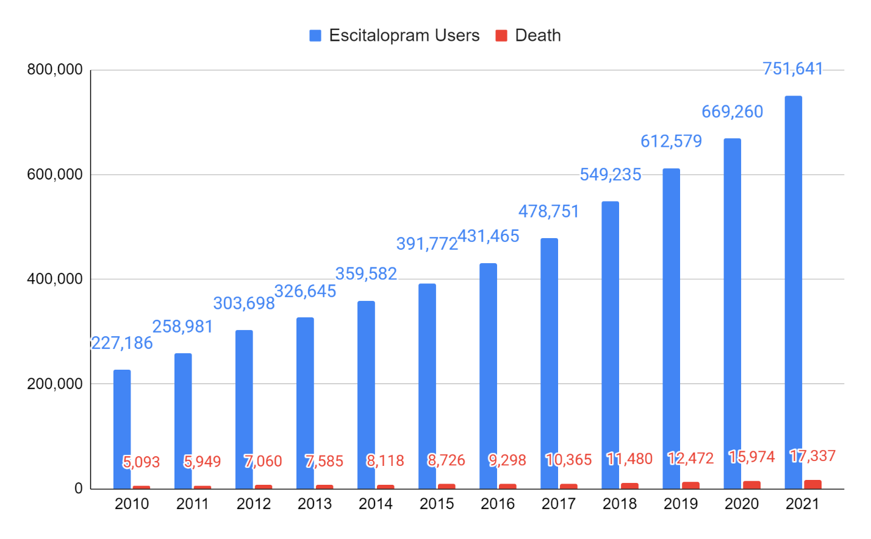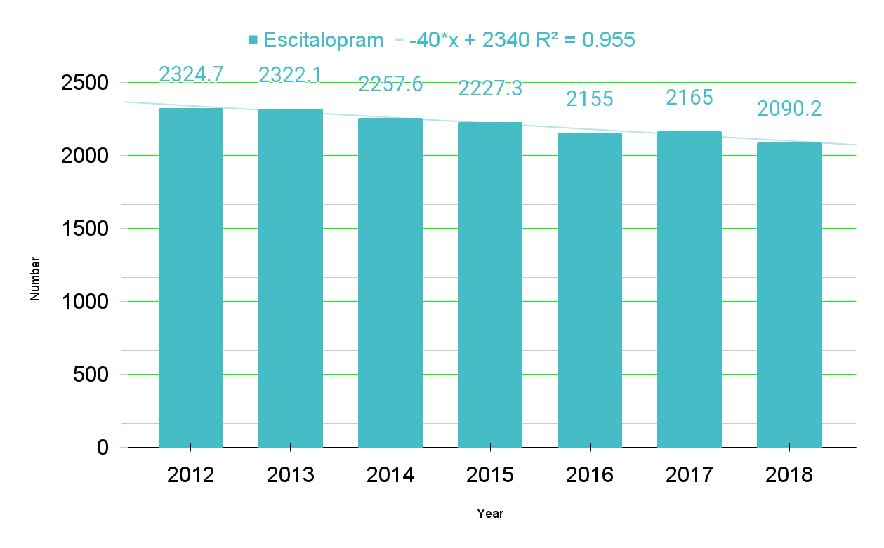

Fig. S8. Escitalopram Trend line. --40*x + 2340 R² = 0.955

Table S16. Fluvoxamine and User and the Death Toll
year | code | Fluvoxamine user | death
2010 | 9999 | 20423 | 273
2011 | 9999 | 17695 | 255
2012 | 9999 | 15921 | 235
2013 | 9999 | 14122 | 215
2014 | 9999 | 12661 | 208
2015 | 9999 | 12273 | 174
2016 | 9999 | 12826 | 235
2017 | 9999 | 12409 | 202
2018 | 9999 | 12381 | 169
2019 | 9999 | 11845 | 192
2020 | 9999 | 11912 | 179
2021 | 9999 | 12191 | 120

year | Code | Fluvoxamine user | *death
2012 | 9999 | 100000 | 1476.0
2013 | 9999 | 100000 | 1522.4
2014 | 9999 | 100000 | 1642.8
2015 | 9999 | 100000 | 1417.7
2016 | 9999 | 100000 | 1832.2
2017 | 9999 | 100000 | 1627.9
2018 | 9999 | 100000 | 1365.0
(*Deaths per 100,000 population)
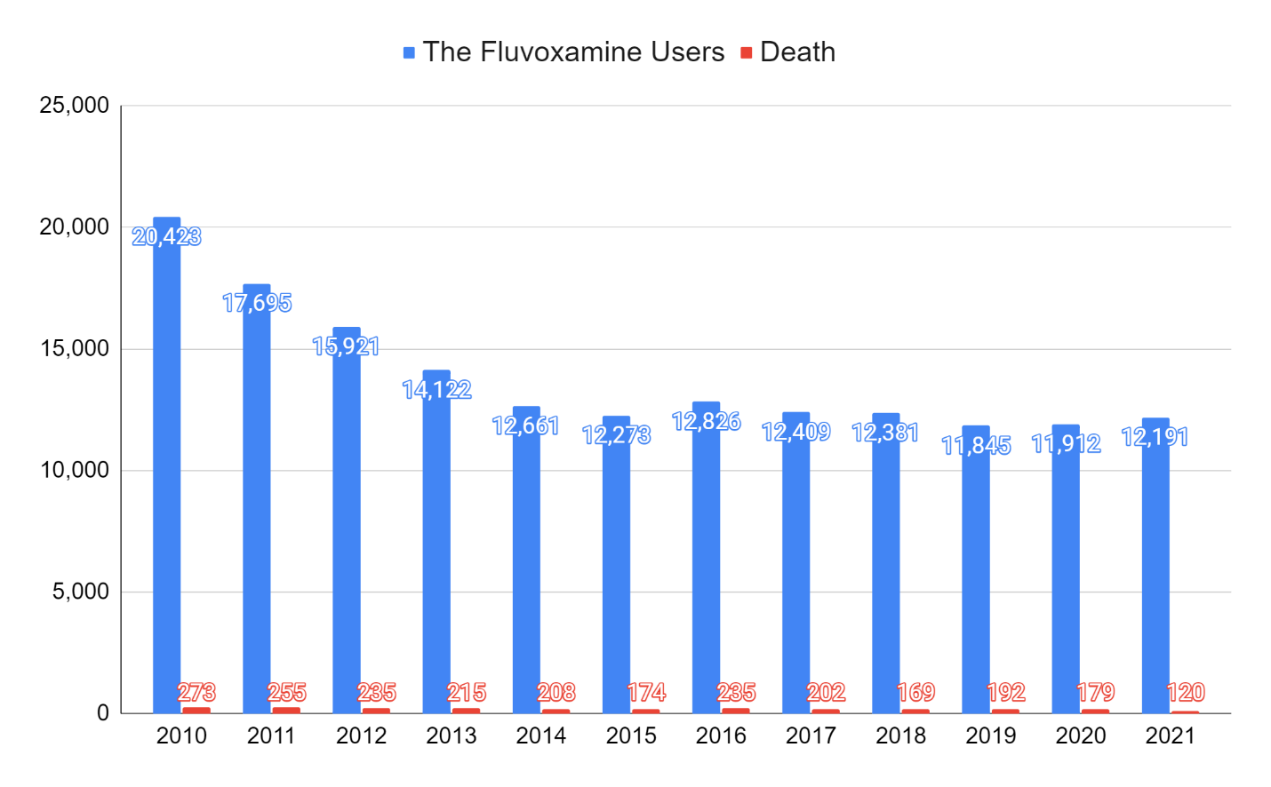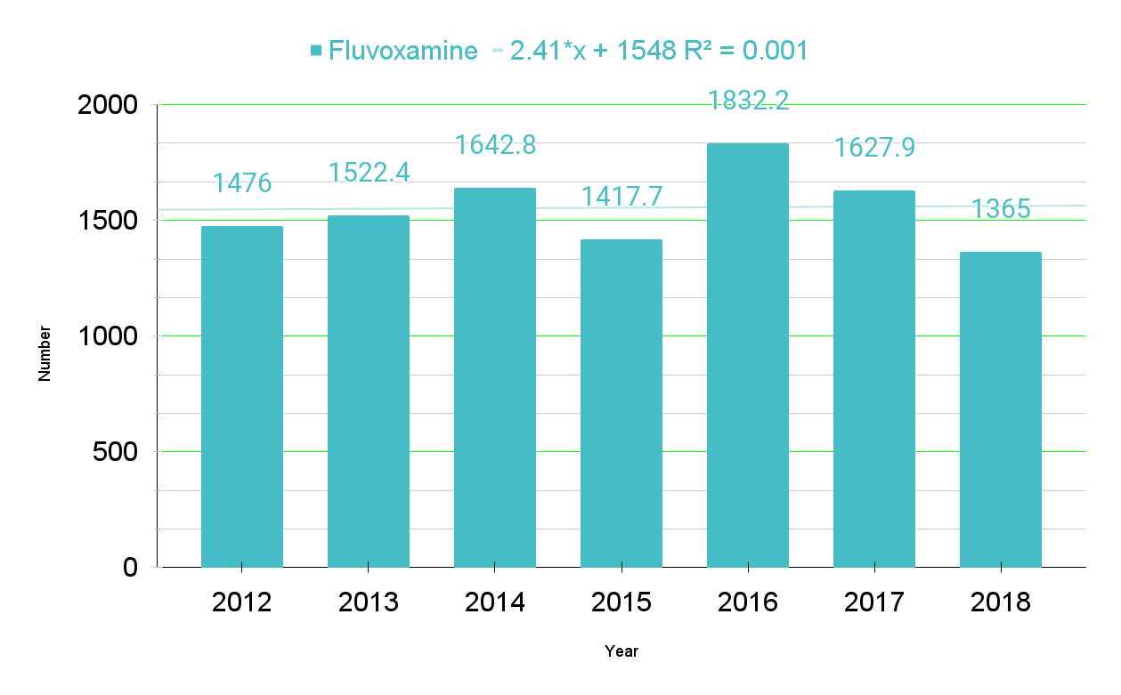

Fig. S9. Fluvoxamine line. 2.41*x + 1548 R² = 0.001

Table S17. Aripiprazole and User and Death Toll
year | code | Aripiprazole User | death
2010 | 4515 | 25,155 | 330
2011 | 4515 | 28,561 | 382
2012 | 4515 | 37,290 | 466
2013 | 4515 | 45,297 | 570
2014 | 4515 | 67,152 | 768
2015 | 4515 | 84,102 | 1,086
2016 | 4515 | 102,241 | 1,164
2017 | 4515 | 133,075 | 1,448
2018 | 4515 | 174,861 | 1,895
2019 | 4515 | 214,761 | 2,211
2020 | 4515 | 248,825 | 2,848
2021 | 4515 | 310,602 | 3,371

year | code | Aripiprazole User | *death
2012 | 4515 | 100000 | 1249.7
2013 | 4515 | 100000 | 1258.4
2014 | 4515 | 100000 | 1143.7
2015 | 4515 | 100000 | 1291.3
2016 | 4515 | 100000 | 1138.5
2017 | 4515 | 100000 | 1088.1
2018 | 4515 | 100000 | 1083.7
(*Deaths per 100,000 population)

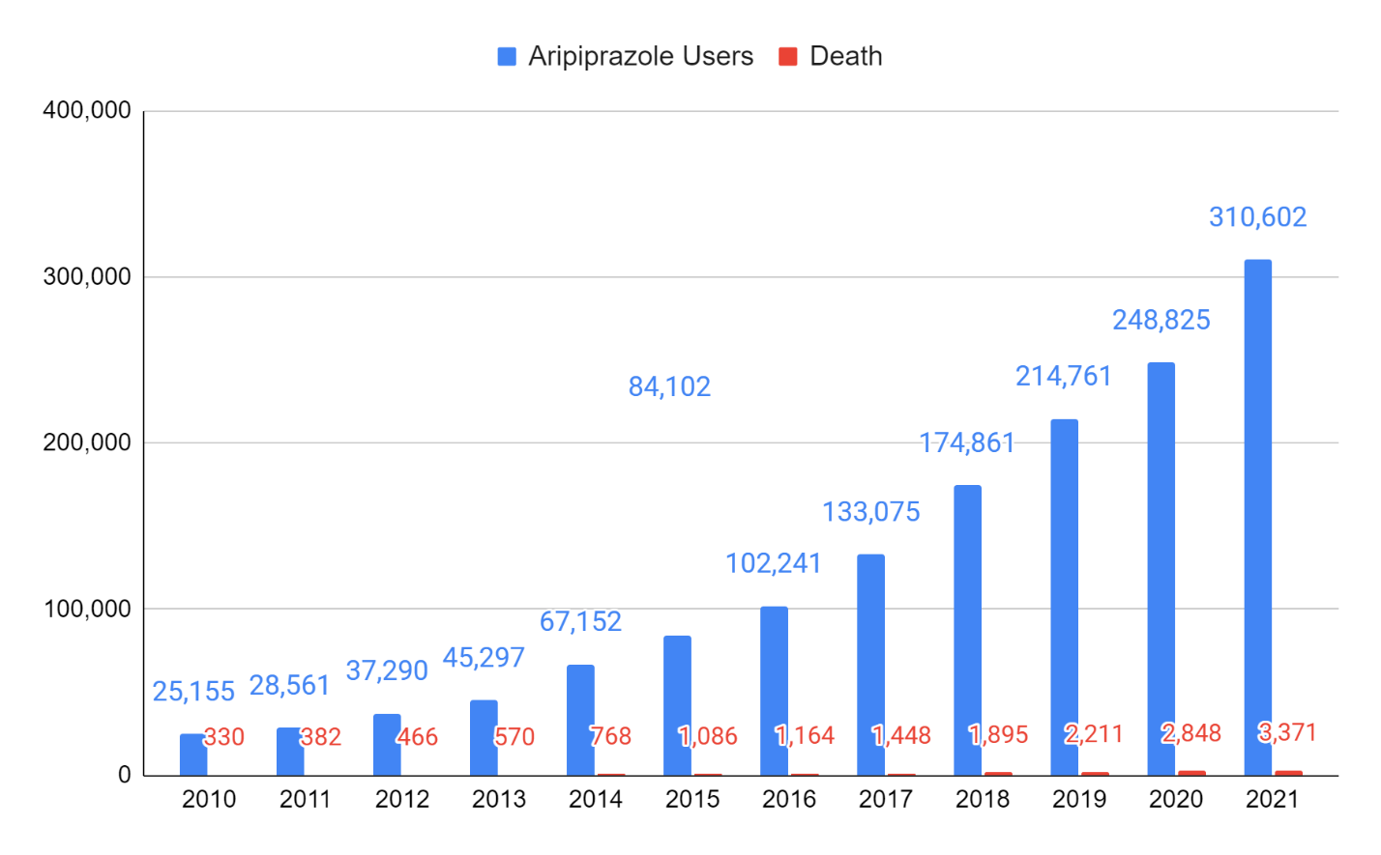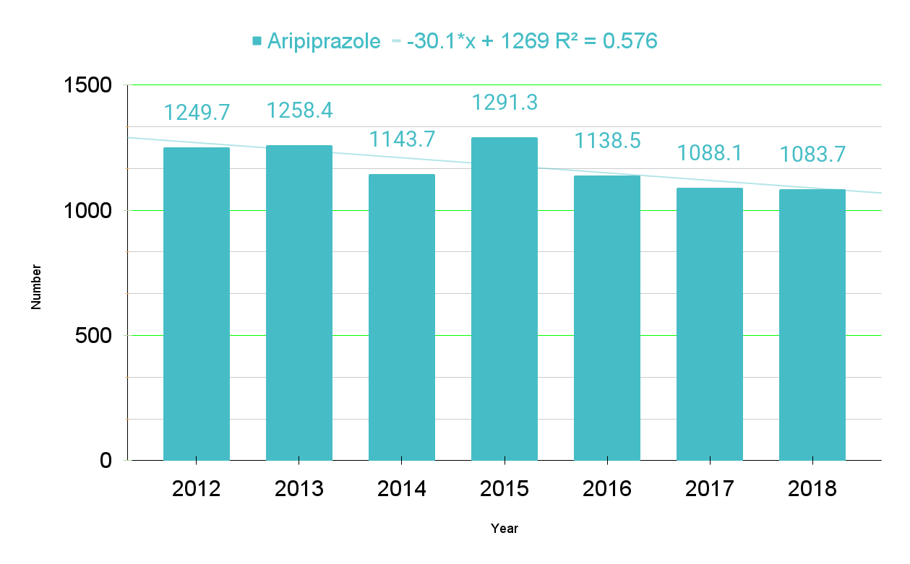

Fig. S10. Aripiprazole Trend line. -30.1*x + 1269 R² = 0.576

Table S18. Nationwide Selective serotonin reuptake inhibitors (SSRIs): Number of users and deaths
year | Fluoxetine* | Sertraline* | Escitalopram* | Fluvoxamine* | Aripiprazole*
2010 | 1148.50 | 1875.70 | 2241.80 | 1336.70 | 1311.90
2011 | 1044.60 | 1717.20 | 2297.10 | 1441.10 | 1337.50
2012 | 1050.10 | 1616.30 | 2324.70 | 1476.00 | 1249.70
2013 | 1026.40 | 1641.50 | 2322.10 | 1522.40 | 1258.40
2014 | 1040.90 | 1756.20 | 2257.60 | 1642.80 | 1143.70
2015 | 1030.30 | 1642.30 | 2227.30 | 1417.70 | 1291.30
2016 | 964.10 | 1633.40 | 2155.00 | 1832.20 | 1138.50
2017 | 877.50 | 1606.10 | 2165.00 | 1627.90 | 1088.10
2018 | 871.00 | 1528.00 | 2090.20 | 1365.00 | 1083.70
2019 | 810.80 | 1405.40 | 2036.00 | 1620.90 | 1029.50
2020 | 996.40 | 1473.60 | 2386.80 | 1502.70 | 1144.60
2021 | 825.00 | 1394.60 | 2306.60 | 984.30 | 1085.30
Sum | 11685.60 | 19290.30 | 26810.20 | 17769.70 | 14162.20
Mean | 973.80 | 1607.53 | 2234.18 | 1480.81 | 1180.18
SD | 104.87 | 141.30 | 104.51 | 208.78 | 104.11
95% CI | 1.90 | 1.99 | 1.25 | 3.07 | 1.71
( | 971.90 | 1605.53 | 2232.93 | 1477.74 | 1178.47
) | 975.70 | 1609.52 | 2235.43 | 1483.88 | 1181.90
¹p-value | 0.65427 | 0.8601 | 0.90611 | 0.90528 | 0.51977
²Kolmogorov-Smirnov Test (D) | 0.19982 | 0.16246 | 0.15193 | 0.15214 | 0.22278
³Skewness  Kurtosis Normality | -0.268186  -0.876854  significantly from that which is normally distributed. | 0.122792  -0.121631  significantly from that which is normally distributed. | -0.571468  -0.403589  significantly from that which is normally distributed. | -0.882363  2.45184  significantly from that which is normally distributed | 0.216978  -1.500598  significantly from that which is normally distributed.
⁴The Friedman Test between five groups |  |  | The X²_{r} statistic is 44.8667 (4, N = 12). The p-value is < .00001.  The result is significant at p < .01.
*Deaths per 100,000 population ¹The p-value quantifies this probability, with a low probability indicating that your sample diverges from a normal distribution to an extent unlikely to arise merely by chance. ²The test statistic (D) provides a measurement of the divergence of your sample distribution from the normal distribution. The higher the value of D, the less probable it is that your data is normally distributed. ³The nearer both these are to zero, the more likely it is that your distribution is normal. ⁴The Friedman test is the non-parametric alternative to the one-way ANOVA with repeated measures.

Table S19. The Friedman Test¹ for Repeated-Measures

year | Fluoxetine* | Sertraline* | Escitalopram* | Fluvoxamine* | Aripiprazole*
2010  2011  2012  2013  2014  2015  2016  2017  2018  2019  2020  2021 | 1  1  1  1  1  1  1  1  1  1  1  1  Sum: 12 | 4  4  4  4  4  4  3  3  4  3  3  4  Sum: 44 | 5  5  5  5  5  5  5  5  5  5  5  5  Sum: 60 | 3  3  3  3  3  3  4  4  3  4  4  2  Sum: 39 | 2  2  2  2  2  2  2  2  2  2  2  3  Sum: 25
Calculation Summary
X²_{r} = (12/(nk(k+1)) * (∑R²) - 3n(k+1)
X²_{r} = 0.033 * 7826 – 216
X²_{r} = 44.8667
The X²_{r} statistic is 44.8667 (4, N = 12).
The p-value is < .00001.
The result is significant at p < .01.
*Deaths per 100,000 population ¹The Friedman test is the non-parametric alternative to the one-way ANOVA with repeated measures. It is used to test for differences between groups when the dependent variable being measured is ordinal.

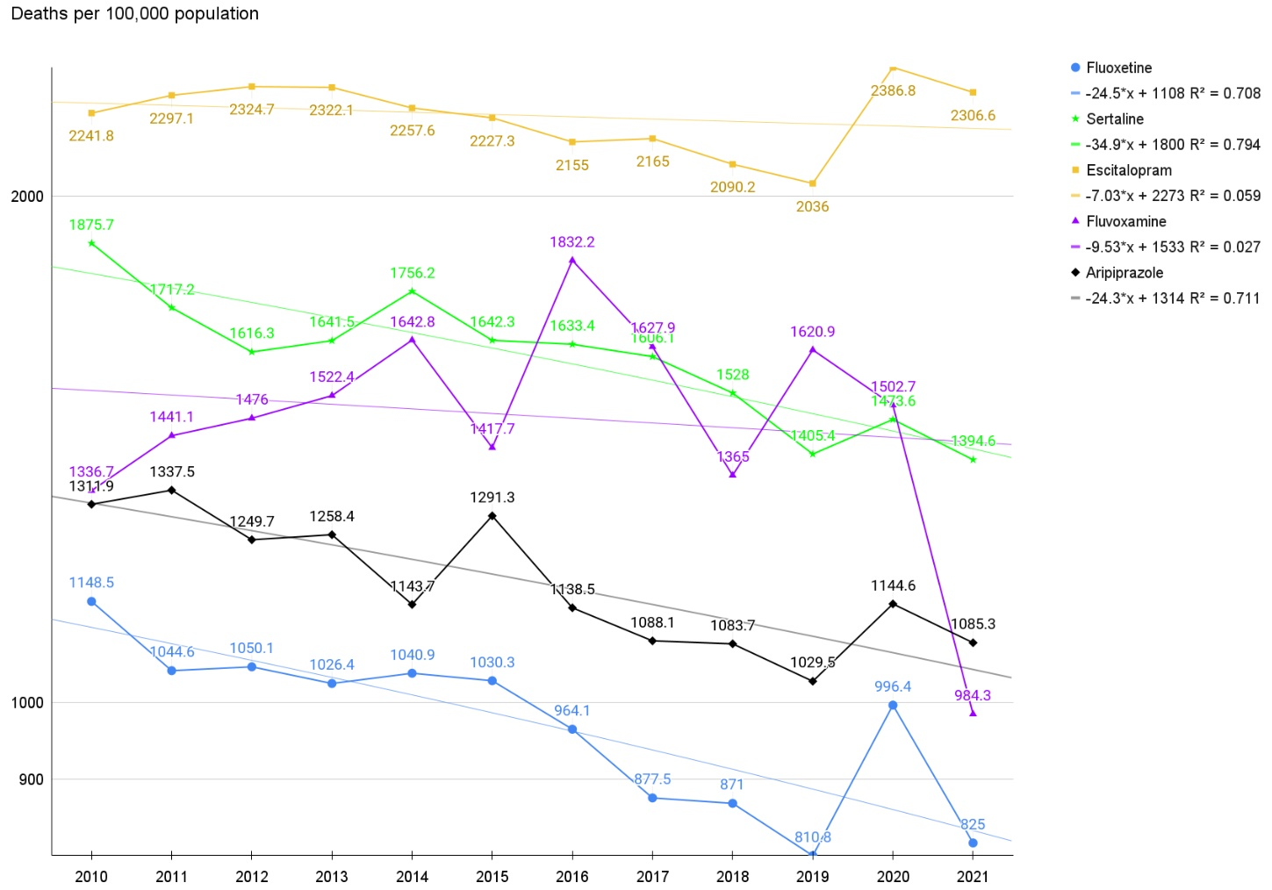

Fig. S11. The trends of deaths with fluoxetine, sertraline, escitalopram, and fluvoxamine use.

The administration of fluoxetine (blue) and sertraline (green) and escitalopram (yellow) and fluvoxamine (purple) and aripiprazole (black) reduced (-) the number of deaths. The R² values of fluoxetine and sertraline and escitalopram and fluvoxamine were -0.708 and -0.794 and -0.059 and –0.027 and -0.711, respectively.

Table S20. Olanzapine and User and Death Toll
year | code | Olanzapine user | death
2010 | 2040 | 37,810 | 1,654
2011 | 2040 | 45,177 | 2,001
2012 | 2040 | 54,344 | 2,681
2013 | 2040 | 59,184 | 3,112
2014 | 2040 | 63,444 | 3,276
2015 | 2040 | 64,123 | 3,036
2016 | 2040 | 66,902 | 3,368
2017 | 2040 | 75,153 | 3,700
2018 | 2040 | 81,868 | 4,042
2019 | 2040 | 87,565 | 4,359
2020 | 2040 | 93,109 | 4,799
2021 | 2040 | 101,480 | 5,141

year | Code | Olanzapine user | *death
2012 | 2040 | 100000 | 4933.4
2013 | 2040 | 100000 | 5258.2
2014 | 2040 | 100000 | 5163.6
2015 | 2040 | 100000 | 4734.7
2016 | 2040 | 100000 | 5034.2
2017 | 2040 | 100000 | 4923.3
2018 | 2040 | 100000 | 4937.2
(*Deaths per 100,000 population)

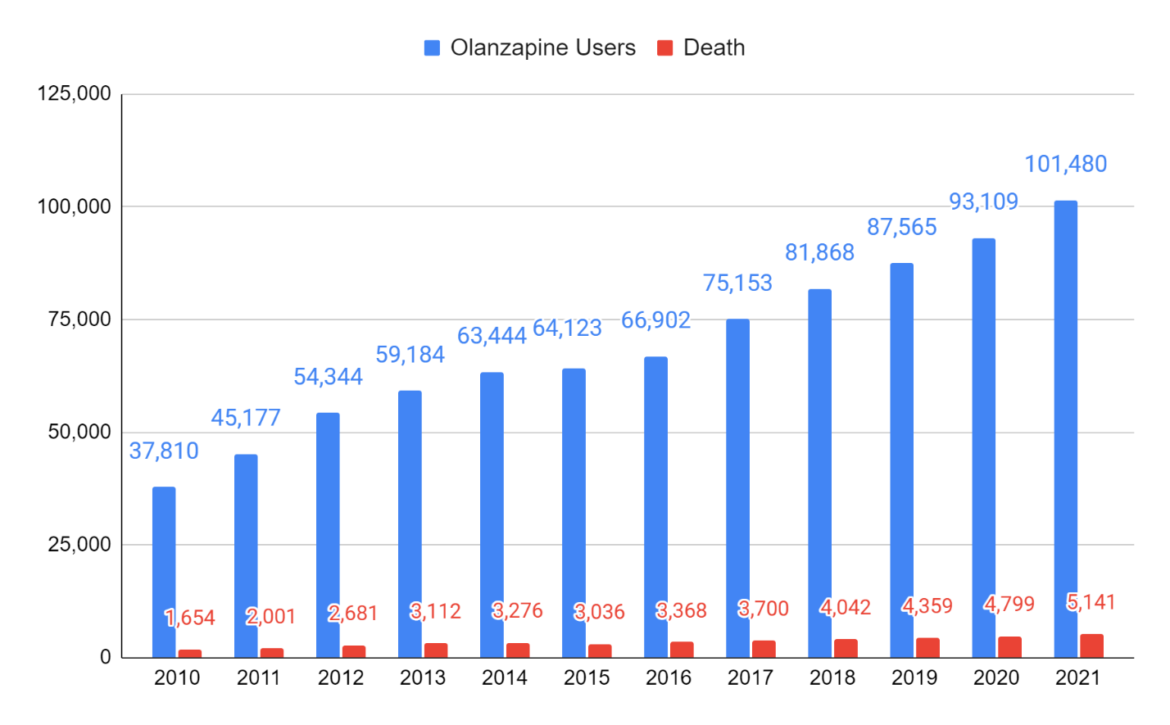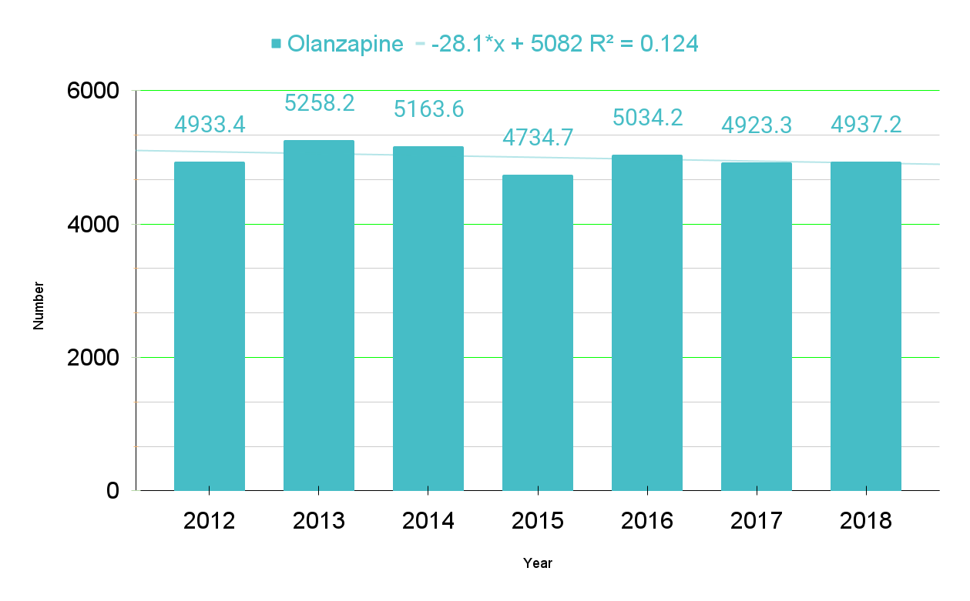

Fig. S12. Olanzapine Trend line. -28.1*x + 5082 R² = 0.124

Table S21. Risperidone and User and Death Toll
year | code | Risperidone user | death
2010 | 2242 | 181,728 | 8,945
2011 | 2242 | 186,077 | 8,976
2012 | 2242 | 191,121 | 9,519
2013 | 2242 | 189,702 | 9,354
2014 | 2242 | 190,178 | 9,271
2015 | 2242 | 195,951 | 10,052
2016 | 2242 | 199,776 | 10,396
2017 | 2242 | 203,635 | 10,822
2018 | 2242 | 208,994 | 11,179
2019 | 2242 | 228,123 | 12,044
2020 | 2242 | 247,005 | 19,545
2021 | 2242 | 246,629 | 18,509

Year | code | Risperidone user | *death
2012 | 2242 | 100000 | 4980.6
2013 | 2242 | 100000 | 4930.9
2014 | 2242 | 100000 | 4874.9
2015 | 2242 | 100000 | 5129.9
2016 | 2242 | 100000 | 5203.8
2017 | 2242 | 100000 | 5314.4
2018 | 2242 | 100000 | 5349.0
(*Deaths per 100,000 population)

Fig. S13. Risperidone Trend line. 78.6*x + 4876 R² = 0.816

Table S22. Quetiapine and User and Death Toll
year | code | Quetiapine user | death
2010 | 3786 | 140,218 | 10,654
2011 | 3786 | 172,218 | 13,466
2012 | 3786 | 202,486 | 17,654
2013 | 3786 | 228,140 | 21,117
2014 | 3786 | 259,635 | 24,520
2015 | 3786 | 290,105 | 27,972
2016 | 3786 | 331,811 | 32,972
2017 | 3786 | 384,209 | 39,984
2018 | 3786 | 439,704 | 46,257
2019 | 3786 | 540,397 | 51,767
2020 | 3786 | 621,069 | 72,887
2021 | 3786 | 655,889 | 77,523

Year | code | Quetiapine user | *death
2012 | 3786 | 100000 | 8718.6
2013 | 3786 | 100000 | 9256.2
2014 | 3786 | 100000 | 9444.0
2015 | 3786 | 100000 | 9642.0
2016 | 3786 | 100000 | 9937.0
2017 | 3786 | 100000 | 10406.8
2018 | 3786 | 100000 | 10520.0
(*Deaths per 100,000 population)

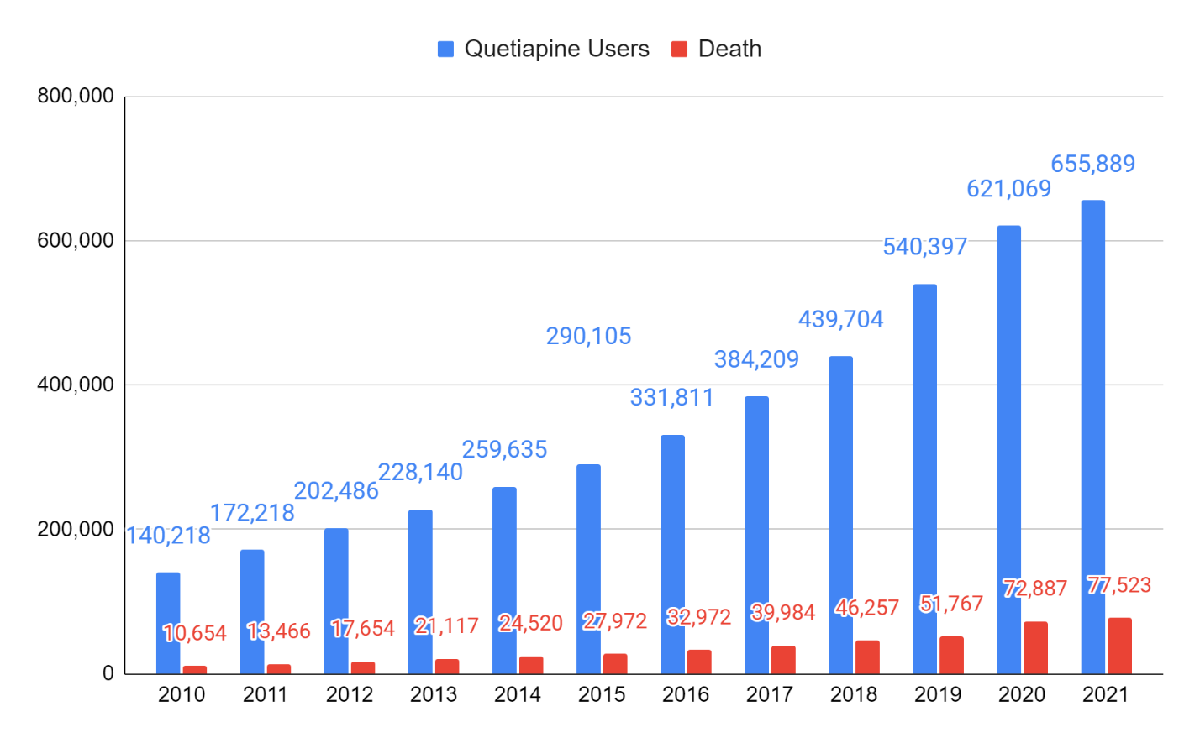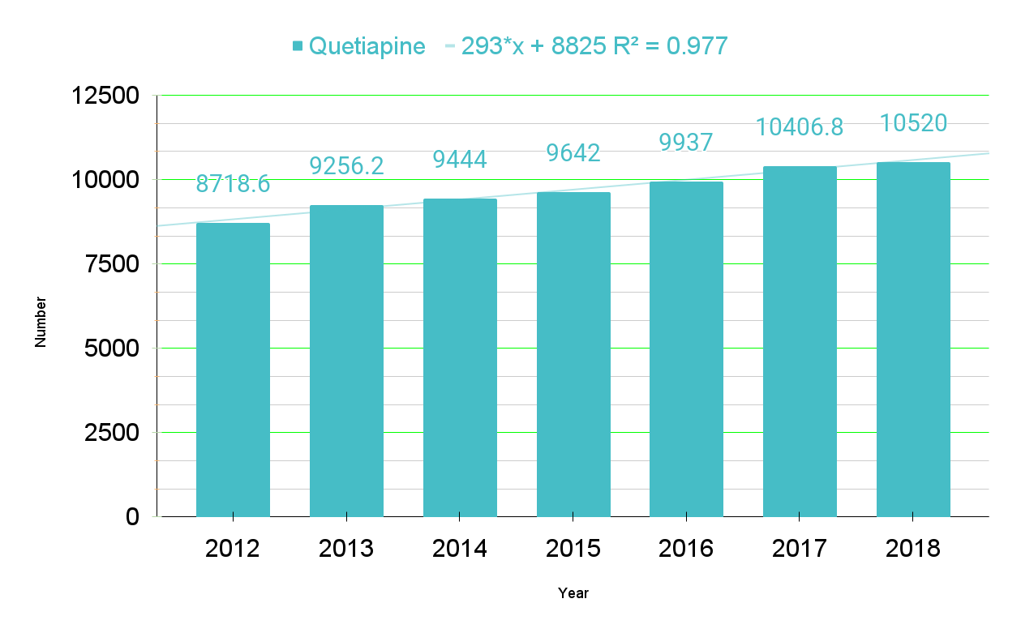

Fig. S14. Quetiapine Trend line. 293*x + 8825 R² = 0.977

Table S23. Haloperidol and User and Death Toll
year | code | Haloperidol user | death
2010 | 3786 | 179,767 | 20,155
2011 | 3786 | 181,837 | 20,675
2012 | 3786 | 189,965 | 22,906
2013 | 3786 | 190,338 | 24,413
2014 | 3786 | 192,201 | 25,595
2015 | 3786 | 199,689 | 28,492
2016 | 3786 | 197,519 | 29,459
2017 | 3786 | 196,288 | 31,339
2018 | 3786 | 195,200 | 32,815
2019 | 3786 | 203,268 | 33,627
2020 | 3786 | 213,121 | 41,358
2021 | 3786 | 204,859 | 41,211

Year | code | Haloperidol user | *death
2012 | 3786 | 100000 | 12058.0
2013 | 3786 | 100000 | 12826.1
2014 | 3786 | 100000 | 13316.8
2015 | 3786 | 100000 | 14268.2
2016 | 3786 | 100000 | 14914.5
2017 | 3786 | 100000 | 15965.8
2018 | 3786 | 100000 | 16811.0
(*Deaths per 100,000 population)
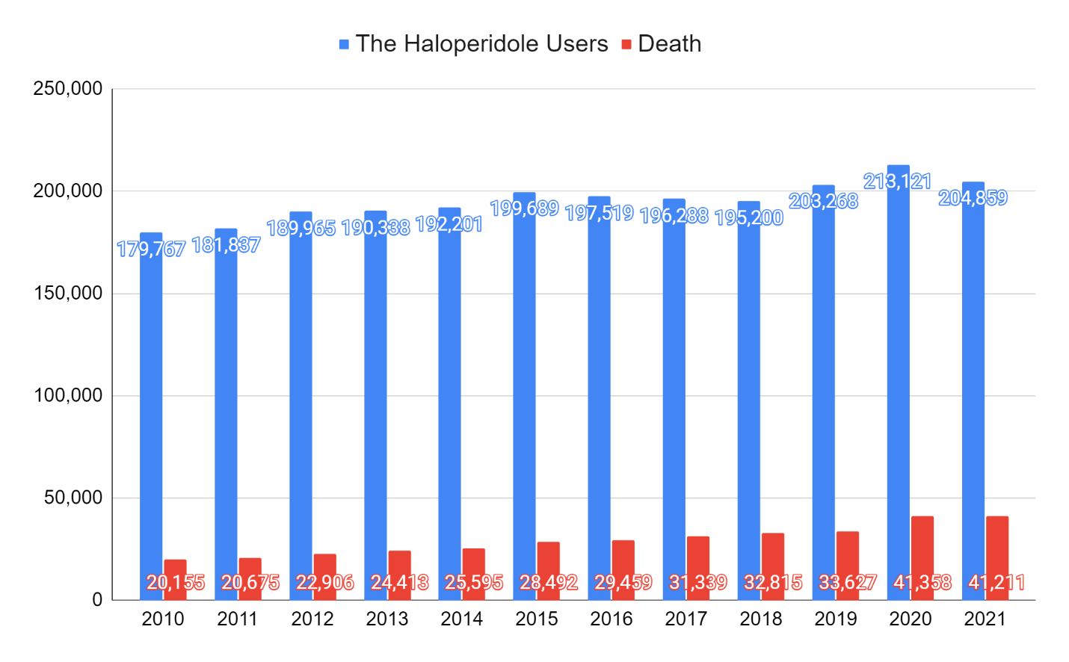
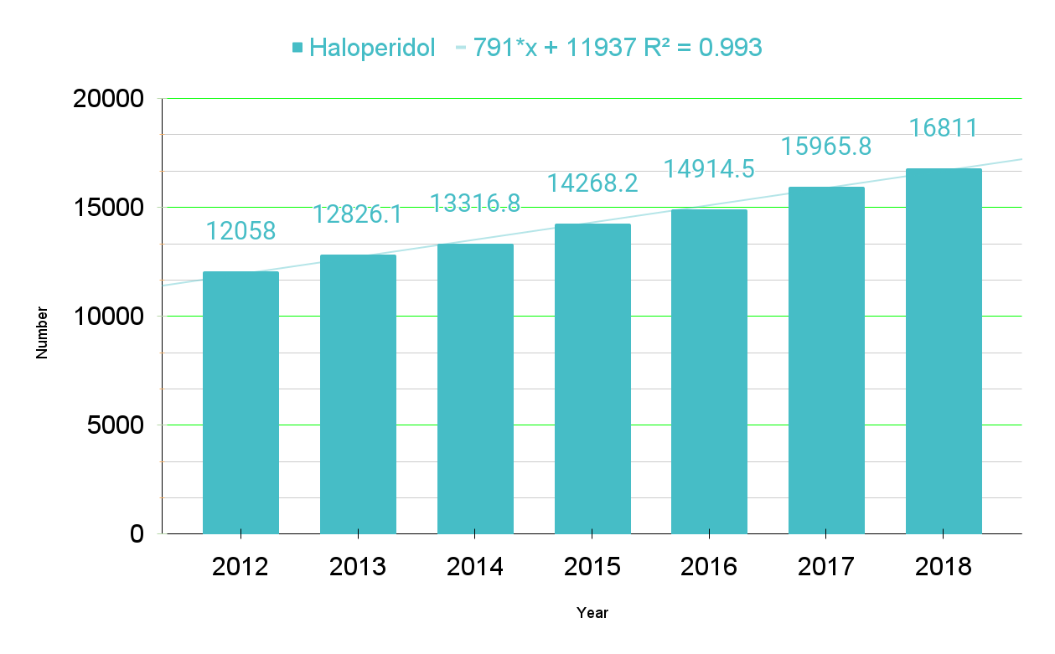

Fig. S15. Haloperidol Trend line. 791*x + 11937 R² = 0.993

Table S24. Oxcarbazepine and User and Death Toll
year | code | Oxcarbazepine user | death
2010 | 3786 | 10,022 | 653
2011 | 3786 | 9,869 | 604
2012 | 3786 | 9,515 | 642
2013 | 3786 | 9,346 | 564
2014 | 3786 | 9,640 | 588
2015 | 3786 | 9,447 | 620
2016 | 3786 | 9,284 | 618
2017 | 3786 | 9,393 | 715
2018 | 3786 | 8,959 | 657
2019 | 3786 | 8,541 | 593
2020 | 3786 | 7,852 | 572
2021 | 3786 | 7,650 | 480

Year | code | Oxcarbazepine user | *death
2012 | 3786 | 100000 | 6747.2
2013 | 3786 | 100000 | 6034.7
2014 | 3786 | 100000 | 6099.6
2015 | 3786 | 100000 | 6562.9
2016 | 3786 | 100000 | 6656.6
2017 | 3786 | 100000 | 7612.1
2018 | 3786 | 100000 | 7333.4
(*Deaths per 100,000 population)

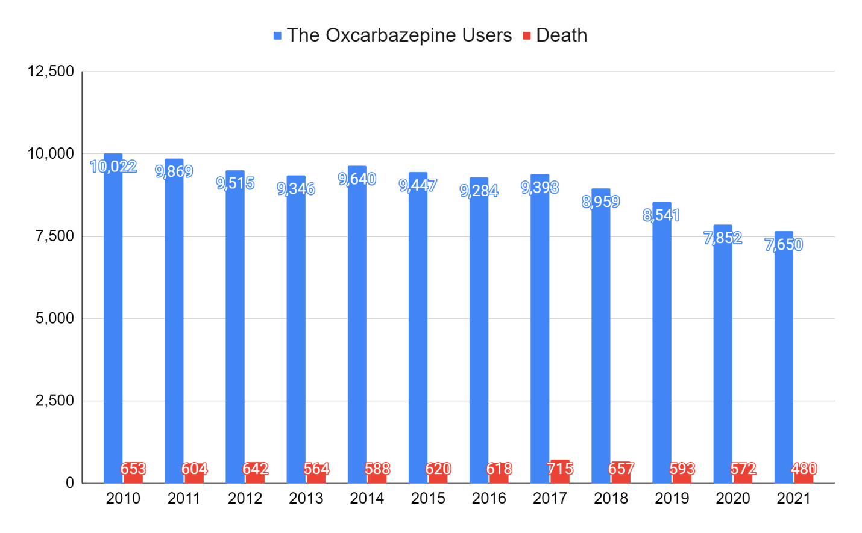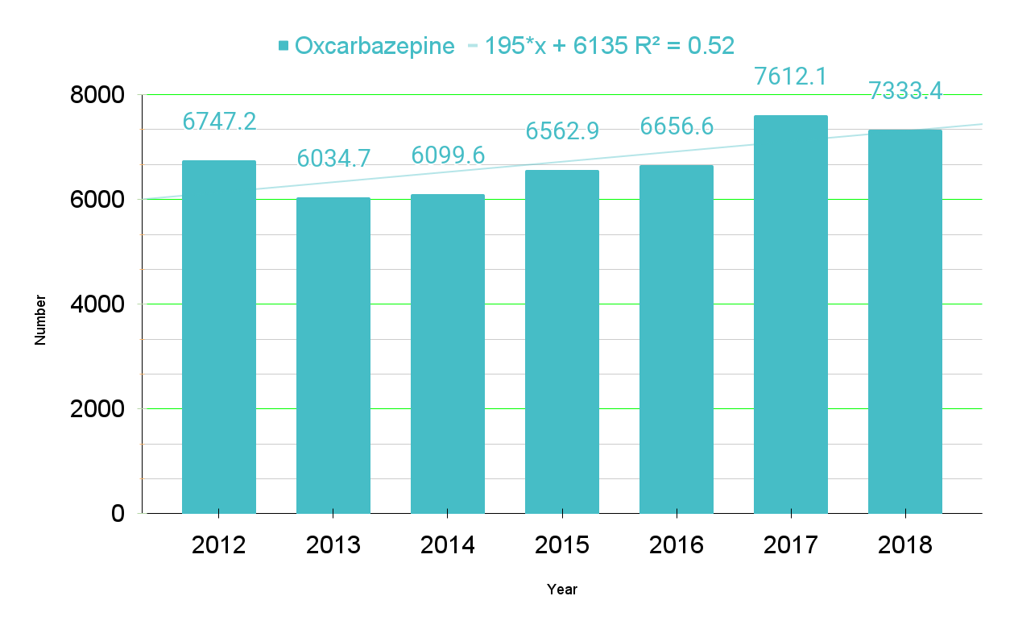

Fig. S16. Oxcarbazepine Trend line. 195*x + 6135 R² = 0.52

Table S25. Trazodone and User and Death Toll
year | code | Trazodone user | Death
2010 | 3786 | 337,236 | 10,383
2011 | 3786 | 358,037 | 10,845
2012 | 3786 | 387,534 | 11,485
2013 | 3786 | 395,160 | 11,747
2014 | 3786 | 421,839 | 12,195
2015 | 3786 | 447,822 | 13,151
2016 | 3786 | 473,024 | 13,719
2017 | 3786 | 503,264 | 14,811
2018 | 3786 | 548,863 | 15,905
2019 | 3786 | 614,224 | 16,923
2020 | 3786 | 670,131 | 22,903
2021 | 3786 | 725,006 | 23,952

Year | code | Trazodone user | *Death
2012 | 3786 | 100000 | 2963.6
2013 | 3786 | 100000 | 2972.7
2014 | 3786 | 100000 | 2890.9
2015 | 3786 | 100000 | 2936.7
2016 | 3786 | 100000 | 2900.3
2017 | 3786 | 100000 | 2943.0
2018 | 3786 | 100000 | 2897.8
(*Deaths per 100,000 population)

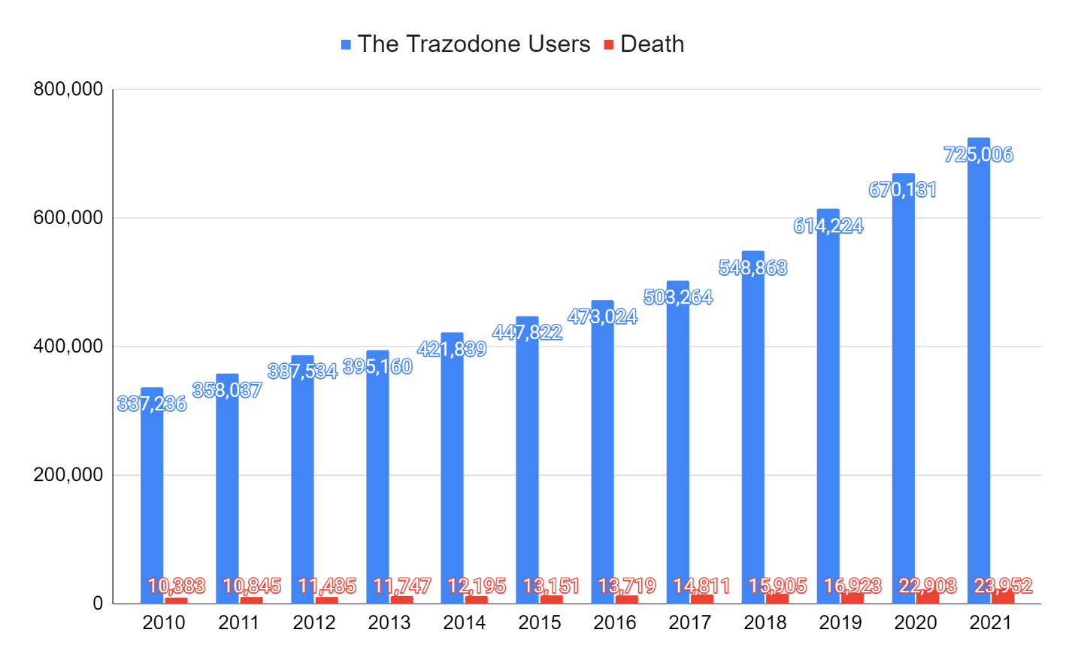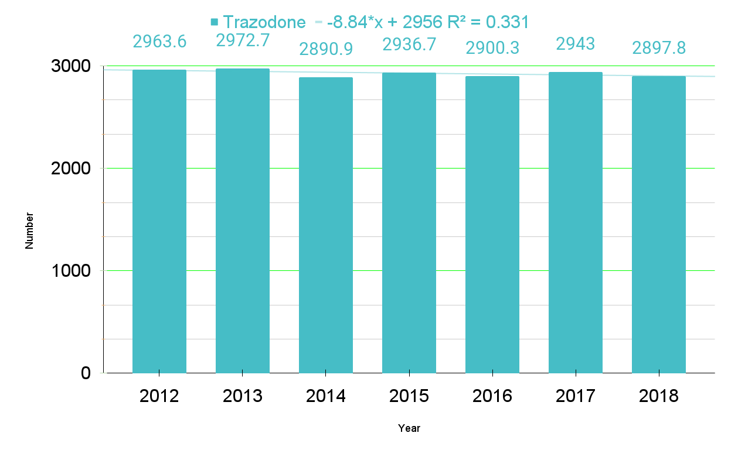

Fig. S17. Trazodone Trend line. -8.84*x + 2956 R² = 0.331

Table S26. Nationwide Antipsychotic drugs: Number of users and deaths
year | Olanzapine* | Risperidone** | Quetiapine* | Haloperidol* | Oxcarbazepine* | Trazodone*
2010 | 4374.5 | 4922.2 | 7598.2 | 11211.7 | 6515.7 | 3078.9
2011 | 4429.2 | 4823.8 | 7819.2 | 11370.1 | 6120.2 | 3029.0
2012 | 4933.4 | 4980.6 | 8718.6 | 12058.0 | 6747.2 | 2963.6
2013 | 5258.2 | 4930.9 | 9256.2 | 12826.1 | 6034.7 | 2972.7
2014 | 5163.6 | 4874.9 | 9444.0 | 13316.8 | 6099.6 | 2890.9
2015 | 4734.7 | 5129.9 | 9642.0 | 14268.2 | 6562.9 | 2936.7
2016 | 5034.2 | 5203.8 | 9937.0 | 14914.5 | 6656.6 | 2900.3
2017 | 4923.3 | 5314.4 | 10406.8 | 15965.8 | 7612.1 | 2943.0
2018 | 4937.2 | 5349.0 | 10520.0 | 16811.0 | 7333.4 | 2897.8
2019 | 4978.0 | 5279.6 | 9579.4 | 16543.2 | 6943.0 | 2755.2
2020 | 5154.2 | 7912.8 | 11735.7 | 19405.9 | 7284.8 | 3417.7
2021 | 5066.0 | 7504.8 | 11819.5 | 20116.8 | 6274.5 | 3303.7
Sum | 58986.50 | 66226.70 | 116476.60 | 178808.10 | 80184.70 | 36089.50
Mean | 4915.54 | 5518.89 | 9706.38 | 14900.68 | 6682.06 | 3007.46
SD | 276.23 | 1041.96 | 1316.42 | 2959.63 | 522.89 | 184.55
95% CI | 2.23 | 7.94 | 7.56 | 13.72 | 3.62 | 1.90
( | 4913.31 | 5510.96 | 9698.82 | 14886.96 | 6678.44 | 3005.55
) | 4917.77 | 5526.83 | 9713.94 | 14914.39 | 6685.68 | 3009.36
¹p-value | 0.32492 | 0.02972 | 0.99326 | 0.97413 | 0.95876 | 0.4038
²Kolmogorov-Smirnov Test (D) | 0.2617 | 0.40095 | 0.11298 | 0.12857 | 0.1357 | 0.24464
³Skewness  Kurtosis Normality | -1.060511  0.412013  significantly from that which is normally distributed. | 1.953674  2.539917  This provides good evidence that your data is not normally distributed. | 0.072726  -0.307183  significantly from that which is normally distributed. | 0.486603  -0.737203  significantly from that which is normally distributed | 0.45597  -0.905645  significantly from that which is normally distributed. | 1.292697  1.483183  significantly from that which is normally distributed.
⁴The Friedman Test between five groups** | The X²_{r} statistic is 48 (4, N = 12). The p-value is < .00001.  The result is significant at p < .01.
*Deaths per 100,000 population **Risperidone was excluded from The Friedman Test. ¹The p-value quantifies this probability, with a low probability indicating that your sample diverges from a normal distribution to an extent unlikely to arise merely by chance. ²The test statistic (D) provides a measurement of the divergence of your sample distribution from the normal distribution. The higher the value of D, the less probable it is that your data is normally distributed. ³The nearer both these are to zero, the more likely it is that your distribution is normal. ⁴The Friedman test is the non-parametric alternative to the one-way ANOVA with repeated measures.

Table S27. The Friedman Test¹ for Repeated-Measures

year | Olanzapine* | Quetiapine* | Haloperidol* | Oxcarbazepine* | Trazodone*
2010  2011  2012  2013  2014  2015  2016  2017  2018  2019  2020  2021 | 2  2  2  2  2  2  2  2  2  2  2  2  Sum: 24 | 4  4  4  4  4  4  4  4  4  4  4  4  Sum: 48 | 5  5  5  5  5  5  5  5  5  5  5  5  Sum: 60 | 3  3  3  3  3  3  3  3  3  3  3  3  Sum: 36 | 1  1  1  1  1  1  1  1  1  1  1  1  Sum: 12
Calculation Summary
X²_{r} = (12/(nk(k+1)) * (∑R²) - 3n(k+1)
X²_{r} = 0.033 * 7920 - 216
X²_{r} = 48
The X²_{r} statistic is 48 (4, N = 12).
The p-value is < .00001.
The result is significant at p < .01.
*Deaths per 100,000 population ¹The Friedman test is the non-parametric alternative to the one-way ANOVA with repeated measures. It is used to test for differences between groups when the dependent variable being measured is ordinal.

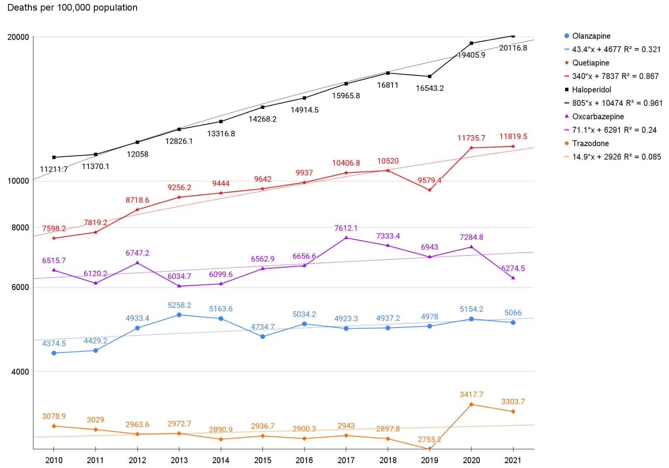

Fig. S18. The trends of deaths with olanzapine, quetiapine, haloperidol, oxcarbazepine and trazodone use.

The administration of olanzapine (blue) and quetiapine (red) and haloperidol (black) and oxcarbazepine (purple) and trazodone (orange) increased (+) the number of deaths.

Table S28. 7759328

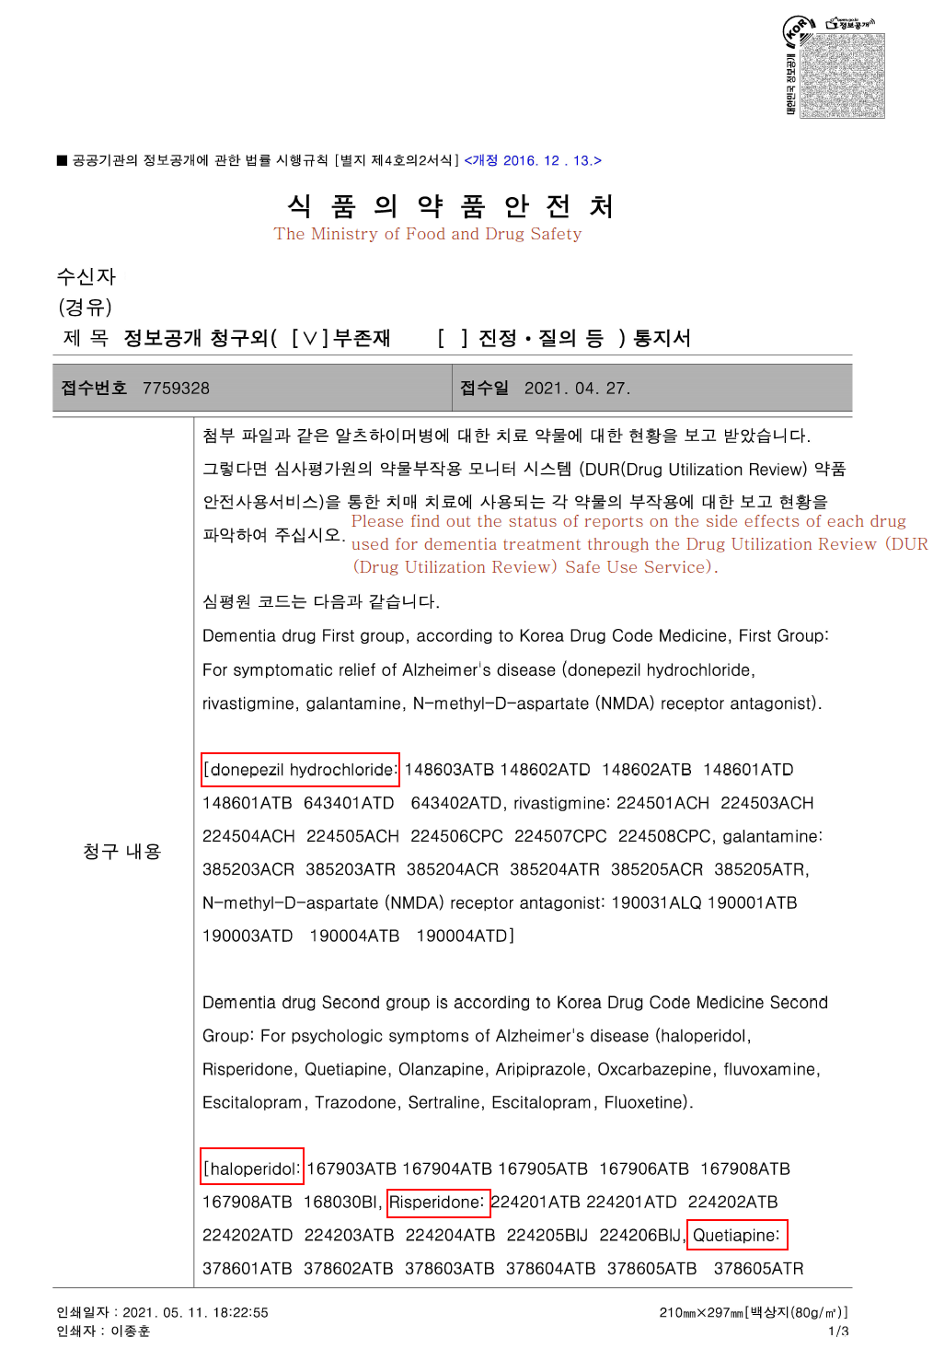

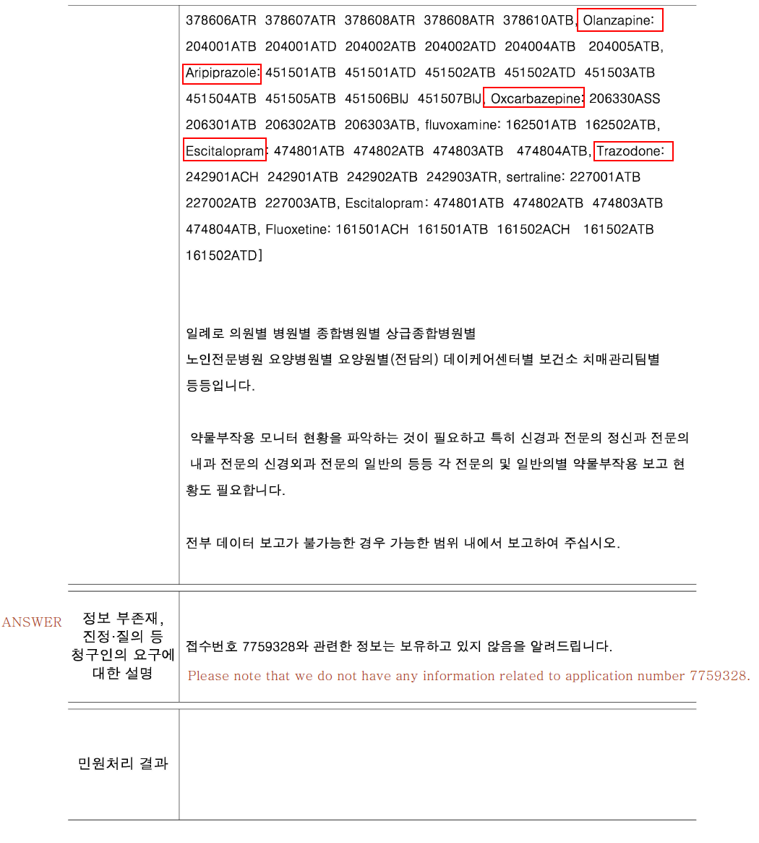

Table S29. Dementia Demography of NHIS from Central Dementia Center.
Number of people with dementia
▶ Source: National Health Insurance Corporation (2019)
▶ Extraction criteria:
In 2019, NHIS extracted Dementia care: Inpatient, outpatient, and drug prescription with dementia disease code assigned as main disease code based on ICD codes: F00, F01, F02, F03 , G30 and G31.)
division | all | gender |  | age
division | all | male | female | under 60 | 60+ | under 65 | 65 years or older
Nationwide | 880,371 | 253,813 | 626,558 | 44,576 | 835,795 | 94,187 | 786,184
Seoul | 127,676 | 38,732 | 88,944 | 7,866 | 119,810 | 16,848 | 110,828
Busan | 63,187 | 18,410 | 44,777 | 3,258 | 59,929 | 7,086 | 56,101
Daegu Metropolitan City | 40,093 | 11,192 | 28,901 | 2,340 | 37,753 | 4,857 | 35,236
Incheon Metropolitan City | 40,350 | 11,486 | 28,864 | 2,780 | 37,570 | 5,618 | 34,732
Gwangju | 24,157 | 6,963 | 17,194 | 1,222 | 22,935 | 2,629 | 21,528
Daejeon | 22,160 | 6,504 | 15,656 | 1,110 | 21,050 | 2,361 | 19,799
Ulsan Metropolitan City | 13,765 | 3,805 | 9,960 | 844 | 12,921 | 1,755 | 12,010
Sejong Special Self-Governing City | 3,829 | 1,112 | 2,717 | 170 | 3,659 | 338 | 3,491
Gyeonggi-do | 171,027 | 50,773 | 120,254 | 10,059 | 160,968 | 20,525 | 150,502
Gangwon-do | 30,369 | 8,741 | 21,628 | 1,404 | 28,965 | 3,121 | 27,248
Chung-cheong bukdo | 33,970 | 10,007 | 23,963 | 1,926 | 32,044 | 3,904 | 30,066
Chungcheongnam-do | 49,678 | 14,858 | 34,820 | 1,798 | 47,880 | 3,900 | 45,778
Jeollabuk do | 50,338 | 14,292 | 36,046 | 1,654 | 48,684 | 3,541 | 46,797
Jeollanam-do | 64,560 | 17,682 | 46,878 | 2,420 | 62,140 | 5,233 | 59,327
Gyeongsangbuk-do | 64,410 | 17,835 | 46,575 | 2,138 | 62,272 | 4,871 | 59,539
Gyeongsangnam-do | 70,201 | 18,612 | 51,589 | 3,148 | 67,053 | 6,688 | 63,513
Jeju Special Self-Governing Province | 10,601 | 2,809 | 7,792 | 439 | 10,162 | 912 | 9,689
(Unit: person )

▶ Source : National Health Insurance Corporation (2010-2019)
▶ Table S29-1. Extraction criteria :
In 2019, NHIS extracted Dementia care: Inpatient, outpatient, and drug prescription with dementia disease code assigned as main disease code based on ICD codes: F00, F01, F02, F03 , G30 and G31. The status of the total number of persons with dementia who are eligible for health insurance and those who are eligible for medical benefits, changes in qualifications are not reflected.
( Unit: person )

 |  | 2010 | 2011 | 2012 | 2013 | 2014 | 2015 | 2016 | 2017 | 2018 | 2019
gender | age group
 | all | 285,773 | 341,889 | 395,901 | 450,917 | 505,555 | 577,427 | 664,475 | 755,871 | 859,132 | 959,001
 | under 60 | 13,388 | 15,179 | 17,718 | 20,293 | 21,434 | 24,114 | 30,168 | 37,453 | 40,624 | 42,812
 | 60+ | 272,385 | 326,710 | 378,183 | 430,624 | 484,121 | 553,313 | 634,307 | 718,418 | 818,508 | 916,189
 | under 65 | 26,426 | 29,668 | 33,751 | 38,081 | 40,583 | 46,925 | 59,446 | 73,349 | 83,950 | 94,196
 | 65 or older | 259,347 | 312,221 | 362,150 | 412,836 | 464,972 | 530,502 | 605,029 | 682,522 | 775,182 | 864,805
total | 40-44 | 871 | 845 | 975 | 1,081 | 1,003 | 1,032 | 1,243 | 1,340 | 1,410 | 1,345
total | 45-49 | 1,778 | 1,854 | 2,050 | 2,366 | 2,247 | 2,487 | 3,059 | 3,679 | 3,784 | 3,752
total | 50-54 | 4,179 | 4,569 | 5,360 | 5,930 | 6,026 | 6,493 | 7,895 | 9,577 | 10,198 | 11,045
total | 55-59 | 6,560 | 7,911 | 9,333 | 10,916 | 12,158 | 14,102 | 17,971 | 22,857 | 25,232 | 26,670
total | 60-64 | 13,038 | 14,489 | 16,033 | 17,788 | 19,149 | 22,811 | 29,278 | 35,896 | 43,326 | 51,384
total | 65-69 | 25,822 | 28,477 | 29,317 | 32,019 | 35,334 | 41,401 | 49,050 | 55,789 | 65,183 | 75,238
total | 70-74 | 46,545 | 54,193 | 62,462 | 68,110 | 71,641 | 78,055 | 84,228 | 87,329 | 97,844 | 110,037
total | 75-79 | 63,159 | 76,221 | 87,800 | 100,172 | 111,144 | 122,742 | 137,466 | 155,853 | 172,229 | 183,020
total | 80-84 | 61,583 | 75,299 | 88,301 | 100,770 | 115,608 | 134,774 | 156,337 | 175,339 | 199,795 | 222,812
total | 85-89 | 41,961 | 51,528 | 60,759 | 70,658 | 83,802 | 97,973 | 113,031 | 130,807 | 149,474 | 169,975
total | 90-94 | 15,996 | 20,886 | 26,429 | 32,818 | 37,591 | 43,894 | 50,524 | 59,281 | 68,610 | 79,724
total | 95-99 | 3,713 | 4,871 | 6,108 | 7,154 | 8,539 | 10,096 | 12,457 | 15,782 | 19,445 | 21,027
total | over 100 | 568 | 746 | 974 | 1,135 | 1,313 | 1,567 | 1936 | 2,342 | 2,602 | 2,972
male | 40-44 | 473 | 475 | 516 | 559 | 478 | 513 | 584 | 635 | 655 | 572
male | 45-49 | 969 | 1006 | 1,041 | 1,167 | 1,077 | 1,163 | 1,327 | 1,548 | 1,520 | 1,461
male | 50-54 | 2,088 | 2,294 | 2,415 | 2,554 | 2,582 | 2,726 | 3,204 | 3,621 | 3,631 | 3,861
male | 55-59 | 3,208 | 3,794 | 4,157 | 4,693 | 5,194 | 5,827 | 7,072 | 8,679 | 8,990 | 9,154
male | 60-64 | 6,159 | 6,638 | 7,000 | 7,419 | 7,993 | 9,165 | 11,512 | 14,000 | 16,088 | 18,393
male | 65-69 | 10,261 | 11,382 | 11,671 | 12,707 | 14,169 | 16,530 | 19,372 | 21,617 | 24,344 | 27,509
male | 70-74 | 16,436 | 19,062 | 22,095 | 24,060 | 25,210 | 27,679 | 30,349 | 32,061 | 35,968 | 40,676
male | 75-79 | 19,122 | 23,001 | 26,685 | 30,924 | 34,506 | 38,289 | 43,540 | 50,237 | 55,925 | 60,569
male | 80-84 | 15,417 | 18,401 | 21,836 | 25,107 | 29,175 | 35,154 | 41,675 | 47,402 | 55,285 | 63,085
male | 85-89 | 9,230 | 11,104 | 12,936 | 14,878 | 17,306 | 19,918 | 23,097 | 27,452 | 32,556 | 37,928
male | 90-94 | 3,017 | 3,946 | 4,950 | 6,023 | 6,861 | 7,782 | 8,796 | 10,121 | 11,839 | 13,835
male | 95-99 | 537 | 684 | 867 | 1,024 | 1,272 | 1,576 | 1,939 | 2,438 | 2,968 | 3,141
male | over 100 | 77 | 99 | 124 | 135 | 146 | 178 | 211 | 259 | 313 | 384
female | 40-44 | 398 | 370 | 459 | 522 | 525 | 519 | 659 | 705 | 755 | 773
female | 45-49 | 809 | 848 | 1,009 | 1,199 | 1,170 | 1,324 | 1,732 | 2,131 | 2,264 | 2,291
female | 50-54 | 2,091 | 2,275 | 2,945 | 3,376 | 3,444 | 3,767 | 4,691 | 5,956 | 6,567 | 7,184
female | 55-59 | 3,352 | 4,117 | 5,176 | 6,223 | 6,964 | 8,275 | 10,899 | 14,178 | 16,242 | 17,516
female | 60-64 | 6,879 | 7,851 | 9,033 | 10,369 | 11,156 | 13,646 | 17,766 | 21,896 | 27,238 | 32,991
female | 65-69 | 15,561 | 17,095 | 17,646 | 19,312 | 21,165 | 24,871 | 29,678 | 34,172 | 40,839 | 47,729
female | 70-74 | 30,109 | 35,131 | 40,367 | 44,050 | 46,431 | 50,376 | 53,879 | 55,268 | 61,876 | 69,361
female | 75-79 | 44,037 | 53,220 | 61,115 | 69,248 | 76,638 | 84,453 | 93,926 | 105,616 | 116,304 | 122,451
female | 80-84 | 46,166 | 56,898 | 66,465 | 75,663 | 86,433 | 99,620 | 114,662 | 127,937 | 144,510 | 159,727
female | 85-89 | 32,731 | 40,424 | 47,823 | 55,780 | 66,496 | 78,055 | 89,934 | 103,355 | 116,918 | 132,047
female | 90-94 | 12,979 | 16,940 | 21,479 | 26,795 | 30,730 | 36,112 | 41,728 | 49,160 | 56,771 | 65,889
female | 95-99 | 3,176 | 4,187 | 5,241 | 6,130 | 7,267 | 8,520 | 10,518 | 13,344 | 16,477 | 17,886
female | over 100 | 491 | 647 | 850 | 1,000 | 1,167 | 1,389 | 1,725 | 2,083 | 2,289 | 2,588

Table S29-2. Current status of long-term care for the elderly with dementia
▶ Source : National Health Insurance Corporation (2019)
▶ Extraction criteria :
In 2019, NHIS extracted Dementia care: Inpatient, outpatient, and drug prescription with dementia disease code assigned as main disease code based on ICD codes: F00, F01, F02, F03 , G30 and G31.

 |  | gender | Age  -specific section | recipients  Total | recipients
 |  |  |  |  | classification
 |  |  |  |  | Grade 1 | 2nd grade | 3rd grade | 4th grade | 5th grade | Supportive
 |  |  |  | 352,165 | 17,630 | 42,269 | 105,418 | 133849 | 48,771 | 4,228
Nationwide |  | male | 1-59 | 1,483 | 125 | 196 | 527 | 468 | 147 | 20
 |  | male | 60-64 | 2,490 | 161 | 334 | 831 | 851 | 288 | 25
 |  | male | 65-69 | 4,949 | 269 | 530 | 1,612 | 1,827 | 652 | 59
 |  | male | 70-74 | 8,751 | 442 | 953 | 2,781 | 3,282 | 1,196 | 97
 |  | male | 75 years or older | 69,112 | 2,460 | 7,044 | 21,088 | 27,585 | 10,066 | 869
 |  | female | 1-59 | 1,233 | 167 | 168 | 428 | 315 | 135 | 20
 |  | female | 60-64 | 2,097 | 264 | 258 | 665 | 594 | 280 | 36
 |  | female | 65-69 | 4,775 | 407 | 555 | 1,315 | 1,641 | 762 | 95
 |  | female | 70-74 | 11,929 | 741 | 1,252 | 3,118 | 4,435 | 2,136 | 247
 |  | female | 75 years or older | 245,346 | 12,594 | 30,979 | 73,053 | 92,851 | 33,109 | 2,760
( Unit: person )

Table S29-3. Dementia Relief Center Registration Status by Subject
▶ Source : Dementia Relief Center (2019)
▶ Extraction criteria
1) As of Statistics (~ '19 .12.31) ANSYS chlorotic advantage of the features and chlorotic one except person (including death) a person with parental
2) Diagnosis undecided: None of the subjects registered in ANSYS on the statistical basis date have ever been diagnosed with dementia or Screening results cognitive decline and early screening after of non - total number of subjects
3) Normal: Among the subjects registered in ANSYS on the statistical basis date, the external diagnosis result is normal or Total number of subjects who were normal as a result of early examination by the Dementia Relief Center
4) Mild cognitive impairment: As a result of external diagnosis among subjects registered in ANSYS on the statistical basis date, mild cognitive impairment or Dementia relief centers perform early screening results of the sum of mild cognitive impaired subjects
5) Dementia (external diagnosis ): The total number of subjects who were diagnosed with dementia at an external hospital other than the early diagnosis of the dementia safety center among subjects registered in ANSYS on the statistical basis date
6) Dementia (Safety Center Diagnosis ): The total number of subjects registered in ANSYS on the statistical basis date for dementia diagnosis as a result of the 2nd stage of early diagnosis diagnostic test or differential test performed by the Dementia Safety Center
7) Guardians: Total number of guardians registered in ANSYS on the statistical basis date

( Unit: person )
division | Total number of registrants | subject |  |  |  |  |  |  | guardian
division | Total number of registrants | Total subjects | Diagnosis undecided | normal | mild cognitive impairment | dementia patient |  |  | guardian
 |  |  |  |  |  | Subtotal | external diagnosis | Safety Center Diagnosis | guardian
Nationwide | 3,459,423 | 3,360,816 | 165,138 | 2,663,512 | 111,154 | 421,012 | 276,814 | 144,198 | 98,607
Seoul | 832,374 | 824,338 | 46,606 | 665,989 | 53,438 | 58,305 | 14,042 | 44,263 | 8,036
Busan | 190,919 | 182,486 | 7,875 | 148,067 | 5,718 | 20,826 | 13,914 | 6,912 | 8,433
Daegu Metropolitan City | 178,799 | 177,030 | 12,815 | 143,570 | 3,251 | 17,394 | 11,196 | 6198 | 1,769
Incheon Metropolitan City | 111,560 | 106,997 | 6,616 | 82,603 | 2,188 | 15,590 | 12,225 | 3,365 | 4,563
Gwangju | 62,580 | 61,298 | 3,156 | 48,344 | 1,272 | 8,526 | 6,452 | 2,074 | 1,282
Daejeon | 55,017 | 50,790 | 1,964 | 37,088 | 1,827 | 9,911 | 7,618 | 2,293 | 4,227
Ulsan Metropolitan City | 70,157 | 69,331 | 1,818 | 60,587 | 987 | 5,939 | 4,060 | 1,879 | 826
Sejong Special Self-Governing City | 8,025 | 7,912 | 335 | 5,689 | 428 | 1,460 | 1,009 | 451 | 113
Gyeonggi-do | 527,273 | 506,840 | 18,896 | 408,782 | 13,390 | 65,772 | 45,882 | 19,890 | 20,433
Gangwon-do | 119,311 | 112,491 | 4,470 | 89,008 | 3,522 | 15,491 | 11,251 | 4,240 | 6,820
Chung-cheong bukdo | 120,307 | 113,962 | 11,814 | 85,684 | 1,625 | 14,839 | 11,195 | 3,644 | 6,345
Chungcheongnam-do | 218,557 | 214,386 | 6,900 | 174,153 | 3,429 | 29904 | 22,609 | 7,295 | 4,171
Jeollabuk do | 171,886 | 168,849 | 7,100 | 119,523 | 5,480 | 36,746 | 28,586 | 8,160 | 3,037
Jeollanam-do | 217,543 | 205,493 | 10,192 | 157,084 | 3,729 | 34,488 | 24196 | 10,292 | 12,050
Gyeongsangbuk-do | 239,895 | 229,180 | 8,985 | 178,102 | 4,603 | 37,490 | 27,016 | 10,474 | 10,715
Gyeongsangnam-do | 300,078 | 295,302 | 13,472 | 234,695 | 4,916 | 42219 | 30,519 | 11,700 | 4,776
Jeju Special Self-Governing Province | 35,142 | 34,131 | 2,124 | 24,544 | 1,351 | 6,112 | 5,044 | 1,068 | 1,011

Table S29-4. Dementia Patient Dementia Relief Center Registration Status
▶ Source: Dementia Relief Center (2019)
▶ Extraction standard
- Statistical base date ('~ '19.12.31) by using the ANSYS withdrawal function

division | Total number of registered dementia patients | gender |  | age
division | Total number of registered dementia patients | male | female | Less than 40 years | 40-45 | 45-50 | 50-55 | 55-60 | 60-64 | 65-69 | 70-74 | 75-80 | 80-85 | 85+
Nationwide | 421,012 | 117,302 | 303,710 | 20 | 42 | 110 | 429 | 1,467 | 5,655 | 14,964 | 33,352 | 78,116 | 117,667 | 169,190
Seoul | 58,305 | 18,163 | 40,142 | One | 4 | 23 | 76 | 277 | 893 | 2,121 | 4,644 | 10,361 | 14,645 | 25,260
Busan | 20,826 | 6,491 | 14,335 | One | 0 | 6 | 17 | 71 | 326 | 930 | 2,063 | 4,405 | 6,095 | 6,912
Daegu Metropolitan City | 17,394 | 5,101 | 12,293 | 0 | 3 | One | 15 | 44 | 200 | 728 | 1,416 | 3,403 | 4,905 | 6,679
Incheon Metropolitan City | 15,590 | 4,320 | 11,270 | 0 | 0 | 5 | 15 | 61 | 230 | 557 | 1,180 | 2,753 | 4,086 | 6,703
Gwangju | 8,526 | 2,361 | 6,165 | 0 | 0 | 0 | 5 | 25 | 102 | 279 | 719 | 1,696 | 2,374 | 3,326
Daejeon | 9,911 | 2,893 | 7,018 | 2 | 2 | 2 | 20 | 50 | 140 | 337 | 714 | 1,700 | 2,585 | 4,359
Ulsan Metropolitan City | 5,939 | 1,643 | 4,296 | One | One | 0 | 11 | 42 | 154 | 347 | 556 | 1,163 | 1,580 | 2,084
Sejong Special Self-Governing City | 1,460 | 421 | 1,039 | 0 | 0 | 0 | 0 | 5 | 18 | 52 | 117 | 303 | 390 | 575
Gyeonggi-do | 65,772 | 19,481 | 46,291 | 5 | 10 | 21 | 70 | 266 | 1,027 | 2,443 | 5,262 | 11,970 | 18,404 | 26,294
Gangwon-do | 15,492 | 4,281 | 11,211 | One | 2 | 7 | 25 | 71 | 250 | 520 | 1,099 | 2,741 | 4,391 | 6,385
Chung-cheong bukdo | 14,839 | 4,290 | 10,549 | 0 | 2 | One | 17 | 63 | 234 | 502 | 1,019 | 2,608 | 4,251 | 6,142
Chungcheongnam-do | 29904 | 8,597 | 21,307 | 2 | 5 | 7 | 11 | 78 | 333 | 945 | 2,246 | 5,333 | 8,815 | 12,129
Jeollabuk do | 36,746 | 9,427 | 27,319 | One | 3 | 6 | 24 | 74 | 320 | 1,061 | 3,037 | 7,208 | 10,714 | 14,298
Jeollanam-do | 34,488 | 8,202 | 26,286 | 0 | 2 | 5 | 22 | 72 | 325 | 1,031 | 2,762 | 6,956 | 10,421 | 12,892
Gyeongsangbuk-do | 37,490 | 9,785 | 27,705 | 3 | 3 | 8 | 43 | 126 | 479 | 1,344 | 2,843 | 6,905 | 10,537 | 15,199
Gyeongsangnam-do | 42,218 | 10,389 | 31,829 | 3 | 5 | 14 | 49 | 123 | 566 | 1,594 | 3,286 | 7,726 | 12,002 | 16,850
Jeju Special Self-Governing Province | 6,112 | 1,457 | 4,655 | 0 | 0 | 4 | 9 | 19 | 58 | 173 | 389 | 885 | 1,472 | 3,103
( Unit: person )

Table S29-5. Current status of mild cognitive impairment registered at Dementia Relief Center
▶ Source : Dementia Relief Center (2019)
▶ Extraction standard
1) Excluding regressors
2) Total number of subjects registered in ANSYS on the statistical basis date ('~ Dec. 31, '19) who have mild cognitive impairment as a result of external diagnosis or who have mild cognitive impairment as a result of early screening at the Dementia Safety Center

division | Cognitive impairment can be mild overall subscribers | gender |  | age
division | Cognitive impairment can be mild overall subscribers | male | female | Less than 40 years | 40-45 | 45-50 | 50-55 | 55-60 | 60-64 | 65-69 | 70-74 | 75-80 | 80-85 | 85+
Nationwide | 111,154 | 41,062 | 70,092 | 7 | 14 | 42 | 166 | 556 | 3,723 | 11,046 | 19,841 | 30,010 | 26,447 | 19,302
Seoul | 53,438 | 20,313 | 33,125 | 5 | 11 | 25 | 95 | 297 | 1,426 | 4,675 | 9,479 | 14,276 | 12,694 | 10,455
Busan | 5,718 | 2,126 | 3,592 | 0 | 0 | 2 | 3 | 23 | 248 | 685 | 1,165 | 1,711 | 1,242 | 639
Daegu Metropolitan City | 3,251 | 1208 | 2,043 | 0 | 0 | One | 0 | 4 | 114 | 383 | 550 | 884 | 797 | 518
Incheon Metropolitan City | 2,188 | 813 | 1,375 | 0 | 0 | One | 4 | 12 | 85 | 210 | 361 | 579 | 541 | 395
Gwangju | 1,272 | 501 | 771 | 0 | 0 | 0 | 0 | 2 | 53 | 120 | 247 | 373 | 288 | 189
Daejeon | 1,827 | 710 | 1,117 | 0 | 0 | 2 | 3 | 8 | 68 | 179 | 323 | 534 | 461 | 249
Ulsan Metropolitan City | 987 | 396 | 591 | 0 | 0 | 2 | 5 | 14 | 86 | 177 | 191 | 240 | 184 | 88
Sejong Special Self-Governing City | 428 | 153 | 275 | 0 | 0 | 0 | 0 | 0 | 10 | 52 | 72 | 115 | 94 | 85
Gyeonggi-do | 13,390 | 5,167 | 8,223 | 0 | One | 3 | 12 | 54 | 574 | 1,400 | 2,435 | 3,507 | 3,190 | 2,214
Gangwon-do | 3,522 | 1,209 | 2,313 | One | 0 | One | 4 | 21 | 115 | 286 | 505 | 986 | 975 | 628
Chung-cheong bukdo | 1,625 | 578 | 1,047 | 0 | 0 | One | 5 | 11 | 67 | 193 | 250 | 433 | 412 | 253
Chungcheongnam-do | 3,429 | 1,252 | 2,177 | One | 0 | 0 | 3 | 10 | 156 | 366 | 605 | 860 | 867 | 561
Jeollabuk do | 5,480 | 1,821 | 3,659 | 0 | 0 | 0 | 7 | 13 | 220 | 689 | 1,082 | 1,564 | 1,209 | 696
Jeollanam-do | 3,729 | 1,217 | 2,512 | 0 | 0 | 0 | 4 | 10 | 105 | 334 | 588 | 1,133 | 930 | 625
Gyeongsangbuk-do | 4,603 | 1,521 | 3,082 | 0 | 0 | One | 9 | 33 | 167 | 596 | 816 | 1,176 | 1,084 | 721
Gyeongsangnam-do | 4,916 | 1,616 | 3,300 | 0 | 2 | 3 | 11 | 33 | 189 | 593 | 974 | 1,305 | 1,143 | 663
Jeju Special Self-Governing Province | 1,351 | 461 | 890 | 0 | 0 | 0 | One | 11 | 40 | 108 | 198 | 334 | 336 | 323
( Unit: person )

Table S29-6. AchE + Memantine or Choline alfoscerate
Dementia Medication Prescription Status_ Nursing Days
Source: National Health Insurance Corporation (2019)
Substitution Criteria:
1) Excluding non-payment. Excluding deaths, including overlapping by type of medical institution.
2) A person with dementia has been diagnosed with six dementia disease codes (F00, F01, F02, F03, G30, G31) based on ICD-10 codes.
3) Dementia care: Hospitalization, outpatient and pharmaceutical prescriptions with dementia codes

※ Ingredient combination parallel
D: Donepezil | 148601ATB','148601ATD','148602ATB','148602ATD','148603ATB'
G: Galantamine | 385203ACR','385203ATR','385204ACR','385204ATR','385205ACR','385205ATR'
R: Rivastigmine | 224501ACH','224503ACH','224504ACH','224505ACH','224506CPC','224507CPC'
M: Memantine | 190001ALQ','190001ATB','190001BIJ','190002ASY'
C: Choline Alfoscerate | 138101ACH','138101ACS','138101APD','138101ATB','138102BIJ'

D | 56174057
G | 1967039
R | 2364961
M | 7791481
C | 23914113
D+M | 7892440
G+M | 313882
R+M | 563054
D+C | 19418212
G+C | 955319
R+C | 1130814
D+M+C | 3988509
G+M+C | 183702
R+M+C | 283490
ETC | 10350168

ETC
Serial No. | 1 | 3 | 4 | 5 | 6 | 7 | 8 | 9 | 10
Ingredient name corresponding to ETC | quetiapine fumarate | magnesium hydroxide | escitalopram oxalate | mosapride citrate | alprazolam | rebamipide | clopidogrel | aspirin (enteric coated) | clonazepam

Table S30. Total and User and Death Toll
year | code | Total user | Death
2010 |  | 1047141 | 54109
2011 |  | 1121502 | 59058
2012 |  | 1224932 | 67375
2013 |  | 1270658 | 72336
2014 |  | 1352654 | 78559
2015 |  | 1445071 | 87548
2016 |  | 1550707 | 94758
2017 |  | 1666561 | 104538
2018 |  | 1814366 | 113877
2019 |  | 1956381 | 117800
2020 |  | 2068962 | 131532
2021 |  | 2239580 | 137279

Year | code | Trazodone user | *Death
2010 |  | 100,000 | 5167
2011 |  | 100,000 | 4825
2012 |  | 100,000 | 4417
2013 |  | 100,000 | 4258
2014 |  | 100,000 | 4000
2015 |  | 100,000 | 3744
2016 |  | 100,000 | 3489
2017 |  | 100,000 | 3247
2018 |  | 100,000 | 2982
2019 |  | 100,000 | 2766
2020 |  | 100,000 | 2615
2021 |  | 100,000 | 2416
(*Deaths per 100,000 population)

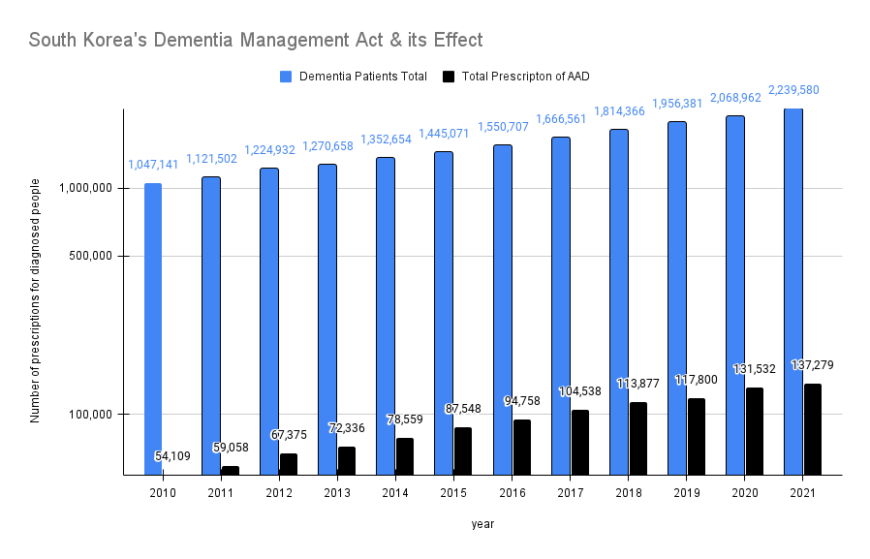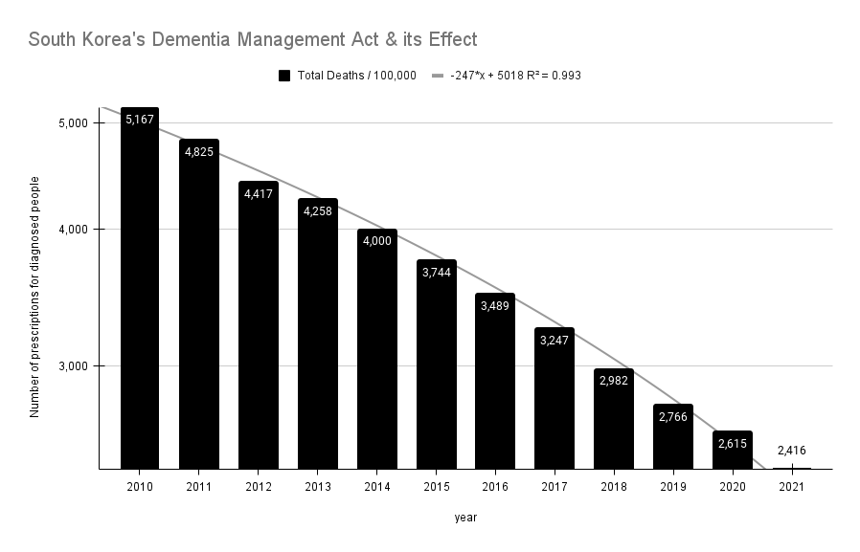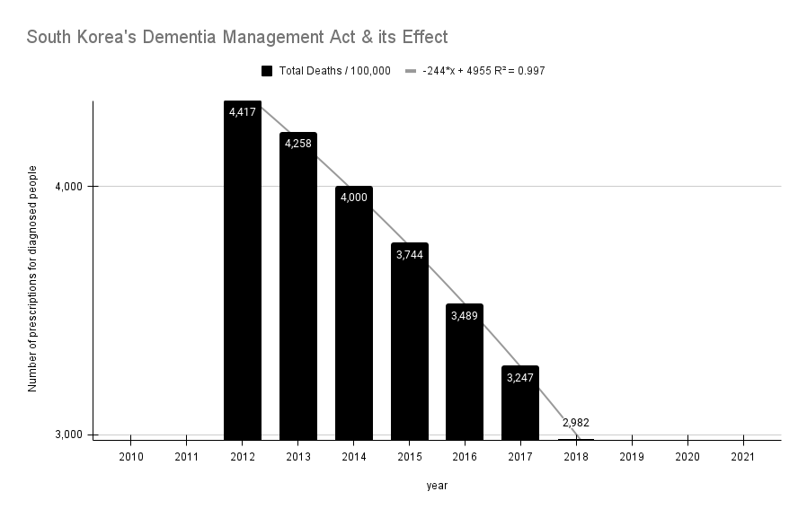

Fig. S19. Total Deaths with AAD Trend line. -247*x + 5018 R² = 0.993 / -244*x + 4955 R² = 0.997

Reference
1 Lee, J. H. The listed, delisted, and sustainability of therapeutic medicines for dementia patients: the study is specific to South Korea. Naunyn Schmiedebergs Arch Pharmacol 395, 535-546 (2022). https://doi.org/10.1007/s00210-022-02209-3
2 Lee, J. H. et al. Bronchitis, COPD, and pneumonia after viral endemic of patients with leprosy on Sorok Island in South Korea. Naunyn-Schmiedeberg's Archives of Pharmacology (2023). https://doi.org/10.1007/s00210-023-02407-7
3 Lee, J. H. The Regulatory Capture in the National Health Insurance System of South Korea. (INFOMEDPRESS, 2021).
4 Lee, J. H., Kanwar, B., Lee, C. J., Sergi, C. & Coleman, M. D. Dapsone is an anticatalysis for Alzheimer’s disease exacerbation. iScience (2022). https://doi.org/10.1016/j.isci.2022.104274

