GEOSPATIAL VARIABILITY OF VEGETATION RESPONSE TO METEOROLOGICAL DROUGHT IN NORTH-EAST
AND NORTH-WEST NIGERIA

BY

OYEMITAN SURAJU NIFEMI MET/12/9254

A THESIS IN THE DEPARTMENT OF METEOROLOGY AND CLIMATE SCIENCE SUBMITTED TO THE SCHOOL OF POSTGRADUATE STUDIES, IN PARTIAL FULFILLMENT OF THE REQUIREMENTS FOR THE AWARD OF MASTER OF TECHNOLOGY (M. TECH) IN METEOROLOGY AND CLIMATE SCIENCE OF FEDERAL UNIVERSITY OF TECHNOLOGY, AKURE, ONDO STATE, NIGERIA.

JUNE, 2023

DECLARATION

I hereby declare that this thesis was written by me and is a correct record of my research work. It has not been presented elsewhere for the award of diploma or degree of this or any other University. All citations and sources of information are clearly acknowledged by means of references.

Candidate’s Name: OYEMITAN Suraju Oluwanifemi

Signature………………….. Date…………………….

CERTIFICATION

I certify that this Thesis titled “Geospatial Variability of Vegetation Response to Meteorological Drought in North-East and North-West Nigeria” is the outcome of the research carried out by Oyemitan Suraju Oluwanifemi in the Department of Meteorology and Climate Science, Federal University of Technology, Akure.

………………….…... ………………………………. Prof. E.C. Okogbue Date

……………………… ……………………………….. Dr. R.A. Balogun Date

ACKNOWLEGEMENT

I am grateful for the dedication and support from everyone who has played a part in ensuring the successful completion of my master’s program.
I extend my heartfelt appreciation to my compassionate supervisor, Prof. E.C. Okogbue, and my co-supervisor, Dr. R.A. Balogun, for their exceptional understanding, unwavering commitment, and immense patience throughout the entire journey of this project.
My profound gratitude goes to my mother, Mrs. B.J. Falusi, for her unwavering support during my studies at FUTA. Her constant encouragement has been instrumental in my success. Additionally, I would like to extend my appreciation to the entire staff and students of the Nigeria Meteorological Agency (NIMET) for their kind support and encouragement throughout my academic journey.
Also, I want to express my heartfelt gratitude to my lecturers in the Department of Meteorology and Climate Science for their assistance, commitment and the knowledge imparted on me to making sure the dream of acquiring this degree became a reality.
Furthermore, I would like to convey my sincere appreciation to the lecturers in the Department of Meteorology and Climate Science. Their invaluable assistance, unwavering commitment, and imparted knowledge have played a crucial role in transforming my dream of obtaining this degree into a remarkable reality.

DEDICATION

This thesis is dedicated to Almighty God for his mercy and protection over my life for giving me the opportunity and kept me alive for the successful completion of my academic pursuit in this university. I also dedicate this research work to my mother and brothers for their encouragement and counsel.

ABSTRACT

Increasing variability of droughts in northern Nigeria is generating serious concern. This research work investigated extreme drought variability and future trends in North-East and North-West Nigeria. The study utilized observational data from the Climate Research Unit (CRU) and simulation datasets from 2020-2100 (Cordex; daily rainfall and minimum and maximum temperature). The Standardized Precipitation Evaporation Index (SPEI) was used to determine the occurrence of drought of different intensities particularly near normal, moderate, and severe drought in the study area within range of 1.99 to -1.99. Also, Inverse Distance Weighted (IDW) technique was used to determine the risk level and vulnerability by analyzing the SPEI values in the region over different time intervals. Image Geo-Processing for vegetation change was used to determine the existence of relationship between Normalized Difference Vegetation Index (NDVI) and rainfall in the region. Also, Consecutive dry days (Drought Index) was applied at every grid point over Northwest and Northeast using both SPI and SPEI from 2011 to 2100 that was later divided into three 30 years periods (near, middle and far) to incorporate climate change and variability into the analysis and presented spatially and droughts critical/threshold level was set to be -0.4 to 1.2. The study revealed that Bornu, Kano, and Katsina had extremely low drought vulnerability, compared to Bauchi, Zamfara, and Yobe which experienced very high risk during the historical climate period. The projected trend of consecutive dry days between 2020 and 2040 (-0.8 to 1.2) was somewhat lower under the RCP 4.5 and RCP 8.5 warming scenarios than it is between 2041 and 2070 (-0.4 to 1.6). More greenhouse gas emissions and warming were predicted in the RCP 8.5 scenario compared to the RCP 4.5 scenario, which increased the projected number of consecutive dry days. Midway into the future, the number of dry days in the region increases in all scenarios, pointing to prolonged drought in the region. Analysis of SPEI indicates that a greater proportion of the Northern Nigeria may become drier in the future, because of increasing Potential Evaporation (PET) together with continuous Climatic Water Balance CWB deficit observed over West Africa would enhance evaporation losses and increase irrigation demands for drier soils.

TABLE OF CONTENTS
Content | Page
Title Page
Declaration | I
Certification | Ii
Acknowledgement | Iii
Dedication | Iv
Abstract | V
Table of Content | Vi
List of Table | X

Table of figure xi
CHAPTER ONE 1
INTRODUCTION 1
  - Background Of Study 1
  - The Research Problem 4
  - Aim And Objective of The Study 6
  - Justification Of Study 7
  - Contribution to Knowledge 8
CHAPTER TWO 10
LITERATURE REVIEW 10
  - Concept Of Climate Change 10
    - Causes of Climate Change 9
  - Climate Variabiliy 15
  - Climate Trend 17
  - Effect Of Drought in The North-East and North-West Region Of Nigeria 20
    - Effect on Agriculture and Food Security 22
    - Effect on Water Resources 25
    - Effect on Biodiversity 28
CHAPTER THREE 31
DATA AND METHODOLOGY 31
  - Description Of Study Area 31
    - Geology and Relief 33
    - Climate of Study Area 36
    - Vegetation and Soil 36
  - Rainfall Data 40
  - Remote Sensing and GIS Analysis 42
    - Image-Geoprocessing for Vegetation Change 42
    - Inverse Distance weighted Interpolation 42
    - Standardized Precipitation Index 43
  - Standardized Precipitation Evapotranspiration Index (SPEI) 45
  - Analysis Of Drought Characteristics Using Consecutive Dry Days 48
CHAPTER FOUR 50
RESULT AND DISCUSSION 50
  - Spatial Representation of SPEI Over North-East and North-West Nigeria 50
    - Time Series Variation Over a Certain Period 50
    - Spatial Distribution Drought Risk Classification 62
  - Relationship Between Rainfall and NDVI 66
  - Projection Of Consecutive Dry Days 71
    - Future Projected Change of Consecutive Dry days under RCP4.5 Warming Scenario 71
    - Future Projected Change of Consecutive dry days under RCP8.5 Warming Scenario… 72
CHAPTER 5 75
CONCLUSION AND RECOMMENDATION 75
  - Conclusion 75
  - Recommendation 76
REFERENCE 78

List of Table

Table 3.1: Detail description of the two datasets used 41

Table 3.2: Standardized Precipitation Index. (Mckee et al. 1993) 44

Table 3.3: Drought classification from standardized precipitation index (SPI) and standardized precipitation evapotranspiration index (SPEI) values. 47
Table 4.1: SPEI Drought Classification 50

Table 4.2: Correlation coefficient of NDVI values with Rainfall 66

Table of Figure
Figure 3.1: Nigeria Map Showing Study Area 32
Figure 3.2: Major Geological Formation of The Study Area 34
Figure 3.3: Major Relief of The Study Area 35
Figure 3.4: Vegetation Map of The Study Area 39
Figure 4.1: Variation in SPEI Over Bauchi 51
Figure 4.2: Variation in SPEI Over Birnin Kebbi 51
Figure 4.3: Variation in SPEI Over Gusau 52
Figure 4.4: Variation in SPEI Over Zaria Ibi 54
Figure 4.5: Variation in SPEI Over Kaduna 54
Figure 4.6: Variation in SPEI Over Kano 58
Figure 4.7: Variation in SPEI Over Katsina 56
Figure 4.8: Variation in SPEI Over Maiduguri 56
Figure 4.9: Variation in SPEI Over Nguru 57
Figure 4.10: Variation in SPEI Over Potiskum 57
Figure 4.11: Variation in SPEI Over Sokoto 58
Figure 4.12: Variation in SPEI Over Yewa-Bauchi 58
Figure 4.13: Variation in SPEI Over Yewa-Kebbi 59

Figure 4.14: Variation in SPEI Over Yola 59
Figure 4.15: Variation in SPEI Over Zaria 60
Figure 4.16: Spatial Distribution Drought Risk Level Between 1994 And 1999 62
Figure 4.17: Spatial Distribution Drought Risk Level Between 2004 And 2009 62
Figure 4.18: Spatial Distribution Drought Risk Level Between 2009 And 2014 63
Figure 4.19: Spatial Distribution Drought Risk Level Between 2014 And 2019 63
Figure 4.20: Annual Rainfall and Annual NDVI 67
Figure 4.21: DJF Rainfall and DJF NDVI 67
Figure 4.22: MAM Rainfall and MAM NDVI 68
Figure 4.23: JJA Rainfall and JJA NDVI 68
Figure 4.24: (a) Near Future Projected Change of Cdd (2020 To 2040), (b) Middle Future Projected Change of Cdd (2041 To 2070) And (c) Far Future Projected Change (2071 To 2100) Under Rcp4.5 71
Figure 4.25: (a) Near Future Projected Change of Cdd (2020 To 2040), (b) Middle Future Projected Change of Cdd (2041 To 2070) And (c) Far Future Projected Change of Cdd (2071 To 2100) Under Rcp8.5 72

CHAPTER ONE INTRODUCTION

BACKGROUND OF STUDY

Climate patterns throughout the history of the earth have never remained static, with various degrees of non-static characteristics ranging from variability, fluctuations, trends, to abrupt and gradual changes. Evidence from proxy data such as tidal waves, changing sea and lake levels, pollen counts, and ice-core analyses demonstrate that climatic changes have been remarkable over time scales of 10,000 years or more (Oladipo, 1991).
The earth has experienced a series of ice-ages, and there are concerns about unprecedented global warming resulting from human activities such as the continuous release of industrial by- products into the atmosphere and large-scale deforestation (Oladipo, 1991). Variability, whether in the form of fluctuation or trend, is an inherent characteristic of climate or weather. However, the magnitude and duration of this variability are critical (Ayoade, 2003). Minor fluctuations or variations represent a mere "noise" in the climate series, and human beings can easily adapt to them. However, these effects occur when the fluctuations are not just minor variations from the usual conditions, but rather substantial deviations or departures from what is considered normal, this leads to adjustment problems, and the environment, human beings, and their activities becomes highly vulnerable (Ayoade, 2003).
According to studies in paleoclimatology, the world's climate has never remained static in the geological past. Warm and cold climates have alternated throughout history. Presently, it is widely accepted that the world is experiencing a warm inter-glacial period. As a result, the

current warming trend is not unexpected. However, if we accept that we are in a warm inter- glacial period and that warming is to be expected, several questions arise:
    - Would recent global warming still have occurred even without the greenhouse gases produced by human activities?
    - If human activities are contributing significantly to current global warming, could they delay the onset of a glaciation period in the future or even prevent it from occurring altogether?
    - If the warming trend persists after the Pleistocene glaciations, are we approaching the peak of this warm period?
Insufficient precipitation resulting in drought can have significant impacts on agriculture, natural ecosystems, and water resources, and is a natural disaster that affects a large number of people worldwide. It can cause economic losses, famine, epidemics, and land degradation, and exacerbate structural problems in developing countries, leading to unemployment, poverty, reduced crop yields, and even forced migration. To assess hazard and vulnerability of various systems and regions, it is crucial to understand the spatial and temporal variability of drought, and data that characterizes drought conditions is essential for analysis of past droughts, including onset and end dates, magnitude, and spatial extent, as well as determining drought probabilities and vulnerabilities.
Drought is recognized as one of the most devastating meteorological disasters due to its gradual and cumulative impacts on hydrological, meteorological, socio-economic, and agricultural sectors. The agricultural sector is particularly vulnerable to drought due to deficient precipitation leading to soil water deficits and a discrepancy between actual and potential evapotranspiration. Rainfall is a crucial element of the climate system and is significant for drought mitigation.

However, rainfall is highly variable in North-West and North-East Nigeria, which are considered the country's food basket.
Drought is a recurrent phenomenon in Africa, affecting both high and low rainfall areas, and drought occurrence has increased in many parts of Northern Nigeria since the late 1960s, linked to a steady decline in annual rainfall in the region.
The Northern region of Nigeria is plagued by irregular rainfall patterns that result in dry spells and insufficient rainfall, which affects crop production and livelihood security. Studies by Olaniran (2002) indicated that rainfall patterns have significantly changed in recent times, with rainfall retreating earlier in the year, particularly in Northern Nigeria. This trend of declining rainfall was observed in most states in North-West and North-East Nigeria, and it had significant implications for drought and vegetation cover in the region (Atedhor, 2016).
In recent times, researchers have employed various techniques, including the Standardized Precipitation Index, Remote Sensing, and GIS, to assess drought trends, generate drought risk maps, and analyze vegetation trends in Nigeria. Vegetation is an essential component of the ecosystem, regulating the water balance and carbon cycle, and its dynamics are vital to the functioning of the earth's diverse ecosystems and their services. However, global changes such as climate variability and land-use change have significantly impacted vegetation dynamics. Land- use changes are associated with alterations in hydrological processes and biodiversity loss, while climate variability affects phenology and ecological balance. To assess and monitor vegetation dynamics and land degradation at multiple scales, Satellite Remote Sensing has emerged as a vital tool that provides continuous observations and environmental proxies across geographical boundaries and wide areas. Remote sensing-based vegetation indices and biophysical variables are critical tools for assessing vegetation dynamics and land degradation.

The relationship between climate and vegetation is strongly reflected in Nigeria's vegetation belts, with a west-to-east zonation pattern mirroring that of climate. This zonation is demarcated by transitional zones between each belt, which are characterized by changes in total rainfall and length of the wet season from south to north. The increasing demand for land use and other human activites have threatened the existence of vegetal cover in Nigeria. Therefore, it is crucial to measure and understand the dynamics of vegetal cover health across the country. This is particularly important given emerging issues such as drought and desertification in the north, pastoral clashes, rapid runoff in the southwest, and devastating gullies in the southeast. To support sustainable development, resource conservation, and food security policy development, there is an urgent need for a quantitative and reproducible assessment of the vegetation cover (FORMECU 1996; Aweto 2001; FAO 2005).

THE RESEARCH PROBLEM

The occurrence of global climate change has been established by the Intergovernmental Panel on Climate Change (IPCC, 2021). The effects of climate change, variation, fluctuation, and trend are evident and will continue to impact the world. However, the specific nature of these changes in regions like the Northeast and Northwest parts of Nigeria, where rain-fed agriculture is the primary source of livelihood, remains unclear. The unpredictability of these changes, whether gradual or sudden, can significantly affect the lives of those in these regions. Therefore, it is crucial to gain comprehensive understanding of the present and future behavior of climate to enhance the well- being of people living in these areas.
Investigating the accuracy of climate change predictions is particularly important in the Northeast and Northwest parts of Nigeria, where aridity is increasing, the Sahara Desert is advancing, and Lake Chad is rapidly shrinking. Thus, this study addressed essential questions related to these changes.
- What are the patterns of temporal and spatial variations in the length of rainy and dry seasons in the northeast and northwest Nigeria?
- Do these variations follow any specific patterns?

In the twentieth century, Africa witnessed high rainfall amounts for almost five decades, enabling local inhabitants to maintain or even increase their crop yields, cattle herds, and human population levels (Balling, 2005). However, in the early 1960s, the region experienced a decline in rainfall amounts, and by the early 1970s, the Sahel's human and ecological disaster had become a serious issue that received worldwide attention. Although Africa is not immune to human-induced changes in climate, there is still much work to be done in distinguishing between "natural" factors of climate change and human-induced ones (Xue, 1997)
This study increased our understanding of the behavior of our climate in relation to current predictions. It is worth noting that different General Circulation Model (GCM) simulations produce varying regional rainfall responses to a given greenhouse gas forcing, even during the seasonally wet months of June, July, and August in the Sahel. This trend is also observed in parts of Central America and much of Southeast Asia, indicating the need for closer examination of smaller spatial and temporal climate variations in the Northeast and Northwest regions of Nigeria.
Additionally, most climate change scenarios in the Sahel do not adequately represent past, present, and future estimates of the region's climate. (Carter, 2000).
According to Menne and Ebi (2006), as human impact on the environment grows rapidly and the interactions between various components of change become more complex, a better understanding of atmospheric and environmental changes is crucial. Significant progress in this area of study is urgently needed. Understanding the causes and nature of climatic variations and changes is an essential prerequisite for developing effective strategies to cope with the uncertainties of climate.
In the past, drought events were predicted and monitored using weather station data. However, the uneven and sparse distribution of weather stations in developing countries has increased the ambiguity of drought research. This problem has been overcome by using Satellite Remote Sensing Technology, which allows for the easy acquisition of large-scale high-resolution climatic data. Satellite platforms provide frequent, up-to-date, near real-time, and high-resolution spatial data. In this regard, advances in the fields of remote sensing (RS) and Geographic Information Systems (GIS) have greatly assisted in drought risk assessment over the past three decades.

AIM AND OBJECTIVES OF THE STUDY

This study assesses the occurrence of drought in North-West and North-East Nigeria and Vegetation response in the region.
The specific objectives were to:
- determine the occurrence of drought of different intensities particularly near normal, moderate, and severe drought in all the stations considered using Standardized Precipitation-Evapotranspiration Index (SPEI)
- determine the existence of relationship between Normalized Difference Vegetation Index (NDVI) and rainfall in the study area, and
- determine the projection of drought in the North-West and North-East Nigeria.

JUSTIFICATION OF STUDY

Drought is a significant environmental phenomenon that affects vegetation dynamics, biodiversity, and ecosystem functioning. By understanding the geospatial variability of vegetation response to meteorological drought, knowledge of how ecosystems in North-East and North-West Nigeria are influenced by these climatic events are significantly improved. This information is valuable for assessing the vulnerability of vegetation to drought and developing effective conservation and management strategies.
North-East and North-West Nigeria are regions with significant agricultural activities. Drought can have severe implications for crop production, livestock, and livelihoods of local communities. By studying the geospatial variability of vegetation response to drought, valuable insights into the areas that are most susceptible to drought impacts and help in developing sustainable agricultural practices and resilience-building strategies are provided.
Climate change is expected to increase the frequency and intensity of drought events in many regions worldwide. Understanding how vegetation responds to meteorological drought can contribute to climate change adaptation efforts. By identifying the areas with higher vegetation resilience or vulnerability, targeted interventions, such as drought-resistant crop varieties or
introducing appropriate land management practices to mitigate the impacts of drought can be

formulated or implemented.

Geospatial technologies such as remote sensing and geographic information systems (GIS), provide valuable tools for studying vegetation dynamics over large areas. Conducting a study on the geospatial variability of vegetation response to drought allows for exploitation and application of these advanced techniques. It offers an opportunity to gain expertise in remote sensing data analysis, satellite imagery interpretation, and spatial modeling, which are highly relevant and sought-after skills in various professional domains.
Findings from this research can contribute to evidence-based policy and decision-making processes. Government agencies, NGOs, and other stakeholders involved in natural resource management and disaster risk reduction can benefit from this study. This research outcomes can inform the development of strategies, guidelines, and interventions aimed at reducing drought vulnerability, improving ecosystem resilience, and ensuring sustainable development in the region.
Despite the importance of drought and vegetation dynamics, there may be limited research specifically focusing on the geospatial variability of vegetation response to meteorological drought in North-East and North-West Nigeria. This study can help fill this knowledge gap by generating new data, methodologies, and insights specific to this region.

CONTRIUTION TO KNOWLEDGE

    - Regional Understanding: This study contributes to a better understanding of how vegetation in North-East and North-West Nigeria responds to meteorological drought. By analyzing geospatial data, including satellite imagery and climate records, patterns and trends in vegetation response across different regions can be identified within the study area. This information can help in characterizing the spatial variability of vegetation dynamics during drought events and identifying areas with varying levels of resilience or vulnerability.

    - Drought Impact Assessment: This study can contribute to assessing the impact of meteorological drought on vegetation in the study area. By analyzing remote sensing data, changes in vegetation indices or other relevant indicators during drought periods can be quantified. This analysis can provide insights into the severity and extent of vegetation degradation, identify areas with the highest impacts, and contribute to a comprehensive assessment of drought effects on ecosystems.
    - Identification of Hotspots: Through your research, you can identify hotspots of vegetation response to meteorological drought in North-East and North-West Nigeria. By mapping areas with high vulnerability or resilience, valuable information for decision-makers to prioritize resource allocation, target conservation efforts, and implement appropriate adaptation strategies can be provided. These hotspots can serve as a basis for targeted interventions and policy development to mitigate the negative impacts of drought on vegetation and associated ecosystems.
    - Spatial Modeling: The project can contribute to the development of spatial models that relate meteorological drought parameters to vegetation response. By utilizing geospatial analysis techniques and statistical modeling, relationships between drought severity, duration, or other meteorological variables and vegetation dynamics can be established. These models can provide a framework for predicting vegetation response to future drought events and assist in early warning systems or decision support tools for drought management.
    - Data and Methodological Advances: Conducting this research helps to contribute to the advancements in data analysis techniques and methodologies related to geospatial variability of vegetation response to drought. Innovative approaches for processing and analyzing remote sensing data, integrating climate data with vegetation indices, or mapping

vegetation resilience at a regional scale can be developed. These methodological advancements can benefit future studies in similar research domains and provide guidance for researchers and practitioners working on drought and vegetation dynamics.
    - Knowledge for Adaptation and Management: This study findings can provide valuable knowledge for developing adaptation strategies and management plans in the context of drought and vegetation dynamics. The identified spatial patterns and factors influencing vegetation response can inform the selection and implementation of appropriate land management practices, such as reforestation, irrigation, or agroforestry systems. The insights gained from this research can support decision-making processes for sustainable land use, water resource management, and ecosystem conservation in North-East and North-West Nigeria.

CHAPTER TWO LITERATURE REVIEW

CONCEPT OF CLIMATE CHANGE

The climate as we understand it today is a result of long-term weather patterns of a particular location over a period of 30 to 35 years. This involves the calculation of statistical measures such as mean and standard deviation, which provide a starting point for analysis. The longer the duration of the statistical measures, the more accurate the analysis would be. The evidence shows that climate change is happening, and its effects are already evident in our environment. While most people accept the significance of these changes, some still deny these facts. However, it is widely recognized that human activity is the driving force behind the warming of the climate, which has the potential to significantly disrupt fundamental aspects of life, including health, water, air, and food.
The Intergovernmental Panel on Climate Change (IPCC) reported in 2001 that there is strong evidence that most of the global warming observed over the last 50 years is caused by human activities. Climate change could have direct effects, such as increased heat stress and loss of life due to floods and storms, or indirect effects, such as changes in the range of disease vectors like mosquitoes, waterborne pathogens, and air and water quality, as well as the availability and quality of food.
According to Klein Tank (2005), the evidence of climate change is growing, and in Europe, significant investments have been made to forecast its impacts (Parry, 2000). To better understand the patterns of climate change, a study should be conducted to prepare for possible catastrophic effects in the past, present, and future.
The United Nations Framework Convention on Climate Change (UNFCCC) distinguishes between climate change caused by human activities that change the atmosphere's composition and climate variability caused by natural factors (UNFCCC, 2020). Energy producers are responsible for developing global greenhouse gas emissions strategies as the first step in addressing greenhouse gas emission scenario (GHGE).
Climate models indicate that precipitation patterns are more variable than temperature. McCabe (2001) reported that winter precipitation is expected to increase in most of Europe due to an increase in atmospheric moisture content and storm activity. However, in summer, widespread decreases in precipitation are predicted across Europe due to increased blocking activity over the northeastern part of the North Atlantic. The changes in precipitation are not as evident in spring and autumn (Giorgi, 2004).
According to Nenibarini (2007), climate refers to the long-term weather conditions of a region, including typical weather patterns, storm frequency and intensity, cold spells, and heatwaves. Climate is a highly complex system that comprises five interacting components: the atmosphere, hydrosphere, cryosphere, land surface, and biosphere (De Chavez and Tauli-Corpus, 2008). Weather, on the other hand, is the daily fluctuating state of the atmosphere characterized by temperature, wind, precipitation, clouds, and other elements. Climate change refers to changes in climate that can be attributed directly or indirectly to human activities, leading to global warming, and affecting the atmospheric conditions of the earth. Climate change has the potential to impact all natural systems, posing a threat to human development and survival economically, socially, and politically.

In the Sahel region of Western Africa, a correlation has been observed between a reduction in moisture flux and warming of the Southern Hemisphere and Northern Indian Ocean, as well as cooling of the North Atlantic and North Pacific oceans during episodes of reduced rainfall over the past 80 years (Folland, 1996). This period of dryness, which began around 4,000-5,000 years BP, has been characterized by a general trend towards a drier climate (Gillespie, 1993). Paleo- soil studies in the highlands of Northern Ethiopia (Tigray) have also revealed phases of soil formation and degradation that suggest changes in water conditions at various points in time (Machando, 1998). Historical records of climate events in Ethiopia are rare, and mostly come from royal chronicles (Pankhurst, 1985).
According to the United Nations Framework Convention on Climate Change (UNFCCC) in 1992, climate change is defined as a change of climate that can be attributed directly or indirectly to human activity altering the composition of the global atmosphere and is in addition to natural climate variability observed over comparable time periods. Climate change refers to a statistically significant variation in the mean state or variability of the climate that persists for an extended period, typically decades or longer, and may result from natural internal processes or external forces, as well as persistent anthropogenic changes in the atmosphere's composition or land use.
De Chavez and Tauli-Corpus (2008) define global warming as the overall increase in the Earth's surface temperature and ocean temperatures compared to previous centuries. This is caused by the continuous trapping of heat in the Earth's atmosphere due to an increase in greenhouse gases. Global warming is a key aspect of climate change, and its impacts can include rising sea levels, warming oceans, melting glaciers, and threats to agricultural productivity and human settlements. Additionally, it may cause changes in rainfall patterns and an increase in soil erosion, storms,

floods, and drought. Ultimately, this could lead to a deepening food crisis, worsening weather, a decrease in energy, and general environmental breakdown around the world. The Greenhouse effect, which is caused by certain gases trapping heat from sunlight, is responsible for the warming effect. The debate about global warming revolves around whether added greenhouse gases released by human activity will cause harmful effects by overheating the Earth.

CAUSES OF CLIMATE CHANGE

The Intergovernmental Panel on Climate Change (IPCC) 4th Assessment Report's summary (IPCC, 2007) indicates that global warming is very likely caused by human actions with a probability of 90% or greater. According to the IPCC's comprehensive assessment of scientific evidence, human activities, particularly the burning of fossil fuels and deforestation, are contributing to climate change, which is superimposed on and partially masked by natural climate fluctuations.
Climate change and global warming are due to the accumulation of greenhouse gases (GHGs) in the atmosphere, such as carbon dioxide, nitrous oxide, chlorofluorocarbons (CFCs), and methane, as a result of human activities including fossil fuel burning, bush burning, and the use of machines that produce smoke during cooking, among other things (http://www.news.dailytrust.com). The earth is surrounded by an atmosphere that contains gases that regulate temperature, and various human activities contribute to changes in the climate system. The burning of coal, oil, and natural gas, as well as deforestation and various agricultural and industrial practices, are altering the atmosphere's composition and contributing to climate change (www.gcrio.org). These human activities have resulted in increased atmospheric concentrations of several greenhouse gases.

De Chavez and Tauli-Corpus (2008) define greenhouse gases (GHGs) as chemical compounds, including water vapor, carbon dioxide, methane, and nitrous oxide, which exist in the atmosphere and could absorb and radiate heat. While some GHGs, such as water vapor, carbon dioxide, methane, ozone, and nitrous oxide, occur naturally, others, including hydrofluorocarbons (HFCs) and perfluorocarbons (PFCs), result exclusively from human industrial processes. While all these gases contribute to the greenhouse effect, water vapor and carbon dioxide account for 90% of total GHG emissions, with carbon dioxide contributing 55% and methane contributing 15% of direct GHG emissions (www.undp.org).
Human activities, including the burning of fossil fuels such as coal, oil, and natural gas for transportation, manufacturing, heating, cooling, electricity generation, and other applications, are responsible for producing carbon dioxide. Currently, fossil fuels contribute 80% to 85% of carbon dioxide being added to the atmosphere. Clearing land for logging, ranching, and agriculture also leads to carbon dioxide emissions, with land use changes responsible for 15% to 20% of current carbon dioxide emissions (www.gcrio.org). Methane, the second most important GHG resulting from human activities, is emitted during coal mining, oil drilling, and through leaky gas pipelines. Nitrous oxide is produced by various agricultural and industrial practices (http://climate.jpl.nasa.gov/causes). Chlorofluorocarbons (CFCs), which have been used in refrigeration, air conditioning, and as solvents, and ozone in the lower part of the atmosphere, are also important GHGs resulting from industrial activities.

Natural changes in climate result from internal factors, such as interactions between the atmosphere and ocean, and external factors, and the amount of material injected into the upper atmosphere by explosive volcanic eruptions (www.gcrio.org).

CLIMATE VARIABILIY
The term "climate variations" refers to the natural fluctuations in climate that occur on different temporal scales, ranging from individual weather events to periods longer than a decade (Ayoade, 2003). These variations are not static and can be described as "climatic noise" around the mean state of an area. However, if the variations are significant, they are classified as climate anomalies. The nature of these variations can be periodic, quasi-periodic, or non-periodic in nature. By analyzing rainfall and temperature patterns, existing theories can be used to determine the nature of the variations.
Climate variability refers to changes in the mean state and other statistics of climate on temporal and spatial scales beyond individual weather events. Such variations can be caused by natural internal processes within the climate system or by natural and anthropogenic external forcing.
Europe has experienced both a medieval warm period (MWP) and a little ice age (LIA) over the past 1000 years. During the MWP, temperatures were warmer than in the 15th to 19th centuries, but they never reached the levels recorded in the 20th century. The LIA began in the 13th or 14th centuries and peaked somewhere between the mid-16th and 19th centuries. The North Atlantic Oscillation (NAO) is an oscillation in atmospheric pressure that occurs over sub-polar and sub-
tropical latitudes in the North Atlantic. During a strong positive phase of the NAO, an intense winter atmospheric circulation occurs over Western Europe, resulting in mild and wet conditions. Meanwhile, Southern Europe and the Mediterranean experienced warm and dry conditions.
Like the atmosphere, interactions between the ocean and atmosphere, particularly through changes in sea surface temperatures (SST), have a significant influence on the thermodynamics and dynamics of the atmosphere.
SST variations have also impacted stream flow patterns in Europe (Rimbu, 2002). While the land surface plays a crucial role in climate, little research has explored the relationship between land surface characteristics and climatic variability (Dirmeyer, 2003; Pitman, 2003). Land cover changes occur over timescales beyond inter-annual variability, and the climatic response to natural or human-induced alterations in surface characteristics may manifest over decades or longer (Schneider, 2004).
Bryson (1973) suggested that human pollution in the Northern Hemisphere acted as a "volcano," causing cooling on a hemispheric scale. According to Bryson, this cooling resulted in a southward shift of the Northern circumpolar vortex (jet stream) and the subtropical high-pressure belt. This was one of the earliest attempts to explain climate anomalies, particularly the drought in the Sahel. This pattern would restrict the northward movement of the rain producing ITCZ into the Sahel, leading to lower precipitation levels during the rainy season in the summer. Bryson attributed the Sahelian drought to industrial activity in developed nations in the Northern Hemisphere.
Cloudsley-Thompson (1974) identified overgrazing in the Sahel as the main cause of droughts. Overgrazing can lead to increased surface albedo (reflectivity) and soil compaction, resulting in greater surface runoff and reduced soil moisture. The expansion of the Sahara could be the result of local activities rather than the industrialization of mid-latitudes in the Northern Hemisphere.
Similarly, Otternan (1974) argued that overgrazing in dry land areas could increase albedo, reduce surface and near-surface air temperatures, stabilize the atmosphere, and lower local rainfall levels.

Recent research has confirmed that Nigeria is experiencing an increasing frequency and intensity of extreme weather-related events, including erratic rainfall patterns, floods, and rising sea levels (Odjugo, 2010). These changes are linked to decreasing rainfall, increasing temperatures, and higher evaporation rates, which have resulted in reduced water levels and the drying up of some rivers and lakes in Northern Nigeria. Additionally, since the 1970s, Lake Chad has been shrinking at an alarming rate. In Nigeria's coastal region, sea levels have risen by 0.20m, and saltwater has encroached on an area of about 2000 to 3400km^2 (Odjugo, 2010). The study by Odjugo (2010) also found that the number of rainy days has decreased by 53% in North-eastern Nigeria and 14% in the Niger-Delta coastal areas. Furthermore, the areas experiencing double rainfall maximal have shifted southward, and the short dry season (August break) is being experienced more in July than in August, as it did before the 1970s. These significant disruptions in Nigeria's climate patterns provide further evidence of climate variability in the region.

CLIMATE TREND

Numerous theories have been proposed to explain both past and future changes in climate, but none have been able to fully account for these changes. Despite this, some theories have gained popularity and will be reviewed here. However, it has become apparent over the past few decades that no single theory can explain all scales of climatic change. In fact, the same cause has been used to explain opposite effects, such as cold winters favoring dryness while mild winters are best for dryness.
It is important to note that climatic anomalies occur when significant departures from the norm are observed on a monthly, seasonal, or annual basis. These departures are simply fluctuations. One feature of the period from 1946 to 2004 is symmetric warming, meaning that there has been an equal increase in both cold and hot extremes and, thus, no change in temperature variability. However, within this period, two asymmetric sub-periods can be identified: 1946-1975 and 1976- 1999. During 1946-1975, a slight cooling occurred across Europe with a decrease in the number of warm extremes.
However, the annual number of cold extremes did not increase, implying a decrease in temperature variability. In contrast, pronounced warming and an increase in the annual warm extremes at a rate of two times faster than the expected change in cold extremes, which implies increased variability characterized the period 1976 -1999 (Klein Tank and Konnen, 2003). Froma bio-meteorological point of view such changes have had an impact as levels of human thermal comfort and the length of the discomfort season (McGregor 2002), the phenology of a range of plant and animal species (Ahas. 2002, Van Velt and Schwartz, 2002) and the possible re-emergence of some tick- borne disease (Randolph, 2004).
During the 1990s, temperatures in various regions of Africa including the Sahel, East Africa and South-east Africa were higher than they have been throughout the 20th century, except for a period at the end of the 1930s in the Sahel. Hulme (1990s) pointed out that drying in the Sahel was associated with a moderate warming trend. The ENSO is one of the more important controlling factors for inter-annual rainfall variability in Africa, at least for some regions (Janowiak 1988; Ropelewski and Halpert, 1987).
Even though the works of IPCC (1999), Mitchell (1990), Kittell (1998) and Giorgi Francisco (2003) did not provide detailed scenarios of future Africa climate, there have been some studies that analyzed GCM-simulated climate change for several regions in Africa. However, the downscaling of GCM outputs to finer spatial and temporal scales had received relatively little attention in Africa. Tyson (1991) studied Southern Africa using GCM equilibrium CO_2 experiments, while Hulme (1994) compared GCM to IPCC I992 emission scenarios.
Rainfall is an important factor for social and economic development in sub-Saharan Africa. Several studies analyzed trends of rainfall using time series data from different parts of the globe. The analysis of the studies showed that inter-annual rainfall variability was large over most of Africa and in some regions multi-decadal variability was also substantial. A decline in annual rainfall has been observed in West Africa since the end of the 1960s, with a decrease of 20% to 40% noted between 1931-1960 and 1968-1990. In the tropical rainforest zone, a decline in the mean annual precipitation was noted for the period 1960 to 1998, with around 4% in West Africa, 3% in North Congo and 2% in Southern Congo. However, a 10% increase in annual rainfall along the Guinean coast during the last 30 years was observed. No long-term trend was noted in Southern Africa, but increased inter-annual variability was observed in the post-1970 period, with higher rainfall anomalies and more intense and widespread droughts reported.
A decrease in rainfall of 8.8% from the long-term mean of 1968 to 2008 was reported in north- western Nigeria, and a consistent decline of 8mm in annual rainfall was observed in the north- eastern region (Ekpoh & Nsa, 2011; Hess et al., 1995). Rainfall trends have shown mixed impacts across different locations, with some studies reporting a decline in rainfall and others noting an increase in rainfall intensity during the 20th century. Several analyses involving various stations in Nigeria over different periods of time have been conducted to study rainfall study in the Sahe-lian region. These studies include those by Adefolalu (1986, 1990), Alli (2010), Bello (1998), Hess et al. (1995), Odjugo (2010), Oguntunde et al. (2012), and Tarhule & Woo (1998). In recent years, anomalous climate trends have been observed in northern Nigeria (NIMET, 2011).

EFFECT OF DROUGHT IN THE NORTH-EAST AND NORTH-WEST REGION OF NIGERIA

The northward expansion of the Sahara Desert is contributing to drought and desertification in the Sahelian region of Africa. Decreasing rainfall and increasing temperatures have resulted in annual expansion rates of 1-10 km towards the Sahel, burying vast stretches of farmland and leading to emigration and resettlement of people to areas that are less threatened. The process of desertification is further fueled by human activities such as deforestation, overgrazing, and poor farming techniques which reduce water retention of the soil and contribute to soil degradation.
The livestock population in Nigeria has increased from 6 million to 66 million between 1950 and 2006, putting immense pressure on the grasslands and leading to the conversion of 351,000 hectares of land into desert each year. Such farming practices are particularly devastating in marginal lands like arid and semi-arid lands, hilly and mountainous areas, and wetlands. The resulting effects of drought and desertification include loss of arable land and reduced crop production, leading to social effects such as loss of dignity and social values, and an increase in communal clashes among herdsmen and farmers, with fatal consequences.
In Northern Nigeria, there are several records of drought occurrences which resulted in famines, such as the droughts of 1903 and 1911–1914 (Shiru et al., 2018). Other droughts occurred in
1919, 1924, 1935 (Tarhule and Woo, 1997), 1951–1954, 1972–1973, 1984–1985 (Mortimore

1989), 2007 and 2011 (Abaje et al. 2013). Consequently, the situation is being exacerbated by the increasing human population, overgrazing, over-cultivation, and high poverty rate (Eze, 2017). The predominant economic activity in the region is farming. Moreover, the region is known for its grain products such as maize, millet, sorghum, and wheat (Eze, 2017).
Agricultural production in Nigeria particularly in Northern Nigeria is mainly rain-fed and naturally prone to vagaries of rainfall variability (Tiamiyu et al., 2015). During the years of abundant rainfall, households in the region experience bumper harvest from both crop and livestock productions. Conversely, during the years with rainfall deficit, the households experience crop failure, poor crop yield, leading to famine, hunger, and death, including livestock (Eze et al., 2018). Khalil (1974) shows that about 300, 000 livestock died during the drought that occurred in the year 1972 to 1973. The number of livestock that died during this period represents about 13% of the total livestock population in the north-eastern part of Nigeria (Khalil, 1974). Moreover, in the year 1987, towards the end of the growing season, huge crop losses to drought were recorded in many parts of northern Nigeria, particularly, in the Sahel region (Mortimore, 1989).
Rainfall trend in Nigeria between 1901 and 2005 shows a general decline. Within the 105 years, rainfall amount in Nigeria dropped by 81mm. The declining rainfall became worst from the early 1970s, and the pattern has continued till date. This period of drastic rainfall decline corresponds with the period of sharp temperature rise. Although there is a general decrease in rainfall in Nigeria, the coastal areas of Nigeria like Warri, Brass and Calabar are observed to be experiencing slightly increasing rainfall in recent times (Odjugo, 2007). This is a clear evidence of climate change because a notable impact of climate change is, increasing rainfall in most coastal areas and decreasing rains in the continental interiors (IPCC 1996; NEST 2003). Odjugo (2005, 2007) observe that the number of rain days dropped by 53% in the north-eastern and north- western Nigeria.

EFFECT ON AGRICULTURE AND FOOD SECURITY

Previous research has shown that global warming is negatively affecting agricultural productivity, leading to declining food production (Kurukulasuriya & Mendelsohn, 2006; IISD, 2007; Lobell et al., 2008). As the global population increases, there is a higher demand for food and other resources, leading to the depletion of fertile soils, fossil groundwater, biodiversity, and other non- renewable resources (Abrahamson, 1989; Ehrlich & Ehrlich, 1990). Climate change has played a significant role in this resource depletion, with the injection of greenhouse gases into the atmosphere being a major human impact on the environment (Adams et al., 1988; Fischer et al., 2002; Spore, 2008). This has resulted in a range of effects on human societies, as documented in various studies (Wolfe et al., 2005; ODI, 2007; Apata et al., 2009).
Despite these challenges, Nigeria has a diverse range of climate variations that enable the production of a variety of food and cash crops, including cassava, yam, corn, cocoyam, cowpeas, beans, sweet potatoes, millet, plantains, bananas, rice, sorghum, and various fruits and vegetables (Encyclopedia of Nations, 2008). The agricultural sector in Nigeria is also diverse, involving cattle herding, fishing, poultry, and lumbering, and contributing over 2% to GDP in the1980s. However, there have been reports of a decline in the output of agricultural produce due to environmental degradation and water pollution resulting from climate change (Encyclopedia of Nations, 2008). In 1987, there were an estimated 12.2 million pigs, 700,000 donkeys, 250,000 horses, and 18,000 camels in Nigeria, mostly owned by rural dwellers rather than commercial farms/companies, and mostly located in the northern region.

According to Zhu (2005), climate change has both positive and negative effects on farming, but there could be a more negative influence in the long run, which may lead to food scarcity if there are no immediate efforts to confront these problems. Crop yields are affected by many factors associated with climate change which includes temperature, rainfall, extreme weather events, climate variability and even carbon dioxide concentration in the atmosphere which is predicted to cause global warming that will have a significant impact on crop production (USDA, 2007).
The rate at which a plant matures is influenced by temperature, as it affects the plant's progress through various growth stages. Plant tissues tend to increase with rising temperature, leading to reduced digestibility and degradation rates of plant species, according to the International Fund for Agricultural Development (IFAD, 2009). However, temperature also accelerates plant maturity, especially in crop species, shortening the growth stages during which seeds and grains can absorb photosynthetic products. Temperature also determines the length of growing and grazing seasons and has a significant effect on the timing of developmental processes and the expansion rates of plant leaves. The impact of these factors on plant biomass depends on the growth habit of the plant, whether it has a discrete life cycle that ends when the grain is mature, such as cereals, or if it continues to grow and yield throughout the season, such as in grasses and root crops. For example, temperature reduces the combined production of wheat, corn, and barley - cereal grains that form the foundation of much of the world's diet - by 40 million metric tons per year (Lorraine, 2007).
Adapting to the adverse effects of climate change is a critical issue, particularly for developing countries, which are often the most vulnerable and least equipped to adapt. Adaptation is widely recognized as an essential component of any policy response to climate change, as it enables

farmers to achieve their food, income, and livelihood security goals despite changing climatic and socioeconomic conditions, including climate variability, extreme weather conditions such as droughts and floods, and volatile short-term changes in local and large-scale markets (Kandlinkar & Risbey, 2000). Research shows that climate change is generally detrimental to the agricultural sector without adaptation, but vulnerability can be significantly reduced with adaptation (Easterling et al., 1993; Rosenzweig and Parry, 1994; Reilly and Schimmel Fennig 1999; Smit and Kinner, 2002). The degree to which an agricultural system is affected by climate change depends on its adaptive capacity, which refers to its ability to adjust to climate change (including variability and extremes) to moderate potential damage, take advantage of opportunities, or cope with the consequences (IPCC, 2001). Adaptation measures to climate change include:
- Pastoralists adapt to climate extremes by making use of emergency fodder, culling of weak livestock for food, and multi-species composition of herds to survive climate extremes. They also try to move from the dry northern areas to the wetter southern areas during drought season in order to survive and sustain their domestic animals.
- Women plant crops that are more resistant to droughts and pests, providing a reserve for extended periods of economic hardships. They also select and save seeds for planting each year. They preserve a variety of seeds that will ensure resistance to the range of conditions that may arise in any given growing season.
- Other indigenous strategies include controlled bush clearing; using tall grasses for fixing soil surface nutrients which have been washed away by runoff; erosion-control to reduce the effects of runoff; restoring lands by using green manure; constructing stone dikes; managing low-lying land sand protecting riverbanks (IPCC, 2007).

Most of the populations in the drought prone states live on marginal lands in rural areas practicing rain-fed agriculture. Drought threatens agricultural production on these marginal lands, exacerbating poverty and undermining economic development. The impact of drought and climatic variability in both economic and mortality terms is generally larger for relatively simple and predominantly agricultural economies. The drought of 1971-72 for example reduced Agricultural contribution to GDP in Nigeria from 18.4% in 1971-72 to 7.3% in 1972-1973. The poor crop yields or total crop failure due to drought result in mass poverty and starvation as agriculture is the mainstay of Nigeria’s rural economy. Although agriculture will remain for many years as major contributor to the economies of most developing countries (Van Crowder et al., 1998), in some countries, however, its share of GDP will progressively decline as drought and desertification take their toll with food shortages increasing at the same time. The poor households that are affected by drought and desertification do not have adequate resources to deal with food shortages leading to food insecurity and hunger that affects millions of people. Agriculture is one of the main economic activities in Nigeria (which account for around 40 percent of the country’s GDP and employs about 60 percent of the active labor force), thus drought would lead to a catastrophe with unprecedented repercussions. The most severe consequence of drought is famine.

EFFECT ON WATER RESOURCES

Climate variability has a multitude of immediate and long-term impacts on water resources worldwide. These include flooding, drought, sea-level rise in the estuaries, drying up of rivers, poor water quality in surface and groundwater systems, precipitation and water vapor pattern distortions and snow and land ice mal distributions (Urama and Ozor, 2010). West Africa sub region has experienced a significant decline in rainfall in recent decades. A noticeable decline in

rainfall series was observed around the year 1968 to 1972 with the year 1970 as a transitional year. The drop in average rainfall, before and after 1970, ranges from 15% to over 30% depending on the area. This situation has resulted in about 200 kilometers southwards shift in isohyets. In the whole region, the decline in rainfall results from reduced number of rainy days and events (Niasse et al., 2004). As in the case of the annual rainfall series, a significant variation in the annual average discharge has, also, been observed since the 1970’s I n most rivers within the region. Across the major basins in the region, the variation in discharge time is generally like that of the rainfall. However, the decline in discharge is more significant than that of the rainfall, 40% to 60% average decline in discharge since the early 1970s as against 15% to 30% decline in rainfall (Niasse et al., 2004). About 60% decline had been observed in the discharges of rivers Senegal and Gambia within the Northern guinea Savannah (NGS) over the period 1971 to 1989 compared to the period 1951 to 1989 against a drop of 25% in the average annual rainfall across the same basin and for the same reference period (Niasse et al (Eds.), 2004). In the region’s large basins, the reduction in discharge ranges from 25% to 50% for the same period. In the region’s largest river, the river Niger, in addition to a drop discharge, severe low flow conditions that resulted in the stoppage of flows were observed in 1983, 1984 and 1987 over the Bani tributary at Douna, Mali and in 1985 in Niamey (Niasse et al., 2004).
Climate change will alter all aspects of the hydrological cycle ranging from evaporation through precipitation, run off and discharge (Mcguire et al., 2002). The global warming and decreasing rainfall together with the erratic pattern of rainfall produce a minimal recharge of groundwater resources, wells, lakes, and rivers in most parts of the world especially in Africa thereby creating water crisis. In Nigeria, many rivers have been reported to have dried up or are becoming more seasonally navigable while Lake Chad shrunk in area from 22,902k𝑚2 in 1963 to 1304k𝑚2 in

2000. This shows that what is left of Lake Chad in the year 2000 is just 5.7% of 1963 (Odjugo, 2007). Awake (2009) also confirms the fact that Lake Chad has shrunk by 95% since the1960s and Aral Sea in Central Asia was the fourth largest lake in the planet in 1960, but by 2007 It had shrunk to 10% of its original size. Lake Chad and so many rivers in Nigeria, especially in Northern Nigeria, are in the danger of disappearing.
Drought influences water availability, which is projected to be one of the greatest constraints to economic growth in the future. Reduced annual average rainfall and its run-off would increase desertification in Nigeria. Most of the rivers and streams in the drought prone areas flow into Lake Chad. Therefore, drought exacerbates the shrinking of the lake. The rivers in addition to contributing to recharging Lake Chad are catchments to several dams built for irrigation and domestic water supply. This means that the regions will not have sufficient water resources to maintain their current level of per capita food production from irrigated agriculture - even at high levels of irrigation efficiency - and to meet reasonable water needs for domestic, industrial, and environmental purposes.
Another consequence of climate variability on water resource in the West Africa sub-region is proliferation of invasive weeds such as water lettuce, water hyacinth, Typha and so forth. The decline in discharges, global warming, and eutrophication, which reduces the velocity of flood propagation and causes virtual stagnation of water in some places, create favorable conditions for these weeds to grow. Floating weeds hinder fishing, navigation, proper functioning of irrigation schemes and hydroelectric power development. In addition, the weeds create an environment conducive to the breeding of vectors of water borne and water related diseases such as malaria. In recent years, water hyacinth has been growing on the Otti sub catchment across the Volta and Typha and has been significantly expanding over Komadugu Yobe basin (Northern Nigeria)

including Lake Nguru. Upstream of the Diama dam at the mouth of the Senegal River, on the edges of the Djoundi and Diawling Ramsar site, the expansion of Typha was compared to giant carpet spread over the rivers (Niasse et al., 2004). The decline in rainfall and surface runoff due to climate variability has significantly reduced the recharge areas of aquifers which, therefore, reduce the input of groundwater into major water courses (Niasse et al., 2004). The recurrent drought resulting from climate variability accelerates desertification and deforestation which in turn contributes to the persistent drought.
Coping with changing water resources can be achieved through the following:

      - Revising water storage and release programs for reservoirs.

      - Adopting crops and cropping practices that are robust over a wider spectrum of water availability.
      - Expanding and adjusting crop insurance program (such as the Multi-Peril Crop Insurance Program’s Prevented Planting Provision)
      - Adjusting water prices to encourage conservation and the expansion of water supply infrastructure and supporting water transfer opportunities (Adams, R.M and D. E. Peck. (2008).)

EFFECT ON BIODIVERSITY

Biodiversity refers to the variation in species composition within a community (Don-Pedro, 2009). However, desertification poses a threat to many species, making them vulnerable to endangerment. In Nigeria's drylands, many species of plants and animals are at risk due to the ongoing process of desertification. According to NAP (2000), important animal species such as Sitatunga antelopes, cheetahs, giraffes, lions, and elephants in northern Nigeria are now endangered, and locating
indigenous plant species with medicinal values, such as Mitrogina spp (Known as Giyaya in the area), has become challenging.
Drought, one of the most significant impacts of desertification, can lead to a reduction in biodiversity. Non-resistant flora and fauna may become extinct. In Nigeria's drought-prone region, several animal and plant species are disappearing due to the combined effects of drought and bush burning during the dry season. Consequently, the flora goes extinct, and the animals migrate to safer havens. The impact of drought, land degradation, and desertification has reduced the richness and diversity of plants and animals in the region. As plant biodiversity changes over time, unpalatable species will dominate, and total biomass production will decrease.

CHAPTER THREE DATA AND METHODOLOGY

Description of Study Area

The Northwest and Northeast Nigeria are majorly made up of the Sudan Savannah grassland and the Guinea Savannah. The topography is even, and Precambrian igneous and metamorphic rocks of the basement complex are the most common. But peaks such as the Mambila Plateau and the Adamawa highlands are mostly of granites and volcanic rocks (Oguntoyinbo, Areola and Filani, 1978). The major river traversing the place are Rivers Benue and Niger at the Southern boundaries and Rivers Rima, Hadejia, Nguru, Sokoto, Gana, Jamaare, and a large area covered by the Lake Chad at the North-Eastern corner.
Groundwater is highly used in this region, often to a depth of 100 meters for a borehole. Static water could be found at depths of 40 meters. The region has about four of the River Basins in Nigeria, namely, Upper Benue River Basin, Lake Chad Basin, Heidejia-Jamare River Basin and Sokoto-Rima River Basin. Deforestation is active in the region contributing significantly to desertification and drought.
The region experiences two distinct seasons namely: dry season with northeast winds (October– April) and wet season (May September) with strong southwest winds, resulting in widespread heavy rainfall in some areas, while other location receives very low rainfall. Rainy seasons decline correspondingly in length as one moves north (Binboll and Edicha, 2016). Temperature is generally high with values ranging between 27˚C and 30˚C.

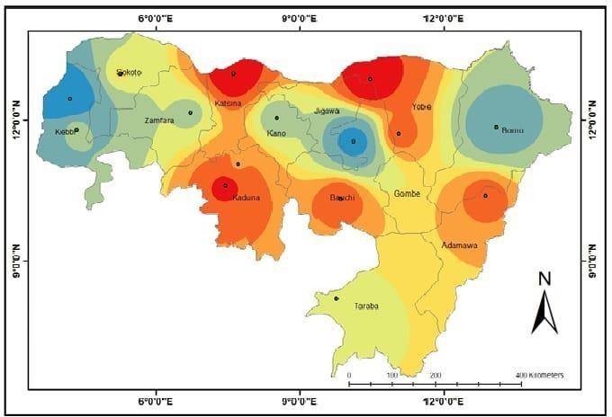

FIGURE 3.1: NIGERIA MAP SHOWING STUDY AREA

GEOLOGY AND RELIEF

The Geology and Topography of Northern-Eastern and North-Western Nigeria described here are mainly based on the work of Tuley and Alford (1975). Northern-Eastern and North-Western Nigeria belongs almost completely to the Basement Complex. In association with the Basement Complex are the pre-cambian igneous and metamorphic rocks and granite rocks. The granite rocks are in general associated with porosities of about 1%, compared to such rocks as limestone with a porosity of 10%. Their permeability is also in the same range of about 1%. There also exist cretaceous deposits such as gravels, clay sands, shales, gypsum, having marl, and ferruginous sand stones.
The relief ranges from 300m to 750m around Katsina and Zaria provinces and around 1,600m in the Bauchi and Adamawa highlands (fig 3). The region has an average slope of about 2˚C (Tuley and Alford, 1975). Pugh and Kings (1952) have outlined the geo-morphological history of the country regarding the landscape as an arrangement of plantation surfaces of different levels separated by escarpments or broad zones of dissection.
The influence of climatic fluctuations is reflected in the superficial deposits overlaying most of northern Nigeria. In the Chad Basin, there led to the deposition of series of longitudinal and traverse dunes (Grove 1958, Grove and Pullan 1964, Grove and Warren 1968). Repeated regressions of Lake Chad led to the formation of stand line ridges such as the Barma and Ngelewa ridges, and the deposition of lagoonal clay flate and deltas in between these ridges. The Northern part of Nigeria is underlain by the Basement Complex and the sedimentary rocks in the Chad Basin. The Basement Complex is pre-cambian. Volcanic rocks present in the Biu, Languda and Mambila areas are of tertiary age.

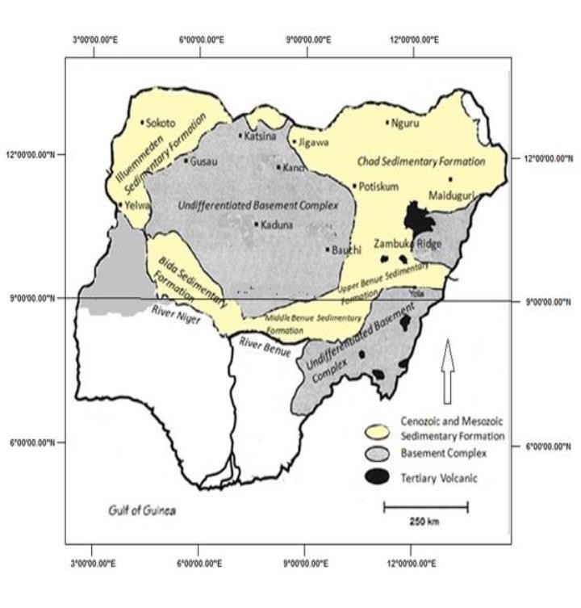

Figure 3.2: Major Geological Formation of The Study Area (Opara 2021)

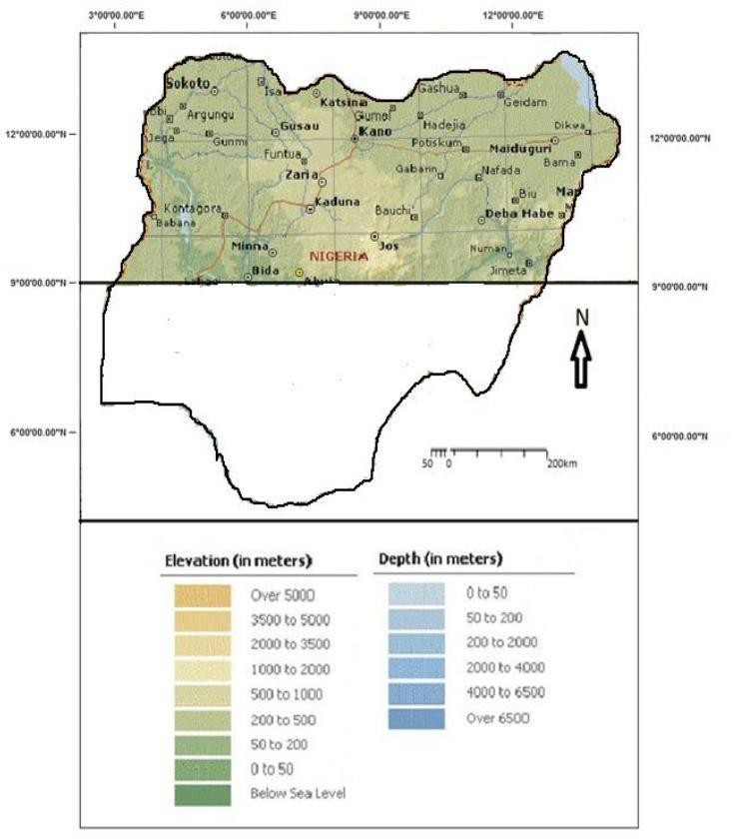

Figure 3.3: Major Relief of the Study Area (Boma 2020)

CLIMATE OF THE STUDY AREA

The study area is characterized by the presence of distinct wet and dry seasons, often referred to as the rainy and dry seasons, which alternate as the major climatic pattern (Oguntoyinbo, Areola and Filani, 1978). This is as a result of the migration of the ITD or ITCZ. This line is formed by the meeting of the Tropical Maritime Airmass (TM) which is wet and the Tropical Continental Airmass (TC) which is dry. Generally, the climate of Northern Nigeria like elsewhere in Nigeria is controlled by temperature, wind, pressure, atmospheric humidity, and precipitation.

VEGETATION AND SOIL

The natural vegetation is that of the Guinea and Sudan Savannah grassland, woodlands, shrubs, and parklands. Impact of agricultural practices and open range grazing has affected the vegetation types greatly. Tuley and Alford (1975) summarized the relations between the soils and vegetation as:
- Soils of hills and rocks which are largely shallow with pockets of deep often fertile soils carry a diverse and composite vegetation.
- Soils over iron pan carry a characteristic plant community with dwarf grasses and specialized herbs.
- Infertile soils with gravels carry lower grassland of thin leaved species.

Whyte (1966) observed that the disappearance of the woody plants in the tropic sand reduction in their average height adversely affects the micro-climate. As a result, the Sahelian drought of 1973 was blamed on industrial activity in the developed nations of the Northern Hemisphere

Soils and vegetation are closely related, and they are associated with one another in the people’s mind (Areola, 1978). The vegetation cover has always served as an indicator of soil status for the local people in their agricultural and other primary production activities. In the absence of animal and chemical manure, Nigerian farmers relied on bush fallow for the restoration of soil fertility. The rudosols occur mainly in the Chad Basin. They are brown to grey-brown coarse sandy soils developed on desert sand drift, found principality in central Borno and the north-eastern margins of the Kano region. Some lateralization has taken place so that iron concretions occur in the weathering profile in some places. Apart from the poor profile development and low water retention, their productivity is further impaired by the lack of an adequate vegetation cover to supply soil organic matter. The vegetation consists of scattered thickets of shrubs with a sparse grown flora of tufted grasses. The area is used mainly for grazing and browsing by cattle and goats.
In the savanna regions of the north, the terrain consists of isolated rocky hills and hill ranges rising above extensive plains dissected by streams. Where the underlying rock is made up of biotite granite or greiss, moderately deep soils occur in close rock out crops. Elsewhere lithosols and shallow soils are most widespread close to the hills. The soil becomes progressively deeper towards the valleys. The deep soils of the rolling plains which support most of the agricultural products of the region have low to medium organic matter content, moderate to good water holding capacity and a friable consistency. Furthermore, over large areas, the vegetation does not provide adequate cover for the soil, especially at the beginning of the rains. This is because incessant annual bush burning has reduced the grass cover so that large tracts are occupied by shrubs and woody plants between which the ground surface is exposed (Areola, 1978).
Incessant annual bush burning has reduced the grass cover so that large tracts are occupied by shrubs and woody plants between which the ground surface is exposed (Areola, 1978).

Shaduf irrigation and flood plain farming are practiced in the dry savanna regions (Floyed, 1965). In the savanna regions, organic litter is usually ploughed into the soil when heaps or ridges are being made. Savanna vegetation covers over three-quarters of the land area of Nigeria, but it contains very low timber tree species. In fact, most of the savannas have a crop fit only for firewood.

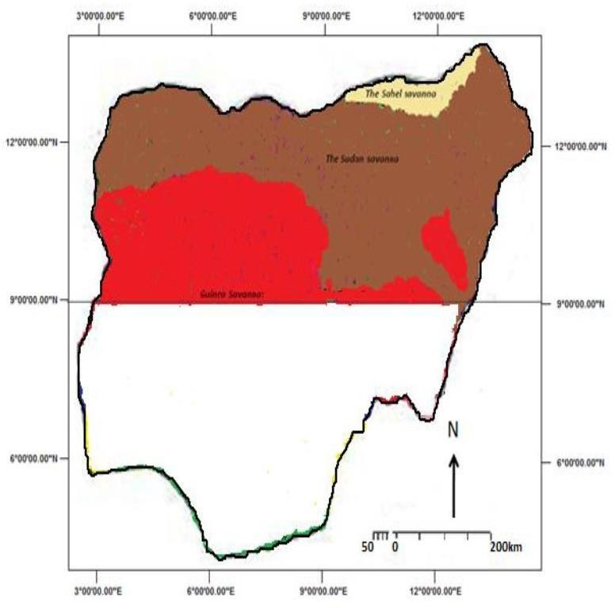

Figure 3.4: VEGETATION MAP OF THE STUDY AREA

Rainfall Data

Observed rainfall and simulation dataset were used and analyzed in this study. Daily and Monthly observation dataset at a resolution of (0.5⁰ x 0.5⁰) was retrieved from the global gridded climatology of Climate Research Unit (CRU; version 4.01; Harris et al., 2014). The dataset provided by CRU covers the entire global land-surface over the period of (1981 to 2019).
Daily dataset simulated by Rossby Center for Atmospheric Regional Climate Model (RCA4- RCM; Popke et al., 2013) driven by MPI-ESM-LR GCM was obtained from CORDEX (Nikulin et al. 2018) at a resolution of (0.44⁰ x 0.44⁰) horizontal grid size over Africa. The simulation RCA4 comprises of the historical (1976-2005) and the projection part (2020-2100) under two different emission scenarios (RCP4.5 and RCP8.5; Thomson et al. 2011; Riahi et al. 2011; Samuelsson et al. 2015). Temperature (minimum and maximum) and precipitation over West Africa were analyzed for both datasets.

Table 3.1: Detail description of the two datasets used.

Dataset type | Observation | Simulation
Dataset Name | CRU | RCA
Dataset Version | 4.01
Period | 1981-2019 | 1976-2005, 2020-2100
Historical/RCP | Historical | Historical, 4.5 and 8.5
Parameters | Precipitation, Minimum and Maximum Temperature | Precipitation, Minimum and Maximum Temperature

Resolution | 0.5 x 0.5 degree | 0.44 x 0.44 degree
Driving Model |  | MPI-ESM-LR

Remote Sensing and GIS Analysis

Image Geo-Processing for Vegetation Change

A Linear Regression Model was used to achieve the existence of relationship between NDVI and rainfall in the study area for objective 2 in which the average of the mean value of NDVI at grid point was correlated against the mean value of rainfall at each grip point.
The study made use of the near real time data of Moderate Resolution Imaging Spectroradiometer (MODIS), Terra and Aqua Normalized Difference Vegetation Index (NDVI) of 16 Day L3 Global 250 m resolution. NDVI values from 2000 to 2019 were considered for this study.
A linear regression line has an equation of the form.
Y = a + bX → (1)
where X is the explanatory variable and Y is the dependent variable. The slope of the line is b, and a is the intercept (the value of y when x = 0).
The coefficient of determination (R²) measures how well a statistical model predicts an outcome. The lowest possible value of R² is 0 and the highest possible value is 1. Put simply, the better a model is at making predictions, the closer its R² will be to 1.

Inverse Distance Weighted Interpolation

The Inverse Distance Weighted (IDW) technique was used for the generation of drought risk maps for three different periods. This method assumes that the interpolating surface is easily influenced mostly by near points. Inverse distance weighted (IDW) interpolation determines cell values using a linearly weighted combination of a set of sample points. The weight is a function of inverse distance. The surface being interpolated should be that of a locationally dependent variable.

Standardized Precipitation Index (SPI)

This was used to determine the occurrence of drought of different intensities particularly near normal, moderate and severe drought in the study area for objective 1. The standardized Precipitation index (SPI) is a tool widely used in measuring drought intensity. The method was developed by (Mckee et al., 1993), using only observed precipitation as primary variable in its computation. Mathematically, it is stated as follow:
12
1

𝐴𝑅 = 12 ∑ 𝑅𝑖
𝑖=1
→ (2)

Where R is the monthly rainfall amount, i is the months of the year, and 𝐴𝑅 is the annual rainfall amount at that station.
The standardized values were calculated for all the years from the use of the long-term mean, yearly mean and the standard deviation using equation (3)

𝜑 =
𝑋 − 𝑋̅
𝜎 → (3)

Where 𝜑 represent the standardized Precipitation 𝑋 is the actual value of Rainfall Parameter, 𝑋̅ is the long term mean value of the Rainfall Parameter and 𝜎 is the standard deviation.
The standardized precipitation index (SPI) drought categorization table shown in Table 3.3 was used to access possible drought occurrence in each of the stations. SPI values can be positive or negative. All negative SPI values represent drought occurrence, while the positive values show no drought. In this study, only the 12-month standardized Precipitation Index (SPI) was applied in each station to determine the risk and vulnerability of drought in the study area. The 12-monthSPI is usually tied to stream-flows and reservoir levels as well as annual drought intensity.

The SPI calculation used in Table 3.2 was based on the long-term precipitation record for a desired period. This long-term record is fitted to a probability distribution, which is then transformed into a normal distribution so that the mean SPI for the location and desired period is zero (Edwards and McKee, 1997). Positive SPI values indicate greater than median precipitation, and negative values indicate less than median precipitation. Because the SPI is normalized, wetter and drier climates can be represented in the same way, and wet periods can also be monitored using the SPI.

STANDARDIZED PRECIPITATION EVAPOTRANSPIRATION INDEX (SPEI)

This was also used to determine the occurrence of drought of different intensities particularly near normal, moderate, and severe drought in the study area for objective 1. This is considered as relatively new drought index, SPEI makes use of the basis of SPI but includes a temperature parameter in its computation, which makes it necessary for the SPEI to give an account of the effect of temperature on drought development through a basic water balance calculation. The intensity scale of SPEI can be calculated in both positive and negative values, identifying wet and dry events. It can be calculated for time steps of 1-month up to 48-months and more. The operational monthly update allows it to be useful, and the longer the time series of data available, the more robust the results will produce. Mathematically, it can be determined by the difference
(D) between precipitation (P) and potential evapotranspiration (PET) that can be computed using different methods and approaches. In this work, Hargreaves's temperature-based PET (Hargreaves, 1982; Hargreaves, and Samani, 1985) was used to calculate the potential evapotranspiration over the study area and periods. This is given below as:

D = Pi - PETi → (4)

Like SPI, SPEI is calculated at a different timescale of 3-, 6- and 12-month to determine short, medium and long-term drought over the study area.
PET = 0.0023 * Ra * (Tmax - Tmin) * √(Tavg + 17.8) → (5)
Then it was standardized using the mean and standard deviation to obtain the Standardized
Precipitation Evapo-Transpiration Index (SPEI) values.
SPEI = (Precipitation Deficit - μ) / σ → (6)
Drought conditions were classified using the SPI and SPEI. Table 3.3 shows the dryness/wetness grade categorized according to SPI and SPEI (McKeel et a.,1993; Vicente-Serrano et al. 2010a, b); this standardization is a mechanism for applying both the SPEI and SPI to determine the
rarity of a projected drought. An index of 0.0 to -1.0 indicates mildly dry; -1.0 to -1.49 is moderately dry; -1.5 to -1.99 regarded as severely dry; -2.0 or less depicts extremely dry.

Table 3.2: Standardized Precipitation Index. (Mckee et al. 1993)

2.0+ | Extremely wet
1.5 to 1.99 | Very wet
1.0 to 1.49 | Moderately wet
-0.99 to 0.99 | Near normal
-1.0 to -1.49 | Moderately dry
-1.5 to -1.99 | Severely dry
-2 and less | Extremely dry

Table 3.3 Drought classification from standardized precipitation index (SPI) and standardized precipitation evapotranspiration index (SPEI) values.

SPI/SPEI Value | Classification
-0.49 to 0.49 | Near Normal
-0.99 to -0.50 | Mildly Dry
-1.49 to -1.00 | Moderately Dry
-1.99 to -1.50 | Severely Dry
Less than -2.00 | Extremely Dry

DROUGHT CHARACTERISTICS USING CONSECUTIVE DRY DAYS THEORY

This was used to determine the projection of drought in the study area for objective 3. Maximum number of consecutive dry days per time-period with daily precipitation amount of less than 1 mm. Consecutive dry days are included in the index as an indication of drought conditions. It is defined as the number of consecutive days with less than 1mm of rain up to a maximum of 365 days.
A threshold value of 0.1 mm is used and days with precipitation less than this threshold are considered dry days. The duration of CDDs indicates the number of consecutive days with daily precipitation than this threshold.
CDD (days) = count ∑₁ⁿ (Pᵣ ≥ 0.1 → (7)
For each day (r = 1 to n), check if the precipitation value Pᵣ is greater than or equal to 0.1 (the threshold). If the condition is met, increase the count of consecutive dry days. If the condition is not met, reset the count to zero.
The drought index measures low precipitation, where high values indicate prolonged periods of little rainfall and conditions favorable for drought. If the index increases over time, it indicates a growing likelihood of drought conditions.

CHAPTER FOUR

RESULT AND DISCUSSION

Spatial Representation of SPEI over North-East and North-West Nigeria

The SPEI is a drought index that measures the balance between precipitation and evapotranspiration. It is calculated by comparing the actual moisture levels in an area to what is considered the normal or average moisture levels.
Over Bauchi, the SPEI ranges between 2.5 and -2.5, with the highest value of 2.5 recorded in the year 2002 and the lowest value of -2.4 in the year 1983. A value of 2.5 indicates a significant amount of moisture in the area, which is well above the average. This could be due to above- average rainfall levels or higher levels of evapotranspiration, which is the release of moisture from the ground and vegetation into the atmosphere.
It is interesting to note that the SPEI value in Bauchi has shown a decreasing trend over the years, with its highest value recorded in 1984 decreasing progressively and close to zero between 2001 to 2019. The decrease in drought severity over the years is a positive sign, as it means that the area has become more resilient to the impacts of drought. This can have significant benefits for the local communities, as they are less likely to experience water shortages and crop failures Like Bauchi, Birnin Kebbi and Gusua also have a similar pattern in the SPEI index, ranging between - 3 to 3. The highest index was recorded at 2.5 in 1990-1991 in Birnin Kebbi and at 2.3 in 2002- 2003 in Gusua. The lowest index was -2.8 in 1983-1984 in Birnin Kebbi and in both 1983-1984 and 1986-1987 in Gusua, which were severe droughts in these regions.
From 1984 to 1986, the SPEI value in both Birnin Kebbi and Gusua decreased progressively, which indicates an increase in the severity of the droughts. This trend continued and both regions remained close to zero, which is considered normal, from 1988 to 2019.
Noting that the two regions experienced severe droughts in the years 1983-1984, 1986-1987, and 2001-2002, as reflected in the low SPEI values during these periods. These droughts might have an impact on the local communities, including water shortages, crop failures, and economic losses.
Ibi, like Birnin Kebbi and Gusua, also experiences severe droughts as indicated by low SPEI values. The severe droughts in Ibi were recorded in the years 1985-1986, 1987-1988, 1991- 1992, and 2010-2011. It is also worth noting that Ibi experienced a similar SPEI value of -0.5 between 1981 to 1985, which indicates a below-average moisture balance in the area during this period. Conversely, the SPEI value was +0.5 from 2000 to 2007, which indicates above- average moisture levels in the area.
Sokoto, on the other hand, had a moderate drought from 1982-1999 with the highest index recorded at 2.5 in 1990-1991 and lowest at -2.8 in 1983-1984. This shows that Sokoto was less affected by the extreme drought compared to other regions. It was also observed that the trend of drought occurrence in Sokoto was decreasing progressively from 1984 to 1986 and maintained close to zero, which is considered normal from 1988 to 2019.
Comparing the SPEI over these regions, it is observed that Kano, Katsina, Nguru, Potiskum, Yola, Zaria, and Maiduguri have the highest vulnerability to drought, with extreme drought occurrences observed in the 1980s and 1990s. On the other hand, Yewa-Bauchi and Yewa-Kebbi had a moderate to wet period between 1993-2000, followed by an extreme drought period in 2002. Sokoto had a moderate to wet period between 1997-2002.
However, Maiduguri experienced severe drought in the year 1983-1984, 1986-1987, and 2001- 2002. The SPEI index showed a low value of -0.5 between 1981 to 1985 and a value of +0.5 from 2000 to 2007. In general, the SPEI index indicates that the regions of Kano, Katsina, Nguru, Potiskum, Yola, and Zaria had a higher vulnerability to drought compared to other regions.

Table 4.1: SPEI Drought Classification

SPEI range | Drought class
1.99 or more | Extremely wet
1.49 to 1.99 | Very wet
0.99 to 1.49 | Moderately wet
0 to 0.99 | Normal
0.99 to −0.99 | Near normal
−0.99 to −1.49 | Moderately dry
−1.49 to −1.99 | Severely dry
−1.99 and less | Extremely dry

Time Series Variation from 1981 to 2019

Figure 4.1: Variation in SPEI over Bauchi

Figure 4.2: Variation in SPEI over Birnin Kebbi

Figure 4.3: Variation in SPEI over Gusau

Figure 4.4: Variation in SPEI over Ibi

Figure 4.5: Variation in SPEI over Kaduna

Figure 4.6: Variation in SPEI over Kano

Figure 4.7: Katsina SPI Variation in SPEI over Katsina

Figure 4.8: Variation in SPEI over Maiduguri

Figure 4.9: Variation in SPEI over Nguru

Figure 4.10: Variation in SPEI over Potiskum

Figure 4.11: Variation in SPEI over Sokoto

Figure 4.12: Variation in SPEI over Yewa-Bauchi

Figure 4.13: Variation in SPEI over Yewa-Kebbi

Figure 4.14: Variation in SPEI over Yola

Figure 4.15: Variation in SPEI over Zaria

Spatial Distribution Drought Risk Classification

The risk level and vulnerability were determined by analyzing the SPEI values in the region over different time intervals. Figure 4.16 shows the vulnerability level Between 1994 and 1999, Katsina, Kaduna, Bauchi, Yobe, and Adamawa experienced extremely dry conditions with negative SPEI values, indicating that these regions were at a high risk of drought and highly vulnerable to the negative impacts of below-average moisture balance.
Sokoto, Gombe, Taraba, and Kano had a moderately dry occurrence with moderate SPEI values, suggesting that these regions were at a moderate risk of drought and moderately vulnerable to the negative impacts of below-average moisture balance.
Bornu, Zamfara, Kebbi, and Jigawa had a normal occurrence with close-to-zero SPEI values, indicating that these regions were at a low risk of drought and less vulnerable to the negative
impacts of below-average moisture balance. The eastern and western part is less vulnerable to drought while the central is highly vulnerable to drought as observed in figure 4.16.
From fig 4.17, which depicts between 2004 and 2009, Sokoto, Bauchi, Yobe, Taraba, and Gombe had extremely dry conditions with no negative SPEI values. Kebbi, Zamfara, Katsina, Jigawa, and Adamawa had moderately extreme conditions while Kaduna, Kano, and Borno had normal conditions.
Deductions from fig 4.18, Between 2009 and 2014, Sokoto, Zamfara, Kaduna, Jigawa, Adamawa, had extreme dry conditions with negative SPEI values while Kebbi, Katsina, Bauchi, Gombe, and Borno had moderate dry conditions and Kano, Yobe, and Taraba had low vulnerability to drought.
Also, Fig 4.19 shows vulnerability Between 2014 and 2019, extreme dry conditions were observed in Kebbi, Sokoto, Zamfara, Kaduna, Jigawa, Gombe, and Adamawa, moderate dry conditions in Yobe and Taraba, and low vulnerability to drought in Borno, Kano, and Katsina.

Generally, it is observed that the eastern part of the region has low susceptibility to drought. Throughout the study period, it is observed that Bornu, Kano, Katsina has very low vulnerability to drought while Bauchi, Zamfara and Yobe has a very high vulnerability to drought. The vulnerability and risk level of each station to drought in Nigeria is a critical issue in view of the growing concern over global climate change and its impacts. Several studies have been conducted to assess the vulnerability and risk of Nigeria's regions to drought, particularly in the northern regions.
Adelekan and Oke (2018), in a study, assessed the vulnerability and risk of drought in Nigeria using the Standardized Precipitation Evapotranspiration Index (SPEI) and a combination of biophysical and socioeconomic indicators. The study found that the northern regions are more vulnerable to drought compared to the southern regions due to their relatively lower rainfall patterns and high levels of poverty. The study also found that Bauchi, Kaduna, Katsina, Yobe and Adamawa are the most vulnerable regions to drought in Nigeria.
Also, Olaniran et al. (2017) analyzed the risk and vulnerability of Nigeria's agricultural sector to drought using the SPEI. The study found that the northern regions, particularly Zamfara, Sokoto and Kebbi, are at higher risk of drought due to the frequency of droughts and the lack of agricultural adaptation measures.

In agreement with the two authors, Nigeria's northern regions are more susceptible to drought and face a higher risk and vulnerability to drought due to their low rainfall patterns, poverty levels and lack of adequate adaptation measures. It is crucial that effective measures are taken to reduce the risk and vulnerability of these regions to drought through the development of drought early warning systems, the promotion of drought-resilient agricultural practices and the improvement of socio-economic conditions in these regions.

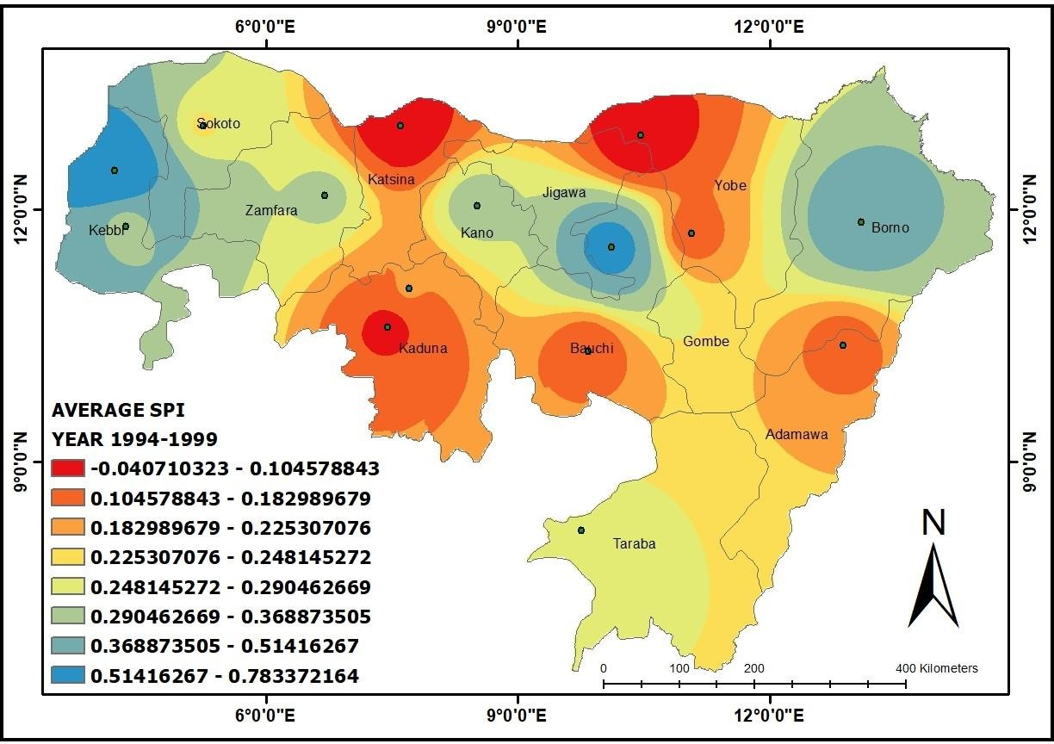

Figure 4.16: Spatial Distribution Drought Risk Level between 1994 and 1999

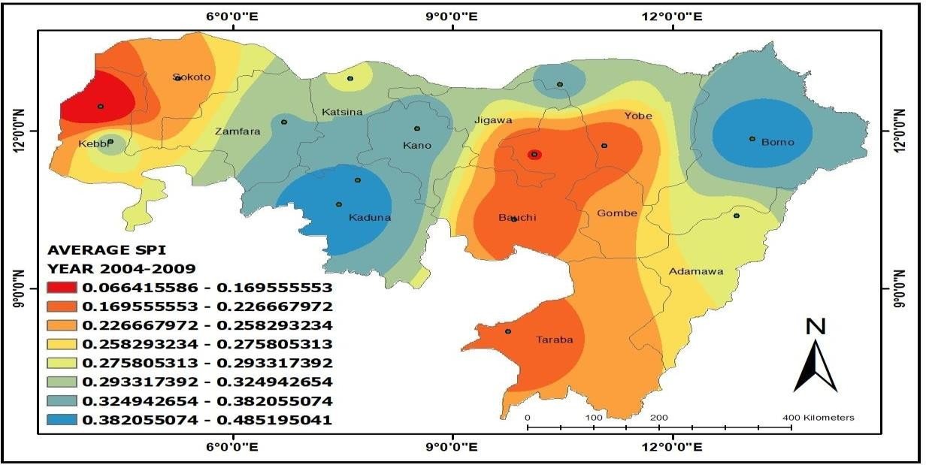

Figure 4.17: Spatial Distribution Drought Risk Level between 2004 and 2009

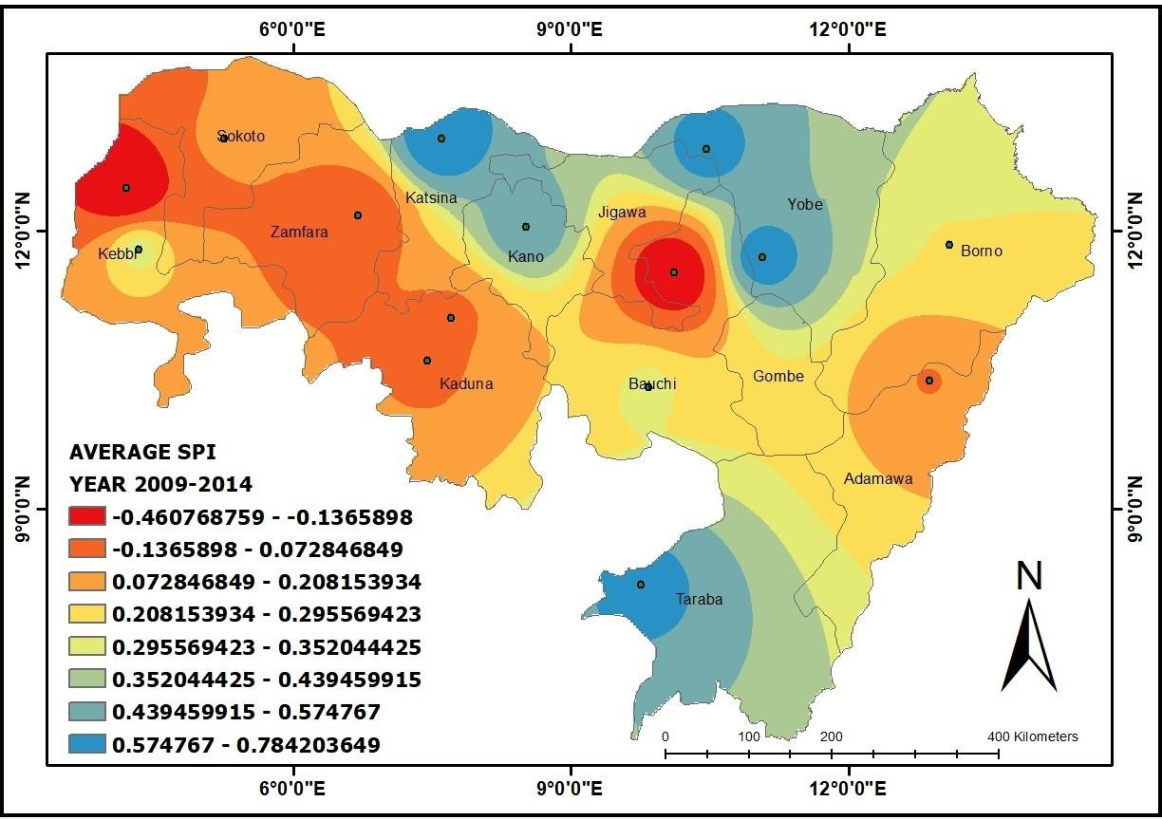

Figure 4.18: Spatial Distribution Drought Risk Level between 2009 and 2014

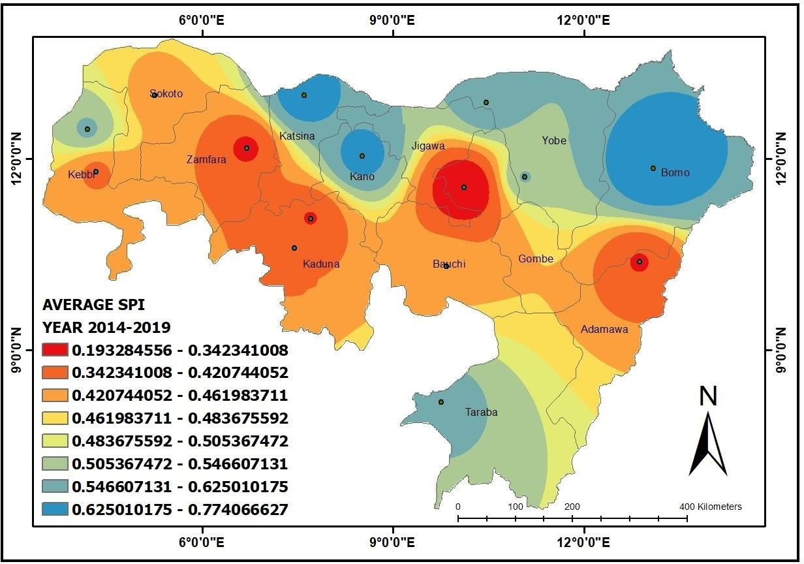

Figure 4.19: Spatial Distribution Drought Risk Level between 2014 and 2019

RELATIONSHIP BETWEEN RAINFALL AND NDVI

The relationship between Annual Normalized Difference Vegetation Index (NDVI) and Annual Rainfall in Northern Nigeria exhibits interesting patterns and variations across different stations.
In Figure 4.20, we can observe two prominent patterns. The first pattern reveals that Bauchi, Birnin Kebbi, Gusua, Ibi, and Kaduna exhibit no correlation between Annual NDVI and Annual Rainfall. This indicates that changes in rainfall do not have a substantial impact on the overall health of vegetation, as indicated by NDVI, in these regions. Several factors might contribute to this absence of a relationship, such as soil characteristics, vegetation types, and local climate dynamics.
On the other hand, figure 4.21 also shows a linear relationship between DJF NDVI and DJF rainfall in Kano, Katsina, Maiduguri, Nguru, Potiskum, Sokoto, and Yelwa-Bauchi. Specifically, as NDVI decreases, rainfall also decreases. This suggests that in these areas, a decrease in rainfall directly impacts vegetation health, resulting in a decline in NDVI values.
During the onset of the rainy season (March, April, May - MAM) as observed in Figure 4.22, from Kano to Zaria, the linear relationship between NDVI and rainfall is observed to be maintained. This indicates that as rainfall increases during the MAM season, NDVI also increases, reflecting a positive impact on vegetation growth and health. This finding highlights the significance of the early stages of the rainy season in supporting vegetation in these regions.
Furthermore, figure 4.23 emphasizes the JJA season (June, July, August), which is the predominant season with the highest rainfall over Nigeria. During this period, a more pronounced linear relationship between NDVI and rainfall is observed, especially in Maiduguri, Nguru, Potiskum, Sokoto, Yola, and Yelwa-Kebbi. This indicates that the high rainfall during JJA significantly influences vegetation growth, resulting in higher NDVI values.

It is important to consider various factors that can influence the relationship between NDVI and rainfall. Soil characteristics, such as water-holding capacity and nutrient availability, can impact vegetation response to rainfall. Additionally, temperature, solar radiation, and evapotranspiration rates can affect the overall moisture availability for plants. Vegetation types, such as grasslands, forests, or croplands, may respond differently to changes in rainfall. Land use changes and human activities, such as irrigation or deforestation, can also influence the relationship between NDVI and rainfall.
Differences in elevation across the Northern Nigerian region can lead to variations in rainfall distribution and intensity, further influencing the relationship between NDVI and rainfall.
Generally, the relationship between Annual NDVI and Annual Rainfall in Northern Nigeria exhibits regional variations. Bauchi, Birnin Kebbi, Gusua, Ibi, and Kaduna: These regions show no relationship between Annual NDVI and Annual Rainfall. This suggests that variations in rainfall do not significantly influence vegetation health, as measured by NDVI, in these areas.
While some areas show no significant relationship between NDVI and rainfall, others demonstrate a clear linear relationship, indicating the impact of rainfall on vegetation health. The information provided emphasizes the influence of the MAM and JJA seasons, reflecting the importance of the onset of the rainy season and the high rainfall period on vegetation growth.

Table 4.2: Correlation coefficient of NDVI values with Rainfall

Season | Min. NDVI value | Max. NDVI value | Correlation coefficient with rainfall
ANNUAL | 0.40 | 0.71 | 0.46
JJA | 0.49 | 0.70 | 0.20
MAM | 0.43 | 0.77 | 0.56
DJF | 0.20 | 0.46 | 0.16

Rainfall
NDVI

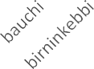



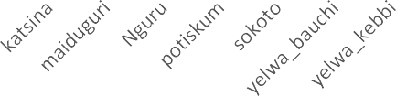


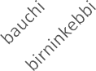



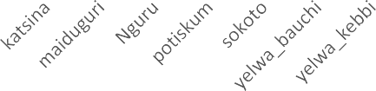


Figure 4.20: Annual Rainfall and Annual NDVI
Annual Rainfall and NDVI
1400
1200
1000
800
600
400
200
0
0.8
0.7
0.6
0.5
0.4
0.3
0.2
0.1
0
y = -9.3121x + 962.54 Stations
R² = 0.0332
y = -0.0115x + 0.643
R² = 0.2907
ANNUAL-RAIN NDVI-annual Linear (ANNUAL-RAIN) Linear (NDVI-annual)
DJF Rainfall and NDVI
3
2.5
2
1.5
1
0.5
0.6
0.5
0.4
0.3
0.2
0.1
Station

DJF Ndvi-djf
Rainfall
NDVI

Figure 4.21: DJF Rainfall and DJF NDVI

Rainfall
NDVI

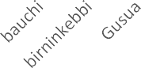

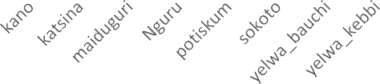


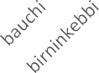



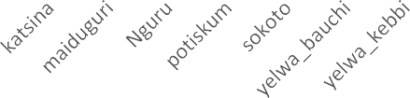


Figure 4.22: MAM Rainfall and MAM NDVI
MAM Rainfall and NDVI
250
200

150

100

50

0
0.9
0.8
0.7
0.6
0.5
0.4
0.3
0.2
0.1
0
Stations

MAM NDVI-mam
JJA Rainfall and NDVI
1200

1000

800

600

400

200

0
0.8
0.7
0.6
0.5
0.4
0.3
0.2
0.1
0
Stations
JJAS
NDVI-jjas
Rainfall
NDVI

Figure 4.23: JJA Rainfall and JJA NDVI

Projection of Consecutive dry days

Based on the projected distribution of consecutive dry days in the future, RCP4.5 warming scenario, in Figure 4.24(a), it describes the projection change of CDD for the near future, which is expected to be within a range of -0.8 to 1.2. This range indicates that some areas may experience fewer consecutive dry days, while others may have more extended dry periods as observed in the southern borders of the study area, the projection shows mild dryness across the study map.
In contrast, Figure 4.24(b) shows the projected change of CDD for the mid-future, which appears to be relatively drier than the near future. The range of CDD values widens, ranging from -0.4 to 1.6, indicating a more significant variation in the number of consecutive dry days across the region. The northern region is expected to have more dryness than the southern region. The positive values suggest that some areas may experience longer dry periods.
Figure 4.24(c) further shows the projected change of CDD for the far future under the RCP 4.5 warming scenario. The range of CDD values widens even further, ranging from -0.6 to 1.8. This range suggests that there may be significant changes in the number of consecutive dry days across northern Nigeria, with major areas in the south experiencing more extended and severe dry periods than the north. The potential impacts of these changes could be severe, affecting agriculture, water resources, and natural ecosystems in the region.
Figure 4.25 also describes the future distribution of consecutive dry days (CDD) under RCP 8.5 warming scenario over northern Nigeria. The RCP 8.5 scenario is a high-emission scenario that assumes no climate change mitigation measures are taken, leading to a significant increase in greenhouse gas emissions and warming of the planet.
Figure 4.25(a)shows the near future of projected change of CDD over northern Nigeria under the RCP 8.5 scenario. The range of CDD is between -0.3 and 1, indicating an overall increase in the number of consecutive dry days. This finding is consistent with the projections made by Adeniyi et al. (2019) in their study on the impact of climate change on CDD in Nigeria under various climate scenarios. Figure 4.25(b) shows the projected change of CDD for the mid-future, which is relatively drier than the near future, with a range of -0.4 to 0.8. Figure 4.25(c) shows the far- future projected change of CDD under the RCP 8.5 scenario, with a range of -0.4 to 1.
In conclusion, the projected change depicted in Figure 4.24 suggest that northern Nigeria is likely to experience changes in the number of consecutive dry days under the RCP 4.5 warming scenario. The changes may vary in the near, mid, and far future, with some areas experiencing longer and more severe dry periods than others. It's crucial for policymakers and individuals to take action to mitigate the impacts of climate change and reduce greenhouse gas emissions to limit global warming and its adverse impacts on northern Nigeria and other regions of the world.
Comparing the projected change of CDD under RCP 4.5 and RCP 8.5 warming scenarios, Figure 4.24 and Figure 4.25 respectively, it is observed that the range of CDD values in Figure 4.25 is slightly lower than that of Figure 4.24, particularly for the near and far future. This is because the RCP 8.5 scenario assumes a higher rate of greenhouse gas emissions and warming than the RCP 4.5 scenario, resulting in a more significant increase in CDD. In both scenarios, however, there is a clear trend towards increased CDD, in the mid-future indicating a more extended period of dry conditions.
Adeniyi et al 2019 in it study examined the impact of climate change on CDD in Nigeria under various climate scenarios. The study projected that CDD would increase across Nigeria under the RCP 4.5 and RCP 8.5 scenarios, with the most significant increases occurring in the northern regions. This finding is consistent with the trends depicted in Figure 4.2
    - Future Projected Change of Consecutive Dry days under RCP4.5 Warming Scenario

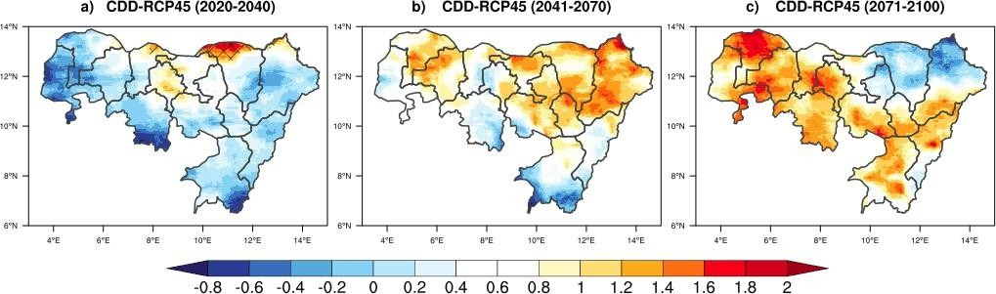

Figure 4.24: (a) Near Future Projected change of CDD (2020 to 2040), (b) Middle Future Projected change of CDD (2041 to 2070) and (c) Far future Projected change (2071 to 2100) under RCP4.5

Future Projected Change of Consecutive Dry days under RCP8.5 Warming Scenario
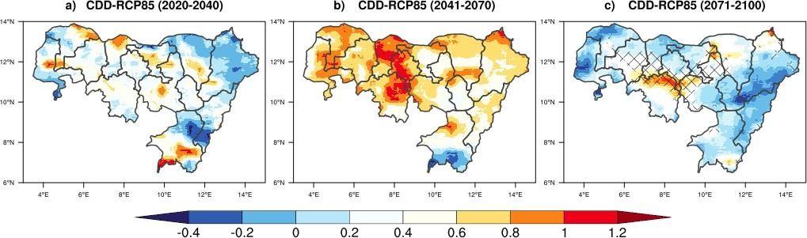

Figure 4.25: (a) Near Future Projected change of CDD (2020 to 2040), (b) Middle Future Projected change of CDD (2041 to 2070) and (c) Far future Projected change (2071 to 2100) under RCP8.5

CHAPTER 5 CONCLUSION AND RECOMMENDATION

CONCLUSION

This study assesses the projected drought characteristics and climate extremes over North-East and North-West Nigeria. The data used consists of observation (CRU) and simulation dataset for projection years from 2020-2100 (cordex; daily rainfall and minimum and maximum temperature). The latter was further divided into three classifications for projection (Near future, mid future and far future) to provide possible climate change trend in the future. Two drought indicators (SPEI and consecutive dry days) were used to characterize historical and projected droughts variability. The result indicated that during the present climate period (1981-2019), it is observed that the eastern part of the study region has low susceptibility to drought. Throughout the study period, it is observed that Bornu, Kano, Katsina has very low vulnerability to drought while Bauchi, Zamfara and Yobe has a very high vulnerability to drought.
The projection of drought characteristics shows an increasing trend over time and a noticeable change in the area to be affected. Drought duration is projected to increase from 2020 till 2100. The study further indicated that the frequency of consecutive dry days in northern Nigeria is projected to increase under the RCP 4.5 warming scenario. In the near (2020 to 2040), mid (2041 to 2070), and far future (2071 to 2100), the changes may vary, with some locations having longer and more severe dry periods than others. To prevent global warming and its negative implications on northern Nigeria and other parts of the world, policymakers and individuals must take action to mitigate the effects of climate change and reduce greenhouse gas emissions.

When the trend pattern of consecutive dry days is compared under RCP 4.5 and RCP 8.5 warming scenarios, the increasing trend in near future (2020 to 2040) is slightly lower than that of mid future (2041 to 2070). This is because the RCP 8.5 scenario forecasts a higher pace of greenhouse gas emissions and warming than the RCP 4.5 scenario, resulting in a greater increase in CDD. However, in both scenarios, there is a definite trend towards higher CDD in the mid- future, indicating a longer duration of dry conditions over the study region.
The analysis of SPEI indicates that a greater proportion of the Northern Nigeria may become drier in the future, because of increasing PET together with continuous CWB deficit observed over West Africa would enhance evaporation losses and increase irrigation demands for drier soils. This will have negative impacts on regional development, as economic activities (e.g., agriculture, home, and industrial water supply, tourism) will take longer than usual to recover after each drought episode. The increasing population also implies that demand for water may escalate.

RECOMMENDATION

The result of this work provides a basis for developing policy and strategy to reduce future drought risks over Northern Nigeria. At the same time, it advocates for a more proactive response to increase adaptive and resilience options at multi-national and local levels. For instance, the analysis of SPEI indicates that a greater area of Northern Nigeria may become drier in the future, because of increasing PET together with continuous CWB deficit observed would enhance evaporation losses and increase irrigation demands for drier soils.
Hence, there is a need for the formulation of strategic policy that can accommodate or encourage
such a land-use change. Also, policies are needed to cope with the increasingly complex interaction
between climate stresses, not only in the short term but importantly, in the long term. There is a
need for better stakeholder engagement in timely planning and implementation of climate autonomous and planned adaptation strategies in Northern Nigeria to address cross-regional and cross- sectoral issues in tackling the potential impacts of projected climatic changes under increasing global warming.
Lastly, this study results can be improved and applied to reduce future drought risks over Northern Nigeria by examining the role of atmospheric processes in the discrepancies observed between consecutive dry days projections; the absence of important upper-level data in the archive of CORDEX did not make such investigation possible in this work.

REFERENCE

Abaje, I.B., Ati, O. F., Iguisi, O. O. (2012). Recent Trends and Fluctuations of Annual Rainfall in the Sudano Sahelian Ecological Zone of Nigeria. Journal of Sustainable Energy 1(2), 44-51, 2012
Alli, A. A., Oguntunde, P. G., Olufayo, A. A., & Fasinmirin, J. T. (2012). "Implications of Trends and Cycles of Rainfall on Agriculture and Water Resource in the Tropical Climate of Nigeria". Special Publication of the Nigerian Association of Hydrological Sciences, 188– 200.
Atedhor, G.O. (2016) Growing Season Rainfall Trends, Alterations and Drought Intensities in the Guinea Savanna Belt of Nigeria: Implications on Agriculture. Journal of Environment and Earth Science, 6. https://www.iiste.org/
Ayoade, J.O. (2003) Climate Change: Synopsis of its Nature, Causes, Effects and management. Vantage Publishers, Ibadan.
Ayuba, H.K., Maryah, U.M. and Gwary, D.M. (2007) Climate Change Impact on Plant Species Composition in Six Semi-Arid Rangelands of Northeastern Nigeria. The Nigerian Geographical Journal, 5, 35-42.
Balling E. (1968). A layman's guide to psychiatry and psychoanalysis (31 ed. rev.). New York: Simon and Schuster. (Original work published 1947 as the mind in action).
Basher, R., (2000). The goals of the forum. Proceedings of the International Forum on Climate Prediction, Agriculture and Development, IRI-CW/00/1, Internatio nal Research Institute for Climate Prediction, 1–2.
Beck H. E., McVicar T. R., Van Dijk A. I, Schellekens J., De Jeu R A & Bruijnzeel L A (2011) Global Evaluation of four AVHRR– NDVI data sets: Intercomparison and Assessment against Landsat imagery, Remote Sensing of the Environment. 115 2547–63
Binboll, N. L., & Edicha, J. A. (2016). Drought Risk Assessment in Yola, Adamawa State Nigeria. Katsina Journal of Natural and Applied Sciences, 2, 1-9.
Bradley, B.A., Jacob, R.W., Hermance, J.F., Mustard, J.F. (2007). A Curve Fitting Procedure to Derive Inter-Annual Phenologies from Time Series of Noisy Satellite NDVI Data, Remote Sensing of the Environment. 106 137–45
Brandt M., Aleixandre V., Abdoul Aziz D., Fr´ed´eric B. & Cyrus S.I, (2014). “Local Vegetation Trends in the Sahel of Mali and Senegal Using Long Time Series FAPAR Satellite Products and Field Measurement (1982–2010)” Remote Sensing 2014, 6, 2402434; doi:10.3390/rs6032408, ISSN 2072-4292, www.mdpi.com/journal/remotesensing

Bryson, R.A., John E. (1973). Climatic variation and implications for world food production.
Christiana F. Olusegun, Akeem B. Rabiu, Jared O.H., Ndeda, Emmanuel C Okogbue (2014) Trends of temperature and signature of solar activity in selected stations in Nigeria
De Chavez and Tauli-corpus (2008). Climate Change and Adaptation Measures In The Northern Nigeria: Empirical Situation And Policy Implications.
Dirmeyer, P.A. (2003). Regions of strong coupling between soil moisture and precipitation.
Ekpoh, I.J. and Nsa, E. (2011) Extreme Climatic Variability in North-Western Nigeria: An Analysis of Rainfall Trends and Patterns. Journal of Geography and Geology, 3, 51-62.
Ekundayo, O.Y., Okogbue, E.C., Akinluyi, F.O., Kalumba, A.M., Orimoloye I.R. (2021) Spatiotemporal drought assessment using vegetation health index and standardized precipitation index over Sudano-Sahelian region of Nigeria
Ekwezuo, C.S., Ezeh, C.U. (2020) Regional characterization of meteorological drought and floods over west Africa. Sustain. Water Resources. Manag. 2020, 6, 80. [CrossRef]
Hulme, M. (1992). Rainfall Changes in Africa: 1931-1960 to 1961-1990. International Journal of Climatology, 12, 685-699.
Klein, T. (2005). Changes in daily temperature and rainfall extremes in Central and South Asia
Mohmmed, A.; Li, J.; Elaru, J.; Elbashier, M.M.; Keesstra, S.; Artemi, C.; Martin, K.; Reuben, M.; Teffera, Z. Assessing drought vulnerability and adaptation among farmers in Gadaref region, Eastern Sudan. Land Use Policy 2018, 70, 402–413. [CrossRef]
Meque, A.; Abiodun, B. Simulating the link between ENSO and summer drought in Southern Africa using regional climate models. Clim. Dyn. 2015, 44, 1881–1900. [CrossRef]
Martin-Vide, J.; Lopez-Bustins, J.A. The western Mediterranean oscillation and rainfall in the Iberian Peninsula. Int. J. Climatol. 2006, 26, 1455–1475. [CrossRef]
Oloruntade, A.J.; Mohammad, T.A.; Ghazali, A.H.; Wayayok, A. Analysis of meteorological and hydrological droughts in the Niger-South Basin, Nigeria. Glob. Planet. Chang. 2017, 155, 225-233. [CrossRef]
Oladipo, E.O., Iliya, B.A. (1991). Recent changes in temperature and rainfall condition over Kaduna state, Nigeria
Oguntoyinbo, O.O., Areola, Filani. M. (1978). Waste Disposal Problems and Management in Ughelli, Nigeria.
Ogunrinde, P. G., Oguntunde, J. T., Fasinmirin, Emmanuel C. Okogbue (2018). Analysis of recent changes in rainfall and drought indices in Nigeria, 1981–2015
Oguntunde, P.G.; Lischeid, G.; Abiodun, B. Impacts of climate variability and change on drought characteristics in the Niger River Basin, West Africa. Stoch. Environ. Res. Risk Assess. 2018, 32, 1017–1034. [CrossRef]
Okogbue, E.C., S.B., Ogungbenro, S.B., Fashanu, O. (2015). Analysis of global solar irradiance over climatic zones in Nigeria for solar energy applications
Oluleye, A., Okogbue, E.C., (2013) Analysis of temporal and spatial variability of total column ozone over West Africa using daily TOMS measurements
Okogbue, E.C., O. Akinluyi, F. (2016). Mapping evapotranspiration for different landcover in the Lake Chad region of Nigeria using landsat datasets
Park, S., Kang, D., Yoo, C. Lam, J., Lee, M.-I. Recent ENSO influence on East African drought during rainy seasons through the synergistic use of satellite and reanalysis data. J. Photogramm. Remote Sens. 2020, 162, 17–26. [CrossRef]
Projected changes in wind energy potential over West Africa under the global warming of 1.5 C and above; W. Sawadogo, B.J., Abiodun, E.C., Okogbue (2019)
Randolph, H.W. (2004). Fostering Intrinsic Motivation in children: A Humanistic Counselling Process.
Statistical modeling of monthly rainfall in selected stations in forest and savannah eco-climatic regions of Nigeria; A. Akinbobola, E.C. Okogbue, A.K. Ayansola (2018)
State-of-the-art climate modeling of extreme precipitation over Africa: analysis of CORDEX added value over CMIP5; P. Gibba, M.B., Sylla, E.C., Okogbue, A.T., Gaye, M.N.
Schneider, S.M., Hebuterne, et al. (2004) Malnutrition Is an Independent Factor Associated with Nosocomial Infections. British Journal of Nutrition, 92, 105-111.
Temidayo, O. Omonijo, Emmanuel C. Okogbue Trend Analysis of Drought in the Guinea and Sudano-Sahelian Climatic Zones of Northern Nigeria (1907-2006)
Tyson, R.V. and Pearson, T.H. (1991) Modern and Ancient Continental Shelf Anoxia: An Overview. In: Tyson, R.V. and Pearson, T.H., Eds., Modern and Ancient Continental Shelf Anoxia, Geological Society Specical Publications, London, 1-24.
Verner, D., Treguer, D., Redwood, J., Christensen, J.. McDonnell, R., Elbert, C., Konishi, Y., Belghazi, S. Climate Variability, Drought, and Drought Management in Morocco’s Agricultural Sector. 2018. Available online: http://hdl.handle.net/10986/30603 (accessed
on 10 November 2021).

Vicente-Serrano, S.M., Aguilar, E., Martínez, R., Martín-Hernández, N., Azorin-Molina, C.; Sánchez-Lorenzo, A., El Kenawy, A., Tomás-Burguera, M., Moran-Tejeda, E., López- Moreno, J. The complex influence of ENSO on droughts in Ecuador. Clim. Dyn. 2017, 48, 405–427. [CrossRef]
Wang, Y., Xia, W.T., Liang, T.G., Wang, C. (2010b). Spatial and Temporal Dynamic Changes of Net Primary Product Based on MODIS Vegetation Index in Gannan Grassland. Acta Prataculturae Sin. 19 201–10 (in Chinese)
Weiss, M., & Baret, F. (2004). Evaluation of Canopy Biophysical Variable Retrieval. Remote Sensing of Environment, 70, 293-306. https://doi.org/10.1016/S0034-4257(99)00045-0
Xue, G., et al. (1997) Optimal Transformations for Multiple Regression: Application to Permeability Estimation to Permeability Estimation from Well Logs.
Yang, L.S., Li, C.B, Wang, S.B., & Yang W J (2014). Sensitive analysis of potential evapotranspiration to key climatic factors in Taohe River Basin Trans. Chin. Soc.Agric. Eng. 30 102–9 (in Chinese with English abstract)
Yang, L., Wylie, B.K., Tieszen, L.L. & Reed, B.C., (1998). An analysis of relationships among climate forcing and time integrated NDVI of grasslands over the US northern and central Great Plains. Remote Sensing of Environment 65, 25–37.
Yengoh, G.T., Dent, D., Olsson, L., Tengberg, A.E. & Tucker III, C.J. (2014). The Use of the Normalized Difference Vegetation Index (NDVI) to Assess Land Degradation at Multiple Scales: A Review of the Current Status, Future Trends, and Practical Considerations.

