Beneficial redox activity of halide solid electrolytes empowering high-performance anodes for all-solid-state batteries
Zhu Cheng, Wenxuan Zhao, Qidi Wang, Chenglong Zhao, Anastasia K. Lavrinenko, Alexandros Vasileiadis, Victor Landgraf, Lars Bannenberg, Swapna Ganapathy and Marnix Wagemaker*
Section Storage of Electrochemical Energy, Radiation Science and Technology, Faculty of Applied Sciences, Delft University of Technology, Delft, The Netherlands

Supplementary Note 1
The calculated dynamic region ranges between 0.6 and -0.14 V, showing a slight underestimation of the voltage. This underestimation is anticipated primarily due to the conditions of the geometry optimization (performed at 0 K) for the construction of the convex hull. Lithiated/delithiated configurations are inherently further from equilibrium compared to Li₃YCl₃Br₃. Consequently, they are more prone to being trapped in metastable states. These states typically have higher energies, leading to increased energy differences and, therefore, causing a downward shift in the calculated voltage region. Further, the selected DFT framework generally underpredicts the voltage¹.
Supplementary Note 2
Challenging the simulation results and the behavior of the stable region (Li₃YCl₃Br₃ to Li₄YCl₃Br₃), one can argue that decomposition might occur outside the given 100 ps simulation window. However, we can contextualize these findings by comparing them with the behavior of argyrodites, as simulated under the same temperature and time conditions in previous work². Notably, lithiated argyrodites exhibit decomposition within a few picoseconds, akin to what is observed for the Li_{6.5}YCl₃Br₃ phase. This comparison highlights a distinct stability behavior in the Li₃YCl₃Br₃ to Li₄YCl₃Br₃ range.
Supplementary Note 3
The entropic contributions to the convex hull might expand slightly the solid solution range. The convex hull, including only enthalpy contributions, quantifies the mixing energy penalty opposing Li to be homogeneous in the structure. The inclusion of entropy, which promotes mixing, drags down points near the convex line, stabilizing them. In that regard, we also conducted MD simulations to concentrations that fall near but not on top of the convex (Li_{4.4}YCl₃Br₃). Our findings suggest that slight decomposition occurs already in the Li_{4.4}YCl₃Br₃ phase, where some octahedra bonds break and Y polyhedra cluster to a greater extent. However, the polyhedra are not destroyed, and we still obtain a layered structure that is probably capable of continuing to function properly (Supplementary Fig. 8). Lastly, we show the volume evolution for the stable points of the convex hull (Supplementary Fig. 9). We observe a slight increase in the volume with Li insertion within the solid solution region, in line with experiments (Fig. 1g), and a sudden jump to significantly higher volumes for phases that fall outside the solid solution range.
Supplementary Note 4
Quantification of exchange between the LYCB and Li₃P was performed by fitting the growing off-diagonal signal to a diffusion model where in a solution to Fick’s law for diffusion is determined $\frac{∂m(\vec{r},\vec{t})}{∂t}=\vec{∇}∙\left\{D(\vec{r})m(\vec{r},\vec{t})\right\}$, where $m(\vec{r},\vec{t})$ is the magnetization of Li at position $\vec{r}$ and t and $D$ is the lithium-ion self-diffusion coefficient. By using the mathematical models of Schmidt-Rohr and co-workers for spin diffusion, and by assuming the overall diffusivity to be equal to the effective diffusion coefficient, the rate of demagnetization of lithium ions in the LYCB can be set equal to the initial magnetization minus the rate of magnetization in the Li₃P. Assuming a cubic shaped LYCB phase embedded in an infinite Li₃P phase, this leads to the following analytical expression for the rate of demagnetization from LYCB into the Li₃P phase as³
$$m\left(t_{mix}\right)={\left\{\frac{m_{0}}{2}\sqrt{4Dt_{mix}}\left[ierfc\left(\frac{d}{\sqrt{4Dt_{mix}}}\right)+ierfc\left(\frac{-d}{\sqrt{4Dt_{mix}}}\right)-\frac{2}{\sqrt{π}}\right]\right\}}^{3}$$
where $ierfc\left(x\right)=1/{\sqrt{π}}\exp\left(-x^{2}\right)-x\left[l-erf⁡(x)\right]$ and $d$ is the Li diffusion distance from the LYCB particle to the Li₃P.

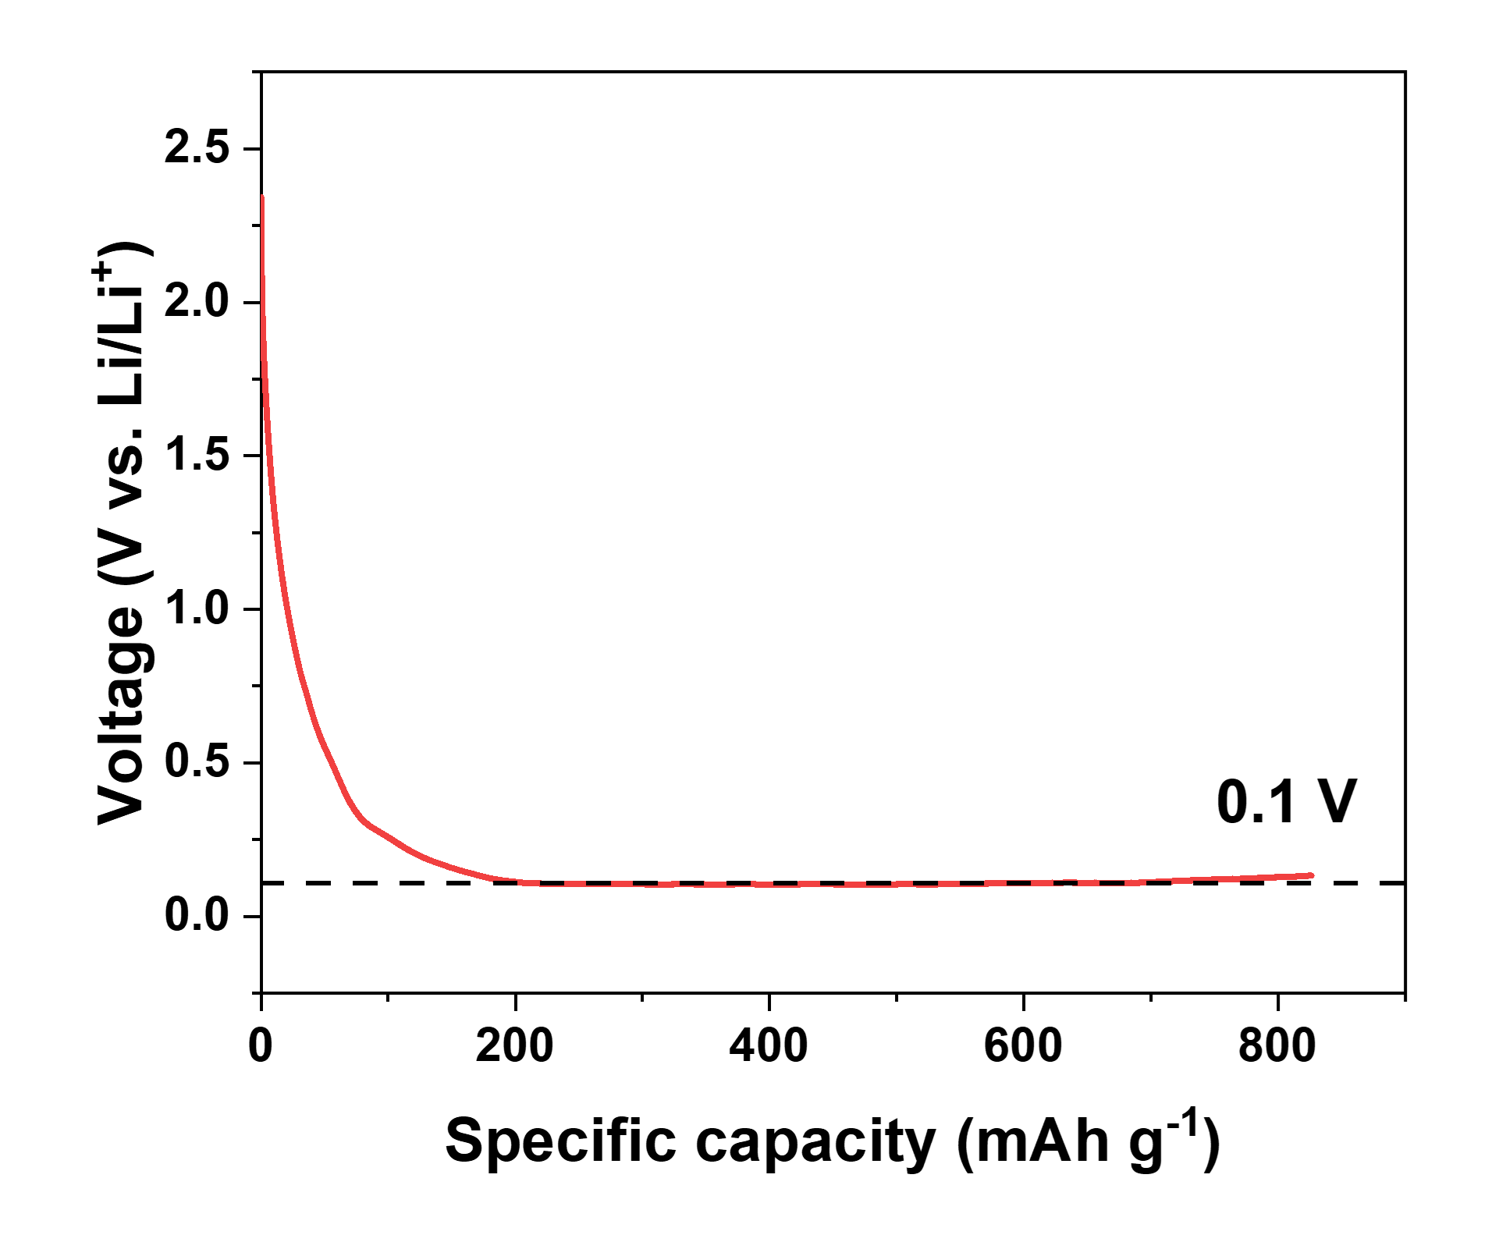
Supplementary Figure 1. Discharge profile of the Li-In|LYCB|LYCB-CNF cell at a current density of 0.064 mA cm⁻². Assuming in the LYCB-CNF composite the Y³⁺ in LYCB is fully reduced to Y element, the theoretical specific capacity is calculated to be 176 mAh g⁻¹. Thus, the long plateau at 0.1 V is attributed to the continuous formation of electronic conductive phases from the LYCB-CNF electrode to LYCB SE bulk.

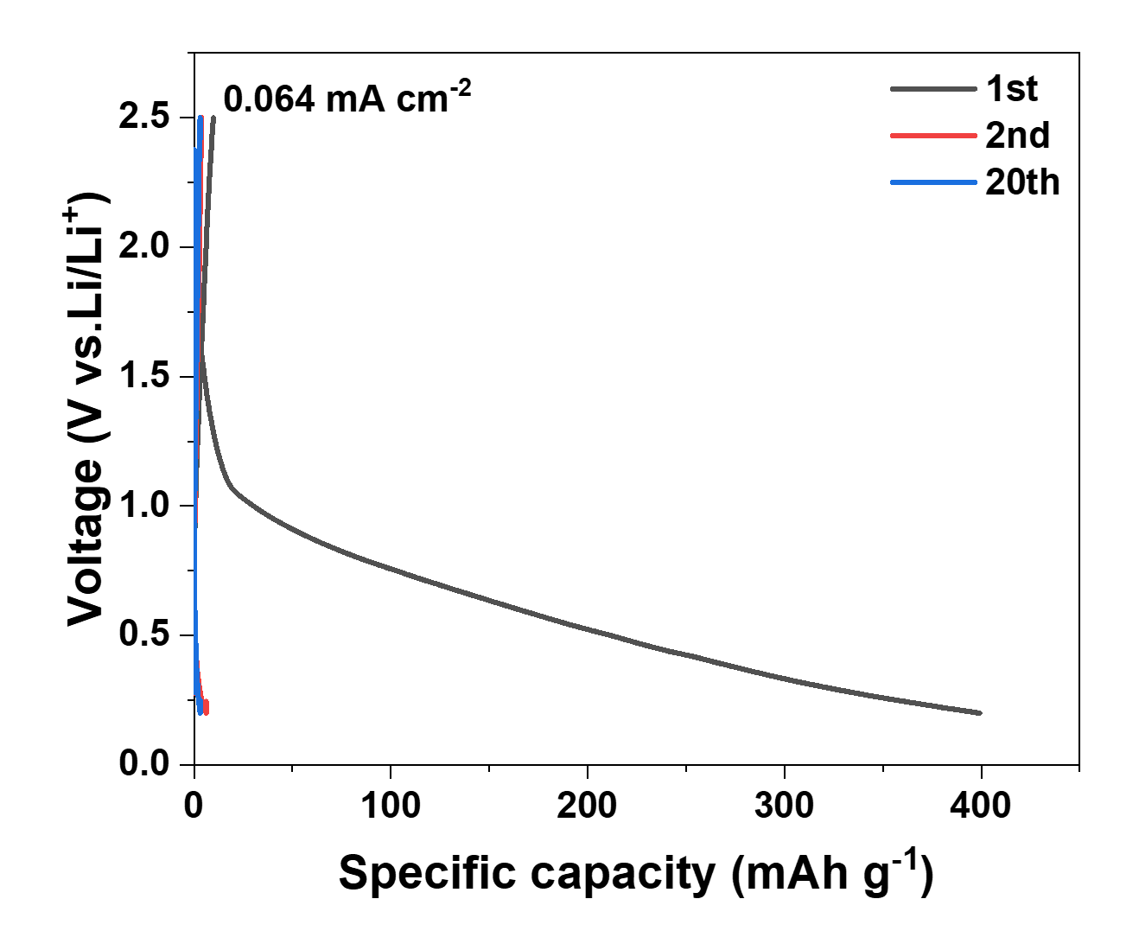
Supplementary Figure 2. Voltage profiles of Li-In|LPSC|LPSC-CNF cell after the 1st, 2nd and 20th cycle when a current density of 0.064 mA cm⁻² was used.

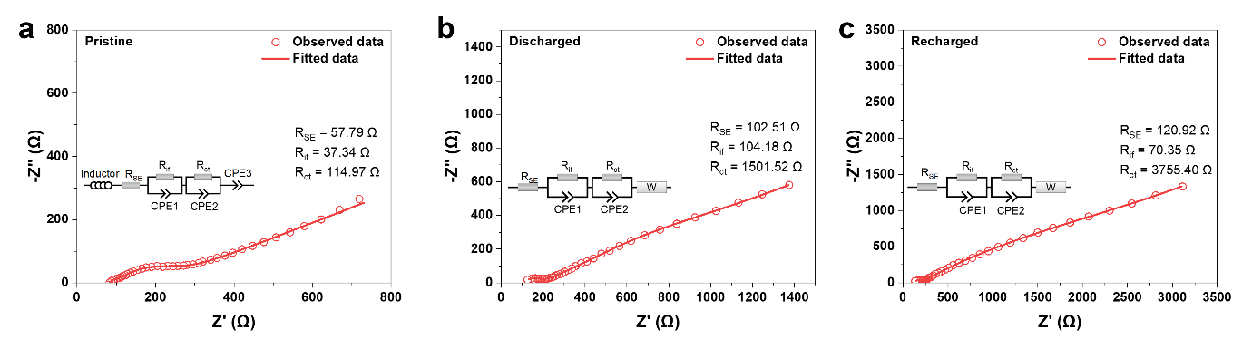
Supplementary Figure 3. Nyquist plots and corresponding equivalent circuit fitting of Li-In|LPSC|LPSC-CNF cell measured at a, a pristine state, b, after 1st discharge and c, after 1st recharge. R_{SE}, R_{if} and R_{ct} represent the resistance of LPSC, interface and charge transfer, respectively. All three i.e. R_{SE}, R_{if} and R_{ct} increase significantly after discharge. Especially the charge transfer resistance increases to 10 times the value of the pristine one, indicating the decomposition of LPSC leads to poor kinetics within the LPSC-CNF electrode.

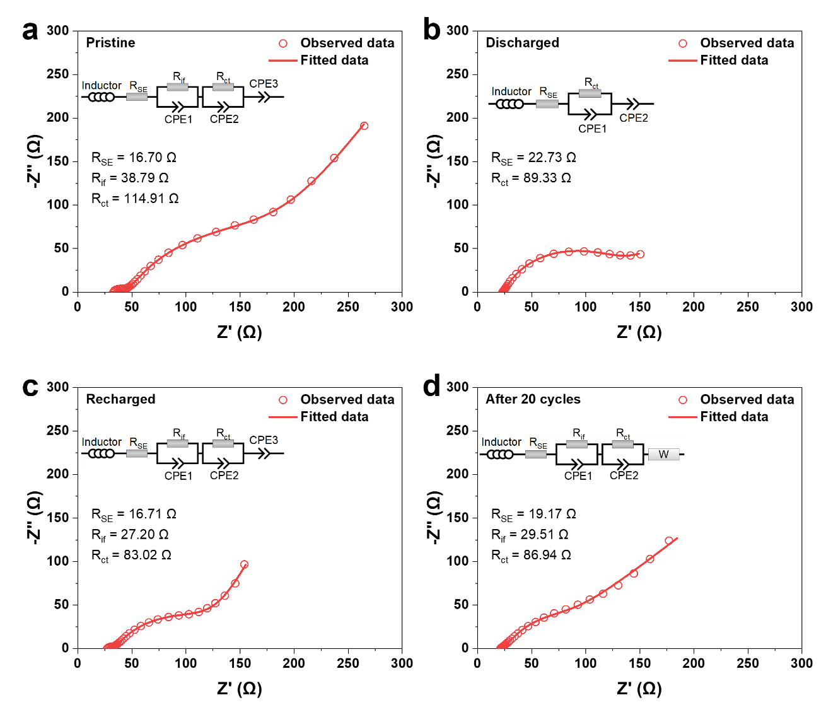
Supplementary Figure 4. Nyquist plots and corresponding equivalent circuit fitting of Li-In|LYCB|LYCB-CNF cell measured at a, a pristine state, b, after the 1st discharge c, after the 1st recharge and d, after 20 cycles. R_{SE}, R_{if} and R_{ct} represent the resistance of LYCB, interface and charge transfer, respectively. We note that for the discharged cell, the two semicircles of the interface resistance and charge transfer resistance merged into one semicircle. The decreased charge transfer resistance of the discharged cell indicates that lithiated LYCB possesses a better Li-ion kinetics than the pristine LYCB.

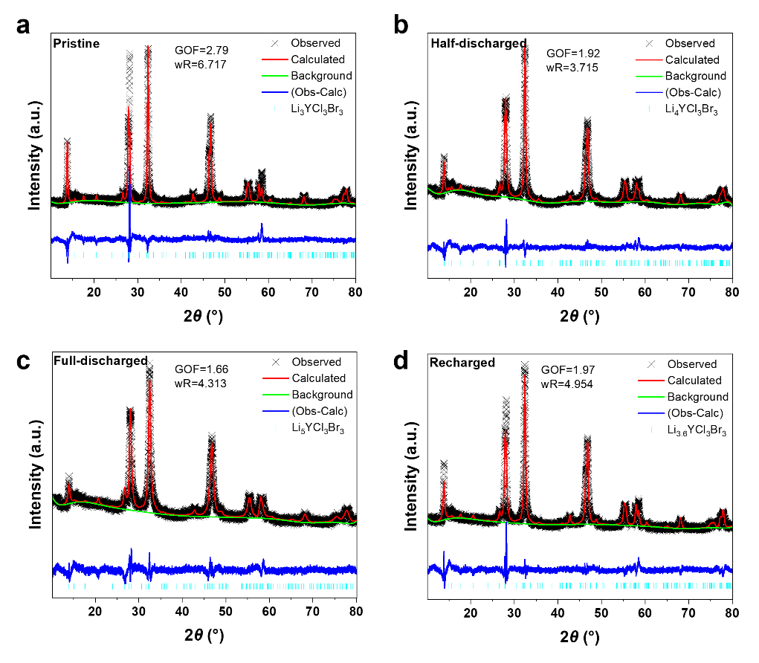
Supplementary Figure 5. a-d, Le Bail refinement of LYCB at various states, namely (a) pristine (Li₃YCl₃Br₃), (b) half-discharged (Li₄YCl₃Br₃), (c) full-discharged (Li₅YCl₃Br₃) and (d) recharged (Li_{3.6}YCl₃Br₃).

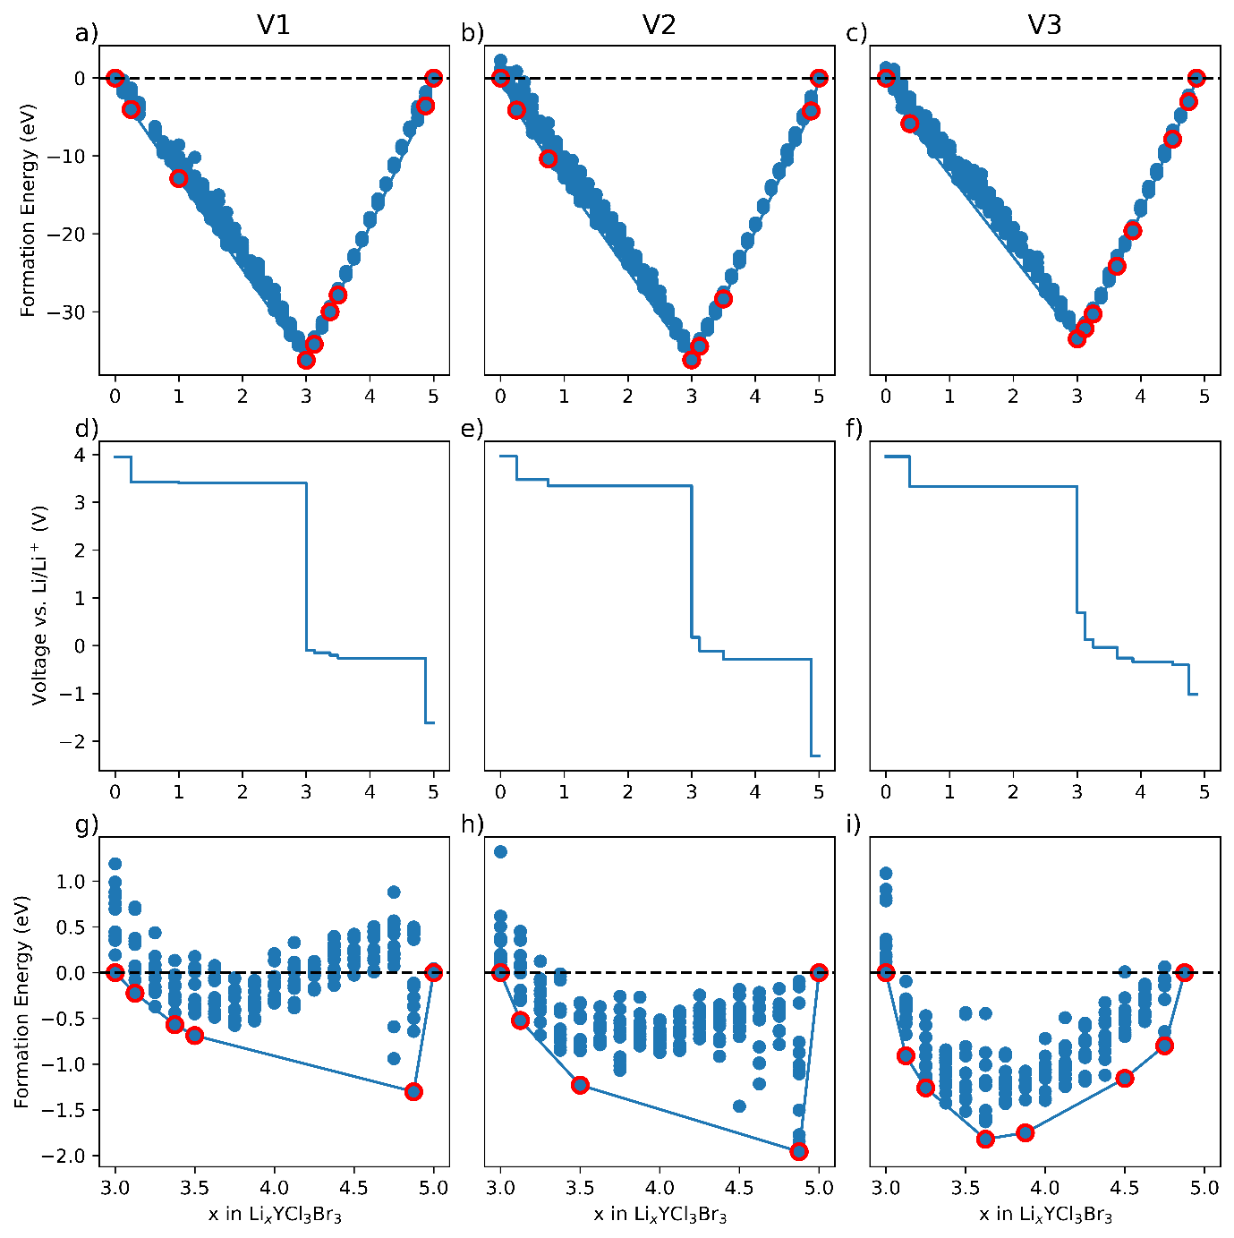
Supplementary Figure 6. Thermodynamic results of variations (v1, v2 and v3) of the LYCB structure. Details on the structural information of v1, v2,v3 and the structure as refined by XRD data in this work are given in Supplementary Table 5. a-c, Formation energy of v1, v2, and v3 structures, respectively. d-f, voltage profiles of v1, v2, and v3 structures respectively. g-i, Formation energy of v1, v2, and v3 structures replotted for the reduction region. To reduce the number of computations for v1, v2, and v3, we calculated considering only the high symmetry positions 2d and 4g, providing a lithiation range 0<x<5 for x in Li_{x}YCl₃Br₃. The results are consistent with the results presented in the main text. A noteworthy observation is that structures designed with no Y disorder (v1 and v2) show widened stability windows and smaller solid-solution regions for reversible insertion compared to structures that have Y disorder (v3 and the structure presented in the main text). Experimentally, Y disorder is always expected in the 4h or 4g sublattices.

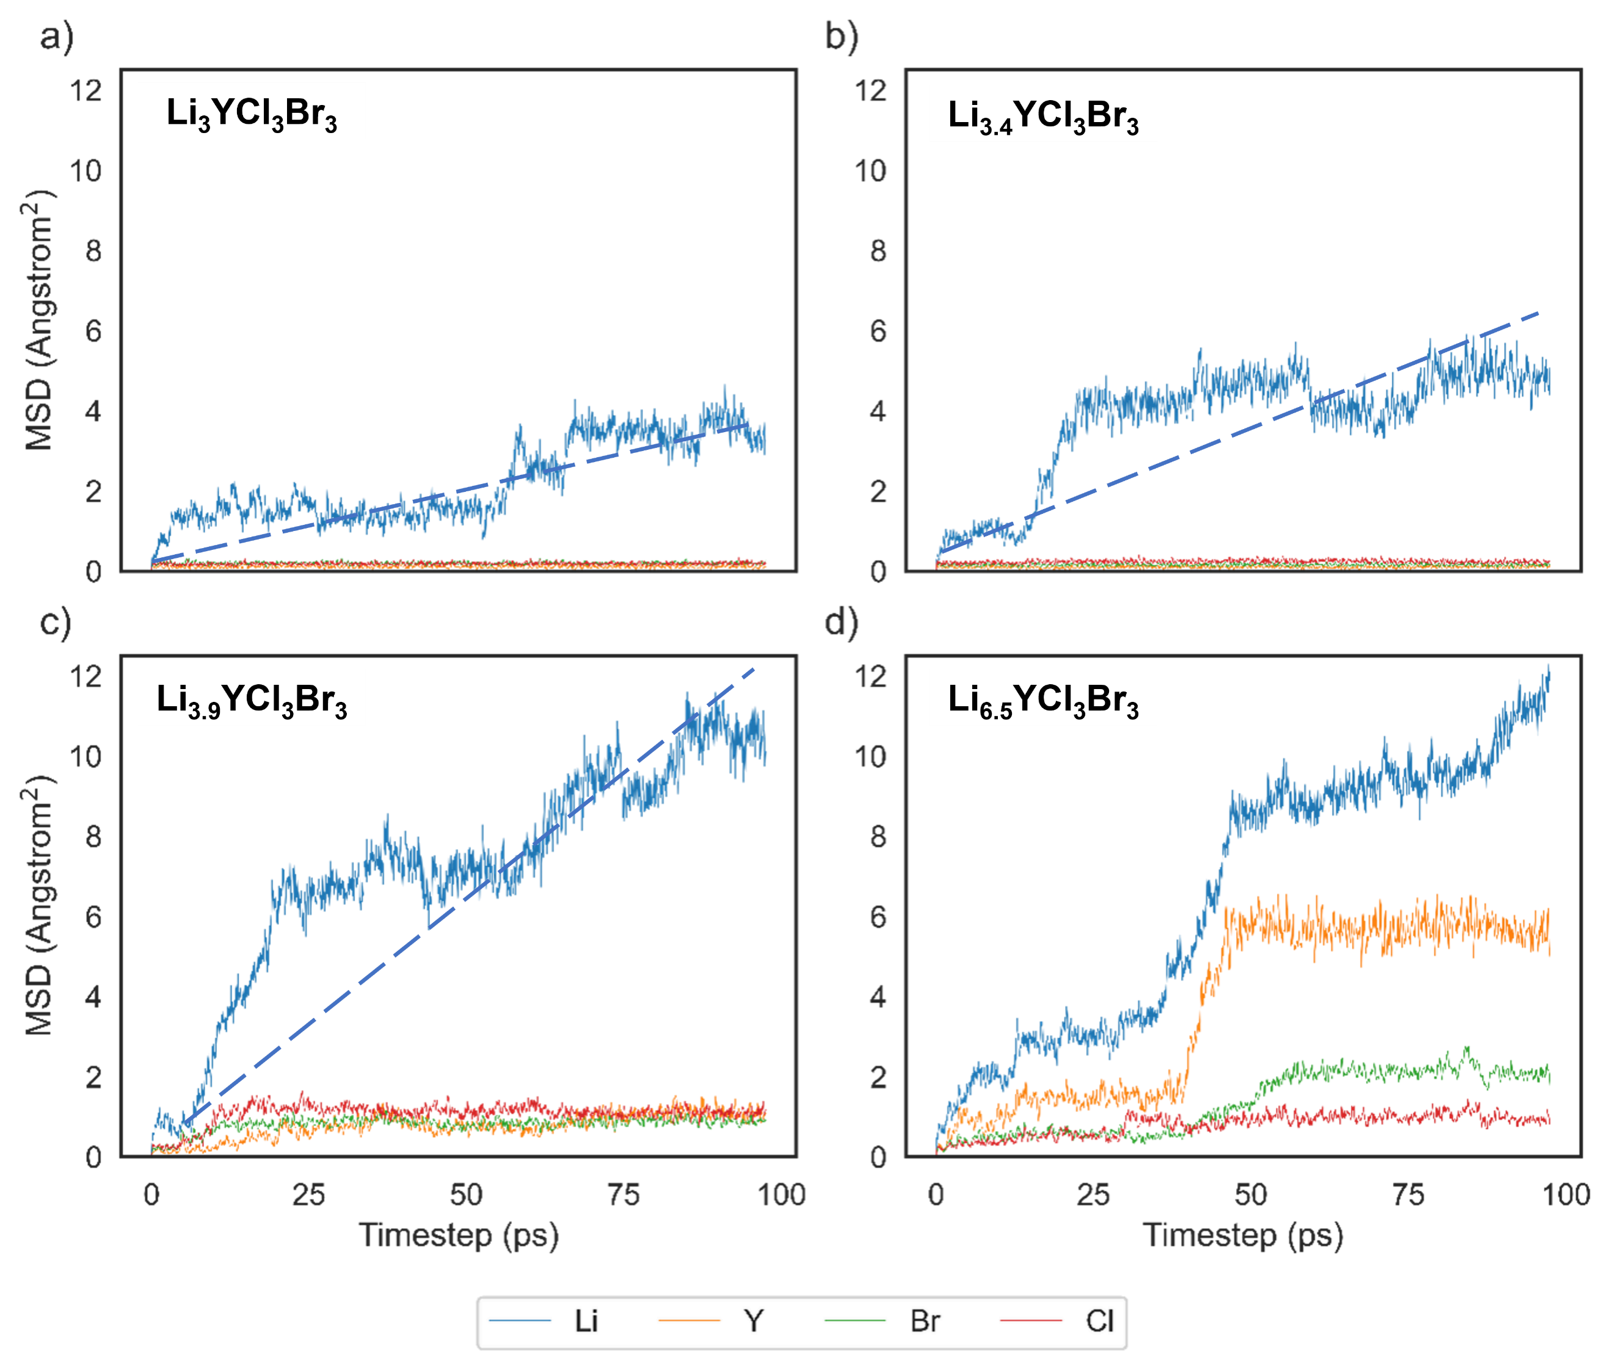
Supplementary Figure 7. Mean square displacement values for 100 ps MD simulations at 400 K. for the a, Li₃YCl₃Br₃, b, Li_{3.4}YCl₃Br₃, c, Li_{3.9}YCl₃Br₃, and d, Li_{6.5}YCl₃Br₃. Focusing on the Y – Cl/Br framework, we observe that the structure remains intact within the solid solution range, while for phases at higher Li concentrations, the monoclinic lattice changes within a few picoseconds. In addition, the MSD plots of Li atoms for Li_{3.9}YCl₃Br₃ and Li_{3.4}YCl₃Br₃ show larger slopes than that for the pristine Li₃YCl₃Br₃, which indicates a higher Li diffusivity for lithiated LYCB.
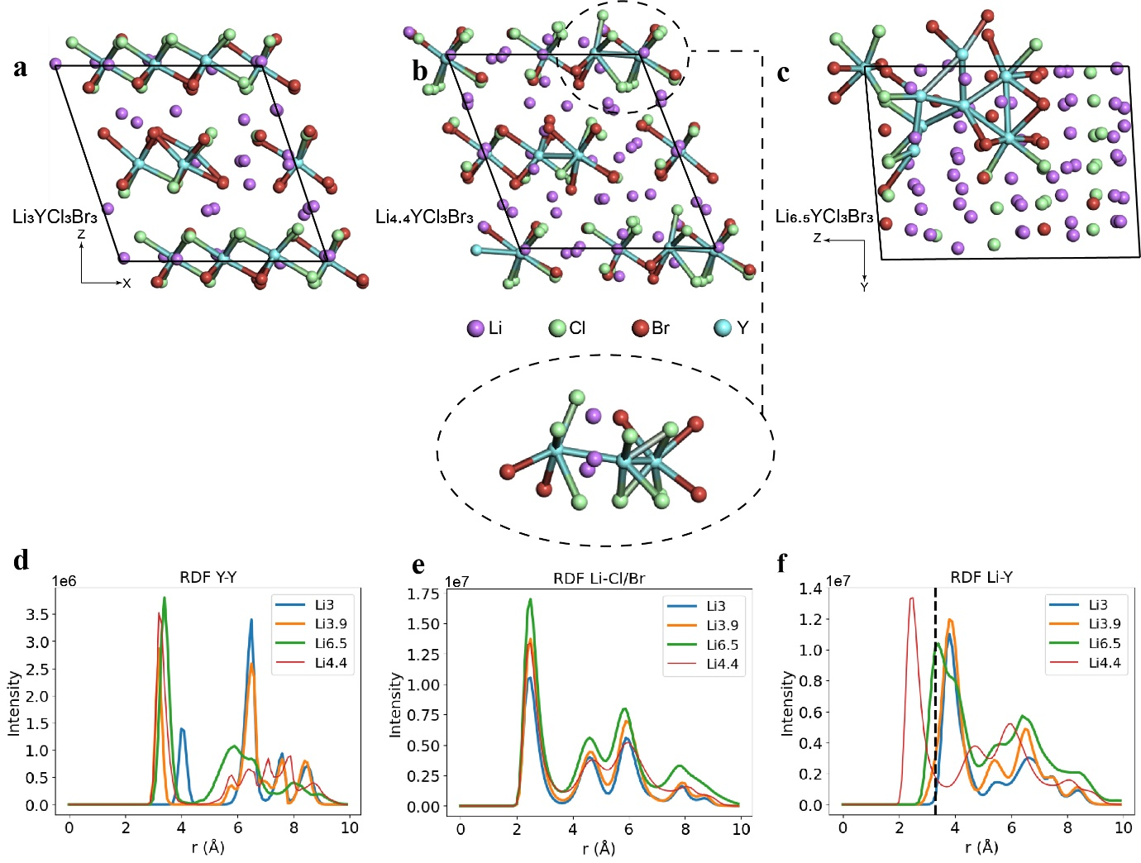
Supplementary Figure 8. Stability of Li_{4.4}YCl₃Br₃ phase after a 100 ps MD simulation at 400 K. a-c, Configurational environment of the (a) Li₃YCl₃Br₃, (b)Li_{4.4}YCl₃Br₃, and (c) Li_{6.5}YCl₃Br₃ phases after a 100 ps AIMD simulation at 400K. d-f, RDFs for a 100 ps AIMD simulation at 400K probing (d) Li – Cl/Br, (e) Li – Y, and (f) Y – Y distances, respectively. The structure of Li_{4.4}YCl₃Br₃ showcases differences from Li₃YCl₃Br₃, Li_{3.9}YCl₃Br₃ and Li_{6.5}YCl₃Br₃. Some decomposition signs are observed where Y – Br/Cl bonds seem to be destabilized. Further, the polyhedra obtain close distances and cluster together in a greater extent than the solid solution range, as more Y disorder is introduced (this can be observed in (d) where the clustered polyhedral obtain different distances). However, even though these changes are observed the structure is much closer to the stable solid solution region than the Li_{6.5}YCl₃Br₃ as the monoclinic layered framework is still present. Another interesting observation is that the polyhedral clustering allows Li to be present at a distance of 3.2 Å from Y (see Fig. 2f, Li-Y RDFs).

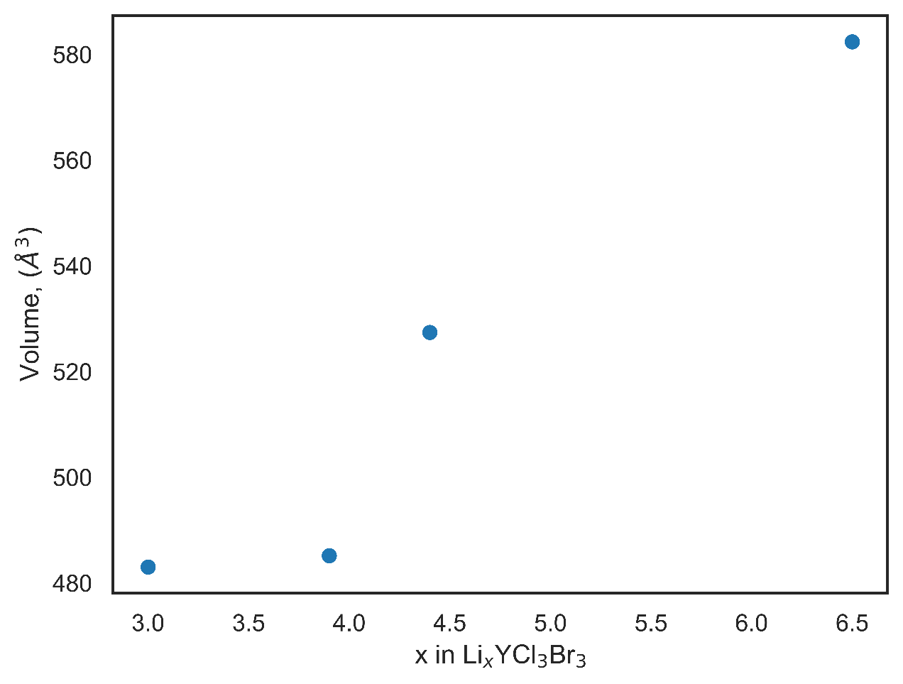
Supplementary Figure 9. Volume change upon lithiation of LYCB obtained from DFT calculations.

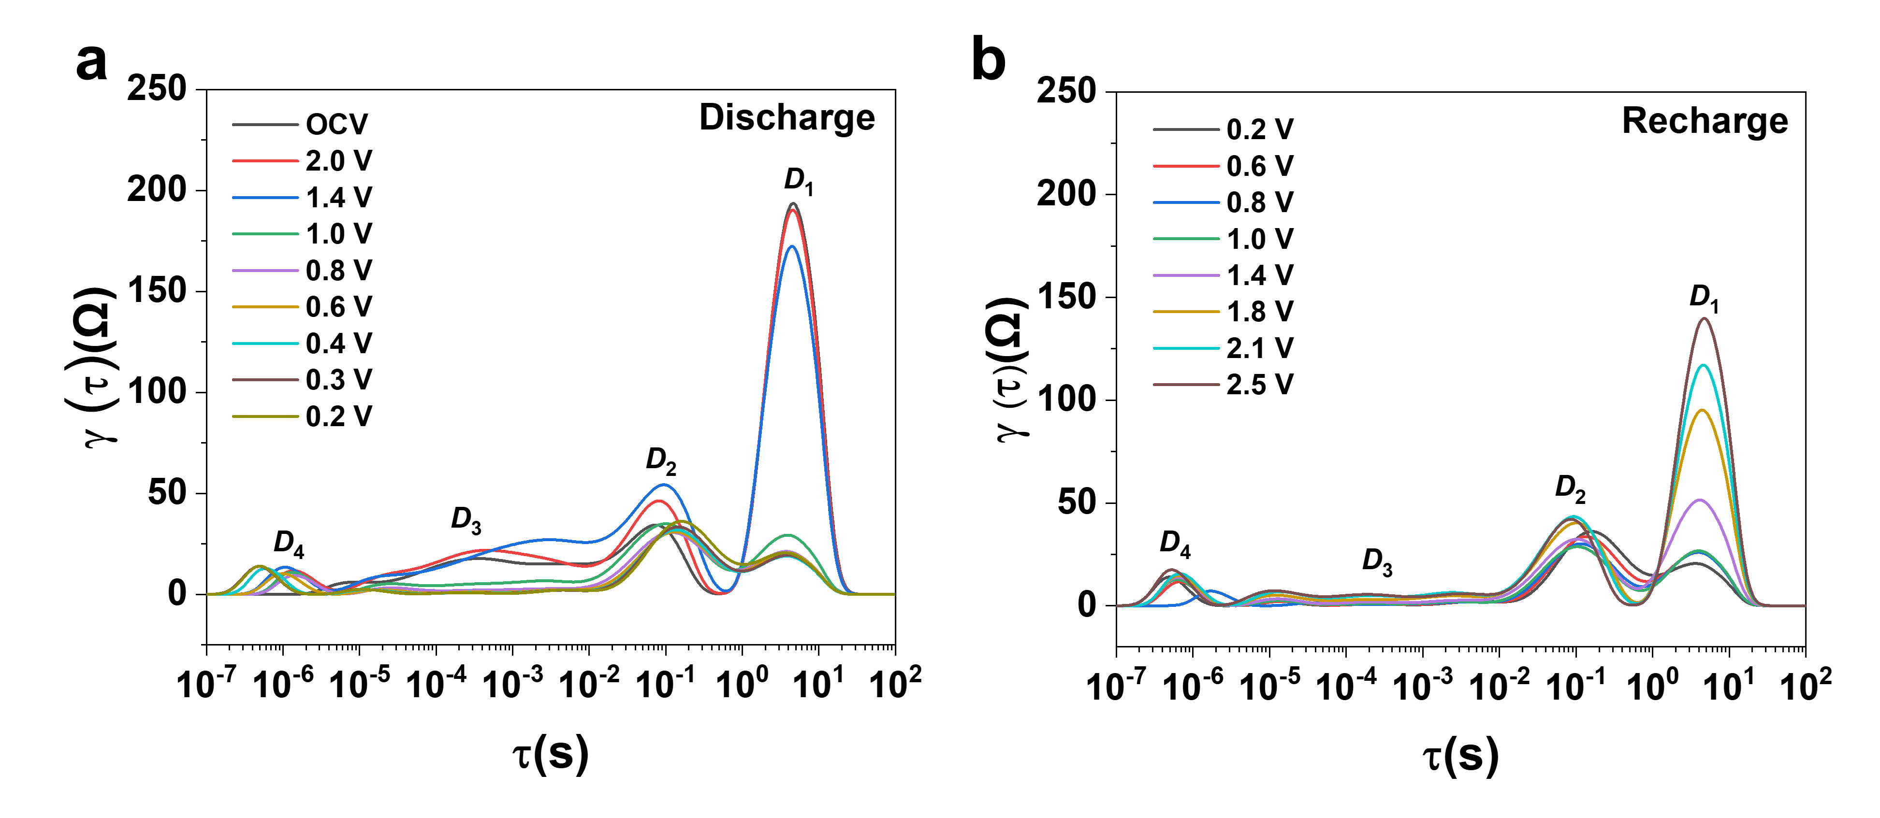Supplementary Figure 10. DRT profile transformation from the EIS measurements of a Li-In|LYCB|LYCB-CNF cell during a, discharge and b, recharge process. As the fastest charge transfer process happens inside the SE, the peak with the smallest time constant around 10⁻⁶ s is attributed to the LYCB SE (D₄). Two peaks with a medium time constant of 10⁻⁵-1 s represent the charge transfer at the anode/LYCB (D₃) and cathode/LYCB (D₂) interfaces, respectively. The peak featured with largest time constant (between 1 s and 10 s) arises from the charge transfer in LYCB-CNF cathode(D₁).

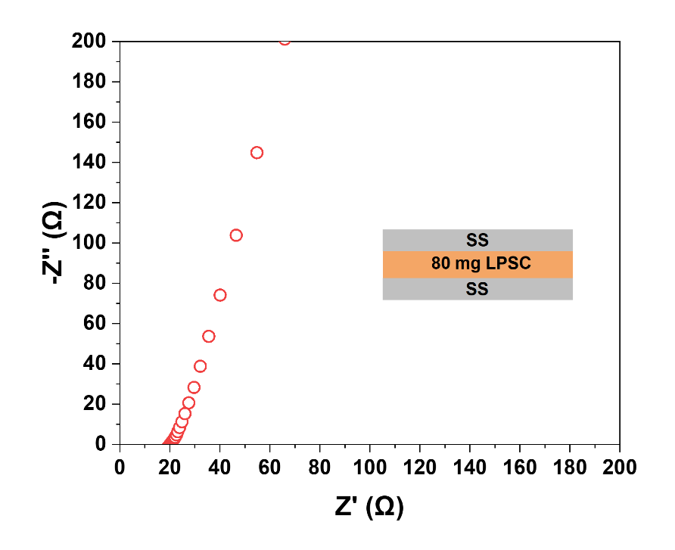
Supplementary Figure 11. Nyquist plot of the SS|LPSC|SS symmetric cell.

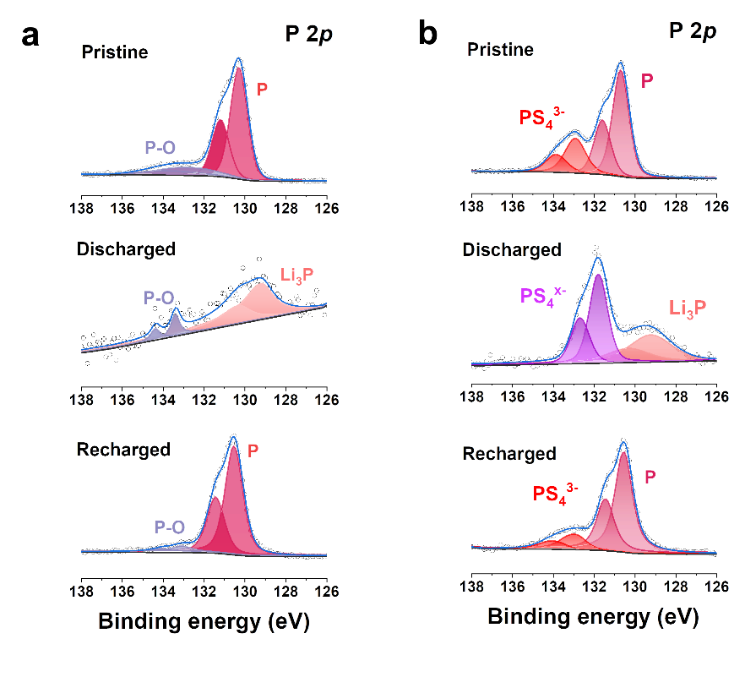
Supplementary Figure 12. P 2p XPS spectra of a, RP-LYCB and b, RP-LPSC anodes at pristine, discharged and recharged states. The pristine RP-LYCB anode showed a binding energy of 130.5 eV for the element P which shifted to 129.5 eV for Li₃P after discharge, and then shifted back to 130.5 eV after recharge. The RP-LPSC anode exhibited similar behavior to RP-LYCB, but the PS₄³⁻ groups got reduced after discharge, proving that the LPSC underwent decomposition during the discharge process.

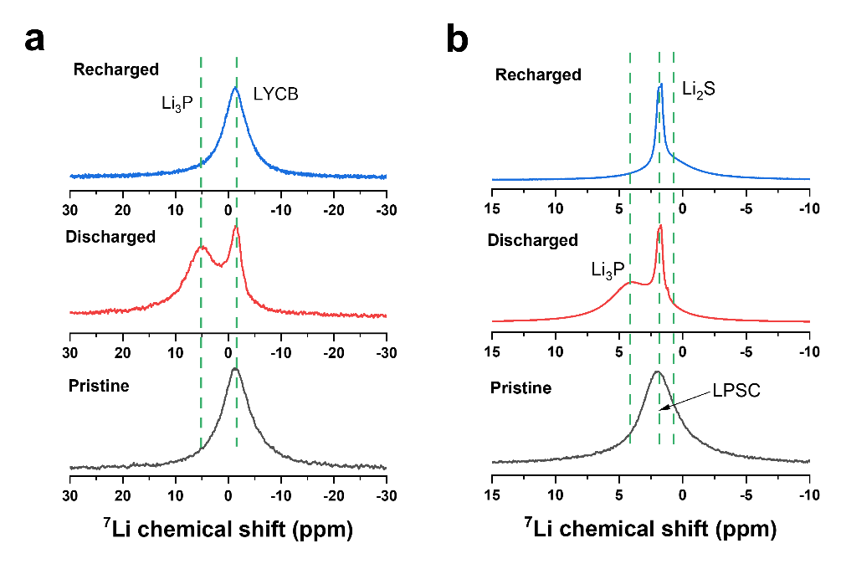
Supplementary Figure 13. ⁷Li MAS NMR spectra of a, RP-LYCB and b, RP-LPSC anodes at pristine, discharged and recharged states. Li₃P was observed for both discharged RP-LYCB and RP-LPSC anodes located at around 5 ppm and then disappeared in both charged RP-LYCB and RP-LPSC anodes. The chemical shift of LYCB was unchanged during the discharge/charge process of the RP-LYCB anode, while the decomposition product of LPSC, Li₂S, was observed in both discharged and charged RP-LPSC anodes.

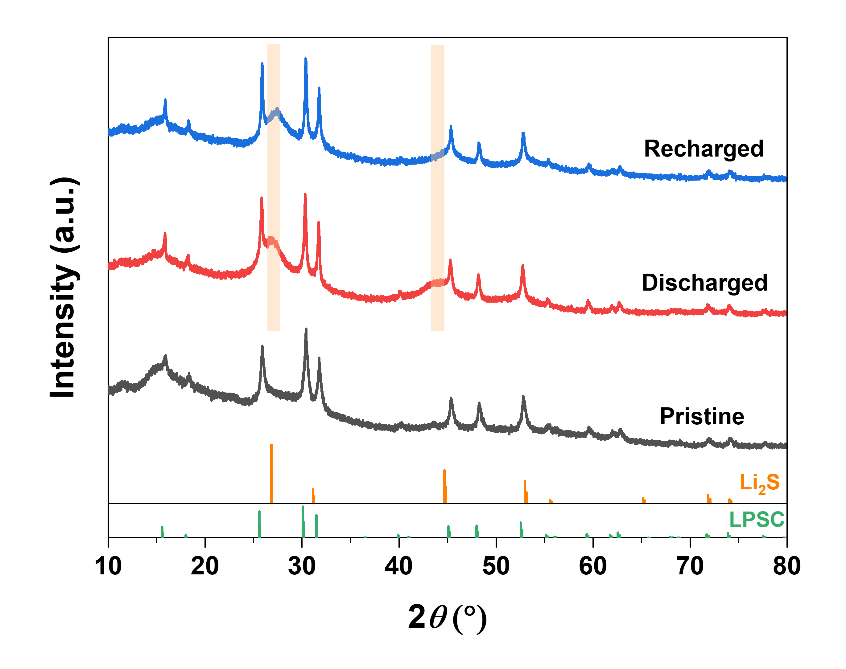
Supplementary Figure 14. XRD patterns of the RP-LPSC anode at pristine, discharged and recharged states. Clear broad Bragg peaks of Li₂S can be observed for both discharged and recharged samples.

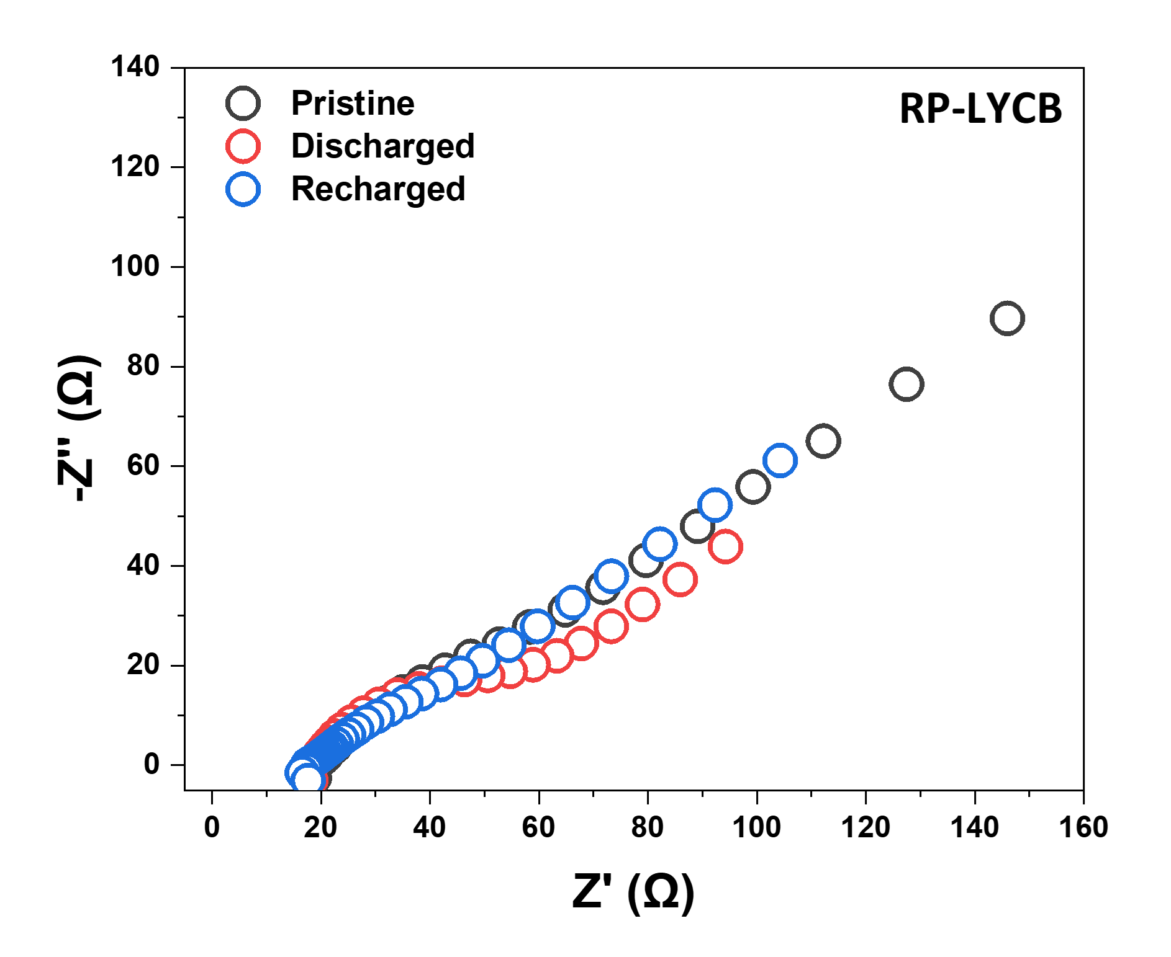
Supplementary Figure 15. Nyquist plots of the RP-LYCB anodes at pristine, discharged and recharged states.

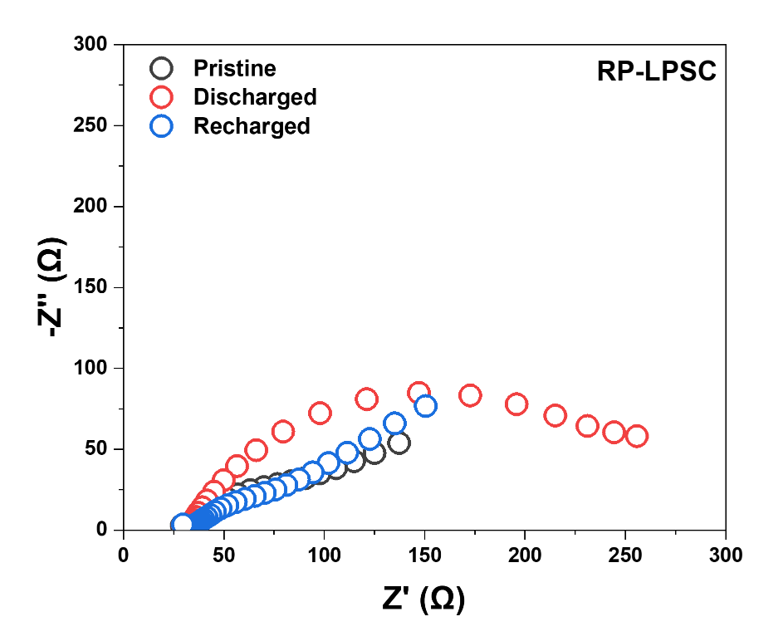
Supplementary Figure 16. Nyquist plots of the RP-LPSC anodes at pristine, discharged and recharged states. The huge semicircle of the discharged RP-LPSC anode signifies poor ionic transport at the RP/SE interface after the decomposition of LPSC.
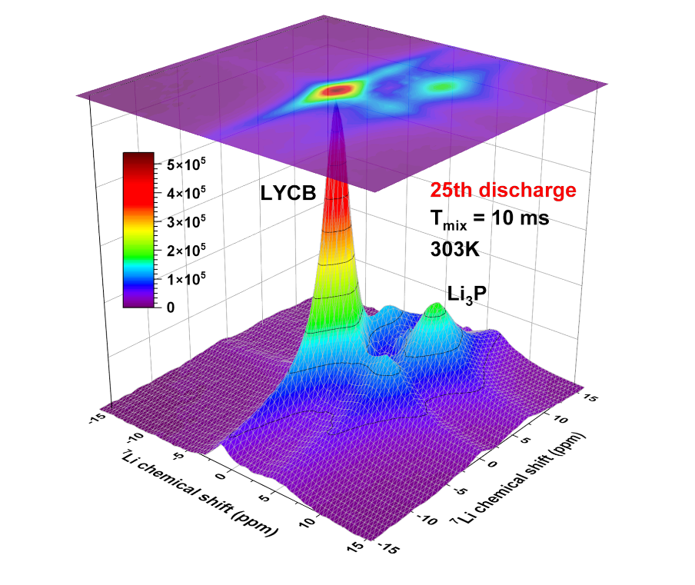
Supplementary Figure 17. ⁷Li NMR 2D exchange spectrum of the RP-LYCB anode after the 25th discharge at 303 K with a mixing time of 10 ms.

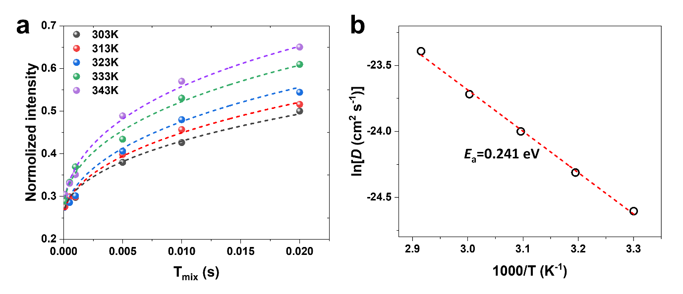
Supplementary Figure 18. a, Evolution of cross-peak intensity as a function of mixing time (T_{mix}) obtained from the 2D NMR exchange measurements performed for the RP-LYCB anode after the 1st discharge at the temperatures indicated in the graph. b, the dependence of the diffusion coefficient D obtained from fitting the data in a to a diffusion model described in the methods, yielding an activation energy of 0.241 eV.

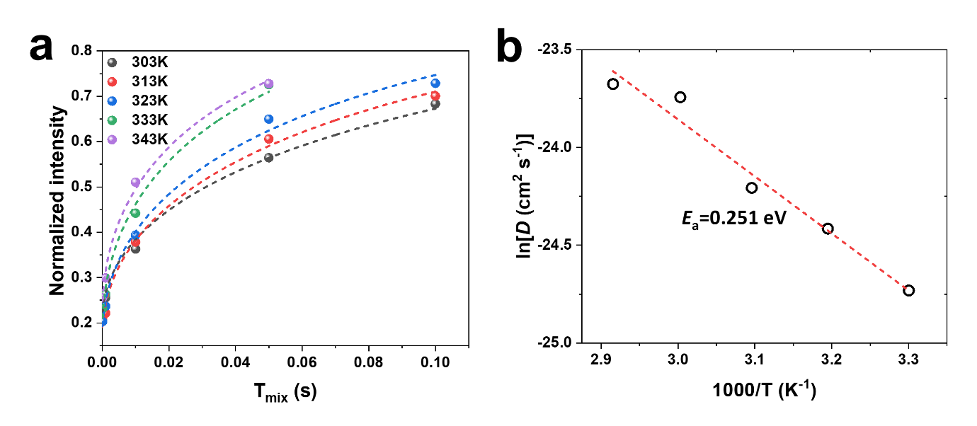
Supplementary Figure 19. a, Evolution of cross-peak intensity as a function of mixing time (T_{mix}) obtained from the 2D NMR exchange measurements performed for the RP-LYCB anode after the 25th discharge at the temperatures indicated in the graph. b, the dependence of the diffusion coefficient D obtained from fitting the data in a to a diffusion model described in the methods, yielding an activation energy of 0.251 eV.

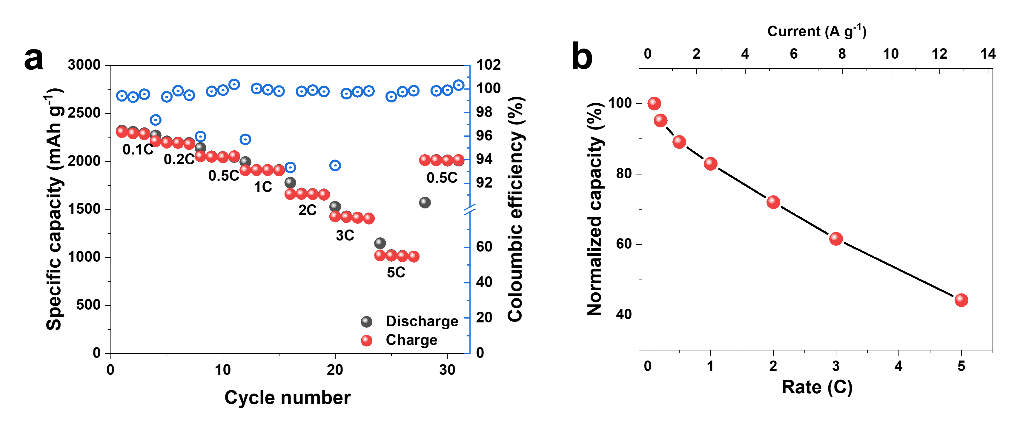
Supplementary Figure 20. a, Rate performance of the Li-In|LYCB|RP-LYCB half-cell with a mass loading of 0.6 mg cm⁻² at room temperature. b, The capacity retention of Li-In|LYCB|RP-LYCB half-cell at different current densities. The capacities were normalized to the capacity achieved at 0.1C.

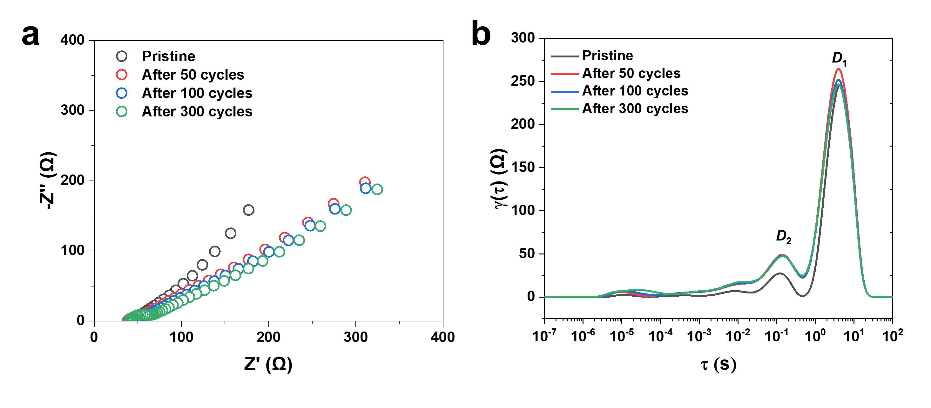
Supplementary Figure 21. a, Nyquist plots of the Li-In|LYCB|RP-LYCB half-cell at a pristine state and after 50, 100, 300 cycles. b, DRT curves obtained from the EIS results of the Li-In|LYCB|RP-LYCB half-cell at a pristine state and after 50, 100, 300 cycles. Very stable overall cell resistance, charge transfer resistance at RP/LYCB interface and within the RP electrode were observed for the Li-In|LYCB|RP-LYCB half-cell over long-term cycling.

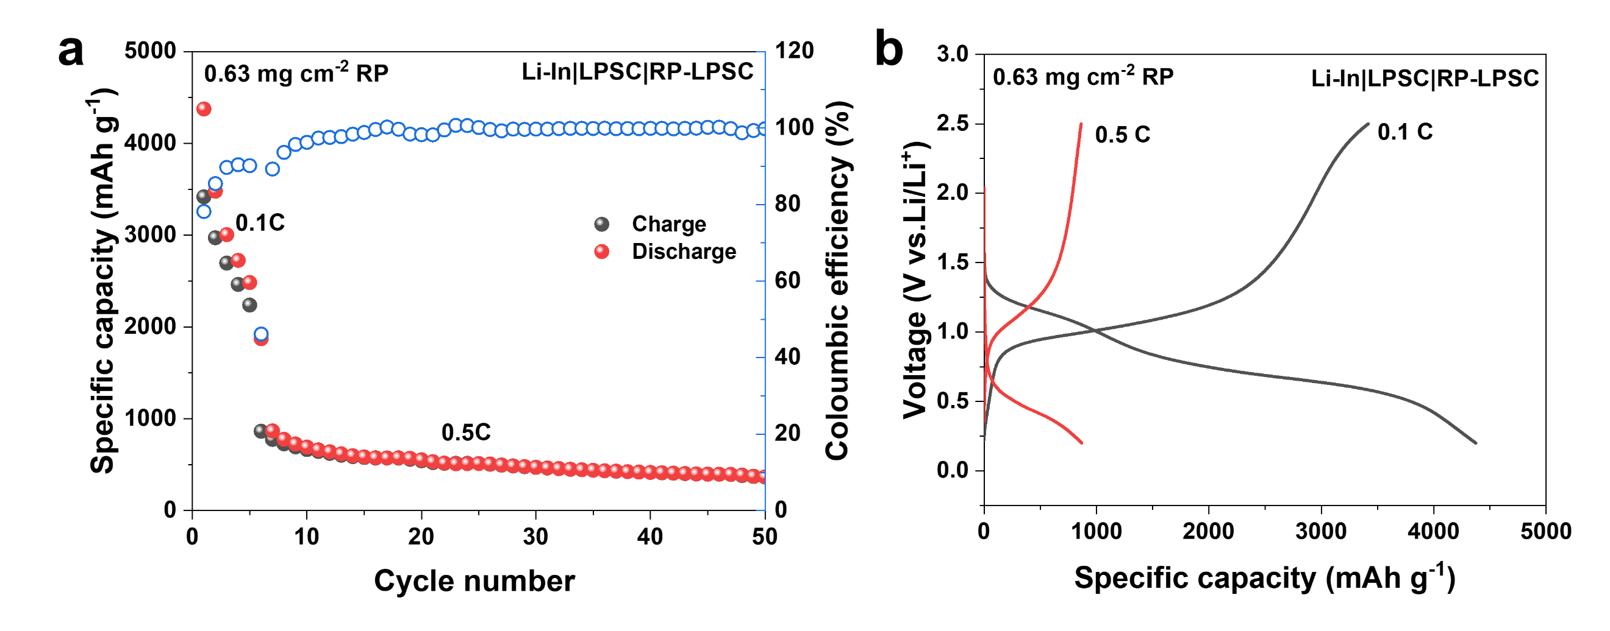
Supplementary Figure 22. a, Cycling stability and coulombic efficiency of the Li-In|LPSC|RP-LPSC half-cell at 0.5C and room temperature. The first five cycles were tested at 0.1C. b, Galvanostatic discharge-charge voltage profiles of the Li-In|LPSC|RP-LPSC half-cell at 0.1C and 0.5C.

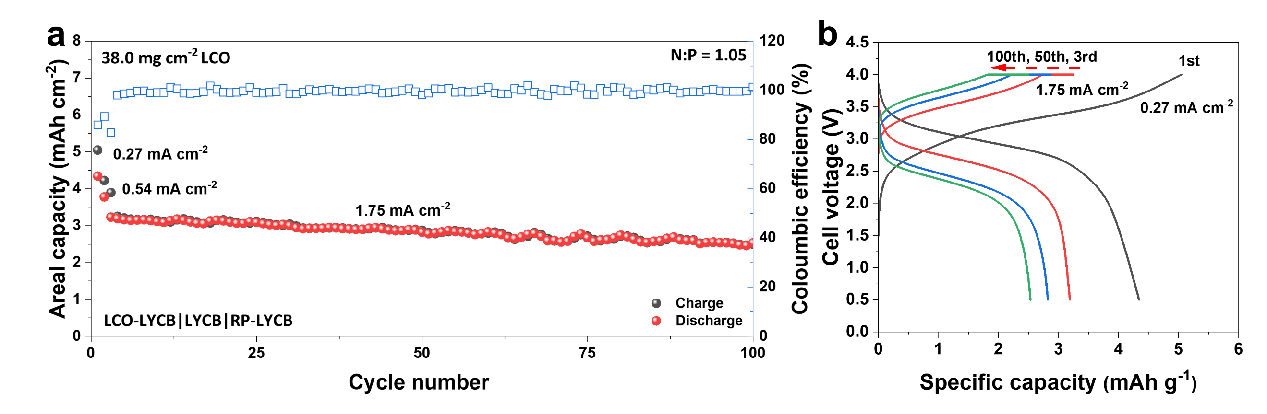
Supplementary Figure 23. a, Cycling stability and coulombic efficiency of the uncoated LCO-LYCB|LYCB|RP-LYCB full-cell with a high areal capacity of 4.4 mAh cm⁻². The first two cycles were tested at 0.27 mA cm⁻² and 0.54 mA cm⁻², respectively. b, Galvanostatic discharge-charge voltage profiles of the LCO-LYCB|LYCB|RP-LYCB full-cell.

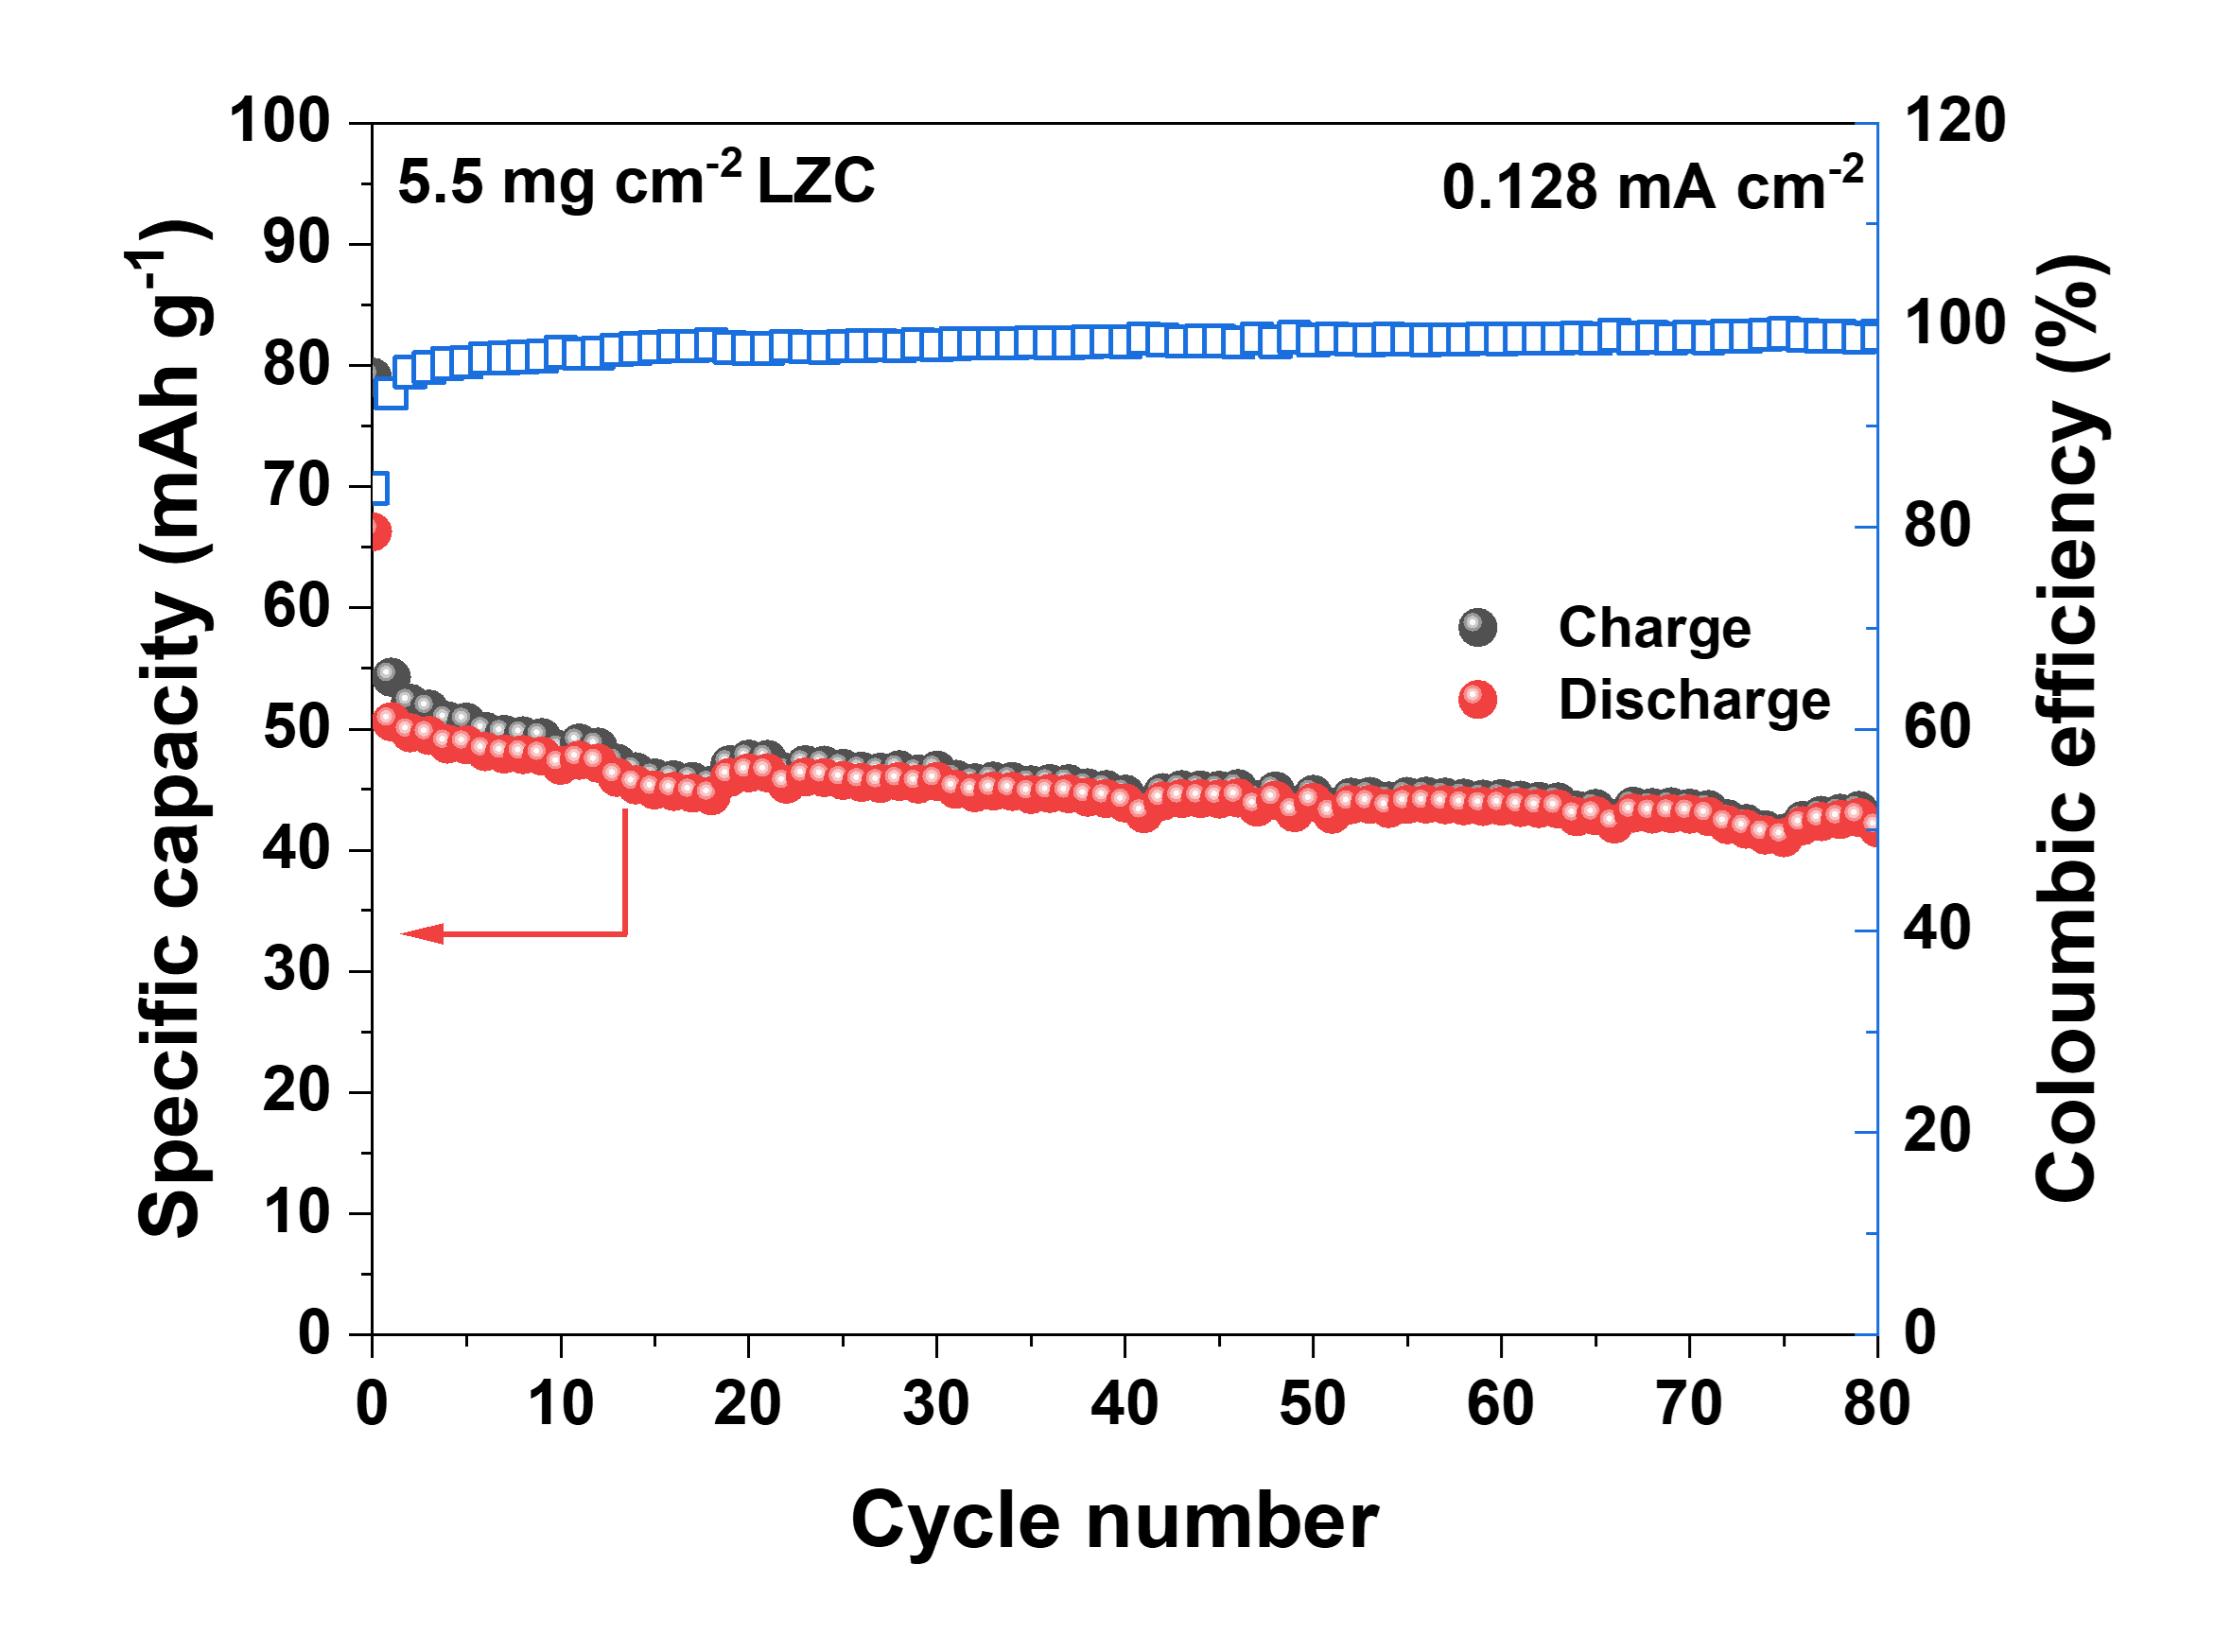
Supplementary Figure 24. Cycling stability and coulombic efficiency of the Li-In|LPSC-LZC|LZC-CNF cell at 0.128 mA cm⁻² and room temperature. The first cycle was tested at 0.064 mA cm⁻².

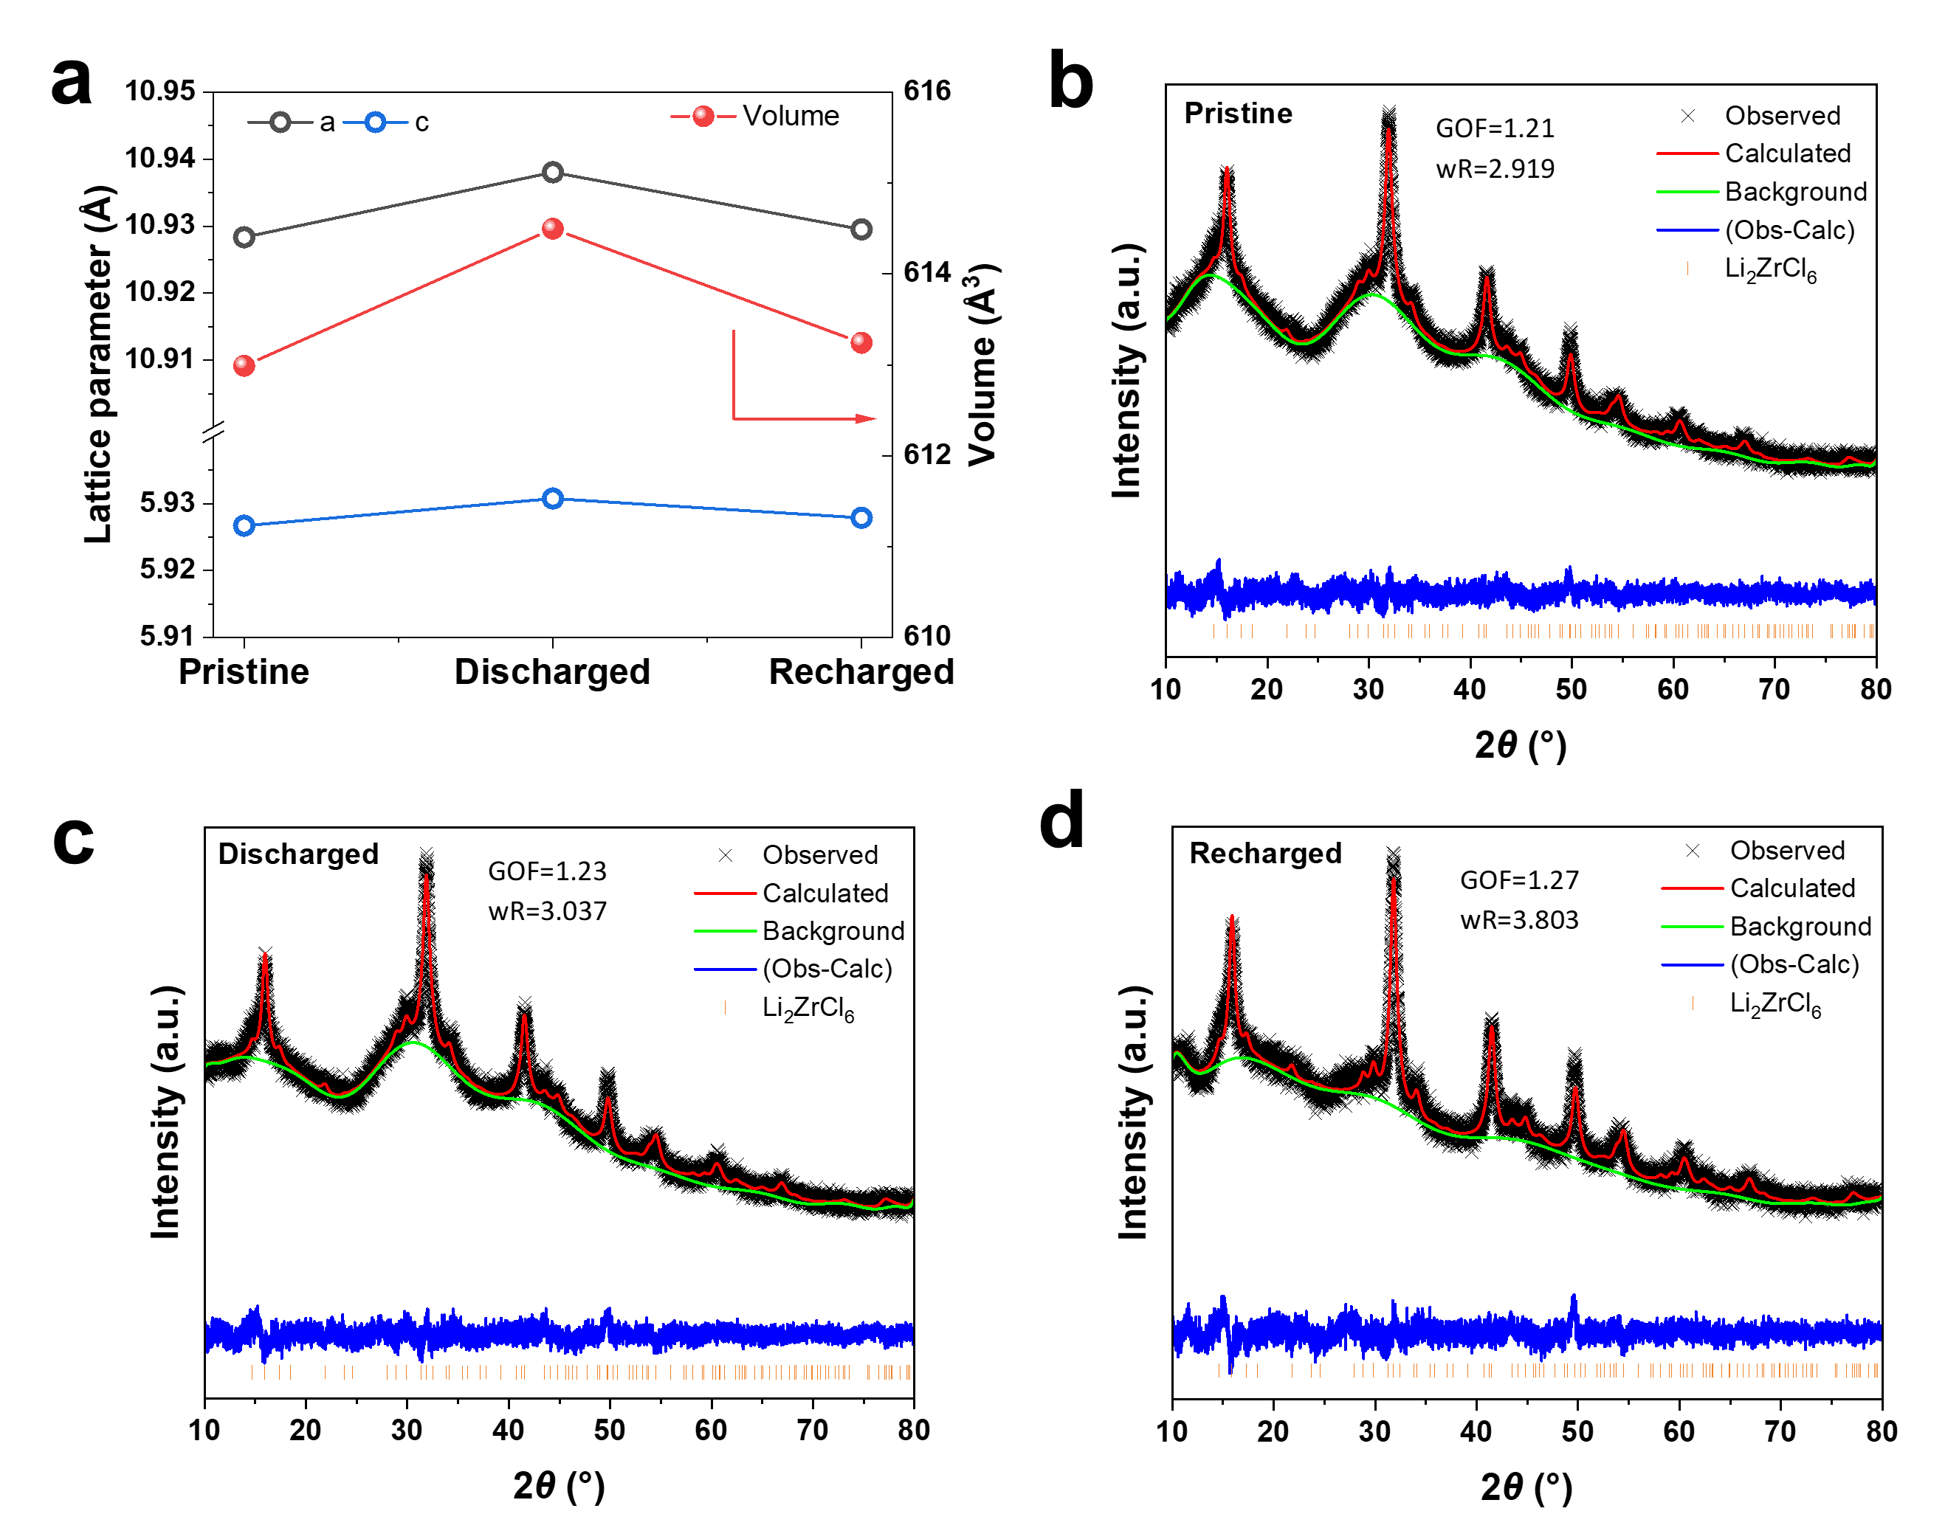
Supplementary Figure 25. a, Lattice parameters and unit cell volume of the LZC at different SOCs obtained from Le Bail refinement. b-d, Le Bail refinement of the LZC (b) at pristine state, (c) after discharge and (d) after charge.

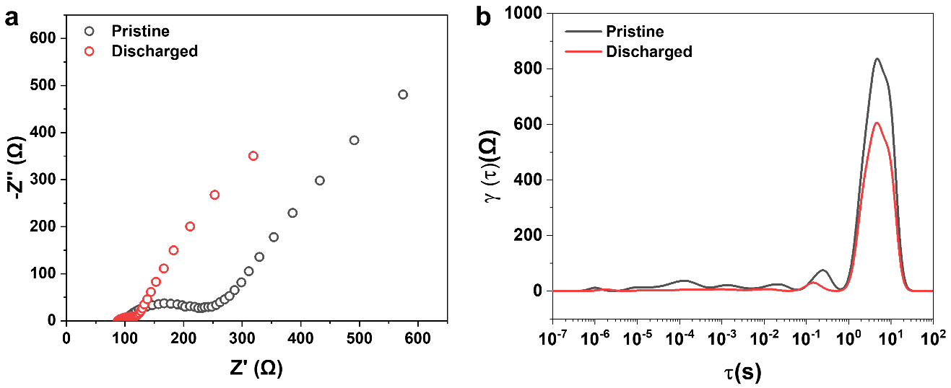
Supplementary Figure 26. a, Nyquist plots of the Li-In|LPSC-LZC|LZC cell at pristine state and after discharge to 1.4 V. b, DRT curves of the Li-In|LPSC-LZC|LZC cell at pristine state and after discharge to 1.4 V.

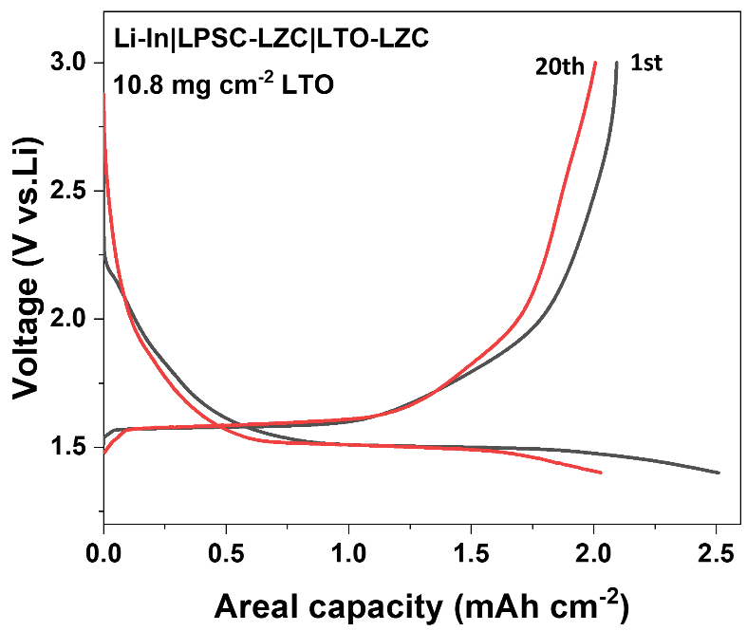
Supplementary Figure 27. Galvanostatic discharge-charge voltage profiles of Li-In|LPSC-LZC|LZC cell with a high areal capacity over 2 mAh cm⁻².

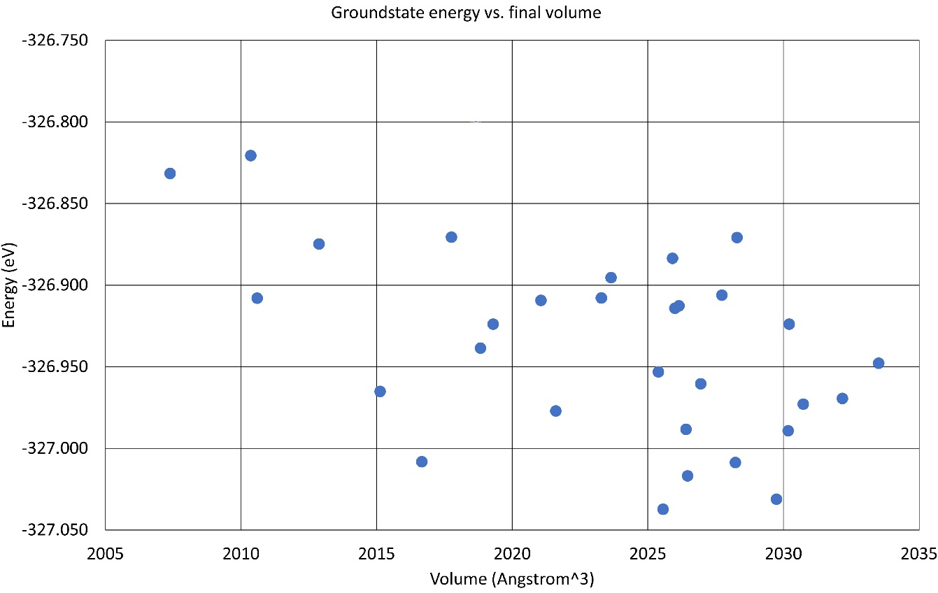
Supplementary Figure 28. Total energies of Cl and Br variations in a 2x1x2 LYBC supercell.

Supplementary Table 1. Le Bail refinement results from the XRD data of the pristine LYCB (Li₃YCl₃Br₃).
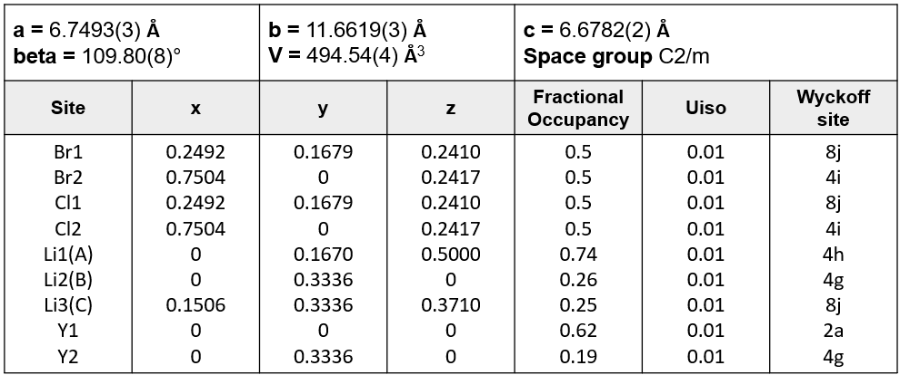

Supplementary Table 2. Le Bail refinement results from the XRD data of the half-discharged LYCB (Li₄YCl₃Br₃).
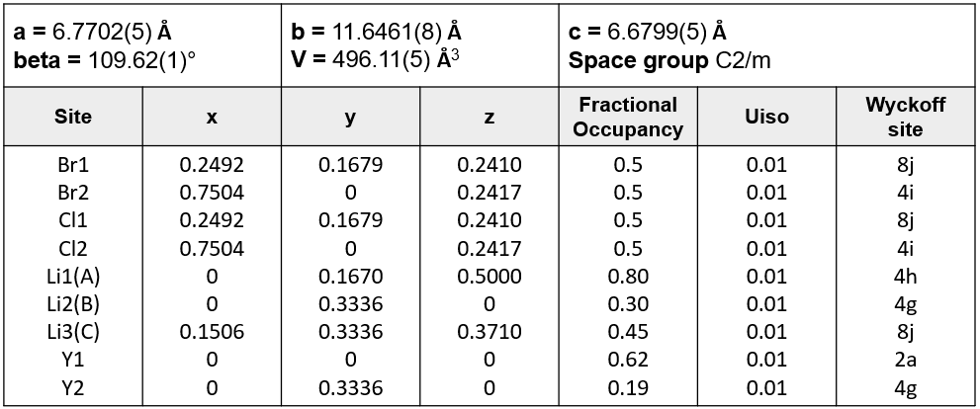

Supplementary Table 3. Le Bail refinement results from the XRD data of the full-discharged LYCB (Li₅YCl₃Br₃).
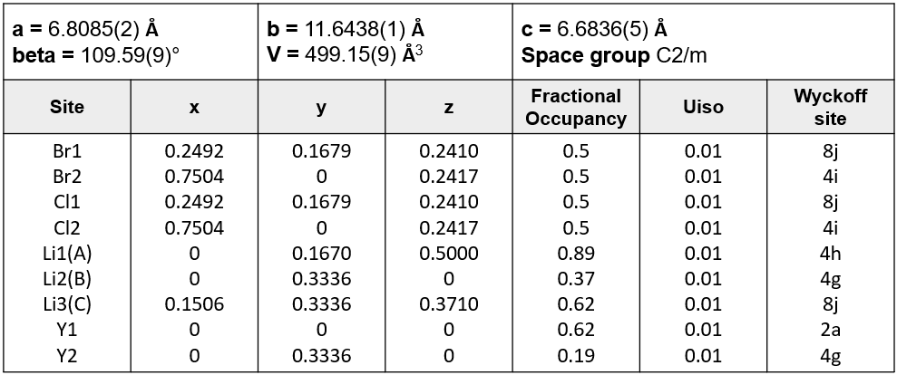

Supplementary Table 4. Le Bail refinement results from the XRD data of the recharged LYCB (Li_{3.6}YCl₃Br₃).
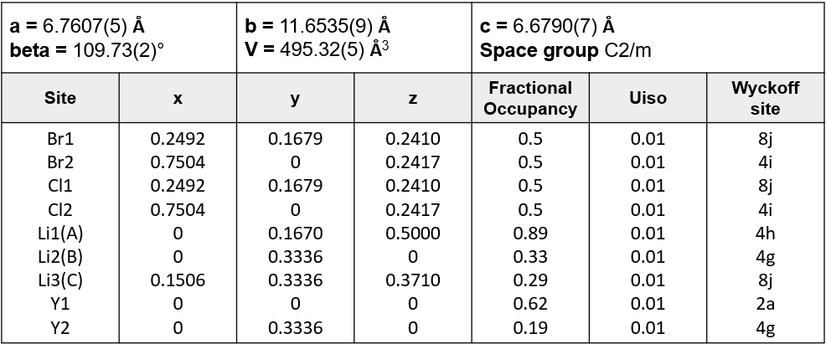

Supplementary Table 5. Details on how the LYBC structures were constructed for DFT calculations.
Structure | Cl-Br disorder | Y sublattice |  | Li sublattice
Build from ref. ⁴ | Lowest energy structure from randomized Cl-Br distribution | 2a  100% | 4h  0% | 2d, 4g  x in Li_{x}YCl₃Br₃, 0<x<5
Build from ref. ⁴ | Lowest energy structure from randomized Cl-Br distribution, manually modified to include all possible octahedra. | 2a  100% | 4h  0% | 2d, 4g  x in Li_{x}YCl₃Br₃, 0<x<5
Build from ref. ⁴ | Lowest energy structure from randomized Cl-Br distribution | 2a  87% | 4h  13% | 2d, 4g  x in Li_{x}YCl₃Br₃, 0<x<5
Build from the refinement in this work | Lowest energy structure from randomized Cl-Br distribution | 2a  87% | 4g  13% | 4h, 4g, 2d,8j  x in Li_{x}YCl₃Br₃, 0<x<9

Supplementary Table 6. Le Bail refinement results from the XRD data of the pristine LZC.
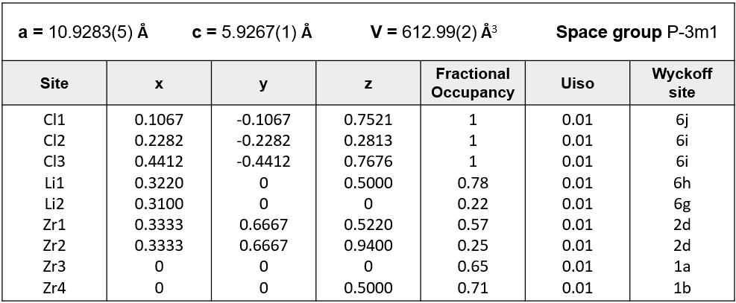

Supplementary Table 7. Le Bail refinement results from the XRD data of the discharged LZC.
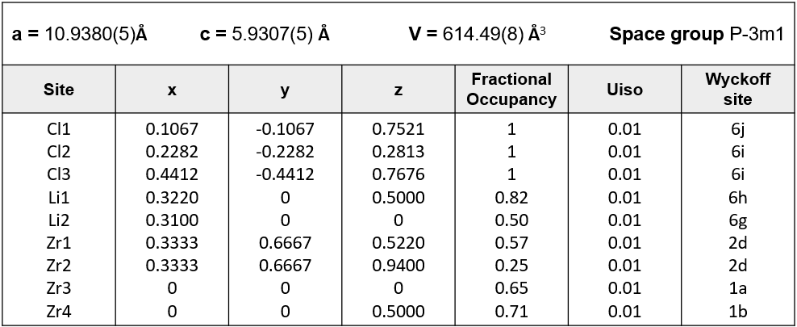

Supplementary Table 8. Le Bail refinement results from the XRD data of the recharged LZC.
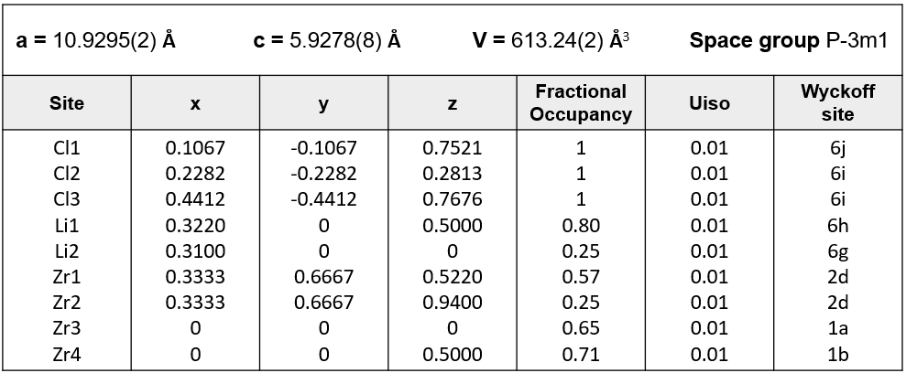

References
1. Seo, D.-H., Urban, A. & Ceder, G. Calibrating transition-metal energy levels and oxygen bands in first-principles calculations: Accurate prediction of redox potentials and charge transfer in lithium transition-metal oxides. Phys. Rev. B 92, 115118 (2015).
2. Schwietert, T. K. et al. Clarifying the relationship between redox activity and electrochemical stability in solid electrolytes. Nat. Mater. 19, 428–435 (2020).
3. Yu, C. et al. Unravelling Li-Ion Transport from Picoseconds to Seconds: Bulk versus Interfaces in an Argyrodite Li6PS5Cl–Li2S All-Solid-State Li-Ion Battery. J. Am. Chem. Soc. 138, 11192–11201 (2016).
4. van der Maas, E. et al. Investigation of Structure, Ionic Conductivity, and Electrochemical Stability of Halogen Substitution in Solid-State Ion Conductor Li3YBrxCl6–x. J. Phys. Chem. C 127, 125–132 (2023).

