Supplementary materials
SFigure 1. Form for military medical examination- filled in by medical doctor at conscription, first day of service and final day of service.
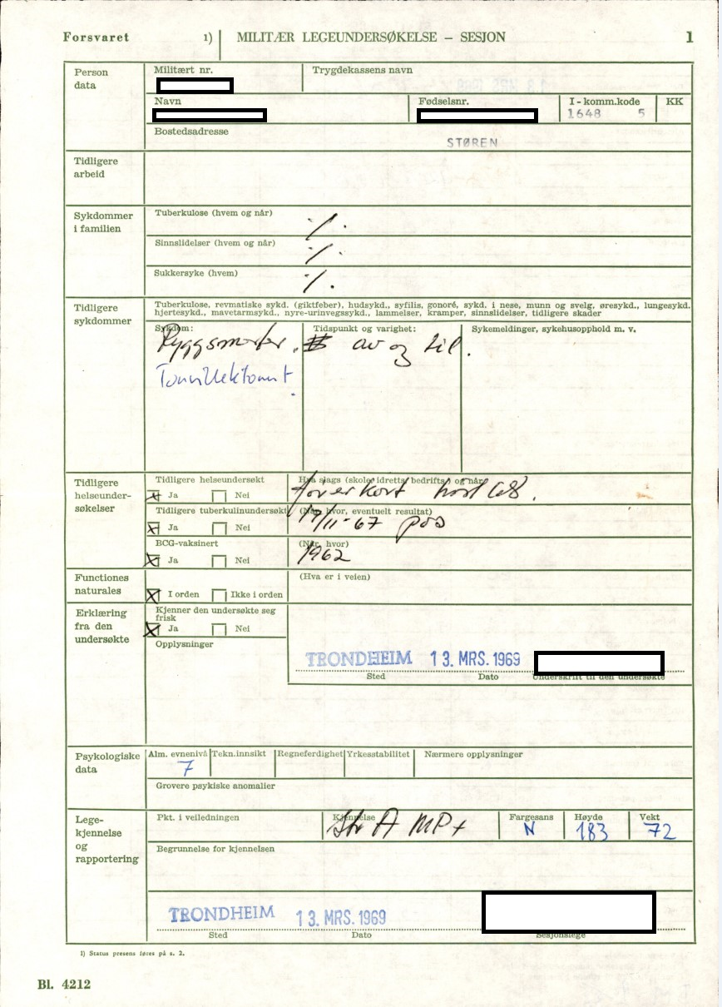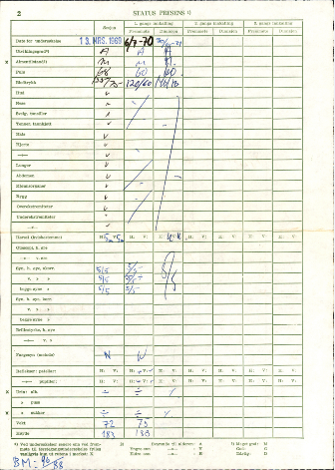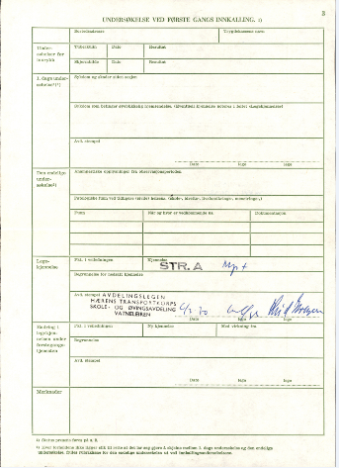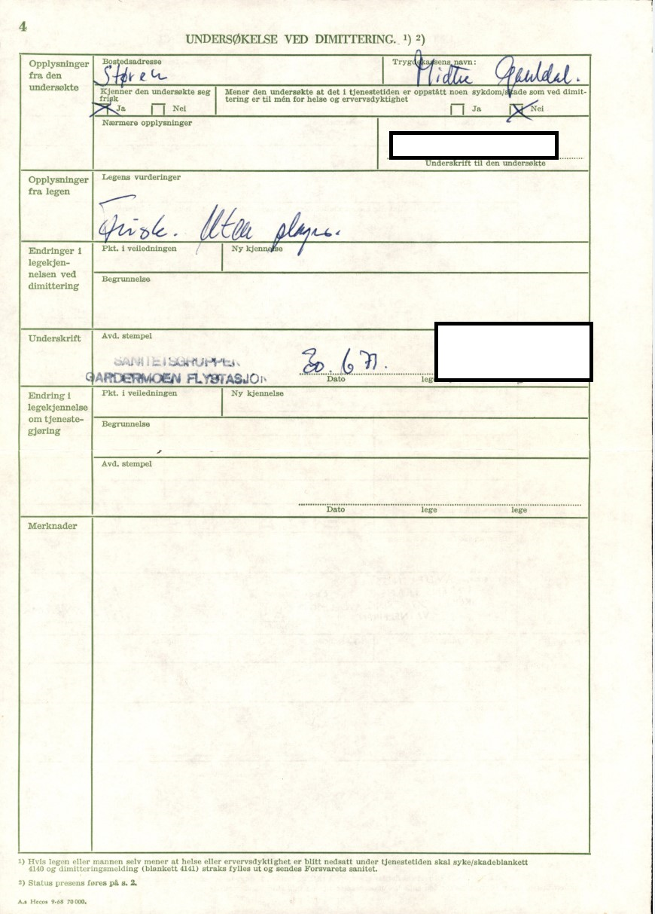

SFigure 2. General ability (GA) stanine scores
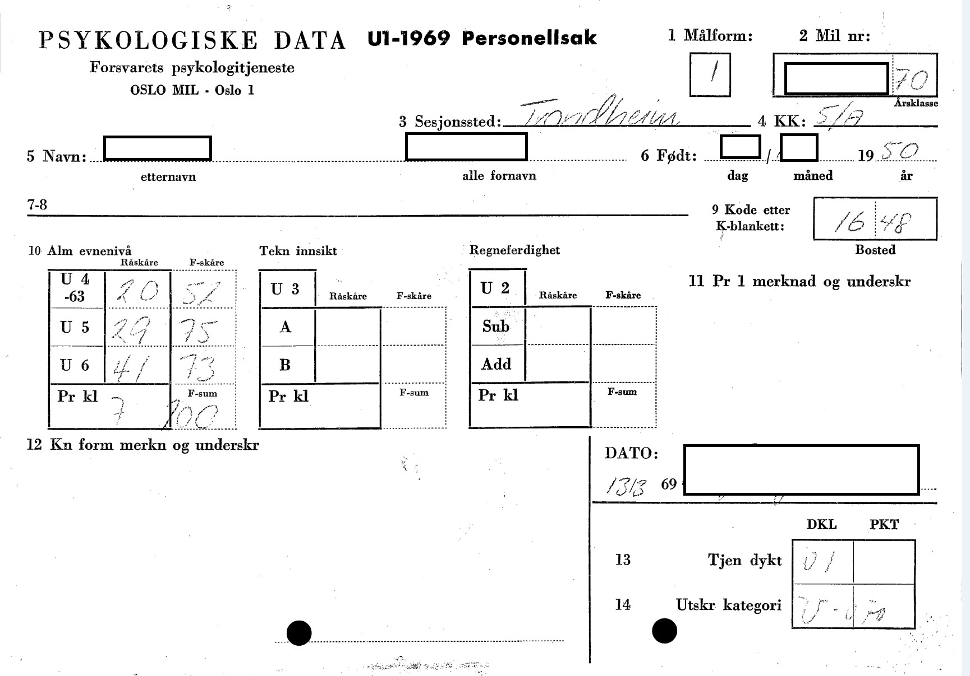
U4 corresponds to a numeracy test, U5 to word similarity, and U6 to the figure test.

SFigure 3. Military service records.

SFigure 4. Self-declaration of health and family health.
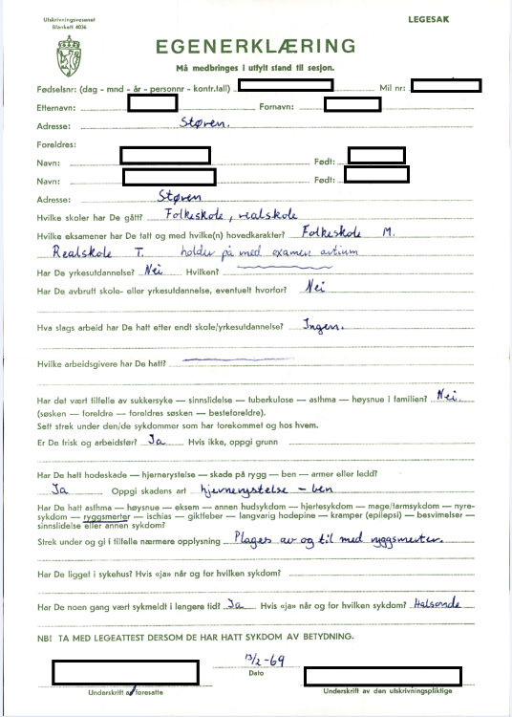
This form (Self-declaration of health and family health) was sent to the man by mail along with the call to conscription examination. The man was instructed to complete the form in company of parents or guardians. The man would hand the completed form to the military medical officer in charge of examinations at the conscription site.

STable1. The number of conscripts identified from archived personnel files and the number of Conscription Board Health Examination (CBHE) locations in 1968-1969, by county.
County* | Examined conscripts  in the digitized 1950 cohort (%) | CBHE sites
Total | 17 324 | 141
Østfold | 711 (4.1) | 6
Akershus | 686 (4) | 5
Oslo | 2146 (12.4) | 5
Hedmark | 679 (3.9) | 7
Oppland | 679 (3.9) | 5
Buskerud | 933 (5.4) | 5
Vestfold | 690 (4.0) | 5
Telemark | 547 (3.2) | 7
Aust-Agder | 342 (2) | 5
Vest-Agder | 516 (3) | 3
Rogaland | 1396 (8.1) | 8
Hordaland | 1745 (10.1) | 6
Sogn og Fjordane | 435 (2.5) | 8
Møre og Romsdal | 948 (5.5) | 10
Sør-Trøndelag | 1100 (6.3) | 8
Nord-Trøndelag | 625 (3.6) | 7
Nordland | 1020 (5.9) | 19
Troms | 788 (4.5) | 10
Finnmark | 310 (1.8) | 12
Missing | 1028 (5.9) | N/A
*This county classification was valid between 1946 and 2018

STable 2. Transcribed data in the digitized cohort of men born in 1950 (n=17 324)

Numbers with valid data
(% of 17 324 transcribed individuals)
Self-declared health***
Vocational education | 15 239 (88)
“Are you healthy and able to work?” | 15 255 (88)
Previous or current illness | 3201 (18)*
Illness in the family | 965 (6)**
* confirmed one or several of the following diseases: asthma, allergies, eczema, skin, heart, stomach, kidney, back, ischial, rheumatic fever, headache epilepsy, fainting, mental problems
** confirmed one or several of the following diseases among siblings/parents/parents’ siblings/grandparents: diabetes, mental disorders, tuberculosis, asthma, allergies
*** not transcribed due to time limitations

STable 3. Causes of deaths (n (%)) in the digitized 1950-cohort and all men born in 1950 and registered in the Norwegian Armed Forces Health Registry (NAFHR).

 | The digitized 1950-cohort | All men born in 1950 and registered in the NAFHR
Total number of deaths from 1969 and 2021 [ICD-10 codes] | 2893 | 6493
- Cardiovascular diseases [I00–I99] | 683 (23.6) | 1403 (21.6)
- Infectious and parasitic diseases [A00–B99] | 35 (0.7) | 86 (1.3)
- Cancer [C00–C97] | 1192 (41.2) | 2190 (34.2)
- Nervous system and sensory organ diseases [G00–H95] | 101 (3.5) | 258 (4)
- Mental and behavior disorders [F01–F99] | 73 (2.5) | 217 (3.3)
- Accidents including suicide[V01–Y89] | 293 (10.1) | 975 (15)
- Others (cirrhosis, influenza, pneumonia) | 403(13.9) | 1065(16)
- Unknown/missing codes | 113 (3.9) | 299 (4.6)

STable 4. Categorization of blood pressure range used in the multivariable logistic models.
CBHE |  | FDHE
SBP | n= 11 581(%) | SBP | n= 7367 (%)
< 115 | 819 (7.1) | < 115 | 374 (5.1)
115 to < 125 (ref) | 4365 (37.7) | 115 to < 125 (ref) | 1650 (22.4)
125 to < 135 | 3647 (31.5) | 125 to < 135 | 2151 (29.2)
≥ 135 | 2750 (23.7) | ≥ 135 | 3192 (43.3)
DBP | n= 11 581 (%) | DBP | n= 7367 (%)
< 65 | 913 (7.9) | < 65 | 263 (3.6)
65 to < 75 (ref) | 2488 (21.5) | 65 to < 75 (ref) | 1356 (18.4)
75 to < 85 | 6135 (53) | 75 to < 85 | 3282 (44.6)
≥ 85 | 2045 (17.7) | ≥ 85 | 2466 (33.5)

