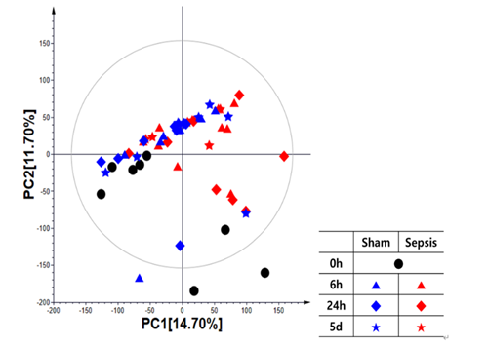
Figure S1. Principal component analysis (PCA) score plot derived from the GC-TOF-MS dataset for PBMCs

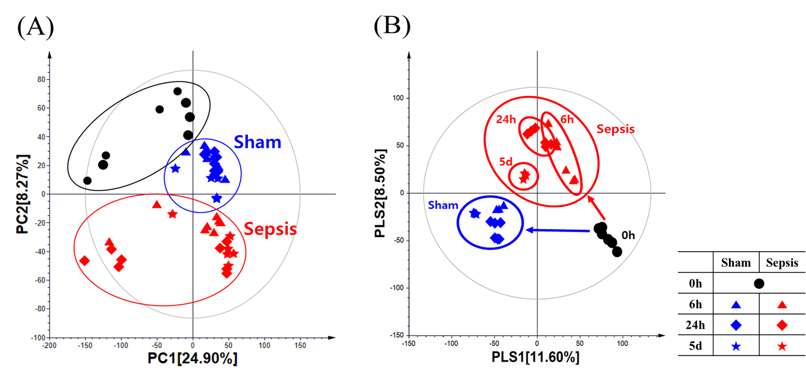
Figure S2. (A) PCA score plot; (B) PLS-DA score plot derived from the UHPLC-LTQ-Orbitrap-MS/MS dataset for PBMCs.

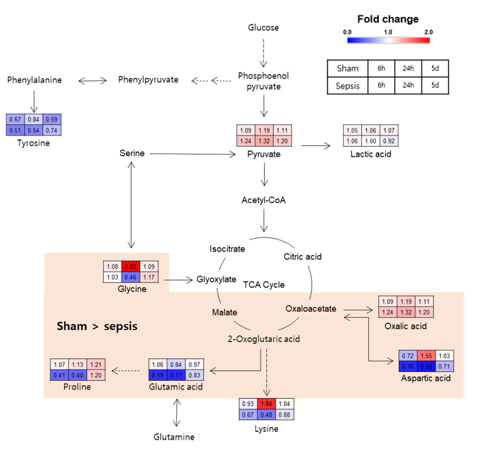
Figure S3. The metabolic pathways and the changes of discriminant metabolites in PBMCs

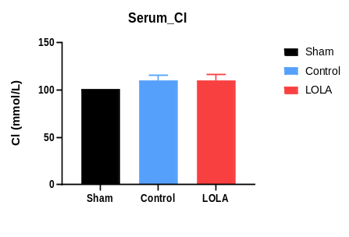
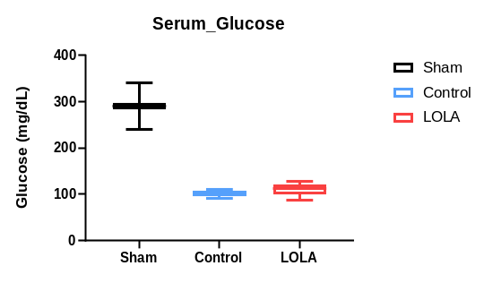
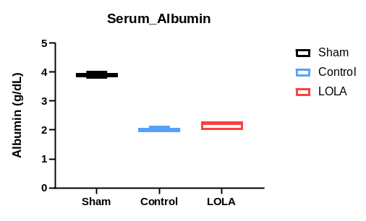
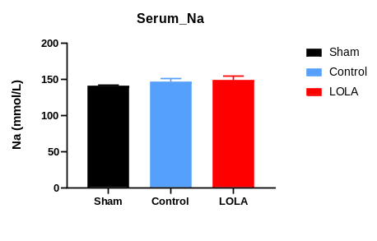
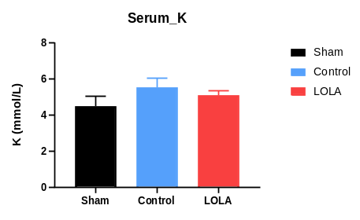
*

B

Figure S4. Effects of ASP supplementation in polymicrobial sepsis model on blood chemistry and electrolyte (Sham=2, Control=3, LOLA=5, Kruskal-Wallis test), (S4-B, Sham=2, Control=3, LOLA=5, One-way ANOVA, *p < 0.05)

Table S1. RNA-seq analysis statistics.
Sample | Replicate | Number of Reads (Sum of Pairs) | Number of Reads after Trimming | Alignment Rate (%)
SHAM | 1 | 62,897,298 | 61,501,892 | 97.92
SHAM | 2 | 52,683,764 | 51,227,740 | 97.83
SHAM | 3 | 42,072,978 | 40,716,902 | 97.64
SHAM | 4 | 50,498,112 | 48,824,828 | 97.77
SHAM | 5 | 58,110,284 | 56,235,544 | 97.49
SHAM | 6 | 46,880,794 | 45,677,320 | 97.85
SHAM | 7 | 62,426,236 | 60,865,762 | 97.89
SHAM | 8 | 58,346,842 | 56,982,916 | 97.87
SEPSIS | 1 | 51,112,394 | 49,633,888 | 97.83
SEPSIS | 2 | 56,013,230 | 54,408,724 | 97.81
SEPSIS | 3 | 39,931,406 | 38,933,498 | 97.34
SEPSIS | 4 | 51,865,950 | 50,019,782 | 97.78
SEPSIS | 5 | 49,415,906 | 47,574,124 | 97.76
SEPSIS | 6 | 42,907,790 | 41,552,740 | 97.79
SEPSIS | 7 | 54,758,540 | 52,893,366 | 97.92
SEPSIS | 8 | 57,989,094 | 55,906,548 | 97.39

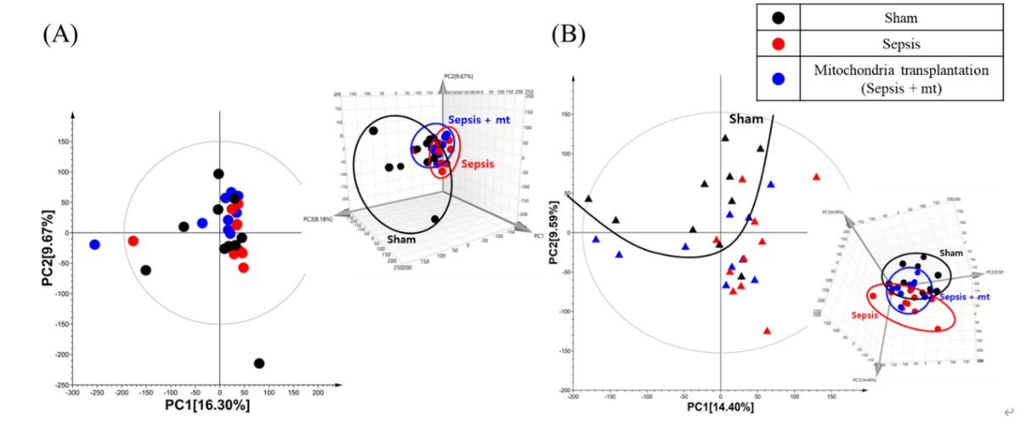
B
A

Figure S5. Principal component analysis (PCA) score plot derived from the GC-TOF-MS dataset for PBMCs (A) PBMCs, (B) Splenocytes.

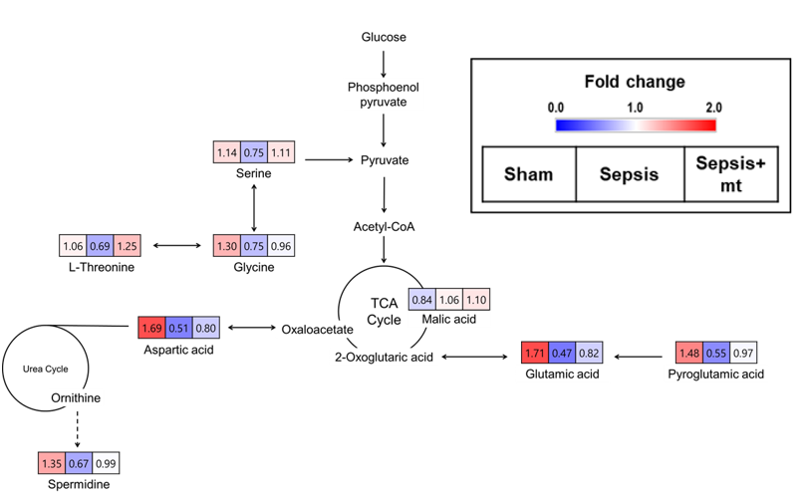
B

Figure S6. The metabolic pathways and the changes of discriminant metabolites with mitochondrial transplantation (A) PBMCs, (B) splenocytes.

