Supplementary Information
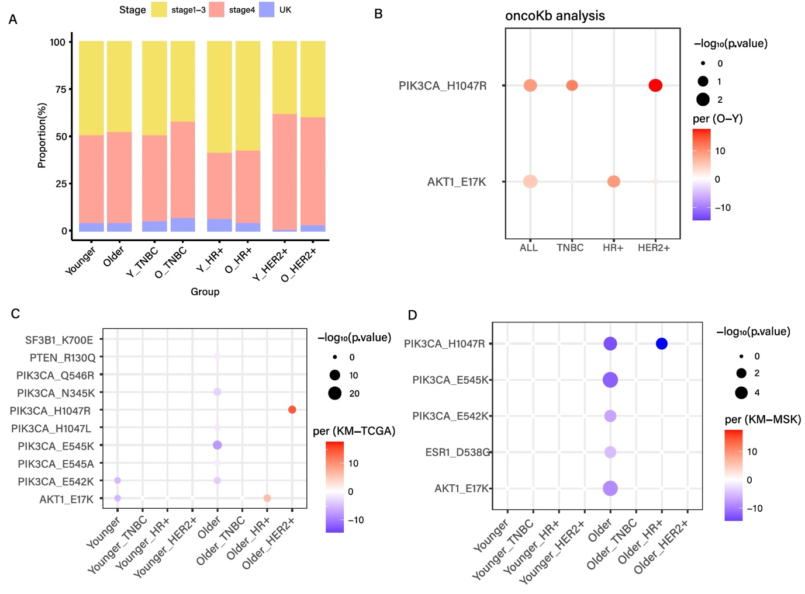
Supplementary Figure 1. (A) Clinical stage distribution of cancer by age and molecular subtype (B) The OncoKB variant differs from the KM YBC and OBC groups. (C) The OncoKB variant differs from the KM and TCGA groups. (D) The OncoKB variant differs from the KM and MSK groups.

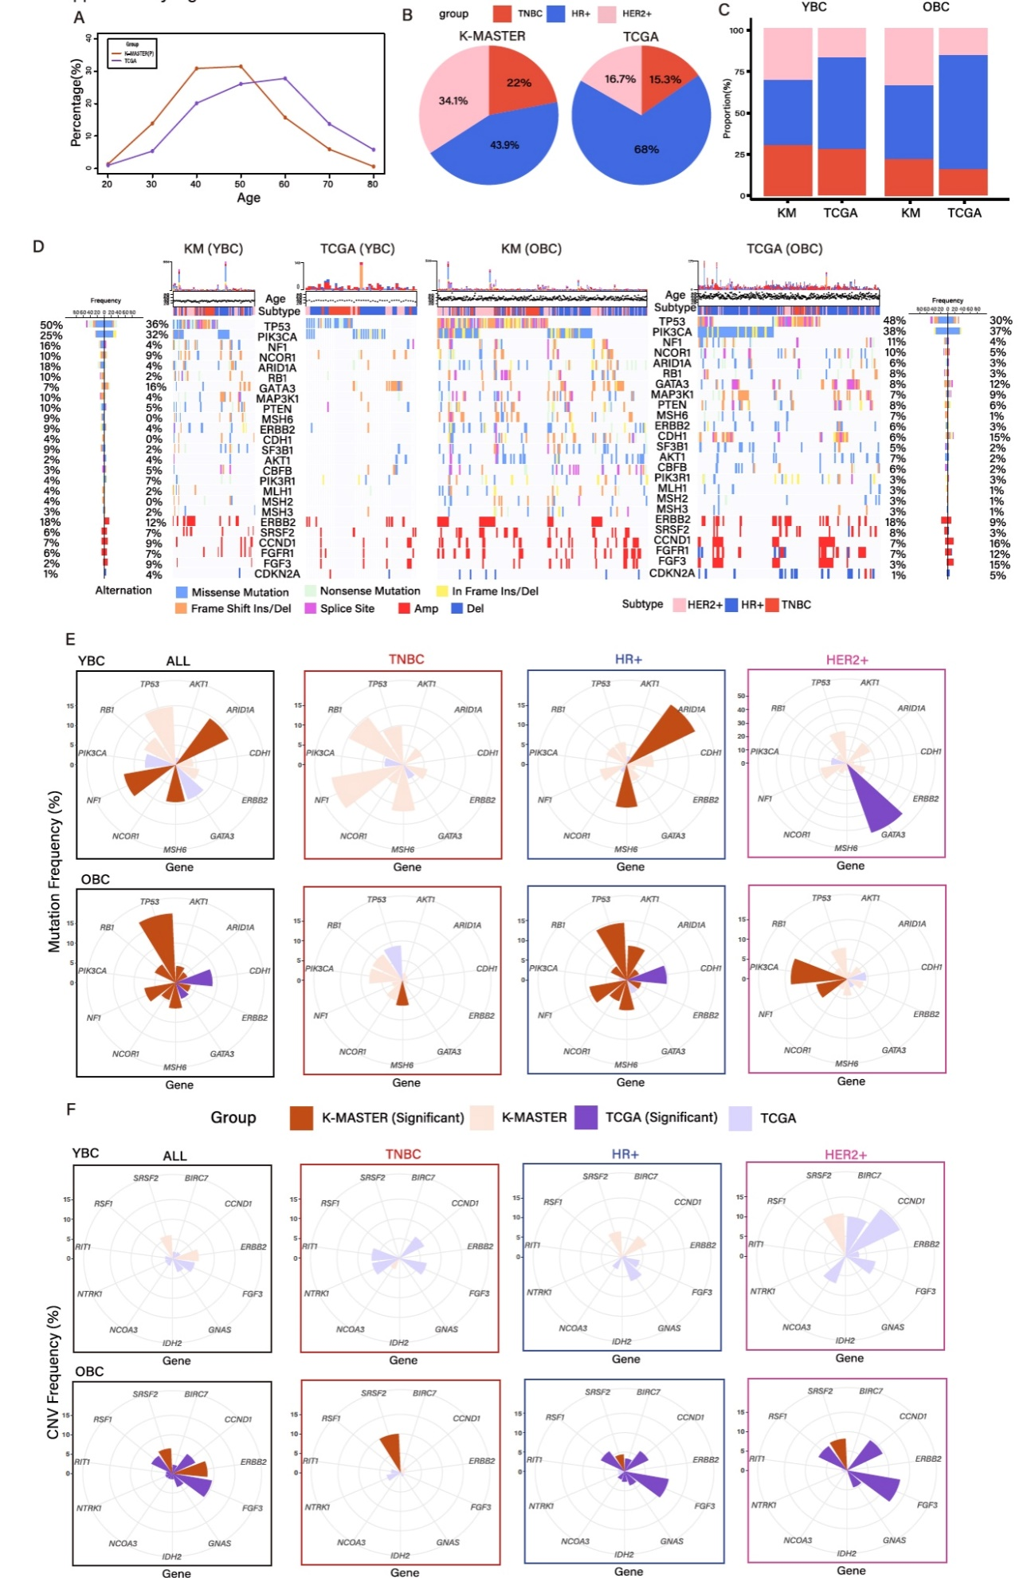
Supplementary Figure 2. Genomic difference of KM and TCGA primary cohort. (A) Age distribution of KM and TCGA. (B) Molecular subtype proportion of KM and TCGA. (C) Molecular subtype proportion of KM and TCGA by age group. (D) Genomic landscape of somatic mutations and copy number alterations of BRCA by age group. (E) Significantly mutated genes according to molecular subtypes and age group in the KM and TCGA cohorts. (F) Significantly copy number altered genes according to molecular subtypes and age group in the KM and TCGA cohorts.

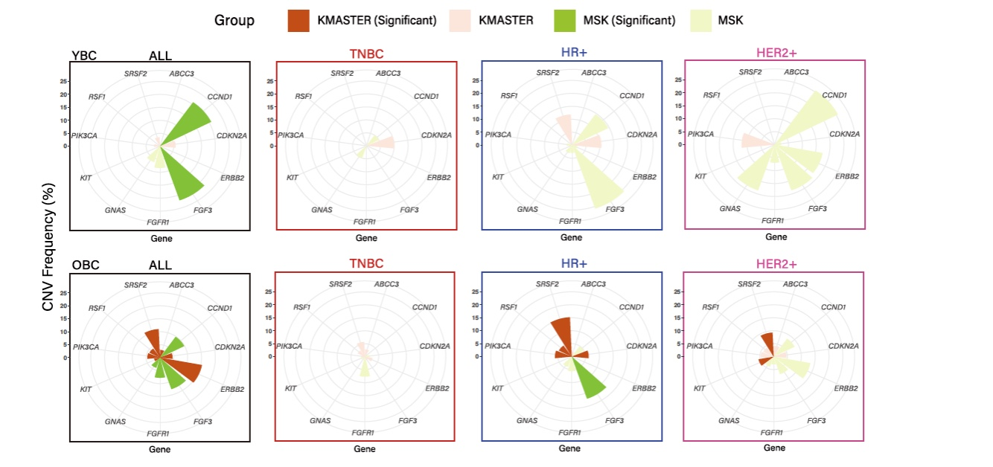
Supplementary Figure 3. Gene with significant copy number variation is analyzed according to age and subtype in KM and MSK groups.
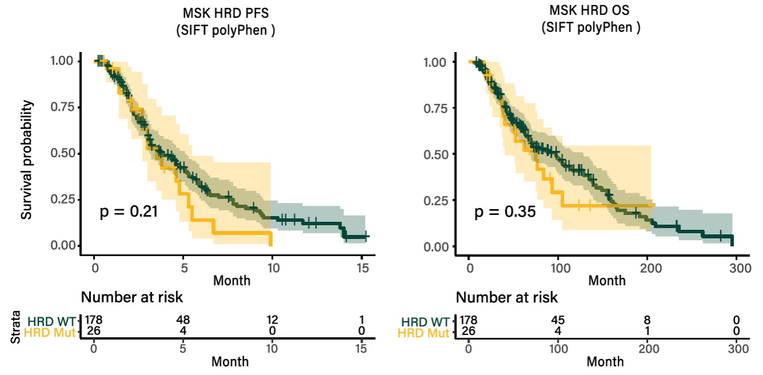
Supplementary Figure 4. (A) PFS of platinum-based therapy treated MSK with deleterious HRD mutation. (B) OS of platinum-based therapy treated MSK with deleterious HRD mutation.

