Dysfunction of heat shock factor 4 impairs retinal structure and visual function in mice and zebrafish
Baixue Liu^{1a}, Youfei Lang ^{1a} , Mengjiao Xue¹ , Ming Jun Jiang¹, Xiaolin Jia¹, Dan-Dan Chen¹, Guiling Zhou¹, Fengyan Zhang¹, Xuyan Peng¹*and Yanzhong Hu^{1,2,3*}
1. The Division of Ophthalmology and Vision Science, Department of Ophthalmology, The First Affiliated Hospital of Zhengzhou University, Zhengzhou University, Zhengzhou, China
2. The joined National Laboratory of Antibody Drug Engineering, The First Affiliated Hospital of Henan University, Henan University, Kaifeng, China
3. Kaifeng Key Lab of Cataracts and Myopia, Kaifeng Central Hospital, Kaifeng, China
4. Department of Medical Genetics and Cell Biology, School of Basic Medical Sciences, Zhengzhou University, 450001, Henan, China

Running Title: HSF4 regulates retinal development

ª These authors contributed equally to this work
* To whom the correspondent should be addressed:
Xuyan Peng，Ph.D.( xuyanpeng331@163.com)
Yanzhong Hu, Ph.D. (hyz@henu.edu.cn)
The Division of Ophthalmology and Vision Science, Department of Ophthalmology, The First Affiliated Hospital of Zhengzhou University, Zhengzhou University, No.1 Long-Hu-Zhong Huan Road, Zhengzhou, China

Figure S1. Hsf4^{del} mice develop cataracts and age-related retinal degeneration. A, the photographs of the eyes of C57BL/6 wild-type and Hsf4^{del} mice at P17 and P27 by using the slit-lamp microscope. B, The H&E staining the whole eye of wild-type and Hsf4^{del} mice at P10, 7 M and 13 M. C, immunoblot the expression of Hsf4 and a-tubulin (a-tub) in the retina of wild-types C57BL/6 mice at P1, P7,P10, P21, and 5-16 months old. D, The immunofluorescent staining the expression of Hsf4 in the retina of 1 month old wild-type vs. Hsf4^{del} mice. E. the immunoblot the expression of Hsf4 in one-month old retina of wild-type vs. Hsf4^{del} mice

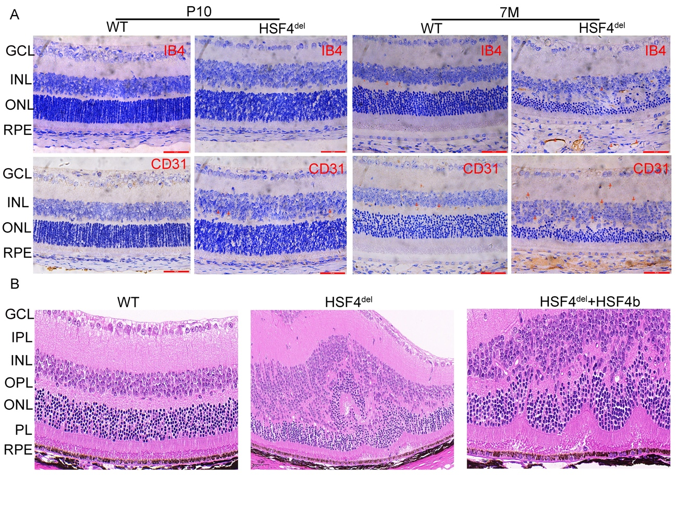
Figure S2. Hsf4^{del} mice upregulates neovascularization in the retina. A, immunohistochemistry staining the expression of IB4 and CD31 in the retina of P10 and 7M wild-type and Hsf4^{del} mice. The expression of IB4 and CD31 was significantly upregulated in the retina of 7 months Hsf4^{del} mice as compared to wild-types. No significant difference of IB4 and CD31 was observed between wild-type and Hsf4^{del} mice at P10. B, Histological analysis of the retinal structure of three months old wild-type, Hsf4^{del} or Hsf4^{del} with subretinal injected AAV2-Hsf4b -flag virus.

Figure S3. Dysfunction of Hsf4 downregulates the expression of visual cycle enzymes in mice and zebrafish. A, the whole mount staining the expression of RPE65, RLBP1 and RDH5 in the RPE tissues of wild-type and Hsf4^{del} mice at 7 M old. B, immunofluorescent staining Flag-Hsf4b in the retina of wild-type, Hsf4^{del} or Hsf4^{del} with subretinal injected AAV2-Hsf4-Flag virus. C, Using a grind-transparent assay to determine lens opacification of wild-type and Hsf4^{null} zebrafish at 4 dpf, 10 dpf, 7 mpf and 13 mpf old. D. the qRT-PCR to measure the expression of RPE65, RLBP1 and RDH5 in the retina of wild-type and Hsf4^{null} zebrafish at 4 dpf, 10 dpf, 7 mpf and 13 mpf old. The shown data were mean ± SD, n=30, *p<005, **p<0.01, ***p<0.001, ns, no statistical significance. E, immunoblot the expression of RPE65, RLBP1 and RDH5 in the retina of wild-type and Hsf4^{null} zebrafish at 4 dpf, 10 dpf, 7 mpf and 13 mpf old. F-H, the densitometry quantitation of the expression of RPE65 , RLPB1 and RDH5 in E by using image J. The shown data represented mean ± SD, n=12, *p<0.05, **p<0.01. zHsf4^{null} downregulates the expression of visual cycle enzymes in retina at least at the embryonic day 4.

Figure S4. Hsf4^{del} mutation upregulates Cryab in retinal RPE cells. A, immunofluorescence staining the expression of Cryab in the retina of Wild-type and Hsf4^{del} mice at P10, 7 M and 13 M old. The expression of Cryab was upregulated predominantly in the RPE cells of Hsf4^{del} mice at P10, 7M and 13M old. B, the whole mount staining of Cryab and ZO-1 expression in the RPE cells of 7-months wild-type retina vs. Hsf4^{del} mice.

Table 1. Primers used in this study. Related to Experimental Procedures.
Test | Symbo | NCBI accession No. | Forward | Reverse
qRT-PCR | Rhodopsin*  Opn1sw*  Opn1mw*  RPE65*  RDH5*  RLBP1*  HSP90aa*  HSP90ab*  HSP25*  aB-crystallin*  GFAP*  GS*  P16*  P21*  IL-1β*  IL-6*  IL-8*  GAPDH*  Rhodopsin#  GNB1#  GNAT2#  RPE65a#  RDH5#  RLBP1A#  RLBP1B#  HSP90aa#  HSP90ab#  HSP25#  aB-crystallin#  GFAP#  GS#  P16#  P21#  IL-1β#  IL-6#  IL-8#  EF1A#  rpl13a# | NM_145383.2  NM_007538.3  NM_008106.2  XM_006501165.2  XM_036155706.1  XM_036152809.1  NM_010480.5  NM_008302.3  NM_013560.2  XM_036154592.1  XM_030245571.2  XM_006498781.4  NM_001040654.1  NM_001111099.2  XM_006498795.5  NM_031168.2  NM_011339.2  NM_001411843.1  NM_131084.1  NM_212609.1  NM_131869.2  NM_200751.1  XM_005173961.4  NM_200705.1  XM_005163003.4  NM_131328.1  NM_131310.3  NM_001008615.2  XM_021476081.1  XM_005163983.4  NM_001006104.1  XM_002660468.5  XM_003200914.5  NM_212844.2  NM_001261449.1  XM_009306855.3  NM_131263.1  NM_212784.1 | CACTCGTTGGCTGGTCCAGGTAC  ACAAAAAGTTGCGACAGCCC  CTTCGTTCTGGGACACCCTC  GGAGTCTTTGGGGAGCCAAC  TGGCTTCTTTCGAACCCCTG  GATTCATTCCCAGCCAGGTT  GTTACGACAGCCTGACGGAC  AGCCTGACGGACCCTTCTAA  CAGGACGAACATGGCTACA  AAGAACGCCAGGACGAACAT  TCTCCAACCTCCAGATCCGA  CCAATAACCCCAGCAAGGGA  CCCGAACTCTTTCGGTCGT  AGTGTGCCGTTGTCTCTTCG  TTCAGGCAGGCAGTATCACTC  TAGTCCTTCCTACCCCAATTTCC  TGTTGAGCATGAAAAGCCTCTAT  GGTTGTCTCCTGCGACTTCA  TACAGAGGGACCGGCATTC  AGATCAGAGATGCGCGGAAA  GCTCCAGGAAGATGCCGATA  TCTTTGTGGAGACGCCTGTG  GACCGGTTGTGACTCTGGTT  CTGCGTGCCTACTGTGTAATCC  CTGAGGGTGAACCCAGAAGT  GACGACCCACAGACTCATGC  TGTCAGAACTGCTGCGTTAC  GATGACCCCGAGTTACGGAC  ATACCGTGTCCCTGTTGGTG  GTGGAGAGCGGCTAGACTTT  CGTCCCAGTCCAGAACATCC  GATGGGTAACGCACCTTTGG  CTAGAGGGCGGAGACTTCCA  GACCGGCAGCTCCATAAACA  ATGACGGCATTTGAAGGGGT  TCCTGGCATTTCTGACCATCAT  AAGCCTGGTATGGTTGTGACC  ACAAAACCAAGAGGGGTCAGG | AGCCGCCTCCTTGACTGTGAAGA  CCATCCTGTCACTAGACCTGC  GAGGCCTGTGATTCCACACA  AGCAACATGAAGCCAAACCC  GTGGGCCTGTATAGCTGGAG  CCAGGTCATCTCCGTGAACAA  TCAGGGTTCGGTCCTGTTTG  GTCATGCCAATGCCTGTGTC  AGAGCGCACAGATTGACAG  GAGAGGATCCACATCGGCTG  TCTGGTGAGCCTGTATTGGGA  ATCAGTAGCACCACCGCATT  GCAGAAGAGCTGCTACGTGA  CAGACGAAGTTGCCCTCCAG  GAAGGTCCACGGGAAAGACAC  TTGGTCCTTAGCCACTCCTTC  AGGTCTCCCGAATTGGAAAGG  TGGTCCAGGGTTTCTTACTCC  GGGTATTCGTATGGGCTCCG  GAATCCGCCCAACAGGATCA  CAGACTGCAGGATGTTGCCA  CTCTCCTGGGTGTTTCCTCG  TGCTTTCGAAGTCCTCGATT  GCTCGGTGTGTTTGATTCCAG  ACACGGCCCTCATAGAGAAC  TCGACCACAGAGTCATCGTCA  ACAAATGCAGAGTGGGCAAC  GAGTCTCCGGTCTGCTTGAC  GAGCTTTAGTGGGCCTGTCA  TTTCATTGGTGCGGGTCTCA  CCCAAATGCACCCAGTTCAC  GTCGGGGTCAGGCACATTAG  TCGTTCTGGTGTTTTCGGGA  CGAATCTTCATACGCGGTGC  TCAGGACGCTGTAGATTCGC  ATGCGTCGGCTTTCTGTTTC  TCTCCAGCCACATTACCACG  GACAACCATGCGCTTTCTCTTG
cDNA clone | pTransfer-Flag-HSF4@ | Gene ID: 3299 | CGG GGTACC GACTACAAAGACCATGACGGTGATTATAAAGATCATGACATCGACTACAAGGATGACGATGACAAG ATGCAGGAAGCGCCAGCT | TTTGTCGACTTAGGGGGAGGGACTGGCTT
cDNA clone | p3xFlag-CMV7.1-HSF4b@ | Gene ID: 3299 | CCCAAGCTTCAGGAAGCGCCAGCTGCG | CCGGAATTCTTAGGGGGAGGGACTGGCTTCC

*defined to Mouse gene ，#defined to Zerafish gene，@defined to Human gene

