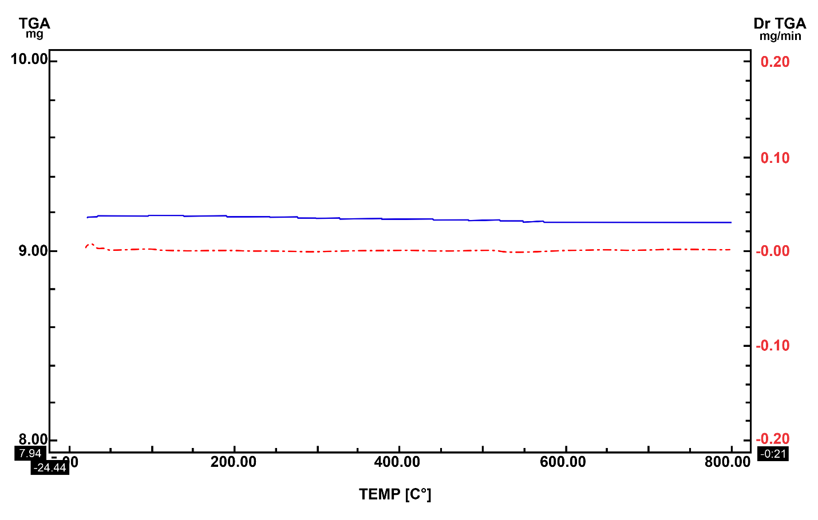
Figure S1. TGA analysis of andesite.

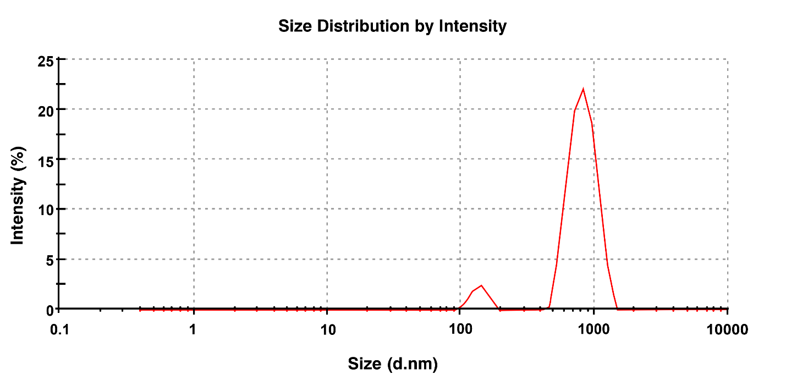
Figure S2. Number-wise distribution of sizes.

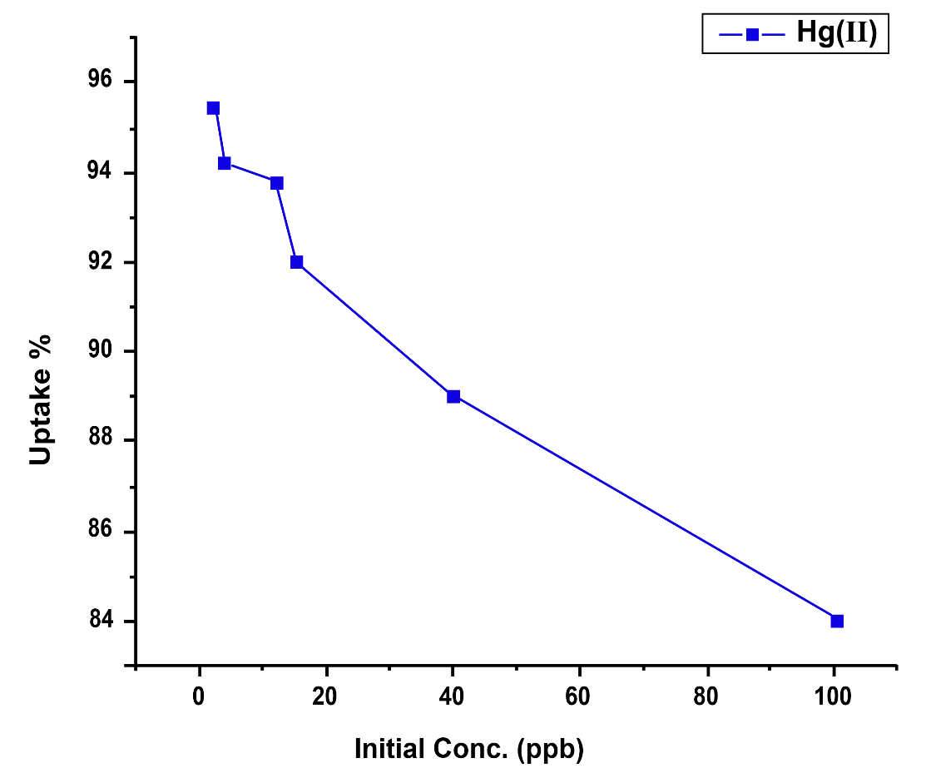
Figure S3. Metal ion concentration influence on Hg(II) uptake%.

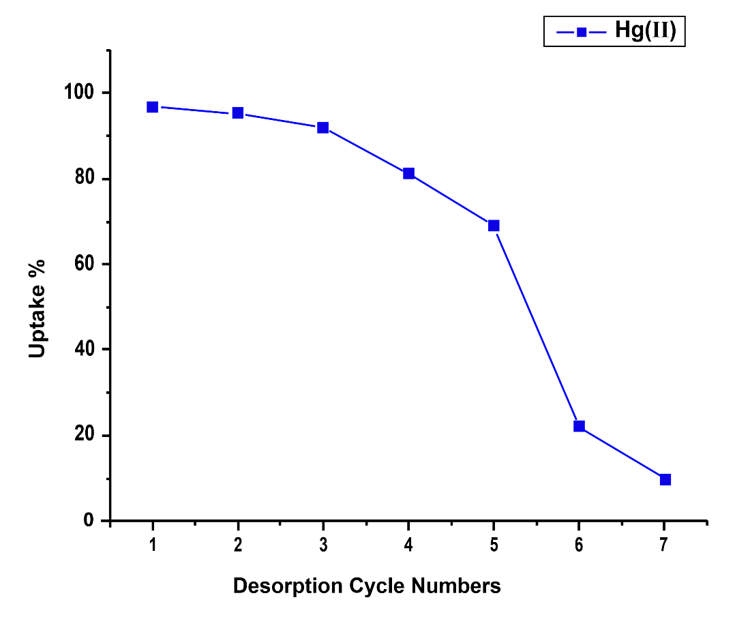
Figure S4. The influence of regeneration cycle numbers on the Hg(II) uptake.

