Stress responses in an Arctic microalga (Pelagophyceae) following sudden salinity change revealed by gene expression analysis

Nastasia J. Freyria^{1*}, Thais C. de Oliveira², Mansi Chovatia³, Jennifer Johnson³, Alan Kuo³, Anna Lipzen³, Kerrie W. Barry³, Igor V. Grigoriev^{3,4} and Connie Lovejoy^{2,5**}

¹Department of Natural Resource Sciences, McGill University, Ste. Anne-de-Bellevue, Québec, QC, H9X 3V9, Canada
²Institut de Biologie Intégrative et des Systèmes, Département de biologie, Université Laval, Québec, QC, G1V 0A6, Canada
³U.S. Department of Energy Joint Genome Institute, Lawrence Berkeley National Laboratory, Berkeley, CA 94720, USA
⁴Department of Plant and Microbial Biology, University of California Berkeley, Berkeley, CA 94720, USA
⁵Québec Océan, Département de biologie, Université Laval, Québec, QC, G1V 0A6, Canada

Supplementary Table 1. Cellular counts and cellular viability from flow cytometry with the use of Invitrogen SYTOX™ Green Nucleic Acid Stain (see Supplementary Fig. 1C). Salinity was measured at the time of sampling for each triplicate.
 |  |  | Cellular concentration
Sample | Time of sampling | Salinity measured | Live cells (cell.ml⁻¹) | % | Dead cells (cell.ml⁻¹) | %
Salinity 45 (control)
C1 | t0h | 48.5 | 2.47 x 10⁵ | 95.7 | 1.09 x 10⁴ | 4.3
 | t2h |  | 2.39 x 10⁵ | 95.9 | 9.82 x 10³ | 4.1
 | t6h |  | 2.20 x 10⁵ | 93.6 | 1.51 x 10⁴ | 6.4
 | t12h | 47.5 | 2.22 x 10⁵ | 91.7 | 2.00 x 10⁴ | 8.3
 | t24h | 48 | 2.86 x 10⁵ | 94 | 1.86 x 10⁴ | 6
C2 | t0h | 45.9 | 2.16 x 10⁵ | 93.1 | 1.61 x 10⁴ | 6.9
 | t2h | 47.4 | 2.36 x 10⁵ | 93.4 | 1.66 x 10⁴ | 6.6
 | t6h | 47.5 | 2.18 x 10⁵ | 93.2 | 1.59 x 10⁴ | 6.8
 | t12h | 47 | 2.15 x 10⁵ | 91.2 | 2.09 x 10⁴ | 8.8
 | t24h |  | 3.12 x 10⁵ | 93.6 | 2.22 x 10⁴ | 6.4
C3 | t0h | 46.7
 | t2h | 46.9 | 2.75 x 10⁵ | 94.3 | 1.64 x 10⁴ | 5.7
 | t6h | 46.7 | 2.73 x 10⁵ | 94.1 | 1.77 x 10⁴ | 5.9
 | t12h | 46.5 | 2.55 x 10⁵ | 91.1 | 2.49 x 10⁴ | 8.9
 | t24h |  | 2.50 x 10⁵ | 92.1 | 2.20 x 10⁴ | 7.9
Salinity 22
R1 | t0h | 22
 | t2h | 22.3
 | t6h | 22.5
 | t12h
 | t24h | 21.6 | 3.71 x 10⁵ | 86.8 | 5.68 x 10⁴ | 13.2
R2 | t0h | 20.6 | 1.75 x 10⁵ | 75.3 | 5.78 x 10⁴ | 24.7
 | t2h | 20.7 | 2.05 x 10⁵ | 80.3 | 5.03 x 10⁴ | 19.7
 | t6h | 20.9 | 2.23 x 10⁵ | 81.1 | 5.20 x 10⁴ | 18.9
 | t12h |  | 2.32 x 10⁵ | 86.5 | 3.68 x 10⁴ | 13.5
 | t24h |  | 2.66 x 10⁵ | 86 | 4.34 x 10⁴ | 14
R3 | t0h | 22
 | t2h | 22.4
 | t6h | 22.2
 | t12h | 22.3
 | t24h | 22.1 | 2.78 x 10⁵ | 68.6 | 1.27 x 10⁵ | 31.3
Salinity 16
R1 | t0h | 16.3
 | t2h | 15.3
 | t6h | 15.3
 | t12h | 15.1
 | t24h | 15 | 2.37 x 10⁵ | 80.1 | 5.91 x 10⁴ | 19.9
R2 | t0h | 16.2 | 1.98 x 10⁵ | 70.2 | 8.44 x 10⁴ | 29.8
 | t2h | 16.5 | 2.52 x 10⁵ | 71.2 | 1.02 x 10⁴ | 28.8
 | t6h | 16.4 | 2.39 x 10⁵ | 74.3 | 8.28 x 10⁴ | 25.7
 | t12h |  | 2.51 x 10⁵ | 73.6 | 8.99 x 10⁴ | 26.4
 | t24h | 16.2 | 2.02 x 10⁵ | 80.7 | 4.87 x 10⁴ | 19.3
R3 | t0h | 15.6
 | t2h | 15.7
 | t6h | 15.2
 | t12h | 15.5
 | t24h | 15.6 | 2.35 x 10⁵ | 66.9 | 1.15 x 10⁵ | 33.1
Supplementary Table 2. Statistic two-way ANOVA for cellular viability for salinity 45 (control), 22 and 16 (see Supplementary Fig. 1C and Supplementary Table 1). Total degree of freedom of 5 for all comparison, except for t0h-t2h and t0h-t24h (control group) where degree of freedom was 3. Letters ‘a’ and ‘b’ refer to the comparison test shown on the Supplementary Fig. 1C.

 | Two-way ANOVA without replication
Comparison | Live cells |  |  |  | Dead cells
Comparison | F | p-value | Significance |  | F | p-value | Significance
t24h
Sal. 45 vs Sal. 22 | 0.17 | 0.85 |  |  | 0.81 | 0.55
Sal. 45 vs Sal. 16 | 0.98 | 0.50 |  |  | 1.05 | 0.48
Sal. 22 vs Sal. 16 | 2.25 | 0.30 |  |  | 0.11 | 0.89
Sal.45 (control)
t0h vs t2h | 1.47 | 0.43 |  |  | 57.49 | 0.08
t2h vs t6h | 30.74 | 0.03 | a* |  | 2.59 | 0.27
t6h vs t12h | 25.39 | 0.03 | b* |  | 9.15 | 0.09
t12h vs t24h | 0.05 | 0.95 |  |  | 3.81 | 0.20
t0h vs t24h | 0.007 | 0.94 |  |  | 30.25 | 0.11
* Significant p-values.

Supplementary Table 3. Mean nutrient concentrations (two replicate of each triplicate) at time of sampling, and nutrient consumptions from calculations based on subtracting the final concentration at the time of sampling from the initial concentration added at the start of the culture (see Supplementary Fig. 1D).

 |  |  | Nutrient concentration (µmol.L⁻¹) |  |  | Nutrient consumption (µmol.L⁻¹)
Sample | Time of sampling | Replicate | Nitrite+Nitrate | Phosphate |  | Nitrite+Nitrate | Phosphate
Salinity 45 (control)
C1 | t0h | 1 | 744.14 | 37.42 |  | 137.86 | 1.22
 |  | 2 | 742.52 | 37.58 |  | 139.48 | 1.38
 | t12h | 1 | 729.70 | 35.49 |  | 152.30 | 0.71
 |  | 2 | 730.38 | 35.97 |  | 151.62 | 0.23
 | t24h | 1 | 725.14 | 35.09 |  | 156.86 | 1.11
 |  | 2 | 721.48 | 34.83 |  | 160.52 | 1.37
C2 | t0h | 1 | 740.90 | 36.12 |  | 141.10 | 0.08
 |  | 2 | 749.30 | 36.89 |  | 132.70 | 0.69
 | t12h | 1 | 735.42 | 34.43 |  | 146.58 | 1.77
 |  | 2 | 735.60 | 34.43 |  | 146.40 | 1.77
 | t24h | 1 | 719.02 | 34.36 |  | 162.98 | 1.84
 |  | 2 | 722.78 | 34.26 |  | 159.22 | 1.94
C3 | t0h | 1 | 730.04 | 34.81 |  | 151.96 | 1.39
 |  | 2 | 731.94 | 34.97 |  | 150.06 | 1.23
 | t12h | 1 | 728.96 | 34.83 |  | 153.04 | 1.37
 |  | 2 | 730.62 | 35.42 |  | 151.38 | 0.78
 | t24h | 1 | 717.78 | 34.41 |  | 164.22 | 1.79
 |  | 2 | 717.84 | 34.31 |  | 164.16 | 1.89
Salinity 22
R1 | t0h | 1 | 718.38 | 29.53 |  | 163.62 | 6.67
 |  | 2 | 718.72 | 30.04 |  | 163.28 | 6.16
 | t12h | 1 | 713.30 | 30.43 |  | 168.70 | 5.77
 |  | 2 | 822.38 | 30.43 |  | 59.62 | 5.77
 | t24h | 1 | 724.64 | 28.50 |  | 157.36 | 7.70
 |  | 2 | 718.64 | 28.54 |  | 163.36 | 7.66
R2 | t0h | 1 | 851.28 | 34.17 |  | 30.72 | 2.03
 |  | 2 | 728.70 | 33.40 |  | 153.30 | 2.80
 | t12h | 1 | 819.14 | 30.71 |  | 62.86 | 5.49
 |  | 2 | 611.88 | 30.86 |  | 270.12 | 5.34
 | t24h | 1 | 741.32 | 30.27 |  | 140.68 | 5.93
 |  | 2 | 739.32 | 29.98 |  | 142.68 | 6.22
R3 | t0h | 1 | 776.96 | 30.82 |  | 105.04 | 5.38
 |  | 2 | 834.70 | 30.64 |  | 47.30 | 5.56
 | t12h | 1 | 866.06 | 31.51 |  | 15.94 | 4.69
 |  | 2 | 716.14 | 32.37 |  | 165.86 | 3.83
 | t24h | 1 | 718.52 | 30.91 |  | 163.48 | 5.29
 |  | 2 | 720.00 | 31.35 |  | 162.00 | 4.85
Salinity 16
R1 | t0h | 1 | 713.88 | 25.75 |  | 168.12 | 10.45
 |  | 2 | 713.84 | 26.16 |  | 168.16 | 10.04
 | t12h | 1 | 726.38 | 28.64 |  | 155.62 | 7.56
 |  | 2 | 721.98 | 28.09 |  | 160.02 | 8.11
 | t24h | 1 | 713.10 | 27.11 |  | 168.90 | 9.09
 |  | 2 | 718.26 | 26.79 |  | 163.74 | 9.41
R2 | t0h | 1 | 741.64 | 26.62 |  | 140.36 | 9.58
 |  | 2 | 737.90 | 26.13 |  | 144.10 | 10.07
 | t12h | 1 | 727.20 | 29.44 |  | 154.80 | 6.76
 |  | 2 | 725.36 | 29.36 |  | 156.64 | 6.84
 | t24h | 1 | 731.74 | 29.19 |  | 150.26 | 7.01
 |  | 2 | 734.18 | 29.09 |  | 147.82 | 7.11
R3 | t0h | 1 | 731.60 | 28.40 |  | 150.40 | 7.80
 |  | 2 | 730.76 | 28.00 |  | 151.24 | 8.20
 | t12h | 1 | 721.48 | 29.02 |  | 160.52 | 7.18
 |  | 2 | 719.28 | 28.92 |  | 162.72 | 7.28
 | t24h | 1 | 720.16 | 28.58 |  | 161.84 | 7.62
 |  | 2 | 719.82 | 29.23 |  | 162.18 | 6.97

Supplementary Table 4. Statistical results of two-way ANOVA for final concentration measured at three time of sampling (t0h, t12h and t24h) and concentration of total nitrate and total phosphate consumption (n = 6, two replicates for each triplicate) for each condition of salinity 16, 22 and 45 (see Supplementary Fig. 1D and Supplementary Table 3). Total degree of freedom was 17 for comparison between the three time of sampling (t0h, t12h and t24h) and 11 for comparison between two time of sampling. Letters ‘c’ to ‘l’ refer comparison test showed on the Supplementary Fig. 1D.

 | Two-way ANOVA repeated measures
 | Total Nitrate |  |  |  |  |  |  |  | Phosphate
Comparison | Final concentration |  |  |  | Consumption |  |  |  | Final concentration |  |  |  | Consumption
Comparison | F | p | Sig. |  | F | p | Sig. |  | F | p | Sig. |  | F | p | Sig.
t0h - t12h - t24h
Sal. 45 (control) | 171.7 | 0.0057 | ** |  | 8.13 | 0.10 |  |  | 36.67 | 0.026 | * |  | 3.66 | 0.21
Sal. 22 | 1.17 | 0.45 |  |  | 0.25 | 0.79 |  |  | 41.88 | 0.023 | * |  | 38.03 | 0.025 | *
Sal. 16 | 4.59 | 0.17 |  |  | 393.3 | 0.0025 | * |  | 165.2 | 0.0060 | ** |  | 135.7 | 0.0073 | **
t0h – t12h
Sal. 45 | 146.3 | 0.0067 | ** |  | 17.76 | 0.053 |  |  | 59.09 | 0.016 | * |  | 0.78 | 0.55
Sal. 22 | 0.59 | 0.62 |  |  | 0.28 | 0.77 |  |  | 443.7 | 0.0022 | ** |  | 38.14 | 0.025 | g*
Sal. 16 | 0.46 | 0.68 |  |  | 484.9 | 0.0020 | c** |  | 402.3 | 0.0024 | ** |  | 153.4 | 0.0064 | j*
t12h – t24h
Sal. 45 | 75.61 | 0.013 | * |  | 6.41 | 0.13 |  |  | 23 | 0.041 | * |  | 44.39 | 0.022 | f*
Sal. 22 | 0.53 | 0.65 |  |  | 0.11 | 0.90 |  |  | 11.05 | 0.083 |  |  | 27.82 | 0.034 | h*
Sal. 16 | 46.17 | 0.021 | * |  | 140.9 | 0.0070 | d** |  | 34.14 | 0.028 | * |  | 22.8 | 0.042 | k*
t0h - t24h
Sal. 45 | 121.8 | 0.0081 | ** |  | 5.33 | 0.15 |  |  | 18.42 | 0.051 |  |  | 5.369 | 0.15
Sal. 22 | 5.88 | 0.14 |  |  | 1.17 | 0.45 |  |  | 103.5 | 0.0095 | ** |  | 44.19 | 0.022 | i*
Sal. 16 | 3.41 | 0.22 |  |  | 138.3 | 0.0071 | e** |  | 40.56 | 0.024 | * |  | 88.38 | 0.011 | l*
* Significant (Sig.) p-values.

Supplementary Table 5 (xlsx). List of the 188 selected significant differentially expressed genes represented in Figs. 6-7 and Supplementary Fig. 10.

Supplementary Table 6. Overall summary of results of the Illumina transcriptome sequencing. Mapping coverage refers to the trimmed reads mapped into the genome of reference.

Sample | Time of sampling | Sequencing nbr. | Raw data (reads) | Trimmed data (reads) | Mapping coverage (%)
Salinity 45 (control)
R1 | t0h | 1 | 13,049,053 | 13,054,275 | 98.35
 |  | 2 | 7,173,477 | 7,147,617 | 97.59
 | t2h
 | t6h
 | t12h | 1 | 14,683,732 | 14,575,292 | 97.20
 |  | 2 | 8,351,239 | 8,229,524 | 96.45
 | t24h | 1 | 11,997,971 | 12,002,772 | 98.67
R2 | t0h | 1 | 12,931,222 | 12,838,222 | 97.22
 |  | 2 | 9,355,102 | 9,220,537 | 96.47
 | t2h | 1 | 29,321,499 | 28,902,528 | 96.48
 | t6h | 1 | 21,596,783 | 21,253,287 | 96.31
 | t12h | 1 | 11,703,033 | 11,630,182 | 97.32
 |  | 2 | 10,530,326 | 10,405,995 | 96.74
 | t24h
R3 | t0h | 1 | 936,991 | 911,365 | 95.09
 |  | 2 | 675,597 | 650,240 | 93.98
 | t2h | 1 | 766,169 | 745,570 | 95.14
 |  | 2 | 494,330 | 476,541 | 94.15
 | t6h | 1 | 11,268,348 | 11,281,706 | 98.08
 |  | 2 | 11,175,827 | 11,138,802 | 97.62
 | t12h | 1 | 20,102,081 | 19,759,491 | 96.19
 | t24h | 1 | 16,692,110 | 16,614,090 | 97.48
Salinity 22
R1 | t0h | 1 | 10,531,483 | 10,503,774 | 97.69
 |  | 2 | 7,114,963 | 7,056,927 | 97.12
 | t2h | 1 | 10,442,283 | 10,448,510 | 98.02
 |  | 2 | 14,047,652 | 13,990,180 | 97.54
 | t6h | 1 | 16,459,998 | 16,379,868 | 97.46
 |  | 2 | 12,487,098 | 12,357,615 | 96.89
 | t12h
 | t24h | 1 | 449,773 | 436,723 | 94.91
 |  | 2 | 272,986 | 262,048 | 93.70
R2 | t0h | 1 | 29,395,504 | 28,877,840 | 96.13
 |  | 2 | 17,313,833 | 17,281,793 | 97.77
 | t2h | 1 | 9,980,147 | 9,905,479 | 97.19
 | t6h | 1 | 11,644,125 | 11,647,643 | 97.99
 | t12h
 | t24h
 |  |  |  |  | 97.50
R3 | t0h | 1 | 7,673,626 | 7,366,855 | 93.71
 |  | 2 | 13,860,280 | 13,153,965 | 92.48
 | t2h | 1 | 19,295,451 | 18,254,437 | 92.14
 | t6h | 1 | 35,779,294 | 35,487,445 | 97.12
 | t12h | 1 | 13,835,364 | 13,566,902 | 95.94
 |  | 2 | 5,146,854 | 5,008,002 | 95.13
 | t24h | 1 | 14,851,271 | 14,813,644 | 97.71
 |  | 2 | 10,042,720 | 9,957,899 | 97.09
Salinity 16
R1 | t0h | 1 | 5,322,414 | 5,301,156 | 97.55
 |  | 2 | 2,731,099 | 2,703,304 | 96.91
 | t2h | 1 | 7,254,864 | 7,267,742 | 98.14
 |  | 2 | 8,197,961 | 8,181,190 | 97.75
 | t6h | 1 | 9,69,7956 | 9,621,656 | 97.15
 |  | 2 | 7,448,930 | 7,339,657 | 96.44
 | t12h | 1 | 456,538 | 446,564 | 95.68
 |  | 2 | 282,986 | 273,863 | 94.56
 | t24h | 1 | 35,887,012 | 35,153,499 | 95.83
R2 | t0h | 1 | 40,453,730 | 40,209,737 | 97.34
 | t2h | 1 | 35,748,007 | 34,615,257 | 94.62
 | t6h | 1 | 9,573,478 | 9,537,103 | 97.57
 |  | 2 | 13,832,496 | 13,698,362 | 96.96
 | t12h
 | t24h | 1 | 13,638,150 | 13,439,382 | 96.45
 |  | 2 | 16,695,533 | 16,310,443 | 95.55
R3 | t0h | 1 | 8,250,761 | 8,225,033 | 97.64
 |  | 2 | 7,684,563 | 7,620,399 | 97.10
 | t2h | 1 | 7,625,162 | 7,615,521 | 97.83
 |  | 2 | 9,881,007 | 9,822,367 | 97.35
 | t6h | 1 | 21,489,143 | 21,066,094 | 95.91
 | t12h | 1 | 4,518,672 | 4,483,121 | 97.15
 |  | 2 | 1,301,964 | 1,281,874 | 96.36
 | t24h | 1 | 9,913,694 | 9,871,208 | 97.52
 |  | 2 | 12,786,810 | 12,649,312 | 96.85

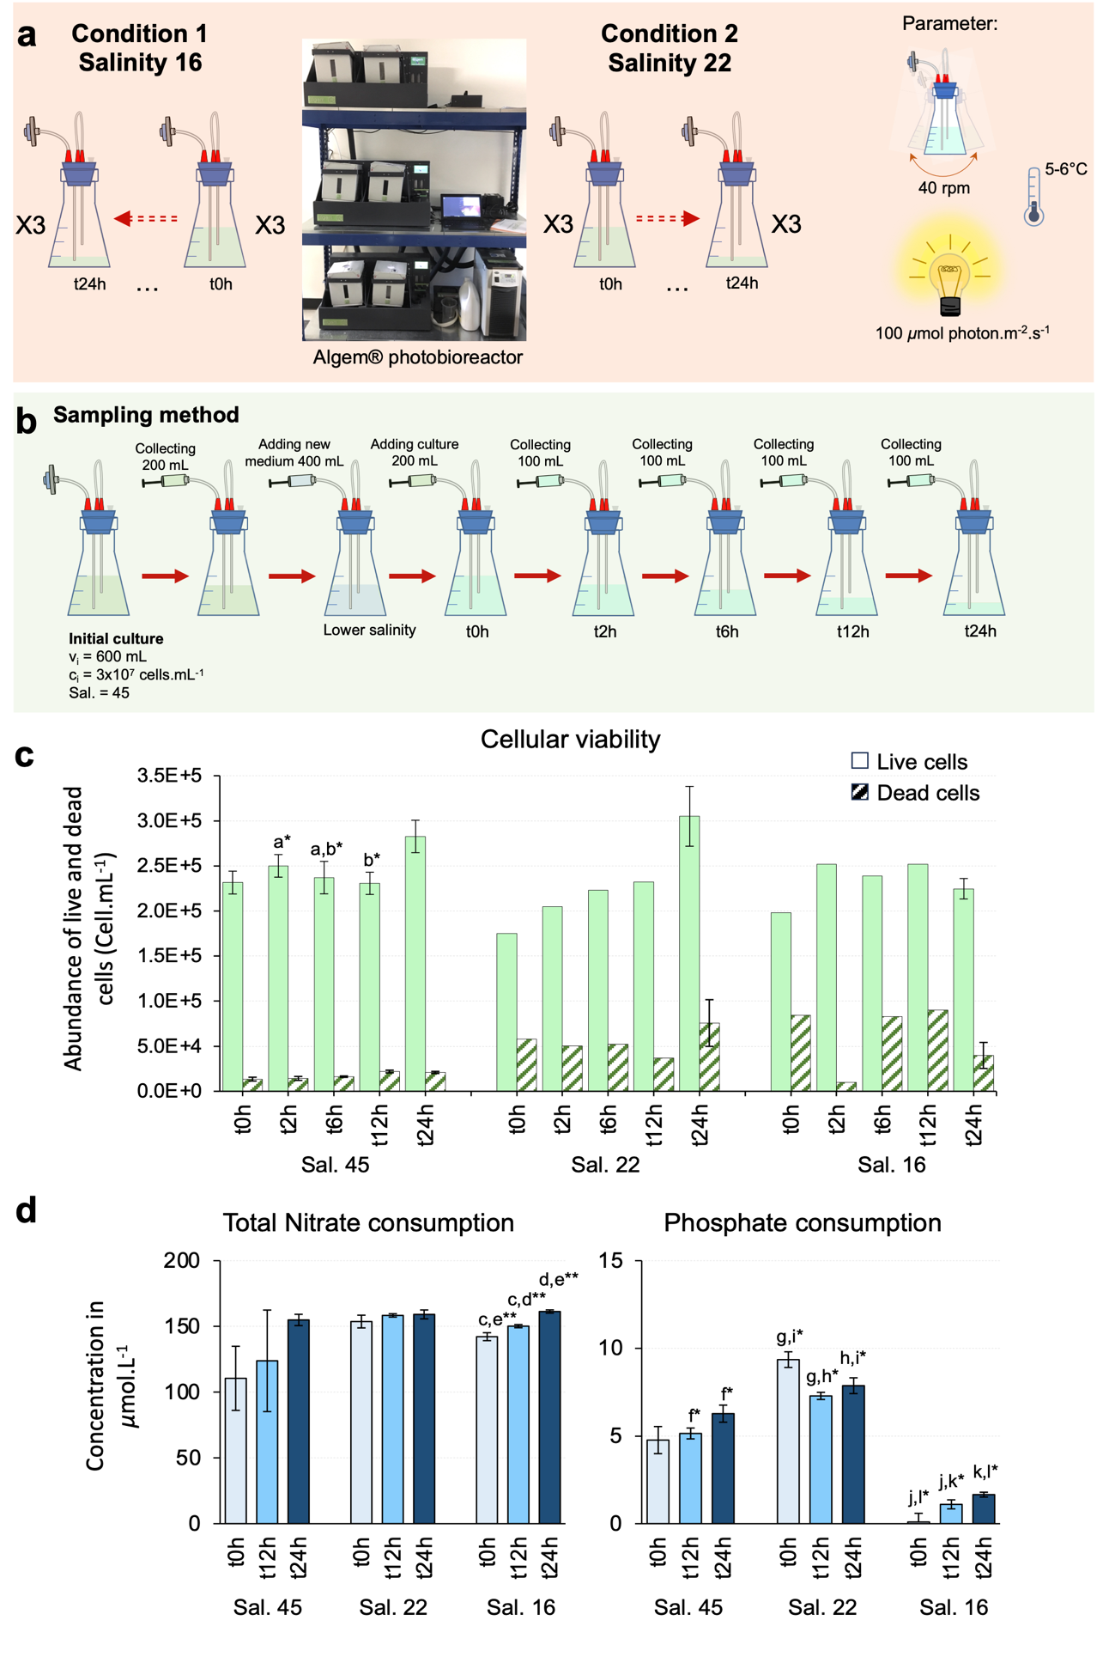
Supplementary Fig. 1. Experiment design for salinity progressive change and cell health and nutrient consumption. (a) Experiment design with both salinity conditions with parameters used, with constant light (24h). (b) Sampling methods during 24h with volume of medium sampled and volume of new medium added. (c) Cellular viability with concentration of live and dead cells per mL at the time of sampling. Error bars of live and dead cells include triplicate values (n = 3). (d) Nutrient (total nitrate and phosphate) consumptions at the time of sampling. Error bars include triplicate culture with biological replicates (n = 6). Standard deviation was used to calculate error bars. Missing error bars mean that triplicate values were not available. Letters ‘a’ to ‘l’ refer to two-way ANOVA tests for cellular viability and nutrient consumption (Supplementary Tables 2 and 4). Only significant p-values (<0.05 * and <0.01 **) are shown.

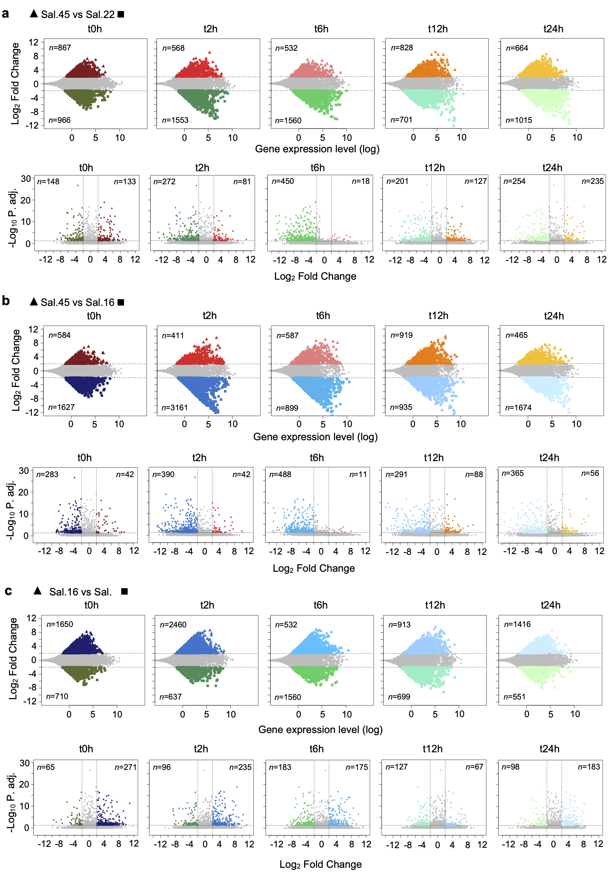
Supplementary Fig. 2. Differential expression genes (DEGs) between salinities (salinity effect) at each time of sampling (t0h to t24h). Comparison scatter plot of RNA-Seq analyses of the (a) control group (Sal.45) versus salinity 22, (b) control vs salinity 16 group and (c) salinity 16 versus salinity 22. Each point represents a unigene. Points higher than 2 of log2 fold change indicate genes up-regulated and each point lower than -2 of log2 fold change indicate genes down-regulated. Each number (n) of up- and down-regulated genes are indicated. Scatter plot of filtered DEGs genes with an adjusted p value of <0.05.

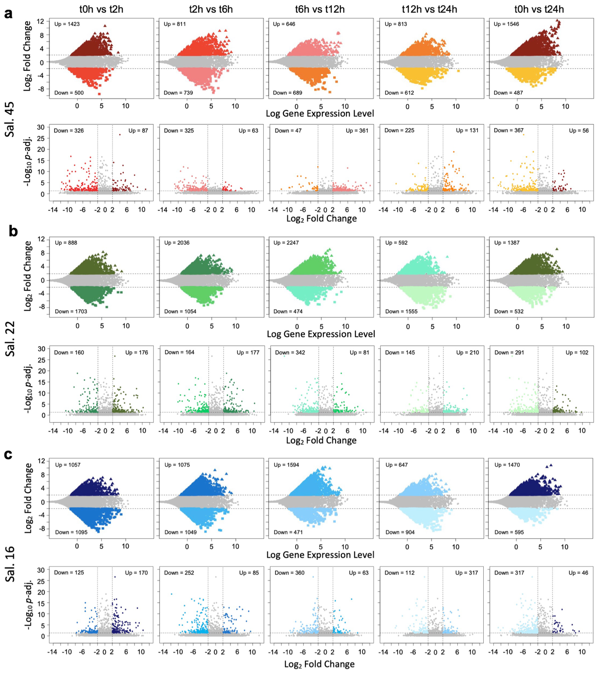
Supplementary Fig. 3. Differential expression genes (DEGs) between time of sampling (time effect) for each salinity. Comparison scatter plot of RNA-Seq analyses of the (a) control group, (b) salinity 22 group and (c) salinity 16 group. Each point represents a unigene. Points higher than 2 of log2 fold change indicate genes up-regulated and each point lower than -2 of log2 fold change indicate genes down-regulated. Each number (n) of up- and down-regulated genes are indicated. Scatter plot of filtered DEGs (up- and down-regulated genes) with an adjusted p value of <0.05.

Supplementary Fig. 4. GO term of biological process. Each salinity condition between times of sampling is shown with DEG indicated by relative size of the dots.
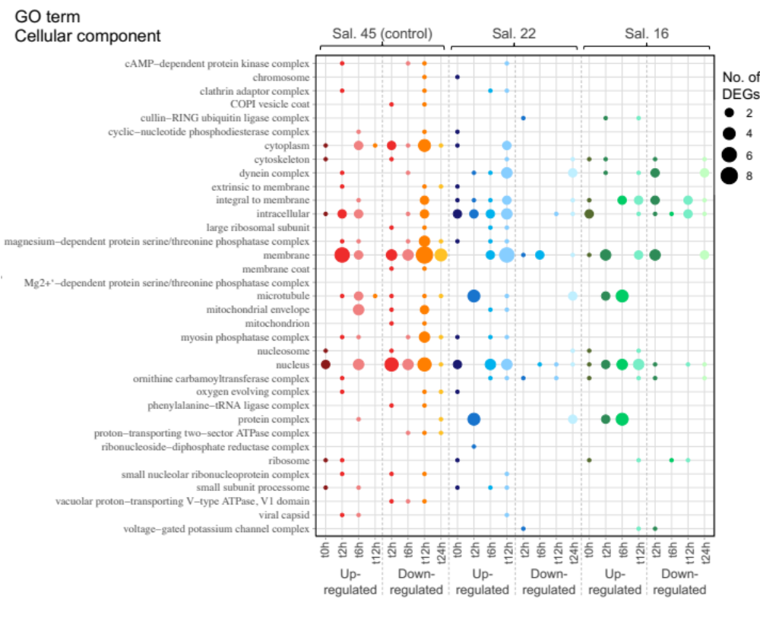
Supplementary Fig. 5. GO term of cellular components. Each salinity condition between times of sampling is shown with DEG indicated by relative size of the dots.

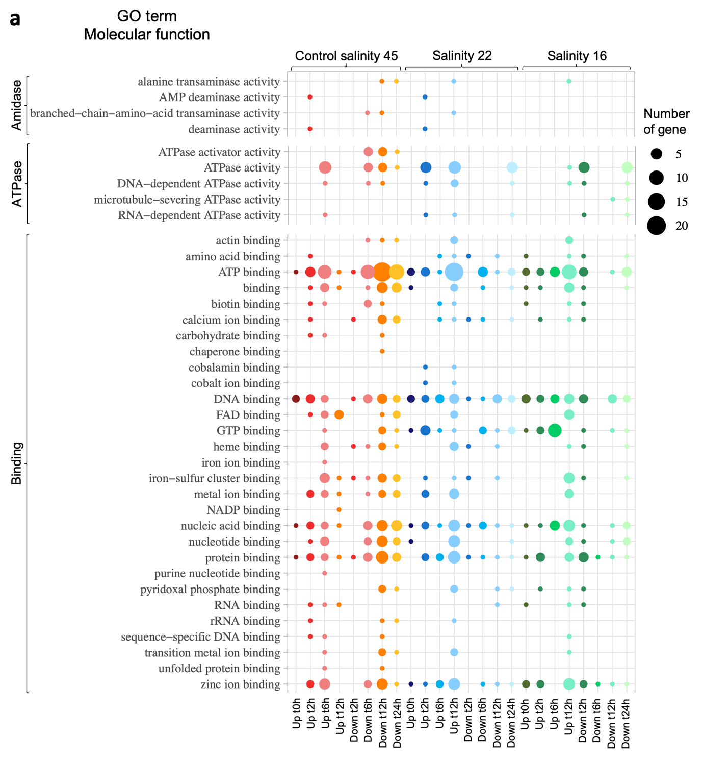
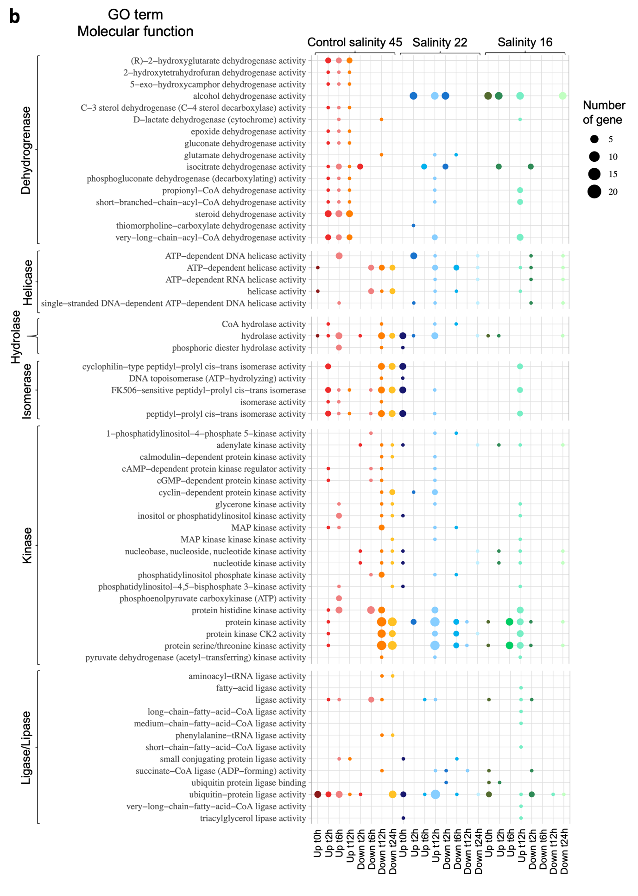
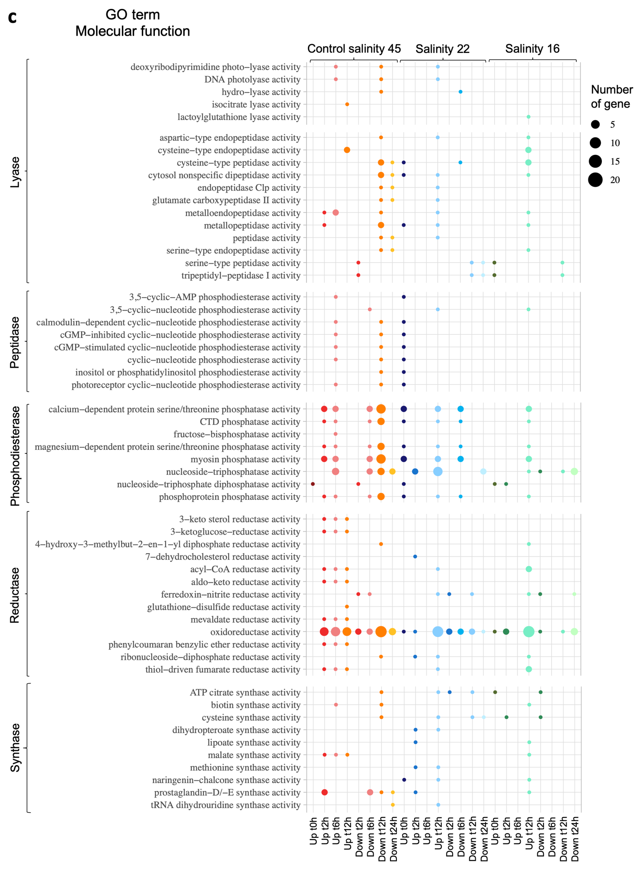
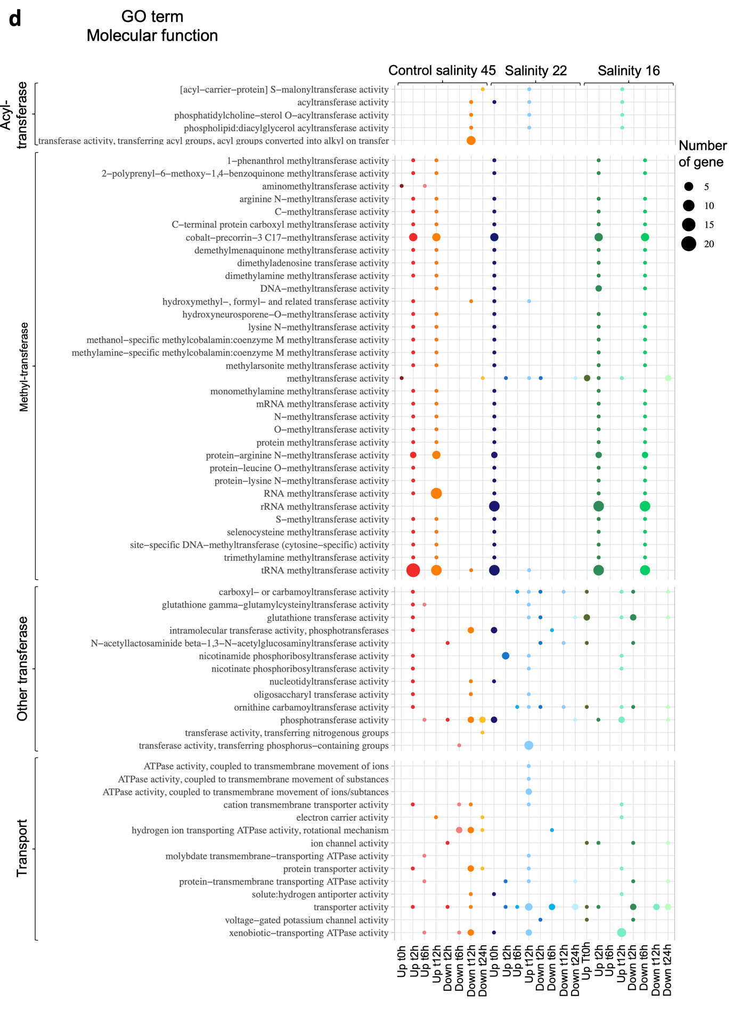
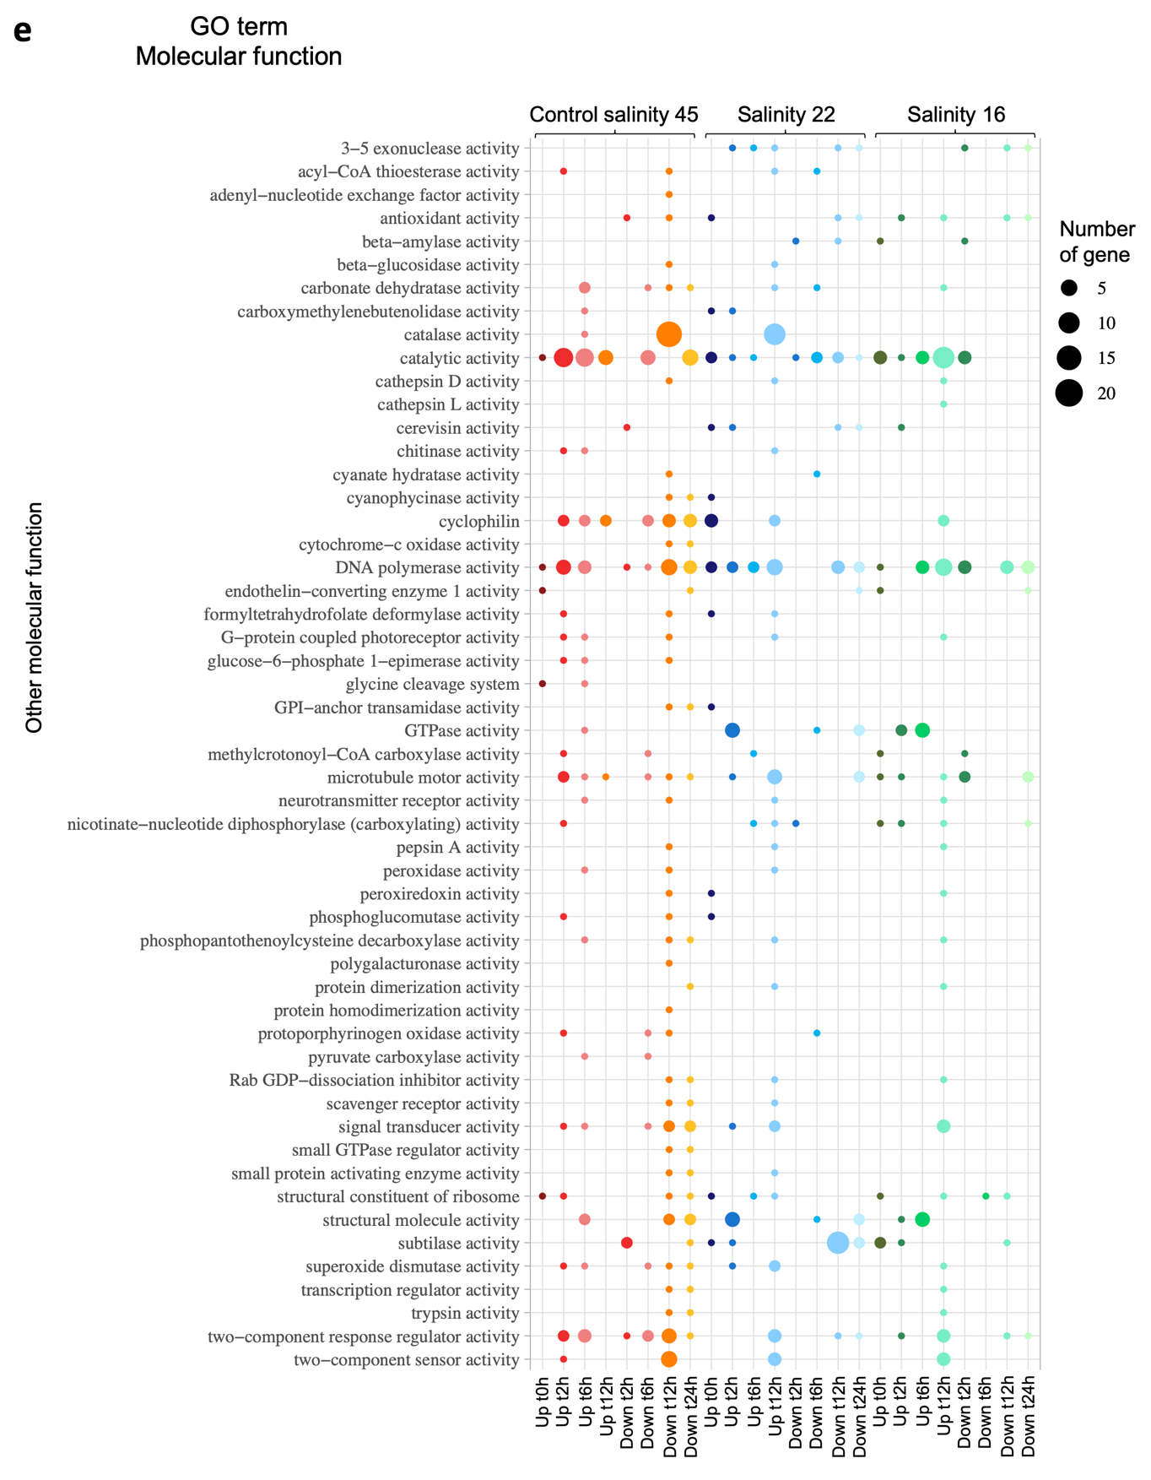
Supplementary Fig. 6. GO term of molecular function Each salinity condition between times of sampling is shown with DEG indicated by relative size of the dots. (a) Amidase, ATPase and binding enzymes category. (b) Dehydrogenase, helicase, hydrolase, isomerase, kinase, ligase and lipase enzymes category. (c) Lyase, peptidase phosphodiesterase, reductase and synthase enzymes category. (d) Acyl-, methyl- and other transferase and transport enzymes category. (e) Other non-categorised enzymes category.
Supplementary Fig. 7. Black module co-expression network based on WGCNA analysis representing the 20 significant differentially expressed genes (DEGs) interaction. Colors of nodes indicate metabolic categories for each DEG. The node size is calculated on the connection weight also called strength between nodes. The correlation value for each DEG was calculated from topological overlap matrix using the TOMsimilarity() function in the WGCNA package on R Studio. The higher value or bigger size node refers to a stronger connection or co-expression of DEGs. ABC2 – ABC-2 type transporter; ALMT – Aluminium activated malate transporter; ATPeV1E – V-type H+-transporting ATPase subunit E; cAMP/cGMP – cAMP-dependent protein kinase types I and II; carA and carB – carbamoyl-phosphate synthase; DCC1 – thiol-disulfide oxidoreductase; GST – glutathione S-transferase; PDZ - PDZ domain (also known as DHR or GLGF); TauE – Transmembrane sulfite exporter TauE/SafE; Unk. – unknown; VDE – violaxanthin de-epoxidase.

Supplementary Fig. 8. Blue module co-expression network based on WGCNA analysis representing the 65 significant differentially expressed genes (DEGs) interaction. Colors of nodes indicate metabolic categories for each DEG. The node size is calculated on the connection weight also called strength between nodes. The higher value or bigger size node refers to a stronger connection or co-expression of DEGs. ABC2 – ABC-2 type transporter; acd – acyl-CoA dehydrogenase; aceA – isocitrate lyase A; apaH – Serine/threonine-protein phosphatase 2A catalytic subunit; AOX and AOX1_2 – alternative oxidase; CA – carbonic anhydrase; Chla – Chlorophyll a; CHI – Chalcone-flavanone isomerase; fabD – [acyl-carrier-protein] S-malonyltransferase; FtsZ – Tubulin/FtsZ, 2-layer sandwich domain; fwdF_fmdF – 4Fe-4S ferredoxin; G6P1 – Glucose-6 phosphate 1-epimerase; Gtr1_RagA_G – Ras-related GTP-binding protein A/B; MFS – Permease of the major facilitator superfamily; NAD_6PGD - NAD binding domain of 6-phosphogluconate dehydrogenase; nhaC – Na+/H+ antiporter; NTH – nucleoside triphosphate hydrolase; pckA – phosphoenolpyruvate carboxykinase (ATP); Pro rich – Proline rich; proV – Glycine betaine/proline transport system ATP-binding protein; RP S30Ae – Ribosomal protein S30Ae/sigma 54 modulation protein; SAM – S-adenosyl-L-methionine-dependent methyltransferase; Unk. – unknown.

Supplementary Fig. 9. Brown module co-expression network based on WGCNA analysis representing the 40 significant differentially expressed genes (DEGs) interaction. Colors of nodes indicate metabolic categories for each DEG. The node size is calculated on the connection weight also called strength between nodes. The higher value or bigger size node refers to a stronger connection or co-expression of DEGs. aceB – isocitrate lyase B; CA – carbonic anhydrase; CRY – Cryptochrome, C-terminal; G6P1 – Glucose-6 phosphate 1-epimerase; GH18 and GH79 – glycosyl hydrolase 18 and 79; GT41 – glycosyltransferase 41; gudB – glutamate dehydrogenase; ISCA1 – Iron-sulfur cluster assembly 1; KatG - catalase-peroxidase; LRRTM – Leucine rich repeat transmembrane; NTF2 – nuclear transport factor 2; PAO1 – polyamine oxidase 1; petB - Cytochrome b6; PK – protein kinase; RPS6K – Ribosomal protein S6 kinase; secA – preprotein translocase subunit; Unk. – unknown; WD – WD40 repeat (also known as WD or beta-transducin repeats); WW – WW domain.

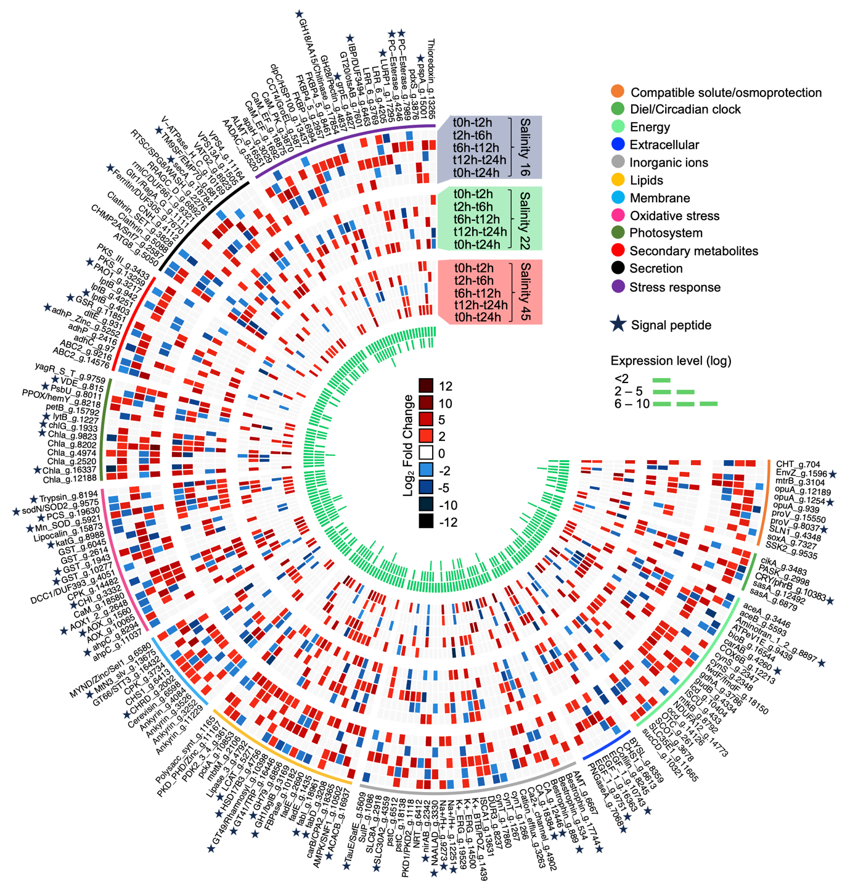
Supplementary Fig. 10. Circular heatmap of 188 selected differentially expressed genes (DEGs) and their expression profile based on the log₂ fold change between time of sampling (time effect) for each salinity. Up-regulated DEGs are indicated by shades of red and down-regulated DEGs by shades of blue. Colors in the outer circle indicate metabolic categories for each DEG. A complete list of genes and annotations can be found in Supplementary Table 5.
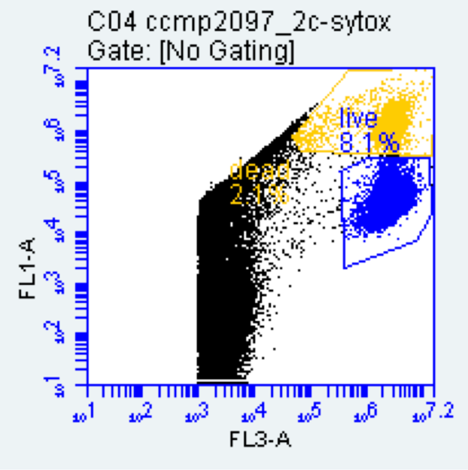
Supplementary Fig. 11. Example of gates used to enumerate live and dead cells using Flow Cytometry. Dot plots displays the number of live and dead cells separated by detectors of fluorescence intensity FL3-A and by FL1-A.

