Supplementary Figure 1: Association of buccal epithelial cell (BEC) proportions estimated by EpiDISH_CBS and EpiDISH_CP with chronological age. An inverse relationship between computed BEC proportion and predicted epigenetic age was observed in pediatric samples using the CP method (Pearson’s on Box-Cox transformed values r = -.40, p < 2.2e-16) and CBS method (Pearson’s on Box-Cox transformed values r = -.41, p < 2.2e-16).

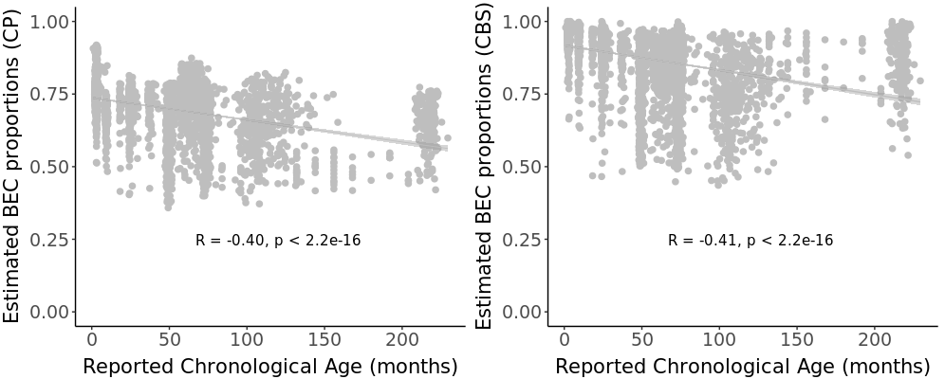

Supplementary Figure 2: No significant association was observed between reported chronological age (in months) and different computed cell types including Eosinophils, Monocytes, CD4T, CD8T, B, Natural Killer cells, and Fibroblasts.

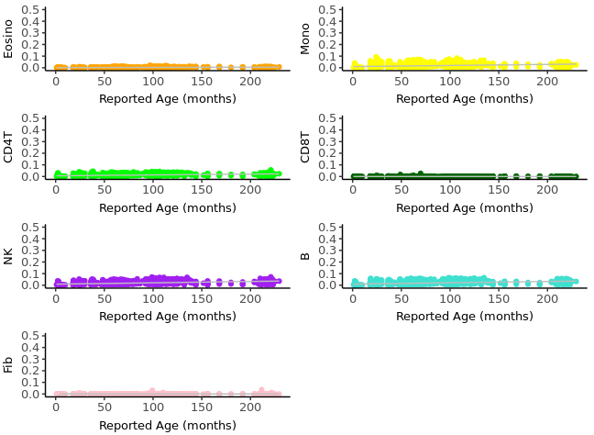

Supplementary Figure 3: Comparison of buccal epithelial cell (BEC) proportions estimated by EpiDISH_CBS and EpiDISH_CP method across two DNA methylation platforms. Both approaches computed significantly higher BEC proportions on the 850K platform compared to the 450K platform.

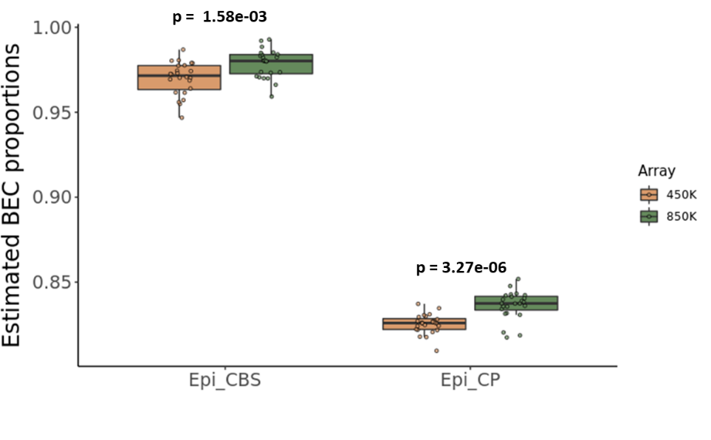

Supplementary Figure 4: Estimated buccal epithelial proportions by EpiDISH-RPC method was not significantly different by: 3A) Sex (Kruskal-Wallis test, H (1) = .81, p = .36) 3B) Breastfeeding status at the time of collection (Kruskal-Wallis test, H (1) = .04, p = .83) and 3C) Mode of delivery (Kruskal-Wallis test, H (1) = .21, p = .64)

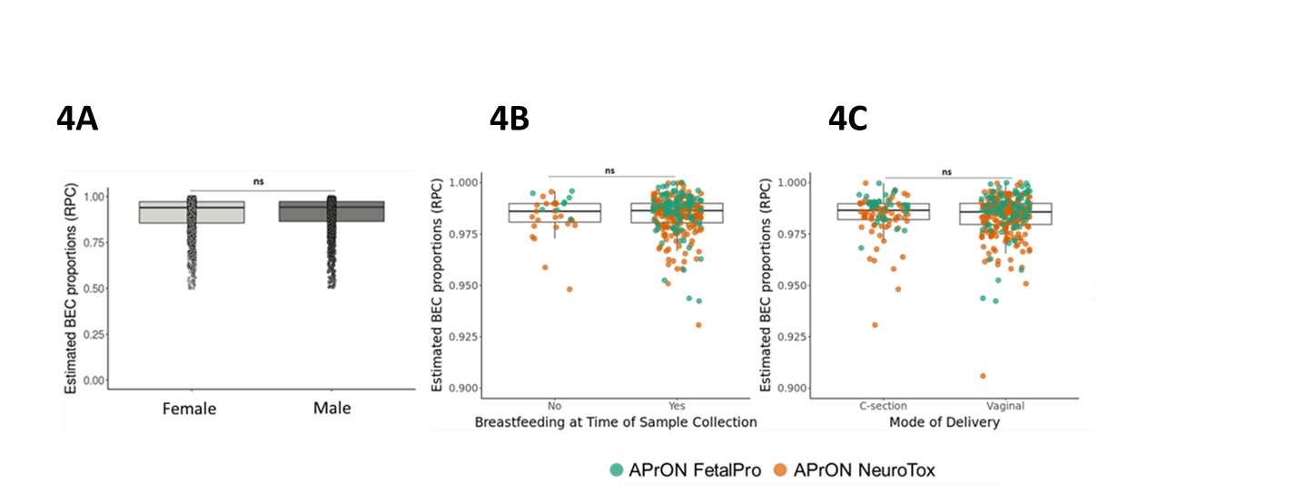

Supplementary Figure 5: No estimated buccal epithelial cell proportion difference was observed between children whose parents reported they brushed their teeth daily and those who did not (F(2,296)=0.16, p=.690, Cohen’s d=0.069). This null finding was robust to differences in exact age at sample collection, sex, and maternally reported racial identity.
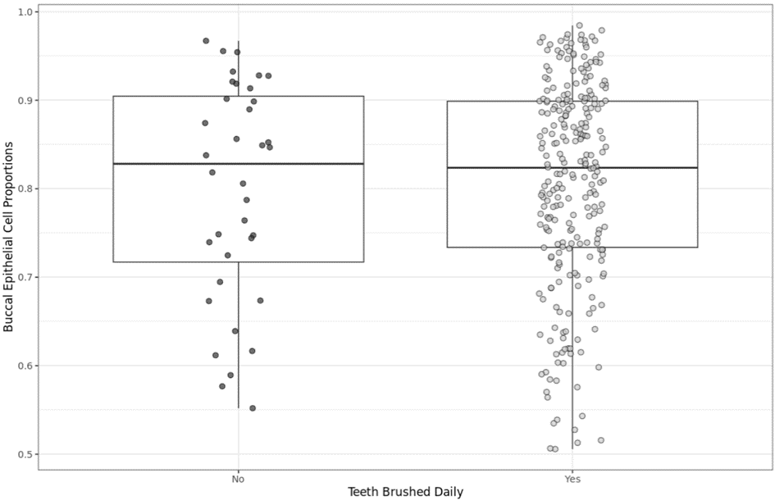

Supplementary Figure 6: Estimated buccal epithelial cell proportion by whether or not parents took their children to the dentist at least once a year. The primary reasons why parents reported not taking to their child to the dentist ("No") were broken down categorically.
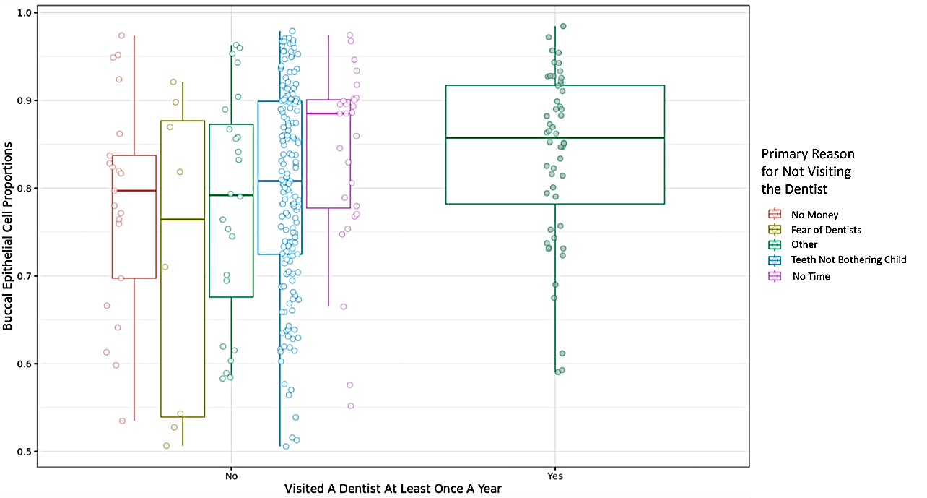

Supplementary Figure 7: PedBE EAA calculated from residuals regressed on both chronological age and estimated BEC proportion showed less correlation between model residuals and estimated BEC proportion (Pearson’s on Box-Cox transformed values r (39) = .03, p = 0.82) than when not r (39) = .14, p = 0.37)

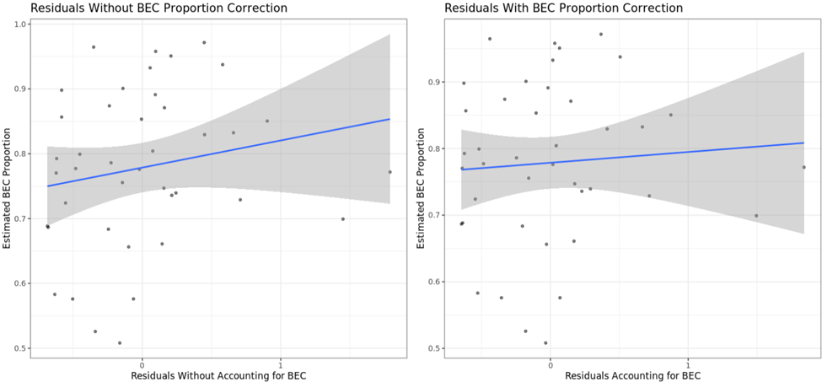

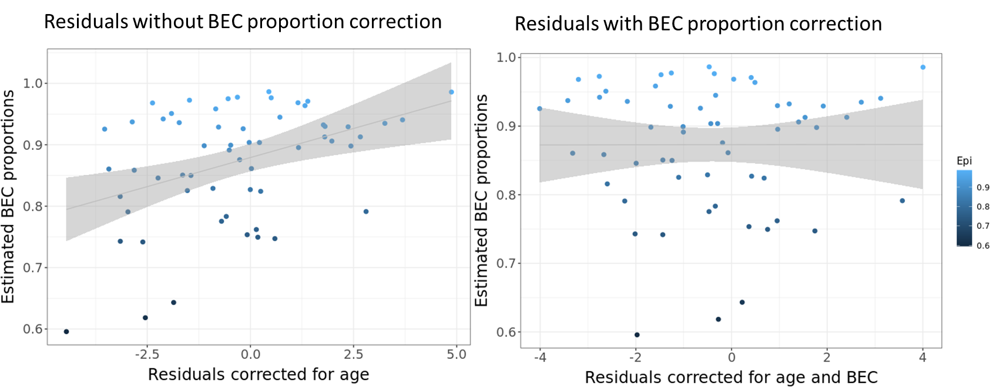
Supplementary Figure 8: PedBE EAA calculated from model residuals accounting for both chronological age and estimated BEC proportions, showed no significant correlation with the computed BEC proportions (Pearson’s on Box-Cox transformed values r (57) = 0, p = 0.99 in the OCD cohort.

Supplementary Figure 9: Comparison of estimated buccal epithelial cell (BEC) proportions for the four approaches across the pediatric cohorts independently where the non-constrained approaches (EpiDISH_RPC, EpiDISH_CBS) consistently inferred higher BEC proportions compared to the constrained methods (EpiDISH_CP, Buccal_Smith).
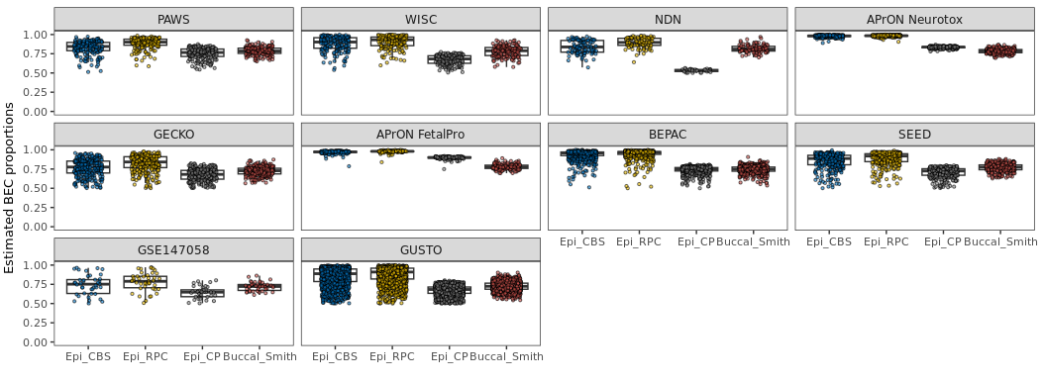

Supplementary Methods
Cohort descriptions
BEPAC
Summary: BEPAC (Biological Evaluation of Psychosocial Adversity in Children) is a longitudinal Canadian cohort of pregnant women recruited within less than 27 weeks gestation with 2-year child follow-up. This cohort was a subsample drawn from the British Columbia Health Connections Project, which evaluates the effectiveness of the Nurse-Family Partnership, an evidence-based intervention shown to improve prenatal health, parenting, and infant outcomes. DNA methylation was measured on cheek swabs obtained from infants at two time points: 2 months and 24 months.
Tissue extraction/genomic DNA isolation: Genomic DNA was extracted using an Isohelix BuccalPrep extraction kit.
Bisulfite conversion: Genomic DNA was bisulfite converted using an EZ DNA Methylation Kit™ (Zymo Research).
Ethics: Ethics approval was obtained from seven research ethics boards of all participating institutions: Simon Fraser University, the University of British Columbia, McMaster University, Ryerson University, the Public Health Agency of Canada, and the two participating health authorities (Fraser Health Authority and Vancouver Coastal Health Research Institute). Participant mothers provided informed written consent for their infants’ participation
Ethics #: FHREB 2013-108
Funding: CIHR, MOP#130496

SEED
Cohort link: https://bushlab.ucsf.edu/seed-stress-eating-and-early-development-study
Summary: SEED (Stress, Eating, and Early Development Study) is a longitudinal US-based cohort drawn from a larger study investigating a mindfulness-based intervention aimed at preventing excessive weight gain during pregnancy. Pregnant women were enrolled at around 8–23 weeks of gestation and their children were followed from birth through age 4 years. DNA methylation data from children’s cheek swabs were quantified at three time points: 48 months, 60 months, and 72 months.
Tissue extraction/genomic DNA isolation: Genomic DNA was extracted using an Isohelix BuccalPrep extraction kit.
Bisulfite conversion: Genomic DNA was bisulfite converted using an EZ DNA Methylation Kit™ (Zymo Research).

Ethics: All procedures in this study were approved by institutional review boards at University of California, San Francisco (UCSF).
Ethics #: IRB 10-04522
Funding: NHLBI 5 R01 HL116511, the Robert Wood Johnson Health and Society Scholars Program, and the Lisa and John Pritzker Family Foundation.

APrON NeuroTox
Cohort link: https://apronstudy.ca/summary/
Summary: APrON (Alberta Pregnancy Outcomes and Nutrition Study)¹ is a longitudinal community Canadian cohort of parents and their children in Calgary, Alberta. The APrON Neurotoxicant (NeuroTox) sub-study was drawn from the larger study of 2189 families, 583 of whom participated in this substudy. This sub-study is investigating the association between maternal and child exposure to environmental neurotoxic chemicals (e.g., bisphenols, phthalates, metals and per- and poly-fluorinated alkyl substances (PFAS)), maternal health, and child neurodevelopment. In addition, associations between maternal exposure to these chemicals during pregnancy and DNA methylation in infant blood and BEC is being examined. Also, the potential mediating role DNA methylation may play in the association between prenatal chemical exposure and child neurodevelopmental outcomes is being investigated. Pregnant mothers were enrolled during their first or second trimester of pregnancy and the parents and child are continuing to be followed. Recruited mothers included in the subset did not smoke, drink, or use steroids during pregnancy. DNA methylation was from cheek swabs (N = 278) when infants were approximately 3-months-old.
Tissue extraction/genomic DNA isolation: Genomic DNA was extracted using Gentra Puregene Buccal Cell Kit.
Bisulfite conversion: Genomic DNA was bisulfite converted using an EZ DNA Methylation Kit™ (Zymo Research).
Ethics: The University of Calgary Conjoint Health Research Ethics Board approved the procedures of the study. Participant’s parents/guardians provided informed written consent for their child’s participation.
Ethics #: 14-1702
Funding: This cohort was established by an interdisciplinary team grant from Alberta Innovates Health Solutions (formally the Alberta Heritage Foundation for Medical Research). Additional funding from the Canadian Institutes of Health Research (MOP-123535), the U.S. National Institutes of Health (Exploration/Development Grant 1R21ES021295-01R21), and the Alberta Children’s Hospital Foundation allowed for the collection of data presented in this manuscript.

OCD
Summary: The pediatric-onset obsessive-compulsive disorder (OCD) cohort was obtained from BC Children’s Hospital BioBank using established protocols. OCD diagnosis was based on The Diagnostic and Statistical Manual of Mental Disorders 5th Edition (DSM-5) criteria, supplemented by the Yale–Brown Obsessive–Compulsive Scale to assess severity of OCD symptoms in children. The OCD-affected cohort was matched and randomized with similarly aged control children from the Wisconsin Study of Families and Work (WSFW) cohort, and samples were run on the Illumina Infinium MethylationEPIC BeadChip (850K) array to quantify DNA methylation. Subjects a current diagnosis of bipolar disorder, psychotic disorder, neurodevelopmental disorder, severe depression, or current or past substance use disorder were excluded.
Ethics: All procedures in this study were approved by the Health Research Ethics Board of the University of British Columbia and BC Children’s Hospital. Participants’ legal guardians provided informed written consent for their child’s participation and children provided informed written assent.
Ethics #: H12-01656 and H21-01470
Funding: BC Children’s Hospital Research Institute Special Funding Award and Michael Smith Foundation for Health Research.

GSE147058
Cohort link: https://arizonatwinproject.org/
Summary: The GSE147058 cohort was obtained from the online GEO SuperSeries repository and supplemented with additional information on exact ages from the cohort custodians. This is a cohort of mid-childhood monozygotic twins from whom both a cheek swab for DNA methylation analysis and saliva samples were obtained over the course of 3 consecutive days for diurnal cortisol slope analysis. Of the 22 twin pairs in the cohort, complete and high-quality data for both daily cortisol slope and DNA methylation were available for 41 individual samples from 20 complete twin pairs and one twin without a pair. Saliva samples were assayed in duplicate at Biochemisches Labor at the University of Trier, Germany. Diurnal cortisol slope was calculated based on the difference in cortisol at 30 min after waking from that at bedtime divided by the time difference. These coefficients were negative as the slope was declining. Details of the samples and processing of these data were described previously ².
Tissue extraction/genomic DNA isolation: Genomic DNA was extracted using a Qiagen Buccal Cell Kit.
Bisulfite conversion: Genomic DNA was bisulfite converted using an EZ DNA Methylation Kit™ (Zymo Research).

Ethics: All procedures in this study were approved by institutional review boards at Arizona State University and are in accordance with the Helsinki Declaration of 1975. Underage participants provided assent and their legal guardians provided informed consent for all study procedures.
Ethics #: IRB study00003325
Funding: NICHD R01 HD079520

