Supplementary materials
A) Reserve
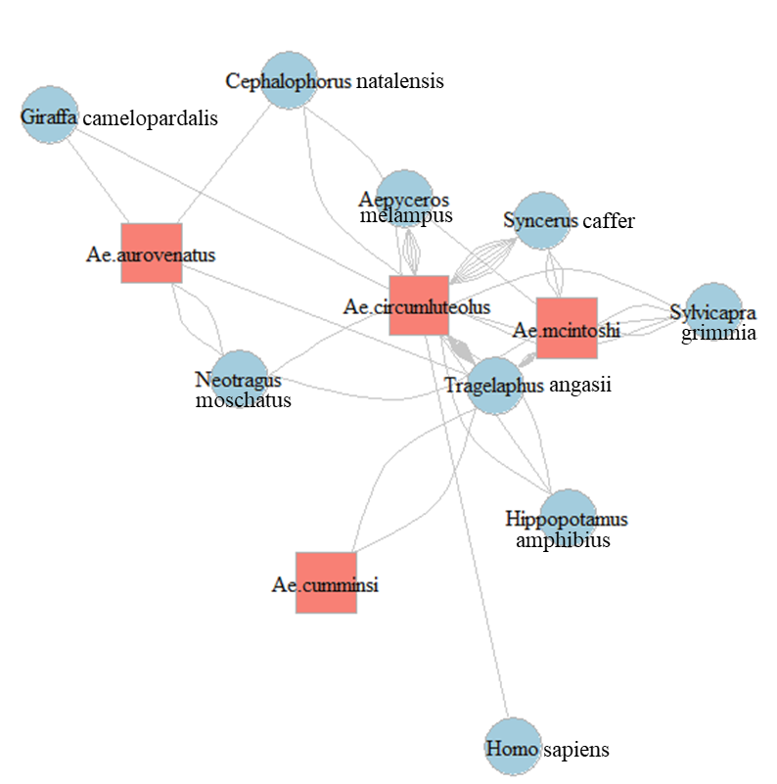

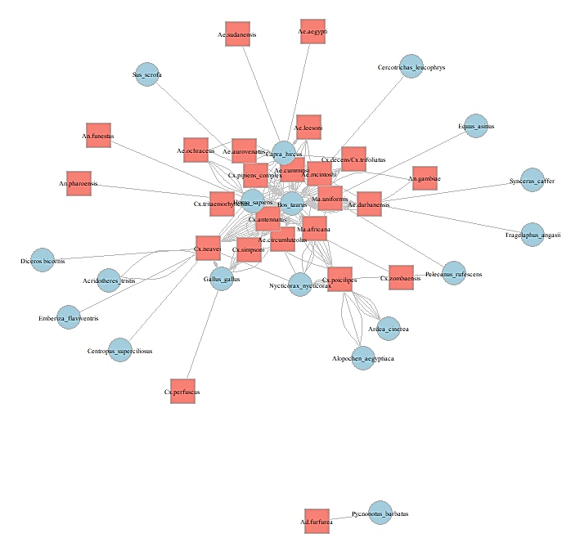
B) Rural

Figure S1. Host-biting networks for a) reserve network and b) rural network of mosquitoes and their vertebrate hosts from the north-eastern KZN. The mosquito species are indicated on the salmon-coloured squares and the hosts on the blue circles.

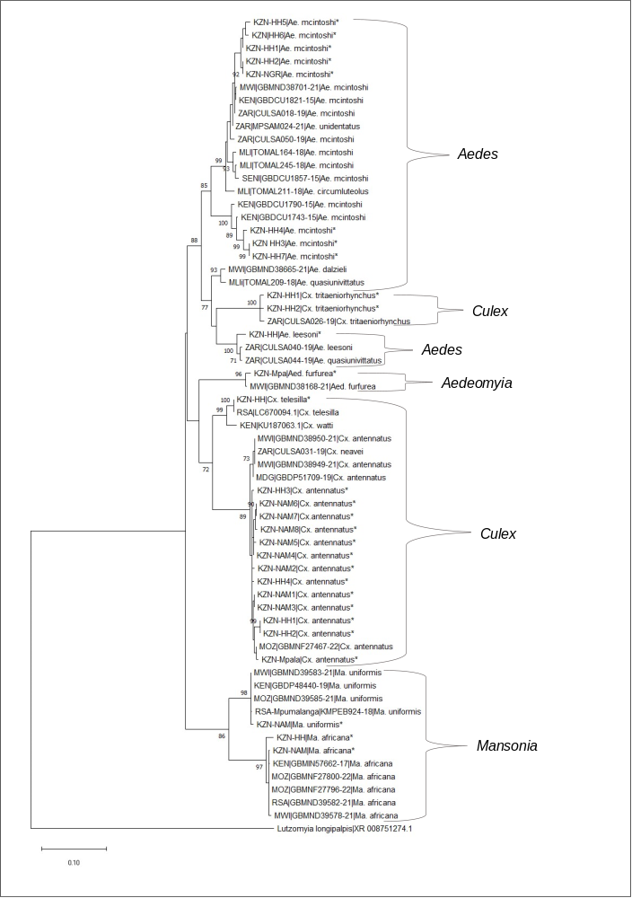

Figure S2: The phylogenetic tree generated using from 63 mosquito sequences of CO1 was inferred by the Maximum Likelihood method and Tamura-Nei model with 1000 bootstrap replicates. Numbers next to branches indicate the branch percentage support. Samples which were part of this study are denoted by the start (*) symbol. Branch support percentages > 70% are shown. GenBank accession numbers and countries of origin are indicated for other sequences. South Africa = ZAR, Malawi = MWI, Madagascar = MDG, Mozambique = MOZ, Mali = MLI, Kenya = KEN, Senegal = SEN

