Supplementary
Supplementary Appendix Table S1: Regression results
Location | Variable | R-squared | P-value
lake nokoué | Length | 0.643 | 4.074804e-29
lake nokoué | Width | 0.504483 | 2.521333e-20
lake nokoué | Area | 0.584413 | 5.133524e-25
lake nokoué | Perimeter | 0.313638 | 1.355337e-11
Cotonou lagoon | Length | 0.036832 | 4.984627e-02
Cotonou lagoon | Width | 0.023065 | 1.219671e-01
Cotonou lagoon | Area | 0.034610 | 5.741564e-02
Cotonou lagoon | Perimeter | 0.000040 | 9.490258e-01
Porto-novo lagoon | Length | 0.017054 | 1.499451e-01
Porto-novo lagoon | Width | 0.015035 | 1.766590e-01
Porto-novo lagoon | Area | 0.019633 | 1.221623e-01
Porto-novo lagoon | perimeter | 0.002402 | 5.903695e-01

Supplementary Appendix Table S 2 : P-value of Asymmetry fluctuating between right and left
 | P VALUE
SITES | Lake Nokoué | Porto-novo lagoon | Cotonou lagoon
Length | 0.091 | 2.206e-06 | 0.248
Width | 0.005 | 8.498e-06 | 7.875e-06
area | 1.140e-05 | 3.069e-09 | 9.091e-08
perimeter | 0.002 | 8.788e-09 | 1.3871e-06

Supplementary Appendix Table S 3 : P-value of Asymmetry fluctuating between right and left
 | P VALUE
SITES | Lake Nokoué | Porto-novo lagoon | Cotonou lagoon
Length | 0.091 | 2.206e-06 | 0.248
Width | 0.005 | 8.498e-06 | 7.875e-06
area | 1.140e-05 | 3.069e-09 | 9.091e-08
perimeter | 0.002 | 8.788e-09 | 1.3871e-06

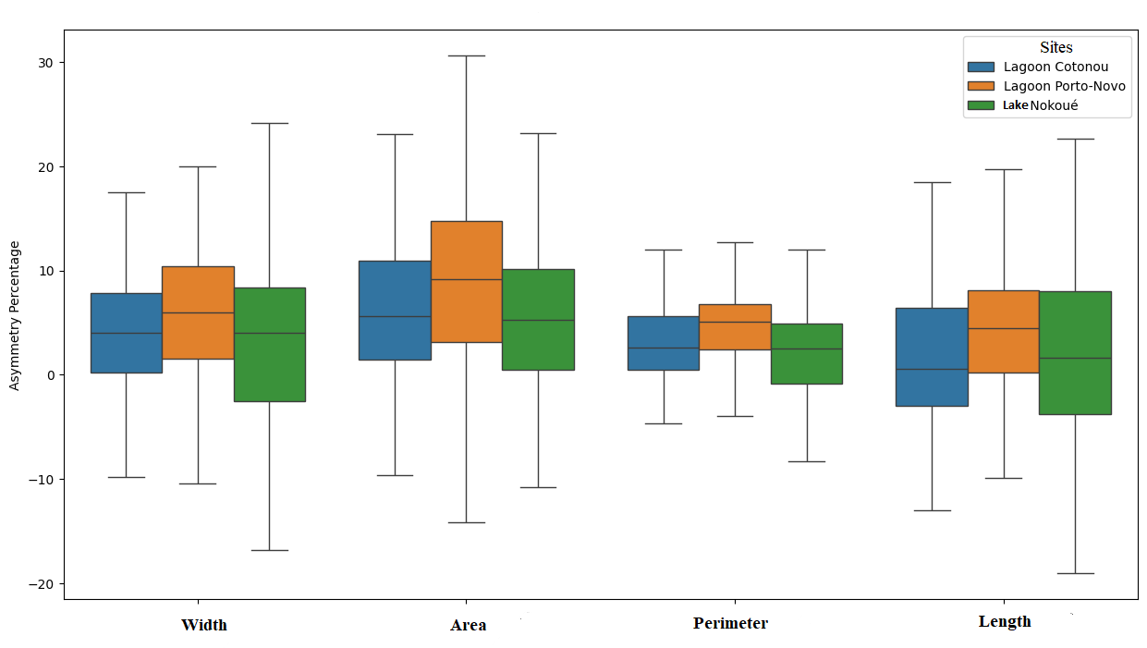
Supplementary Appendix Figure S5: boxplot percentage asymmetry of biometric parameters by Location

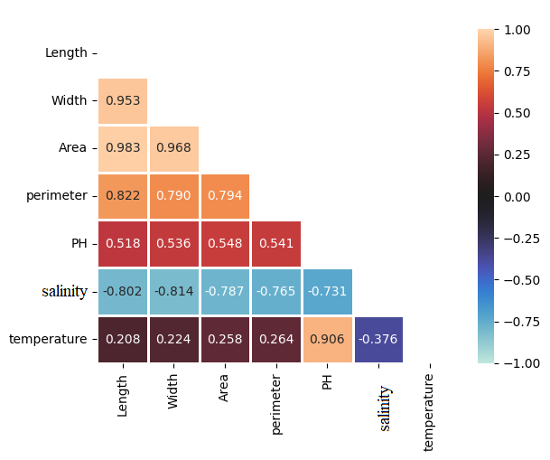
Supplementary Appendix Figure S6: Correlation map between physical-chemical parameters and biometric parameters

