Supplementary material
Synergistic nanocoating: Layer-by-Layer functionalised PCL membranes enhanced with manuka honey and essential oils for advanced wound healing
Camilla Gallo, Joel Girón-Hernández, Daisy A Honey, Edward M Fox, Maria Antonia Cassa, Chiara Tonda-Turo, Irene Camagnola, Piergiorgio Gentile
Table S1. Values of explanatory variables: essential Oil concentration (% w/v) (X₁), homogenisation speed (rpm) (X₂), sonication time (min) (X₃), and response variable: Size (Y₁).
Run | X₁, oil concentration (% w/v) | X₂, homogenisation speed (rpm) | X₃, sonication time (min) | Y₁,  TEO size (nm) | Y₁,  CEO size (nm)
1 | 4.000 | 10000.0 | 8.000 | 17.9 | 15.5
2 | 2.000 | 12500.0 | 12.000 | 22.9 | 12.1
3 | 6.000 | 12500.0 | 4.000 | 18.0 | 27.2
4 | 4.000 | 10000.0 | 8.000 | 18.4 | 25.4
5 | 2.000 | 7500.0 | 12.000 | 77.5 | 57.7
6 | 6.000 | 7500.0 | 12.000 | 55.1 | 44.3
7 | 6.000 | 7500.0 | 4.000 | 40.8 | 18.1
8 | 4.000 | 10000.0 | 8.000 | 19.9 | 16.0
9 | 6.000 | 12500.0 | 12.000 | 21.2 | 12.8
10 | 2.000 | 12500.0 | 4.000 | 37.4 | 21.7
11 | 2.000 | 7500.0 | 4.000 | 40.6 | 32.6
12 | 4.000 | 10000.0 | 8.000 | 21.6 | 13.6
13 | 4.000 | 14082.5 | 8.000 | 22.8 | 21.5
14 | 4.000 | 10000.0 | 14.532 | 18.9 | 32.1
15 | 4.000 | 5917.5 | 8.000 | 87.6 | 57.4
16 | 4.000 | 10000.0 | 1.468 | 22.1 | 18.7
17 | 7.266 | 10000.0 | 8.000 | 23.1 | 19.9
18 | 4.000 | 10000.0 | 8.000 | 19.1 | 16.2
19 | 0.734 | 10000.0 | 8.000 | 18.5 | 9.8
20 | 4.000 | 10000.0 | 8.000 | 18.6 | 15.1

The optimised conditions for the TEO nanoemulsions were as follows: 7.266% w/v of oil concentration, 12515 rpm of homogenisation speed and a sonication time of 14.5 minutes.
The optimised conditions for the CEO nanoemulsions were as follows: 7.266% w/v of oil concentration, 13635 rpm of homogenisation speed and a sonication time of 14.5 minutes.

Table S2. PDI evaluation of the nanoemulsions obtained from the 20 experimental runs indicated by the DOE.
Run | TEO PDI  (%) | CEO PDI  (%)
1 | 26.4 | 24.2
2 | 22.2 | 27.6
3 | 25.7 | 25.4
4 | 27.5 | 24.5
5 | 24 | 24.1
6 | 26.9 | 25.4
7 | 28.3 | 25.3
8 | 27.8 | 25.3
9 | 27.2 | 25.8
10 | 23.7 | 25.5
11 | 24.8 | 25.2
12 | 24.4 | 25.1
13 | 26.9 | 24.4
14 | 28.5 | 25.2
15 | 27.9 | 25.4
16 | 26.7 | 25
17 | 28.3 | 25.9
18 | 26.4 | 24.1
19 | 8.43 | 27.1
20 | 27.2 | 24.8

Figure S1. SEM images of the PCL electrospun membranes at different magnifications X2500 (A), X13000 (B) and X25000 (C).
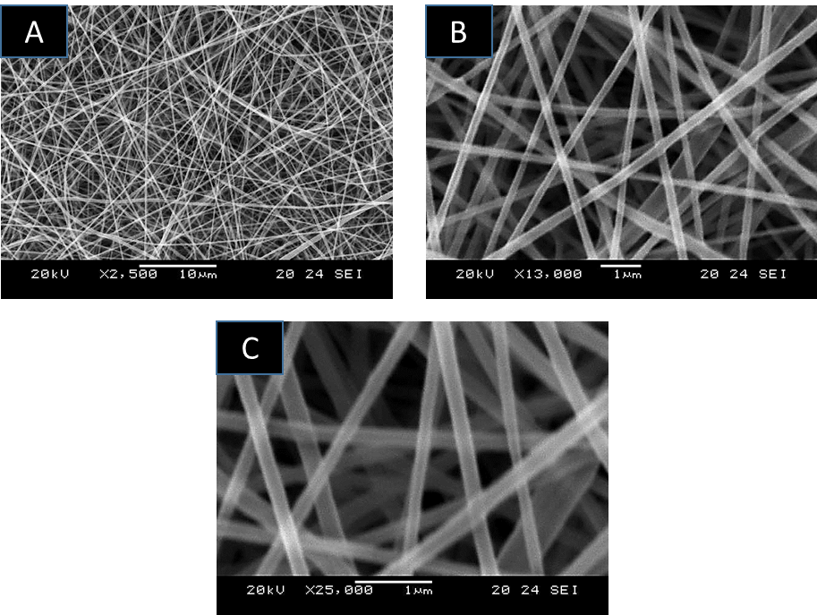
Figure S2. Live/Dead image of the human neonatal dermal fibroblast cells seeded on the tissue culture plates as control. Scale bar = 300 μm.
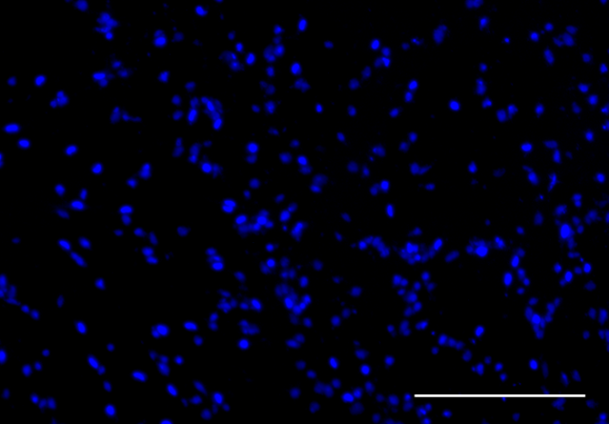

Figure S3. Counts of colony forming units resulting after reduction assay of P. aeruginosa and S. aureus after 24h incubation at 37 °C of LbL-functionalised membranes.
