Supplementary Materials for

Missing Evidence: Tracking Academic Data Use around the World
Brian Stacy* et al.

*Corresponding author. Email: bstacy@worldbank.org

Supplementary Figs. S1 to S5, Tables S1 to S3

Fig. S1
Relationship between Data Research and Data Supply
- Country Scatterplot
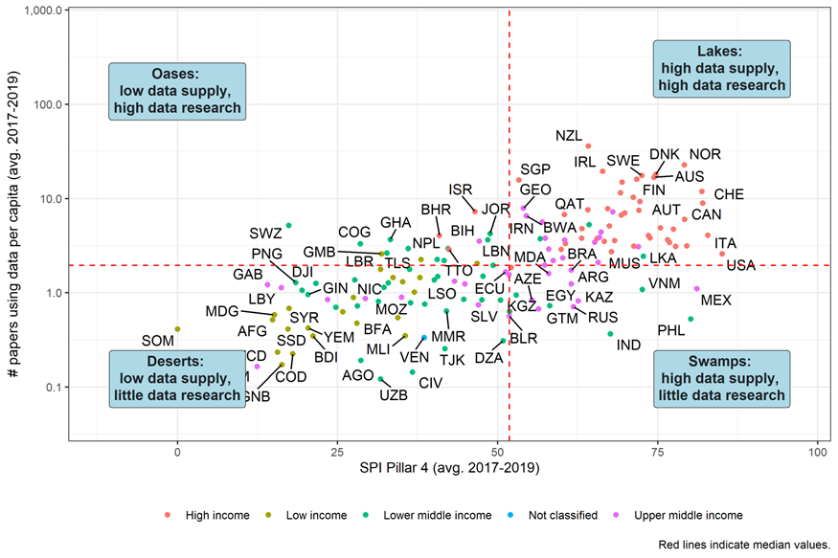
Note: Red lines indicate median values
- Map
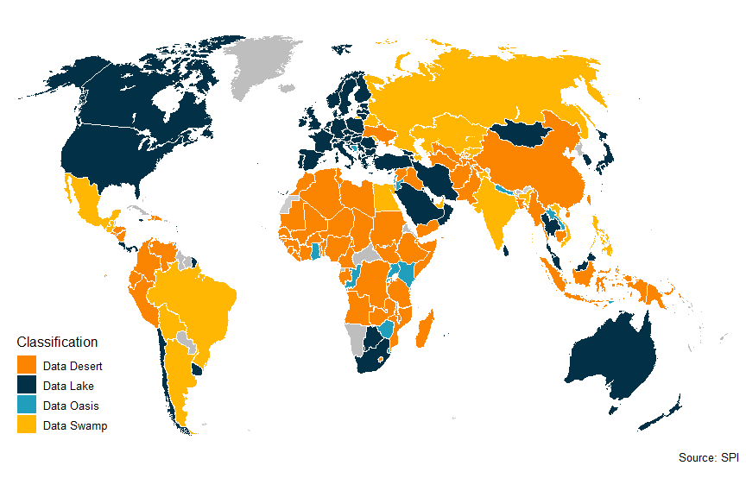Note: a) On the y-axis, this figure plots the average number of data papers per capita between 2017 and 2019. SPI Pillar 4 on the x-axis tracks the availability of recent censuses, surveys, Civil Registration and Vital Statistics, and subnational data (for details see Dang et al. (2023). Red dashed lines represent median values.

Fig. S2.
Amazon Mturk Prompt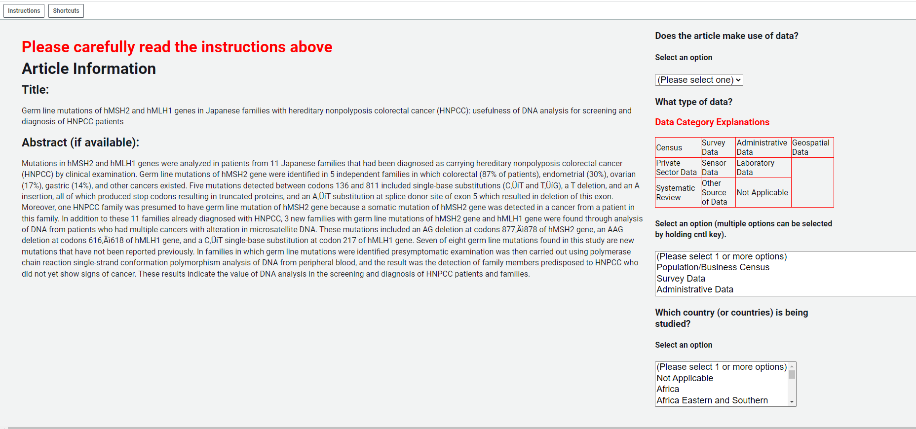

Fig. S3.
Comparison to Number of Academic Articles from other papers
- Comparison with Das et al. (2013)
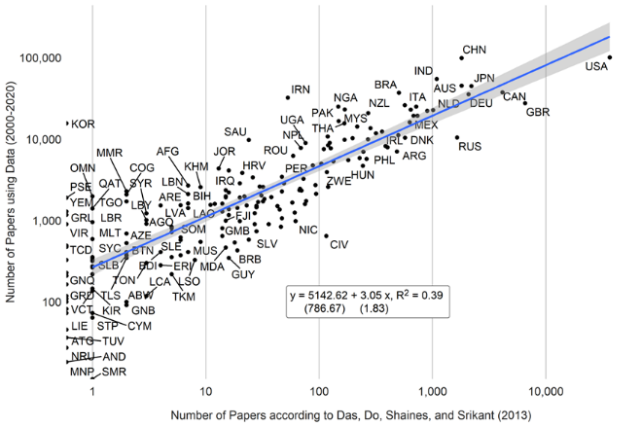
Note: Estimates from Das et al. (2013) are taken from Table A3 of their paper.
- Comparison with Porteous (2020)
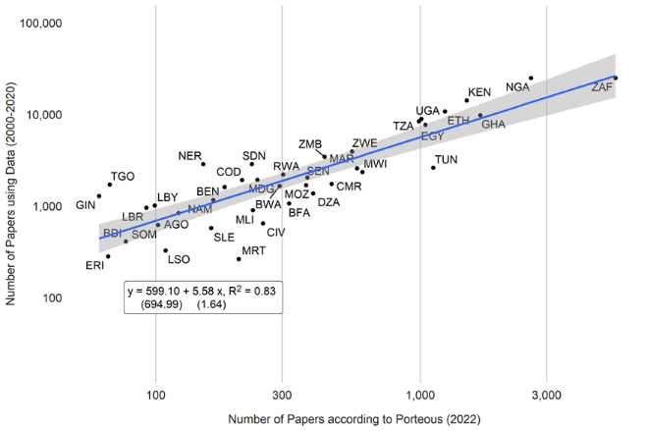
Note: Estimates from Porteous (2020) are taken from Table 3 in that paper and include all journal publications from 2000 to 2019 (column 2 of Table 3).
- Comparison with NSF database of scientific and technical articles (2018)
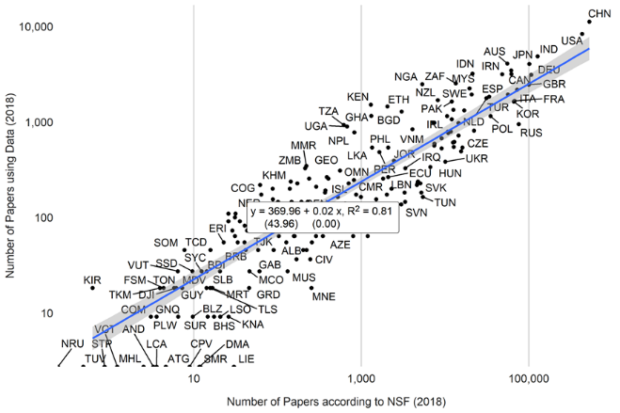
Note: Data from the NSF are papers produced for 2018.

Fig. S4.
Comparison Between All Papers Using Data and Non-Medical Papers Using Data
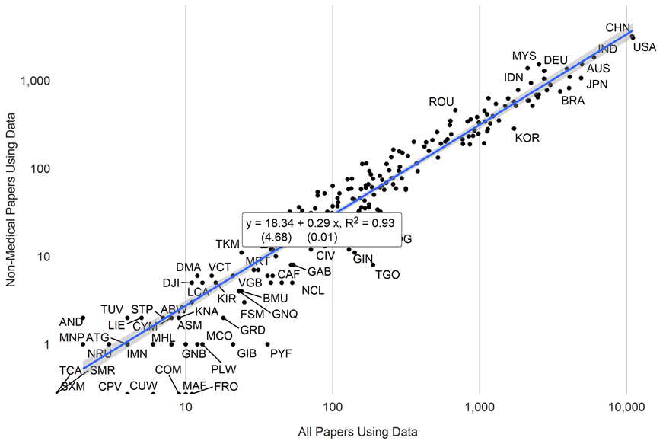

Fig. S5.
Correlation in Papers Using Data Across Subjects. 2000-2020.

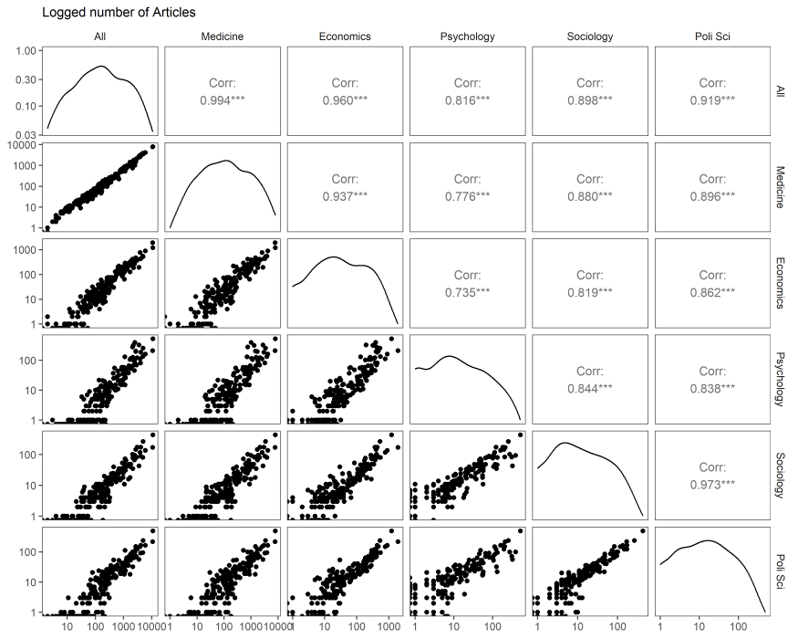

Table S1.
Country Production of Articles Using Data. Per capita and Total. 2017-19.
Country | Articles using data per million persons | Total Number of Articles using data
New Zealand | 35.55 | 133
Norway | 22.56 | 98
Ireland | 19.19 | 68
Denmark | 17.89 | 89
Sweden | 17.35 | 129
Australia | 16.55 | 337
Finland | 16.00 | 68
Singapore | 15.55 | 86
Estonia | 14.82 | 17
Switzerland | 11.78 | 88
Netherlands | 11.45 | 183
Hong Kong SAR, China | 10.52 | 78
Slovenia | 10.22 | 19
Cyprus | 9.22 | 8
Canada | 8.83 | 289
Georgia | 7.88 | 27
Latvia | 7.84 | 12
Croatia | 7.63 | 26
Lithuania | 7.52 | 15
Israel | 7.14 | 52
Malaysia | 7.10 | 200
Greece | 7.03 | 67
Portugal | 6.68 | 60
Qatar | 6.65 | 20
Botswana | 6.40 | 14
Puerto Rico | 6.16 | 19
Austria | 5.97 | 43
Kosovo | 5.96 | 9
North Macedonia | 5.62 | 7
Mongolia | 5.16 | 14
Eswatini | 5.13 | 4
Belgium | 5.08 | 60
Czechia | 4.87 | 43
Oman | 4.78 | 17
Spain | 4.69 | 211
South Africa | 4.35 | 214
Jordan | 4.14 | 49
Italy | 4.10 | 238
Slovak Republic | 4.03 | 10
Bahrain | 4.02 | 4
Germany | 3.80 | 273
Jamaica | 3.79 | 5
West Bank and Gaza | 3.77 | 18
United Kingdom | 3.75 | 219
Lebanon | 3.75 | 21
Iran, Islamic Rep. | 3.71 | 266
Kuwait | 3.68 | 12
Serbia | 3.65 | 18
Ghana | 3.60 | 110
Hungary | 3.58 | 30
Bosnia and Herzegovina | 3.57 | 10
Saudi Arabia | 3.56 | 133
Uruguay | 3.50 | 12
Costa Rica | 3.41 | 16
Korea, Rep. | 3.41 | 169
Chile | 3.27 | 55
Congo, Rep. | 3.23 | 15
Romania | 3.15 | 47
Poland | 3.14 | 134
Bulgaria | 3.11 | 21
Japan | 3.10 | 341
Albania | 2.92 | 6
Nepal | 2.91 | 66
Kenya | 2.89 | 132
Trinidad and Tobago | 2.85 | 2
Panama | 2.84 | 10
France | 2.72 | 165
Timor-Leste | 2.60 | 3
United States | 2.58 | 724
Gambia, The | 2.52 | 4
Sri Lanka | 2.42 | 42
Armenia | 2.36 | 1
Lao PDR | 2.22 | 19
Turkiye | 2.18 | 157
Uganda | 2.18 | 86
Zimbabwe | 2.15 | 29
Mauritius | 2.11 | 3
Rwanda | 2.00 | 28
Thailand | 1.96 | 134
Tunisia | 1.94 | 21
United Arab Emirates | 1.85 | 20
Liberia | 1.74 | 9
Brazil | 1.72 | 323
Zambia | 1.72 | 33
Ecuador | 1.63 | 19
Moldova | 1.63 | 4
Peru | 1.53 | 45
Cambodia | 1.48 | 23
Tanzania | 1.45 | 76
Togo | 1.42 | 9
Ethiopia | 1.41 | 177
Nicaragua | 1.35 | 10
Senegal | 1.33 | 22
Colombia | 1.30 | 70
Malawi | 1.27 | 21
Papua New Guinea | 1.26 | 15
Djibouti | 1.24 | 1
Nigeria | 1.24 | 232
Argentina | 1.23 | 57
Indonesia | 1.23 | 339
Gabon | 1.19 | 4
Eritrea | 1.14 | 5
Cuba | 1.12 | 12
Libya | 1.12 | 2
Benin | 1.11 | 11
Mexico | 1.10 | 124
Equatorial Guinea | 1.07 | 3
Viet Nam | 1.07 | 101
Haiti | 1.05 | 11
Central African Republic | 1.02 | 3
Niger | 0.98 | 26
Bolivia | 0.93 | 12
Guinea | 0.93 | 11
China | 0.89 | 1,191
Sierra Leone | 0.87 | 6
Dominican Republic | 0.86 | 9
Honduras | 0.84 | 10
Ukraine | 0.84 | 33
Azerbaijan | 0.83 | 9
Bangladesh | 0.83 | 116
Iraq | 0.83 | 32
Kazakhstan | 0.81 | 13
Cameroon | 0.79 | 24
Pakistan | 0.77 | 177
Lesotho | 0.75 | 2
El Salvador | 0.74 | 4
Egypt, Arab Rep. | 0.72 | 83
Morocco | 0.72 | 27
Russian Federation | 0.71 | 81
Mauritania | 0.68 | 3
Guatemala | 0.66 | 7
Syrian Arab Republic | 0.66 | 16
Myanmar | 0.63 | 40
Kyrgyz Republic | 0.62 | 4
Sudan | 0.61 | 26
Belarus | 0.57 | 4
Madagascar | 0.57 | 14
Mozambique | 0.53 | 14
Philippines | 0.52 | 52
Afghanistan | 0.50 | 15
Burkina Faso | 0.46 | 8
South Sudan | 0.41 | 3
Yemen, Rep. | 0.41 | 17
Somalia | 0.40 | 6
India | 0.36 | 466
Venezuela, RB | 0.35 | 6
Burundi | 0.34 | 4
Mali | 0.34 | 8
Algeria | 0.30 | 11
Tajikistan | 0.25 | 2
Chad | 0.23 | 3
Congo, Dem. Rep. | 0.22 | 15
Angola | 0.19 | 4
Guinea-Bissau | 0.17 | 0
Turkmenistan | 0.16 | 0
Côte d'Ivoire | 0.14 | 3
Korea, Dem. People's Rep. | 0.14 | 0
Uzbekistan | 0.12 | 1
Note: Countries are divided into five quintiles. Countries shaded in dark orange have the lowest numbers of data use articles, countries in dark green have the highest. Papers include all papers using data years 2017-2019. Population data comes from the World Bank. Only countries with a total population of more than 1 million persons shown.

Table S2.
Relationship between Data Use in Academia and Data Sources from SPI.
 | (1) | (2) | (3) | (4) | (5) | (6) | (7) | (8) | (9) | (10)
Population Census in past 10 years | 0.30+
 | (0.16)
Agriculture Census in past 10 years |  | 0.16
 |  | (0.12)
Business/Establishment Census in past 10 years |  |  | 0.12
 |  |  | (0.11)
Household surveys: 2 or more in 10 years |  |  |  | 0.33
 |  |  |  | (0.21)
Agriculture Surveys: 2 or more in 10 years |  |  |  |  | 0.22*
 |  |  |  |  | (0.10)
Labor Force Surveys: 2 or more in 10 years |  |  |  |  |  | 0.36*
 |  |  |  |  |  | (0.15)
Health Surveys: 2 or more in 10 years |  |  |  |  |  |  | 0.07
 |  |  |  |  |  |  | (0.12)
Business/Establishments: 2 or more in 10 years |  |  |  |  |  |  |  | 0.20*
 |  |  |  |  |  |  |  | (0.10)
Complete Civil Registration and Vital Statistics System |  |  |  |  |  |  |  |  | -0.21
 |  |  |  |  |  |  |  |  | (0.18)
Availability of Data at 1st Admin Level (ODIN) Score |  |  |  |  |  |  |  |  |  | 1.27**
 |  |  |  |  |  |  |  |  |  | (0.44)
Intercept | -4.45*** | -4.15*** | -4.14*** | -4.71*** | -4.37*** | -4.04*** | -4.26*** | -4.06*** | -4.73*** | -4.15***
 | (1.16) | (1.18) | (1.21) | (1.25) | (1.16) | (1.16) | (1.19) | (1.19) | (1.26) | (1.14)
Log GDP per capita | 0.18** | 0.18** | 0.20** | 0.22*** | 0.20** | 0.16* | 0.21** | 0.18** | 0.28** | 0.19**
 | (0.07) | (0.07) | (0.06) | (0.07) | (0.06) | (0.06) | (0.06) | (0.07) | (0.09) | (0.06)
Log Population | 0.30*** | 0.30*** | 0.29*** | 0.30*** | 0.31*** | 0.29*** | 0.29*** | 0.30*** | 0.29*** | 0.29***
 | (0.05) | (0.05) | (0.06) | (0.05) | (0.05) | (0.05) | (0.06) | (0.05) | (0.06) | (0.05)
Log Qualitative Articles | 0.68*** | 0.67*** | 0.69*** | 0.65*** | 0.64*** | 0.66*** | 0.69*** | 0.66*** | 0.69*** | 0.64***
 | (0.08) | (0.08) | (0.08) | (0.08) | (0.08) | (0.08) | (0.08) | (0.08) | (0.08) | (0.08)
Observations | 168 | 168 | 168 | 168 | 168 | 168 | 168 | 168 | 168 | 168
R Sq. | 0.85 | 0.85 | 0.85 | 0.85 | 0.85 | 0.85 | 0.85 | 0.85 | 0.85 | 0.85
Note: GDP and population data are retrieved from the World Bank's World Development Indicators while the data sources are from the SPI. Papers include all papers using data years 2017-2019. ***=0.001 level, **=0.01 level, *=0.05 level, +=0.1 level.

Table S3.
Longitudinal Relationships between Number of Papers Using Data and Statistical Performance
 | (1) | (2) | (3) | (4) | (5) | (6)
Log GDP per capita | 0.58** |  |  | 0.51 | 0.58** | 0.62**
 | (0.20) |  |  | (0.33) | (0.22) | (0.22)
Log Population |  | 0.18 |  | 1.09 | 0.40 | 0.38
 |  | (0.35) |  | (0.69) | (0.37) | (0.37)
SPI Overall Score |  |  | 0.00 | 0.00
 |  |  | (0.00) | (0.00)
SPI Overall Score  (Extended Series) |  |  |  |  | 0.01+
 |  |  |  |  | (0.00)
SPI Data Sources Score  (Extended Series) |  |  |  |  |  | 0.00+
 |  |  |  |  |  | (0.00)
Observations | 1974 | 1974 | 661 | 661 | 1974 | 1974
R² | 0.957 | 0.956 | 0.991 | 0.991 | 0.957 | 0.958
R² Adj. | 0.953 | 0.952 | 0.988 | 0.988 | 0.954 | 0.954
R² Within | 0.025 | 0.001 | 0.001 | 0.013 | 0.036 | 0.039
R² Within Adj. | 0.025 | 0.000 | -0.001 | 0.007 | 0.035 | 0.037
AIC | 1571.9 | 1621.2 | -280.9 | -285.1 | 1554.1 | 1548.5
BIC | 2421.3 | 2470.6 | 492.0 | 496.8 | 2414.6 | 2409.0
RMSE | 0.33 | 0.34 | 0.15 | 0.15 | 0.33 | 0.33
Note: Data from the World Bank’s World Development Indicators (WDI) and SPI. Papers include all papers using data years 2004-2019. SPI Extended Series data supplements SPI data with data from Statistical Capacity Indicator (SCI) to extend series back to 2004. All regressions include standard errors clustered at the country level and country and year fixed effects. ***=0.001 level, **=0.01 level, *=0.05 level,+=0.1 level.

