Supplemental Methods
Metabolomics:
Metabolite analysis was performed as described in Doty et al., 2022. Briefly, S1 DRG samples (30–50 mg) were analyzed by Human Metabolome Technologies-America, Boston, MA. Polar metabolites were detected using capillary electrophoresis time-of-flight mass spectrometry (carried out using Agilent CE-TOFMS system, Agilent Technologies Inc, Waldbronn, Germany), while non-polar metabolites were measured using liquid chromatography time-of-flight mass spectrometry LC-TOFMS (carried out with Agilent 1200 series RRLC system SL, Agilent Technologies Inc, Wadbronn, Germany). CE-TOFMS and LC-TOFMS data was processed with MasterHands (v2.17.1.11) for identification of peaks and quantification based on internal standards. Metabolites detected in fewer than 80% of samples were excluded from downstream analysis. Human Metabolome Database was used to identify metabolite class and directly related enzymes.

PBMC RNA-seq Analysis:
Blood samples from the DRG organ donors were not available, so peripheral blood mononuclear cells (PBMCs) from controls and RA patients were alternatively purchased from Precision For Medicine (Frederick, MD) and STEMCELL Technologies (Cambridge, MA). PBMCs were pelleted (400xg) and RNA was extracted using the RNeasy Plus Universal Mini Kit (Qiagen, Valencia, CA), according to the manufacturer’s protocol. Information about the PBMCs along with the RNA integrity number (RIN) from each sample can be found in Supplemental Table S12. Libraries were prepared and samples were sequenced at the NIH Intramural Sequencing Center (Rockville, MD) while RNA-seq analysis was performed as described for the DRGs and as detailed in Hall et al., 2022. PBMC transcriptomic data is available in supplemental tables S13 and S14.

Supplemental Figure 1

Characterization of DEGs: A) Long noncoding RNAs (lncRNAs) are a class of untranslated transcripts (more than 200 nucleotides) that are thought to regulate cellular gene expression. Heatmap shows about 15 discernable lncRNAs that were dysregulated between subjects with RA and controls. Notably, DOCK9-AS2 is upregulated in RA patients and is implicated in atherosclerosis^{4,2}, while LINC01876, also upregulated, is a human-specific transcript that is linked to brain development¹. Of the 128 significantly DEGs between the RA donors and the controls, 52 were protein-coding. PANTHER Analysis³ was used to characterize these dysregulated protein-coding genes by B) protein class and C) molecular function. Of the characterized protein classes, transmembrane signaling receptors and intercellular signaling molecules together appear to be mostly affected with RA. D) Overall, 9 cell surface receptors (~17% of the protein-coding transcripts) were differentially expressed between RA and the controls.

- Garza R, Atacho DAM, Adami A, Gerdes P, Vinod M, Hsieh P, Karlsson O, Horvath V, Johansson PA, Pandiloski N, Matas-Fuentes J, Quaegebeur A, Kouli A, Sharma Y, Jönsson ME, Monni E, Englund E, Eichler EE, Gale Hammell M, Barker RA, Kokaia Z, Douse CH, Jakobsson J. LINE-1 retrotransposons drive human neuronal transcriptome complexity and functional diversification. Sci Adv. 2023;9(44):eadh9543.

- Shi J, Zhou B, Tian Z. DOCK9 antisense RNA2 interacts with LIN28B to stabilize Wnt5a and boosts proliferation and migration of oxidized low densitylipoprotein-induced vascular smooth muscle cells. Bioengineered. 2022;13(3):7564-7578.

- Thomas PD, Ebert D, Muruganujan A, Mushayahama T, Albou LP, Mi H. PANTHER: Making genome-scale phylogenetics accessible to all. Protein Sci. 2022;31(1):8-22.

- Wang CH, Shi HH, Chen LH, Li XL, Cao GL, Hu XF. Identification of Key lncRNAs Associated With Atherosclerosis Progression Based on Public Datasets. Front Genet. 2019;10:123

Supplemental Figure 2
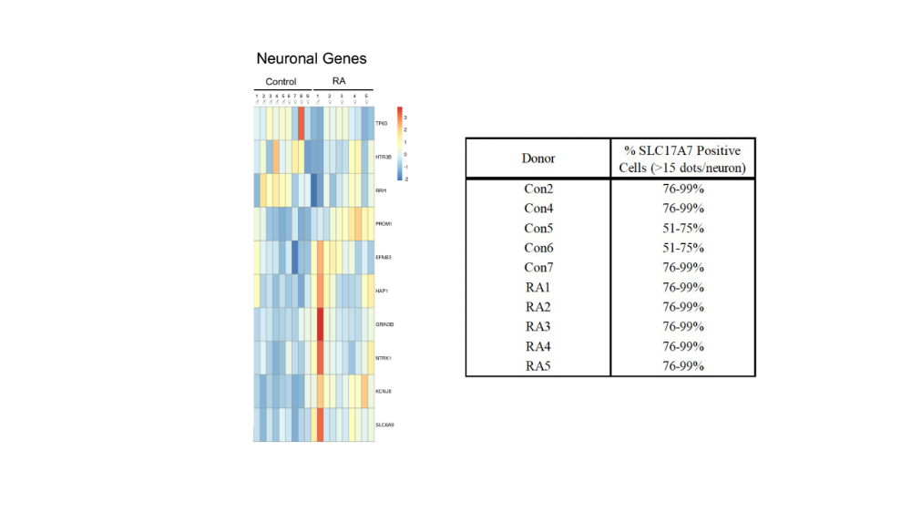
Evaluation of Neuronal Genes in RA donors. A) Heatmap of dysregulated genes that are characterized as neuronal (GO:0097458). B) Semi-quantitative scoring of strongly expressing SLC17A7 cells (>15 dots/neuron).

Supplemental Figure 3
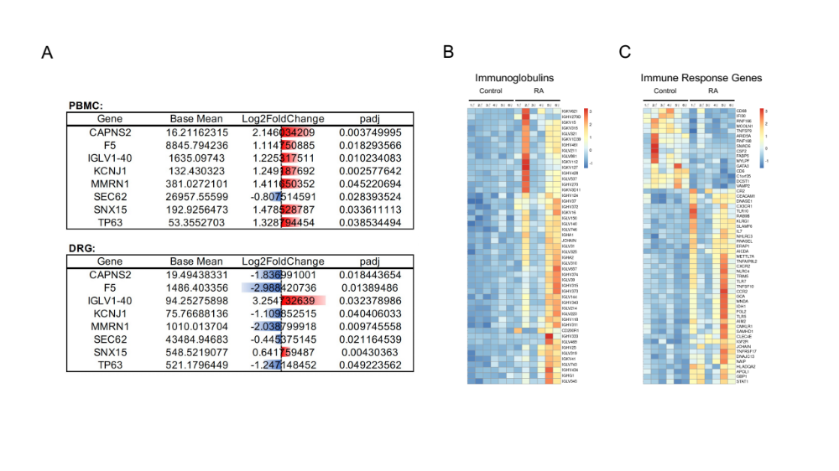
RNA-seq analysis of peripheral blood mononuclear cells (PBMCs) from patients with RA: A) 8 DEGS were common between the bulk sequencing performed on the DRGs and the PBMCs, of which only 3 were dysregulated in the same direction (IGLV1-40, SNX15, and SEC62). B) Nonetheless, both datasets show the overall upregulation in immunoglobulin genes. The heatmap shows genes primarily linked with immunoglobulin complexes (GO:0019814). C) Heatmap with predominately upregulated immune response genes (GO:0006955) in the PBMCs of patients with RA.

Supplemental Figure 4
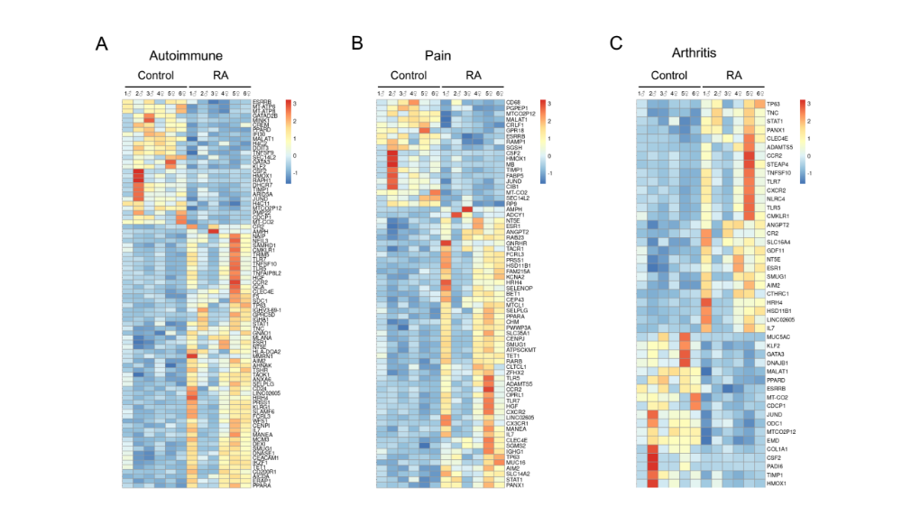
Characterization of PBMC RNA-seq data through DisGeNET: Heatmaps of genes linked with A) autoimmune diseases (C0004364), B) pain (C0030193), and C) arthritis (C0003864). Although upregulated inflammatory mediator signaling is a shared feature to these diseases, only about 12.7% of the selected DisGeNET genes (17 out of 134) were common to all 3 conditions.

Supplemental Figure 5
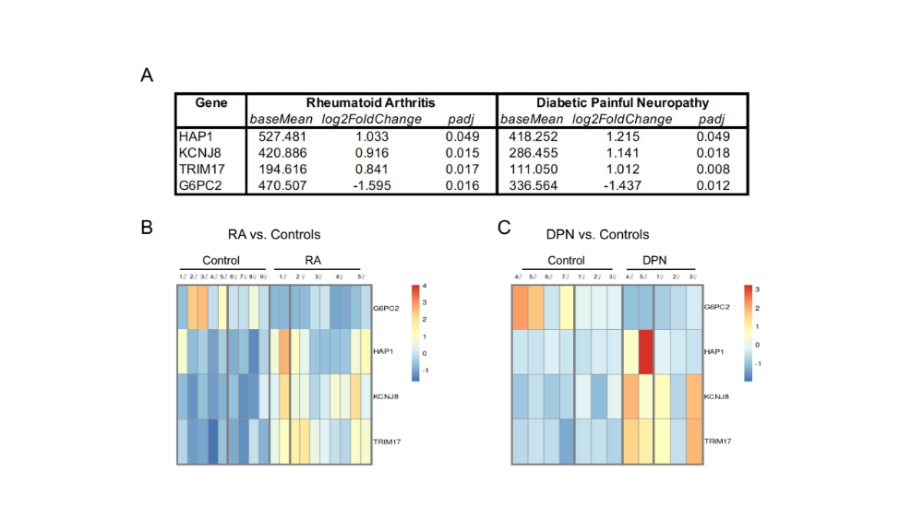
Overlap genes in both diabetic painful neuropathy (DPN) and RA: 10 gene are dysregulated in both DPN and RA, of which 5 are immunoglobulin related genes (IGHG2, IGHG3, IGLC2, and IGKV1-33, with IGHGP being a pseudogene). CRYGN is upregulated in RA while downregulated in DPN, but G6PC2, HAP1, KCNJ8, and TRIM17 show fold changes in the same direction in both chronic pain disorders. A) Table with base mean, log2 fold change, and p adjusted value. B) Heatmap of RA donors and corresponding controls and C) heatmap of DPN donors with data from Hall et. al. 2022. As seen in the heatmaps, there may be gender differences related to dysregulated gene expression within the chronic pain donors.

