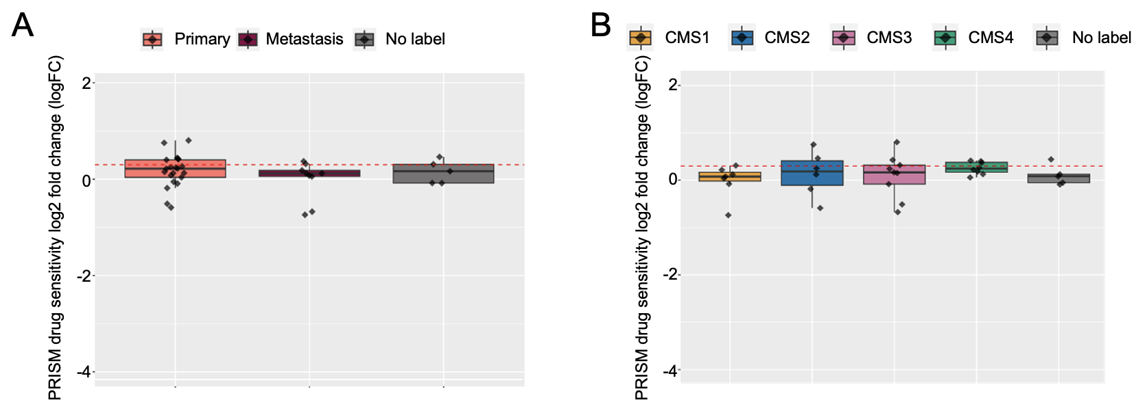
Additional Figure 1. Effective role of metformin for treating specific CMS or metastatic CRC cells. Data was collected from PRISM Repurposing Primary Screening 19Q4. (A) The sensitivity to metformin between primary and metastasis cell lines was insignificant. (B) No difference in the sensitivity to metformin in the four CMS groups.

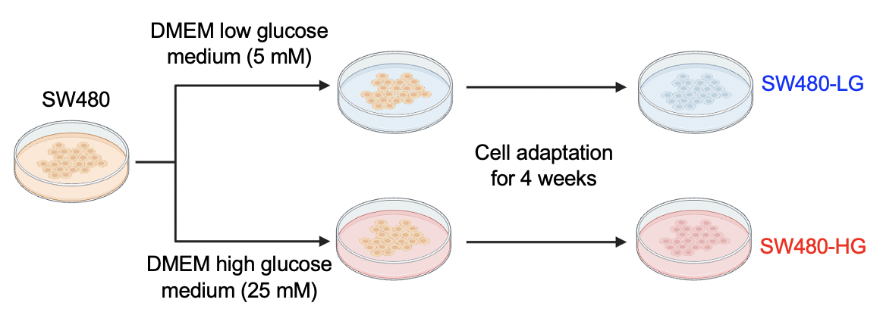
Additional Figure 2. A flowchart illustrating the establishment of SW480-LG and SW480-HG cells. SW480 cells were cultured under normoglycemic conditions (i.e., low glucose, 5 mM) and hyperglycemic conditions (i.e., high glucose, 25 mM) for 4 weeks to simulate normal physiological glucose levels and the elevated blood glucose levels observed in patients with severe diabetic hyperglycemia, respectively.

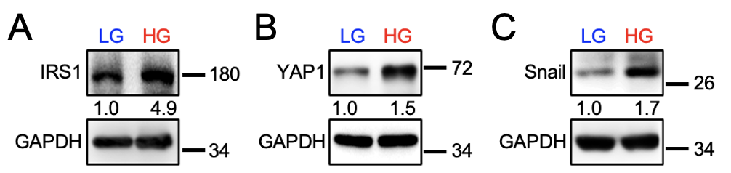
Additional Figure 3. IRS-1, YAP1, and Snail expression in SW480-LG and SW480-HG cells. (A-C) Western blot analysis comparing the expression of markers related to glucose metabolism (IRS1), ER tolerance (YAP1), and metastatic potential (Snail) in SW480-LG and SW480-HG cells.

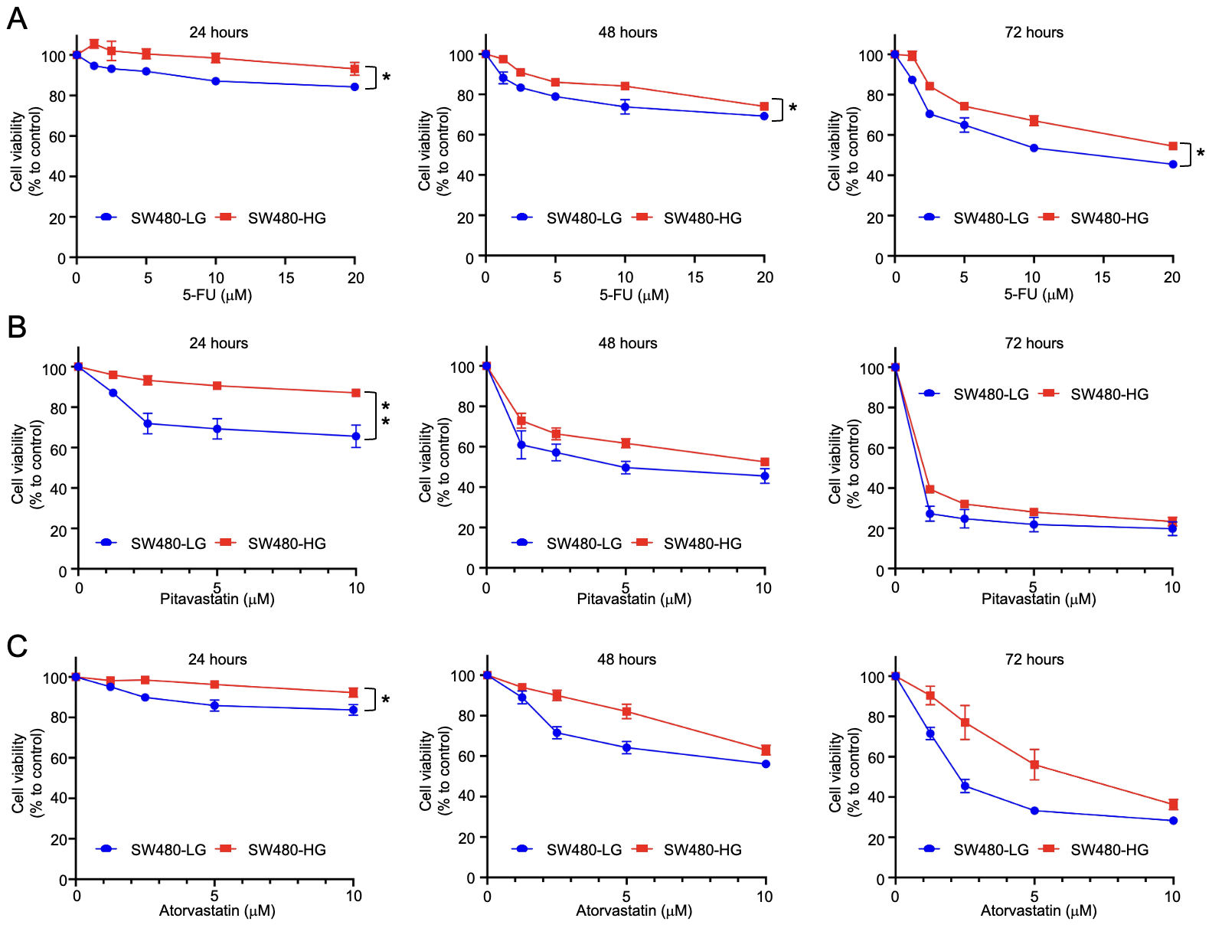
Additional Figure 4. Drug effects of 5-FU, pitavastatin, and atorvastatin on the CMS4 cell line SW480. (A-C) SW480-LG and SW80-HG cells were treated with 5-FU, pitavastatin, and atorvastatin for 24, 48, and 72 hours, respectively. Data are mean ± SEM (N = 3). The number of symbols corresponds to the significance level: one symbol indicates p < 0.05, and two symbols indicate p < 0.01. LG: Low glucose; HG: High glucose.

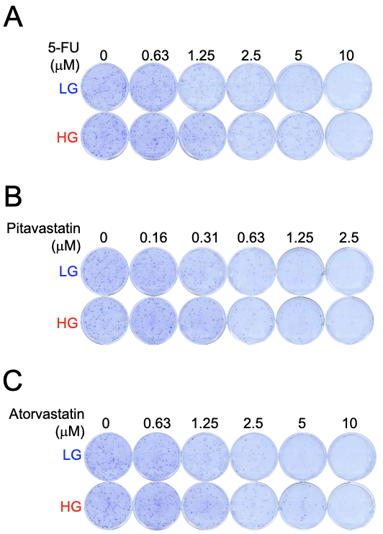
Additional Figure 5. Colony formation assays for SW480-LG and SW480-HG cells. (A-C) Colony formation assay of SW480-LG and SW480-HG cells after treatment with 5-FU, pitavastatin, or atorvastatin for 9 days. Data are mean ± SEM (N = 3). LG: Low glucose; HG: High glucose.

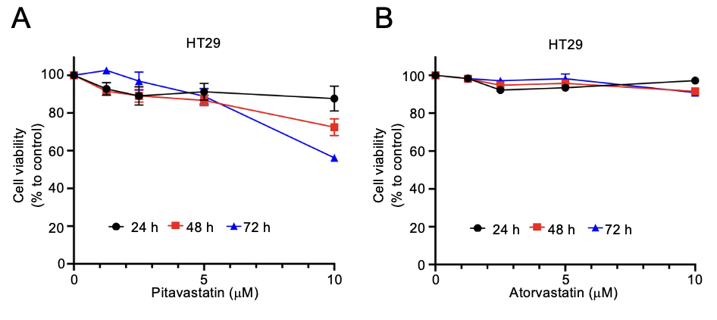
Additional Figure 6. The effects of pitavastatin and atorvastatin on the CMS3 cell line HT29. (A-B) HT29 cells were treated with pitavastatin or atorvastatin for 24, 48, and 72 hours, respectively. Both pitavastatin and atorvastatin were unable to inhibit HT29. Data are mean ± SEM (N = 3).

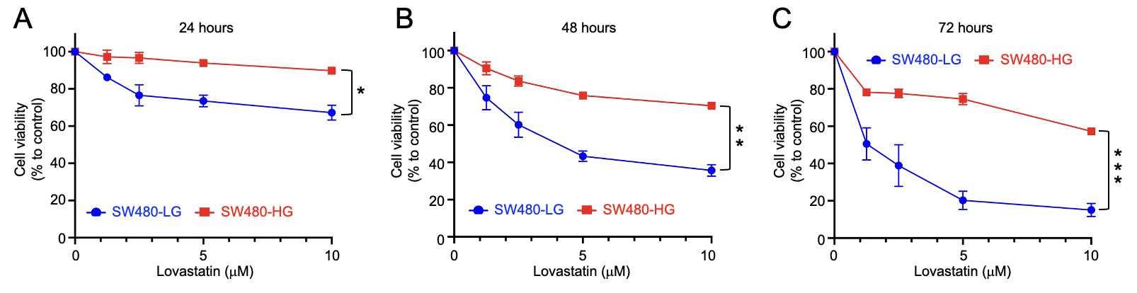
Additional Figure 7. The effects of lovastatin on SW480-LG and SW480-HG cells. (A-C) SW480-LG and SW480-HG cells were treated with lovastatin for 24, 48, and 72 hours. Data are mean ± SEM (N = 3). The number of symbols corresponds to the significance level: one symbol indicates p < 0.05, and two symbols indicate p < 0.01. LG: Low glucose; HG: High glucose.

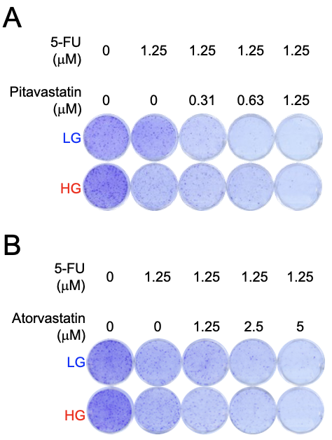
Additional Figure 8. The effect of 5-FU in combination with pitavastatin or atorvastatin in SW480-LG and SW480-HG cells. (A-B) Colony formation assay of SW480-LG and SW480-HG after treatment with a combination of 5-FU and pitavastatin/atorvastatin for 11 days. Data are mean ± SEM (N = 3). LG: Low glucose; HG: High glucose.

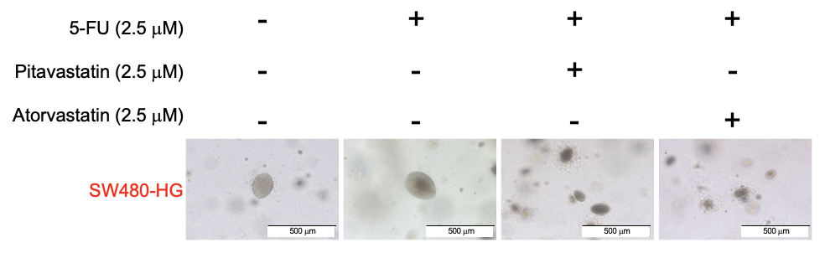
Additional Figure 9. The inhibition of 3D spheroid formation under high glucose conditions by pitavastatin and atorvastatin. SW480-HG cells were cultured using the ACD 3D culture system at a density of 1000 cells per well for 7 days. 5-FU in combination with pitavastatin or atorvastatin was added to the culture medium for 7 days for SW480-HG cells.

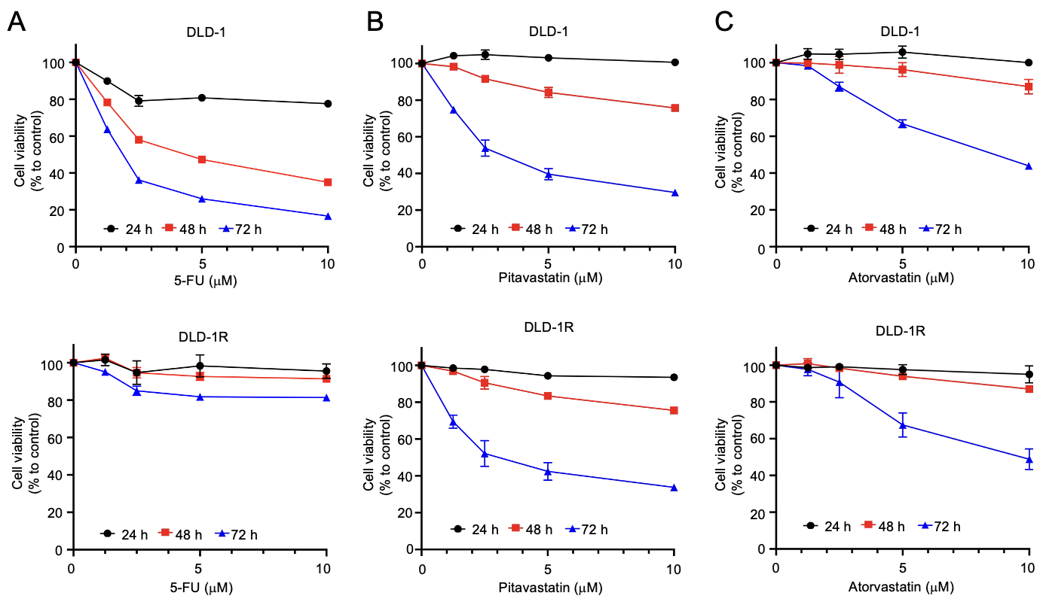
Additional Figure 10. The effects of pitavastatin and atorvastatin on DLD-1 and DLD-1R cells. (A-C) DLD-1 and DLD-1R cells were treated with 5-FU, pitavastatin, and atorvastatin for 24, 48, and 72 hours, respectively. Data are mean ± SEM (N = 3). DLD-1R: DLD-1 5-FU resistance.

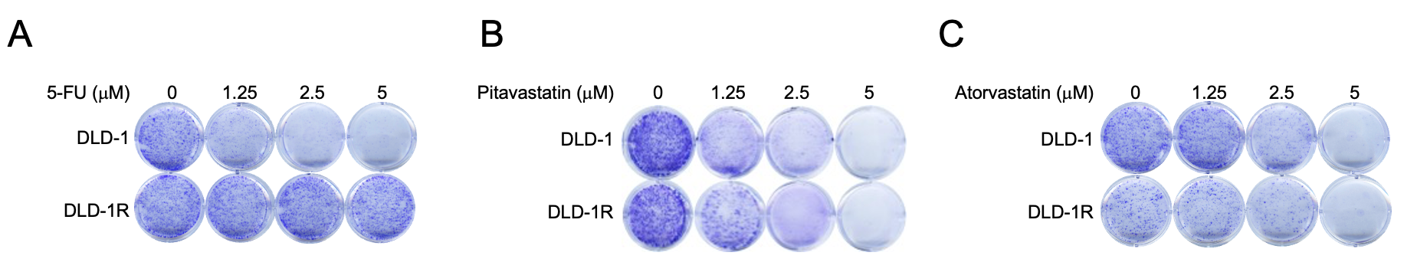
Additional Figure 11. Colony formation assays for DLD-1 and DLD-1R cells. (A-C) Colony formation assay of DLD-1 and DLD-1R cells after treatment with 5-FU, atorvastatin, or pitavastatin for 9 days. DLD-1R cells. Data are mean ± SEM (N = 3). DLD-1R: DLD-1 5-FU resistance.

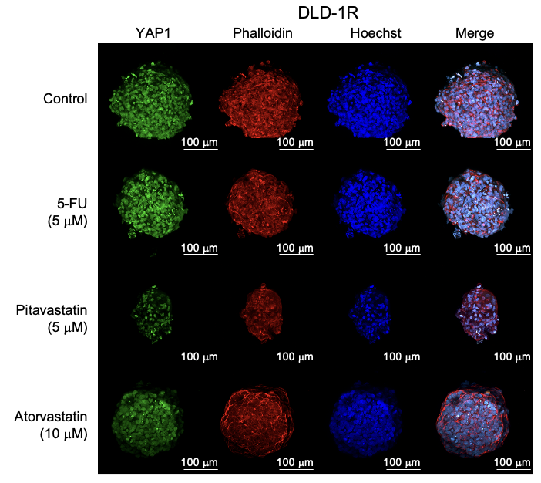
Additional Figure 12. Expression of YAP1 in DLD-1R spheroids following treatment with 5-FU pitavastatin and atorvastatin. Drug-treated DLD-1R spheroids were stained with YAP1 (labeled with Alexa Fluor™ 488), Alexa Fluor™ 568 Phalloidin, and Hoechst 33342. The immunofluorescence staining images were acquired using Zeiss LSM900 confocal microscopy with a 20X objective. Scale bar: 100 μm.

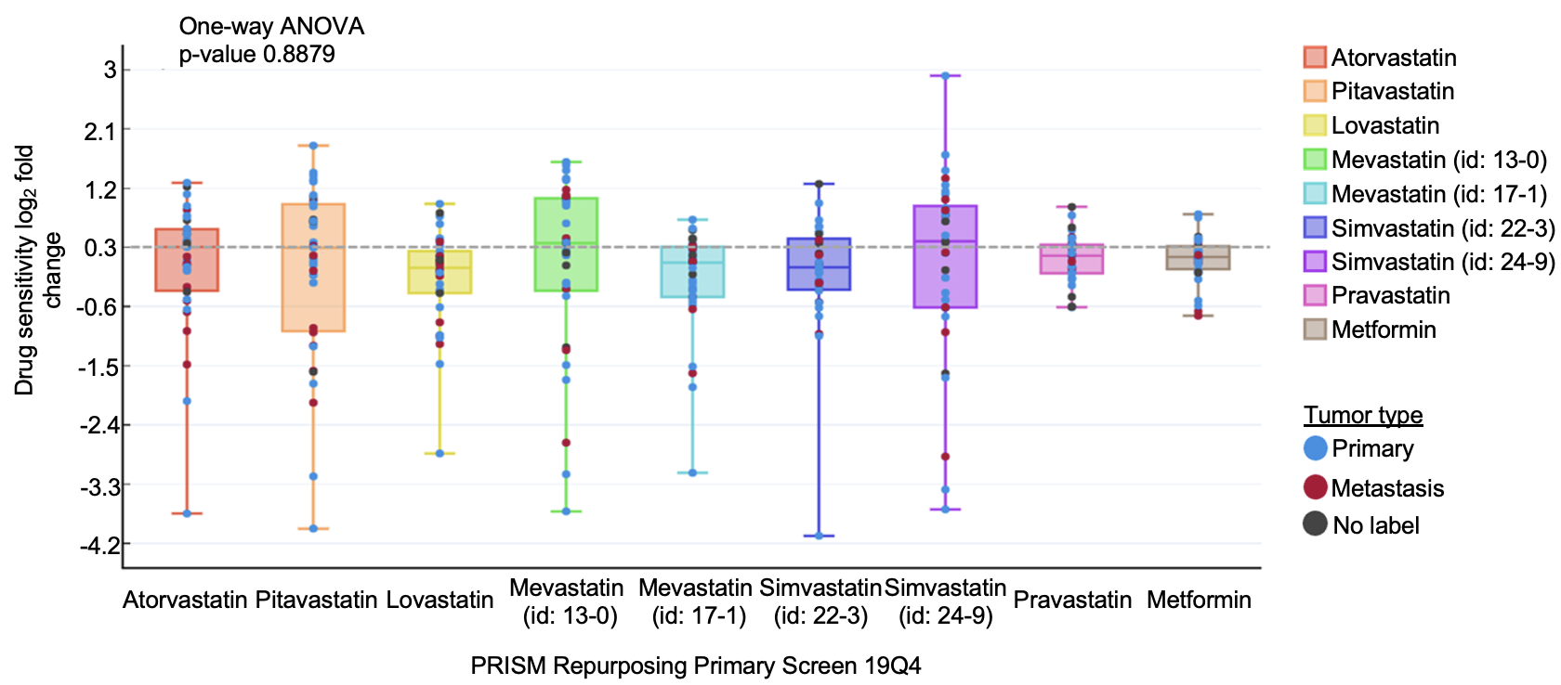
Additional Figure 13. Effects of statins on primary and metastatic colorectal cancer cells. Statins have no specific difference in primary and metastatic colorectal cancer cells. A total of 35 CRC cell lines data was collected from PRISM Repurposing Primary screening 19Q4. The sensitivity of different statins and metformin was insignificant in primary and metastasis. For mevastatin and simvastatin, two vendors of compounds were labeled as the ID number in the database. The cut-off of drug sensitivity was smaller than 0.3.

