Supplementary file 2

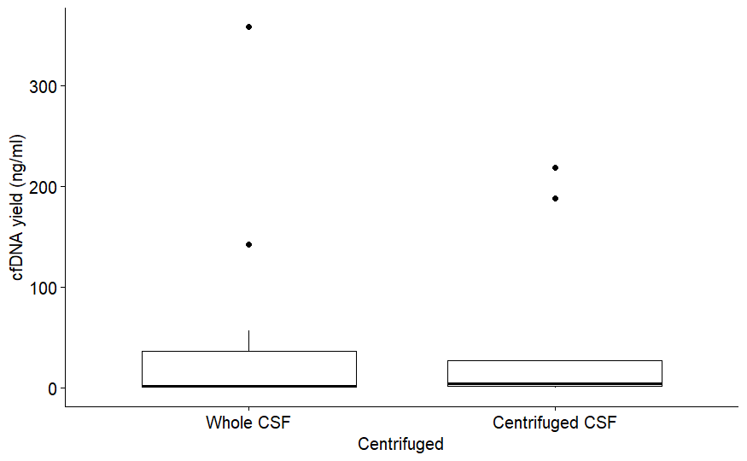
Figure 1: Total cfDNA yield in whole CSF (n=12) versus centrifuged CSF samples (n=20).
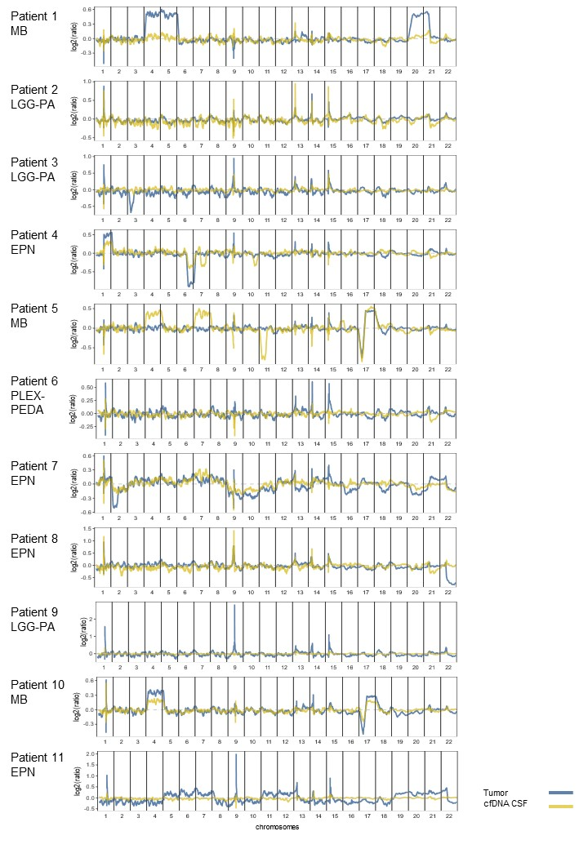
Figure 2: DNA copy number profiles of all patients with matching CSF-cfDNA and FFPE-DNA samples. Overlapping profiles of the tumor formalin fixed paraffin embedded (FFPE) material in BLUE and CSF material in YELLOW show both corresponding aberrations as well as some heterogeneity.

