Supplementary materials:
Table S1. Primer information of DDX39A and reference gene ACTB.
Gene name | Upstream primer sequence | Downstream primer sequence | Amplified fragment length (bp)
DDX39A | CCTAAGAAAGACATCAAGGGAT | TGCTCAAAGCCACAGTCC | 110
ACTB | GCGTGACATTAAGGAGAAGC | CCACGTCACACTTCATGATGG | 236

Figure legends of supplementary pictures:
Figure S1. Hematoxylin and eosin staining of GC and the para-carcinoma tissue. A: Representative image of GC tissue. B: Representative image of adjacent normal tissue. GC, gastric cancer
Figure S2. Scatterplot of the top 9 proteins with the most significant changes in expression by proteomics analysis. a. IKBIP; b. OGFR; c. NCSTN; d. BRIX1; e. DDX39A; f. DECR1; g. FABP3; h. DCXR; i. BCAT2; Pt, paracancerous tissue; Ct, control.
Figure S3. Expression of DDX39A was tested by real-time PCR in four gastric cancer cell lines.

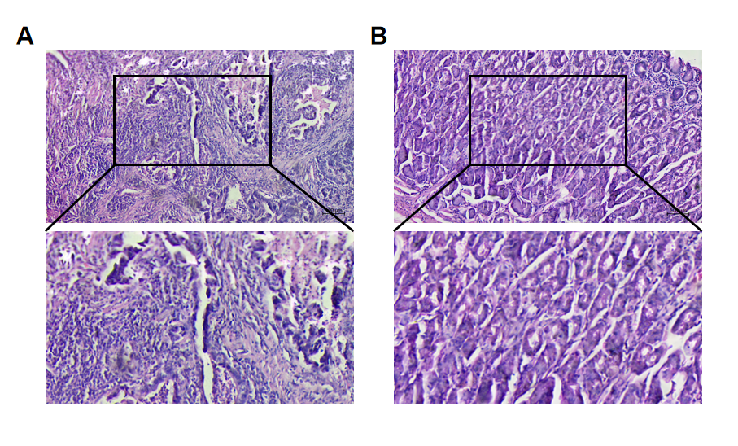
Figure S1

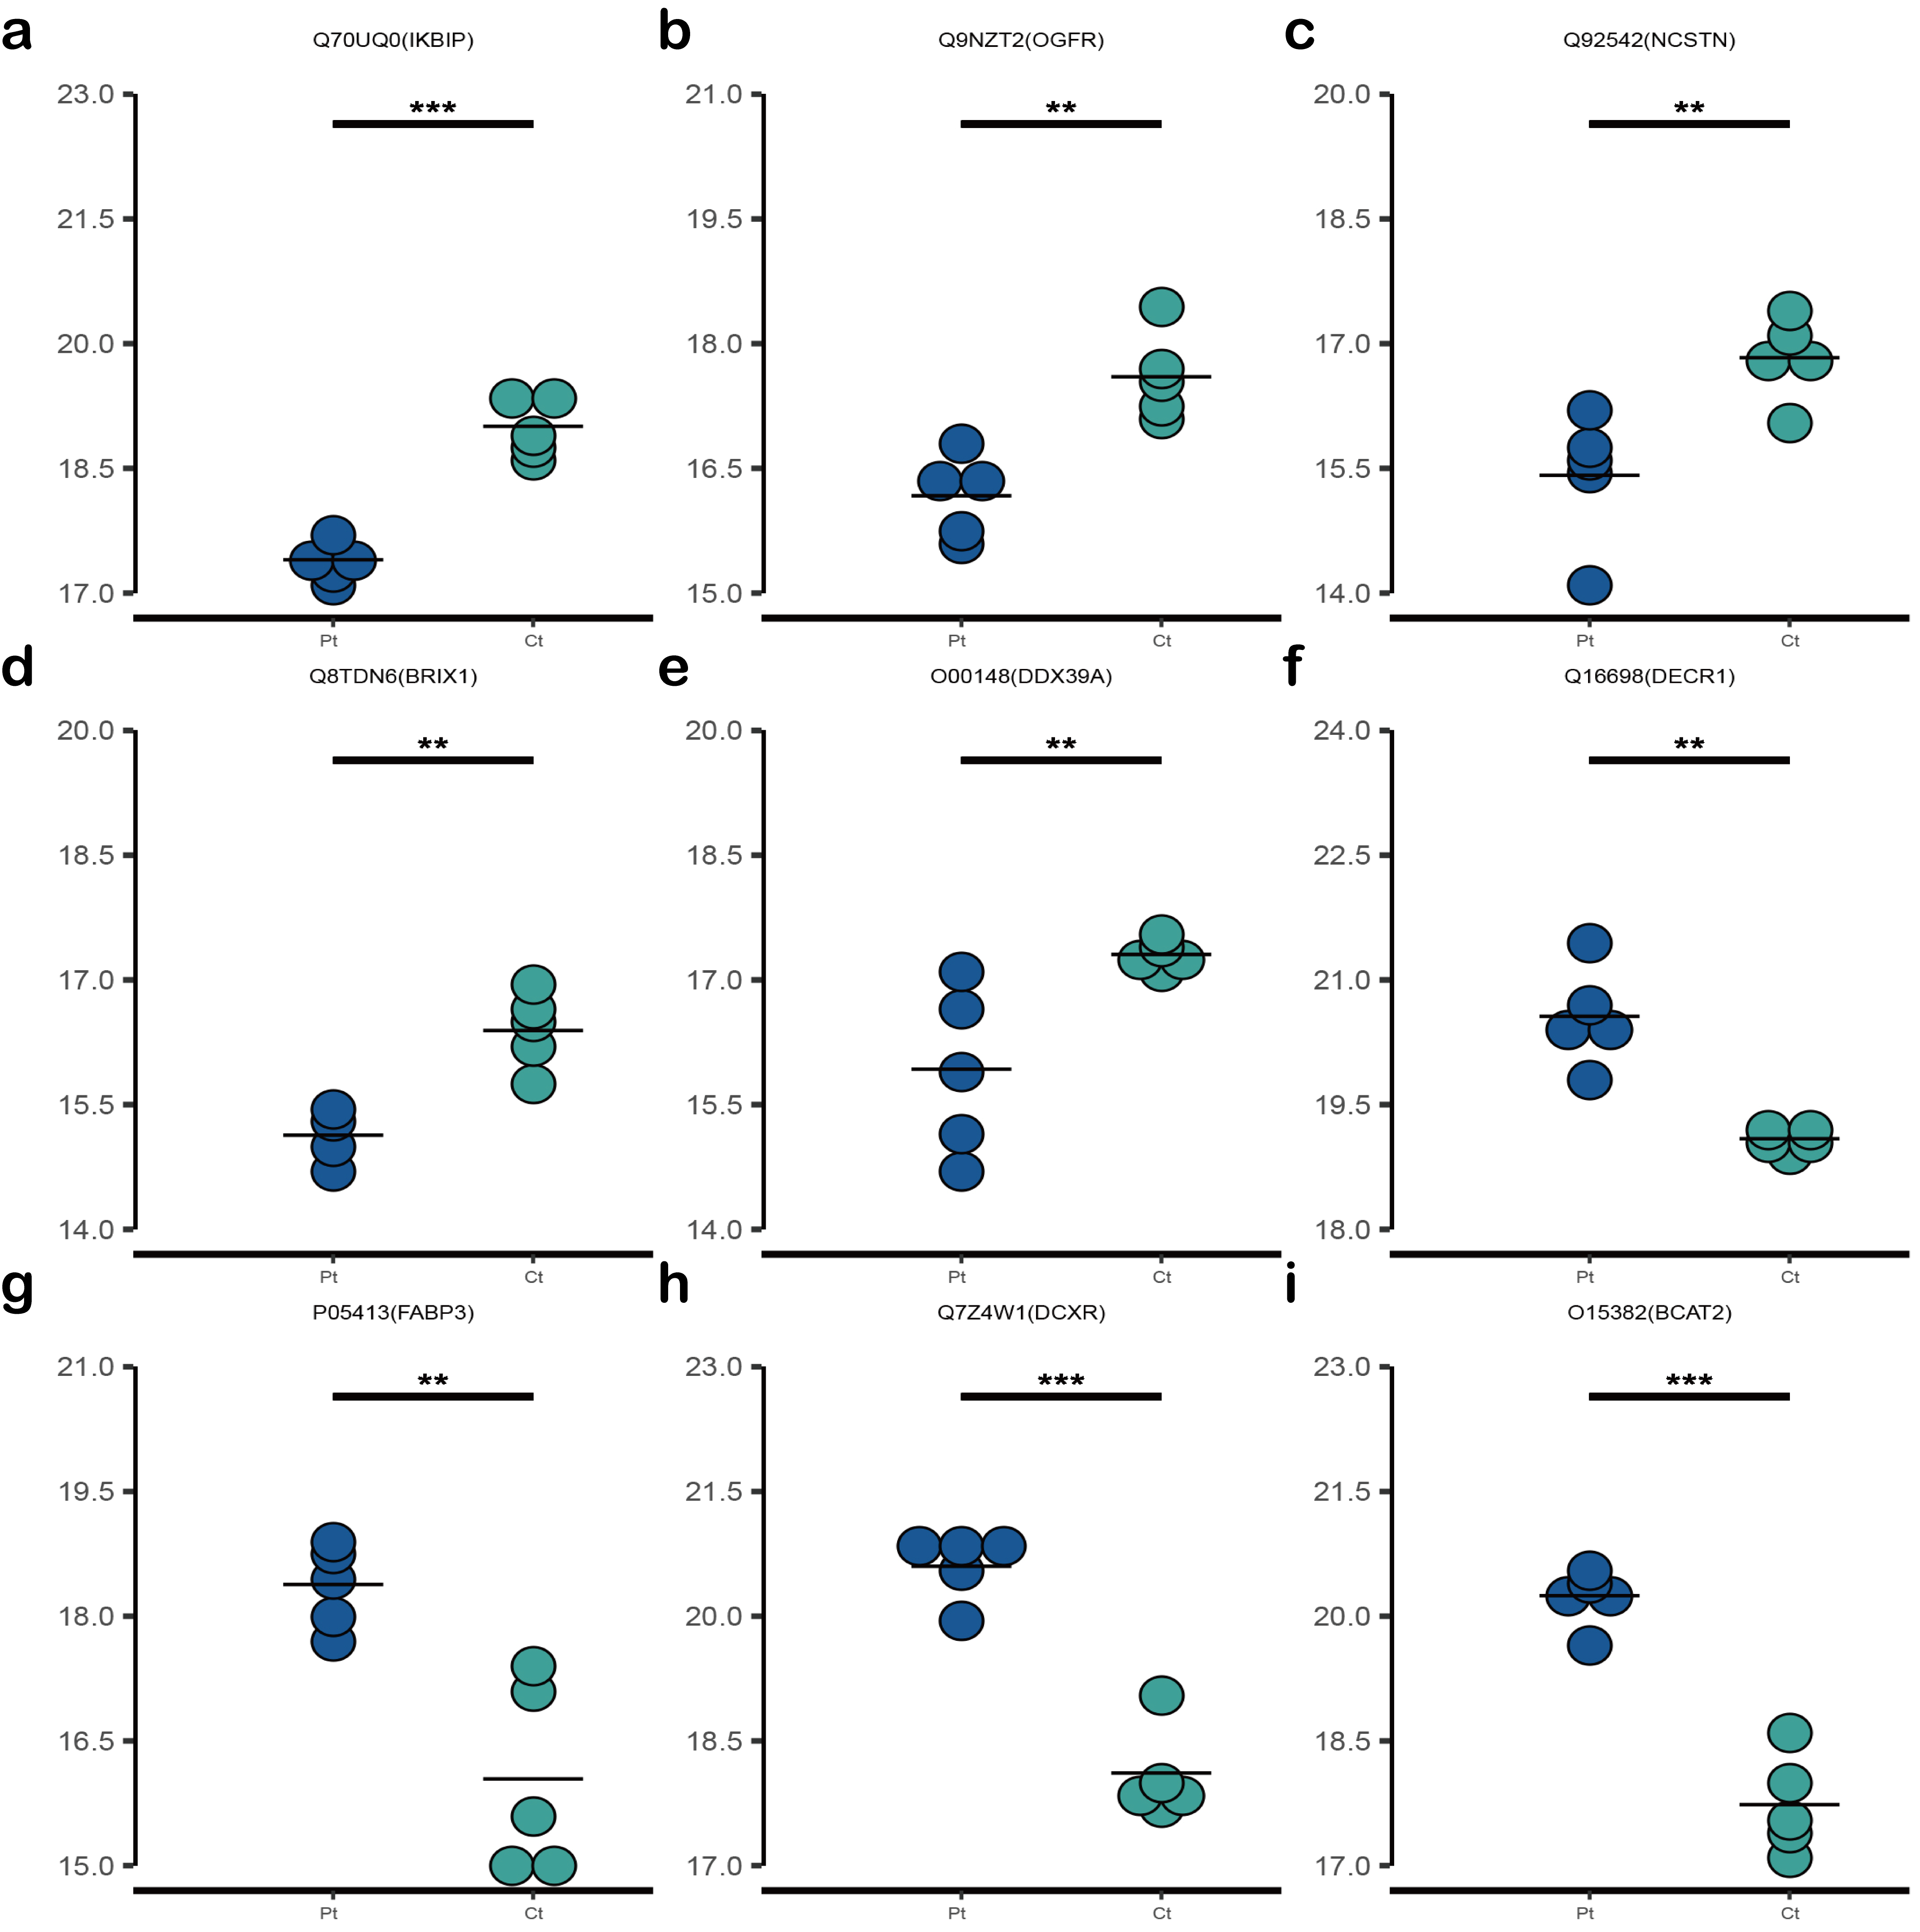
Figure S2

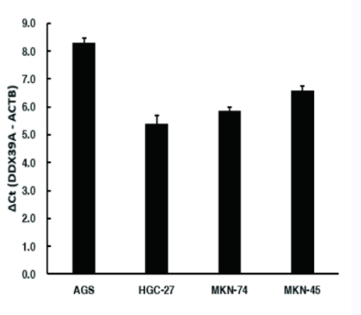
Figure S3

