Supplementary Information for Non-Reciprocity in Photon Polarization based on direction of polarizer under Gravitational Fields
Authors: Hansol Noh^{1,2}, Paul M. Alsing³, Warner A. Miller⁴, and Doyeol Ahn^{1,4*},

Affiliations:
¹Department of Electrical and Computer Engineering and Center for Quantum Information Processing, University of Seoul, 163 Seoulsiripdae-ro, Dongdaemun-gu, Seoul, 02504, Republic of Korea
²Department of Electrical and Computer Engineering, Seoul National University Seoul 08826, Republic of Korea.
³Air Force Research Laboratory, Information Directorate, Rome, NY 13441, USA.
⁴Department of Physics, Florida Atlantic University, 777 Glades Road, Boca Rat Raton, FL 3431-0991, USA.
*Correspondence to: dahn@uos.ac.kr.

Euler-Lagrange equation and local time-reversal symmetry breakdown of Wigner-rotated photon
In this study, we employ non-spinning tetrads that are parallel transported along the geodesics of satellites (massive particles) orbiting around Earth. However, the Wigner rotation angle (WRA) should be calculated with covariant derivatives of tetrads along the geodesics of photons (massless particles). Consequently, while the variation of WRAs can be measured by comparing the phases of photons observed in local frames at initial and final events, we can alternatively introduce a fictitious observer whose local frame is described with a set of chosen tetrads defined along events on null geodesics. In the latter case, considering the acceleration of frames can be interpreted as the sequential applications of different boosts over time, the application of different local Lorentz transformations induced from tetrad variations along null geodesics leads to fictitious accelerations. Accordingly, as in the case of the Coriolis force, the fictitious acceleration can break time reversal symmetry in the local non-inertial frame.
We demonstrate the breakdown of time reversal symmetry by showing that time-reversed photon state does not follow the Euler-Lagrange equation obtained. To achieve this, we first approximate the spacetime of Earth as being geodesically complete, i.e., the paths of freely falling particles can be extended near the Earth indefinitely without encountering singularities or other obstructions by taking advantages of much smaller Schwarzschild radius of Earth ( ~ 9mm) than the size of system. Considering the variations of local inertial frames defined with tetrad fields e^{â}_{μ}(x) are mapped into others by local Lorentz transformations, we can introduce Lorentz-invariant four-dimensional volume of each infinitesimal local tangent space along the geodesics depicted with black boxes in Fig.S1. By continuously placing each of infinitesimal box, we may consider an “extended” flat spacetime 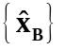, which is not “flat spacetime” with zero curvature but rather it is an approximated description of spacetime by assuming a smooth integration of infinitesimal boxes. Moreover, as the boundary of the neighborhood can be defined with parallel transportation of tetrad fields at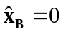, there may be no boundary deficit in covering the entire spacetime. The similar approach has been reported to address the validity of Fourier transformation on any non-compact geodesically complete manifold⁵³.
In this system, Einstein’s equivalence principle supports that a single-component vector potential 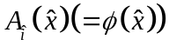 follows the Klein-Gordon equation. The corresponding field has the form:
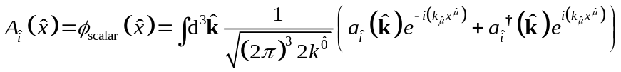 (S1)
Here, 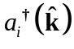 and 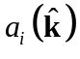 are the creation and annihilation operators of eigen momentum states with =1 and 2, and the local coordinates are defined as
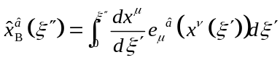; 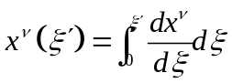. (S2)
Accordingly, the eigen-helicity states of photons can be described with complex scalar fields such that
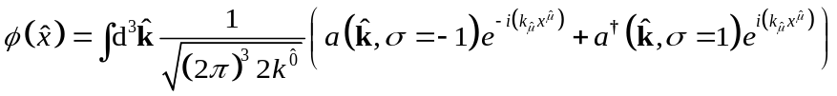 (S3)
with
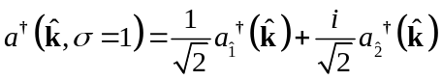 and 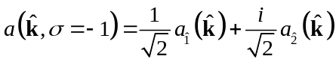. (S4)
Then, considering the variation of tetrad fields along geodesics of photons as well, the ansatz of complex scalar fields operator φ(x̂), describing the photon’s helicity (σ) states, accounting for the Wigner rotation angle ψ(Λ(x̂), k̂/|k̂|) are introduced such that
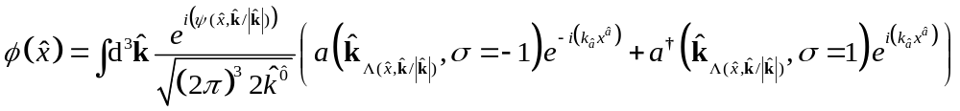 (S5)
Here, it is exploited that under the Lorentz transformation Λ, the creation and annihilation operators are transformed as³³
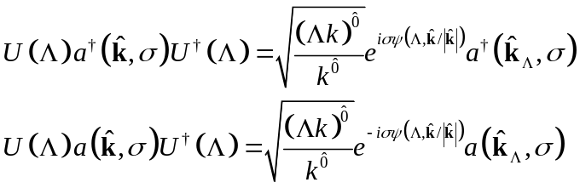. (S6)
As with the Berry phase, the Wigner rotation angle (WRA) can be expressed solely in terms of the local time-coordinate (t̂ =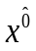) along a photon's trajectory x̂(ξ) as
(S7)
where t̂(ξ_{t̂}) = t̂. Subsequently, the related field operator and Lagrangian density L can be formulated such that
(S8)
and
(S9)
with D_{k̂â}=∇_{â}-i∂_{â}ψ(t̂, k̂/|k̂|). Here, ∇_{â} is the covariant derivative defined with Christoffel symbols of a local frame, ∇_{ĉ}V^{b̂}=∂_{ĉ}V^{b̂}+(∂_{ĉ}e_{a}^{μ}(x̂))e_{μ}^{b̂}(x̂)V^{â}= ∂_{ĉ}V^{b̂}+Γ^{b̂}_{ĉâ}V^{â}. In the Lagrangian density, the term ∂_{â}ψ(t̂, k̂/|k̂|) can be treated as a gauge field A_{k̂â} interacting with a photon. With this, we derive the Euler-Lagrange equations as follows:
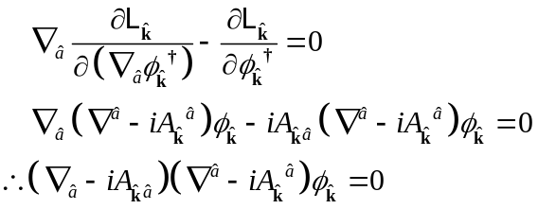 (S10)
and
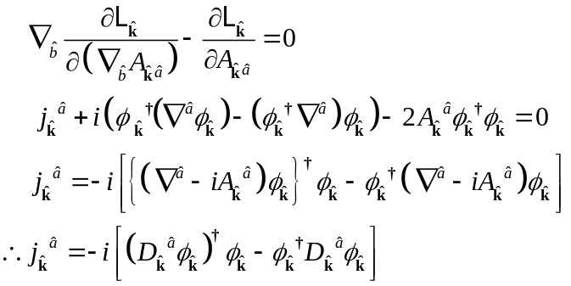 (S11)
Considering the introduced gauge field depends on the momentum, it is challenging to define a field strength tensor whose surface integration over an enclosed region becomes the line integration of Wigner rotation angle; the momentum dependence could lead to non-reciprocity, and WRAs integrated along an open path not to be cancel ed out with those along the opposite direction. Therefore, we introduce the exterior-current coupled term j_{k̂}^{â}A_{k̂â} rather than the field strength term F_{k̂âb̂}F_{k̂}^{âb̂} in the Lagrangian, treating the gauge field as an exterior background field as the case of Coriolis force and quantum Hall effect.

Derivation of breakdown of local time-reversal symmetry using Euler-Lagrange equations
According to the equivalence principle, in each local frame, local time reversal operator should act as time reversal operator does in quantum field theory, which transforms timelike tetrad e^{t̂} into -e^{t̂}. Considering the transformation of creation and annihilation operators under the local-time reversal operator T, Ta_{î}†(k̂) T⁻¹ = e^{iζ}a_{î}†(-k̂) and Ta_{î}†(k̂)T⁻¹ = e^{-iζ}a_{î}†(-k̂) with î = 1 and 2³³, and taking into account anti-unitarity of the operator T as well, the creation and annihilation operators for eigen-helicity states are transformed as follows:
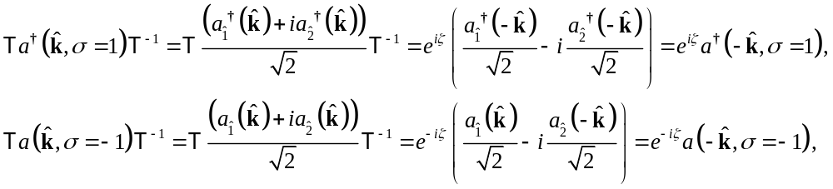 (S12)
Then, the time reversed field operator has the form
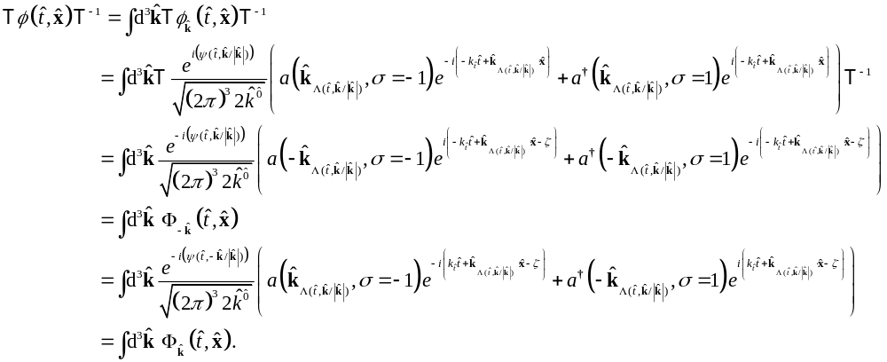 (S13)
Here, Ф_{k̂}(x̂) represents the time-reversed field operator of mode k̂. While WRA is defined in the positive local time coordinate domain, we can extend the gauge field on the entire local time coordinate to enable the time-reversed field operator to be considered the field operator ϕ(-t̂, x̂) with the sign-flipped local time coordinate such that
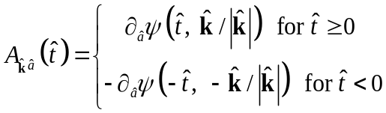 (S14)
Then, considering the introduced gauge field A_{k̂â}(t̂) is real scalar field but not an operator or complex function, it undergoes the transformation as
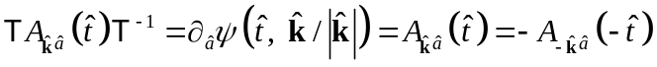. (S15)
Then, the time reversed Lagrangian TL_{k̂}T⁻¹ of a mode k̂ field operator becomes
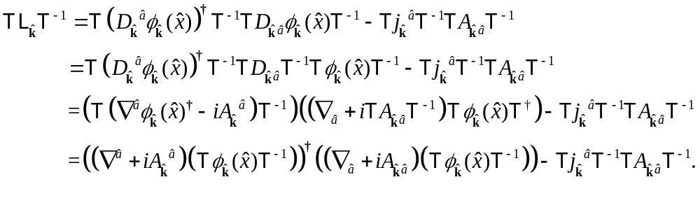 (S16)
Here, we use that
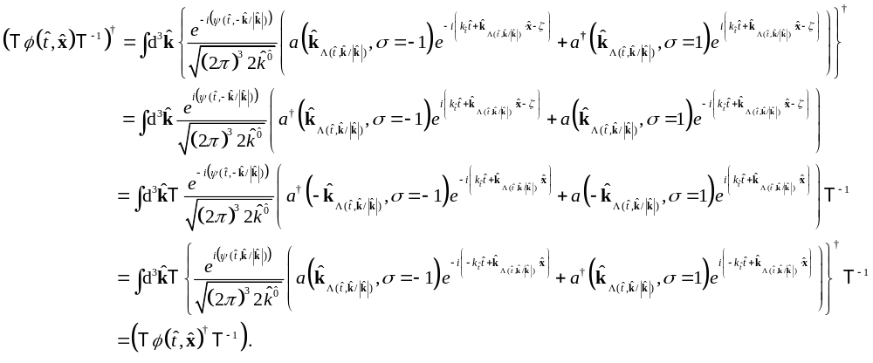 (S17)
As a result, the local time-reversed Euler-Lagrange equation of a mode k̂ field operator is given by
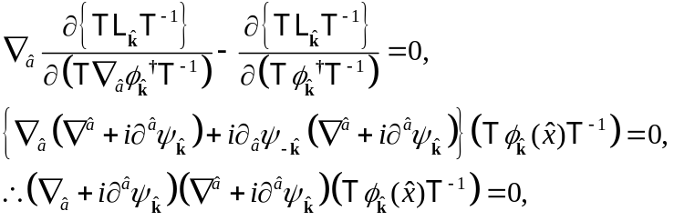 (S18)
where ψ (t̂, k̂/|k̂|) is denoted by ψ _{k̂} for simplicity.
Comparing the Euler-Lagrange equation of a mode k̂ field operator, as presented in Eq.(S10), with its counterpart derived from the time-reversed Euler-Lagrange equation,
(S19) , (S20)
it is found that, unless ∂^{â}(ψ_{k̂}+ψ-_{k̂}) is zero, the field operator of mode k̂, ϕ_{k̂}(x̂), and the time-reversed, Ф_{k̂}(x̂), follow different governing equations. In other words, the non-reciprocity in Wigner rotation angles (ʃdψ-_{k̂}dξ ≠ ʃ dψ_{k̂}dξ) can be seen as breaking time reversal symmetry for the fictitious observer moving along a photon trajectory.
In this framework, each observer’s frame is described as local flat spacetime and the effects of its variations from curvature of spacetime are considered as gauge fields. Lars Onsager and Hendrik Casimir demonstrated that a linear, time-invariant medium slightly perturbed from thermodynamic equilibrium, with microscopic governing equations obeying time-reversal symmetry, must be a reciprocal medium⁵⁴⁻⁵⁶. This theorem implies that macroscopic time-reversal symmetry breakdown does not always induce non-reciprocity such as viscous fluids where the physics is reciprocal and not time reversal symmetric, but the microscopic time-reversal symmetry breakdown is required for the linear and time-invariant system to be non-reciprocal. Given the non-reciprocity of WRA, it is consistent with Onsager’s theorem to time-reversal symmetry is broken down in local frames. The breakdown of local time reversal symmetry is demonstrated above by showing the transformed photon state under the time-reversed operator in Hilbert space defined at each event does not follow Lagrange equations with the untransformed gauge field. This is consistent with the case of quantum Hall effect where time reversal symmetry breaks down by treating a gauge field as an external field.

The effects of spin angular momentum of M87* on WRAs
As consistent with the report of gravity Probe B, the spinning angular momentum of the Earth does not affect WRA by to any measurable order, but that of M87* leads to a WRA differences on the order of a few degrees of differences as shown in Fig.S2.
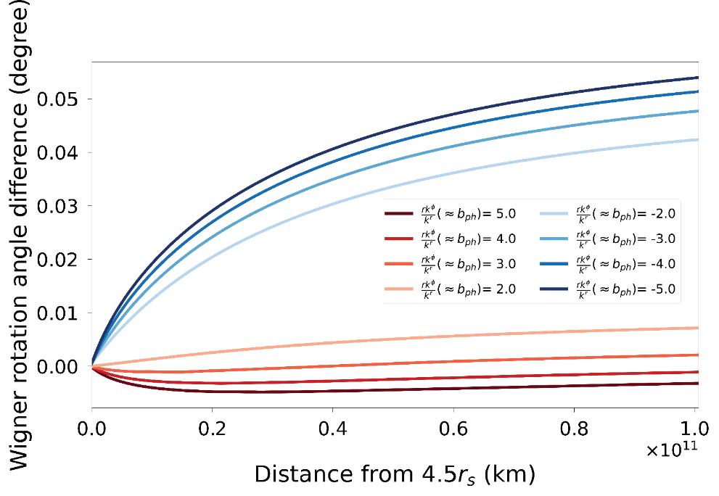
Fig. S2 Wigner rotation angle differences between the observers orbiting around the equatorial plane around BH with the mass of M87* and zero and 0.45r_{s} of spin parameter a. The large angular momentum of M87* leads to a few degrees of WRA differences for various impact factors of photons’ trajectories.

The WRAs of photon trajectories with positive and negative impact paramteres for observers in polar orbits
In Figure S3, we present the Wigner rotation angles and 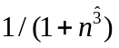for observers in polar orbits around Earth (Figs.S3A-C) and the supermassive black hole M87* (Figs.S3D-F). Notably, we observe a distinctive trend in these values for both cases. When considering negative impact parameters, exhibits values that are ten times larger compared to those associated with positive impact parameters. This significant difference in results in a consistent pattern in the Wigner rotation angles (WRAs).
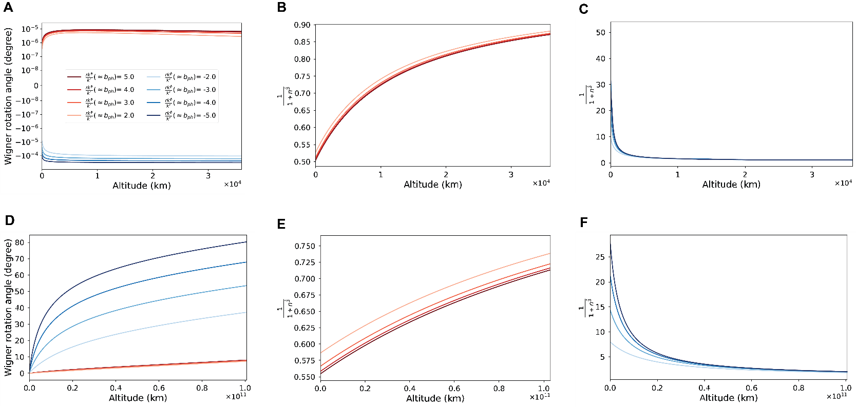
Fig. S3 Wigner rotation angles and for the observers in polar orbits around Earth (Figs.S3A-C) and M87* (Figs.S3D-F). For both cases, has ten times larger values for negative impact parameters that those for positive, resulting in a consistent pattern in WRAs.

WRAs under local-space inversion operator
It is worth noting that under local-space inversion operator P becomes
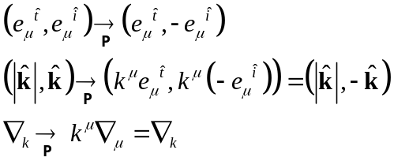, (S21)
These conditions are not obtained with flipping the signs of affine parameter ξ and the proper time τ and give the opposite results of sign-change of infinitesimal Lorentz transformation terms: the signs of local infinitesimal rotations, λ^{î}_{ĵ} = (∇_{k}e^{îμ})e_{μĵ}, are remain but those of local infinitesimal boosts, λ^{t̂}_{ĵ} = (∇_{k}e^{t̂μ})e_{μĵ} = (∇_{k} dx^{μ}/dτ)e_{μĵ} , are changed. The corresponding local-space inversed infinitesimal Wigner rotation angle has the opposite sign but the same values with the local-time reversal one. Considering the sign of helicity σ is preserved under the former only, the geometric phase 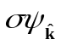 of a photon is PT symmetric, but the photon trajectory defined with momentum k in global coordinate is not.

Numerical Calculation Method used for Figure 4 in the main text.
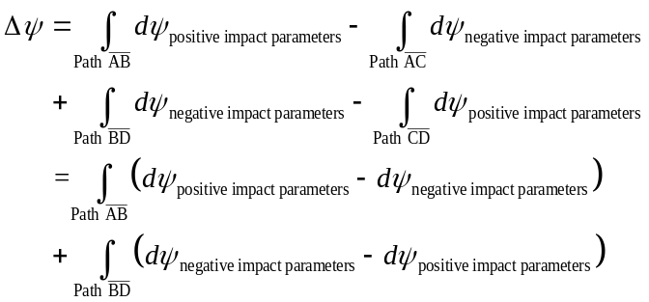 (S22)
Here, we utilize the understanding that the WRA near Earth depends directly on the radius 'r', rather than on other coordinates. Based on this, the integration for the path from Alice to Bob is the same as that for Alice to Charlie. Similarly, the integration for Bob to David matches that for Charlie to David. Then, utilizing the relation , Eq.(S22) can be reformulated as follow:

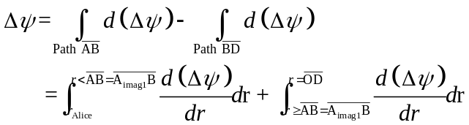. (S23)
Here, r_{Alice} represents the distance between the origin O and Alice. The distance from Alice to David (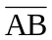) needs to be determined for the calculation of the relative WRA difference WRA (Δψ). To obtain the distance, first, we obtain the angle β between Alice and Bob by solving the following equations for obtaining,

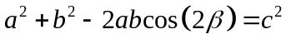 and 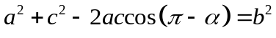, (S24)
where a, b, and α are given. Then, by substituting the β into the relation 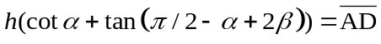 and then h into 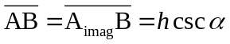, we obtain the distance between Alice and Bob for the integration given in Eq.S23. Here h is half the distance between Bob and Charlie as depicted in Fig.S4.
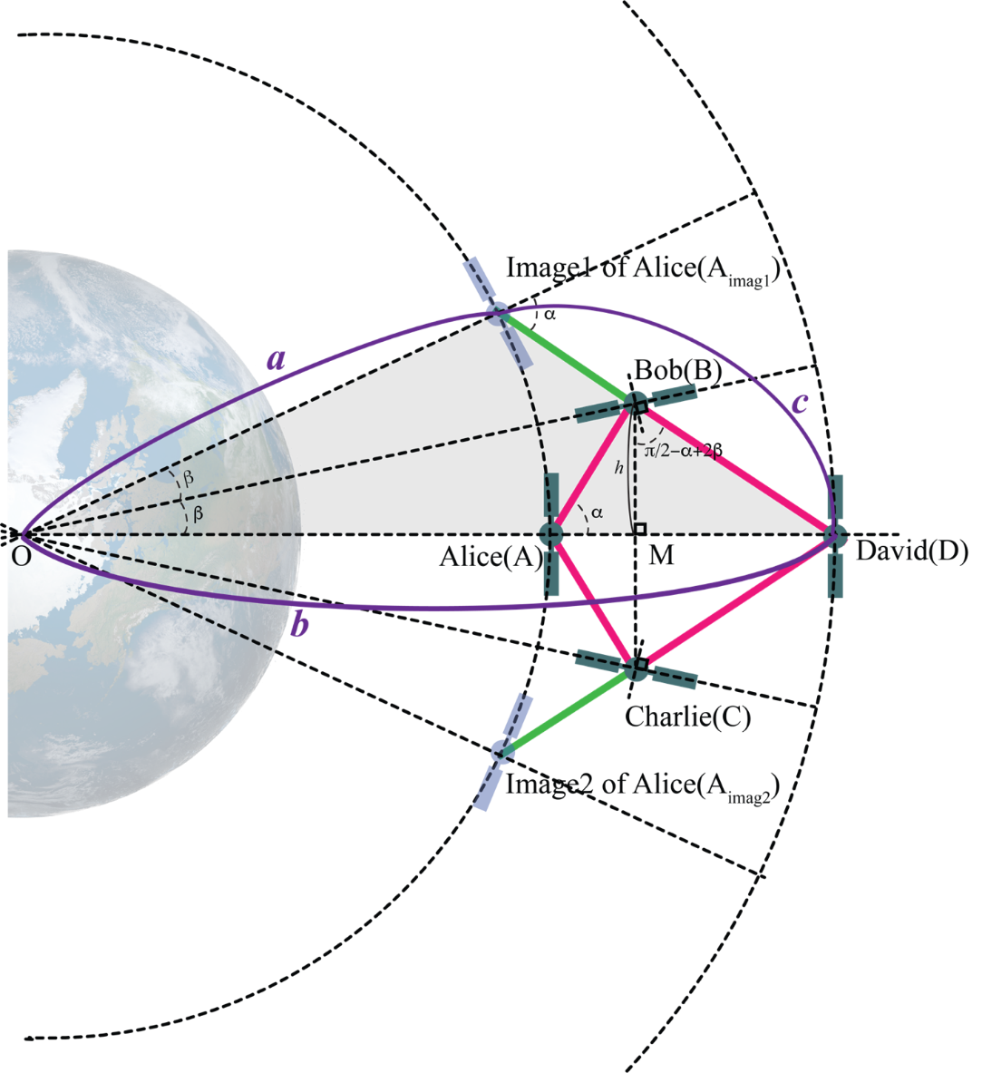
Fig. S4 Schematic representation of an astronomical interferometer showcasing various elements, including the lengths between the origin and observers (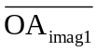 = a, 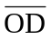 = b, 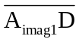 = c, and 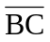/2=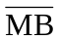 = h), along with the angles of outgoing light waves (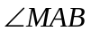=α) and between two observers Alice and Bob (∠AOB=β). The distance between Alice and Bob (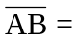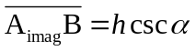) is specified by the relation, 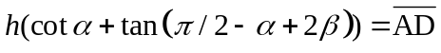, 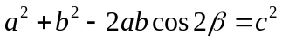, and 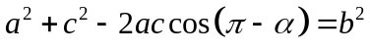, proved that tan(α) and 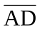 are given.

