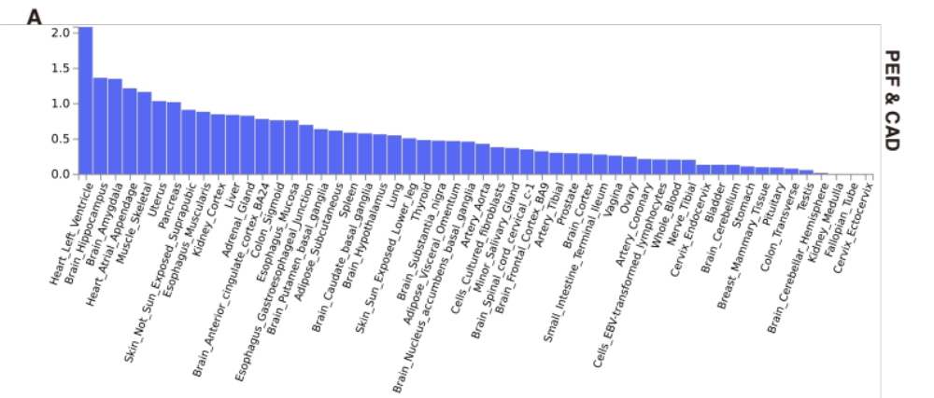
Figure S1. Tissue enrichment analysis of associations between PEF and CAD. The genes were annotated for the signiﬁcant variants identiﬁed from the Cross Phenotype Association analysis. PEF, peak expiratory flow; CAD: coronary artery disease.

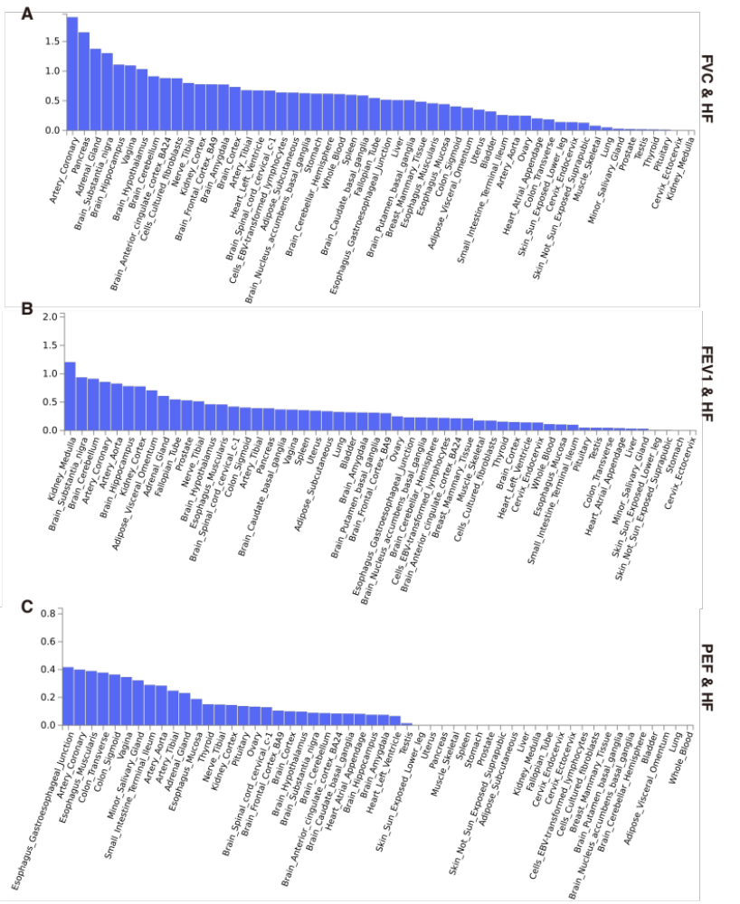
Figure S2. Tissue enrichment analysis of associations between lung function and HF. The genes were annotated for the signiﬁcant variants identiﬁed from the Cross Phenotype Association analysis between (A) FVC and HF, (B) FEV1 and HF, (C) PEF and HF. HF, heart failure; FVC, forced vital capacity; FEV1, forced expiratory volume in 1 second; PEF, peak expiratory flow.
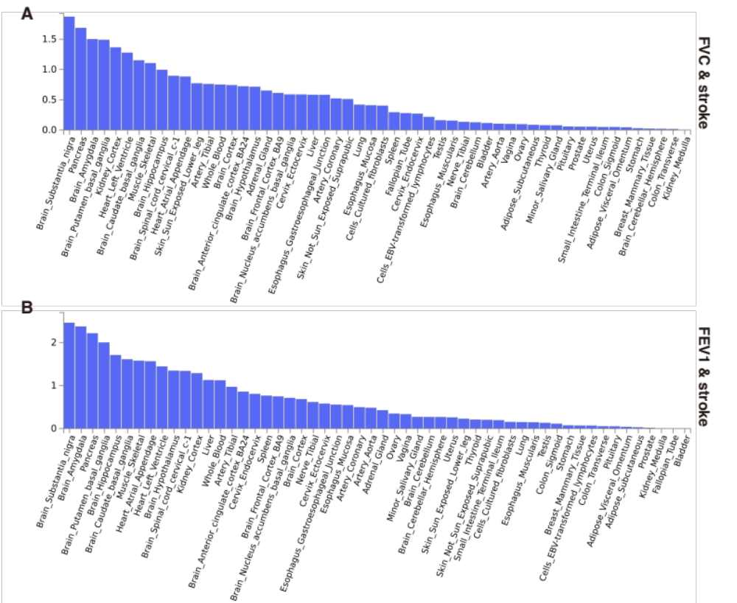
Figure S3. Tissue enrichment analysis of associations between lung function and stroke. The genes were annotated for the signiﬁcant variants identiﬁed from the Cross Phenotype Association analysis between (A) FVC and stroke, (B) FEV1 and stroke. FVC, forced vital capacity; FEV1, forced expiratory volume in 1 second.
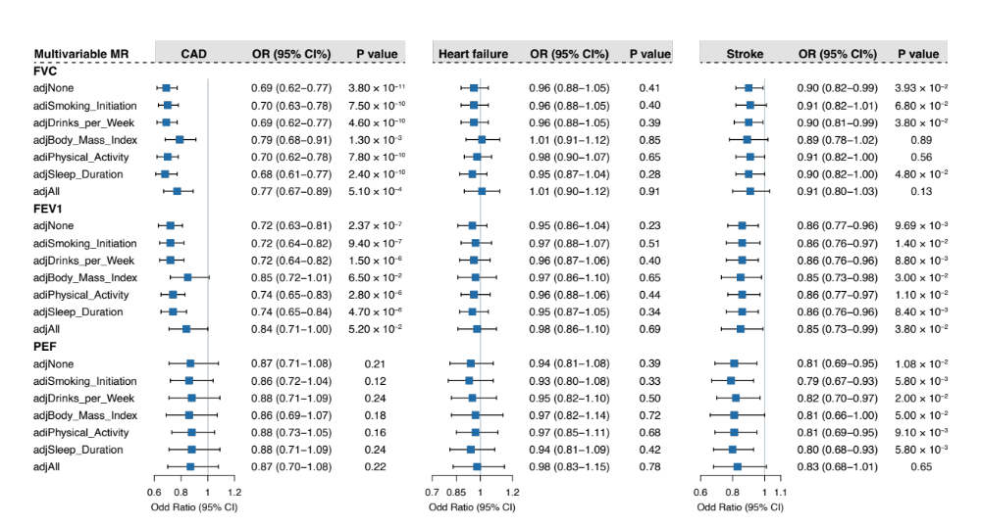
Figure S4. Multivariable Mendelian randomization of genetically predicted lung function on CVD. The estimated effect sizes were adjusted for each potential confounder separately and combined. The y-axis indicates the genetically predicted confounder for which adjustment was made. The boxes represent the point estimates of the causal effects of genetically predicted lung function on CVD, with error bars representing the 95% confidence intervals. “adjNone” refers to the point estimates of the causal effects of genetically predicted lung function on CVD using univariable Mendelian randomization. CAD, coronary artery disease; FVC, forced vital capacity; FEV1, forced expiratory volume in 1 second; PEF, peak expiratory flow.

