Online Resource 2
Survey and genetic diversity of wild Brassica oleracea L. germplasm on the northern coast of Spain
Genetic Resources and Crop Evolution

Lorenzo Maggioni*¹, Therese Bengtsson^{2,} Gert Bungaard Poulsen³ and Roland von Bothmer²
¹ ECPGR, c/o Bioversity International, Rome, Italy; ² Swedish University of Agricultural Sciences, Alnarp, Sweden; ³ Danish Seed Savers, Tjele, Denmark
* Corresponding author’s e-mail: l.maggioni@cgiar.org

Table S2. Number of genotypes and SNP markers after the filtering steps
Filtered subsets | Genotypes | SNP markers
1) all wild and cultivated B. Oleracea accessions | 571 | 2327 (1687)
2) all wild B. Oleracea accessions | 470 | 2307 (1661)
3) all landraces from Italy and Spain | 101 | 2674 (1914)
4) all wild-growing B. Oleracea accessions from France and Spain | 411 | 2310 (1669)
5) all accessions (excluding B. montana from San Marino and Savona and B. incana from Corfu) | 797 | 4941 (3372)
Numbers inside brackets= the number of markers used for STRUCTURE analysis (Pritchard et al. 2000)

Table S3. Pairwise Population Matrix of Nei Genetic Identity between taxa
B. cretica | B. drepanensis | B. incana | B. macrocarpa | B. montana | B. oleracea var. oleracea | B. rupestris | Leafy kales
 |  |  |  |  |  |  |  | B. cretica
  0.000
0.697 |  |  |  |  |  |  |  | B. drepanensis
  0.000
0.852 | 0.724 |  |  |  |  |  |  | B. incana
  0.000
0.717 | 0.747 | 0.774 |  |  |  |  |  | B. macrocarpa
  0.000
0.772 | 0.673 | 0.848 | 0.710 |  |  |  |  | B. montana
  0.000
0.871 | 0.726 | 0.971 | 0.778 | 0.863 |  |  |  | B. oleracea var. oleracea
  0.000
0.756 | 0.811 | 0.812 | 0.757 | 0.729 | 0.809 | 0.000 |  | B. rupestris
0.868 | 0.727 | 0.968 | 0.776 | 0.861 | 0.995 | 0.809 | 0.000 | Leafy kales

Table S4. Genetic diversity indexes for wild and cultivated B. oleracea accessions. NP/A = number of populations/accessions; NI=Number of individuals. Means with different superscripts are significantly different at p<0.01.
 |  |  |  | Mean genetic diversity Shannon Index |  |  | % polymorphic loci
Taxon |  | NP/A | NI | Mean | SE |  | % polymorphic loci
B. oleracea var. viridis (leafy kales) |  | 6 | 101 | 0.288ª | 0.005 |  | 83.84
B. oleracea var. oleracea |  | 25 | 470 | 0.326^{b} | 0.004 |  | 99.57
Total (Mean) |  | 31 | 571 | 0.307 | 0.003 |  | 91.71
Fst | 0.024

Table S5. Genetic diversity data for B. oleracea var. oleracea populations grouped by countries of origin. (NP/A= number of populations/accessions; NI = number of individuals analysed). Means with different superscripts are significantly different at p<0.01.
 |  |  |  |  | Mean Genetic Diversity Shannon Index |  |  | % Polymorphic loci
Country |  |  | NP/A | NI | Mean | SE |  | % Polymorphic loci
Denmark |  |  | 1 | 20 | 0.154ª | 0.005 |  | 35.37
UK |  |  | 1 | 20 | 0.193^{b} | 0.005 |  | 48.29
Germany |  |  | 1 | 19 | 0.275^{c} | 0.005 |  | 65.11
France |  |  | 5 | 98 | 0.313^{d} | 0.005 |  | 87.43
Spain |  |  | 17 | 313 | 0.324e | 0.005 |  | 98.27
Total (Mean) |  |  | 25 | 470 | 0.252 | 0.002 |  | 66.95
Fst | 0.127

Table S6: Pairwise Population Matrix of Nei Genetic Distance of B. oleracea var. oleracea populations grouped by country of origin.
Denmark | France | Germany | Spain | UK
0.000 |  |  |  |  | Denmark
0.057 | 0.000 |  |  |  | France
0.044 | 0.028 | 0.000 |  |  | Germany
0.060 | 0.015 | 0.032 | 0.000 |  | Spain
0.096 | 0.062 | 0.067 | 0.063 | 0.000 | UK

Table S7. Genetic diversity data of B. oleracea var. oleracea of French and Spanish sub-regions (NP/A= number of populations/accessions; NI = number of individuals analysed). Means with different superscripts are significantly different at p<0.01.
 |  |  |  | Mean Genetic Diversity Shannon Index |  | % Polymorphic loci
Group |  | NP/A | NI | Mean | SE | % Polymorphic loci
Somme |  | 1 | 20 | 0.209ª | 0.005 | 51.95
Charente Maritime |  | 1 | 19 | 0.215^{b} | 0.005 | 48.70
Manche |  | 1 | 19 | 0.248^{c} | 0.005 | 57.75
Cantabria |  | 4 | 78 | 0.293^{d} | 0.005 | 82.94
Seine-Maritime |  | 2 | 40 | 0.301e | 0.005 | 74.94
Basque Country |  | 5 | 80 | 0.305^{f} | 0.005 | 87.97
Asturias |  | 8 | 155 | 0.320^{g} | 0.005 | 91.90
Total (Mean) |  | 22 | 411 | 0.270 | 0.002 | 70.88
Fst | 0.124

Table S8. Pairwise population Fst values of B. oleracea var. oleracea from France and Spain, grouped by region.
Asturias | Basque Country | Cantabria | Charente-Maritime | Manche | Seine-Maritime | Somme
0.000 |  |  |  |  |  |  | Asturias
0.030 | 0.000 |  |  |  |  |  | Basque Country
0.021 | 0.030 |  |  |  |  |  | Cantabria
  0.000
0.065 | 0.071 | 0.074 |  |  |  |  | Charente-Maritime
  0.000
0.063 | 0.062 | 0.066 | 0.119 |  |  |  | Manche
  0.000
0.043 | 0.045 | 0.049 | 0.083 | 0.075 |  |  | Seine-Maritime
  0.000
0.069 | 0.072 | 0.076 | 0.124 | 0.116 | 0.066 | 0.000 | Somme

Table S9: Pairwise Population Matrix of Nei Genetic Distance of B. oleracea var. oleracea populations from France and Spain, grouped by region.
Asturias | Basque Country | Cantabria | Charente-Maritime | Manche | Seine-Maritime | Somme
0.000 |  |  |  |  |  |  | Asturias
0.020 | 0.000 |  |  |  |  |  | Basque Country
0.013 | 0.020 | 0.000 |  |  |  |  | Cantabria
0.047 | 0.051 | 0.051 | 0.000 |  |  |  | Charente-Maritime
0.045 | 0.043 | 0.046 | 0.075 | 0.000 |  |  | Manche
0.031 | 0.032 | 0.035 | 0.055 | 0.050 | 0.000 |  | Seine-Maritime
0.051 | 0.052 | 0.054 | 0.076 | 0.075 | 0.040 | 0.000 | Somme

Table S10. Genetic diversity data for cultivated accessions (NI = number of individuals analysed). Means with different superscripts are significantly different at p<0.01.
 |  | Mean Genetic Diversity Shannon Index |  |  | % polymorphic loci
Group | NI | Mean | SE |  | % polymorphic loci
Cultivated Spain | 44 | 0.244ª | 0.004 |  | 78.98
Cultivated Italy | 57 | 0.268^{b} | 0.005 |  | 84.37
Total Mean | 101 | 0.256 | 0.003

Table S11. Min-max range values of all the populations within each species/group for Shannon diversity.
 | I – Shannon | No. individuals
B. cretica | 0.043-0.056 | 37
B. incana | 0.049-0.106 | 108
B. drepanensis | 0.093 | 19
B. macrocarpa | 0.078 | 20
B. montana | 0.073 | 18
B. rupestris | 0.049-0.263 | 24
B. oleracea var. oleracea | 0.058-0.129 | 470
B. oleracea var. viridis (leafy kale) | 0.063-0.122 | 101

Table S12. Pairwise Population Nei Unbiased Genetic Distance of the closest populations to each of the analyzed populations. The high frequency of ‘De Baudo’s neighbour’ and ‘Laredo’ are highlighted in blue and red, respectively.
Population code | Closest populations based on Pairwise Population Nei Unbiased Genetic Distance
BcreCr_w | Debau_lr 0.257; Urgull_w 0.257
BcreLi_w | Debau_lr 0.195; Laredo_w 0.195
BdreEr_w | BrupTa_w 0.161; Torim_lr 0.343
BincCa_w | BincCp_w 0.041; BincSo_w 0.056
BincCp_w | BincSo_w 0.018; BincTi_w 0.026
BincIs_w | BincSo_w 0.035; BincCp_w 0.034
BincML_w | BincCp_w 0.072; BincSo_w 0.076
BincSo_w | BincCp_w 0.018; BincTi_w 0.033
BincTi_w | BincCp_w 0.026; BincSo_w 0.033
BmacFa_w | BrupTa_w 0.200; Urgull_w 0.269
BMoSta_w | Helgo_w 0.160; Granw_w 0.161
BrupPA_w | BrupTa_w 0.332; Debau_lr 0.342
BrupTa_w | Torim_lr 0.148; Debau_lr 0.152
Cpena_w | Laredo_w 0.014; Xago_w 0.014
Cuchia_w | Elped_w 0.013; Torim_w 0.014
Cudil_w | Elped_w 0.012; Torim_w 0.012
Debau_lr | Laredo_w 0.010; GetarW_w 0.014; Helgo_w 0.014
Elmus_w | Torr_w 0.014; Urgull_w 0.021; Debau_lr 0.021
Elped_w | Cudil_w 0.012; Cuchia_w 0.013;  Laredo_w 0.013; Torim_w 0.013  Torr_w 0.013
garCal_lr | Debau_lr 0.016; Laredo_w 0.022
Gazte_w | Laredo_w 0.011; GetarW_w 0.015
Getar_w | GetarW_w 0.009; Laredo_w 0.009
GetarW_w | Getar_w 0.009; Laredo_w 0.009
Granw_w | Laredo_w 0.013; Helgo_w 0.014
Helgo_w | Laredo_w 0.011; 0.014; Debau_lr; Getar_w 0.014 Granw_w 0.014;  Pendu_w 0.014; Rødvig_w 0.014; Trepo_w 0.014
Laredo_w | Getar_w 0.009; GetarW_w 0.009
Latas_lr | Debau_lr 0.018; Laredo_w 0.018
MLbain_w | Trepo_w 0.011; Laredo_w 0.014
Mortag_w | Laredo_w 0.014; Helgo_w 0.016
Ondar_w | Laredo_w 0.018; Getar_w 0.021; GetarW_w 0.021
Oyam_w | Laredo_w 0.015; Getar_w 0.017; Torim_lr 0.017
Pendu_w | Laredo_w 0.011; GetarW_w 0.013
Petdal_w | Laredo_w 0.014; Helgo_w 0.015
Rødvig_w | Helgo_w 0.014; Laredo_w 0.020;
Taz_EP_lr | Laredo_w 0.012; Taz_w 0.013
Taz_LM_lr | Laredo_w 0.019; Debau_lr 0.021; GetarW_w 0.021; Taz_EP_lr 0.021; Taz_w 0.021; Torim_lr 0.021
Taz_w | Taz_EP_lr 0.013; Laredo_w 0.014
Tenby_w | Helgo_w 0.020; Laredo_w 0.020
Torim_lr | Laredo_w 0.012; Taz_EP_lr 0.014
Torim_w | Cudil_w 0.012; Elped_w 0.013
Torr_w | Laredo_w 0.011; Cudil_w 0.013; Elped_w 0.013
Trepo_w | MLbain_w 0.011; Laredo_w 0.012
Urgull_w | Laredo_w 0.010; Getar_w 0.014; GetarW_w 0.014
Xago_w | Cpena_w 0.014; Laredo_w 0.016

Table S14: Pairwise Population Matrix of Nei Unbiased Genetic Distance between eight B. oleracea var. oleracea populations from Asturias and Cantabria (‘AsCan’ type) and their most distant B. oleracea populations. The largest distances of each row are indicated in red.
 | Tenby | Rødvig | Second garden | Tazones Les Mestes
Cudillero | 0.028 | 0.028 | 0.028 | 0.026
Xago | 0.030 | 0.031 | 0.034 | 0.031
Cabo Peñas | 0.029 | 0.029 | 0.030 | 0.030
El Musel | 0.032 | 0.033 | 0.030 | 0.030
Torres | 0.025 | 0.025 | 0.026 | 0.023
Torimbia | 0.034 | 0.032 | 0.034 | 0.031
El Pedrero | 0.029 | 0.026 | 0.029 | 0.026
Cuchia | 0.032 | 0.034 | 0.035 | 0.035

Figure S1. NJ Tree of all the 47 accessions analyzed in this study
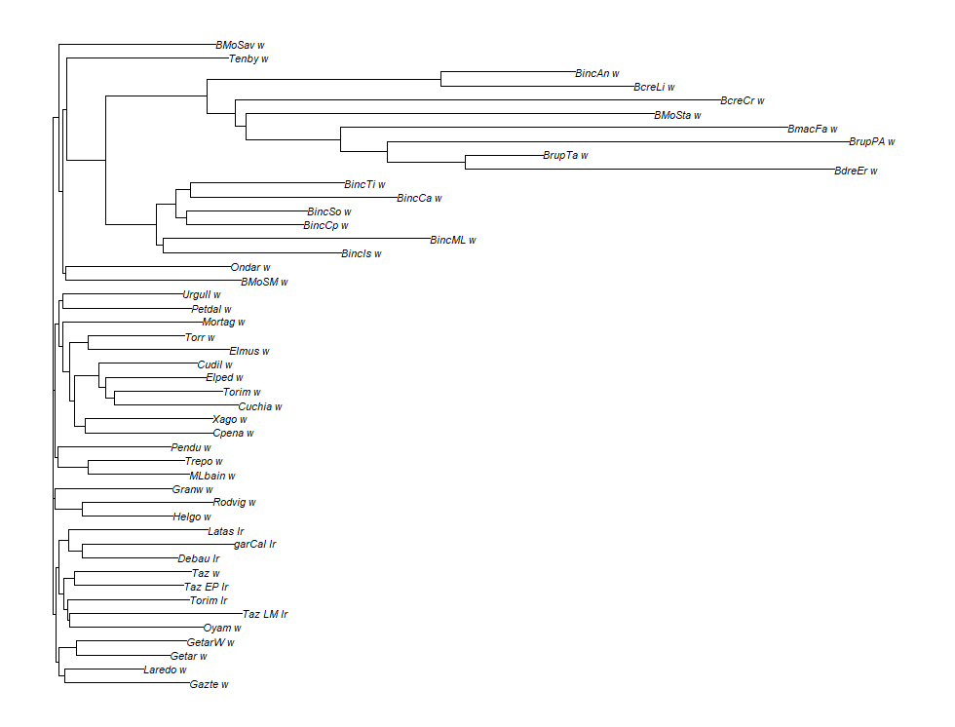

Figure S2. PCoA of the Italian (57 individuals) and Spanish (44 individuals) landraces. Symbols represent single individuals. Cumulated percentage of variation explained by the first two axes = 17.42%

Figure S3. A) PCoA of B. oleracea (571 individuals), and B. incana (108 individuals). Symbols represent single individuals. Cumulated percentage of variation explained by the first two axes = 12.2%. B) STRUCTURE bar plot of B. oleracea (571 individuals), and B. incana (108 individuals) for K=2.
.
A

B

