Supplementary figures
Figure S1
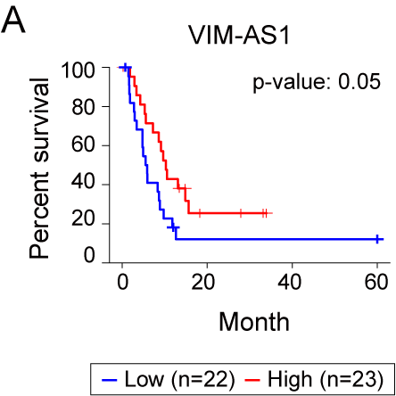
Supplementary Figure S1. Reduced expression of VIM-AS1 is related to poor prognosis in HCC. A Kaplan–Meier survival curves representing the impact of VIM-AS1 expression levels on disease-free survival in patients with HCC. These data were analyzed using Q-omics. P-value = 0.05.

Figure S2
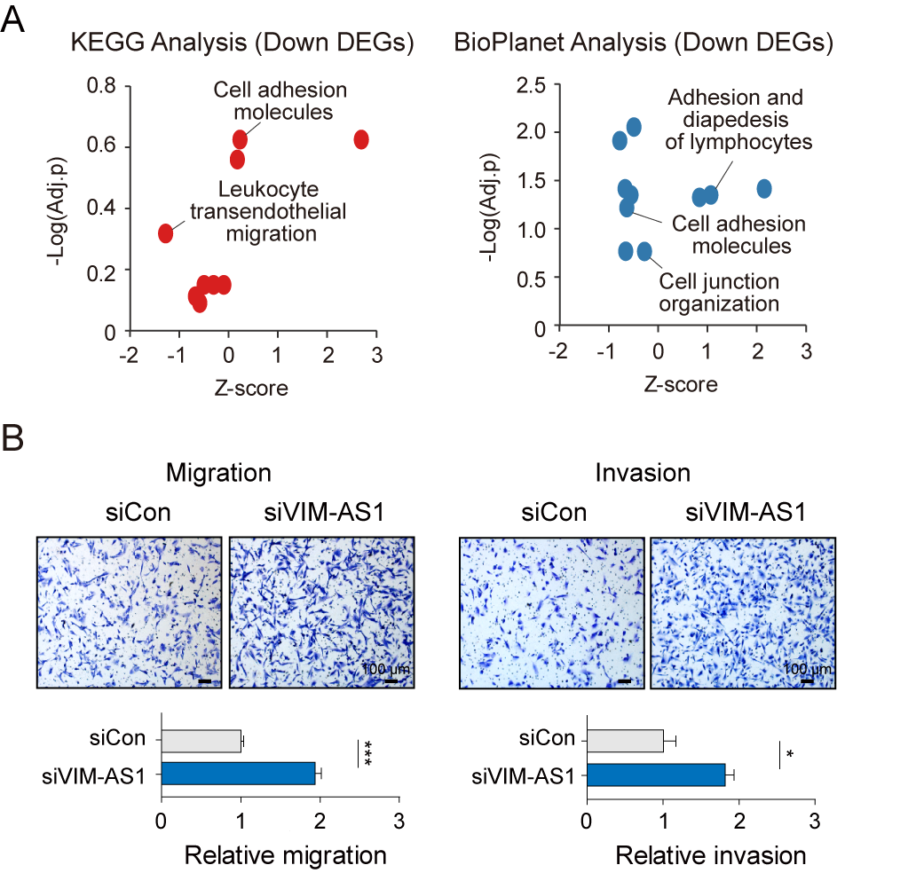
Supplementary Figure S2. VIM-AS1 regulates genes associated with cell adhesion. A Dot plot representing the result of ontology analysis for DEGs downregulated by the enriched VIM-AS1. B Transwell migration and invasion assays following VIM-AS1 knockdown (siVIM-AS1) compared those in the control (siCon). *p < 0.05, ***p < 0.001.

Figure S3
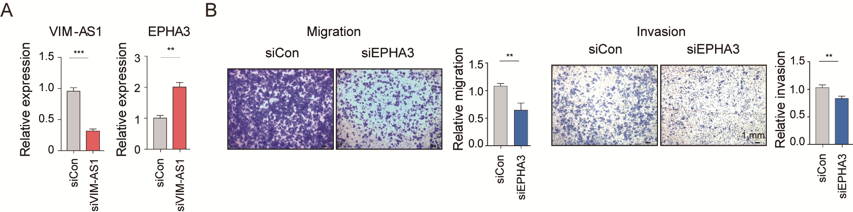
Supplementary Figure S3. EPHA3, regulated by VIM-AS1, increases migration and invasion of HCC cells A Relative expression levels of VIM-AS1 and EPHA3 in THLE2 cells after VIM-AS1 knockdown (siVIM-AS1 B Representative images and quantitative analysis of the migration and invasion assays in HUH7 cells after EPHA3 knockdown (siEPHA3). siCon = siControl, **p < 0.01, ***p < 0.001.

Figure S4
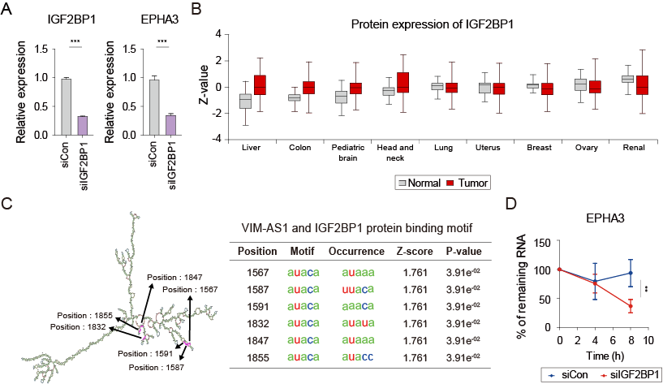
Supplementary Figure S4. IGF2BP1 potentially binds to VIM-AS1, regulating EPHA3 mRNA stability. A Relative mRNA expression levels in HUH7 cells after knockdown of IGF2BP1. B Boxplot showing the differential protein levels of IGF2BP1 in various cancers using UALCAN. C Structure of VIM-AS1 with IGF2BP1 binding site predicted using ViennaRNA Web Services. Pink highlight and black arrow: IGF2BP1 binding region predicted using RBP map in VIM-AS1. D Stability curve of EPHA3 mRNA after actinomycin D treatment in HUH7 cells. **p < 0.01, ***p < 0.001.

Figure S5
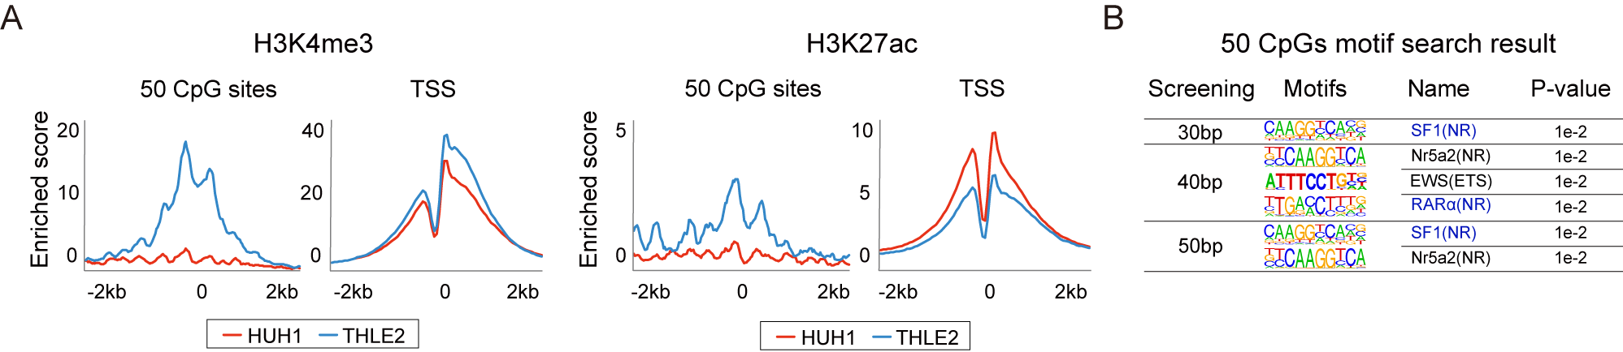
Supplementary Figure S5. Altered histone modifications in methylated CG sites and the potential transcription factors bind to these regions A Density plot showing the enrichment of ChIP-seq peaks of H3K4me3 and H3K27ac near the 50 CpG sites and near all TSSs in HUH1 and THLE2. B Predicted transcription factors that may bind to 50 CpG sites found using motif search analysis.

