Supplementary Information for

High-density asymmetric iron dual-atom sites for efficient and ultra-stable electrochemical water oxidation
Zhang etal.

Methods
Chemicals. Melamine (> 99%, Aladdin), 2-benzimidazolethiol (> 99%, Aladdin), trimesic acid (> 98%, Aladdin), iron (III) chloride (> 99%, Sigma-Aldrich), dicyandiamide (> 99%, Sigma-Aldrich), potassium hydroxide (95%, Aladdin), commercial Pt/C (20 wt% metal, Aladdin ltd), ruthenium (IV) oxide (99.9 %, Aladdin), nafion117 solution (~5% in a mixture of lower aliphatic alcohols and water, Aladdin), carbon cloth (CC, type: WOS1009, thickness: 0.33 mm), ethanol (> 99.5 %, Aladdin). All chemical reagents were utilized as received. The distilled water with a resistivity of 18.2 MΩ cm⁻¹ was used in all experiments.
Preparation of SNC and NC. In a typical synthesis of S, N co-doped carbon nanosheets, the mixture of melamine and 2-benzimidazolethiol with certain mass ratios (7:1) were firstly ground into a homogenous precursor and then subjected to thermal polymerization and carbonization in the flowing N₂ atmosphere, which was performed in a horizontally tubular quartz tube with the heating rate of 2 ºC min⁻¹ to 1000 ºC maintaining for 2 h. The final synthesized sample products were designed as SNC. The NC support was obtained from the same process as SNC, except that the S source (2-benzimidazolethiol) was not added.
Preparation of Fe₂N₆/NC, and Fe₁N₄/NC. To prepare the Fe₂N₆/NC, the obtained NC nanosheet support was ultrasound dispersion in 10 mL of ethanol, then 40 mg iron (III) chloride, 1.0 g dicyandiamide, and 0.1 g trimesic acid were added into the above suspension and stirred vigorously for 30 minutes. The suspension was then evaporated to dry the solvent in a rotary evaporator to obtain a grey powder. The grey powder was annealed at different temperatures 900 1000 ºC with a heating rate of 2 ºC min⁻¹ and maintained for 2 h under the N₂ atmosphere. After naturally cooling to room temperature, the black Fe₂-NC nanosheets were obtained. To obtain Fe₁N₄/NC, directly add 40 mg of iron (III) chloride, 1.0 g dicyandiamide and 0.1 g trimesic acid to 15 mL of ethanol and vigorously stir for 30 minutes. The suspension was then evaporated to dry the solvent in a rotary evaporator to obtain a grey powder. The grey powder was annealed at 900 ºC with a heating rate of 2 ºC min⁻¹ and maintained for 2 h under the N₂ atmosphere. After naturally cooling to room temperature, the black Fe₁N₄/NC was obtained.
Characterizations. X-ray diffraction (XRD, D8 Bruker AXS, scan range of 10-80°) test was performed to identify the crystallinity and phase of samples. Raman (Lab RAM HR Evolution spectrometer, excitation line of 532 nm) was analyzed to record the stretching and bond vibration modes. X-ray photoelectron spectroscopy (XPS, Escalab 250Xi, Mg Kα line excitation source) was carried out to explore the elemental compositions. Scanning electron microscopy (SEM, Ultra 55Zeiss) information was acquired to observe the morphology. Transmission electron microscopy (TEM, FEI Talos F200S, acceleration voltage 200 kV) results were performed to confirm structure and morphology. HAADF-STEM was obtained from aberration-corrected TEM (Hitachi HF5000) and JEOL Triple-C TEM. The N₂ adsorption and desorption isotherm (collected from Quantachrone Autosorb iQ-MP-C) was obtained to derive the surface areas and the pore size distribution of the catalysts. ICP-OES (Thermo Fisher Scientific, IRIS Intrepid II XSP spectrometer) was used to determine the contents of Fe species in the samples.
Ex-situ XAFS measurements. The X-ray absorption fine structure spectra data were collected at BL14W1 station in Shanghai Synchrotron Radiation Facility (SSRF, operated at 3.5 GeV with a maximum current of 250 mA), respectively. The data were collected at room temperature (Fe K-edge in fluorescence excitation mode using a Lytle detector). All samples were pelletized as disks of 13 mm diameter with 1mm thickness using graphite powder as a binder.
In-situ synchrotron radiation XAFS measurements. A catalyst-modified carbon paper was used as the working electrode, graphite rod as the counter electrode and Ag/AgCl (KCl-saturated) electrode as the reference electrode. A home-made electrochemical cell was used for in-situ XAFS measurements. The experiments were performed at the BL14W1 station in SSRF.
Electrochemical measurements for ORR. The Oxygen reduction reaction measurements were performed in a three-electrode cell using an electrochemical workstation (CHI 760E) setup with a rotating disk electrode (RRDE-3A). A glassy carbon (GC: 4 mm inner diameter), platinum wire, and saturated calomel electrode (SCE) were used as the working, counter, and reference electrodes, respectively. The catalyst suspension was prepared by dispersing 2 mg catalyst into 250 μL ethanol/Nafion (5 wt%) mixed solution, followed by ultrasonication for 30 min to form a homogenous ink. Afterward, 10 μL ink was dropped onto the freshly polished GC electrode and naturally dried in air for all the catalysts. Before the ORR test, the electrolyte was purged with O₂ to form the O₂ saturated 0.1 M KOH solution. Cyclic voltammograms (CVs) were recorded at 50 mV s⁻¹ in O₂ saturated 0.1 M KOH. Linear sweep voltammetry (LSV) polarization curves for ORR were obtained at a rotating rate of 1,600 rpm, without iR compensation at 5 mV s⁻¹. Durability tests were performed by cycling between 0.6-1.0 V versus RHE for 30,000 cycles at room temperature.
Zinc-air battery measurements. The A-Fe₂S₁N₅/SNC ink was uniformly dispersed onto teflon-coated carbon fiber paper with the loading of 1.0 mg cm⁻², then dried at 60 °C. For comparison, Pt/C electrode with the same catalyst loading was also prepared. The polished commercial Zn foil with a thickness of 0.2 mm was used as anode. Both electrodes were constructed into a home-made Zn–air device in 6 M KOH and 0.2 M zinc acetate electrolyte saturated with O₂.

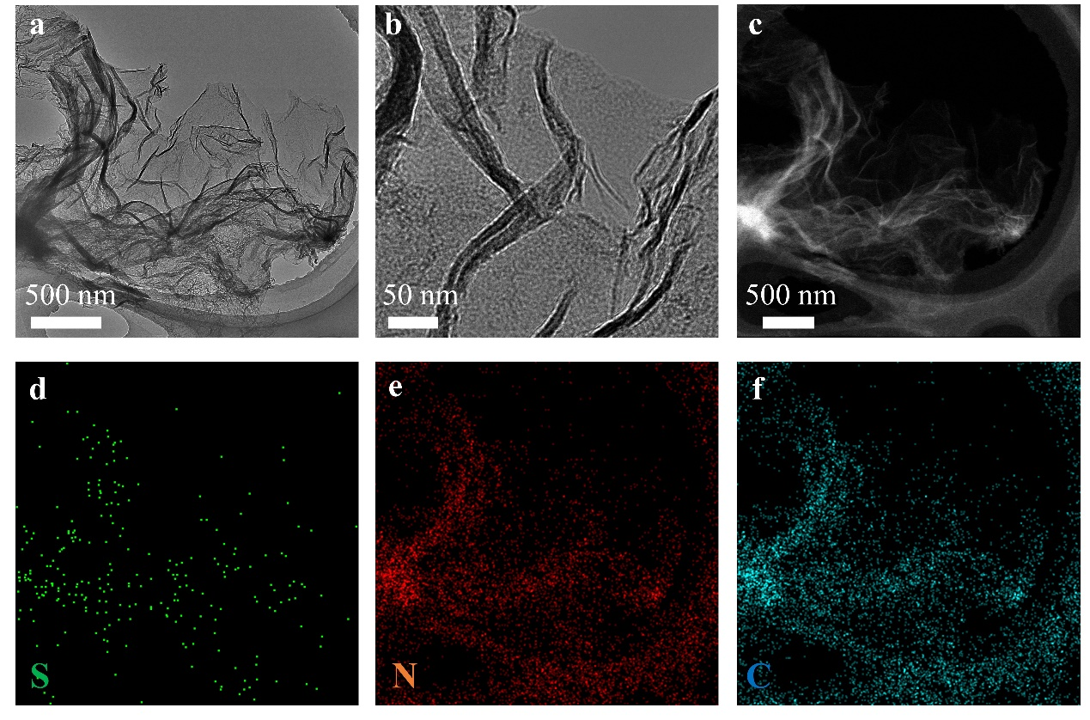
Supplementary Fig. 1. TEM images of SNC at (a) 500 nm and (b) 50 nm scale bar showing the two-dimensional folded sheet-like structure. (c-f) Corresponding EDS mapping images of SNC. Highly wrinkled SNC nanosheets with numerous tortuous edges can be observed in the transmission electron microscope (TEM) image, which provides a considerable number of active sites for trapping and anchoring metal atoms.
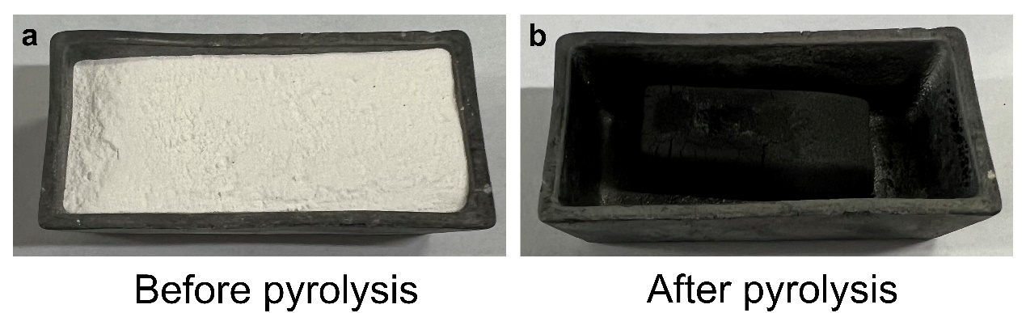
Supplementary Fig. 2. Controllable expansion preparation of SNC nanosheets. (a) Before and (b) after pyrolysis.

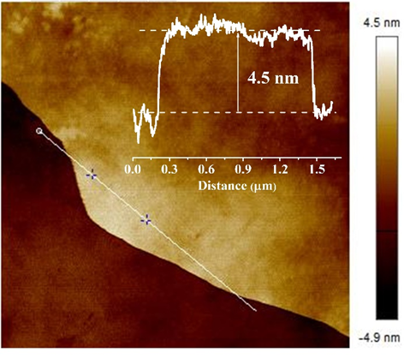
Supplementary Fig. 3. AFM image and corresponding height profile of A-Fe₂S₁N₅/SNC.

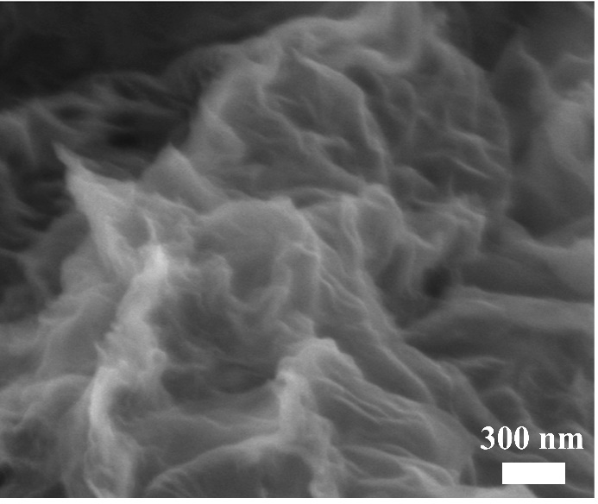
Supplementary Fig. 4. High magnification SEM image of A-Fe₂S₁N₅/SNC.

Supplementary Fig. 5. (a-f) EELS mapping of Fe, S, N, and C for A-Fe₂S₁N₅/SNC.

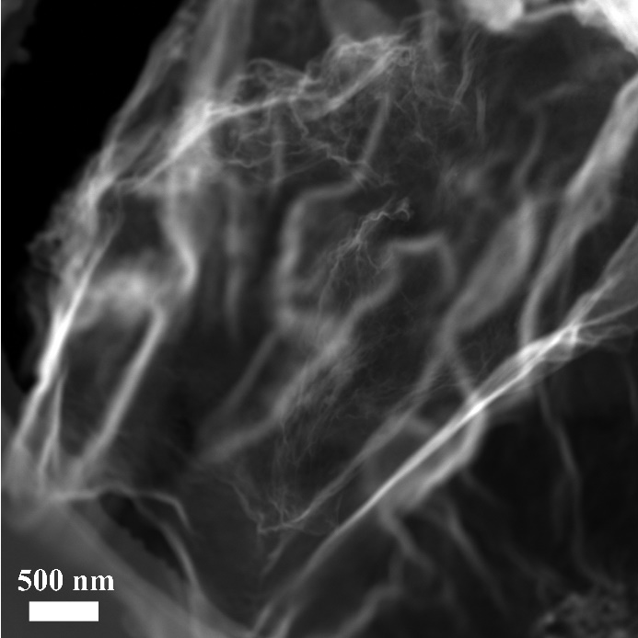
Supplementary Fig. 6. HAADF-STEM images of A-Fe₂S₁N₅/SNC.

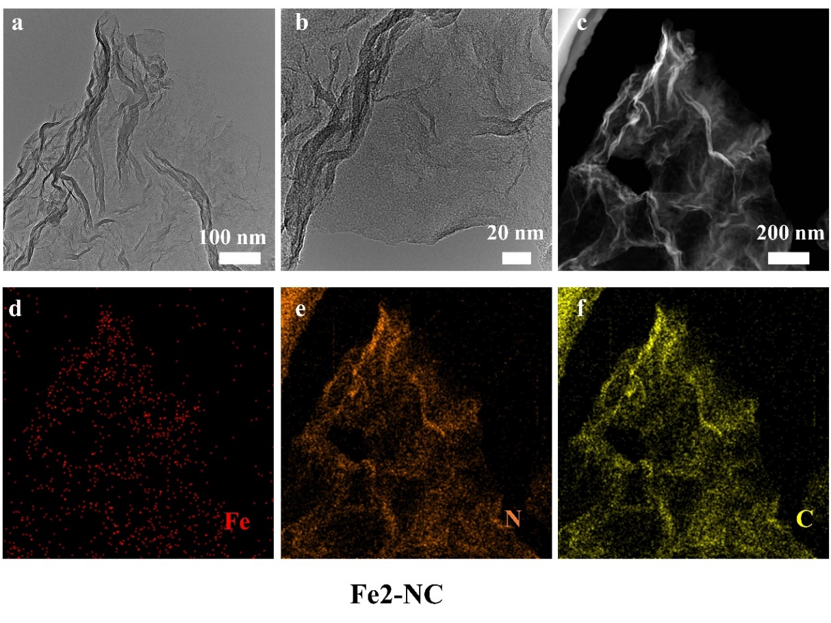
Supplementary Fig. 7. TEM images of Fe₂N₆/NC at (a) 100 nm and (b) 20 nm scale bar showing the two-dimensional wrinkle sheet-like structure. (c-f) Corresponding EDS mapping images of Fe₂N₆/NC showing the Fe, N, and C elements are uniformly distributed throughout the entire Fe₂N₆/NC.

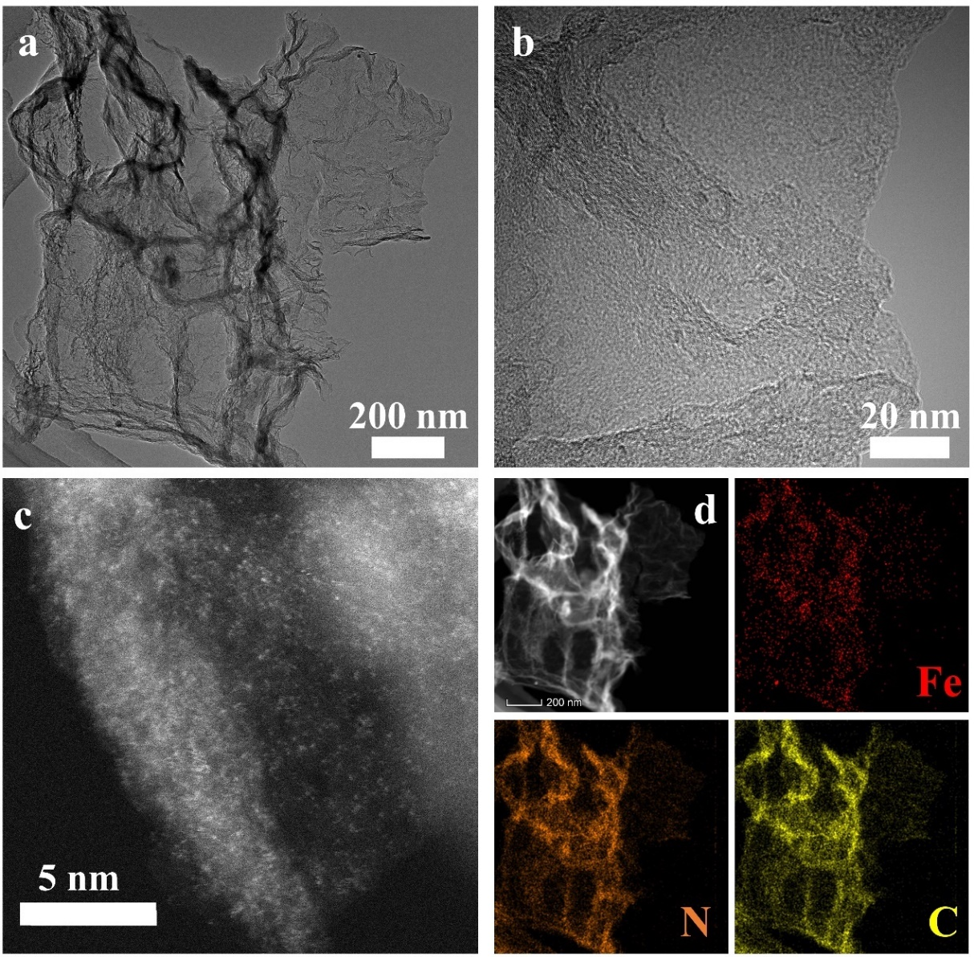
Supplementary Fig. 8. TEM images of Fe₁N₄/NC at (a) 200 nm and (b) 20 nm scale bar showing the two-dimensional sheet-like structure. (c, d) Corresponding EDS mapping images of Fe₁N₄/NC.

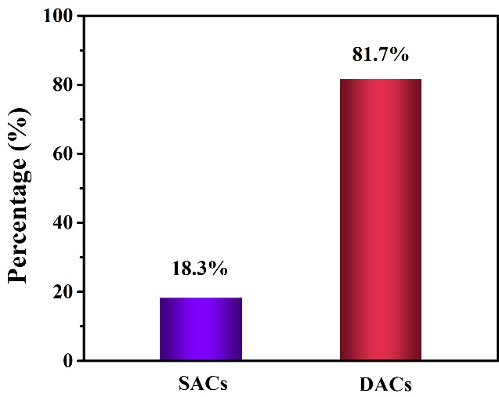
Supplementary Fig. 9. The diagram for the percentages of single metal atom catalysts and dual-metal atom catalysts. According to the statistical data, the proportion of diatoms Fe reaches ~81.7 %, and the proportion of single atoms Fe is ~18.3%.

Supplementary Fig. 10. (a) Aberration-corrected HAADF-STEM of the Fe₂N₆/NC. (b) corresponding intensity profile in Region A of (a). The diatomic Fe pair circled with the red dashed line. (c) Distance between two adjacent Fe atoms in Region A and Region B.

Supplementary Fig. 11. XRD patterns of A-Fe₂S₁N₅/SNC, Fe₁N₄/NC, Fe₂N₆/NC, and SNC. The broad peaks at 20-30°and 40-50°are assigned to the (002) and (101) plane of graphite, respectively.

Supplementary Fig. 12. Raman patterns of A-Fe₂S₁N₅/SNC, Fe₁N₄/NC, Fe₂N₆/NC, and SNC. The results showed that I_{D}/I_{G} was slightly elevated for the A-Fe₂S₁N₅/SNC compared with the Fe₁N₄/NC and Fe₂N₆/NC, indicating a much higher percentage of carbon atoms at the defects/edges of the A-Fe₂S₁N₅/SNC thin sheet, which were regarded as potential active sites for catalysis.

Supplementary Fig. 13. Characterization of Fe oxidation state from XANES. (a-b) The Fe K-edge XANES spectra of the references (Fe foil, Fe₃O₄, FePc, FeS₂, Fe₁N₄/NC, and Fe₂N₆/NC).

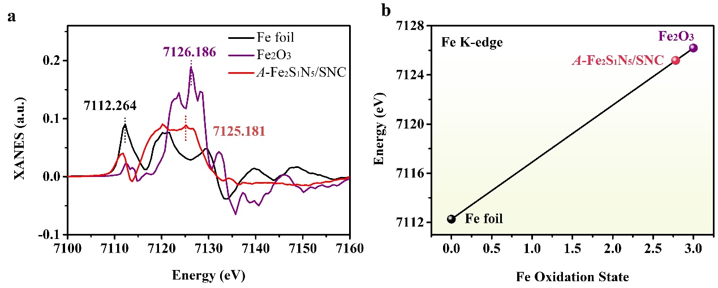
Supplementary Fig. 14. (a) First-derivative XANES curves of Fe foil, Fe₃O₄, and A-Fe₂S₁N₅/SNC. (b) Correlation between the Fe oxidation state and the energy position of the XANES spectrum, determined as the first maximum of the first derivative spectrum of A-Fe₂S₁N₅/SNC and different Fe reference compounds.

Supplementary Fig. 15. FT-EXAFS fitting curves of A-Fe₂S₁N₅/SNC, Fe₂N₆/NC, and Fe₁N₄/NC.

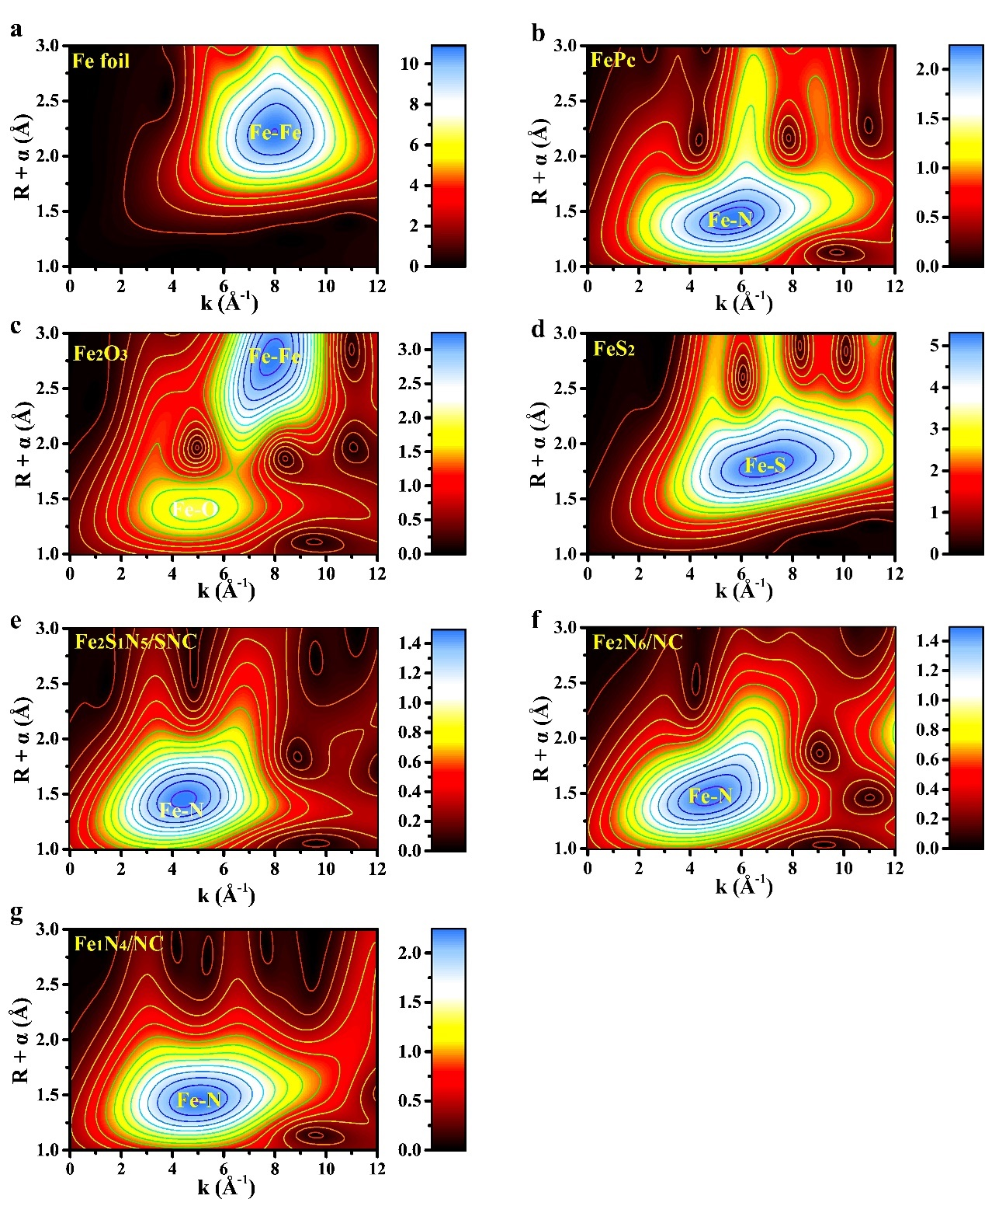
Supplementary Fig. 16. WT-EXAFS plots of (a) Fe foil, (b) FePc, (c) Fe₂O₃, (d) FeS₂, (e) A-Fe₂S₁N₅/SNC, (f) Fe₂N₆/NC, and (g) Fe₁N₄/NC.

Supplementary Fig. 17. EXAFS fitting curves of Fe foil (a) the FT-EXAFS fitting curve of Fe foil at Fe K-edge, (b) k space fitting curve and (c) q space fitting curve.

Supplementary Fig. 18. EXAFS fitting of A-Fe₂S₁N₅/SNC. (a) the EXAFS fitting curve of A-Fe₂S₁N₅/SNC at Fe K-edge. We carried out EXAFS curve-fitting for the first coordination shell of Fe by considering two backscattering paths, including Fe-N and Fe-S. (b) q space fitting curve at Fe K-edge of A-Fe₂S₁N₅/SNC. The best-fit structural parameters are listed in Supplementary Table 2.

Supplementary Fig. 19. Atomic coordination environment of Fe₁N₄/NC. (a) FT k³-weighted EXAFS spectra of Fe₁N₄/NC and the reference samples. (b) FT-EXAFS fitting curves of Fe₁N₄/NC and the corresponding Fe K-edge EXAFS fitting curves. (c) q space fitting curve at Fe K-edge. (d) Atomic interface structure model of Fe₁N₄/NC. The best-fit structural parameters are listed in Supplementary Table 2. The gray, blue, and orange spheres represent the C, N, and Fe elements, respectively.

Supplementary Fig. 20. Atomic coordination environment of Fe₂N₆/NC. (a) FT k³-weighted EXAFS spectra of Fe₂N₆/NC and the reference samples. (b) FT-EXAFS fitting curves of Fe₂N₆/NC and the corresponding Fe K-edge EXAFS fitting curves. (c) q space fitting curve at Fe K-edge. (d) Atomic interface structure model of Fe₂N₆/NC. The best-fit structural parameters are listed in Supplementary Table 2. The gray, blue, and orange spheres represent the C, N, and Fe elements, respectively.

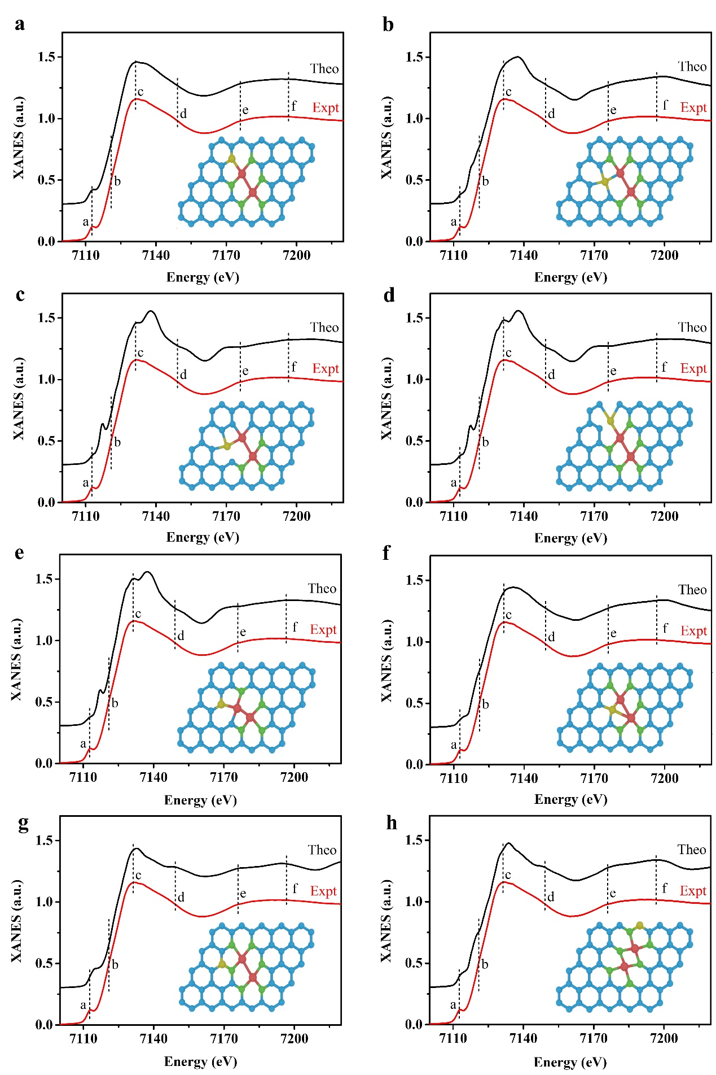Supplementary Fig. 21. Comparison between the experimental Fe K-edge XANES spectrum of A-Fe₂S₁N₅/SNC and the theoretical spectra calculated with the depicted structures based different Fe-S or C-S positions.

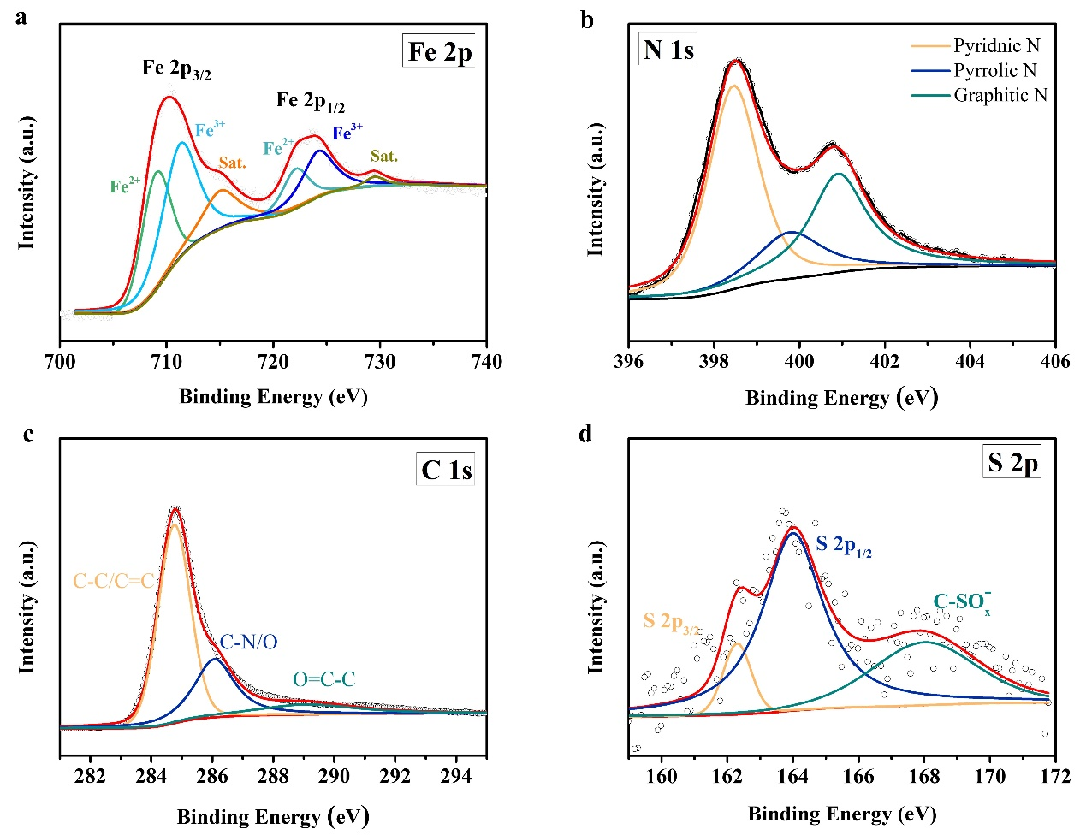
Supplementary Fig. 22. (a) The Fe 2p, (b) N 1s, (c) C 1s, and (d) S 2p XPS spectrum of A-Fe₂S₁N₅/SNC. It was obvious from the Fe 2p spectra that the two peaks at the binding energies of 709.3 eV and 722.3 eV were generally attributed to the Fe (II) species in A-Fe₂S₁N₅/SNC, and the other two peaks at 712.4 eV and 724.4 eV were the characteristic peaks of Fe (III). The Fe³⁺/Fe²⁺ ratio was 1.51 for A-Fe₂S₁N₅/SNC. The coexistence of Fe (Ⅱ) and Fe (Ⅲ) species, suggested partial charge transfer from SNC to Fe³⁺ centers.

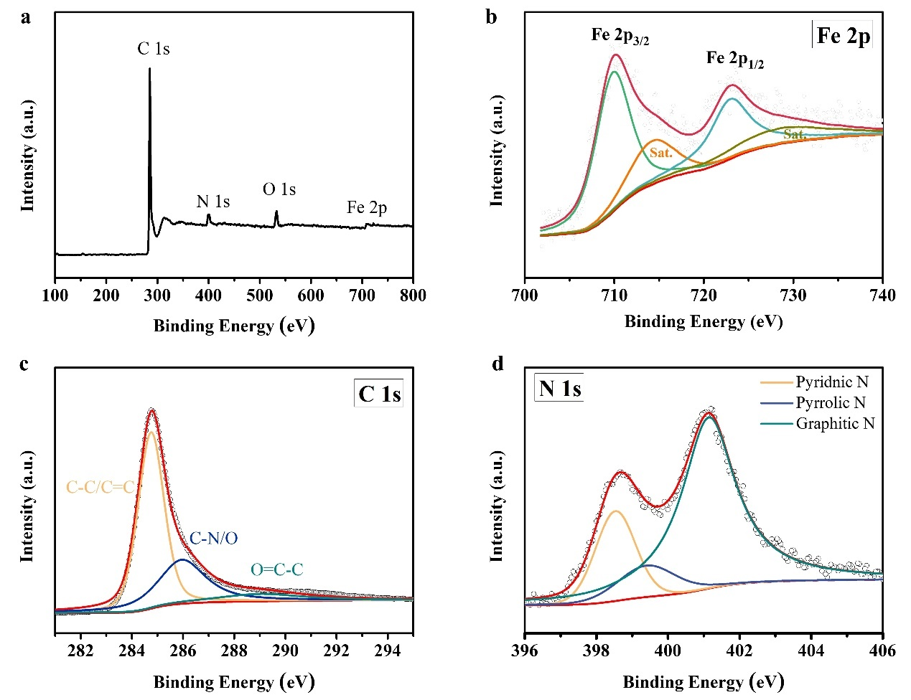
Supplementary Fig. 23. XPS spectrum of Fe₂N₆/NC (a) survey spectrum, (b) The Fe 2p, (c) N 1s, and (d) C 1s.

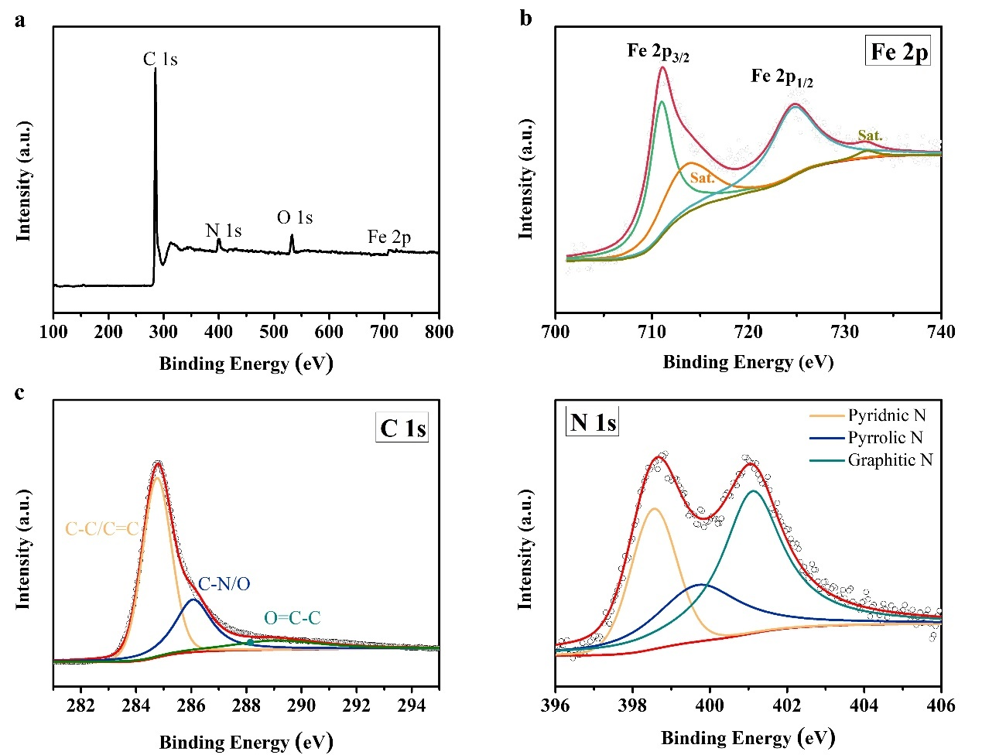
Supplementary Fig. 24. XPS spectrum of Fe₁N₄/NC (a) survey spectrum, (b) The Fe 2p, (c) N 1s, and (d) C 1s.

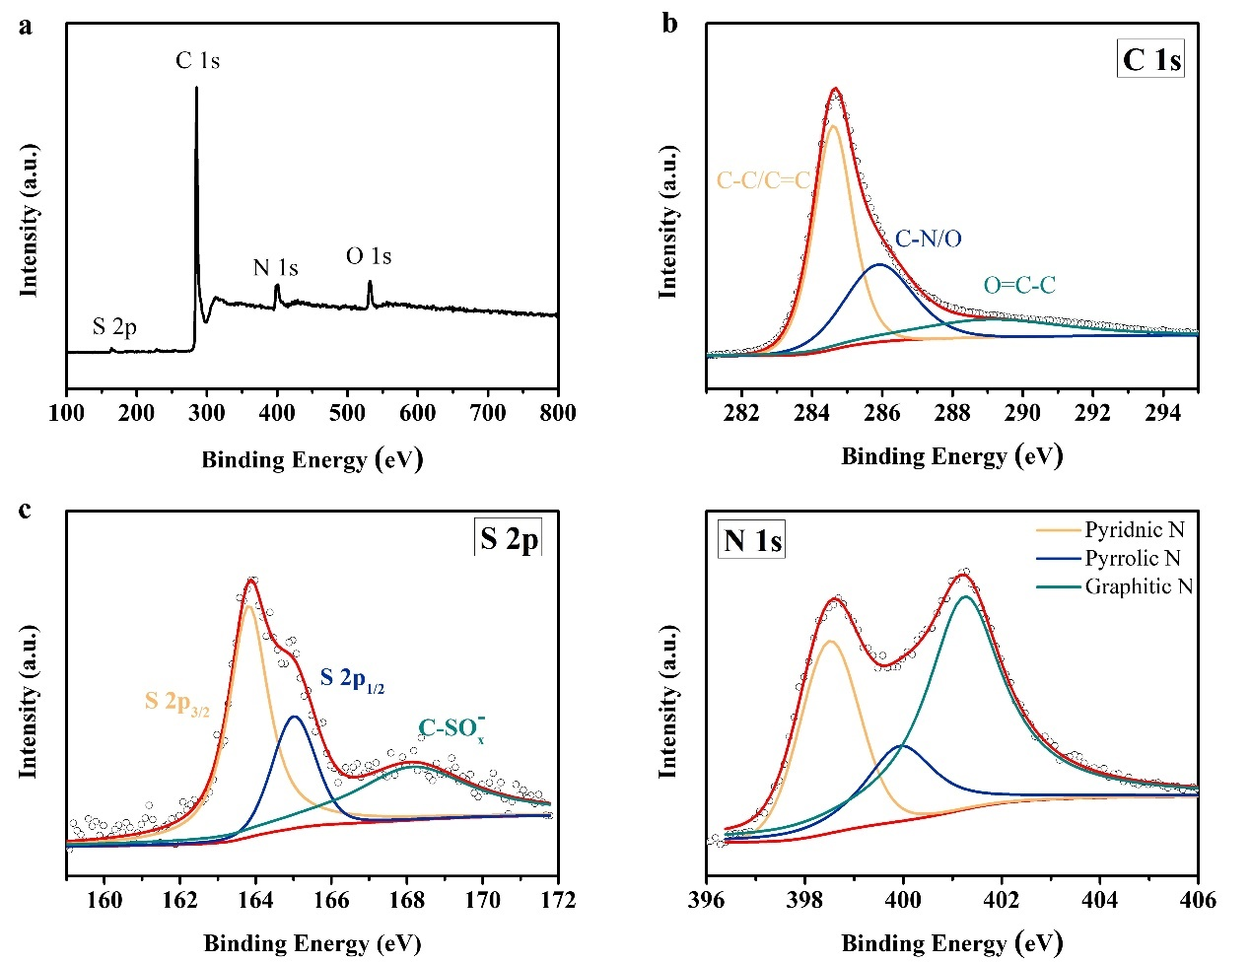
Supplementary Fig. 25. XPS spectrum of SNC (a) C 1s, (b) N 1s, and (c) S 2p.

Supplementary Fig. 26. (a) Fe L-edge XANES spectra. (b) C K-edge and (c) N K-edge XANES spectra of the A-Fe₂S₁N₅/SNC, Fe₂N₆/NC, and Fe₁N₄/NC. (d) S L-edge XANES spectra of the A-Fe₂S₁N₅/SNC. The S L-edge features result from the electronic transitions of 2p electrons to partially filled or empty molecular orbitals.

Supplementary Fig. 27. Tafel slope of A-Fe₂S₁N₅/SNC, Fe₂N₆/NC, Fe₁N₄/NC, and RuO₂.

Supplementary Fig. 28. (a) Comparison of overpotential and Tafel slope values at a current density of 10 mA cm⁻². (b) Comparison of overpotential and Tafel slope values with other catalysts Supplementary Table 2 at a current density of 10 mA cm⁻².

Supplementary Fig. 29. CV plots at various sweep rates of (a) A-Fe₂S₁N₅/SNC, (b) Fe₂N₆/NC, (c) Fe₁N₄/NC, and (d) SNC for OER.

Supplementary Fig. 30. Calculated C_{dl} values of of A-Fe₂S₁N₅/SNC, Fe₂N₆/NC, Fe₁N₄/NC, and SNC.

Supplementary Fig. 31. (a) ECSA normalized LSV curves. (b) EIS curves of A-Fe₂S₁N₅/SNC, Fe₂N₆/NC, Fe₁N₄/NC, and SNC at an overpotential of 10 mV.

Supplementary Fig. 32. (a) TOFs of the measured catalysts calculated on the basis of the loaded Fe atoms at different overpotentials. (b) Mass activity of the measured catalysts calculated on the basis of the loaded Fe atoms at different overpotentials.

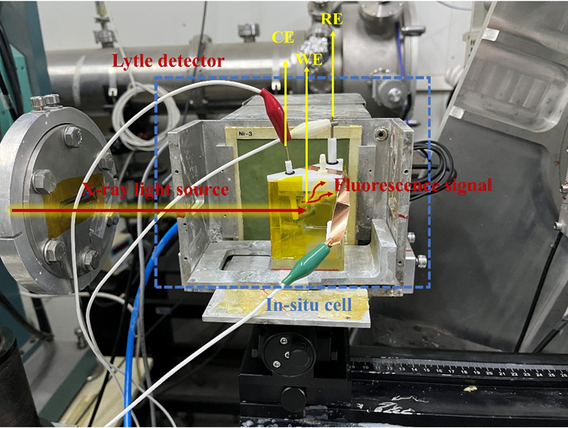
Supplementary Fig. 33. The detail of the in-situ X-ray absorption spectroscopy measurement. The device is set up at 14W1 beam line with the support from SSRF, where the X-ray induced fluorescence model is applied. CE, counter electrode; WE, working electrode; RE, reference electrode.

Supplementary Fig. 34. (a) Corresponding first-derivative XANES curves at the Fe K-edge for OER. (b) Oxidation state of A-Fe₂S₁N₅/SNC at Fe K-edge for OER derived from (a).

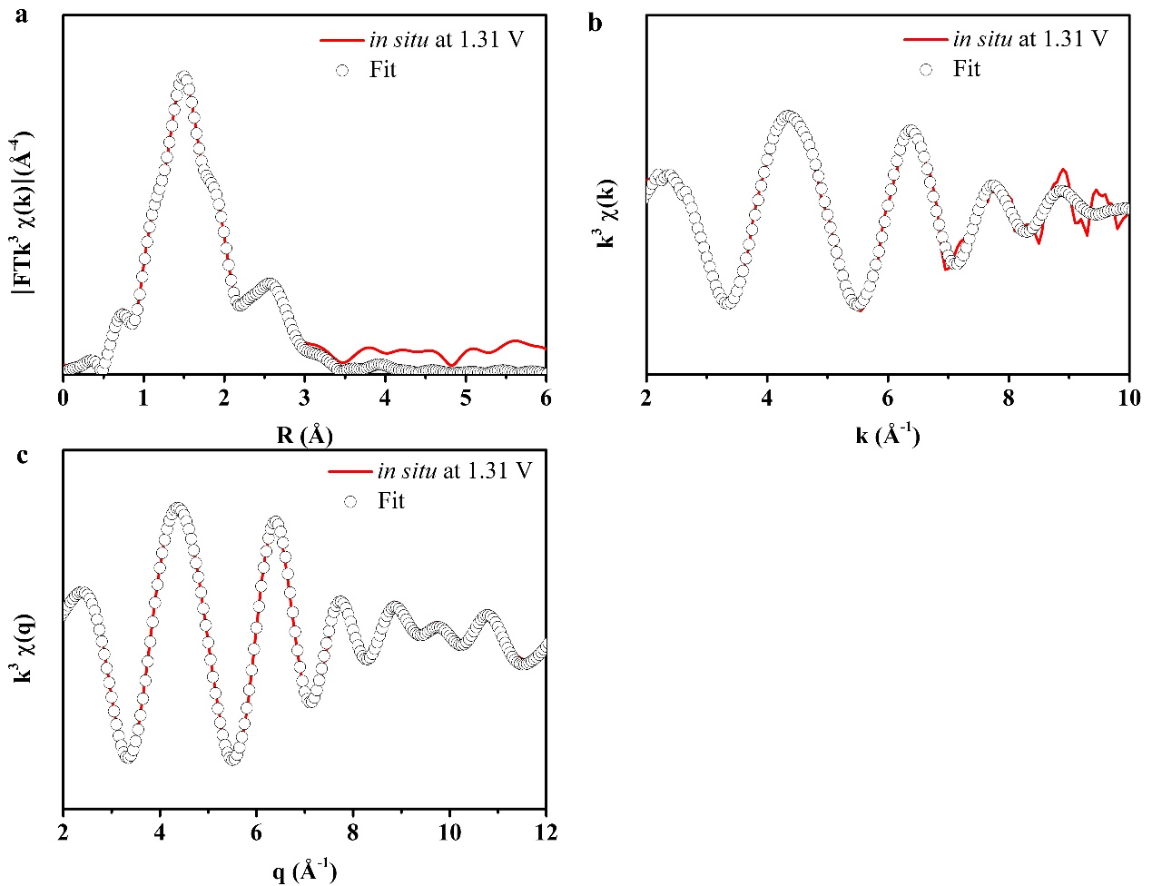
Supplementary Fig. 35. EXAFS fitting curves of A-Fe₂S₁N₅/SNC-in situ at 1.31 V. (a) The FT-EXAFS fitting curve at Fe K-edge, (b) k space fitting curve and (c) q space fitting curve.

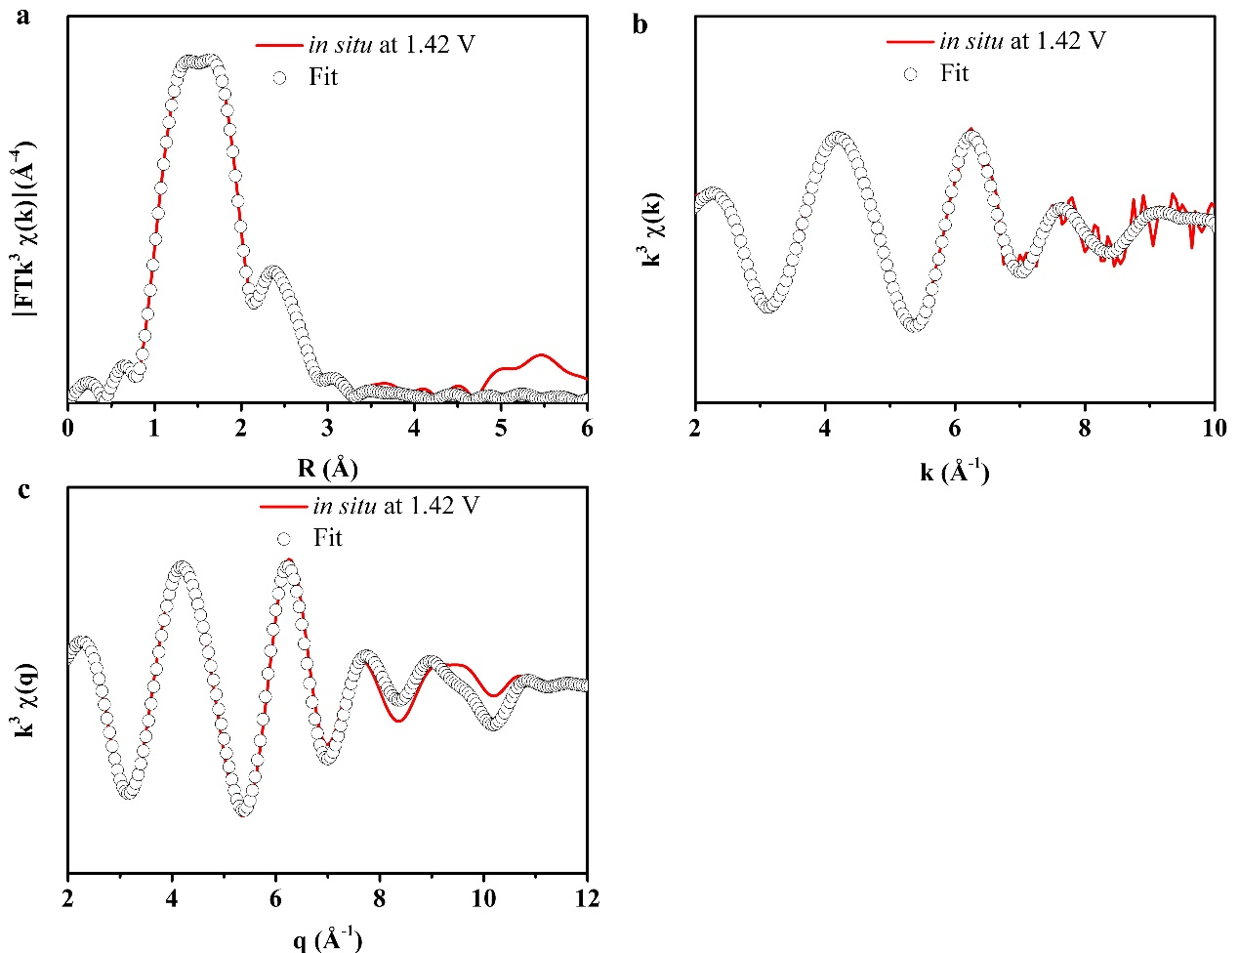
Supplementary Fig. 36. EXAFS fitting curves of A-Fe₂S₁N₅/SNC-in situ at 1.42 V. (a) The FT-EXAFS fitting curve at Fe K-edge, (b) k space fitting curve and (c) q space fitting curve.

Supplementary Fig. 37. LSV curves before and after 50000 CV stability test.

Supplementary Fig. 38. Summary of the long-term durability in water electrolysis for A-Fe₂S₁N₅/SNC and other reported electrocatalysts (Supplementary Table 2).

Supplementary Fig. 39. A-Fe₂S₁N₅/SNC after the 50000 cycles CV tests. (a-c) TEM, (d) Aberration-corrected HAADF-STEM, (e-h) EDS mapping images of Fe, S, N, and C.

Supplementary Fig. 40. Structural characterization of A-Fe₂S₁N₅/SNC after the OER 50000 cycles CV test. (a) XRD pattern. (b) Raman pattern. XPS spectra for (c) Fe 2p, (d) N 1s, (e) C 1s, and (f) S 2p.

Supplementary Fig. 41. (a) XRD and (b) XPS survey spectrum of A-Co₂S₁N₅/SNC, A-Cu₂S₁N₅/SNC, A-Ni₂S₁N₅/SNC, and A-Mn₂S₁N₅/SNC.

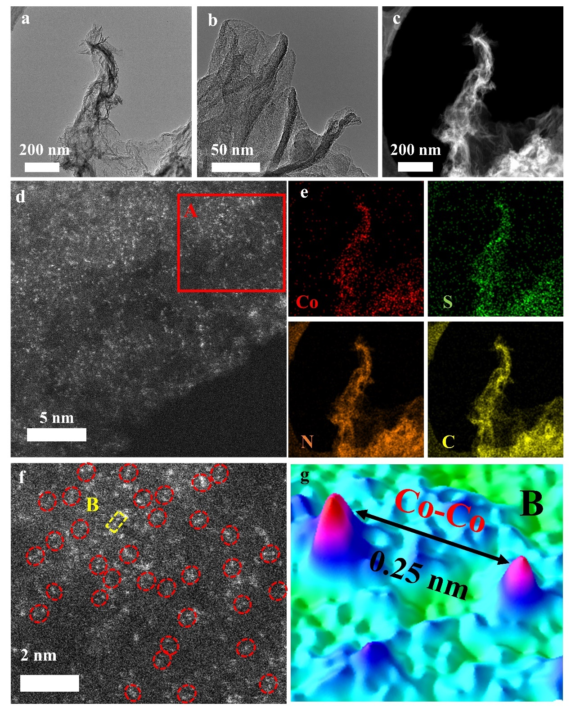
Supplementary Fig. 42. Morphology characterizations of A-Co₂S₁N₅/SNC. (a, b) TEM. (c) HAADF-STEM. (d, f) Aberration-corrected HAADF-STEM. (e) EDS mapping images of Co, S, N, and C. (g) statistical Co-Co distance in the observed diatomic pairs in region B of figure f.

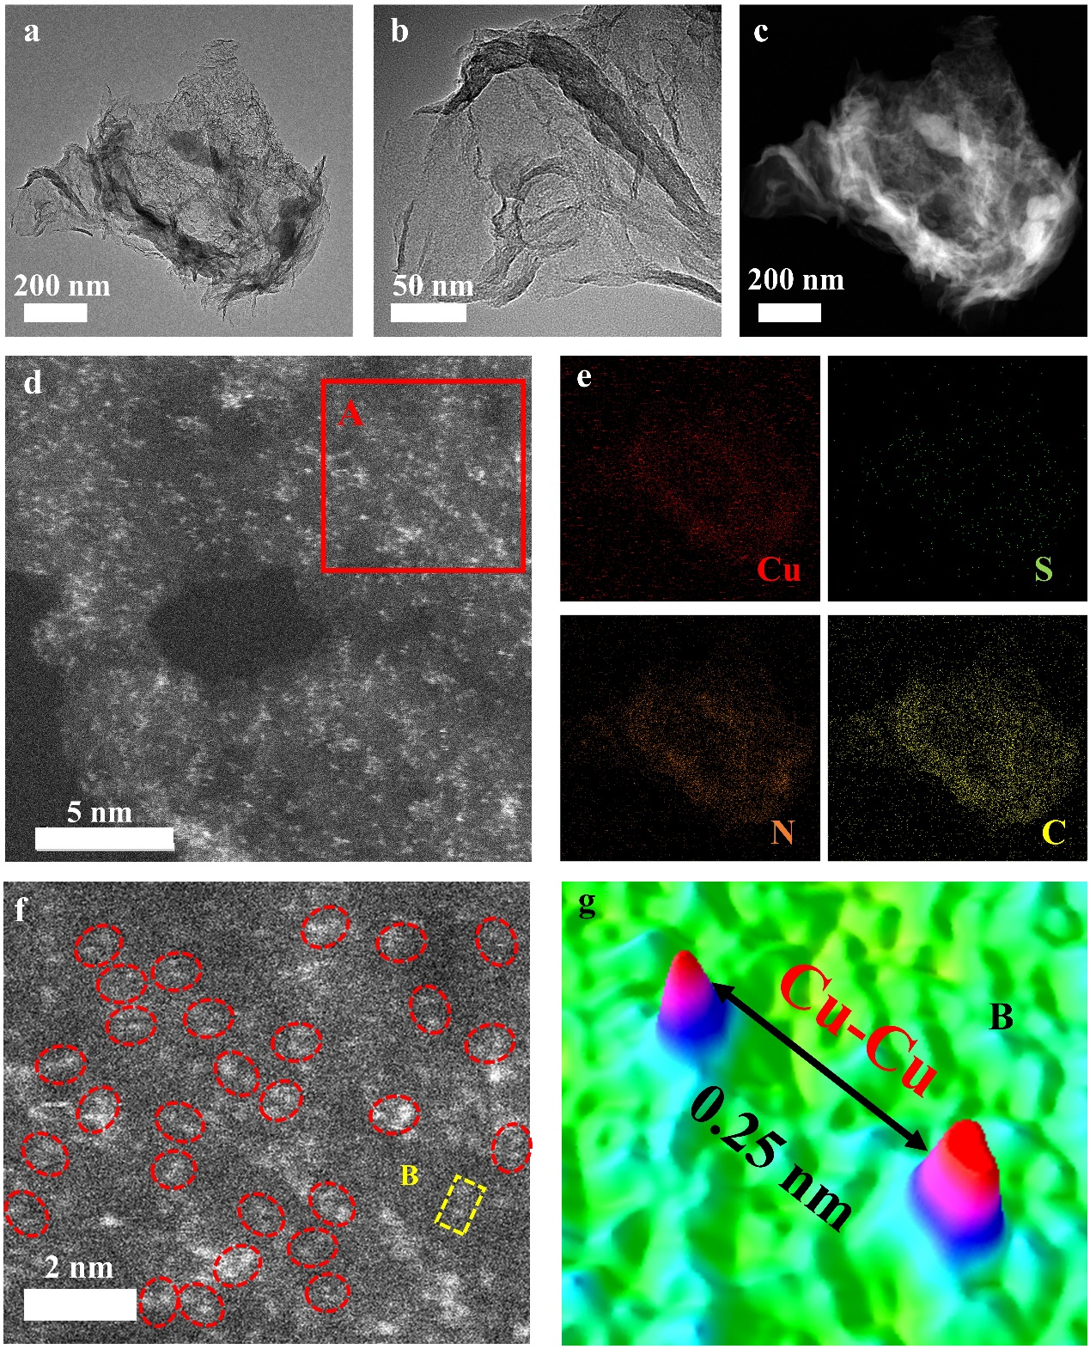
Supplementary Fig. 43. Morphology characterizations of A-Cu₂S₁N₅/SNC. (a, b) TEM. (c) HAADF-STEM. (d, f) Aberration-corrected HAADF-STEM. (e) EDS mapping images of Cu, S, N, and C. (g) statistical Cu-Cu distance in the observed diatomic pairs in region B of figure f.

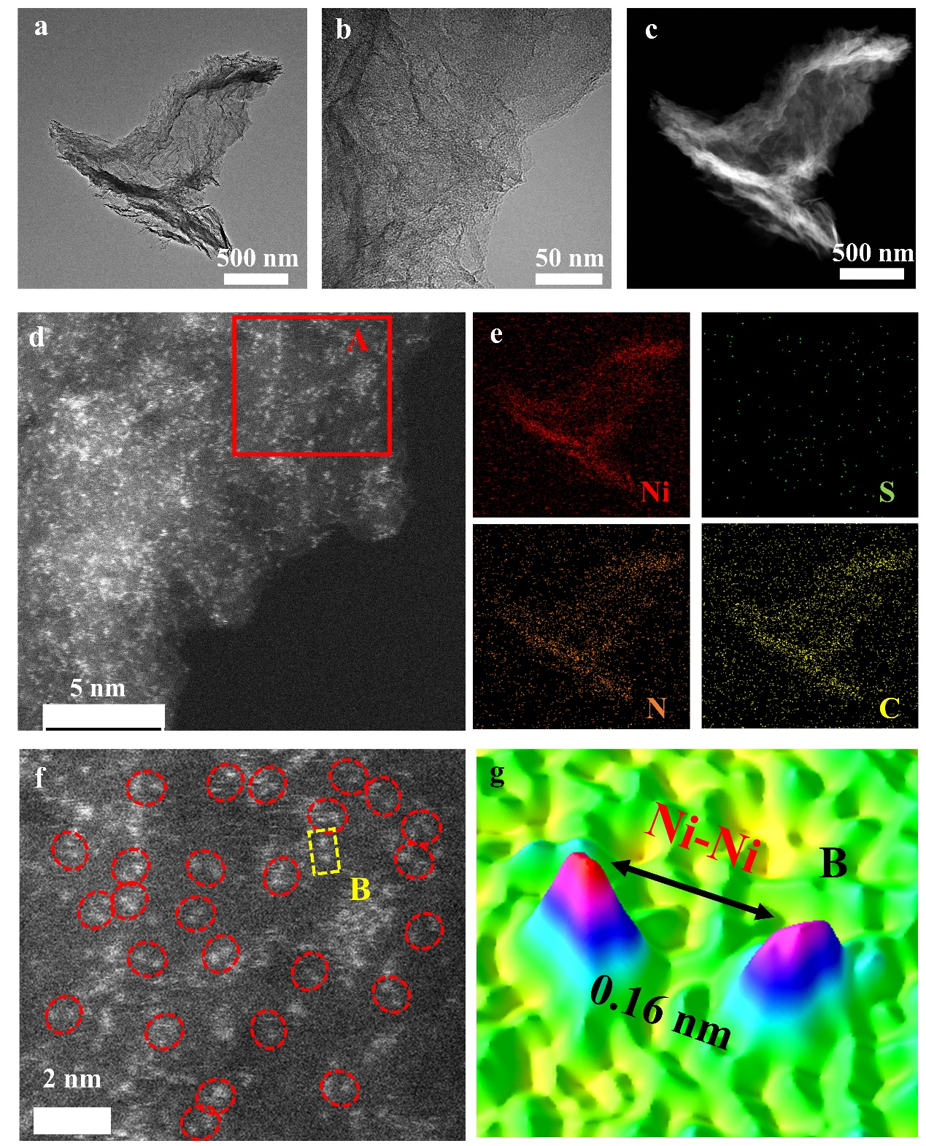
Supplementary Fig. 44. Morphology characterizations of A-Ni₂S₁N₅/SNC. (a, b) TEM. (c) HAADF-STEM. (d, f) Aberration-corrected HAADF-STEM. (e) EDS mapping images of Ni, S, N, and C. (g) statistical Ni-Ni distance in the observed diatomic pairs in region B of figure f.

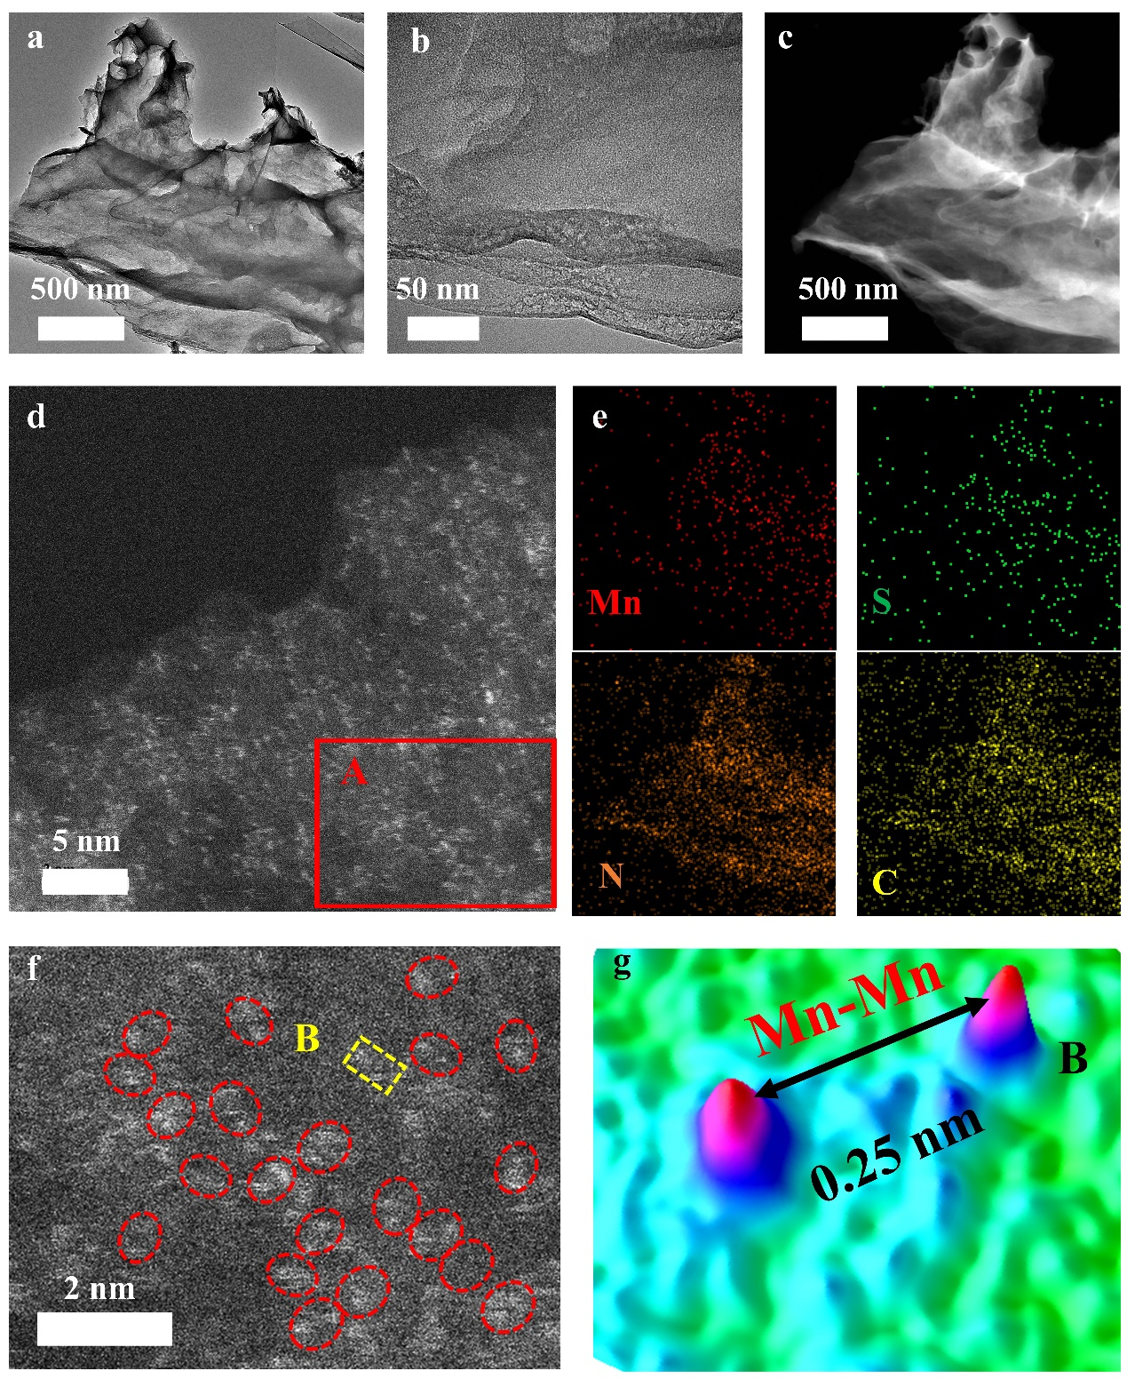
Supplementary Fig. 45. Morphology characterizations of A-Mn₂S₁N₅/SNC. (a, b) TEM. (c) HAADF-STEM. (d, f) Aberration-corrected HAADF-STEM. (e) EDS mapping images of Mn, S, N, and C. (g) statistical Mn-Mn distance in the observed diatomic pairs in region B of figure f.

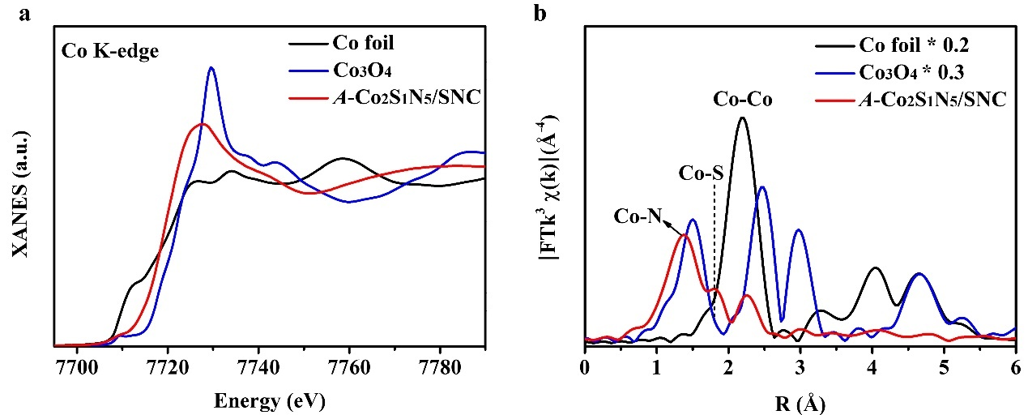
Supplementary Fig. 46. (a) XANES spectra at the Co k-edge of A-Co₂S₁N₅/SNC, Co₃O₄, and Co foil. (b) Fourier transform (FT) at the Co k-edge of A-Co₂S₁N₅/SNC, Co₃O₄, and Co foil.

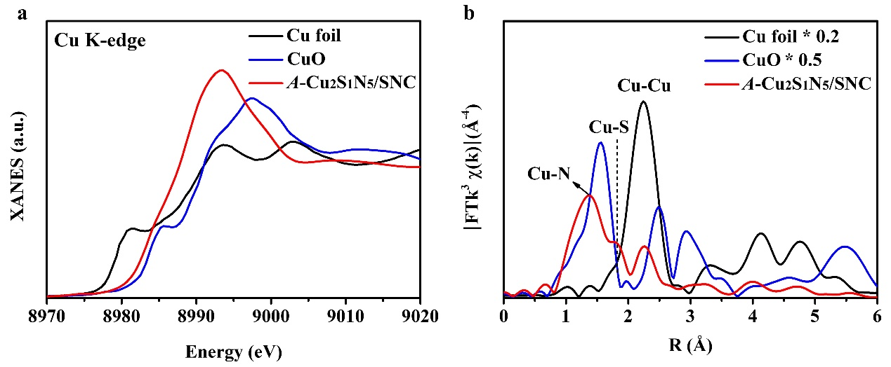
Supplementary Fig. 47. (a) XANES spectra at the Cu k-edge of A-Cu₂S₁N₅/SNC, CuO, and Cu foil. (b) Fourier transform (FT) at the Cu k-edge of A-Cu₂S₁N₅/SNC, CuO, and Cu foil.

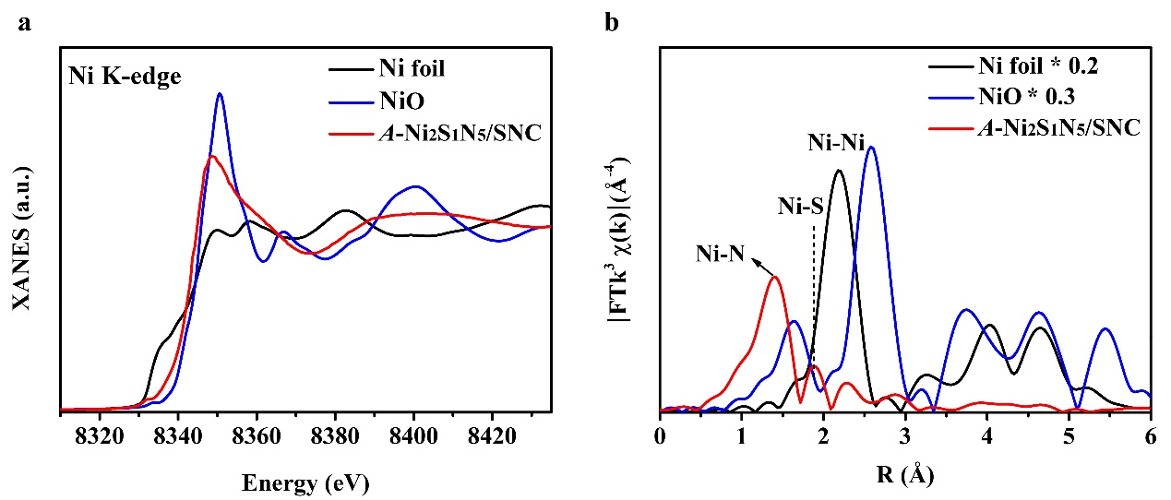
Supplementary Fig. 48. (a) XANES spectra at the Ni k-edge of A-Ni₂S₁N₅/SNC, NiO, and Ni foil. (b) Fourier transform (FT) at the Ni k-edge of A-Ni₂S₁N₅/SNC, NiO, and Ni foil.

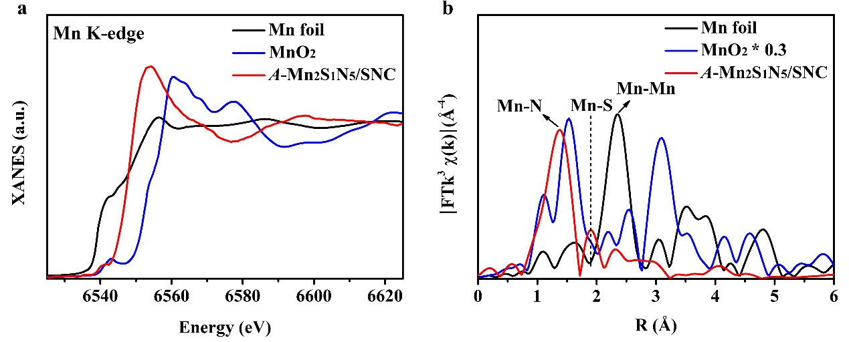
Supplementary Fig. 49. (a) XANES spectra at the Mn k-edge of A-Mn₂S₁N₅/SNC, MnO₂, and Mn foil. (b) Fourier transform (FT) at the Mn k-edge of A-Mn₂S₁N₅/SNC, MnO₂, and Mn foil.

Supplementary Fig. 50. The FT-EXAFS fitting curve of A-Co₂S₁N₅/SNC, A-Cu₂S₁N₅/SNC, A-Ni₂S₁N₅/SNC, and A-Mn₂S₁N₅/SNC.

Supplementary Fig. 51. The k space fitting curve of A-Co₂S₁N₅/SNC, A-Cu₂S₁N₅/SNC, A-Ni₂S₁N₅/SNC, and A-Mn₂S₁N₅/SNC.

Supplementary Fig. 52. The q space fitting curve of A-Co₂S₁N₅/SNC, A-Cu₂S₁N₅/SNC, A-Ni₂S₁N₅/SNC, and A-Mn₂S₁N₅/SNC.

Supplementary Fig. 53. OER performance of A-Co₂S₁N₅/SNC, A-Cu₂S₁N₅/SNC, A-Mn₂S₁N₅/SNC, and A-Ni₂S₁N₅/SNC. (a) LSV curves, (b) Tafel slope.

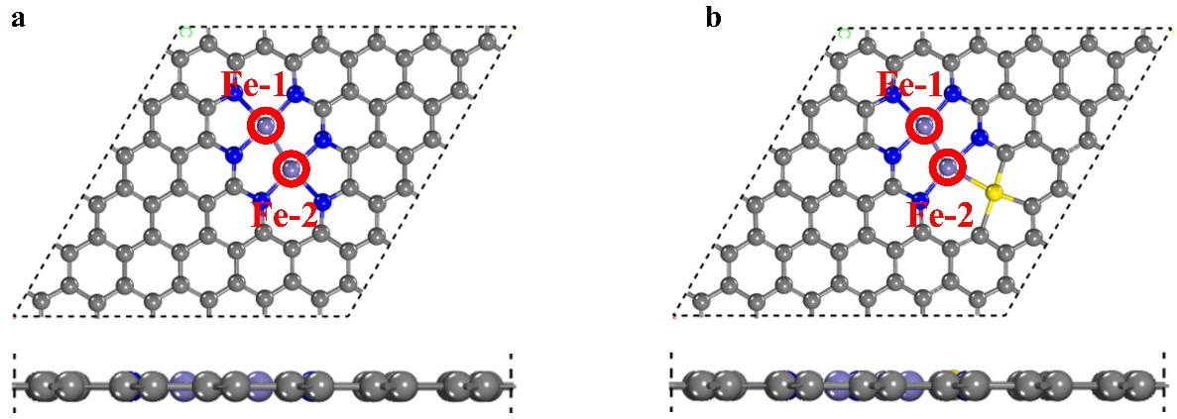
Supplementary Fig. 54. The optimized configuration of (a) Fe₂N₆/NC and (b) A-Fe ₂S₁N₅/SNC structures. Purple, blue, and gray ball marks Fe, N, and C atom, respectively. Two Fe sites was named as Fe-1 and Fe-2.
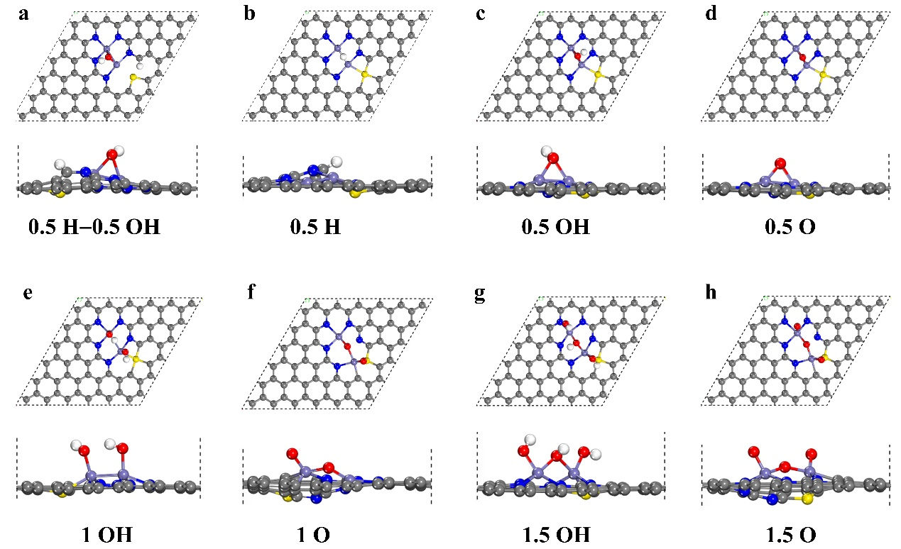
Supplementary Fig. 55. Optimized configurations with different H, OH, and O coverages on the A-Fe₂S₁N₅/SNC system. Purple, red, gray, blue, and white ball marks Fe, O, C, N, and H atom, respectively.

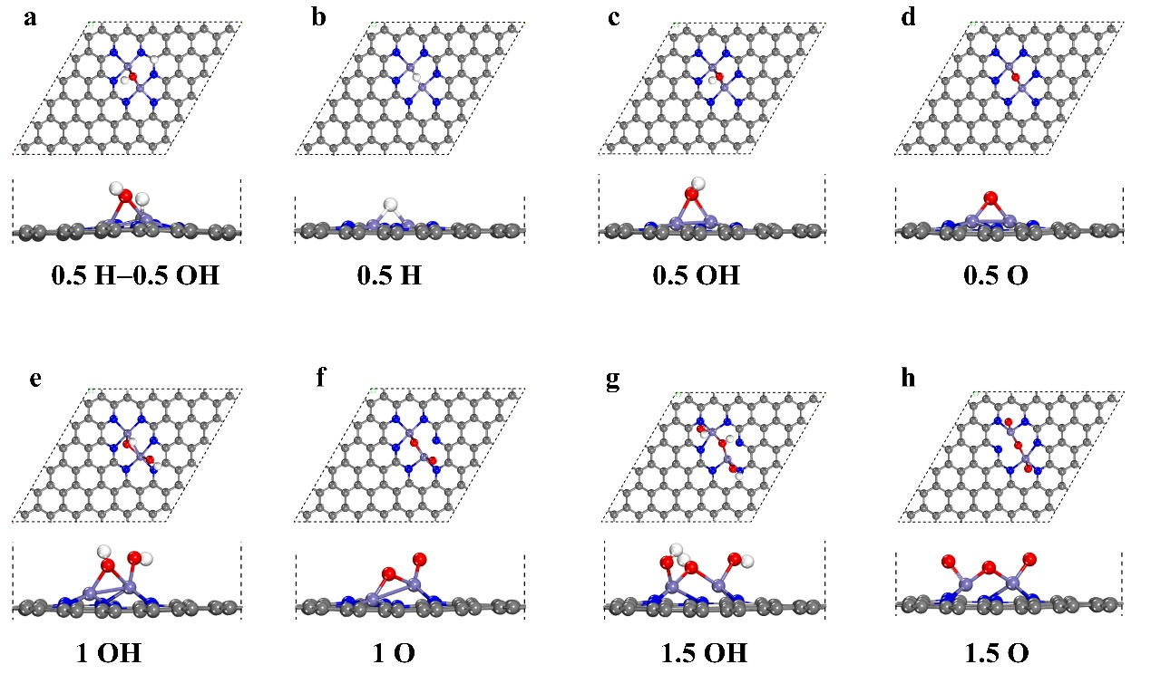
Supplementary Fig. 56. Optimized configurations with different H, OH, and O coverages on the Fe₂N₆/NC system. Purple, red, gray, blue, and white ball marks Fe, O, C, N, and H atom, respectively.

Supplementary Fig. 57. Free energy of a series of coverage fraction surfaces sampled for the Fe₂N₆/NC catalysts.

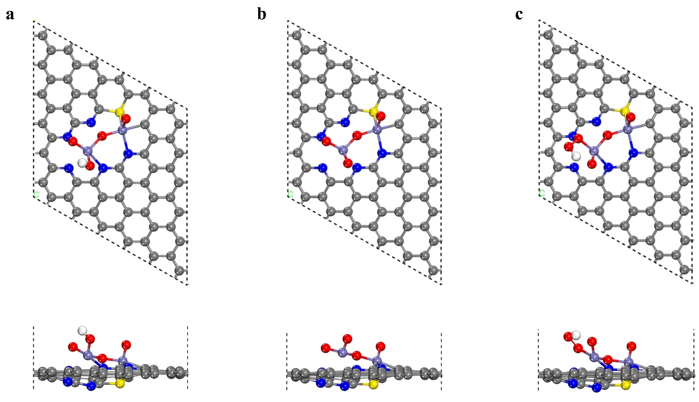
Supplementary Fig. 58. The optimized models of (a) OH, (b) O, and (c) OOH intermediates on the Fe-1 site of 1.5 O-Fe₂S₁N₅/SNC system. Purple, red, gray, blue, and white ball marks Fe, O, C, N, and H atom, respectively.

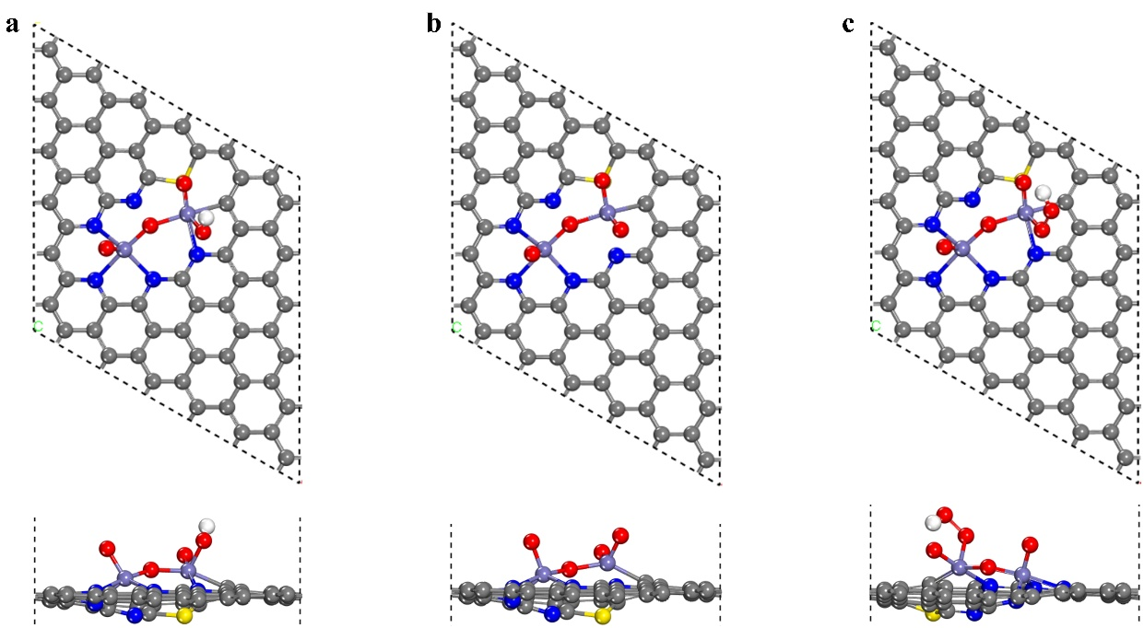
Supplementary Fig. 59. The optimized models of (a) OH, (b) O, and (c) OOH intermediates on the Fe-2 site of 1.5 O-Fe₂S₁N₅/SNC system, Purple, red, gray, blue, and white ball marks Fe, O, C, N, and H atom, respectively.

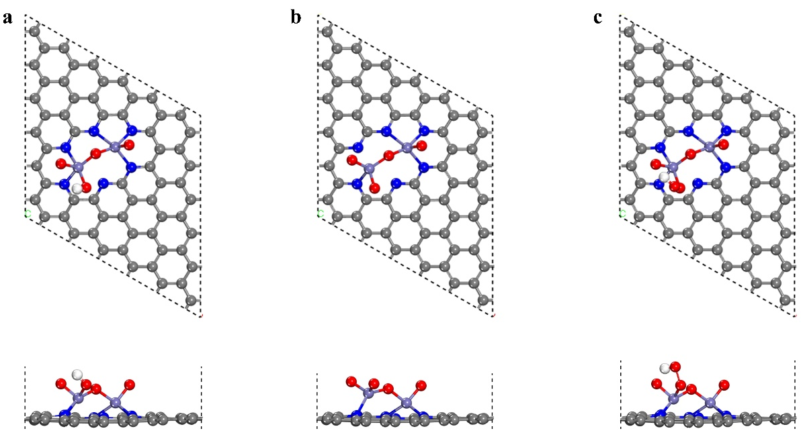
Supplementary Fig. 60. The optimized models of (a) OH, (b) O, and (c) OOH intermediates on the Fe-1 site of 1.5 O-Fe₂N₆/NC system, Purple, red, gray, blue, and white ball marks Fe, O, C, N, and H atom, respectively.

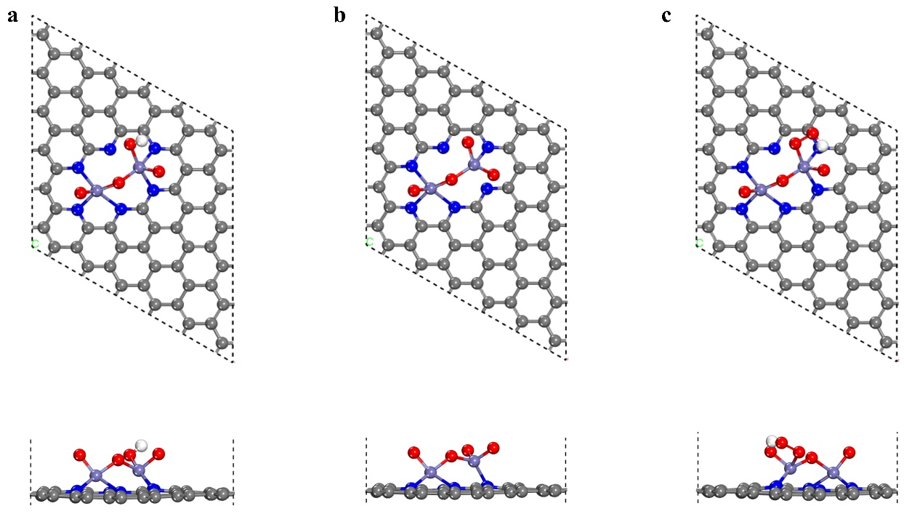
Supplementary Fig. 61. The optimized models of (a) OH, (b) O, and (c) OOH intermediates on the Fe-2 site of 1.5 O-Fe₂N₆/NC system, Purple, red, gray, blue, and white ball marks Fe, O, C, N, and H atom, respectively.

Supplementary Fig. 62. Free energy change of ORR mechanism on the Fe-2 site of (a) 1.5 O-Fe₂S₁N₅/SNC (a) and (b) 1.5 O-Fe₂N₆/NC catalyst under the electrode potential of 0 V, 1.23 V, and limiting-determined potential.

Supplementary Fig. 63. The free energy change of (a) OER and (b) ORR on the Fe-1 site of 1.5 O-Fe₂S₁N₅/SNC model under the electrode potential of 0 V, 1.23 V, and the limiting-determined potential.

Supplementary Fig. 64. The free energy change of (a) OER and (b) ORR on the Fe-1 site of 1.5 O-Fe₂N₆/NC model under the electrode potential of 0 V, 1.23 V, and the limiting-determined potential.

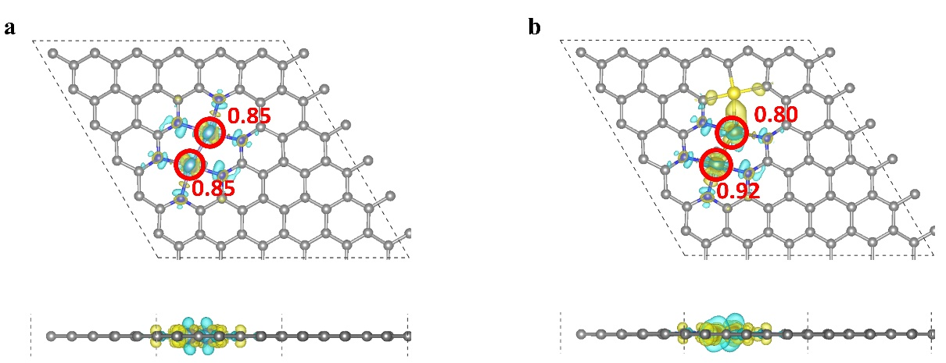
Supplementary Fig. 65. Differential charge density diagram of (a) bare-Fe₂N₆/NC and (b) A-Fe₂S₁N₅/SNC. The yellow and cyan contour with the isosurface value of 0.008 e/bohr³ marks augmented and reduced charge density, respectively. Purple, gray, blue, and white ball marks Fe, C, N, and H atom, respectively. The red number indicates the charge transfer number of Fe atoms.

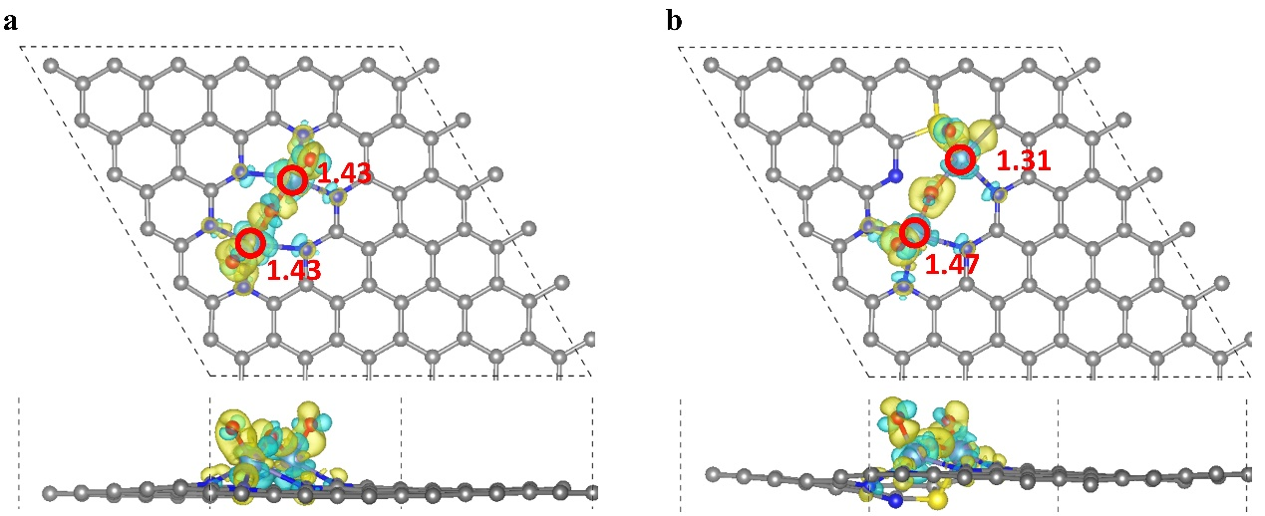
Supplementary Fig. 66. Differential charge density diagram of (a) 1.5 O-Fe₂N₆/NC and (b) 1.5 O-Fe₂S₁N₅/SNC. The yellow and cyan contour with the isosurface value of 0.008 e/bohr³ marks augmented and reduced charge density, respectively. Purple, red, gray, blue, and white ball marks Fe, O, C, N, and H atom, respectively. The red number indicates the charge transfer number of Fe atoms.

Supplementary Fig. 67. CV test at different atmosphere. (a) CV curves of A-Fe₂S₁N₅/SNC in O₂- and N₂-saturated 0.1 M KOH electrolyte at a scan rate of 50 mV/s.

Supplementary Fig. 68. ORR electrochemical activity in 0.1 M KOH. (a) Linear sweep voltammetry curves (LSV) and (b) the corresponding Tafel plots of the different catalysts at 1600 rpm. (c) Kinetic current density (J_{k}) at 0.85 V versus reversible hydrogen electrode (versus RHE) and half-wave potentials of A-Fe₂S₁N₅/SNC, Fe₂N₆/NC, Fe₁N₄/NC, SNC, and Pt/C catalysts. (d) Calculated C_{dl} values from corresponding samples. As shown in Supplementary Fig. 68a, A-Fe₂S₁N₅/SNC displayed superior ORR activity as evidenced by a high onset potential (E_{onset}) of 0.98 V, close to that of Pt/C (0.99 V). However, Fe₂N₆/NC, Fe₁N₄/NC, and SNC exhibited lower electrocatalytic performance with E_{onset} values of 0.83, 0.89, and 0.79 V, respectively. Linear sweep voltammetry (LSV) curves of these catalysts indicated the best activity of A-Fe₂S₁N₅/SNC with aspect to its highest halfwave potential (E_{1/2}). Specifically, E_{1/2} of A-Fe₂S₁N₅/SNC, Fe₂N₆/NC, Fe₁N₄/NC, SNC, and Pt/C was 0.91, 0.82, 0.79, 0.70, and 0.85 V vs. RHE, respectively. The lowest Tafel slope of A-Fe₂S₁N₅/SNC (87 mV dec⁻¹) among those of Fe₂N₆/NC (91 mV dec⁻¹), Fe₁N₄/NC (109 mV dec⁻¹), SNC (110 mV dec⁻¹), and Pt/C (101 mV dec⁻¹) also supported the superior ORR kinetics of A-Fe₂S₁N₅/SNC (Supplementary Fig. 68b). Moreover, A-Fe₂S₁N₅/SNC exhibited a remarkable kinetic current density (J_{k}) of 12.6 mA cm⁻² at 0.85 V vs. RHE, about 4 times and 7 times higher than that of Fe₂N₆/NC (3.5 mA cm⁻²) and Fe₁N₄/NC (1.8 mA cm⁻²), respectively (Supplementary Fig. 68c).

Supplementary Fig. 69. CV plots at various sweep rates of (a) A-Fe₂S₁N₅/SNC, (b) Fe₂N₆/NC, (c) Fe₁N₄/NC, and (d) SNC for ORR.

Supplementary Fig. 70. (a) LSV curves of A-Fe₂S₁N₅/SNC at various rotation rates. (b) The K-L plots for A-Fe₂S₁N₅/SNC. (c) Electron transfer number (n, bottom) and H₂O₂ yield (top) versus potential for A-Fe₂S₁N₅/SNC. (d) Stability test of A-Fe₂S₁N₅/SNC. To further analyze the ORR reaction mechanism of the A-Fe₂S₁N₅/SNC catalyst, Koutecky-Levich plots at various applied potentials (Supplementary Fig. 70a) were collected to determine the electron transfer number (n) based on the LSV curves at various rotating speeds ranging from 400 rpm to 2025 rpm. Linear plots comply with the first-order reaction kinetic of the dissolved oxygen concentration and the n. According to the Koutecky-Levich equation, the n was calculated to be ≈ 4, signifying a high 4e– selectivity for ORR (Supplementary Fig. 70b). Durability was another important evaluation indicator of the electrocatalyst. In addition, the catalyst could still maintain high electrochemical durability after 40000 s of continuous operation under a constant voltage (Supplementary Fig. 70d).

Supplementary Fig. 71. Cyclic voltammetry (CV) data for A-Fe₂S₁N₅/SNC in O₂-saturated 0.1 M KOH without and with 0.5 M CH₃OH. There was no obvious change in the current density for the A-Fe₂S₁N₅/SNC catalyst after methanol injecting.

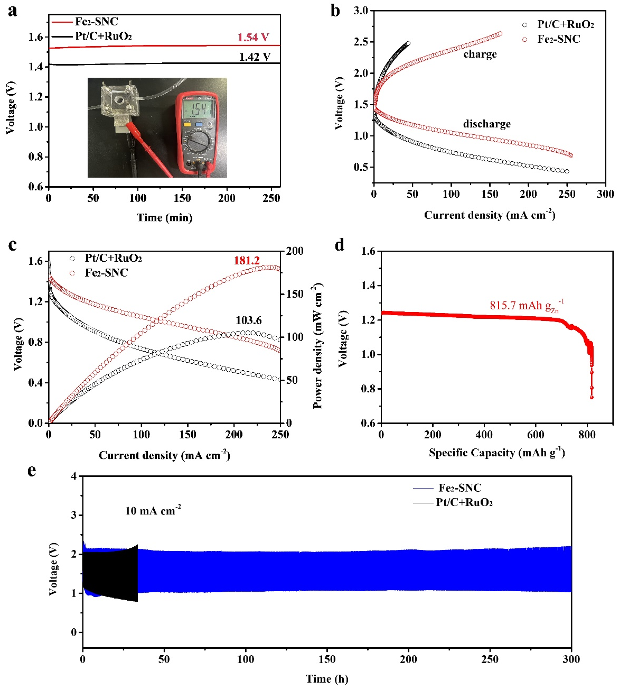
Supplementary Fig. 72. Rechargeable Zn-air battery performance. A-Fe₂S₁N₅/SNC -based battery shows a maximum peak power density of 182.1 mW cm⁻², significantly higher than that of Pt/C+RuO₂ (103.6 mW cm⁻²) based batteries. Importantly, the A-Fe₂S₁N₅/SNC-based battery delivered exceptional performance and outperformed most reported results. In Supplementary Fig. 72d, the specific capacity of A-Fe₂S₁N₅/SNC-based battery at discharge currents of 10 mA cm⁻² was determined to be 815.7 mA h g⁻¹, and the corresponding Zn utilization ratios were calculated to be 95.7%. The cyclability of ZAB was evaluated under continuous galvanostatic discharge/charge at a current density of 10 mA cm⁻² with a duration of 30 min per cycle (Supplementary Fig. 72e). Compared with Pt/C+RuO₂-based battery, A-Fe₂S₁N₅/SNC demonstrated negligible voltage decay within 300 h (600 discharge/charge cycles), revealing superior long-term durability. More importantly, the zinc–air battery assembled with A-Fe₂S₁N₅/SNC exhibited superior performance than other benchmarking counterparts in terms of peak power density, specific capacity, and cycling stability. The highly exposed active sites and unique electronic structure in SACs obtained by different synthesis methods contribute to the excellent bifunctional ORR and OER performance in rechargeable zinc–air batteries. Taken together, these results strongly support the superiority of A-Fe₂S₁N₅/SNC as a potential material in the zinc-air battery.

XAFS measurements
The X-ray absorption fine structure spectra data were collected at BL1W1B station in Beijing Synchrotron Radiation Facility (BSRF) respectively. The data of the samples were collected at room temperature (Fe K-edge in fluorescence excitation mode using a Lytle detector). All samples were pelletized as disks of 13 mm diameter with 1mm thickness using PVDF powder as a binder.
The EXAFS spectra were obtained by subtracting the post-edge background from the overall absorption and then normalizing with respect to the edge-jump step. Subsequently, the χ(k) data of were Fourier transformed to real (R) space using a hanning windows (dk = 1.0 Å⁻¹) to separate the EXAFS contributions from different coordination shells. To obtain the quantitative structural parameters around central atoms, least-squares curve parameter fitting was performed using the ARTEMIS module of IFEFFIT software packages.
The following EXAFS equation was used:
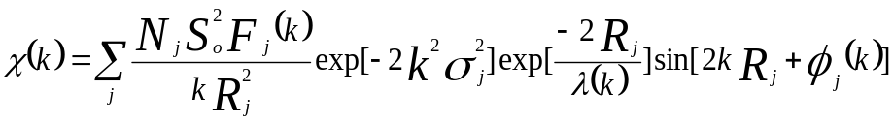
S₀² is the amplitude reduction factor, F_{j}(k) is the effective curved-wave backscattering amplitude, N_{j} is the number of neighbors in the j^{th} atomic shell, R_{j} is the distance between the X-ray absorbing central atom and the atoms in the j^{th} atomic shell (backscatterer), λ is the mean free path in Å, ϕ _{j}(k) is the phase shift (including the phase shift for each shell and the total central atom phase shift), σ_{j} is the Debye-Waller parameter of the j^{th} atomic shell (variation of distances around the average R_{j}). The functions F_{j}(k), λ and ϕ _{j}(k) were calculated with the ab initio code FEFF8.2. The additional details for EXAFS simulations are given below.
The coordination numbers of model samples were fixed as the nominal values. The obtained S₀² was fixed in the subsequent fitting. While the internal atomic distances R, Debye-Waller factor σ², and the edge-energy shift ΔE₀ were allowed to run freely.

Supplementary Table 1 Structural parameters extracted from the Fe K-edge EXAFS fitting. (S₀²=0.87)

sample | Scattering pair | CN | R(Å) | σ²(10⁻³Å²) | ΔE₀(eV) | R factor
Fe foil | Fe-Fe1 | 8 | 2.47 | 6.5 | 1.5 | 0.008
Fe foil | Fe-Fe2 | 6 | 2.84 | 7.3 | 1.5 | 0.008
Fe₁N₄/NC | Fe-N | 4.0 | 1.95 | 6.7 | 1.0 | 0.005
Fe₂N₆/NC | Fe-N | 3.1 | 1.92 | 5.4 | 2.0 | 0.008
Fe₂N₆/NC | Fe-Fe | 1.0 | 2.52 | 5.9 | 2.0 | 0.008
A-Fe₂S₁N₅/SNC | Fe-N | 2.5 | 1.90 | 4.1 | 2.0 | 0.006
A-Fe₂S₁N₅/SNC | Fe-S | 0.5 | 2.30 | 4.6 | 2.0 | 0.006
A-Fe₂S₁N₅/SNC | Fe-Fe | 1.0 | 2.56 | 6.9 | 2.0 | 0.006
S₀² is the amplitude reduction factor; CN is the coordination number; R is interatomic distance (the bond length between central atoms and surrounding coordination atoms); σ² is Debye-Waller factor (a measure of thermal and static disorder in absorber-scatterer distances); ΔE₀ is edge-energy shift (the difference between the zero kinetic energy value of the sample and that of the theoretical model). R factor is used to value the goodness of the fitting.

Supplementary Table 2 Comparison of OER performance with other catalysts.
Catalyst | Tafel slope  (mV dec⁻¹) | η₁₀ (mV) | Durability  (h) | reference
A-Fe₂S₁N₅/SNC | 61 | 193ª | >2000  50000 CV | This work
Ni-NHGF | 63 | 331ª | 20 | [1] Nature Catalysis 2018, 63-72
WC_{x}-FeNi | 44 | 237ª | 1000 | [2] Nature Materials 2021, 20, 1240-1247
Ir₁/Ni LDH-T | 41 | 228ª | 12 | [3] Nat. Commun. 2024, 152:559
Ni/Fe-CNG | 74 | 270^{b} | 72 | [4] Nat. Commun. 2021, 12, 5589
NiFe-DASC | 45 | 310ª | 30 | [5] Nat. Commun. 2021, 12:4088
EA-FCCN  (FeCoCrNi MCA) | 38.7 | 221ª | 20 | [6] Nat. Commun. 2020, 11:4066
Ru/CoFe-LDHs | 39 | 198ª | 24 | [7] Nat. Commun. 2019, 10:1711
S|NiNx-PC | 45 | 280ª | 10 | [8] Nat. Commun. 2019, 10:1392
Ni₃Fe_{1-x}V_{x}/CFP | 39 | 264ª | 60 | [9] Nat. Commun. 2018, 9:2885
Au-NiFeOOH | 36 | 237ª | 20 | [10] J. Am. Chem. Soc. 2018, 140, 3876-3879
Fe-Co-Ni MOF | 53.1 | 254ª | 48 | [11] J. Am. Chem. Soc. 2022, 144, 3411-3428
Co-Fe-N-C | 37 | 309ª | 16 | [12] J. Am. Chem. Soc. 2019, 141, 14190–14199
FeNiP/NCH | 69 | 250ª | 72 | [13] J. Am. Chem. Soc. 2019, 141, 7906-7916
P/Fe-N-C | 65 | 304^{b} | 10 | [14] J. Am. Chem. Soc. 2023, 145, 3647-3655
Co-SeMON | 57.4 | 265ª | 50 | [15] J. Am. Chem. Soc. 2023, 145, 2, 1144-1154
Co₂Fe₁@NC | 141.6 | 420^{b} | 6 | [16] J. Am. Chem. Soc. 2020, 142, 7116-7127
Fe₂/Co₁-GNCL | 70 | 350ª | 200 | [17] Angew. Chem. Int. Ed. 2023, 62, e202314303
Mg/Fe-N-C | 52 | 224^{b} | 15 | [18] Angew. Chem. Int. Ed. 2019, 58, 13565-13572
S, N-Fe/N/C-CNT | 82 | 370^{b} | 11 | [19] Angew. Chem. Int. Ed. 2016, 55, 1-6
a-NiCo/NC | 49 | 252ª | 150 | [20] Angew. Chem. Int. Ed. 2022, 61, e202207537
(Ni,Fe)P(S,Se)₃ | 34 | 210ª | 50 | [21] Angew. Chem. Int. Ed. 2023, e202214570
ZnCo₂O₄/CNTs | 59.2 | 350^{b} | 14 | [22] Angew. Chem. Int. Ed. 2023, 62, e202301408
Fe-UNT | 36.6 | 270ª | 10 | [23] Angew. Chem. Int. Ed. 2020, 59, 2313-2317
Ir₁@Co/NC | 119 | 315ª | 5 | [24] Angew. Chem. Int. Ed. 2019, 19, 11868-11873
Fe-N₄ SAs/NPC | 95 | 430ª | 20 | [25] Angew. Chem. Int. Ed. 2018, 57, 8614-8618
CoFe/N-GCT | 106 | 310^{b} | 10 | [26] Angew. Chem. Int. Ed. 2018, 57, 16166-16170
Ni-BDC-1 | 89 | 225ª | 100 | [27] Angew. Chem. 2022, 134, e202214794
Ni SAs@S/N-FCS | 56.5 | 249ª | 166 | [28] Angew. Chem. Int. Ed. 2022, 61, e202212542
S/N-CMF@Fe_{x}Co_{y}Ni_{1-x-y}-MOF | 53.5 | 296ª | 100 | [29] Adv. Mater. 2023, 35, 2207888
Fe/N-G-SAC | 73 | 370^{b} | 2000 CV | [30] Adv. Mater. 2020, 2004900
Fe SAs/NC | 55.5 | 320^{b} | 25 | [31] Adv. Mater. 2022, 2209644
HCM@Ni-N | 76 | 304ª | 12 | [32] Adv. Mater. 2019, 31, 1904548
CoNi-SAs/NC | 58.7 | 340ª | 10 | [33] Adv. Mater. 2019, 31, 1905622
Mo₁-NiFeOxHy | 32.33 | 193ª | 30 | [34] Adv. Mater. 2022, 34, 2202523
Ni SAs@S/N-CMF | 50.8 | 285ª | 60 | [35] Adv. Mater. 2022, 34, 2203442
Fe-NiMo-NH₃/H₂ | 28 | 192ª | 18 | [36] Adv. Energy Mater. 2020, 2002285
Pt₁@Fe-N-C | 62 | 310^{b} | 5 | [37] Adv. Energy Mater. 2018, 8, 1701345
SCoNC | 74 | 310^{b} | 56 | [38] Adv. Energy Mater. 2019, 1900149
FePc||CNTs||NiCo/CP | 50 | 358^{b} | 5000 CV | [39] Adv. Energy Mater. 2022, 12, 2202984
Fe_{0.55}Co_{0.45}BPO | 26 | 270ª | 50 | [40] Adv. Energy Mater. 2023, 2203886
FeNi SAs/NC | 54.68 | 270ª | 35 | [41] Adv. Energy Mater. 2021, 11, 2101242
S-Fe-Co-N₅ | 59.2 | 260^{b}(𝜂₅₀) | 20 | [42] Adv. Energy Mater. 2023, 13, 2301547
NiFeLDH/Fe₁-N-C | 41 | 320ª | 12 | [43] Adv. Energy Mater. 2023, 2203609
Mn/Fe-HIB-MOF | 45 | 280^{b} | 100 | [44] Energy Environ. Sci., 2019, 12, 727-738
Co/Fe-SNC800 | 47.92 | 240ª | 26 | [45] Energy Environ. Sci., 2023, 16, 1685–1696
Mn/Fe-HIB-MOF | 45 | 280^{b} | 100 | [46] Energy Environ. Sci., 2019, 12, 727-738
A-Ni@DG | 47 | 270ª | 10 | [47] Chem 2018, 4, 285-297
planar-Fe-Co DSC | 33.6 | 190ª | 160 | [48] PNAS 2024, 121, e2317247121
Cu,Co/NSC3 | 85.4 | 339ª | 25 | [49] Adv. Funct. Mater. 2024, 34, 2311664
Fe₃Co₇-NC | 69 | 343^{b} | 60 | [50] Adv. Funct. Mater. 2023, 33, 2212299
SS-Co-SAC NSAs | 94.2 | 348^{b} | 80 | [51] Adv. Funct. Mater. 2019, 29, 1906477
Ni_{0.5}Fe_{0.5}-THQ | 47.9 | 272^{b} | 40 | [52] Adv. Funct. Mater. 2024, 34, 2310902
Co₁/TaS₂-3 | 70 | 330ª | 121 | [53] ACS Nano 2021, 15, 7105-7113
NiSO₄-GF | 80 | 300ª | 20 | [54] ACS Nano 2020, 14, 11662-11669
S-R-NiFe-CPs | 30.8 | 245ª(𝜂₂₀) | 25 | [55] ACS Nano 2022, 16, 15318-15327
Fe,Co,N-C | 76 | 410^{b} | 20 | [56] ACS Nano 2022, 16, 5, 7890-7903
FePc-GO | 112 | 420^{b} | 17 | [57] ACS Nano 2020, 14, 13279–13293
Fe-N/S-CNT-GR | 78 | 370ª | 12 | [58] ACS Catal. 2022, 12, 7994-8006
Fe₁Co₃-NC-1100 | 99.93 | 349b | 5000 CV | [59] ACS Catal. 2022, 12, 1216-1227
Fe₁(OH)_{x}/P-C | 41 | 320ª | 20 | [60] Nano Lett. 2021, 21, 4795-4801
NiFe-DG | 76 | 358ª | 12 | [61] Nano Energy 2021, 90, 106488
CoFe-N-C | 68 | 360^{b} | 25 | [62] Nano Lett. 2022, 22, 3392−3399
Fe–NiNC-50 | 54 | 340^{b} | 5000 CV | [63] Nano Energy, 2020, 71, 104597
FeCo/Se-CNT | 74.2 | 340^{b} | 9 | [64] Nano Lett. 2021, 21, 2255-2264
Ni-O-G SACs | 42 | 224ª | 50 | [65] Adv. Sci. 2020, 7, 1903089
FeCoDACys | 67 | 320^{b} | 12 | [66] Chem. Commun. 2022, 58, 1934
Fe-N-NDC-900 | 66.3 | 350^{b} | 12 | [67] J. Mater. Chem. A 2021, 9, 5556-5565
NiFe@g-C₃N₄/CNT | 67 | 326ª | 16 | [68] J. Mater. Chem. A 2018, 6, 6840–6846
Fe-NC | 114 | 450^{b} | 3000 CV | [69] J. Mater. Chem. A, 2020, 8, 9981-9990
Ni-O-G SACs | 42 | 224ª | 50 | [70] Adv. Sci. 2020, 7, 1903089
H-Co@FeCo/N/C | 96 | 378^{b} | 12 | [71] Applied Catalysis B: Environmental. 2020, 278, 119259
ª in 1.0 M KOH electrolyte. ^{b} in 0.1 M KOH electrolyte.

Supplementary Table 3 Structural parameters extracted from the Fe K-edge EXAFS fitting. (S₀²=0.87)
sample | Scattering pair | CN | R(Å) | σ²(10⁻³Å²) | ΔE₀(eV) | R factor
A-Fe₂S₁N₅/SNC-in situ-1.31V | Fe-N | 2.4 | 1.88 | 3.7 | 3.0 | 0.007
A-Fe₂S₁N₅/SNC-in situ-1.31V | Fe-O | 1.1 | 2.01 | 5.6 | 3.0 | 0.007
A-Fe₂S₁N₅/SNC-in situ-1.31V | Fe-S | 0.5 | 2.29 | 4.9 | 3.0 | 0.007
A-Fe₂S₁N₅/SNC-in situ-1.31V | Fe-Fe | 1.0 | 2.53 | 6.5 | 3.0 | 0.007
A-Fe₂S₁N₅/SNC-in situ-1.42V | Fe-N | 2.3 | 1.85 | 6.5 | 2.0 | 0.009
A-Fe₂S₁N₅/SNC-in situ-1.42V | Fe-O | 1.4 | 2.01 | 5.8 | 2.0 | 0.009
A-Fe₂S₁N₅/SNC-in situ-1.42V | Fe-S | 0.4 | 2.27 | 5.9 | 2.0 | 0.009
A-Fe₂S₁N₅/SNC-in situ-1.42V | Fe-Fe | 1.1 | 2.49 | 7.0 | 2.0 | 0.009
S₀² is the amplitude reduction factor; CN is the coordination number; R is interatomic distance (the bond length between central atoms and surrounding coordination atoms); σ² is Debye-Waller factor (a measure of thermal and static disorder in absorber-scatterer distances); ΔE₀ is edge-energy shift (the difference between the zero kinetic energy value of the sample and that of the theoretical model). R factor is used to value the goodness of the fitting.

Supplementary Table 4 Structural parameters extracted from the Mn, Cu, Co and Ni K-edge EXAFS fitting. (S₀²=0.86)
sample | Scattering pair | CN | R(Å) | σ²(10⁻³Å²) | ΔE₀(eV) | R factor
A-Mn₂S₁N₅/SNC | Mn-N | 2.3 | 1.91 | 4.1 | 4.8 | 0.008
A-Mn₂S₁N₅/SNC | Mn-S | 0.6 | 2.34 | 2.5 | 4.8 | 0.008
A-Cu₂S₁N₅/SNC | Cu-N | 2.4 | 2.02 | 3.2 | 5.9 | 0.005
A-Cu₂S₁N₅/SNC | Cu-S | 0.5 | 2.31 | 6.8 | 5.9 | 0.005
A-Co₂S₁N₅/SNC | Co-N | 2.6 | 1.95 | 4.6 | 2.5 | 0.008
A-Co₂S₁N₅/SNC | Co-S | 0.4 | 2.33 | 7.3 | 2.5 | 0.008
A-Ni₂S₁N₅/SNC | Ni-N | 2.5 | 1.93 | 5.3 | 3.7 | 0.007
A-Ni₂S₁N₅/SNC | Ni-S | 0.6 | 2.32 | 6.4 | 3.7 | 0.007

Supplementary Table 5 The total energy and free energy correction of free-state molecule and adsorbed intermediates. G_{corr} = ZPE + H (0 → 2981.5 K) ̶ TS
Species | E | ZPE | H (0→298.15 K) (eV) | TS (eV) | G_{corr} (eV)
H₂O | -14.22 | 0.56 | 0.10 | 0.67 | -0.01
H₂ | -6.77 | 0.26 | 0.09 | 0.40 | -0.06
*OH | / | 0.37 | 0.04 | 0.07 | 0.34
*O | / | 0.08 | 0.02 | 0.04 | 0.06
*H | / | 0.32 | 0.32 | 0 | 0.32

Supplementary Table 6 The adsorption free energy of various intermediates on the A-Fe₂S₁N₅/SNC catalysts. MM represents total magnetic moment. ΔG=ΔG_{corr}+ΔE
Species | MM | ΔE | ΔG_{corr} | ΔG
*H | 4.22 | -1.38 | 0.35 | -1.03
*O | 3.44 | -0.12 | 0.01 | -0.11
*OH | 5.89 | -0.93 | 0.32 | -0.61
2*O | 1.00 | 0.17 | -0.01 | 0.16
2*OH | 6.96 | -0.80 | 0.53 | -0.27
3*O | 0.99 | 1.89 | 0.03 | 1.92
3*OH | -0.08 | -0.54 | 0.95 | 0.41

Supplementary Table 7 The adsorption free energy of various intermediates on the Fe₂N₆/NC catalysts. MM represents total magnetic moment.
Species | MM | ΔE | ΔG_{corr} | ΔG
*H | 3.22 | -0.55 | 0.33 | -0.22
*O | 4.22 | -0.11 | 0.01 | -0.10
*OH | 5.22 | -0.68 | 0.30 | -0.38
2*O | 6.01 | 1.17 | 0.02 | 1.19
2*OH | 8.22 | -0.63 | 0.60 | -0.03
3*O | 6.00 | 3.05 | 0.03 | 3.08
3*OH | -1.68 | -0.45 | 0.89 | 0.44

Supplementary Table 8 The adsorption free energy of intermediates for OER/ORR in 1.5O-Fe₂S₁N₅/SNC model.
site | Species | MM | ΔE | ΔG_{corr} | ΔG
Fe-1 | *O | -0.66 | 2.44 | -0.01 | 2.43
Fe-1 | *OH | 0 | 0.77 | 0.29 | 1.06
Fe-1 | *OOH | 0 | 3.70 | 0.27 | 3.98
Fe-2 | *O | 1.00 | 2.32 | -0.01 | 2.32
Fe-2 | *OH | 0.02 | 0.69 | 0.29 | 0.98
Fe-2 | *OOH | 0.01 | 3.62 | 0.27 | 3.89

Supplementary Table 9 The adsorption free energy of intermediates for OER/ORR in 1.5O-Fe₂N₆/NC model.
site | Species | MM | ΔE | ΔG_{corr} | ΔG
Fe-1 | *O | -0.30 | 2.33 | 0.00 | 2.33
Fe-1 | *OH | -1 | 0.70 | 0.31 | 1.01
Fe-1 | *OOH | -1.08 | 3.73 | 0.27 | 4.00
Fe-2 | *O | -0.31 | 2.33 | 0.00 | 2.33
Fe-2 | *OH | 1 | 0.70 | 0.31 | 1.01
Fe-2 | *OOH | -1.13 | 3.71 | 0.27 | 3.99

