Sleep and degenerative skeletal disorders: observational and mendelian randomization study

Supplementary material 1

Content:
eMethods 1: Definition of sleep score and sleep patterns.................................................................2
eMethods 2: Polygenic risk scores (PRS)...........................................................................................3
eTable 1: ICD 10 codes for Degenerative skeletal disorders............................................................5
eTable 2: Descriptions of genetic summary association data of degenerative skeletal disorders.6
eTable 3: Descriptions of genetic summary association data of sleep characteristics...................7
eTable 4: Baseline characteristics of participants with genetic information..................................8
eTable 5: HR for degenerative skeletal disorders by sleep disorders..............................................9
eTable 6: Association between genetic risks and degenerative skeletal disorders..........................9
eFigure 1: The joint effects of PRS and sleep pattern on degenerative skeletal disorders..........10
eTable 7: 8 associations reaching the multiple-testing significant levels in MR analyses............11
eTable 8: Heterogeneity and pleiotropy test for the 8 associations................................................12
eFigure 2. Leave-one-out analyses of the 8 causal associations......................................................13
eFigure 3. Scatter plot of effects of SNPs used in forward MR analysis.......................................14
eFigure 4. Funnel plots of SNPS used in forward MR analyses, assessing heterogeneity...........14
eFigure 5. Forest plot of single SNP analyses in forward MR........................................................15
eFigure 6. The reverse MR................................................................................................................16
eFigure 7. Fitted results of all PRS for degenerative skeletal disorders........................................17

eMethods 1. Definition of sleep score and sleep patterns
The sleep score and sleep pattern were defined based on five sleep characteristics: insomnia, sleep duration, daytime sleepiness, snoring, and chronotype. A low-risk or healthy sleep characteristic was defined as having no or rarely self-reported insomnia, 7-8 hours of sleep per day, no or rarely daytime sleepiness, no self-reported snoring, and an early chronotype ('morning' or 'morning than evening'). Each participant received a score of 1 if they were classified as low risk for a sleep characteristic and a score of 0 if they were at high risk. The exact sleep duration was recorded by asking participants on the touch screen: 'About how many hours of sleep do you get in every 24 hours?' Answers less than 1 or greater than 23 were rejected, while answers less than 3 or greater than 12 were further confirmed. Each participant eventually received a sleep score ranging from 0 to 5 points, with a higher score indicating healthier sleep. Additionally, a score of 0 to 1 points was classified as a poor sleep pattern, a score of 2 to 3 points as a intermediate sleep pattern, and a score of 4 to 5 points as a healthy sleep pattern.

eMethods 2. Polygenic risk scores (PRS)
1. Quality control of GWAS datasets for PRS generation
For GWAS datasets of bone diseases, there are some quality control procedures conducted before the PRS calculation: (1) To match the UK Biobank data (build GRch37), GWAS datasets from the FinnGen were lifted over from reference genome build GRch38 to GRch37 using the hg38 to hg19 chain file downloaded from UCSC (https://hgdownload.soe.ucsc.edu/goldenPath/hg19/liftOver. ). (2) Variants with minor allele frequency (MAF) < 0.01 were excluded. (3) Indel variants were excluded. (4) Variants with alleles mismatched with the target genotyped data were excluded. (5) Ambiguous variants with palindromic alleles were excluded. (6) Variants with different effect alleles or strand with the target genotype data will be swapped or flipped. (7) Variants with duplicated names will only be kept at the first time when it was observed. (8) Variants on the sex chromosomes were excluded because such chromosomes were unavailable in our UK Biobank genotype data.
2. Genotyping and imputation of UK Biobank data
Genotyping and imputation of UK Biobank data were conducted as the procedures published in previous study, in which the details of the array design, genotyping process and quality control can be found^{[1]}. Subsequently, participants with a mismatch between reported and genetic sex, sex chromosome aneuploidy, a high missingness or excess heterozygosity, participants of non-European ancestry, second-degree (or higher) related participants (kinship coefficient≥0.088) were excluded in our study. At last, among the 488377 participants with genetic data in the raw UK Biobank cohort, 378658 were remained for the following analysis.
- Construction of PRS for degenerative skeletal disorders
Based on variants extracted from corresponding GWAS after quality control procedures, we constructed PRS for each degenerative skeletal disorders in our study, using the clumping and thresholding approach (C+T). Firstly, SNPs were selected by a range of thresholds ( p < 0.5, 5 × 10 ⁻², 5 × 10 ⁻³, 5 × 10⁻⁴, 5 × 10⁻⁵, 5 × 10⁻⁶, 5 × 10⁻⁷, and 5 × 10⁻⁸ ). Meanwhile, SNPs were clumped with three linkage disequilibrium metric ( r²<0.1, 0.01, 0.001) within a distance of 1000kb, using the reference panel of European population from 1000 Genome project (http://fileserve.mrcieu.ac.uk/ld/1kg.v3.tgz )^{[2]}. Next, PRS were created in an additive model, in which dosage of the effect alleles were summed weighted by effect sizes (the beta) . Therefore, up to 27 candidate PRS datasets were generated for each degenerative skeletal disorders trait.
- Selecting the best fitted PRS for each degenerative skeletal disorders
We then use logistic regression model to evaluate the association of every candidate PRS and degenerative skeletal disorders outcomes in UK Biobank cohort. Considering the outcomes were binary variables, among the PRS that were significantly related to the outcome ( P < 0.05 ), the one with the highest pseudo r-squared values ( Nagelkerke’s ) was selected as the best-performing PRS for the following analysis. Associations of all candidate PRS and corresponding outcomes were showed in figure 7.
5. Statistical analysis
The lift over analysis of the FinnGen data was conducted in R using Package ‘rtracklayer’ and ‘GenomicRanges’. Clumping of the base GWAS for PRS construction was performed using the PLINK 1.9 and generation of PRS was conducted on PLINK 2.0. Other procedures of quality control as well as selection of best fitted PRS were performed at R and python.

Reference.
[1] Bycroft C; Freeman C; Petkova D, et al. The UK Biobank resource with deep phenotyping and genomic data. Nature.2018, 562 (7726), 203-209.
[2] Abecasis GR; Altshuler D; Auton A, et al. A map of human genome variation from population-scale sequencing. Nature.2010, 467 (7319), 1061-1073.

eTable 1. ICD 10 codes for Degenerative skeletal disorders.
Osteoarthritis |  |  |  | Intervertebral disc disorders
Hand OA | Hip OA | Knee OA | Other OA |  | CDD | LDD | Spondylosis |  | Osteoporosis
  M15.1
  M15.2
  M15.4
  M18.0
  M18.1
  M18.9
  M19.04
  M19.94
  M16.0
  M16.1
  M16.9
  M17.0
  M17.1
  M17.9
  M19.00
  M19.01
  M19.02
  M19.03
  M19.05
  M19.06
  M19.07
  M19.08
  M19.09
  M19.90
  M19.91
  M19.92
  M19.93
  M19.95
  M19.96
  M19.97
  M19.98
  M19.99
  M50.0
  M50.1
  M50.2
  M50.3
  M50.8
  M50.9
  M51.0
  M51.1
  M51.2
  M51.3
  M51.4
  M51.8
  M51.9
  M47.1
  M47.2
  M47.8
  M47.9
  M80
  M81
  M82

eTable 2. Descriptions of genetic summary association data of degenerative skeletal disorders.
ICD-10 | Phenocode | Trait | Samples | Cases / Controls
M15-19 | M13_ARTHROSIS | Overall OA | 314572 | 73710 / 240862
https://r9.risteys.finngen.fi/endpoints/M13_ARTHROSIS
M16 | M13_ARTHTROSIS_COX | Hip OA | 263116 | 22254 / 240862
https://r9.risteys.finngen.fi/endpoints/M13_ARTHTROSIS_COX
M17 | M13_ARTHROSIS_KNEE | Knee OA | 285550 | 44688 / 240862
https://r9.risteys.finngen.fi/endpoints/M13_ARTHROSIS_KNEE
M47 | M13_SPONDYLOSIS | Spondylosis | 290856 | 19892 / 270964
https://r9.risteys.finngen.fi/endpoints/M13_SPONDYLOSIS
M50 | M13_CERVICDISC | CDD | 284358 | 13394 / 270964
https://r9.risteys.finngen.fi/endpoints/M13_CERVICDISC
M51 | M13_INTERVERTEB | LDD | 308600 | 37636 / 270964
https://r9.risteys.finngen.fi/endpoints/M13_INTERVERTEB
M80+M81+M82 | M13_OSTEOPOROSIS | OP | 365314 | 7300 / 358014
https://r9.risteys.finngen.fi/endpoints/M13_OSTEOPOROSIS
M19.042+M19.04+M19.049+M18.0+M18.1+M18.10+M18.11+M18.12+M18.9 | / | Hand OA | 303782 | 20901 / 282881
https://www.ncbi.nlm.nih.gov/pmc/articles/PMC8658458/

eTable 3. Descriptions of genetic summary association data of sleep characteristics.
Trait | Samples | Cases / Controls
Daytime sleepiness | 452071 | 29 / 11963 / 92794 / 347285
https://sleep.hugeamp.org/dinspector.html?dataset=GWAS_UKBB_eu
Genome-wide association analysis of self-reported daytime sleepiness identifies 42 loci that suggest biological subtypes.
Early Chronotype | 403195 | 252287 / 150908
https://sleep.hugeamp.org/dinspector.html?dataset=GWAS_UKBB_eu
Genome-wide association analyses of chronotype in 697,828 individuals provides insights into circadian rhythms.
Insomnia | 386988 | 109548 / 277440
https://sleep.hugeamp.org/dinspector.html?dataset=Watanabe2022_Insomnia_EU
Genome-wide meta-analysis of insomnia prioritizes genes associated with metabolic and psychiatric pathways,
< 7 h sleep duration | 411934 | 106192 / 305742
https://sleep.hugeamp.org/dinspector.html?dataset=GWAS_UKBB_eu
Genome-wide association study identifies genetic loci for self-reported habitual sleep duration supported by accelerometer-derived estimates.
≥ 9 h sleep duration | 339926 | 34184 / 305742
https://sleep.hugeamp.org/dinspector.html?dataset=GWAS_UKBB_eu
Genome-wide association study identifies genetic loci for self-reported habitual sleep duration supported by accelerometer-derived estimates.
Self-report Snoring | 408317 | 152302 / 256015
https://sleep.hugeamp.org/dinspector.html?dataset=GWAS_UKBiobankSnoring_eu
Insights into the aetiology of snoring from observational and genetic investigations in the UK Biobank

eTable 4. Baseline characteristics of participants with genetic information based on healthy sleep scores.
 |  | Healthy sleep score
Characteristic | Overall | 0-1 | 2 | 3 | 4 | 5
Participants, n | 296672 | 6673 | 32454 | 82913 | 109983 | 64649
Mean age (SD), years | 57.19 (7.95) | 57.27 (7.61) | 57.46 (7.68) | 57.41 (7.82) | 57.10 (8.01) | 56.92 (8.16)
Sex, Male, (n%) | 135679 (45.7) | 3356 (50.3) | 15653 (48.2) | 40718 (49.1) | 51625 (46.9) | 24327 (37.6)
White, n (%) | 296672 (100) | 6673 (100) | 32454 (100) | 82913 (100) | 109983 (100) | 64649 (100)
Mean IDM (SD) | 16.09 (13.28) | 20.02 (15.71) | 17.88 (14.44) | 16.64 (13.68) | 15.54 (12.79) | 15.01 (12.49)
Obesity, n (%) | 105018 (35.4) | 3696 (55.5) | 14957 (46.2) | 32711 (39.5) | 36530 (33.3) | 17124 (26.5)
Mean TG(SD), mmol/L | 1.75 (1.02) | 2.07 (1.21) | 1.91 (1.09) | 1.81 (1.05) | 1.72 (1.00) | 1.58 (0.91)
Mean HDL(SD), mmol/L | 1.46 (0.38) | 1.35 (0.37) | 1.41 (0.38) | 1.43 (0.38) | 1.46 (0.38) | 1.52 (0.39)
Diabetes, n(%) | 50155 (19.1) | 1768 (29.7) | 6810 (23.6) | 14920 (20.3) | 17563 (18.1) | 9094 (16.1)
Hypertension, n(%) | 218299 (73.6) | 5288 (79.3) | 24972 (77.0) | 62634 (75.6) | 80459 (73.2) | 44946 (69.6)
Smoking (%)
Current | 29592 (10.0) | 1167 (17.5) | 4663 (14.4) | 9710 (11.7) | 9951 (9.0) | 4101 (6.3)
Never | 162685 (54.8) | 2853 (42.8) | 15174 (46.8) | 42551 (51.3) | 61703 (56.1) | 40404 (62.5)
Previous | 104395 (35.2) | 2653 (39.8) | 12617 (38.9) | 30652 (37.0) | 38329 (34.8) | 20144 (31.2)
Drinking (%)
Daily or almost daily | 64920 (21.9) | 1539 (23.1) | 7578 (23.3) | 19178 (23.1) | 24263 (22.1) | 12362 (19.1)
1-4 times a week | 152035 (51.2) | 3020 (45.3) | 15582 (48.0) | 41805 (50.4) | 57463 (52.2) | 34165 (52.8)
1-3 times a month | 32160 (10.8) | 803 (12.0) | 3565 (11.0) | 8810 (10.6) | 11690 (10.6) | 7292 (11.3)
Special occasions only/Never | 47557 (16.0) | 1311 (19.6) | 5729 (17.7) | 13120 (15.8) | 16567 (15.1) | 10830 (16.8)
Fruits&Vegetables ≥ 5 portion, n(%) | 109420 (36.9) | 2041 (30.6) | 10768 (33.2) | 28558 (34.4) | 40898 (37.2) | 27155 (42.0)
Vitamin intake, n(%) | 43088 (14.5) | 1046 (15.7) | 4807 (14.8) | 12028 (14.5) | 15722 (14.3) | 9485 (14.7)
Mineral intake, n(%) | 62922 (21.2) | 1296 (19.4) | 6666 (20.5) | 17323 (20.9) | 23369 (21.2) | 14268 (22.1)
Mean MET (SD) | 24.50 (31.52) | 20.80 (31.28) | 21.91 (31.03) | 23.65 (31.29) | 24.95 (31.51) | 26.50 (31.92)
Sleep duration (SD) | 7.19 (1.06) | 6.48 (1.73) | 6.66 (1.51) | 7.02 (1.24) | 7.35 (0.83) | 7.46 (0.50)

eTable 5. Hazard ratios of degenerative skeletal disorders by sleep disorders among UK Biobank participants.
Sleep Disorders | Model 1 |  |  | Model 2 |  |  | Model 3
Sleep Disorders | HR (95%CI) | p |  | HR (95%CI) | p |  | HR (95%CI) | p
Degenerative disorders | 1.55 (1.47,1.62) | <0.01 |  | 1.42 (1.35,1.49) | <0.01 |  | 1.41 (1.34,1.48) | <0.01
Overall OA | 1.51 (1.42,1.60) | <0.01 |  | 1.35 (1.27,1.43) | <0.01 |  | 1.34 (1.26,1.42) | <0.01
Hand OA | 1.87 (1.54,2.26) | <0.01 |  | 1.80 (1.48,2.19) | <0.01 |  | 1.79 (1.47,2.17) | <0.01
Hip OA | 1.28 (1.15,1.43) | <0.01 |  | 1.20 (1.07,1.34) | <0.01 |  | 1.20 (1.07,1.34) | <0.01
Knee OA | 1.53 (1.41,1.66) | <0.01 |  | 1.31 (1.21,1.42) | <0.01 |  | 1.30 (1.19,1.41) | <0.01
Spondylosis | 1.72 (1.55,1.92) | <0.01 |  | 1.55 (1.39,1.73) | <0.01 |  | 1.53 (1.37,1.71) | <0.01
Cervical disk disorders | 1.49 (1.11,2.00) | <0.01 |  | 1.40 (1.04,1.87) | 0.02 |  | 1.38 (1.03,1.86) | 0.03
Lumbar disk disorders | 1.75 (1.54,1.98) | <0.01 |  | 1.56 (1.37,1.77) | <0.01 |  | 1.54 (1.35,1.75) | <0.01
Osteoporosis | 1.39 (1.24,1.56) | <0.01 |  | 1.37 (1.22,1.55) | <0.01 |  | 1.37 (1.22,1.54) | <0.01
Model 1:adjusted for age and sex.
Model 2: model 1 + BMI, ethnic, IDM, drinking, smoking, MET, fruit&vegetable intake, vitamin intake, and mineral intake.
Model 3: model 2 +triglyceride (TG), high density lipoprotein (HDL), obesity, diabetes, and hypertension.

eTable 6. Association between genetic risks and degenerative skeletal disorders.
 | Low PRS |  | Intermediate PRS |  |  | High PRS
Characteristics | HR (95%CI) |  | HR (95%CI) | p |  | HR (95%CI) | p
LDD | reference |  | 1.05 (0.98, 1.12) | 0.14 |  | 1.12 (1.04, 1.20) | < 0.01
CDD | reference |  | 1.12 (0.97, 1.29) | 0.11 |  | 1.16 (0.99, 1.36) | 0.06
Overall OA | reference |  | 1.05 (1.02, 1.08) | < 0.01 |  | 1.11 (1.08, 1.14) | < 0.01
Hand OA | reference |  | 1.13 (1.01, 1.25) | 0.02 |  | 2.01 (1.81, 2.24) | < 0.01
Hip OA | reference |  | 1.07 (1.02, 1.12) | < 0.01 |  | 1.11 (1.06, 1.17) | < 0.01
Knee OA | reference |  | 1.05 (1.01, 1.09) | 0.01 |  | 1.12 (1.07, 1.17) | < 0.01
Spondylosis | reference |  | 1.05 (0.99, 1.11) | 0.13 |  | 1.13 (1.06, 1.20) | < 0.01
OP | reference |  | 1.03 (0.98, 1.08) | < 0.01 |  | 1.07 (1.00, 1.13) | 0.03
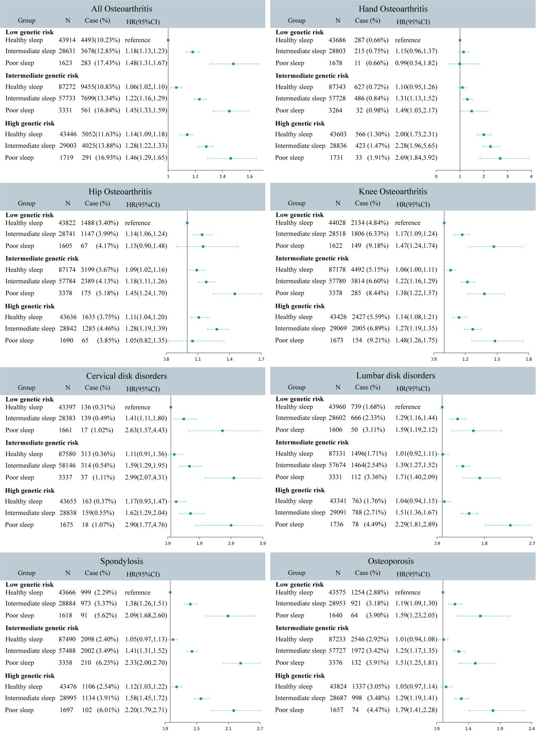
eFigure 1. The joint association of genetic risk and sleep pattern with degenerative skeletal disorders.
eTable 7. 8 associations reaching the multiple-testing significant levels in MR analyses.
Exposure | Outcome | Methods | OR (95%CI) | FDR adjusted P
Insomnia | Spondylosis | MR-PRESSO | 1.31 [1.11, 1.55] | 1.38E-02
 |  | MR-Egger | 1.18 [0.73, 1.89] | 9.88E-01
 |  | Weighted median | 1.23 [0.97, 1.56] | 9.82E-02
Insomnia | LDD | MR-PRESSO | 1.25 [1.07, 1.47] | 1.61E-02
 |  | MR-Egger | 1.22 [0.77, 1.93] | 9.88E-01
 |  | Weighted median | 1.18 [0.98, 1.43] | 9.82E-02
Early Chronotype | Overall OA | MR-PRESSO | 1.09 [1.02, 1.16] | 1.54E-02
 |  | MR-Egger | 0.97 [0.80, 1.17] | 9.88E-01
 |  | Weighted median | 1.00 [0.93, 1.08] | 9.20E-01
<7 h sleep duration | Overall OA | MR-PRESSO | 2.88 [1.63, 5.07] | 6.39E-03
 |  | MR-Egger | 5.33 [0.21, 135.39] | 9.88E-01
 |  | Weighted median | 2.49 [1.23, 5.04] | 2.74E-02
<7 h sleep duration | Knee OA | MR-PRESSO | 2.50 [1.33, 4.68] | 1.38E-02
 |  | MR-Egger | 14.43[0.35, 588.64] | 9.88E-01
 |  | Weighted median | 2.99 [1.32, 6.78] | 2.74E-02
<7 h sleep duration | CDD | MR-PRESSO | 5.41 [1.95, 15.01] | 9.01E-03
 |  | MR-Egger | 0.96 [0.01, 178.12] | 9.88E-01
 |  | Weighted median | 3.53 [0.88, 14.22] | 9.82E-02
<7 h sleep duration | LDD | MR-PRESSO | 2.97 [1.63, 5.41] | 6.39E-03
 |  | MR-Egger | 1.30 [0.04, 43.14] | 9.88E-01
 |  | Weighted median | 2.78 [1.29, 5.96] | 2.74E-02
≥9 h sleep duration | LDD | MR-PRESSO | 0.13 [0.03, 0.53] | 1.61E-02
 |  | MR-Egger | 0.69 [0.00, 186.13] | 9.88E-01
 |  | Weighted median | 0.12 [0.02, 0.65] | 2.74E-02

eTable 8. Heterogeneity and pleiotropy test for the 8 associations reaching the multiple-testing significant levels in MR analyses.
Exposure | Outcome | Q statistic | P for heterogeneity | Egger intercept | Egger standard error | P for pleiotropy
Insomnia | Spondylosis | 10.80 | 4.60E-01 | 4.47E-03 | 9.44E-03 | 6.45E-01
Insomnia | LDD | 18.35 | 7.38E-02 | 1.06E-03 | 9.10E-03 | 9.09E-01
Early Chronotype | Overall OA | 623.49 | 9.76E-37 | 3.24E-03 | 2.13E-03 | 1.29E-01
<7 h sleep duration | Overall OA | 49.43 | 1.67E-03 | -3.04E-03 | 1.08E-02 | 7.81E-01
<7 h sleep duration | Knee OA | 44.00 | 7.64E-03 | -1.03E-02 | 1.24E-02 | 4.13E-01
<7 h sleep duration | CDD | 32.62 | 1.12E-01 | 1.15E-02 | 1.74E-02 | 5.15E-01
<7 h sleep duration | LDD | 37.48 | 3.92E-02 | 6.55E-03 | 1.17E-02 | 5.80E-01
≥9 h sleep duration | LDD | 16.51 | 1.23E-01 | -9.93E-03 | 1.65E-02 | 5.60E-01

eTable 9. Associations between sleep characteristics and hand OA corrected by Mrlap.
Exposure | Outcome | OR (95%CI) | Corrected P
Insomnia | Hand OA | 1.27 [1.02,1.59] | 3.44E-02
Early Chronotype | Hand OA | 1.02 [0.97,1.07] | 4.02E-01
<7 h sleep duration | Hand OA | 1.08 [0.92,1.27] | 3.25E-01
≥9 h sleep duration | Hand OA | 0.83 [0.64,1.08] | 1.75E-01
Daytime sleepiness | Hand OA | 1.01 [0.90,1.14] | 8.44E-01
Self-report Snoring | Hand OA | 1.03 [0.91,1.17] | 6.00E-01
Note. Such associations corrected by Mrlap showed no distinct changes compared with results in IVW, indicating that the impact of sample overlap between sleep exposures and hand OA was mild and haven’t distorted our conclusion.

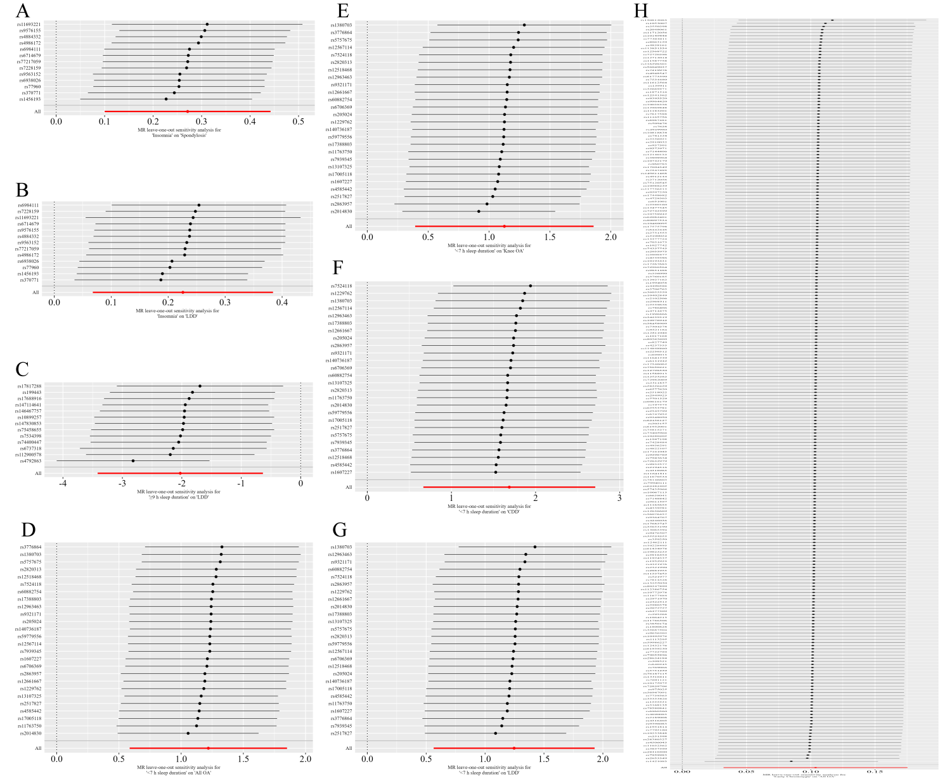

eFigure 2. Leave-one-out analyses of 8 causal associations reaching the multiple-testing significant levels in forward MR analyses. (A) insomnia and spondylosis; (B) insomnia and LDD; (C) long sleep duration and LDD; (D) short sleep duration and overall OA; (E) short sleep duration and knee OA; (F) short sleep duration and CDD; (E) short sleep duration and LDD; (H) early chronotype and overall OA.

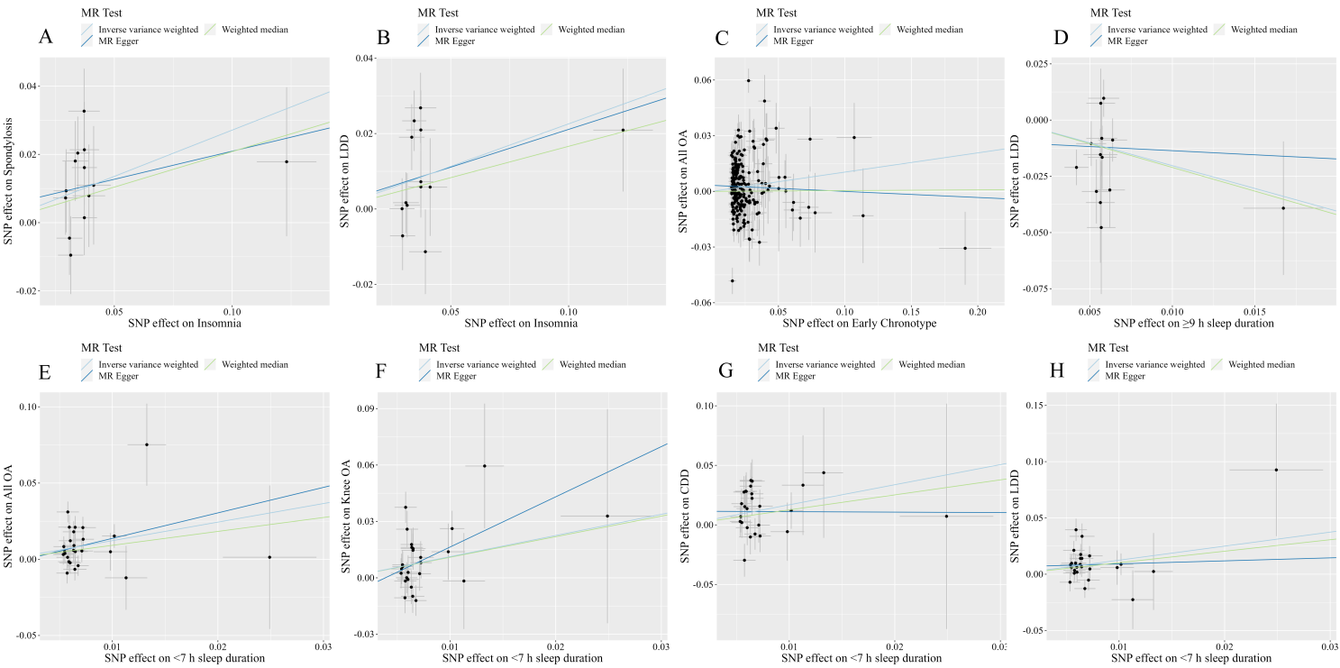
eFigure 3. Scatter plot of effects of SNPs used in forward MR analysis. (A) insomnia and spondylosis; (B) insomnia and LDD; (C) early chronotype and overall OA; (D) long sleep duration and LDD; (E) short sleep duration and overall OA; (F) short sleep duration and knee OA; (E) short sleep duration and CDD; (H) short sleep duration and LDD.

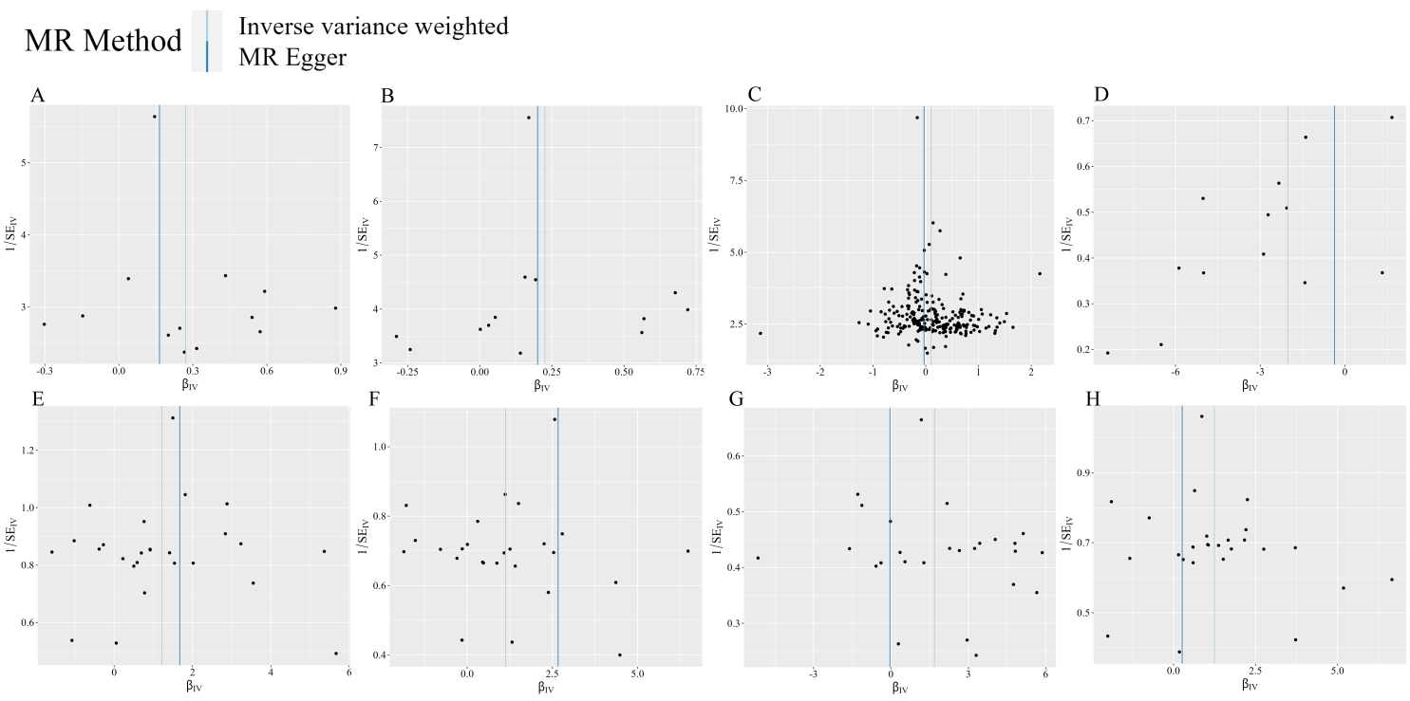
eFigure 4. Funnel plots of SNPS used in forward MR analyses, assessing heterogeneity. (A) insomnia and spondylosis; (B) insomnia and LDD; (C) early chronotype and overall OA; (D) long sleep duration and LDD; (E) short sleep duration and overall OA; (F) short sleep duration and knee OA; (E) short sleep duration and CDD; (H) short sleep duration and LDD.

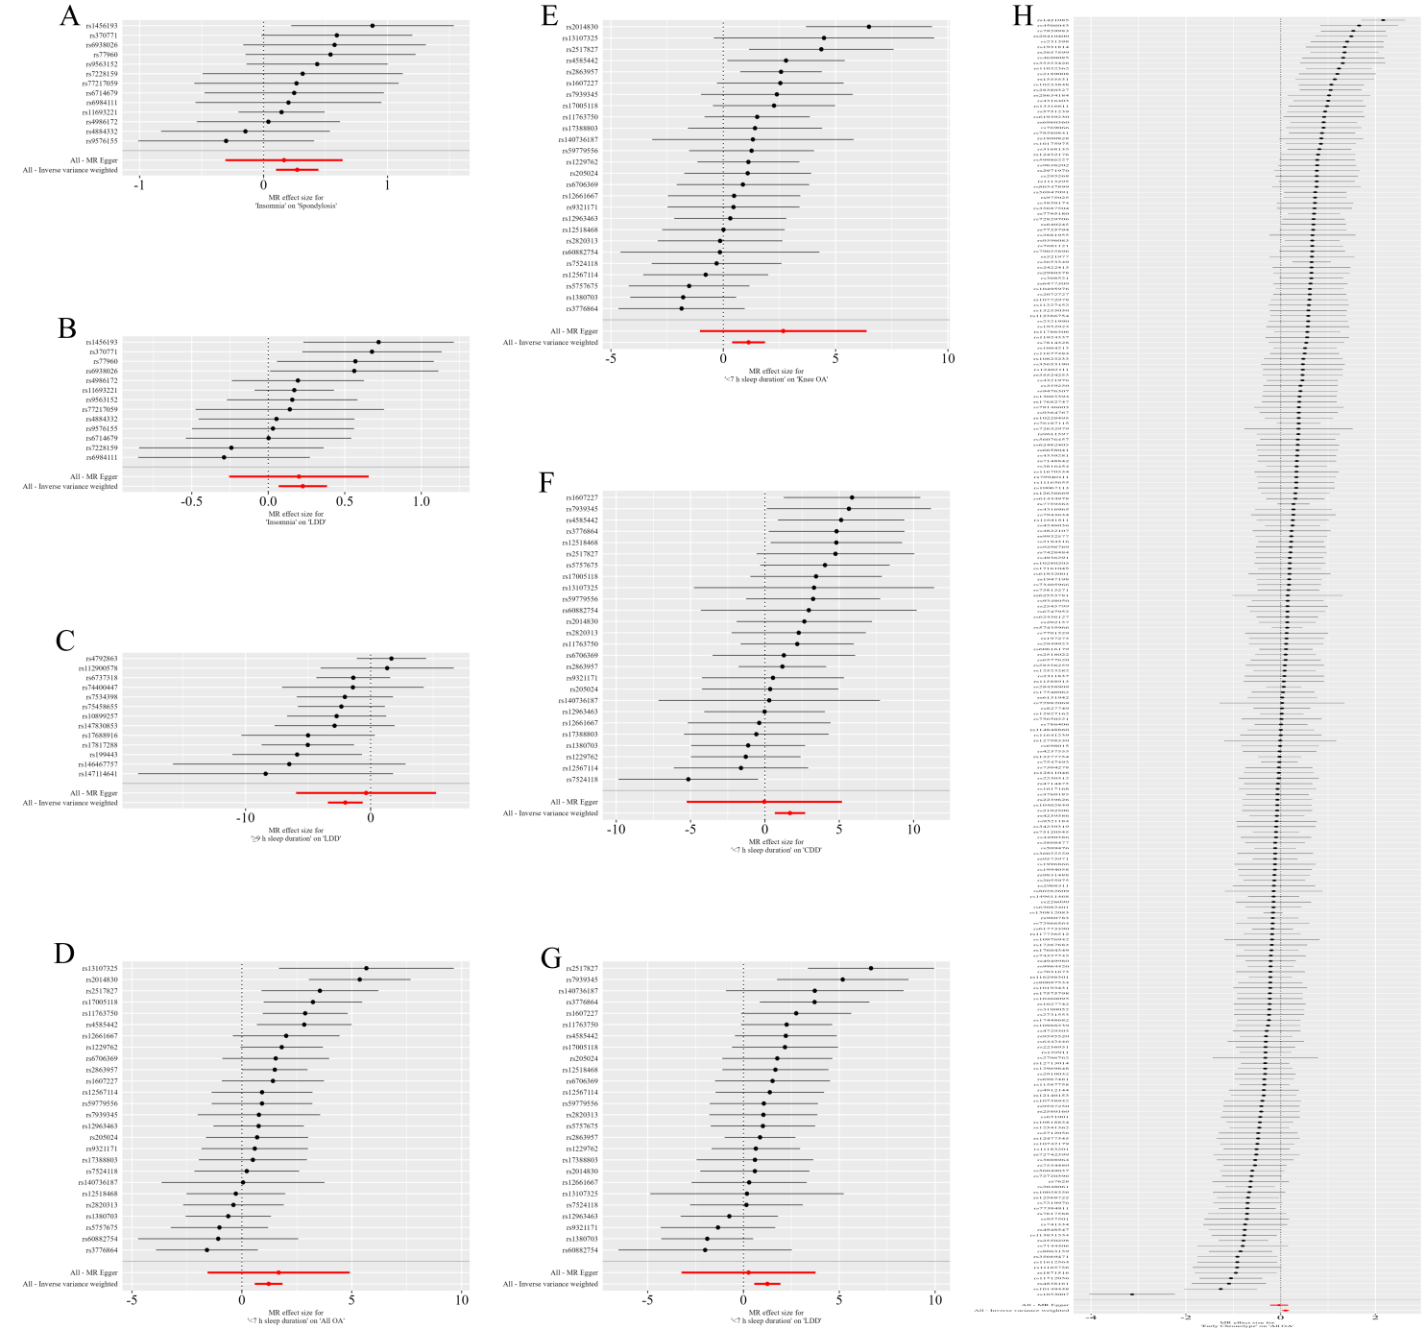
eFigure 5. Forest plot of single SNP analyses in forward MR. The single SNP analyses showed effects of every SNP on the outcomes. (A) insomnia and spondylosis; (B) insomnia and LDD; (C) long sleep duration and LDD; (D) short sleep duration and overall OA; (E) short sleep duration and knee OA; (F) short sleep duration and CDD; (E) short sleep duration and LDD; (H) early chronotype and overall OA.

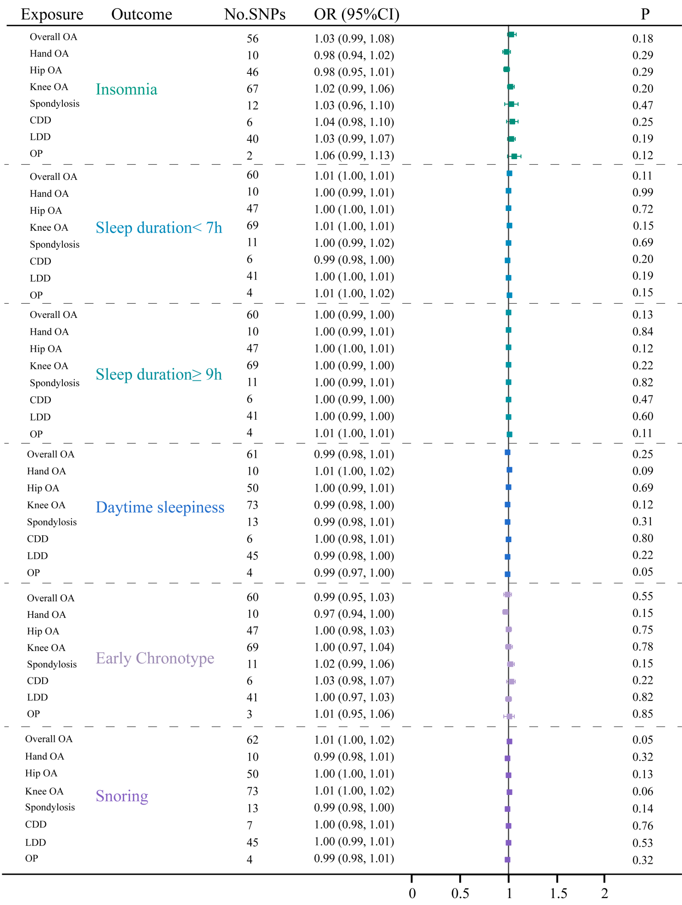
eFigure 6. The reverse MR estimating the association between degenerative skeletal disorders and sleep characteristics.
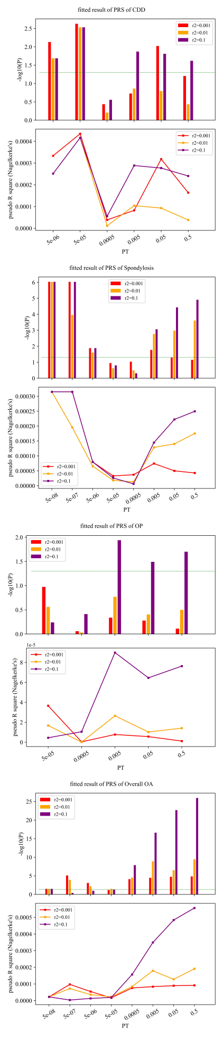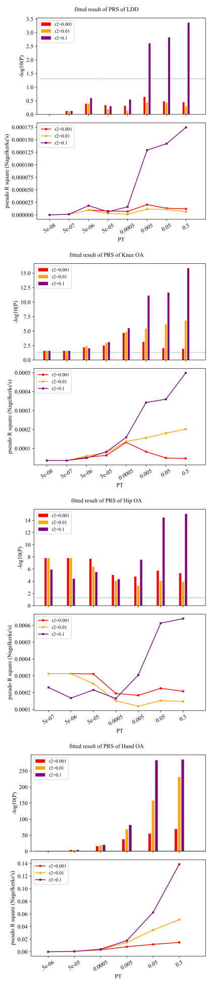
eFigure 7. Fitted results of all PRS and corresponding degenerative skeletal disorders
Note: The green line means P = 0.05 and bar higher than the line means that the PRS was significantly related with the outcome ( P < 0.05 ).

