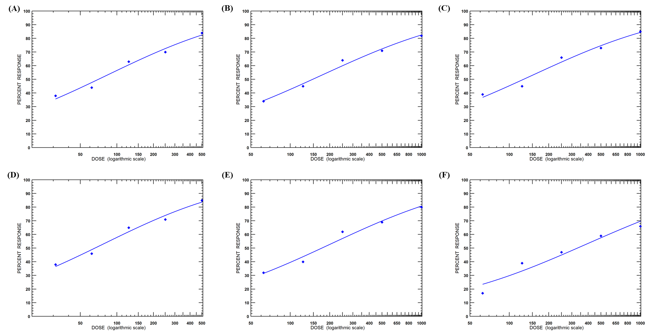
Figure S1: Dose dependent mortality of the treatments after 96 hours: 2 (A), 4 (B), 5 (C), 6 (D), Carbofuran (E), and crude methanolic extract (F)

Table S2: Molecular interaction details between ligands and target protein
Ligand | Interaction between | Distance (Å) | Category | Type | Binding energy (kcal/mol)
Compound 2 | :UNK0:H - A:GLN332:O  A:SER124:HG - :UNK0:O  A:THR127:HG1 - :UNK0:O  A:THR127:HG1 - :UNK0:O  :UNK0:C - A:TRP138  :UNK0:C - A:TYR390  :UNK0:C - A:TRP391  :UNK0:C - A:TRP138  A:TRP138 - :UNK0:C  A:TRP138 - :UNK0:C  A:TRP138 - :UNK0:C  A:TYR390 - :UNK0:C  A:TYR390 - :UNK0:C  A:TRP391 - :UNK0:C  A:TRP391 - :UNK0:C  A:HIS514 - :UNK0:C  A:HIS514 - :UNK0:C | 2.32976  2.31501  2.37759  2.49772  3.73076  3.64505  3.98869  3.9787  4.28457  4.537  3.83534  5.35647  4.19674  5.19628  4.30476  5.06728  5.10473 | Hydrogen Bond  Hydrogen Bond  Hydrogen Bond  Hydrogen Bond  Hydrophobic  Hydrophobic  Hydrophobic  Hydrophobic  Hydrophobic  Hydrophobic  Hydrophobic  Hydrophobic  Hydrophobic  Hydrophobic  Hydrophobic  Hydrophobic  Hydrophobic | Conventional Hydrogen Bond  Conventional Hydrogen Bond  Conventional Hydrogen Bond  Conventional Hydrogen Bond  Pi-Sigma  Pi-Sigma  Pi-Sigma  Pi-Sigma  Pi-Alkyl  Pi-Alkyl  Pi-Alkyl  Pi-Alkyl  Pi-Alkyl  Pi-Alkyl  Pi-Alkyl  Pi-Alkyl  Pi-Alkyl | -9.2
Compound 4 | :UNK0:C - A:PRO345:O  :UNK0:C - A:GLU251:OE1  :UNK0:C - A:GLU251:OE2  A:SER174:CB - :UNK0:O  :UNK0 - A:TRP391  :UNK0 - A:TYR394  A:GLY169:C,O;GLY170:N - :UNK0  :UNK0:C - A:PRO345  A:TRP138 - :UNK0:C  A:TRP391 - :UNK0:C  A:TRP391 - :UNK0:C  A:HIS514 - :UNK0:C  A:HIS514 - :UNK0:C | 3.58607  3.29473  3.57365  3.68112  4.8459  5.18158  4.24737  4.76983  4.02914  5.35862  4.94201  5.1452  4.50736 | Hydrogen Bond  Hydrogen Bond  Hydrogen Bond  Hydrogen Bond  Hydrophobic  Hydrophobic  Hydrophobic  Hydrophobic  Hydrophobic  Hydrophobic  Hydrophobic  Hydrophobic  Hydrophobic | Carbon Hydrogen Bond  Carbon Hydrogen Bond  Carbon Hydrogen Bond  Carbon Hydrogen Bond  Pi-Pi T-shaped  Pi-Pi T-shaped  Amide-Pi Stacked  Alkyl  Pi-Alkyl  Pi-Alkyl  Pi-Alkyl  Pi-Alkyl  Pi-Alkyl | -8.9
Compound 5 | :UNK0:H - A:HIS514:O  A:SER174:HG - :UNK0:O  A:SER174:CB - :UNK0:O  A:HIS514:CD2 - :UNK0:O  A:ASP126:OD2 - :UNK0  A:ASP126:OD2 - :UNK0  :UNK0 - A:TRP138  A:TRP138 - :UNK0  :UNK0 - A:TYR390  A:TRP138 - :UNK0:C  A:TRP391 - :UNK0:C  A:TYR394 - :UNK0:C | 2.2249  2.00696  3.40472  3.07868  4.91629  4.6461  3.83262  3.74702  5.06142  4.29231  4.93503  4.03063 | Hydrogen Bond  Hydrogen Bond  Hydrogen Bond  Hydrogen Bond  Electrostatic  Electrostatic  Hydrophobic  Hydrophobic  Hydrophobic  Hydrophobic  Hydrophobic  Hydrophobic | Conventional Hydrogen Bond  Conventional Hydrogen Bond  Carbon Hydrogen Bond  Carbon Hydrogen Bond  Pi-Anion  Pi-Anion  Pi-Pi Stacked  Pi-Pi Stacked  Pi-Pi T-shaped  Pi-Alkyl  Pi-Alkyl  Pi-Alkyl | -10.0
Compound 6 | :UNK0:H - A:HIS514:O  :UNK0:H - A:SER124:O  A:ASP126:HN - :UNK0:O  :UNK0:C - A:ASP126:OD2  A:SER174:CB - :UNK0:O  A:HIS514:CD2 - :UNK0:O  A:ASP126:OD2 - :UNK0  A:ASP126:OD2 - :UNK0  :UNK0 - A:TRP138  A:TRP138 - :UNK0  :UNK0 - A:TYR390  A:TRP391 - :UNK0:C  A:TYR394 - :UNK0:C | 2.31849  2.15422  3.00975  3.62897  3.58341  3.10564  4.82782  4.57423  3.84218  3.73238  5.10783  5.05816  3.95153 | Hydrogen Bond  Hydrogen Bond  Hydrogen Bond  Hydrogen Bond  Hydrogen Bond  Hydrogen Bond  Electrostatic  Electrostatic  Hydrophobic  Hydrophobic  Hydrophobic  Hydrophobic  Hydrophobic | Conventional Hydrogen Bond  Conventional Hydrogen Bond  Conventional Hydrogen Bond  Carbon Hydrogen Bond  Carbon Hydrogen Bond  Carbon Hydrogen Bond  Pi-Anion  Pi-Anion  Pi-Pi Stacked  Pi-Pi Stacked  Pi-Pi T-shaped  Pi-Alkyl  Pi-Alkyl | -9.9
Carbofuran | :UNK0:H - :UNK0:O  A:TYR182:HH - :UNK0:O  :UNK0:C - A:TRP138:O  :UNK0 - A:TRP138  A:TRP138 - :UNK0  A:HIS514 - :UNK0  :UNK0 - A:TYR390  A:TRP138 - :UNK0  A:TRP138 - :UNK0:C  A:TRP138 - :UNK0:C  A:TRP138 - :UNK0  A:TRP138 - :UNK0:C  A:TYR390 - :UNK0  A:TRP391 - :UNK0  A:TRP391 - :UNK0:C | 2.27197  2.80517  3.77585  3.93736  4.11146  5.42524  5.25296  4.55939  4.84193  5.38364  5.16356  4.78732  5.26645  5.14427  5.11137 | Hydrogen Bond  Hydrogen Bond  Hydrogen Bond  Hydrophobic  Hydrophobic  Hydrophobic  Hydrophobic  Hydrophobic  Hydrophobic  Hydrophobic  Hydrophobic  Hydrophobic  Hydrophobic  Hydrophobic  Hydrophobic | Conventional Hydrogen Bond  Conventional Hydrogen Bond  Carbon Hydrogen Bond  Pi-Pi Stacked  Pi-Pi Stacked  Pi-Pi Stacked  Pi-Pi T-shaped  Pi-Alkyl  Pi-Alkyl  Pi-Alkyl  Pi-Alkyl  Pi-Alkyl  Pi-Alkyl  Pi-Alkyl  Pi-Alkyl | -7.5

