Supplementary Digital Material: Bot Fit assistance algorithm
1. Delayed output feedback control (DOFC) for gait assistance
As shown in Fig. S1(A), this time-delayed, self-excited feedback control method does not include a gait phase estimator as well as a reference lookup for generating assistive torques. The assistive torques are immediately computed and applied as the user changes the joint angles. The torques are updated following hip motion changes at every control period (100Hz). Fig. S1(B) shows the control flow of the DOFC based assistance.

1.1 Smoothing hip sensor data with low pass filter (LPF)
The left and right hip angles q_{r}^{raw}(t), q_{l}^{raw}(t) are obtained from the angular sensors located at the hip joints. These angles are then smoothed by passing through a 1st order FIR filter, the output of which is calculated as follows.
q_{r}(n) = (1 - α) q_{r}(t - t_{s}) + α q_{r}^{raw}(t), (0 < α <1) (1)

where t_{s} is the sampling period, q_{r}^{raw}(t) is the current hip angle, q_{r}(t - t_{s}) is the previous output which is previous smoothed hip angle, α is the smoothing factor. The smoothing factor α = 0.05 (cut-off frequency f_{c} ≈ 0.84 Hz) in Eq. (1) was selected to generate the smoothed output torque. We then calculate the state variable y = sin q_{r}(t) − sin q_{l}(t), to represent the current gait behavior.

1.2 Assistive torque from delayed state feedback
The assistance torque τ is finally generated by incorporating appropriate time delays ∆t and control gain κ into the defined output state y(t).
τ (t) = κ y(t − ∆t) (2)
where ∆t is the time-delay and κ is the feedback gain.

1.3 Synergetic hip extension and flexion assistance
The basic assistance strategy (Fig. S1(B)) can be extended for both right/left hip assistive torque generation τ_{r,des}, τ_{l,des} as the following form.
Gait Status | τ_{r,des}(t) | τ_{l,des}(t)
Right hip flexion / Left hip extension | −τ (t) | τ (t)
Right hip extension / Left hip flexion | τ (t) | −τ (t)

In this way, the hip extension and flexion torques are simultaneously generated for propulsive gait synergy.

1.4 Tunable control parameters of DOFC based assistance
In this controller, there are two main control parameters feedback gain κ and time-delay ∆t.
The torque magnitude is adjusted by the feedback gain κ. As shown in Fig. S2, we can fine-tune the assist intensity linearly by adjusting the gain value.
By increasing or decreasing the time-delay value ∆t in Eq. (2), we can also smoothly adjust the assistance response. Since the maximum assistance may come earlier (early timing) or later (late timing) in response to the walking speed, the time-delay ∆t should be properly set. So, from an initial value of 0.25, ∆t adapts to the walking speed.
Gain | 1.9 | 3.8 | 5.4 | 6.1 | 6.7
Mean Positive Power | 1.79 | 3.61 | 5.40 | 6.18 | 6.89
Mean Negative Power | 0.10 | 0.19 | 0.25 | 0.30 | 0.28

1.5 Seamless assistance in changing walking speed
Fig. S3 illustrates how the assistance torque profile changed as the walking speed changed with the delay and gain parameters (∆t = 0.25~0.11s, κ = 5.4). As one walks faster, his stride gets wider and the generated torque gets higher. This is shown in Fig. S3. However, the much high positive (assistive) power at high speed is largely due to the fast gait swing rather than the wide stride. Negative (resistive) power in Fig. S3 is maintained low owing to the time-delay adaption feature.
Gait Speed [km/h] | 1.5 | 2.0 | 2.5 | 3.0 | 3.5 | 4.0 | 4.5 | 5.0 | 5.5 | 6.0 | 6.5
Mean Positive Power | 2.28 | 2.54 | 3.47 | 3.81 | 4.68 | 5.36 | 6.12 | 6.84 | 7.44 | 7.94 | 8.18
Mean Negative Power | 0.14 | 0.13 | 0.16 | 0.18 | 0.24 | 0.26 | 0.22 | 0.21 | 0.21 | 0.17 | 0.13

1.6 Advanced DOFC algorithm for anaerobic exercise
The key point of the advanced DOFC algorithm is to apply the distinguished control state variable representing characteristics of hip joint movement during step based and non-step based exercise. The control state y(t) = sin(q_{r}(t)) − sin(q_{l}(t)) was defined to represent hip angle difference during step motion like walking exercise. Because bilateral hip joint during non-step motion have similar joint angle profile, control state of non-step exercise was defined to y(t) = sin((q_{r}(t) + q_{l}(t))/2).

Step exercise: y(t) = sin(q_{r}(t)) − sin(q_{l}(t)) (3)
Non-step exercise: y(t) = sin((q_{r}(t) + q_{l}(t))/2)

Based on separated control states, torque application strategies of step and non-step exercise are distinguished. In case of step based exercise, assistive torque for the left hip is generated with positive gain, and conversely, resistive torque is generated with negative gain (Fig. S4(A)). Assistive or resistive torque for the right hip can be obtained by reversing the torque of the left hip (τ_{𝑟𝑖𝑔ℎ𝑡} = −τ_{𝑙𝑒𝑓𝑡}).
On the other hands, in case of step based exercise, assistive torques for the both side hip joints are generated with positive gain and resistive torques are generated with generated with negative gain (τ_{𝑟𝑖𝑔ℎ𝑡} = τ_{𝑙𝑒𝑓𝑡}) (Fig.S4(B)). A balanced exercise effect can be obtained by applying symmetric torques on both side joints.
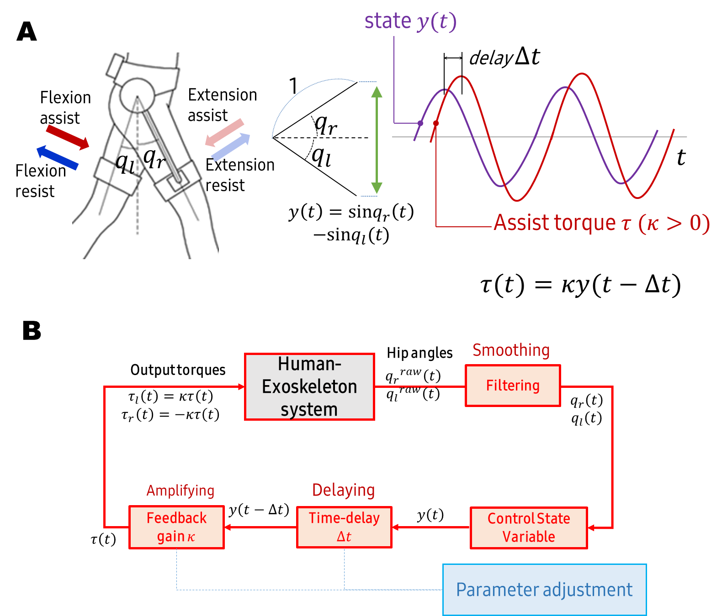
Fig. S1. Gait assistance strategy with delayed output feedback control: q_{r} and q_{l} are the right and left hip angles, respectively. ∆t is the time-delay and κ is the feedback gain. (A) Hip assistance strategy. (B) Self-excited feedback control loop.

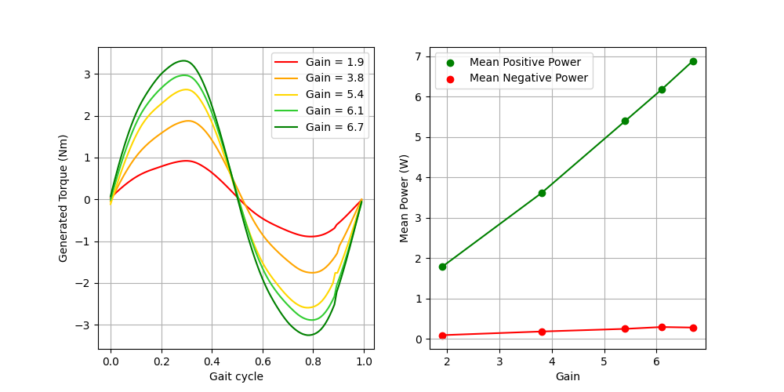
Fig. S2. Torque changes generated by input gain changes: The feedback gain κ was increased for every walking cycle. The treadmill walking speed is 4km/h and the time-delay ∆t is about 0.14 s. (Left) Generated torque. (Right) Mean positive/negative power vs gain.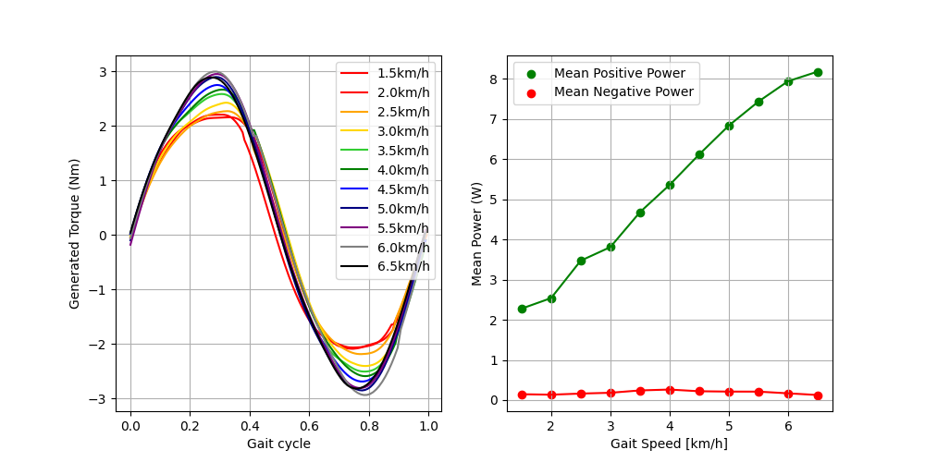
Fig. S3. Torque changes generated by walking speed changes: The treadmill speed was increased from 1.5 to 6.5 km/h with control parameters ∆t = 0.25~0.11s, κ = 5.4. (Left) Generated torque (Right) Mean positive/negative power vs gait speed.

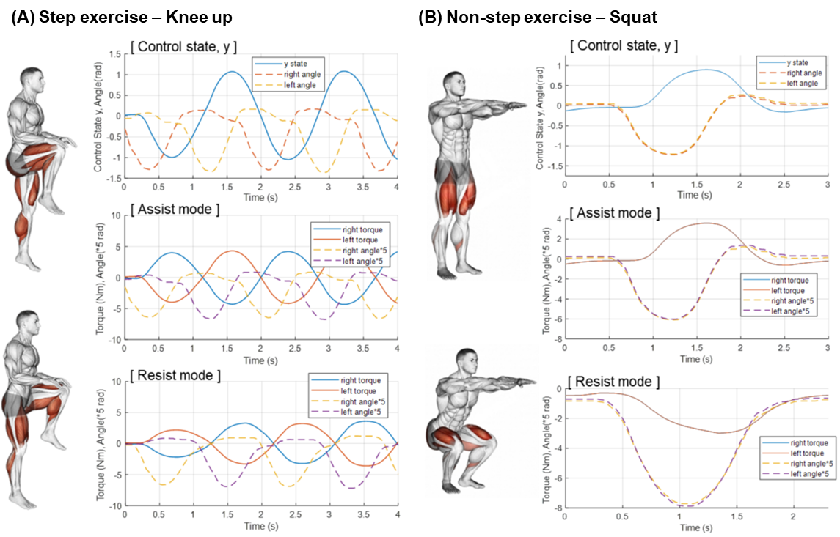
Fig. S4. Example of torque strategy: (A) Step exercise, knee up. (B) Non-step exercise, squat.

