Genomic DNA Library Preparation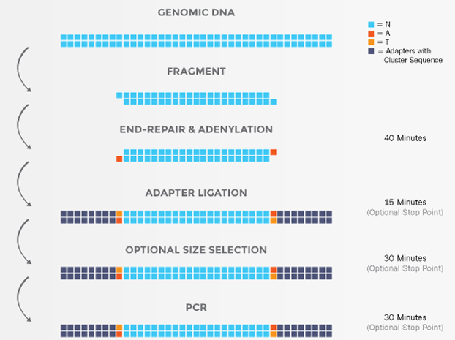
Supplemental Figure S1. Experimental Procedures of Genomic DNA Library

gDNA fragment by sonication
gDNA sample requirements: No degradation or minor degradation, no impurity such as RNA, and OD260/280 = 1.8~2.0.
500–1000 ng of gDNA samples were taken, watered to 21 μL.gDNA fragment by sonication with a main peak of 250-300 bp to avoid overheating of gDNA.1 μL gDNA after sonication was taken to check whether the main peak of the DNA fragment was 250-300 bp by 2% agarose gel electrophoresis to adjust the condition of sonication.

End-joining activity
gDNA fragment by sonication were sampled according to the following reaction system, slightly homogenized, transiently centrifuged and then placed on a low temperature metal bath. The PCR reaction program was initiated, and the reaction system was placed into the PCR instrument after the temperature had dropped to 20℃.
Reaction system (25 μL): DNA fragment 19 μL, End-Repair & Adenylation Buffer 3.5 μL, and End-Repair & Adenylation Enzyme Mix 2.5 μL.
Reaction procedure: 30 min at 20℃, 30 min at 65℃, and 1 min at 10℃.

Linker ligation
The index numbers of Adaptor Oligo Mix in relation to the samples were recorded. Linker ligation system was sampled according to the following reaction system, slightly homogenized, transiently centrifuged and then placed on a low temperature metal bath. The PCR reaction program was initiated, and the reaction system was placed into the PCR instrument after the temperature had dropped to 22℃.
Reaction system (37 μL): End-joining system 25 μL, Ligase Buffer 8 μL, Ligase Mix 1 μL, and Adaptor Oligo Mix 3 μL.
Reaction procedure: 30 min at 22℃.

Linker ligation purified by magnetic bead
17.5 μL Agencourt AMPure XP were added into the Linker ligation system, fully homogenized, and set at room temperature for 5 min. The purification system was placed on the magnet rack for 5 min. The supernatant was aspirated with pipette and discarded until the upper liquid was cleared. 200 μl of 80 % ethanol were added slowly along the tube wall, and the supernatant is removed after resting for 30 s. Then, this step was repeated once. The system was transiently centrifuged, placed on a magnet rack, removed residual fluid, and left to magnet dry for 2 min. 12 μl Nuclease-free Water were added to the tube, with magnetic bead mixed by pipette, then placed on the magnet rack after resting for 2 min. The supernatant was collected for future use.

PCR system
Reaction system (25 μL): Purified products 11.5 μL, 2X PCR Master Mix 12.5 μL, and Primer Mix 1 μL.
Reaction procedure: After 2 min at 98℃, 8-10 cycle s were performed with the following program: 20 s at 98℃, 30 s at 65℃, and 40 s at 72℃, then, 4 min at 72℃.

PCR system purified by magnetic bead
25 μL Agencourt AMPure XP were added into the PCR system, fully homogenized, and set at room temperature for 5 min. The purification system was placed on the magnet rack for 5 min. The supernatant was aspirated with pipette and discarded until the upper liquid was cleared. 200 μl of 80 % ethanol were added slowly along the tube wall, and the supernatant is removed after 30 s rested. Then, this step was repeated once. The system was transiently centrifuged, placed on a magnet rack, removed residual fluid, and left to magnet dry for 2 min. 25 μL TE buffer were added to the tube, with magnetic bead mixed by pipette, then placed on the magnet rack after resting for 2 min. The supernatant was collected for future use.

