Electrically induced redox reaction driven magnon FET

Md Shamim Sarker ^{1,5,*}, Hiroyasu Yamahara ^{1,4*}, Siyi Tang ², Sankar Ganesh Ramaraj ¹, E M K Ikball Ahamed ², Lihao Yao, Munetoshi Seki ^{2,3,4}, Hitoshi Tabata ^{1,2,3,4,*}
¹Department of Bioengineering, Graduate School of Engineering, The University of Tokyo, 7-3-1 Hongo, Bunkyo-ku, Tokyo 113-8656, Japan
² Department of Electrical Engineering and Information Systems, Graduate School of Engineering, The University of Tokyo, 7-3-1 Hongo, Bunkyo-ku, Tokyo 113-8656, Japan
³Center for Spintronics Research Network, Graduate School of Engineering, The University of Tokyo, 7-3-1 Hongo, Bunkyo-ku, Tokyo 113-8656, Japan
⁴Institute for AI and beyond, The University of Tokyo, 7-3-1 Hongo, Bunkyo-ku, Tokyo 113-8656, Japan
⁵Department of Electrical and Electronic Engineering, Khulna University of Engineering and Technology, Khulna-9203, Bangladesh
*Corresponding authors: sarker@bioxide.t.u-tokyo.ac.jp, yamahara@bioxide.t.u-tokyo.ac.jp, tabata@bioxide.t.u-tokyo.ac.jp

Supplementary Materials
S1. Gate voltage-dependent spin wave transmission spectra
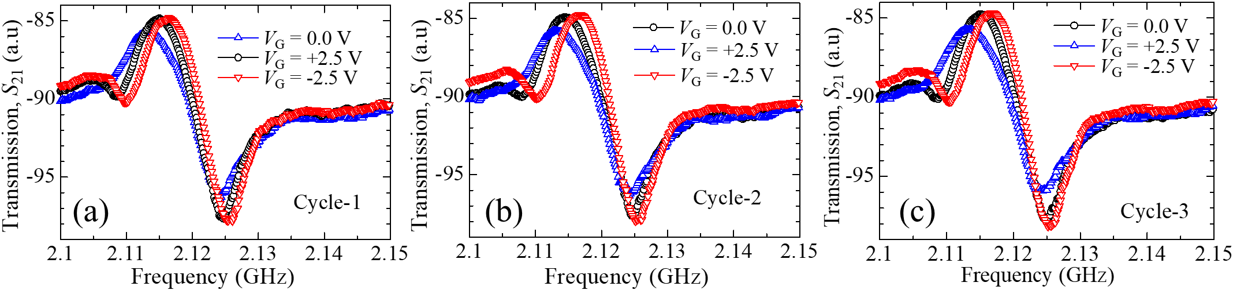
Figure S1. Gate voltage-dependent transmission spectra S₂₁ for repetitive cycles: (a) cycle-1, (b) cycle-2, and (c) cycle-3.

S2. Systematic spin wave spectra
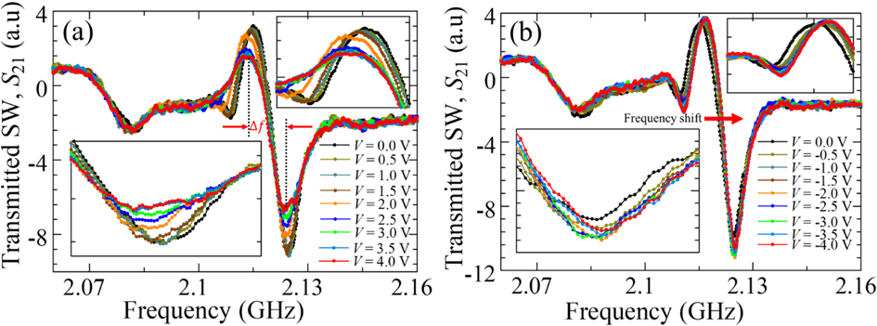
Figure S2. Systematic spin wave spectra under incremental voltage application for (a) positive and (b) negative voltages.

S3. Cyclic voltammetry measurement
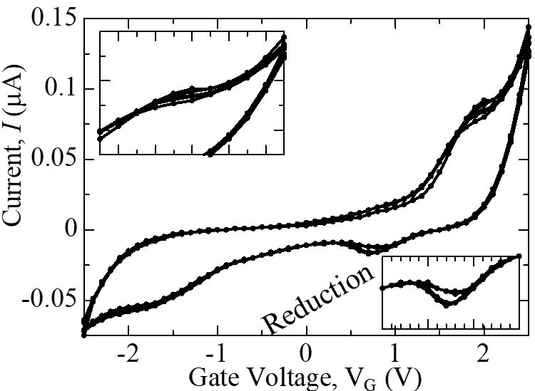
Figure S3. Cyclic voltammetry measurement of the Au/PEDOT:PSS/Pt gate stack. A total of five sweeping cycles were conducted, all consistently exhibiting oxidation and reduction peaks.

S4. Cyclic voltammetry measurement dependent on sweep rate
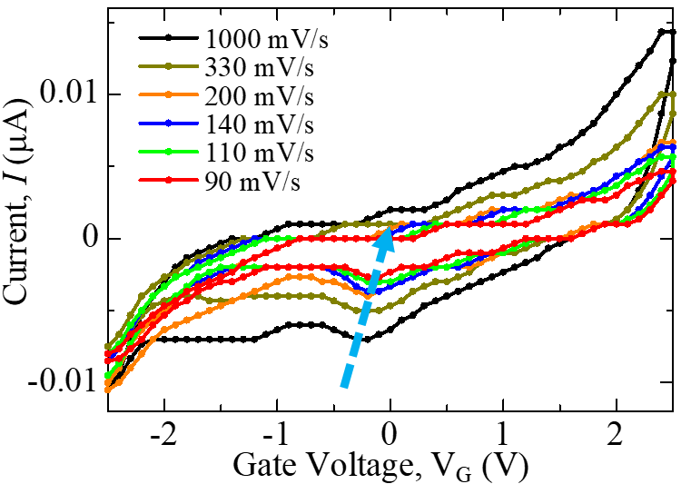
Figure S4. Cyclic voltammetry measurement data dependent on sweep rate.
S5. Charge transfer dependent on scan rate

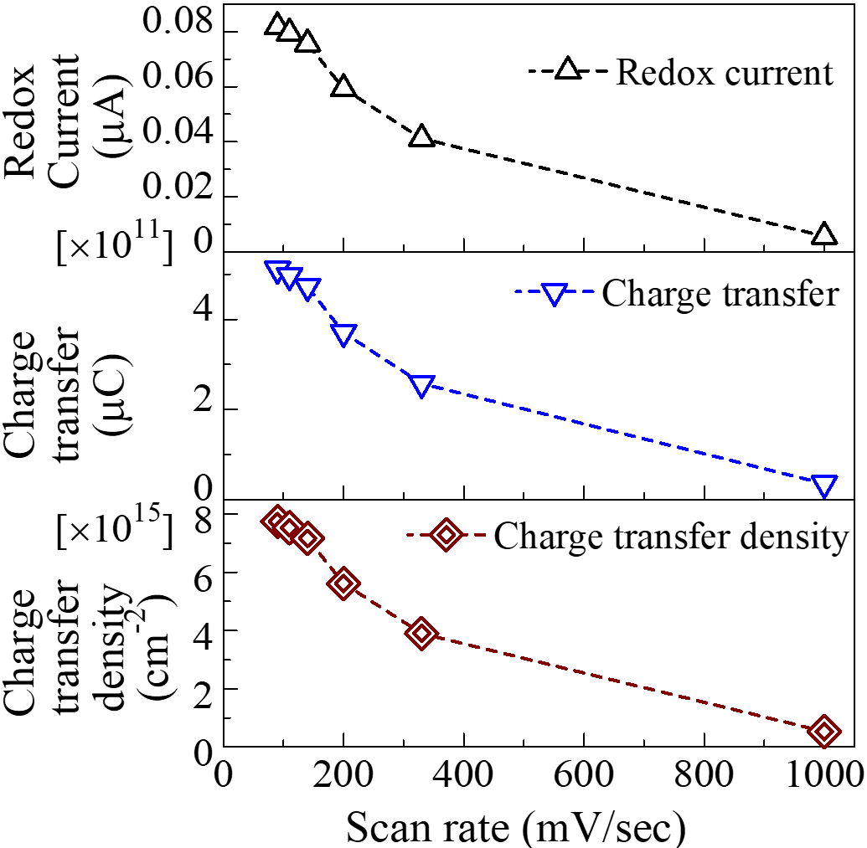

Figure S5. (a) Absolute current, (b) total charge transfer, and (c) charge transfer density of dynamic redox reaction as functions of scan rate.

