Title: Cost-effectiveness of PARP inhibitors for maintenance therapy of patients with a BRCA mutation and primary epithelial ovarian cancer in China

Supplementary Materials
Supplementary Table 1 | Patient baseline characteristics of the included studies
Supplementary Table 2 | Catalog of medical service prices in 12 provinces/municipality
Supplementary Figure 1-4 | Tornado charts from one-way sensitivity analyses (OWSA)

Supplementary Table 1 Patient baseline characteristics comparison among cohorts from the FZOCUS-1, SOLO-1, PRIME, and PAOLA-1 trials
Characteristics | FZOCUS-1 | SOLO-1 | PRIME | PAOLA-1
Characteristics | Fuzuloparib | Olaparib | Niraparib | Olaparib + bevacizumab
Median age, years | 54 | 53 | 53 | 57
Eastern Cooperative Oncology Group (ECOG) performance status 0, % | 56 | 77 | 38 | 73
International Federation of Gynecology and Obstetrics (FIGO) stage III, % | 79 | 85 | 71 | 71
No residual disease after cytoreduction, % | 56 | 78 | 75 | 69
Complete response after platinum-based chemotherapy, % | 80 | 82 | 83 | 81
Neoadjuvant chemotherapy, % | 42 | Not reported | 48 | Not reported
Normal serum CA125 level, % | Not reported | 95 | 99 | 86

Supplementary Table 2 Catalog of medical service prices in 12 provinces/municipality
Provinces/municipality | Original websites
Guangdong (Shenzhen) | http://hsa.sz.gov.cn/zwfw/mdml/ylfwxmjg/jbylfwxmjg/
Shandong | http://www.duyaonet.com/_FileUpLoad/20230307/20230307091958.pdf
Henan | https://oss.henan.gov.cn/typtfile/20230717/a2507e785b1a4865bd3ed264255fb0f9.pdf#pdfjs.action=download
Jiangsu | https://ybj.jiangsu.gov.cn/module/download/downfile.jsp?classid=0&filename=e5d53a8f440648a9b9bf4b863de51405.pdf
Sichuan (Chengdu) | https://cdyb.chengdu.gov.cn/gkml/qtwj/1181545982341414912.shtml
Hebei | http://ylbzj.hebei.gov.cn/cms/upload/e7b93444-c1e3-4da5-a0af-235bbc42e641.pdf
Hunan | https://ybj.hunan.gov.cn/ybj/first113541/firstF/f2113606/202211/t20221110_29122074.html
Zhejiang | http://ybj.zj.gov.cn/art/2023/3/31/art_1229225636_5088355.html
Anhui | https://www.xuanzhou.gov.cn/OpennessContent/show/2584973.html
Hubei | https://test.hb3rm.com/upload/20210521/60a7105c747c3.pdf
Shanghai | http://ybj.sh.gov.cn/qtwj/20211104/8fbf9847c2f945b8a0b3274b8e74bf6f.html
Beijing | https://zyk.bjhd.gov.cn/sjkf/wsyl/201905/t20190515_4318860.shtml

Supplementary Figure 1 Tornado chart of ICER from OWSA (fuzuloparib versus routine surveillance)
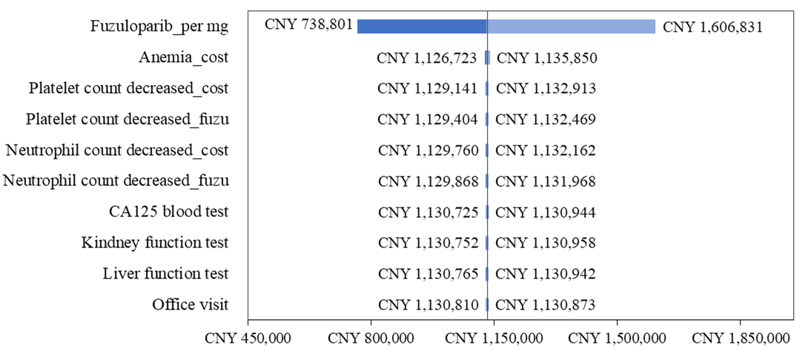

Supplementary Figure 2 Tornado chart of ICER from OWSA (olaparib versus routine surveillance)
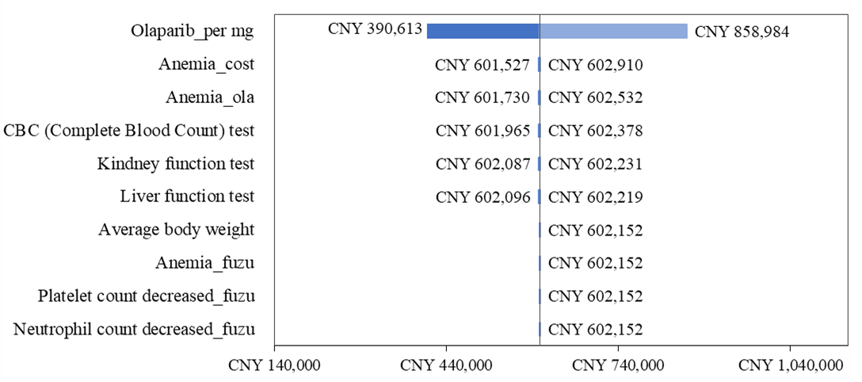

Supplementary Figure 3 Tornado chart of ICER from OWSA (niraparib versus routine surveillance)
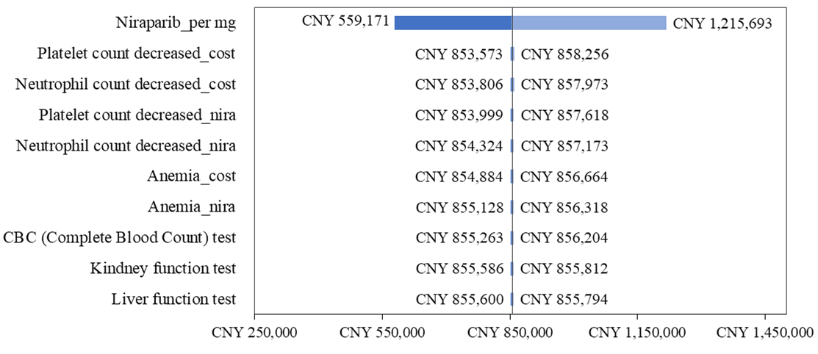

Supplementary Figure 4 Tornado chart of ICER from OWSA (olaparib+bevacizumab versus routine surveillance)
