Supplementary Information for
Intrinsically Stretchable OLEDs with a Designed Morphology-Sustainable Layer and Stretchable Metal Cathode
Je-Heon Oh^{1,†}, Kun-Hoo Jeon^{1,†}, and Jin-Woo Park^{1*}
¹Department of Materials Science and Engineering, Yonsei University, Seoul, 03722, Korea
†These authors contributed equally: Je-Heon Oh, Kun-Hoo Jeon
*Corresponding author’s contact information: E-mail: jwpark09@yonsei.ac.kr, Phone: +82 2 2123 5834, Fax: +82 2 312 5375

This PDF file includes:
Supplementary Figs. 1-28
Supplementary Tables 1-2
Supplementary References

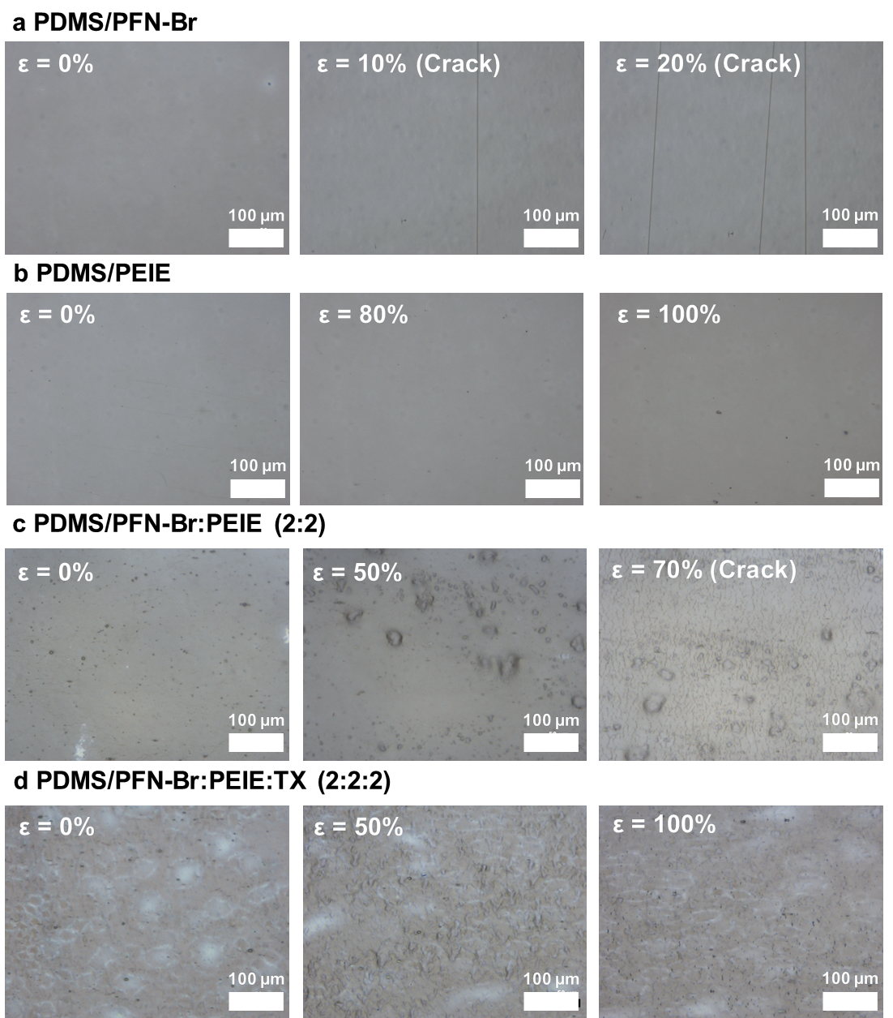
Supplementary Fig. 1 | Mechanical stretchability of PFN-Br and PEIE. Optical Microscopy images of a, PFN-Br, b, PEIE, c, PFN-Br:PEIE, and d, PFN-Br:PEIE:TX under various strain.

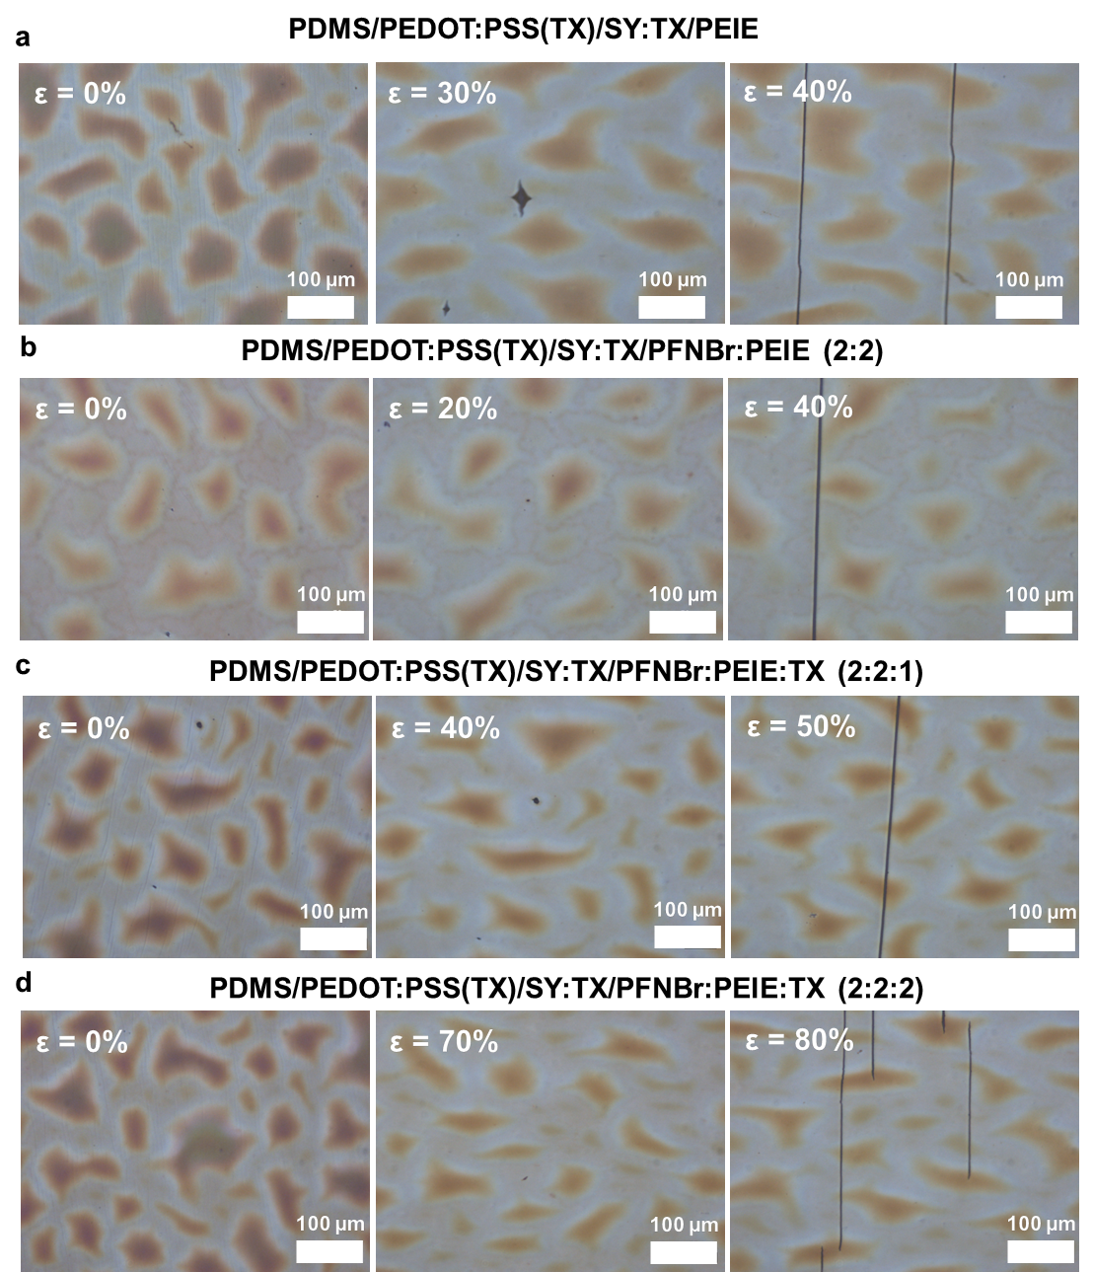
Supplementary Fig. 2 | COS test of PFN-Br:PEIE:TX ETLs on is-EMLs. OM images of a, PDMS/PEDOT:PSS(TX)/is-EML/PEIE, b, PDMS/PEDOT:PSS(TX)/is-EML/PFN-Br:PEIE (2:2), c, PDMS/PEDOT:PSS(TX)/is-EML/PFN-Br:PEIE:TX (2:2:1), and d, PDMS/PEDOT:PSS(TX)/is-EML/PFN-Br:PEIE:TX (2:2:2) under various strains.

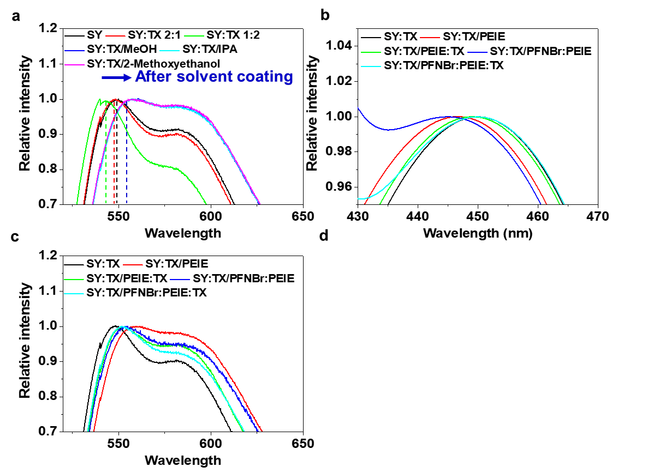
Supplementary Fig. 3 | Abs and PL intensity of SY. a, PL spectra of SY before and after TX blending at various TX blending ratios, and solvent coating effect on the is-EML. b, Abs and c, PL spectra of is-EMLs after coating with various ETL solutions.

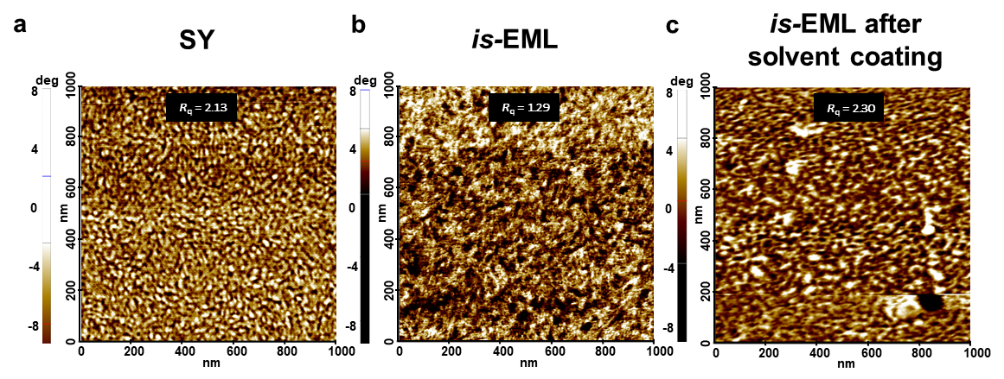
Supplementary Fig. 4 | AFM surface phase images of an is-EML. AFM surface phase images of a, pristine SY, b, an is-EML (SY:TX = 2:1), and c, the is-EML after MeOH solvent coating.

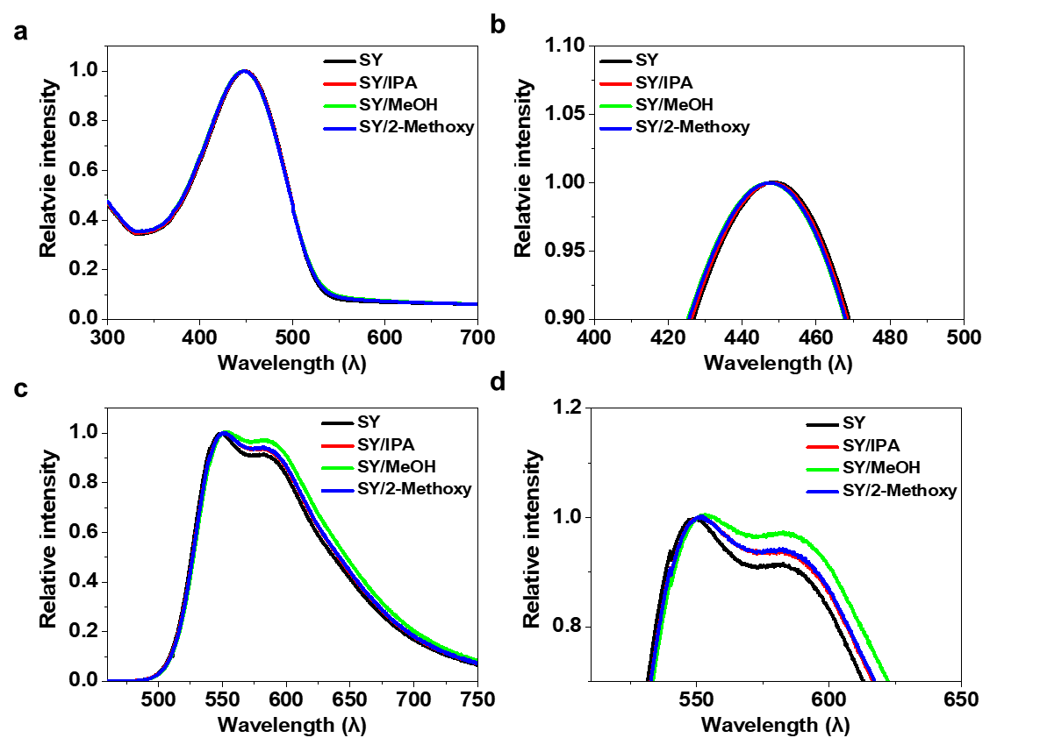
Supplementary Fig. 5 | Solvent effect on the SY optical characteristic. a, b, UV-vis absorption spectra and c, d, Photoluminescence spectra of SuperYellow with/without solvent treatments. For the pristine SY EML, there were negligible changes in both absorbance and photoluminescence peak wavelengths.

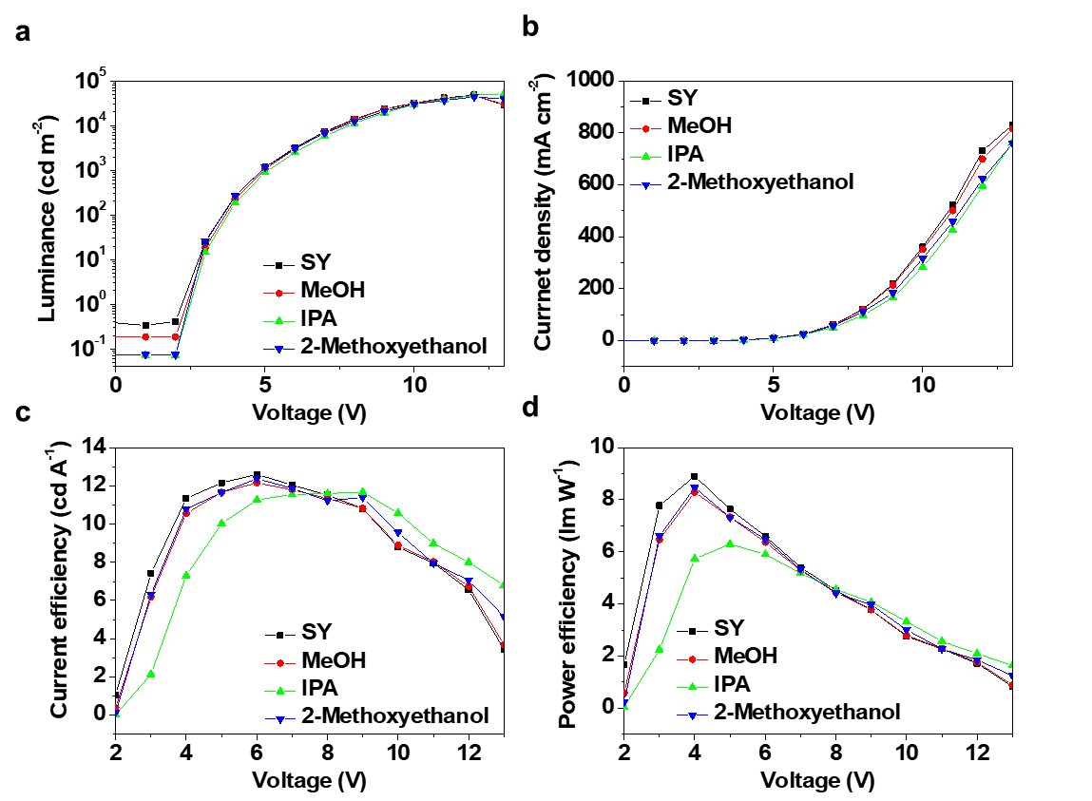
Supplementary Fig. 6 | Effect of solvent treatment on the SY EML in conventional OLEDs. This figure displays a, luminance-voltage (L-V) curve, b, current-voltage (J-V) curve, c, current efficiency, and d, power efficiency of conventional OLEDs both with and without solvent treatment on the SY film. The OLED structure is ITO/PEDOT:PSS(TX)/SY/solvent/d-PEIE/Al.

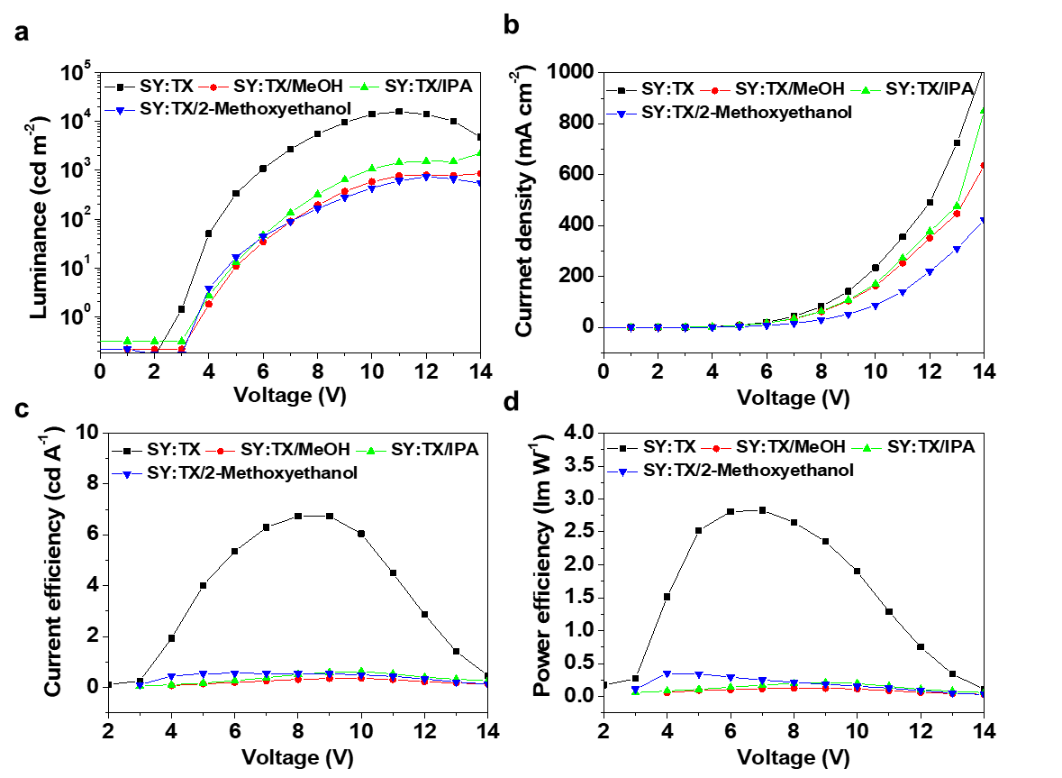
Supplementary Fig. 7 | Solvent effect on the device performance with is-EML. The figure illustrates a L-V curve, b J-V curve, c current efficiency, and d power efficiency of conventional OLEDs with and without solvent treatment on the is-EML. The OLED structure includes ITO/PEDOT:PSS(TX)/SY:TX (is-EML)/solvent/d-PEIE/Al.

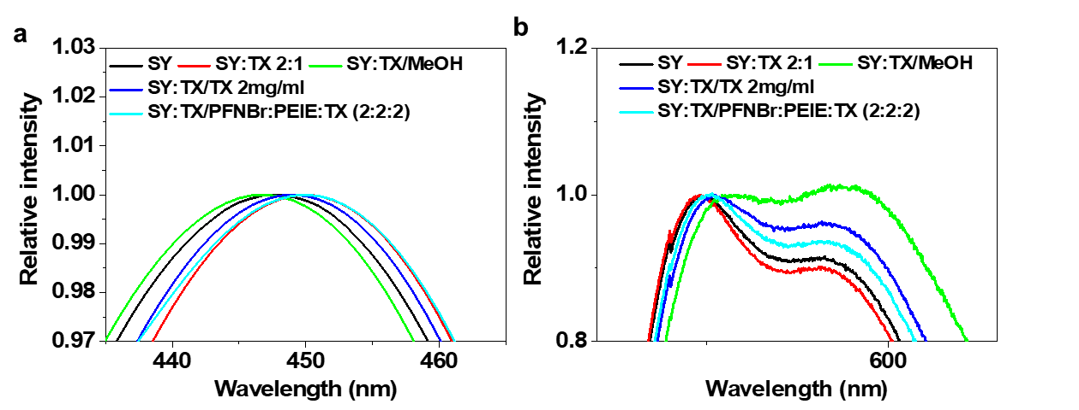
Supplementary Fig. 8 | Effect of TX blended solution on the is-EML. a, Absorbance and b, photoluminescence spectra of SY and SY:TX EML after various ETL solution coating. The application of the TX blended solution on the is-EML resulted in a red shift in the absorbance peak and a blue shift in the photoluminescence peak.

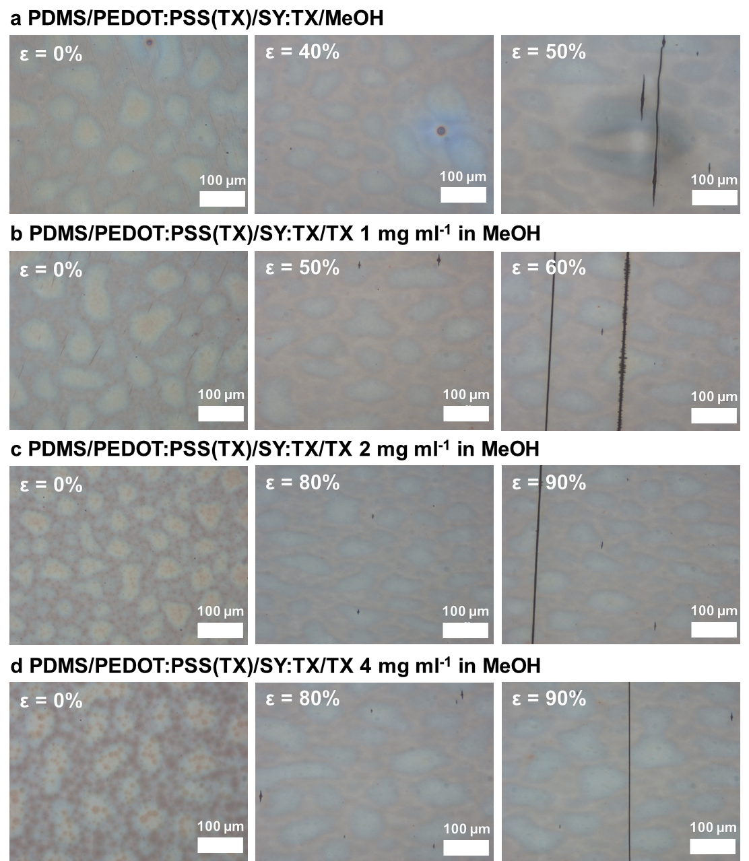
Supplementary Fig. 9 | Mechanical stretchability of is-EML post TX Blended solution coating. Optical Microscopy images of a, is-EML/MeOH, b, is-EML/TX 1 mg/ml, c, is-EML/TX 2 mg/ml, and d, is-EML/TX 4 mg/ml under various strain.

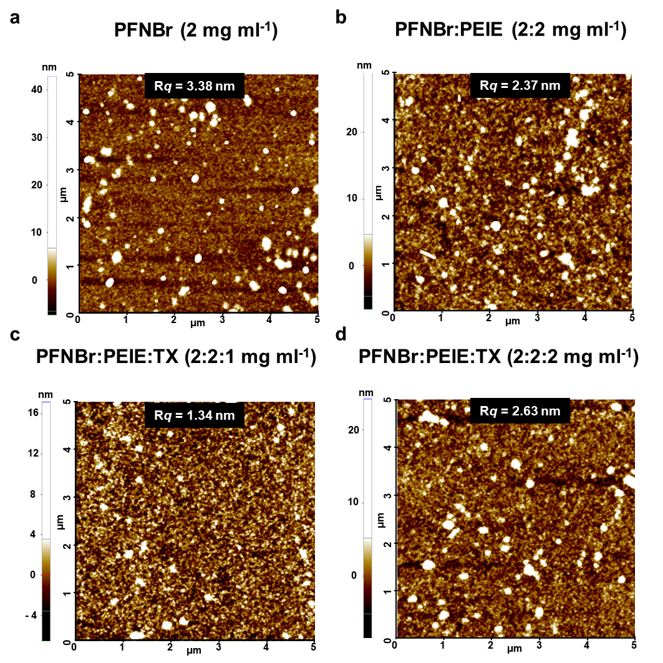
Supplementary Fig. 10 | AFM surface morphology of is-ETL. AFM surface height image of a, PFN-Br, b, PFNBr:PEIE (2:2 mg ml⁻¹), c, PFNBr:PEIE:TX (2:2:1 mg ml⁻¹), and d, PFNBr:PEIE:TX (2:2:2 mg ml⁻¹).

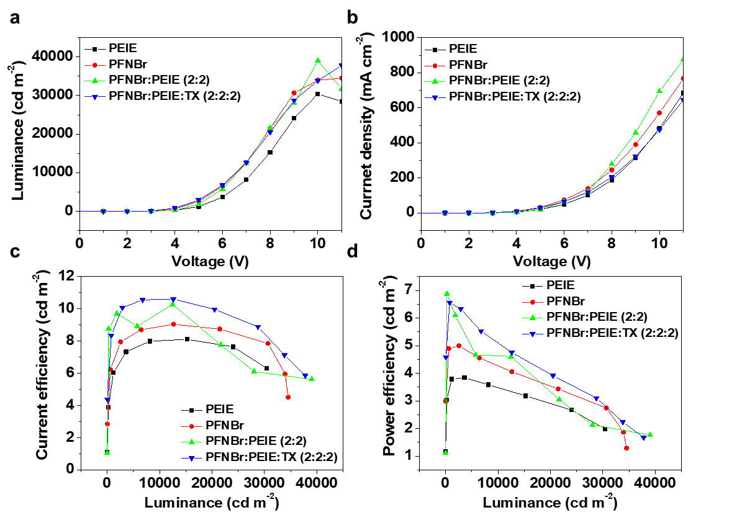
Supplementary Fig. 11 | ITO anode based conventional OLED performance with is-ETL. a, L-V curve, b, J-V curve, c, current efficiency, and d, power efficiency of conventional OLED using PEIE, PFN-Br, PFNBr:PEIE, PFNBr:PEIE:TX as an ETL. (ITO/PEDOT:PSS(TX)/ SY/ETL/Al).

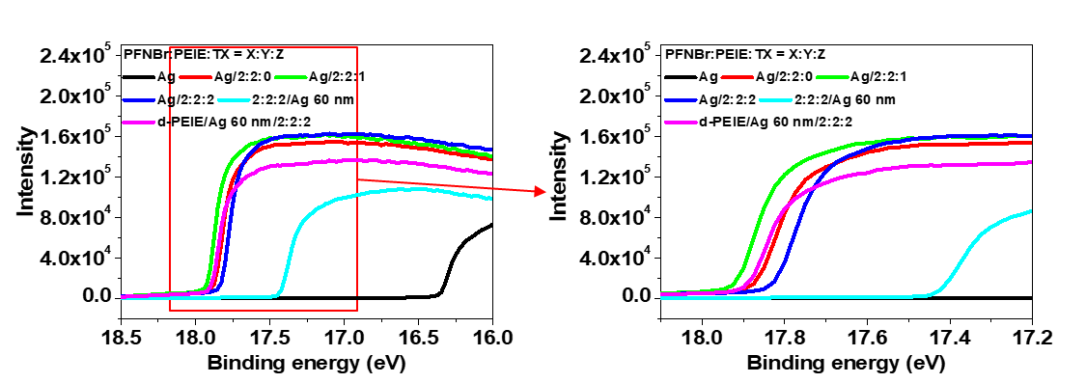
Supplementary Fig. 12 | Work function alteration in Ag film with is-ETL and upper ETL. This figure presents the Ultraviolet Photoelectron Spectroscopy (UPS) intensity profiles for the Ag film, is-ETL, and the d-PEIE upper ETL, showcasing their respective work function changes.

Supplementary Table 1. Work function change of Ag film before and after solution coating of is-ETL and upper ETL.
Structure | Work function (eV)
Ag | 4.8
Ag/PFNBr:PEIE:TX (2:2:0) | 3.3
Ag/PFNBr:PEIE:TX (2:2:1) | 3.25
Ag/PFNBr:PEIE:TX (2:2:2) | 3.35
PFNBr:PEIE:TX (2:2:2)/Ag | 3.7
d-PEIE/Ag/PFNBr:PEIE:TX (2:2:2) | 3.28

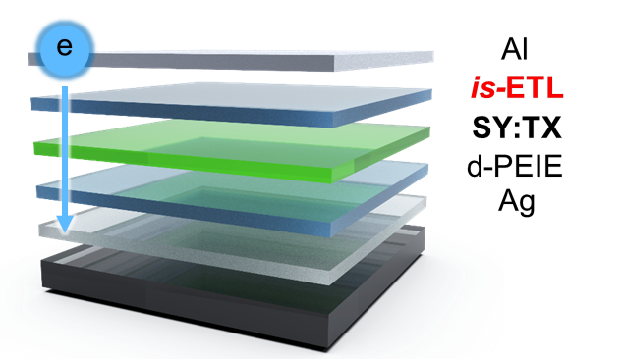
Supplementary Fig. 13 | Electron-only device incorporating is-EML and is-ETL. This figure provides a schematic representation of the electron-only device structure. The layers of d-PEIE, is-EML, and is-ETL were sequentially coated onto an Ag thin film. Subsequently, Al was deposited onto the is-ETL.

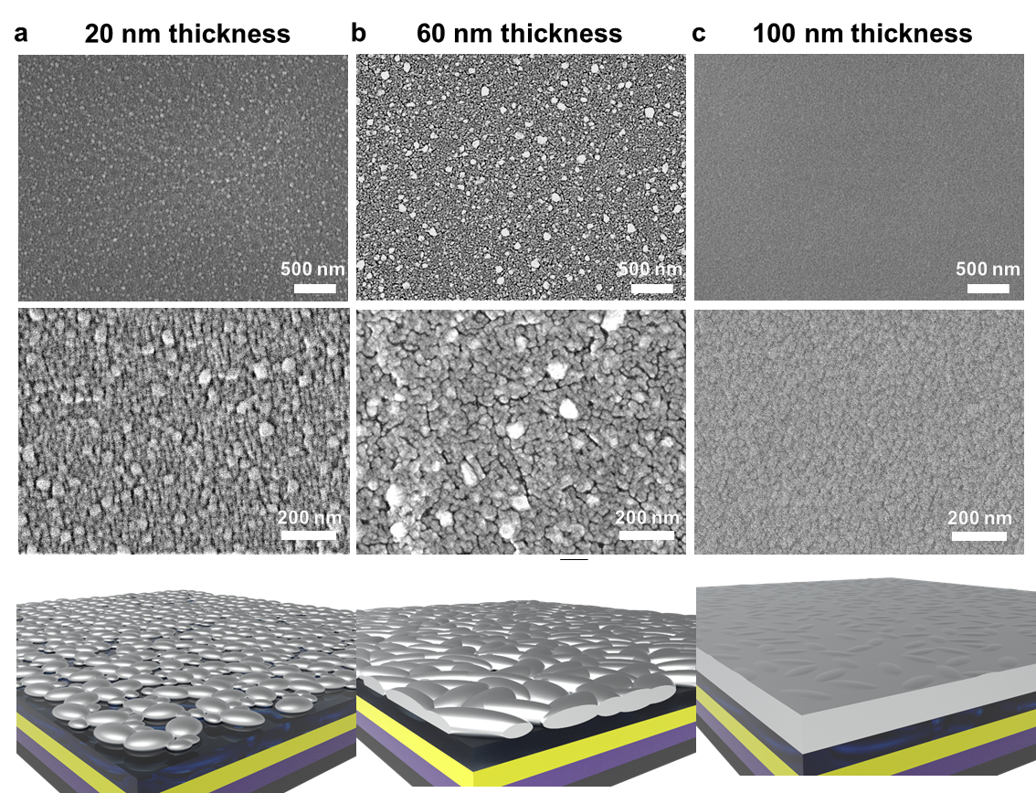
Supplementary Fig. 14 | SEM surface images of Ag cathode films. SEM surface images and schematic images of a, 20 nm thick, b, 60 nm thick, and c, 100 nm thick Ag cathode films on is-ETLs.

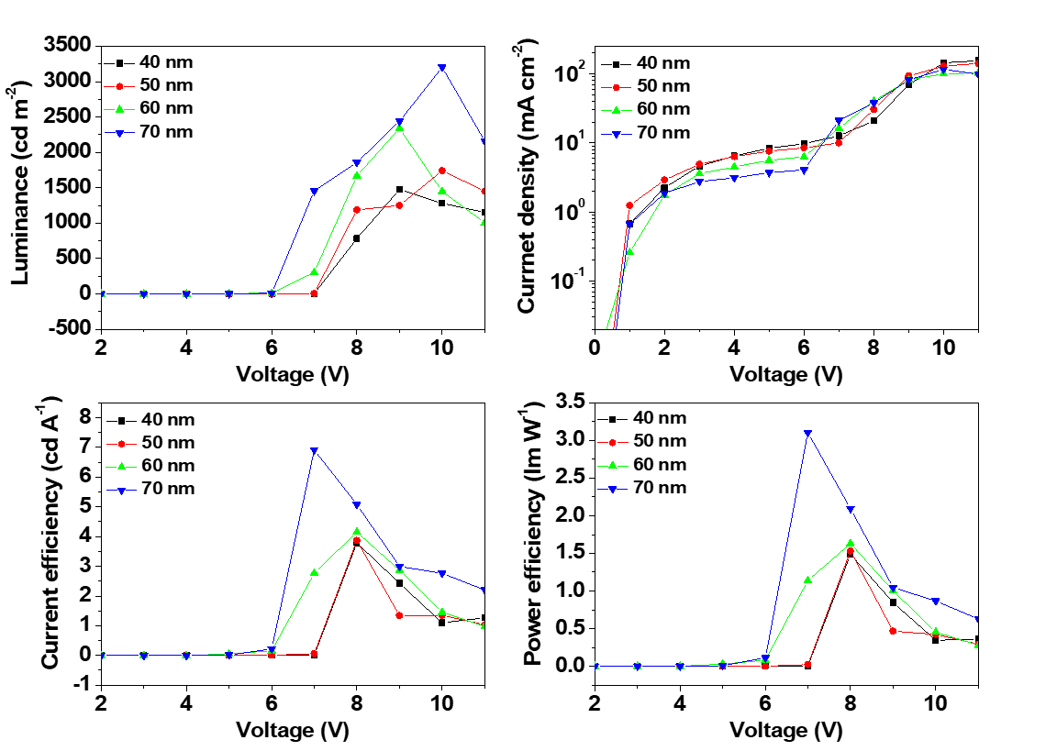
Supplementary Fig. 15 | Performance of is-OLED devices with various Ag thicknesses. a, Luminance, b, current density, c, current efficiency, and d, power efficiency versus voltage curves of is-OLEDs with various Ag cathode film thickness.

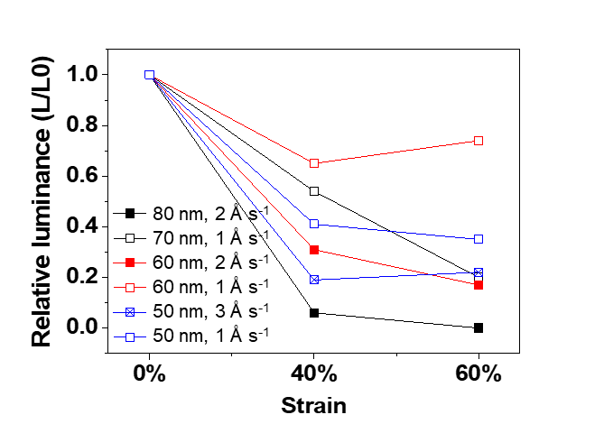
Supplementary Fig. 16 | Changes in the luminance of is-OLEDs under stretching (40% and 60%) for different Ag deposition parameters.

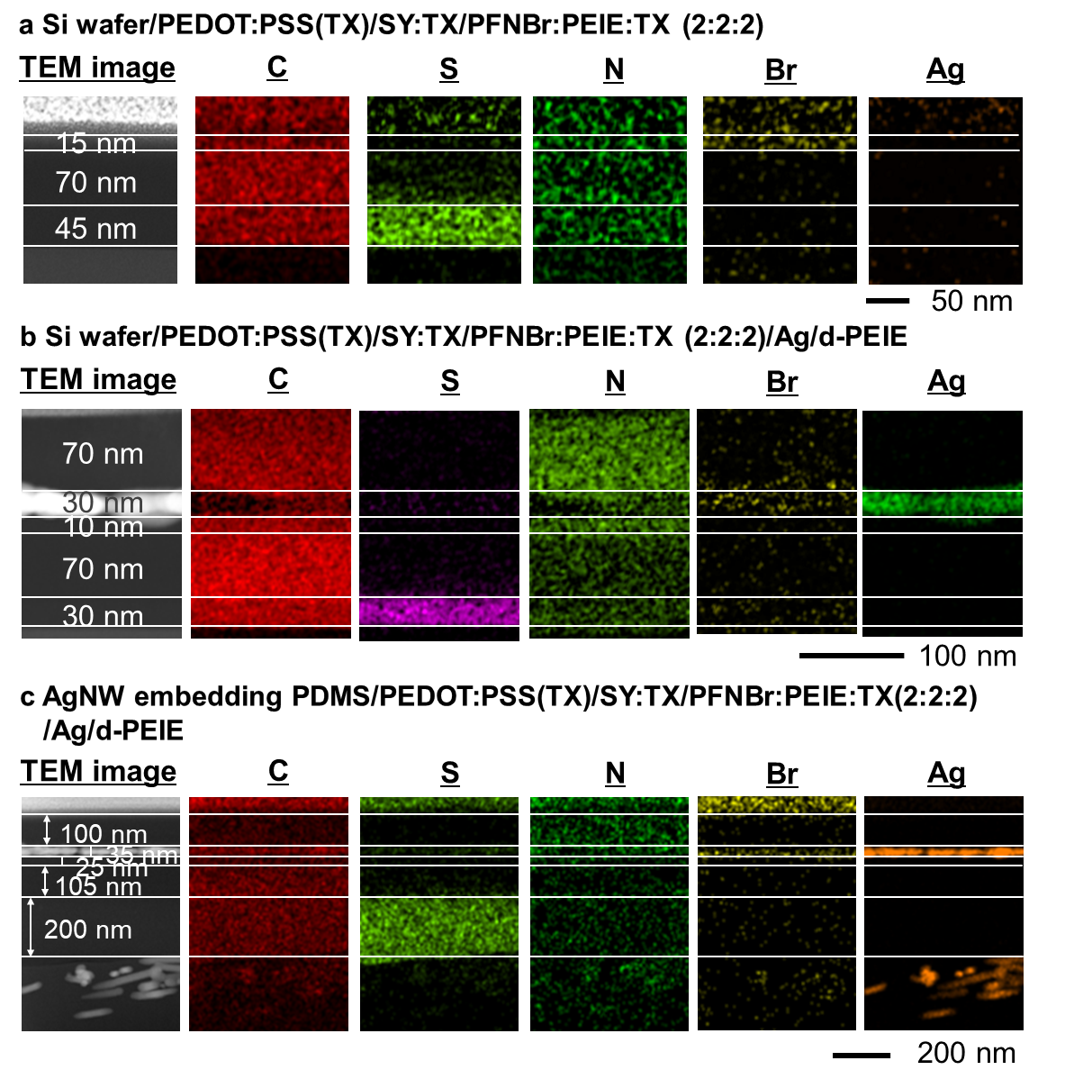
Supplementary Fig. 17 | TEM cross-sectional image of is-OLED. This figure showcases TEM cross-sectional images and EDS data of the organic layers and Ag cathode in is-OLED. The device structures are a, Si wafer/PEDOT:PSS(TX)/SY:TX/PFNBr:PEIE:TX (2:2:2), b, Si wafer/PEDOT:PSS(TX)/SY:TX/PFNBr:PEIE:TX (2:2:2)/Ag/d-PEIE, and c, AgNW embedding PDMS/PEDOT:PSS(TX)/SY:TX/PFNBr:PEIE:TX (2:2:2)/Ag/d-PEIE. A comparison of the thicknesses of the is-ETL after coating and the Ag cathode after deposition revealed a reduction of 5 nm, suggesting possible intermixing between the Ag cathode and the is-ETL.

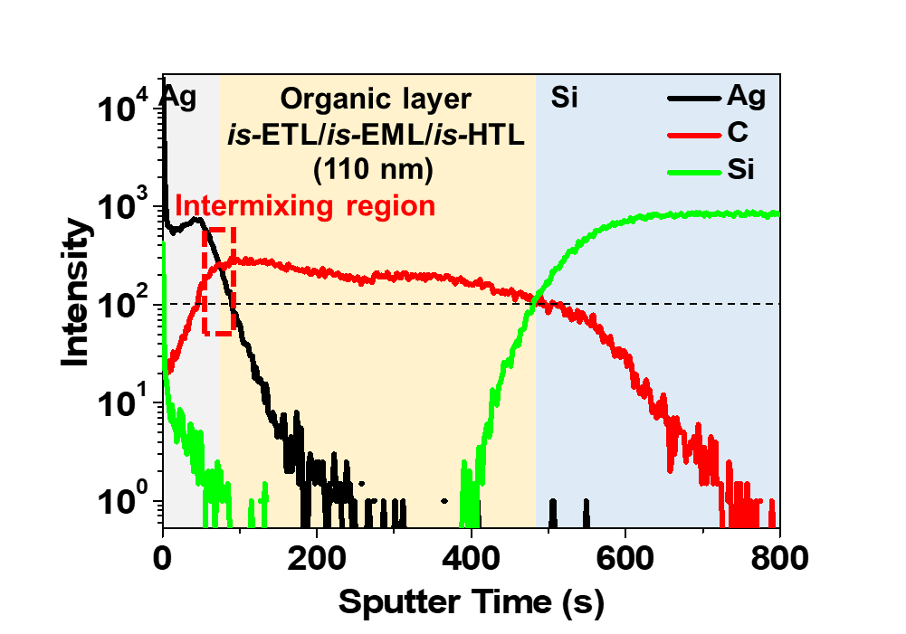
Supplementary Fig. 18 | TOF-SIMS analysis of is-OLED components. This figure displays the intensity of Ag, C, and Si components versus sputtering time in TOF-SIMS data. The structure of the examined device is Si wafer/PEDOT:PSS(TX)/SY:TX/PFNBr:PEIE:TX (2:2:2)/Ag. In this context, sputtering time corresponds to film thickness. Notably, at the interface of the Ag and is-ETL layers, an intermixing region was observed. This intermixing can be attributed to the slow deposition process of the Ag cathode, which led to the formation of an intermixed region between the is-ETL and Ag

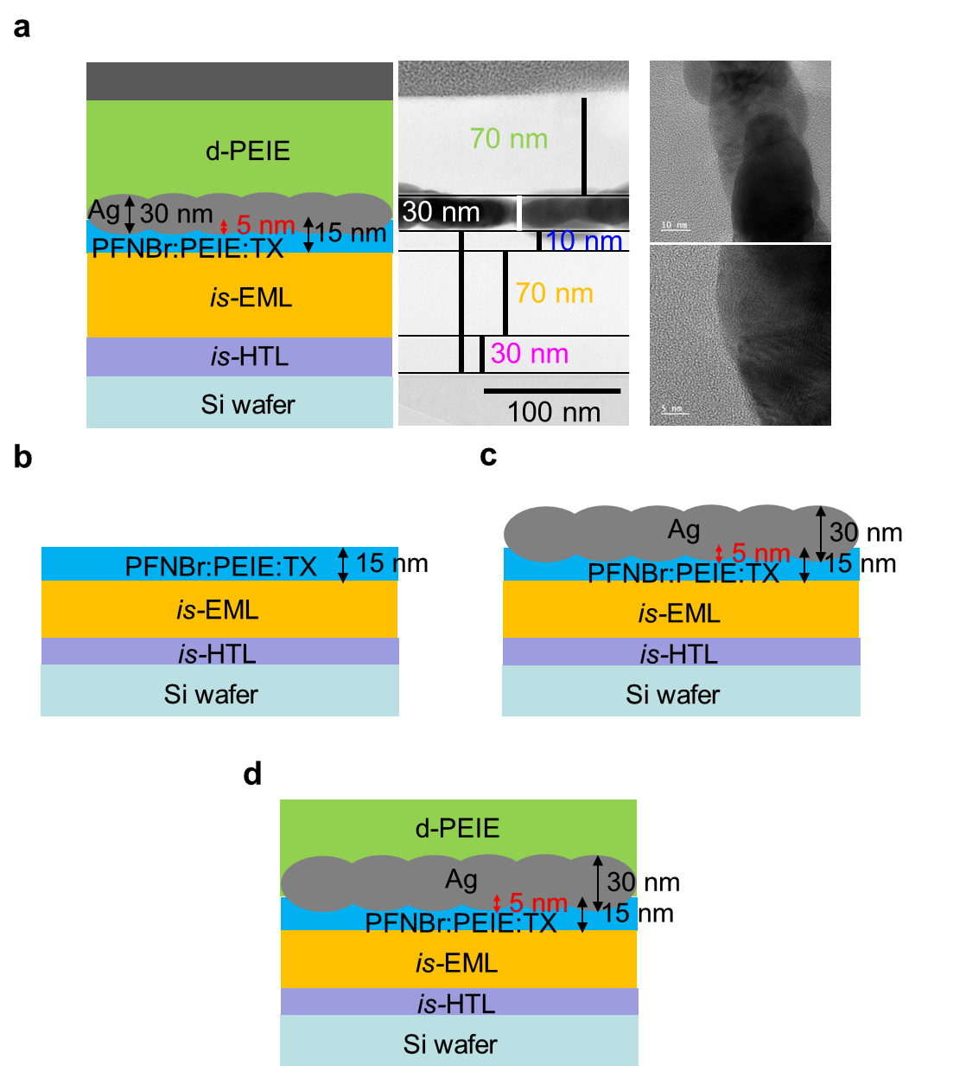
Supplementary Fig. 19 | Schematic representation of the Ag cathode formation process and morphology. a, This Figure shows both the schematic image and TEM cross-sectional image of the is-ETL, is-cathode, and d-PEIE upper ETL layers. The is-ETL had a thickness of 10 nm, while the is-cathode was 30 nm. The Ag cathode exhibited a non-uniform surface and grain structure, appearing as a partially connected morphology. b, Illustration of the is-ETL following solution coating. c, Deposition of Ag onto the is-ETL, where slowly deposited Ag and is-ETL formed an intermixing region. d, Subsequent overcoating of d-PEIE onto the Ag cathode.
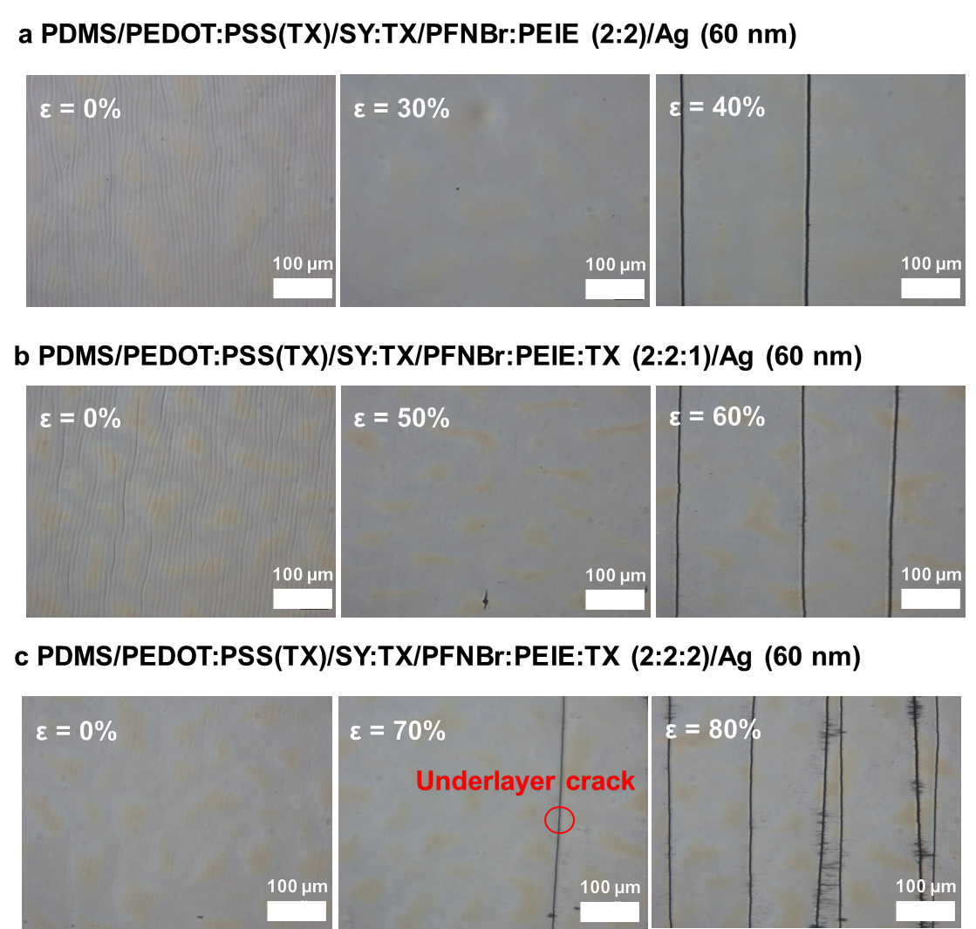
Supplementary Fig. 20 | Mechanical stretchability of Ag cathode. Optical Microscopy images of Ag cathode surface, which deposited on the a, PFNBr:PEIE (2:2), b, PFN-Br:PEIE:TX (2:2:1), and c, PFN-Br:PEIE:TX (2:2:2) under various strain.

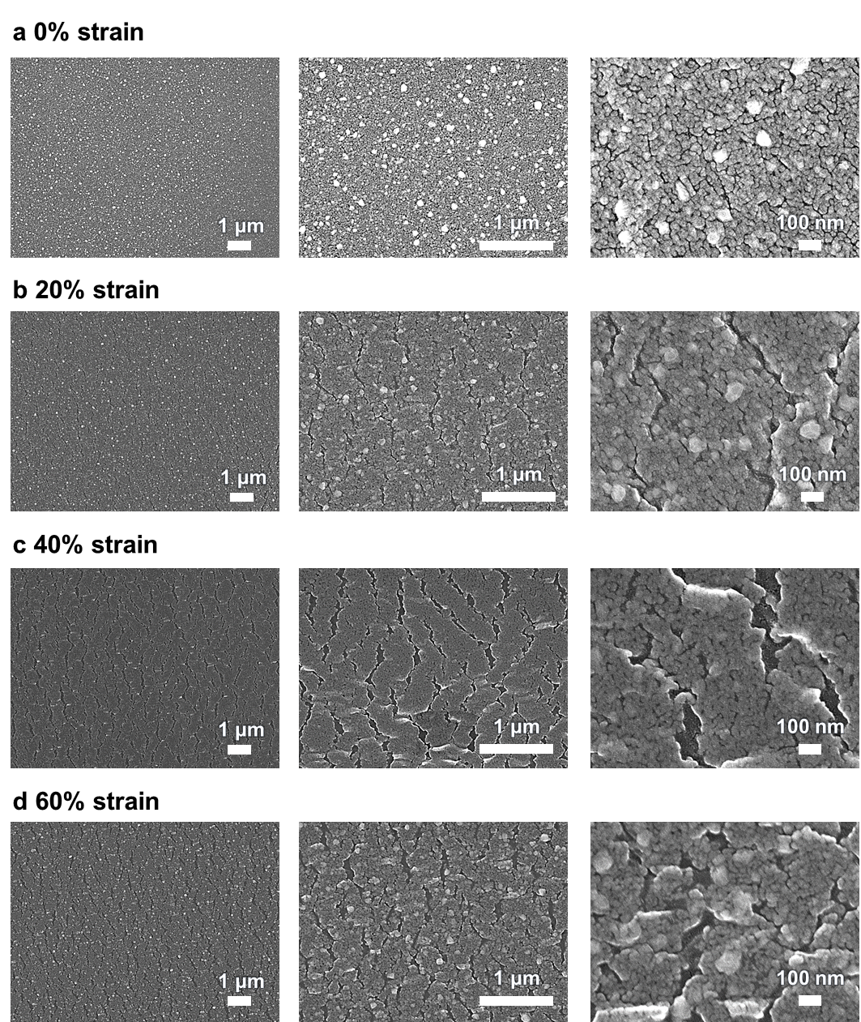
Supplementary Fig. 21 | Surface image of Ag cathode under stretching condition. This figure presents SEM surface images of the Ag cathode subjected to a, 0%, b, 20%, c, 40%, and d, 60% strain. The device structure includes PDMS/PEDOT:PSS(TX)/SY:TX/PFN-br: PEIE:TX/Ag cathode (60 nm thickness, deposited at 1 Å s⁻¹).

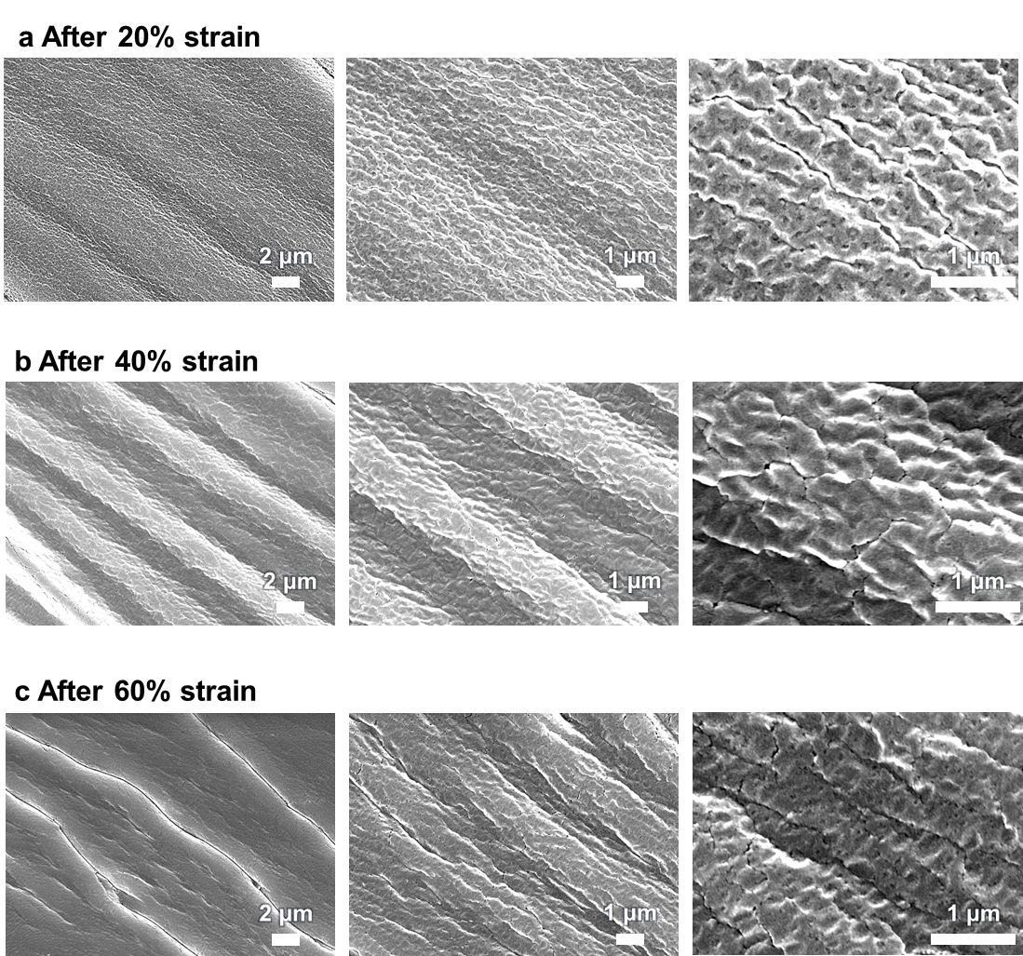
Supplementary Fig. 22 | SEM surface images of Ag cathode post-stretching. This figure displays the surface of the Ag cathode after undergoing a, 20%, b, 40%, and c 60% strain. The device structure comprised PDMS/is-HTL/SY:TX/PFNbr:PEIE:TX/Ag cathode (60 nm thickness, deposited at 1 Å s⁻¹).

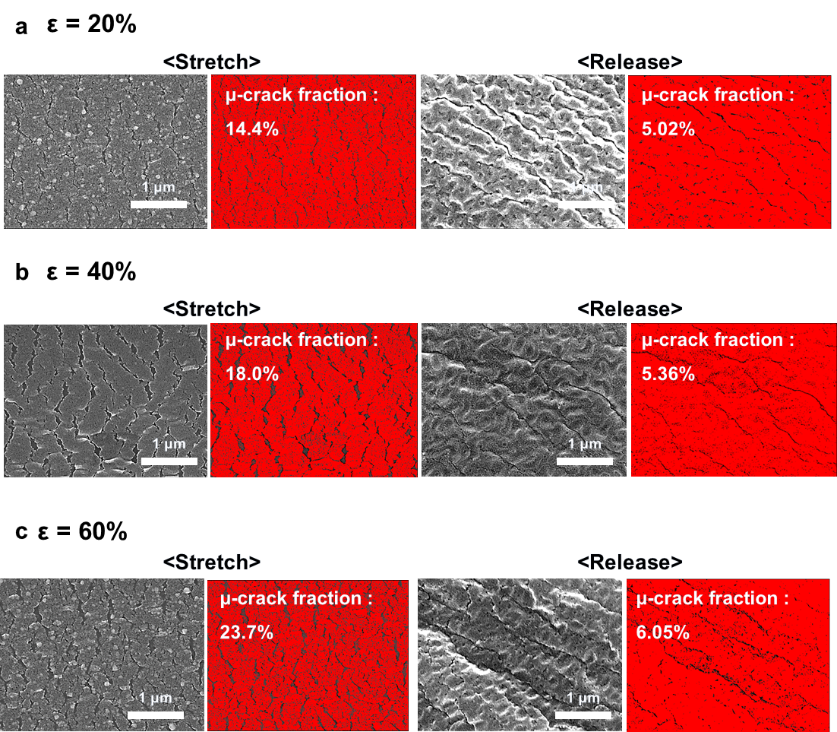
Supplementary Fig. 23 | SEM surface images of Ag cathodes after stretching and release. Microcrack analysis of Ag cathodes during and after stretching with a, 20% strain, b, 40% strain, and c, 60% strain. (Device structure: PDMS/is-HTL/is-EML/is-ETL/Ag (60 nm, 1 A s-1)).

Supplementary Fig. 24 | Effect of the multilayer configuration on the Ag cathode stretchability. Resistance change of Ag cathode films during static stretching tests (0~60% strain). The device structures used were PDMS/is-ETL/Ag (60 nm 1 Å s⁻¹) (black line, 1 interlayer) and PDMS/is-HTL/is-EML/is-ETL/Ag (60 nm 1 Å s⁻¹) (red line, 3 interlayers).

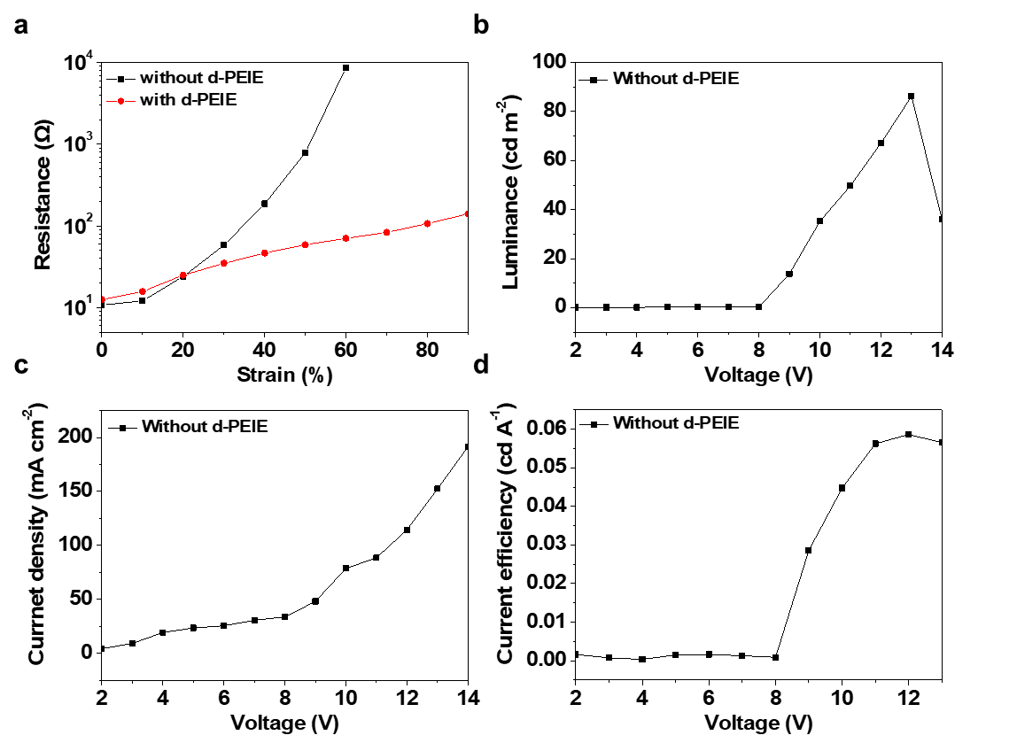
Supplementary Fig. 25 | Performance of an is-OLED device without the d-PEIE upper ETL. a, Resistance change of the Ag cathode deposited on the is-ETL with and without the d-PEIE upper ETL under various strains. b, Luminance, c, current density, and d, current efficiency versus voltage curves of the is-OLED without the d-PEIE upper ETL coating. (Device structure = AgNW-embedded PDMS/PEDOT:PSS(TX)/is-EML/is-ETL/Ag)

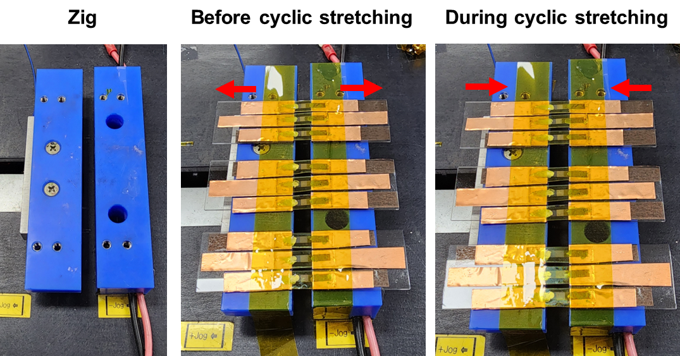
Supplementary Fig. 26 | Cyclic stretching test of is-OLED. A specialized jig was employed for the cyclic stretching test. This jig automatically facilitated the cyclic stretching movements.

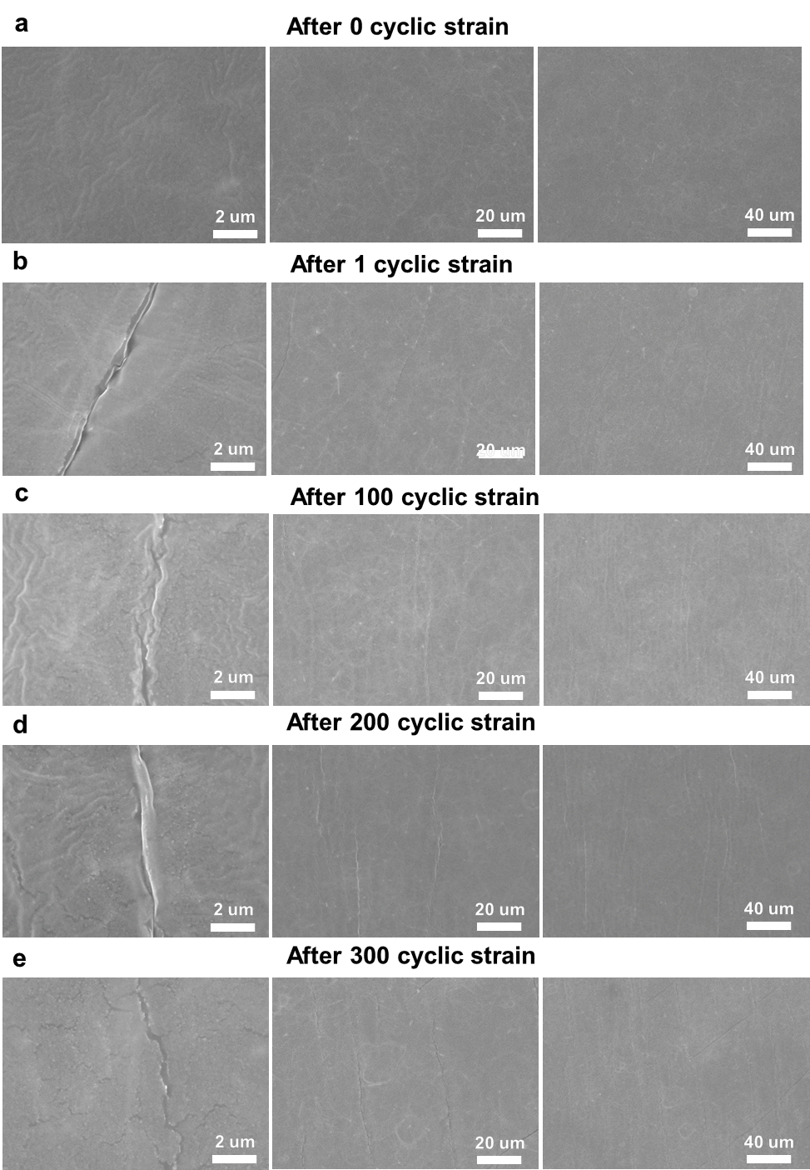
Supplementary Fig. 27 | SEM surface images of an is-OLED after cyclic stretching. SEM surface images of the is-OLED after 40% strain cyclic stretching tests with a, 0, b, 1, c, 50, d, 100, e, 200, and f, 400 cycles.

Supplementary Table 2. Comparison of is-OLED device performance. The fabrication complexity corresponds to the number of transfer and lamination processes during the is-OLED fabrication process.
Ref | Device structure | Fabrication method | Turn-on Voltage  (V) | Maximum luminance  (cd m⁻²) | Maximum current efficiency (cd A⁻¹) | Stretchability (%) | Cyclic stretchability  (strain) | Fabrication complexity
This study | AgNW:PDMS/PEDOT:PSS:TX/SY:TX/PFNBr:PEIE:TX/Ag/d-PEIE | Sequential coating | 6 | 2,340  @ 9 V | 4.2 | 70 | 300  (40%) | 1
S1 | AgNWs:PUA/PEDOT:PSS/S  Y:OXD-7 /PEI/AgNWs:PUA | Lamination | 7 | 1,100  @ 21 V | 2 | 130 | 100  (40%) | 2
S2 | PU/PEDOT:  PSS-PEO/PF-b-PI/EIn-  Ga/PU:AgNWs | Sequential coating | 2 | 70  @ 10 V | - | 140 | 100  (20%) | 1
S3 | AgNW:PDMS/PEDOT:PSS:TX/SY:TX/ZnO/d-PEIE/AgNW/ZnO/d-PEIE | Sequential coating | 8 | 2,500  @ 11 V | 1.6 | 80 | 200  (40%) | 1
S4 | PVDF-HFP/PEDOT:PSS:PR/PEDOT:PSS:TX/TFB:PU/SY:PU/PFNBr:PEIE/PEDOT:PSS:PR/PVDF-HFP | Lamination | 5 | 7,450  @ 15 V | 5.3 | 100 | 100  (40%) | 3
S5 | TCSE/PFI/PEDOT:PSS:TX/SY:TX/PEI:Crown-CPE/PEI/TCSE  (TCSE = GO/AgNW/Graphene/SEBS) | Lamination | 5.3 | 2,185  @ 15 V | 20.3 | 20 | - | 4
S6 | PDMS/Ag/AgNW/Zn-PEIE-pBphen-TX//PMMA/L-SY-PPV:PAN/ PEDOT:PSS:TX/Curved Au | Lamination | 6.5 | 3,780  @ 12 V | 2.35 | 30 | 50  (15%) | 5
S7 | AgNW:PDMS/PEDOT:PSS:PFI/PDKCD/PFNBr:PEIE/AgNW:PDMS | Lamination | 4.75 | 2,175  @ 10 V | 5.3 | 60 | - | 2
S8 | TCSE/PFI/PEDOT:PSS:TX/SY:PEO:KCF₃SO₃/PEI/TCSE | Lamination | 3.7 | 1,754  @ 11 V | 3.14 | 30 | 10  (20%) | 5

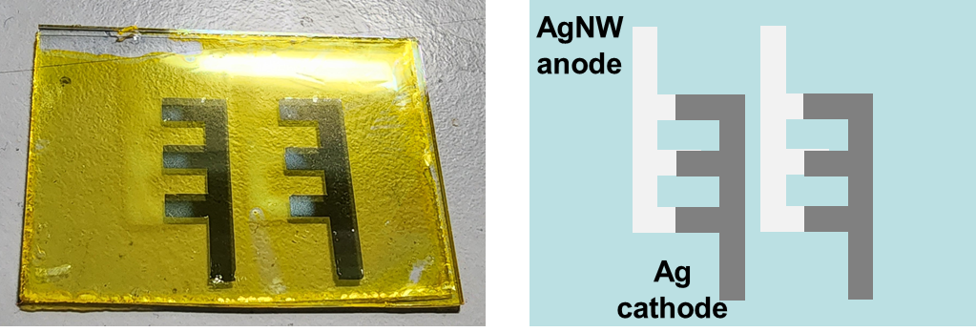
Supplementary Fig. 28 | Structure of a 3x2 array device. This figure includes both a photographic image and a schematic representation of the 3x2 array device.

Supplementary References

S1 Liang, J. et al. Silver nanowire percolation network soldered with graphene oxide at room temperature and its application for fully stretchable polymer light emitting diodes. ACS Nano 8, 1590-1600 (2014).
S2 Jao, C. C. et al. Novel stretchable light‐emitting diodes based on conjugated‐rod block elastic‐coil copolymers. Polym. Int. 70, 426-431 (2020).
S3 Kim, J. H. & Park, J. W. Intrinsically stretchable organic light-emitting diodes. Sci. Adv. 7 (2021).
S4 Zhang, Z. et al. High-brightness all-polymer stretchable LED with charge-trapping dilution. Nature 603, 624-630 (2022).
S5 Zhou, H. et al. Graphene-Based Intrinsically Stretchable 2D-Contact Electrodes for Highly Efficient Organic Light-Emitting Diodes. Adv. Mater. 34, e2203040 (2022).
S6 Liu, Y. et al. A Self-Assembled 3D Penetrating Nanonetwork for High-Performance Intrinsically Stretchable Polymer Light-Emitting Diodes. Adv. Mater. 34, e2201844 (2022).
S7 Liu, W. et al. High-efficiency stretchable light-emitting polymers from thermally activated delayed fluorescence. Nat. Mater. 22, 737-745 (2023).
S8 Han, S. J. et al. Achieving Low‐Voltage Operation of Intrinsically‐Stretchable Organic Light‐Emitting Diodes. Adv. Funct. Mater. 33 (2023).

