Oxygen Vacancy-engineered CeO₂ Mediated by Cu-Pt Exhibit Enhanced SOD/CAT-mimicking Activities to Regulate the Microenvironment
for Osteoarthritis Therapy
Junxu Yang^{1,3#}, Shihui Xiao^{1,3#}, Jiejia Deng^{1,2#}, Yuquan Li^{1,3}, Hao Hu¹, Jiawei Wang¹, Chun Lu⁴, Guanhua Li^{1,3}, Li Zheng^{1*}, Qinjun Wei^{1,3*}, Jingping Zhong^{1*}

¹Guangxi Engineering Center in Biomedical Material for Tissue and Organ Regeneration, Collaborative Innovation Centre of Regenerative Medicine and Medical BioResource Development and Application Co-constructed By the Province and Ministry, Guangxi Key Laboratory of Regenerative Medicine, The First Affiliated Hospital of Guangxi Medical University No. 6 Shuangyong Road, Nanning, Guangxi 530021, P. R. China
²Life Sciences Institute, Guangxi Medical University, No. 22 Shuangyong Road, Nanning, Guangxi 530021, PR China
³Department of Orthopaedics Trauma and Hand Surgery, The First Affiliated Hospital of Guangxi Medical University, No. 6 Shuangyong Road, Nanning, Guangxi 530021, PR China
⁴School of Materials and Environment, Guangxi Minzu University, Nanning, Guangxi, 53000, PR China

Correspondences to: Li Zheng (zhengli224@163.com), Qinjun Wei (weiqingjungxnn@163.com) and Jingping Zhong (jingpingzhong@163.com)
Authors: Junxu Yang(953185845@qq.com), Shihui Xiao(xiaoshihui007@126.com), Jiejia Deng(2954176632@qq.com), Yuquan Li(1139434728@qq.com), Hao Hu(doctorhuhao@163.com), Jiawei Wang(617290535@qq.com), Chun Lu(luchun1024@126.com) and Guanhua Li(2573177917@qq.com)

Supplementary Figures
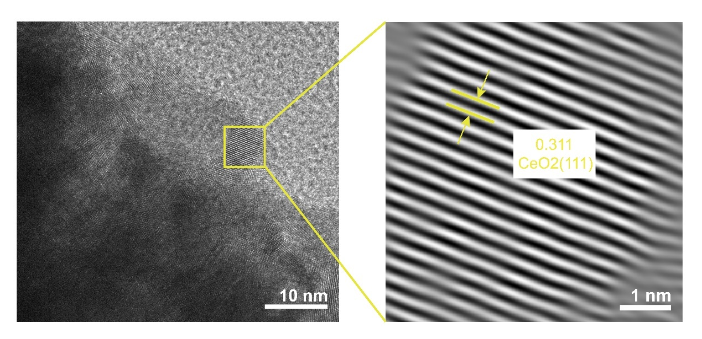
Fig. S1. HRTEM images of CeO₂ and its lattice spacing.

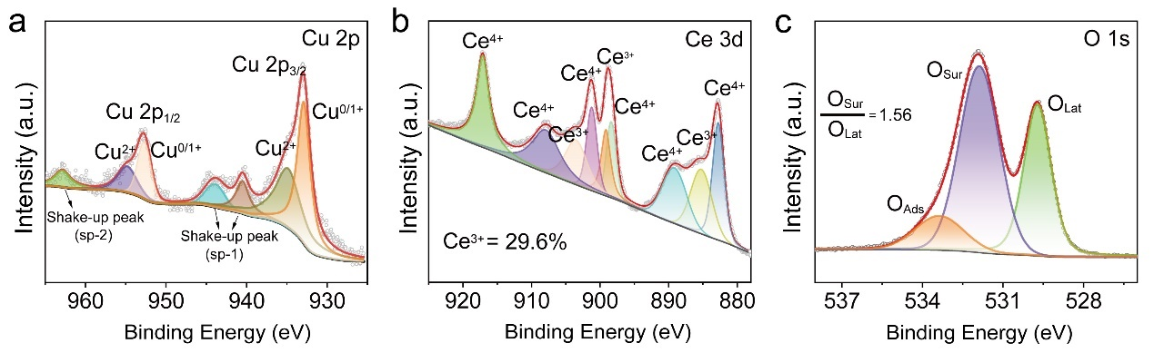
Fig. S2. High-resolution XPS spectra of a) Cu 2p, b) Ce 3d, c) O 1s of CuO_{X}/CeO_{2-X}.

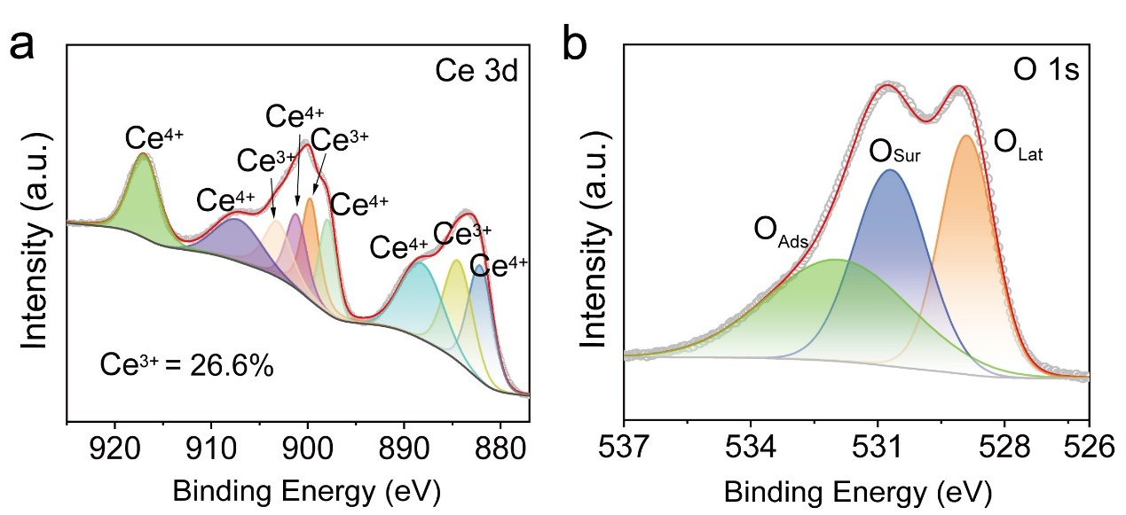
Fig. S3. High-resolution XPS spectra of a) Ce 3d, b) O 1s of CeO2.

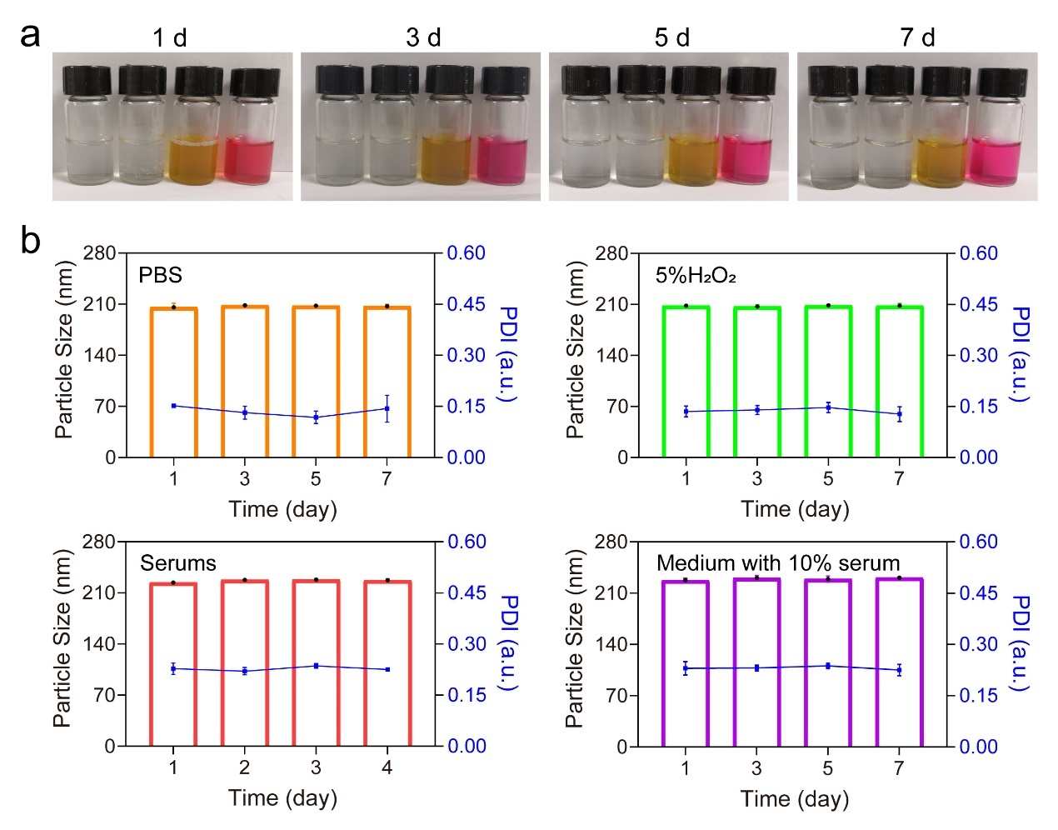
Fig. S4. a) Dispersibility of CeO₂ and PtCuO_{X}/CeO_{2-X} nanospheres at different times (1, 3,5, and 7 days) and in different solutions (PBS, 5% H₂O₂, fetal bovine serum, and medium containing 10% fetal bovine serum, respectively); b) Average particle size and PDI of PtCuO_{X}/CeO_{2-X} nanospheres. Data are expressed as mean ± SD (n=3).

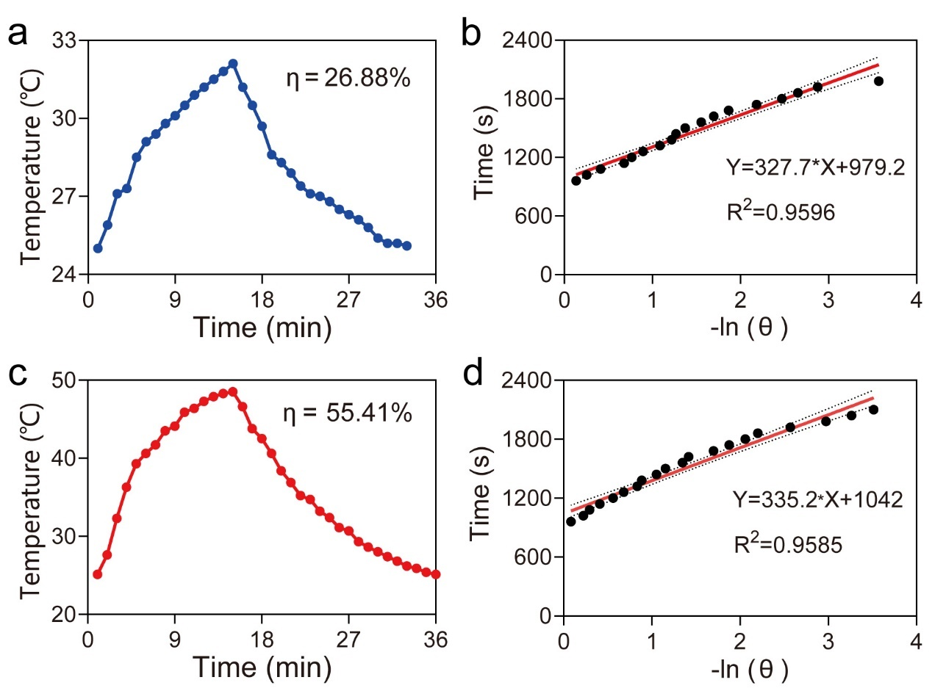
Fig. S5. a) CeO₂ solution for heating/cooling experiments and b) cooling time data vs. negative natural logarithm of temperature increase from Figure S6a. c) PtCuO_{X}/CeO_{2-X} solution for heating/cooling experiments and d) cooling time data vs. negative natural logarithm of temperature increase from Figure S6c (parameters: 808 nm, 1 W/cm², 50 μg/mL).

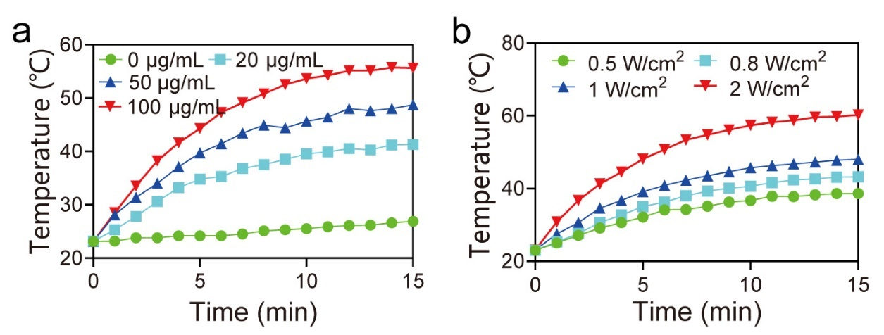
Fig. S6. a) O₂ production during H₂O₂ decomposition by the PtCuO_{X}/CeO_{2-X} at different concentrations. b) O₂ production during H₂O₂ decomposition by PtCuO_{X}/CeO_{2-X} (50 μg/mL) using NIR light irradiation at different power levels.
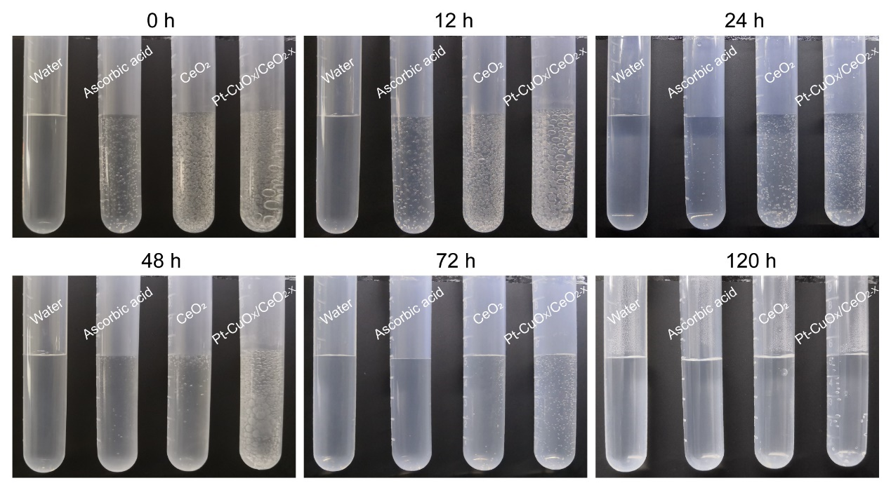
Fig. S7. O₂ production by decomposition of H₂O₂ (10 M) by PBS, Ascorbic acid, CeO₂, and PtCuO_{X}/CeO_{2-X} nanozymes at the same concentration (10 μg/mL).

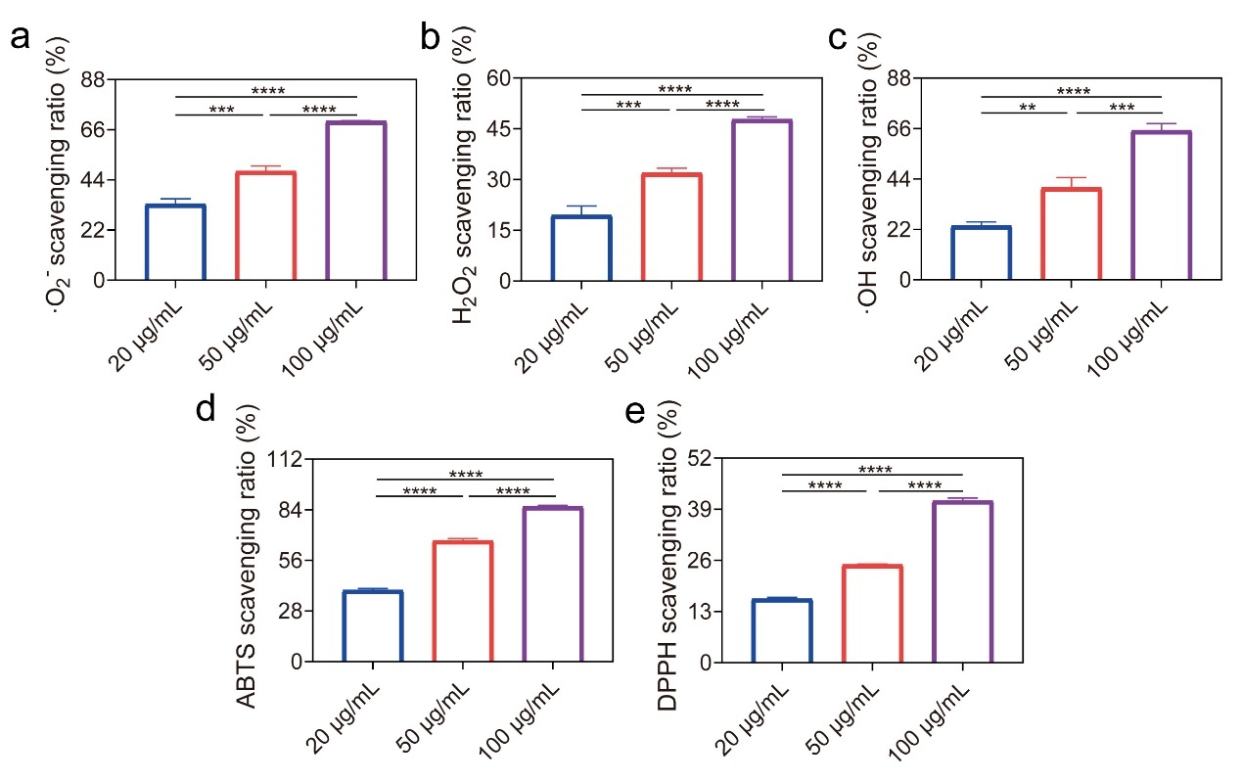
Fig. S8. The ability of different concentrations of v nanozymes to scavenge a) ·O₂⁻, b) H₂O₂, c) ·OH, d) ABTS, and e) NO. Data are expressed as mean ± SD (n=3). * and # for P < 0.05, ** and ## for P < 0.01, *** and ### for P < 0.001, and **** and #### for P < 0.0001.

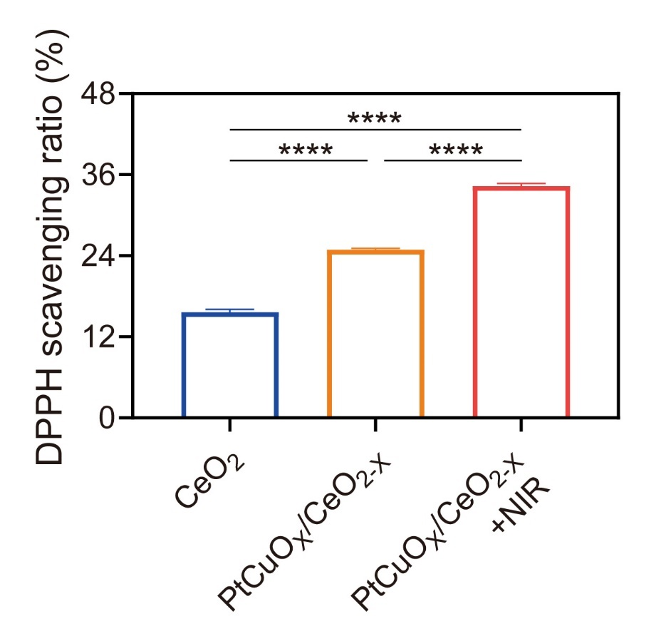
Fig. S9. The scavenging ability of CeO₂, PtCuO_{X}/CeO_{2-X}, and PtCuO_{X}/CeO_{2-X} +NIR was evaluated for DPPH. Data are expressed as mean ± SD (n=3). * and # for P < 0.05, ** and ## for P < 0.01, *** and ### for P < 0.001, and **** and #### for P < 0.0001.

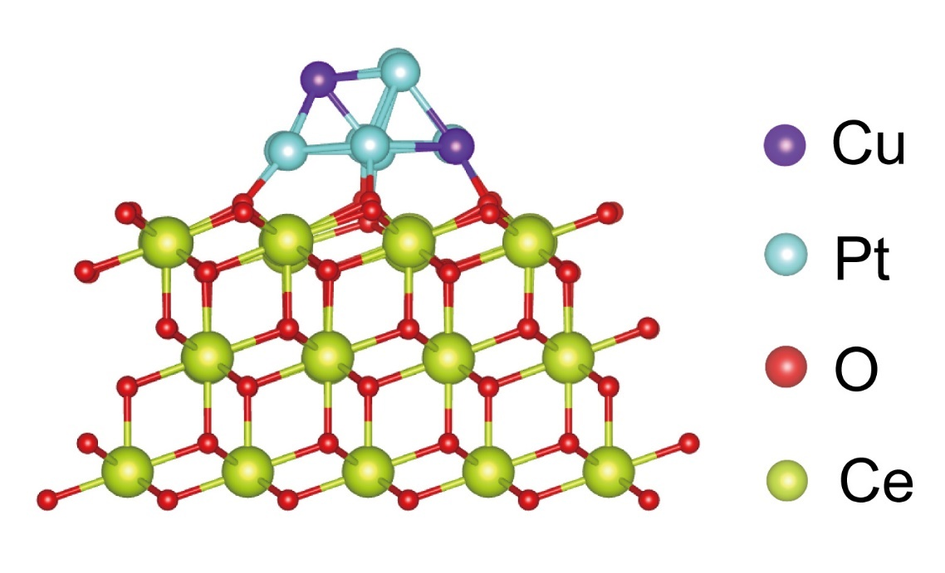
Fig. S10. PtCuO_{X}/CeO_{2-X} nanozymes simulation model based on DFT.
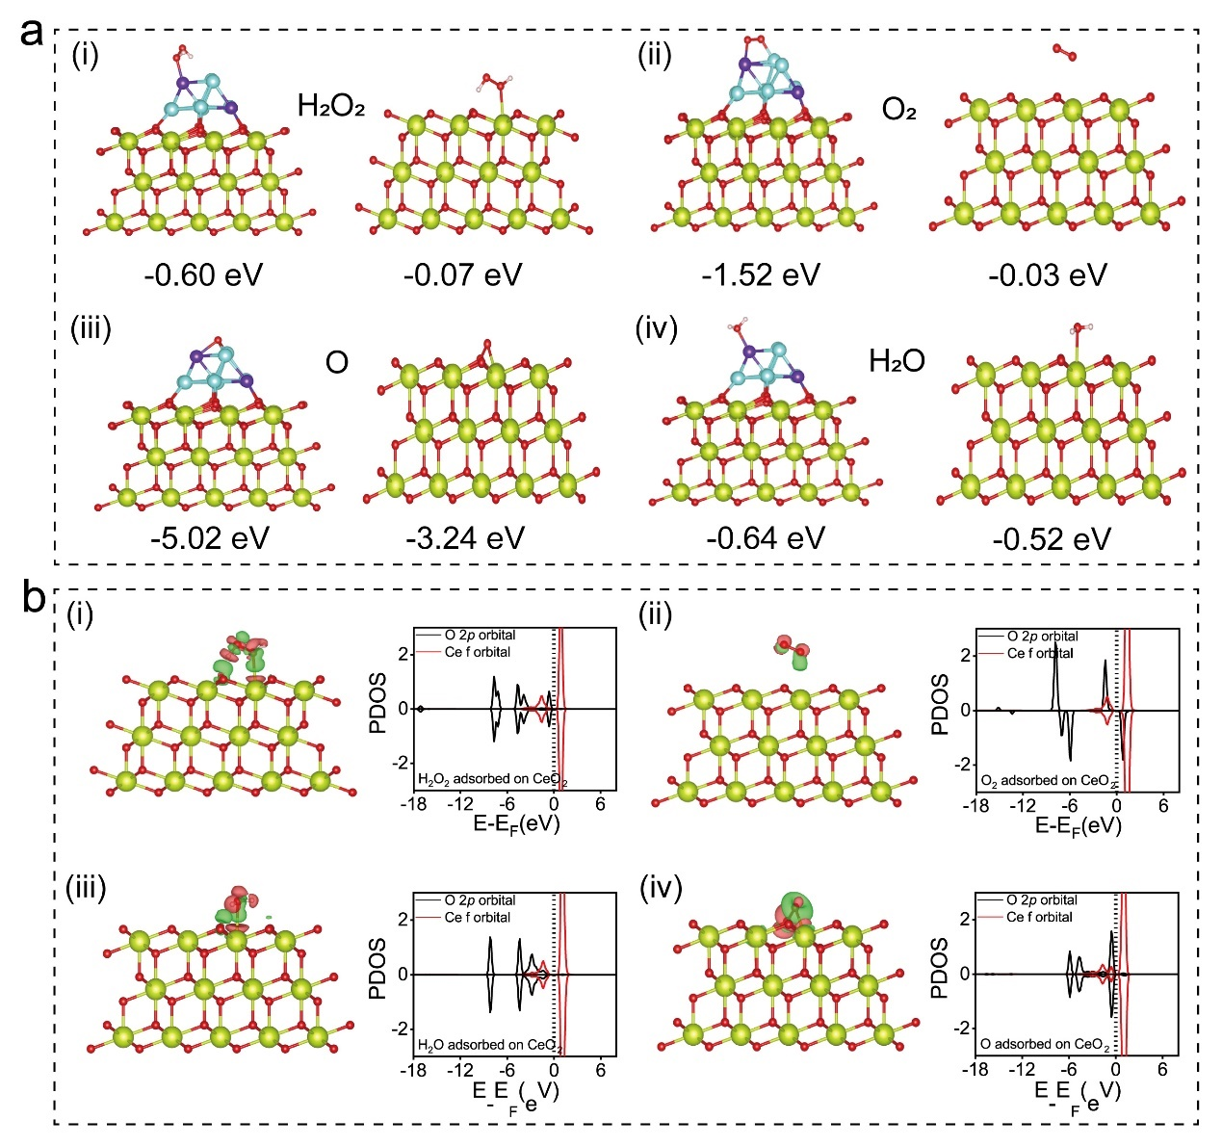
Fig. S11. a) Adsorption energies of different adsorbates on the PtCuO_{X}/CeO_{2-X} surface, including H₂O₂ (ai), O₂ (aii), O (aiii), and H₂O (aiv). b) Differential charge density map and PDOS of different adsorbates (H₂O₂, O₂, O, H₂O) adsorbed on the surface of CeO₂.

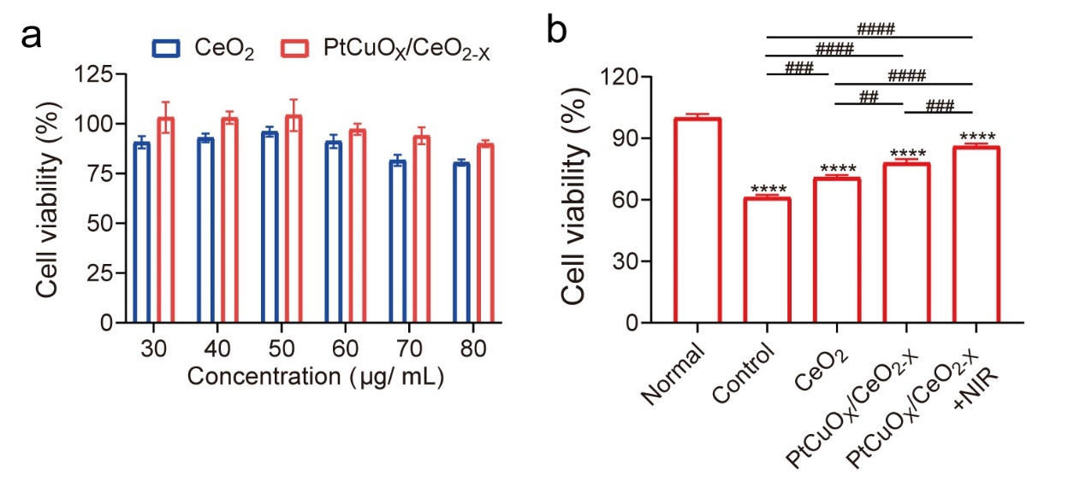
Fig. S12. a) Cell viability of chondrocytes incubated with different concentrations of CeO₂ and PtCuO_{X}/CeO_{2-X}. b) Cell viability of IL-1β-treated chondrocytes incubated with different concentrations of CeO₂ and PtCuO_{X}/CeO_{2-X}. PtCuO_{X}/CeO_{2-X} dose: 50 μg/mL; incubation time: 24 h; NIR parameter: 808 nm, 1 W/cm², 5 min; H₂O₂ concentration: 400 μM. Data are expressed as mean ± SD (n=3). * and # for P < 0.05, ** and ## for P < 0.01, *** and ### for P < 0.001, and **** and #### for P < 0.0001.

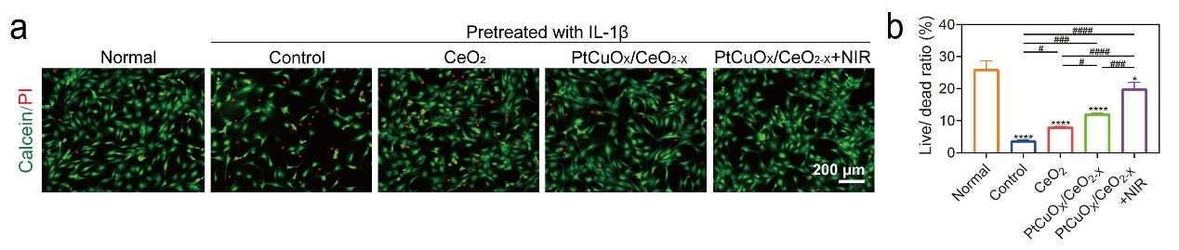
Fig. S13. Chondrocyte staining with PI and calcein after different treatments, with PI (red) and calcein (green) staining dead and live cells, respectively. Data are expressed as mean ± SD (n=3). * and # for P < 0.05, ** and ## for P < 0.01, *** and ### for P < 0.001, and **** and #### for P < 0.0001.

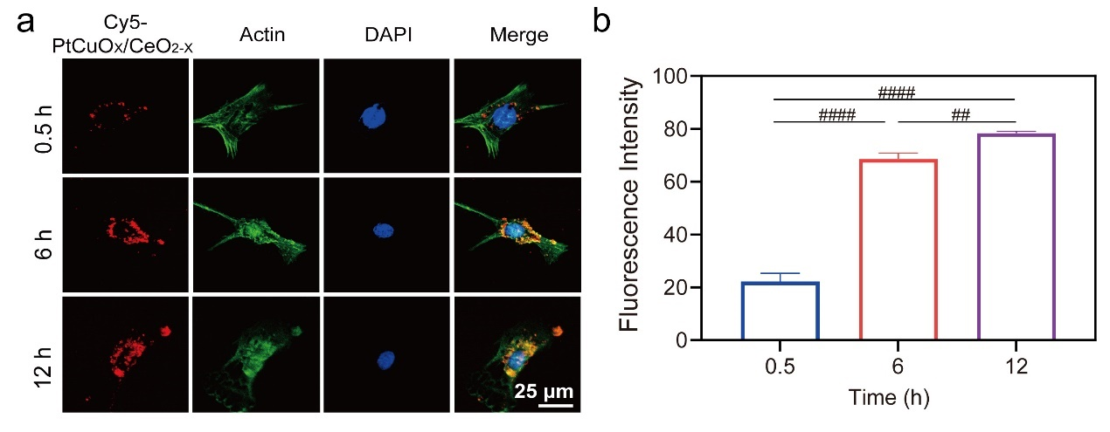
Fig. S14. a) Confocal microscopy was performed to observe the uptake of nanospheres by chondrocytes after co-culture with Cy5- PtCuO_{X}/CeO_{2-X} (0.5, 6, 12 h) and b) the corresponding quantification (Cy5- PtCuO_{X}/CeO_{2-X}: red; actin: green; DAPI: blue). Data are expressed as mean ± SD (n=3). * and # for P < 0.05, ** and ## for P < 0.01, *** and ### for P < 0.001, and **** and #### for P < 0.0001.

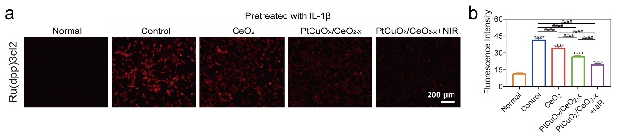
Fig. S15. a) Chondrocyte staining with the indicator (Ru(dpp)3Cl2) and b) corresponding quantification to evaluate H₂O₂ scavenging ability. Data are expressed as mean ± SD (n=3). * and # for P < 0.05, ** and ## for P < 0.01, *** and ### for P < 0.001, and **** and #### for P < 0.0001.

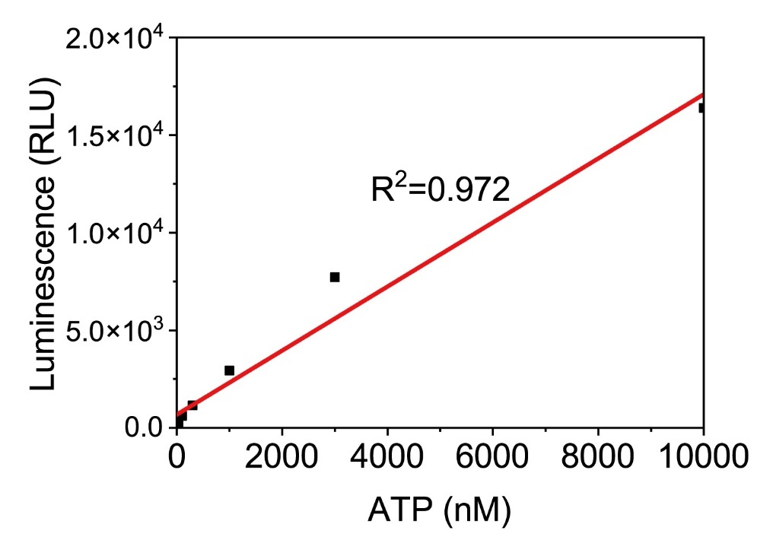
Fig. S16. Concentration-dependent standard curves were plotted after different treatments (Normal, Control, CeO₂, PtCuO_{X}/CeO_{2-X}, PtCuO_{X}/CeO_{2-X} +NIR) of IL-1β-induced chondrocytes when ATP fluorescence intensity was recorded using a microplate reader.
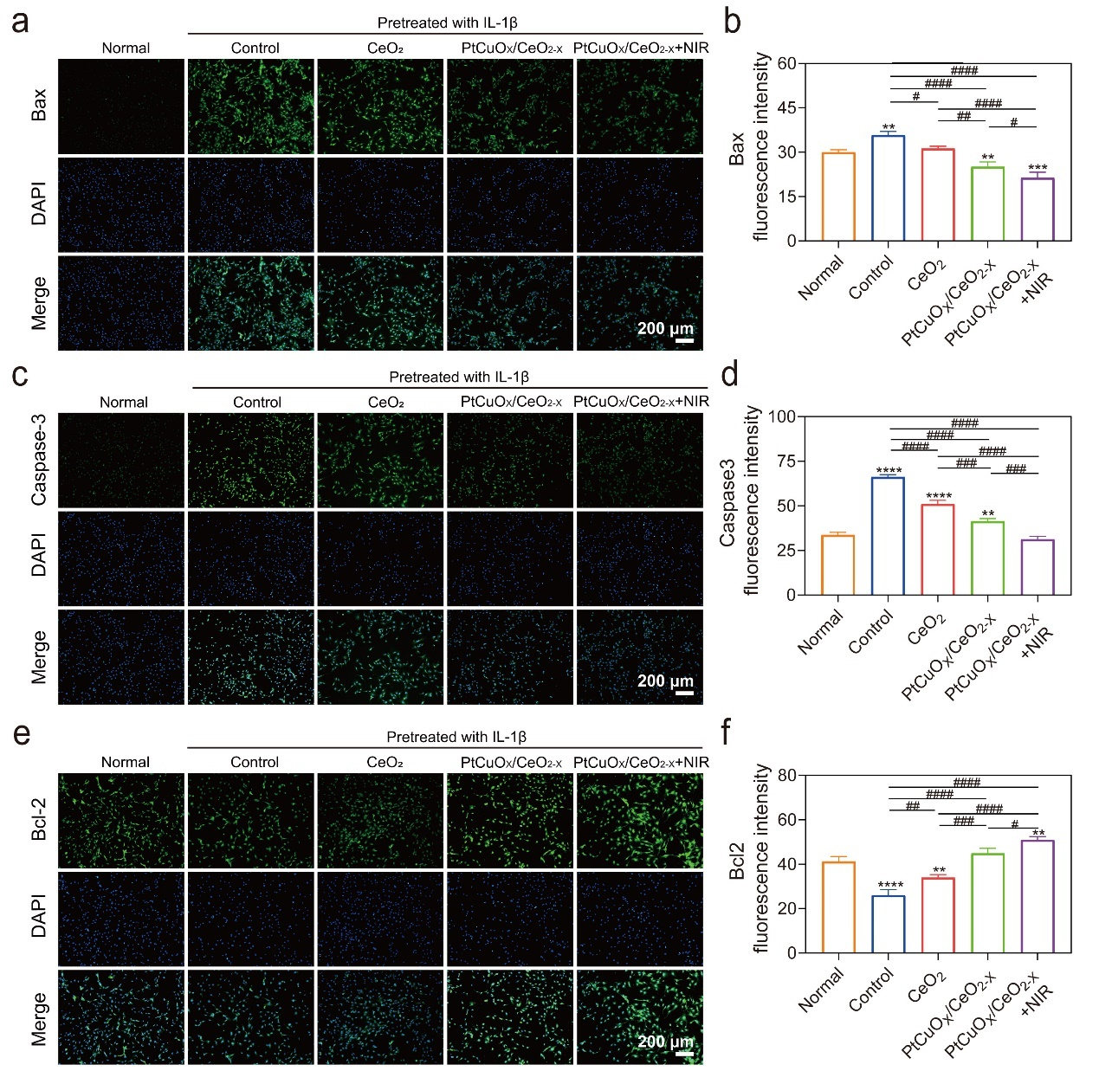
Fig. S17. Chondrocyte staining and corresponding quantification with immunofluorescent antibodies against Bax (a,b), caspase-3 (c,d), and Bcl-2 (e,f). Data are expressed as mean ± SD (n=3). * and # for P < 0.05, ** and ## for P < 0.01, *** and ### for P < 0.001, and **** and #### for P < 0.0001.

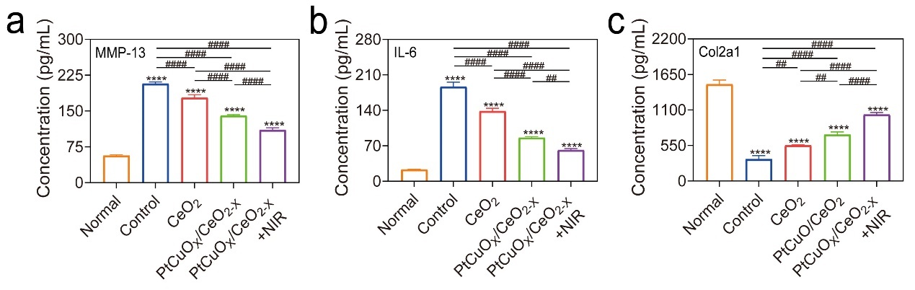
Fig. S18. After corresponding treatments in different groups, the levels of inflammatory proteins (MMP-13, IL-6) and cartilage-specific protective proteins (Col2a1) were determined in cell supernatants using ELISA kits. Data are expressed as mean ± SD (n=3). * and # for P < 0.05, ** and ## for P < 0.01, *** and ### for P < 0.001, and **** and #### for P < 0.0001.

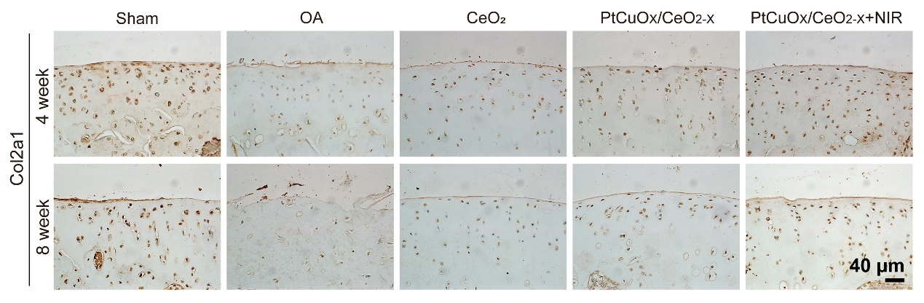
Fig. S19. The articular cartilage was subjected to IHC staining using the Col2a1 antibody at 4 and 8 weeks after different treatments.

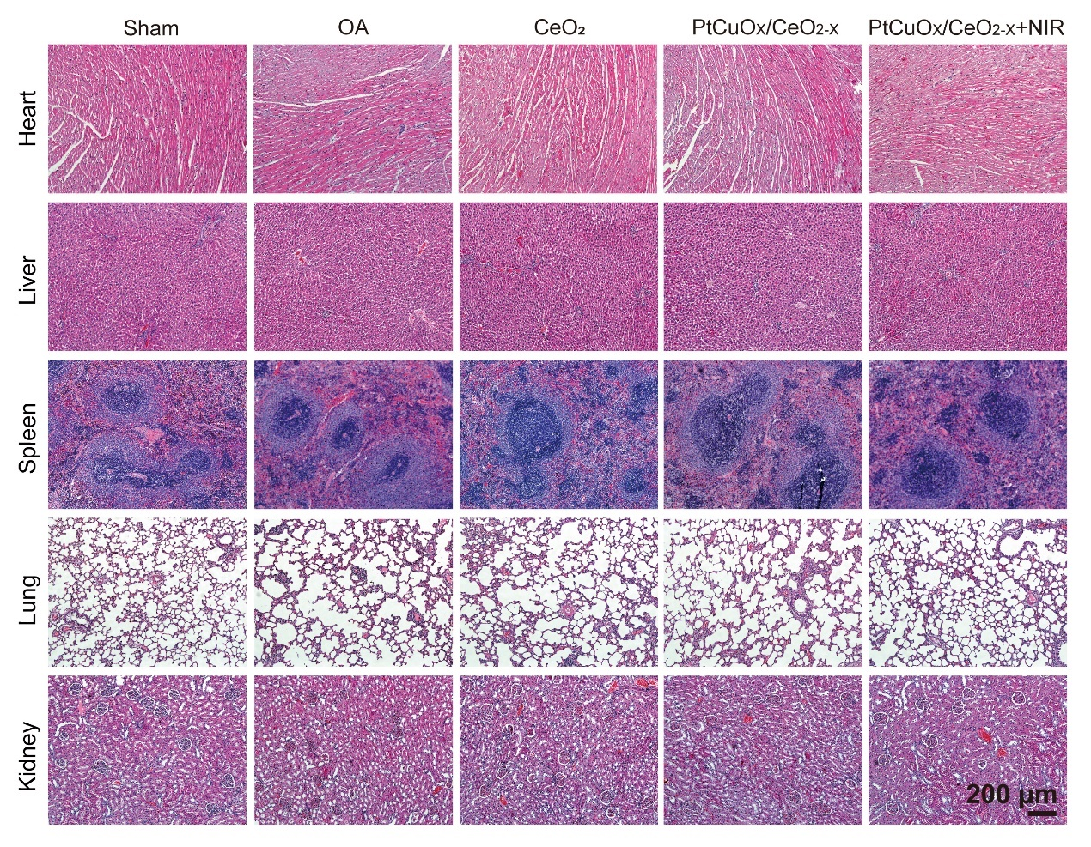
Fig. S20. HE images of major organs extracted from SD rats with OA subjected to various treatments.

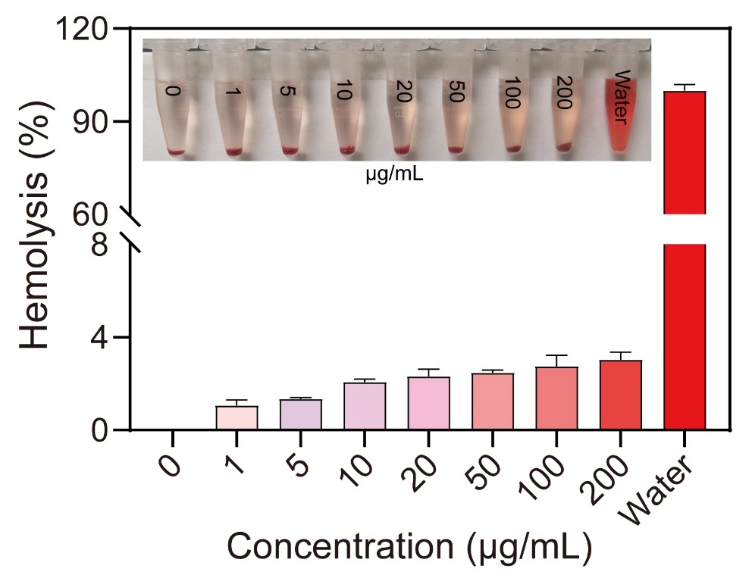
Fig. S21. Hemolysis assay after co-culture with blood cells using different concentrations of PtCuO_{X}/CeO_{2-X}. Data are expressed as mean ± SD (n=3).
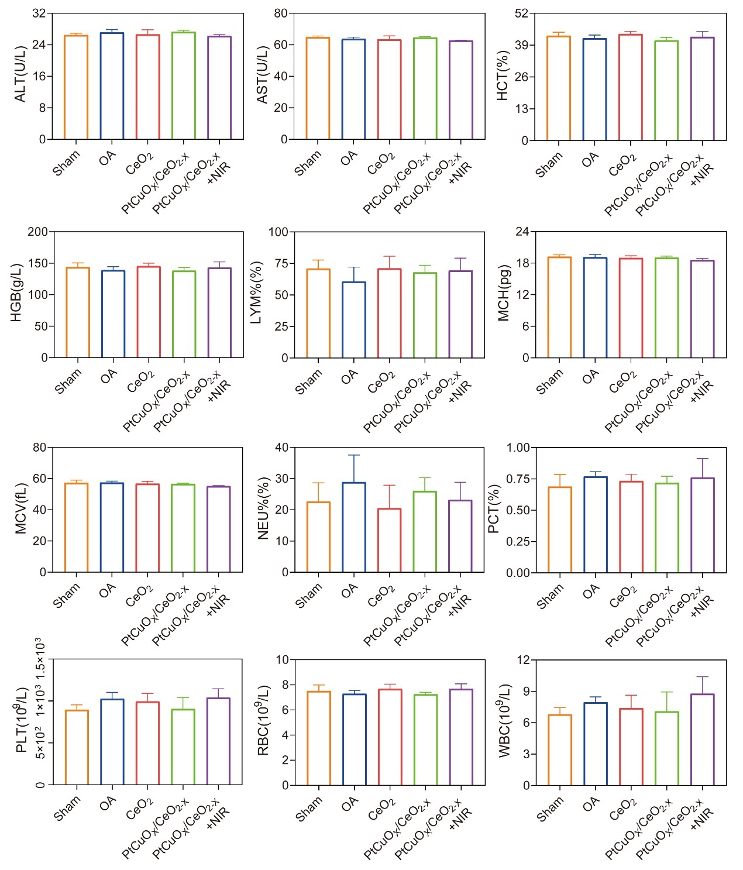
Fig. S22. The concentrations of white blood cells (WBC), red blood cells (RBC), hematocrit (HCT), hemoglobin (HGB), lymphocytes (LYM), and mean hemoglobin content (MCH), mean corpuscular volume (MCV), neutrophils (NEU), procalcitonin (PCT), and platelets (PLT) in serum were measured to evaluate the different groups at 8 weeks after the respective treatments to evaluate the results of routine blood tests in serum of different groups. Serum concentrations of aspartate aminotransferase (AST) and alanine aminotransferase (ALT) were measured to evaluate their hepatotoxicity and nephrotoxicity at 8 weeks after the respective treatments in different groups. Data are expressed as mean ± SD (n=3).

Table S1 XPS peak summary of different atoms in CeO₂
CeO₂ | O 1s |  |  | Ce 3d
CeO₂ | O_{Lat} | O_{Sur} | O_{Adv} | Ce⁴⁺ | Ce³⁺ | Ce⁴⁺ | Ce⁴⁺ | Ce³⁺ | Ce⁴⁺ | Ce³⁺ | Ce⁴⁺ | Ce⁴⁺
 |  |  |  | Ce  3d5/  2 | Ce  3d5/  2 | Ce  3d5/  2 | Ce  3d5/  2 | Ce  3d3/  2 | Ce  3d3/  2 | Ce  3d3/  2 | Ce  3d3/  2 | Ce  3d3/  2
CeO₂ | 528.  90 | 530.  69 | 531.  93 | 882.  42 | 884.  97 | 888.  35 | 898.  25 | 900.  16 | 901.  71 | 903.  80 | 907.  59 | 917.  00

Table S2 XPS peak summary of different atoms in CuO_{X}CeO_{2-X}
CuO_{X}CeO_{2-X} | O 1s |  |  | Cu 2p
CuO_{X}CeO_{2-X} | O_{Lat} | O_{Sur} | O_{Adv} | Cu¹⁺ | Cu²⁺ | Cu¹⁺ | Cu²⁺ | Cu¹⁺ | Cu²⁺ | Cu¹⁺
 |  |  |  | Sat | Cu 2p1/  2 | Cu 2p1/  2 | Sat | Sat | Cu 2p3/  2 | Cu 2p3/  2
CuO_{X}CeO_{2-X} | 529.  71 | 531.  89 | 533.  37 | 962.  85 | 954.  81 | 952.  70 | 943.  92 | 940.  50 | 934.  86 | 932.  90
CuO_{X}CeO_{2-X} | Ce 3d
CuO_{X}CeO_{2-X} | Ce⁴⁺ | Ce³⁺ | Ce⁴⁺ | Ce⁴⁺ | Ce³⁺ | Ce⁴⁺ | Ce³⁺ | Ce⁴⁺ | Ce⁴⁺
CuO_{X}CeO_{2-X} | Ce 2p5/  2 | Ce 2p5/  2 | Ce 2p5/  2 | Ce 2p5/  2 | Ce 2p3/  2 | Ce 2p3/  2 | Ce 2p3/  2 | Ce 2p3/  2 | Ce 2p3/  2
CuO_{X}CeO_{2-X} | 882.  76 | 885.  23 | 889.  14 | 898.  37 | 899.  15 | 901.  22 | 903.  50 | 907.  89 | 917.  12

Table S3 XPS peak summary of different atoms in PtCuO_{X}/CeO_{2-X}
PtCuO_{X}CeO_{2-X} | O 1s |  |  |  | Cu 2p
PtCuO_{X}CeO_{2-X} | O_{Lat} | O_{Sur} | O_{Sur} | O_{Adv} | Cu¹⁺ | Cu²⁺ | Cu²⁺ | Cu¹⁺ | Cu²⁺
 |  |  |  |  | Cu 2p1/  2 | Cu 2p1/  2 | Sat | Cu 2p3/  2 | Cu 2p3/  2
PtCuO_{X}CeO_{2-X} | 528.  96 | 530.  49 | 531.  92 | 534.  16 | 932.  11 | 934.  57 | 943.  69 | 952.  08 | 955.  01
PtCuO_{X}CeO_{2-X} | Pt 4f
PtCuO_{X}CeO_{2-X} | Pt⁰ | Pt⁴⁺ | Pt⁰ | Pt⁴⁺
PtCuO_{X}CeO_{2-X} | Pt 4f7/  2 | Pt  4f7/  2 | Pt 4f5/  2 | Pt 4f5/  2
PtCuO_{X}CeO_{2-X} | 70.  46 | 72.  27 | 73.  90 | 76.  57
PtCuO_{X}CeO_{2-X} | Ce 3d
PtCuO_{X}CeO_{2-X} | Ce⁴⁺ | Ce³⁺ | Ce⁴⁺ | Ce⁴⁺ | Ce³⁺ | Ce⁴⁺ | Ce³⁺ | Ce⁴⁺ | Ce⁴⁺
PtCuO_{X}CeO_{2-X} | Ce 2p5/  2 | Ce 2p5/  2 | Ce 2p5/  2 | Ce 2p5/  2 | Ce 2p3/  2 | Ce 2p3/  2 | Ce 2p3/  2 | Ce 2p3/  2 | Ce 2p3/  2
PtCuO_{X}CeO_{2-X} | 881.  95 | 884.  47 | 888.  25 | 897.  73 | 899.  47 | 900.  80 | 902.  98 | 907.  08 | 916.  80

Table S4 Adsorption energies of different adsorbates on the PtCuO_{X}/CeO_{2-X} surface
Molecule | H₂O₂ | O₂ | O | H₂O
CeO₂ | -0.07eV | -0.03eV | -3.24eV | -0.52eV
PtCuO_{X}CeO_{2-X} | -0.60 eV | -1.52 eV | -5.02 eV | -0.64 eV

Table S5 Primer sequences used in qRT-PCR experiments
Gene name | Forward primer | Reverse primer
GAPDH | 5’-AGGGCCCTGACAACTCTTTT-3’ | 5’-AGGGGTCTACATGGCAACTG-3’
MMP-13 | 5’-GCCATTACCAGTCTCCGAGG-3’ | 5’-TACGGTTGGGAAGTTCTGGC-3’
IL-6 | 5’-TCTGCGCAGCTTTAAGGAGT-3’ | 5’-CCCAGTGGACAGGTTTCTGA-3’
TNF-α | 5’-TCAGAGGGCCTGTACCTCAT-3’ | 5’-GGAGGTTGACCTTGGTCTGG-3’
iNOS | 5’-GTGTTCCACCAGGAGATGTTG-3’ | 5’-CTCCTGCCCACTGAGTTCCGTTC-3’
ACAN | 5’-GAATGGGAGCCAGCCTACAC-3’ | 5’ -GAGAGGCAGAGGGACTTTCG-3’
Col2a1 | 5’-GACTGTGCCTCGGAAGAACT-3’ | 5’ -TCTGGACGTTAGCGGTGTTG-3’

