Supplementary material: Exploring incentives to move up the Food Waste Hierarchy: a case study of the Australian cheese manufacturing sector

Robustness check
Table S1. Comparison of individual motivator-scoring across behaviour sub-groups aligned to the Food Waste Hierarchy.
 | 4-group comparison |  |  |  |  | 2-group comparison
 | Human food products | Animal Feed | Recycling or  recovery | Disposal | P-value | Reduction | Waste | P-value
N | 5 | 15 | 10 | 12 |  | 20 | 22
Median score (IQR)¹:
Maximising profit | 70 (50) | 30 (20) | 45 (50.9) | 20 (27.5) | 0.16 | 30 (32.5) | 31.7 (30) | 0.94
Government regulations | 0 (0)ª | 14 (25)^{b} | 10 (19.8)^{ab} | 20 (12.5)^{b} | 0.09* | 9 (26.3) | 17.5 (10) | 0.39
Buyers’ expectations | 0 (0) | 10 (17) | 2.5 (10) | 12.5 (20) | 0.26 | 4.5 (15.5) | 7.5 (18.8) | 0.66
Society’s expectations | 15 (20) | 10 (14.5) | 4.2 (10) | 5 (16.3) | 0.79 | 10 (16.3) | 5 (10) | 0.56
Protecting the natural environment | 15 (10) | 15 (12.5) | 17.5 (25) | 30 (22.5) | 0.50 | 15 (11.3) | 20 (28.8) | 0.33
Keeping up with practices used by other manufacturers | 0 (0)^{ab} | 0 (10)ª | 0 (0)^{b} | 0 (0)^{b} | 0.10* | 0 (10)ª | 0 (0)^{b} | 0.03**
Other | 0 (0) | 0 (0) | 0 (0) | 0 (0) | 0.51 | 0 (0) | 0 (0) | 0.46
Mean score (SD)²:
Maximising profit | 29.7 (22.4)ª | 50.6 (33.8)ª | 27.1 (20.6)ª | 29.7 (22.4)ª | 0.07* | 35.8 (26.5) | 37.8 (29.3) | 0.82
Government regulations | 19.5 (18.1) | 18.4 (27.5) | 22.9 (19.4) | 19.5 (18.1) | 0.39 | 15.6 (17.5) | 20.9 (22.9) | 0.41
Buyers’ expectations | 8.9 (8.3) | 5.5 (6.9) | 12.1 (11) | 8.9 (8.3) | 0.24 | 7.7 (8.5) | 9.1 (9.7) | 0.61
Society’s expectations | 8.6 (8.7) | 5.8 (6.6) | 10 (12.4) | 8.6 (8.7) | 0.59 | 9.7 (9.8) | 8.1 (10.2) | 0.61
Protecting the natural environment | 20.8 (20.8) | 18.2 (15.4) | 27.1 (17.9) | 20.8 (20.8) | 0.72 | 20.9 (20.8) | 23 (17) | 0.71
Keeping up with practices used by other manufacturers | 5.3 (6.6)ª | 0.5 (1.6)ª | 0.8 (1.9)ª | 5.3 (6.6)ª | 0.07* | 5 (7)ª | 0.7 (1.8)^{b} | 0.01**
Other | 7.3 (23.4) | 1 (3.2) | 0 (0) | 7.3 (23.4) | 0.52 | 5.5 (20.4) | 0.5 (2.1) | 0.3
Note: Motivator scores range between 0 and 100. ¹P-values for median scores depict Kruskal-Wallis test, with Dunn’s Test. ²P-values for mean values depict ANOVA test, with Dunnett’s T3 Test. * P-value < 0.10; ** P-value <0.05. Different letters indicate significant differences (p-value <0.05). IQR: inter-quartile range. SD: standard deviation.

Sample descriptive statistics
Table S2 provides a summary of the survey participants categorised by state and production scale, with a comparison to national data for CMs provided by Dairy Australia, the national research and development corporation and peak industry-body. The Chi-squared results indicate that the participants in the study represent (P>0.05) the distribution of both state and production scale of Australian cheese manufacturing sector captured in Dairy Australia’s database.
Table S2. Distribution of survey participants by state and production size, and statistical comparison with the Dairy Australia’s national database.
 | Interview participants |  | Dairy Australia  database¹ |  | % difference | P-value²
 | N | % | N | %
State:
VIC | 18 | 42.9% | 49 | 37.1% | 5.7% | 0.626
NSW | 7 | 16.7% | 37 | 28.0% | -11.4% | 0.626
QLD | 5 | 11.9% | 18 | 13.6% | -1.7% | 0.626
TAS | 5 | 11.9% | 12 | 9.1% | 2.8% | 0.626
SA | 4 | 9.5% | 9 | 6.8% | 2.7% | 0.626
WA | 3 | 7.1% | 7 | 5.3% | 1.8% | 0.626
Total | 42 | 100.0% | 132 | 100.0%
Production scale³:
Large (>25kt) | 2 | 4.7% | 3 | 2.3% | 2.4% | 0.485
Medium (10-25kt) | 4 | 9.3% | 10 | 7.6% | 1.7% | 0.485
Small (<10kt) | 36 | 86.0% | 119 | 90.2% | -4.1% | 0.485
Total | 42 | 100.0% | 132 | 100.0%
¹Data source: Dairy Australia. ²Statistical test: Chi-squared goodness-of-fit. ³Production scale based on kilotonnes of finished cheese products per annum.

Interview question
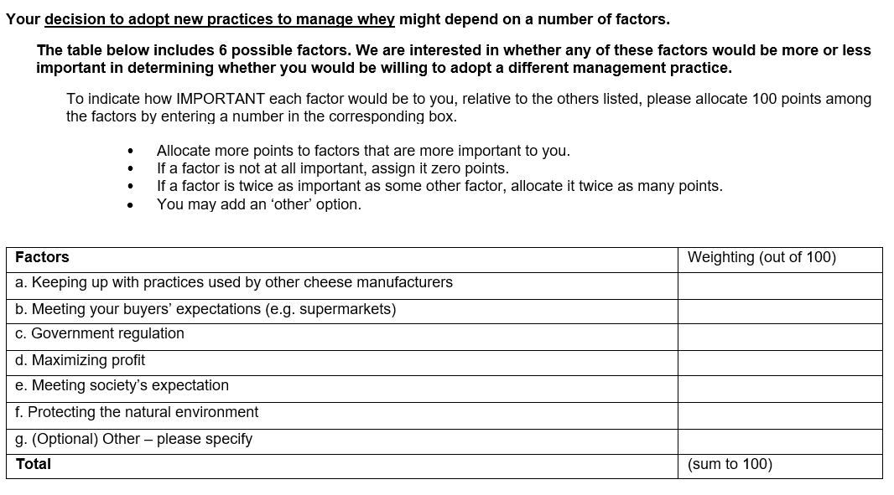
Figure S1. Interview question provided to participants.

