Concave surface-enriched reactant and enhanced mass transfer for electrocatalytic ethylene production from low-concentrated acetylene
Li et al.

Contents
Supplementary Figure 1. Projected crystal orbital Hamilton population (−pCOHP) for the C-C interaction of gaseous C₂H₂.and the adsorption of C₂H₂ on pure Cu.
Supplementary Figure 2. The energy change profiles and theoretical adsorption models of the transition states for C₂H₂ migration over carbon with a concave surface.
Supplementary Figure 3. The energy change profiles and theoretical adsorption models of the transition states for C₂H₂ migration over carbon with a plane surface.
Supplementary Figure 4. SEM and TEM images of the Cu-MOF precursors.
Supplementary Figure 5. SEM and TEM images of the as-prepared Cu-TA.
Supplementary Figure 6. SEM, TEM, and HRTEM images of Cu-PCC and the corresponding energy-dispersive X-ray spectroscopy (EDS) elemental mapping images.
Supplementary Figure 7. SEM, TEM, and HRTEM images of Cu-C and the corresponding energy-dispersive X-ray spectroscopy (EDS) elemental mapping images.
Supplementary Figure 8. The sequential conversion process from Cu-MOF precursors to Cu-PCC.
Supplementary Figure 9. XRD patterns of Cu-PCC and Cu-C.
Supplementary Figure 10. Raman spectra of the Cu-PCC and Cu-C under OCP.
Supplementary Figure 11. The valence state and coordinate environment of Cu sites.
Supplementary Figure 12. Brunauer‒Emmett‒Teller surface area of Cu-PCC and Cu-C.
Supplementary Figure 13. The LSV curve and the corresponding Tafel slopes of Cu-PCC and Cu-C.
Supplementary Figure 14. Enlarged DEMS in LSV mode of Cu-PCC and Cu-C.
Supplementary Figure 15. Electrochemical capacitance measurements of Cu-PCC and Cu-C.
Supplementary Figure 16. Mass fraction of Cu in Cu-PCC and Cu-C from ICP-OES results.
Supplementary Figure 17. The C₂H₄ partial current densities of Cu-PCC and Cu-C after normalization to the ECSA.
Supplementary Figure 18. The stability of Cu-PCC after 12 h of continuous testing.
Supplementary Figure 19. The ATR-FTIR spectra of Cu-PCC and Cu-C at OCP under Ar and C₂H₂ atmospheres.
Supplementary Figure 20. Peak-differentiating and fitting analysis of the ATR-FTIR data of Cu-PCC and Cu-C under a C₂H₂ atmosphere.
Supplementary Figure 21. Potential-dependent in situ ATR-FTIR results under a C₂H₂ atmosphere over Cu-PCC and Cu-C.
Supplementary Figure 22. Peak-differentiating and fitting analysis of the potential-dependent in situ ATR-FTIR data.
Supplementary Figure 23. Theoretical adsorption models of the hydrogenation process of C₂H₂ over high C₂H₂ coverage and low coverage.
Supplementary Figure 24. The energy change profiles and theoretical adsorption models of the transition states for C₂H₂ hydrogenation to C₂H₃ with high C₂H₂ coverage.
Supplementary Figure 25. The energy change profiles and theoretical adsorption models of the transition states for C₂H₃ hydrogenation to C₂H₄ with high C₂H₂ coverage.
Supplementary Figure 26. The energy change profiles and theoretical adsorption models of the transition states for C₂H₂ hydrogenation to C₂H₃ with low C₂H₂ coverage.
Supplementary Figure 27. The energy change profiles and theoretical adsorption models of the transition states for C₂H₃ hydrogenation to C₂H₄ with low C₂H₂ coverage.
Supplementary Notes 1-10.
Supplementary References (1-6).

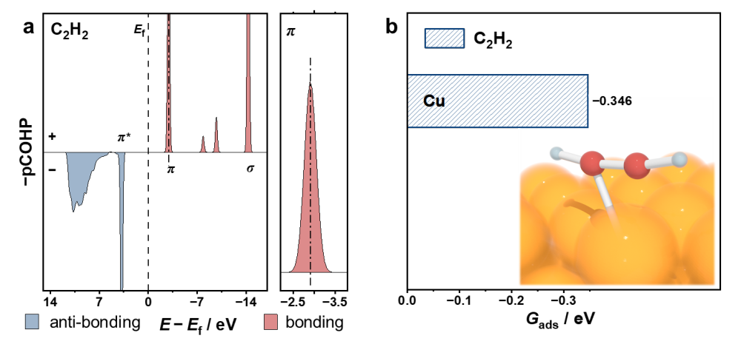
Supplementary Figure 1. (a) Projected crystal orbital Hamilton population (−pCOHP) for the C-C interaction of gaseous C₂H₂. (b) Adsorption of C₂H₂ on pure Cu.
Supplementary Note 1. As shown in Supplementary Figure 1, compared with those of PCC and C (Fig. 2c), the adsorption of C₂H₂ on Cu is greater than that on carbon supports, indicating that hydrogenation is prone to occur at Cu sites.

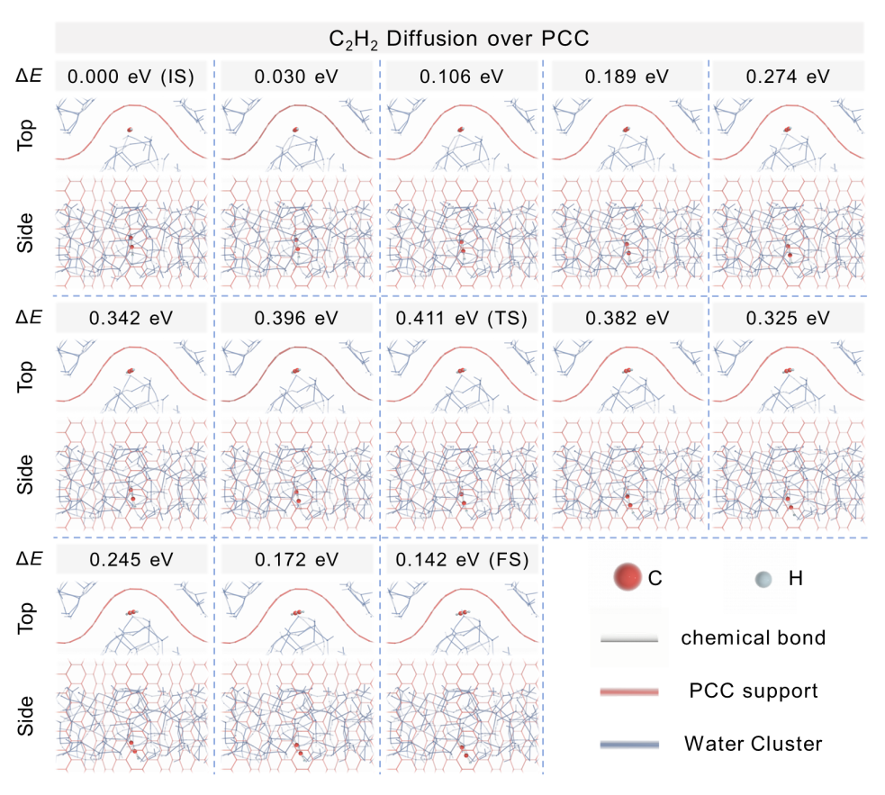

Supplementary Figure 2. The energy change profiles and theoretical adsorption models of the transition states for C₂H₂ migration over carbon with a concave surface.

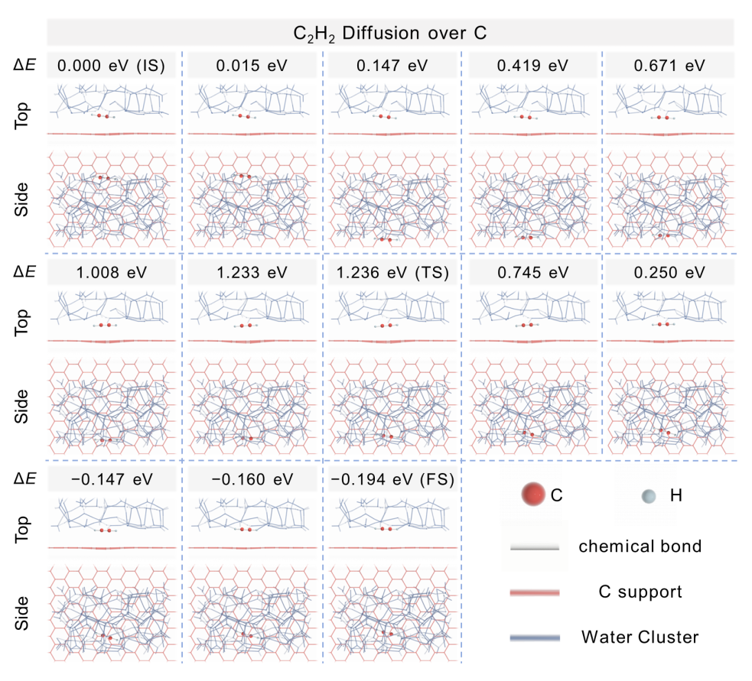

Supplementary Figure 3. The energy change profiles and theoretical adsorption models of the transition states for C₂H₂ migration over carbon with a plane surface.

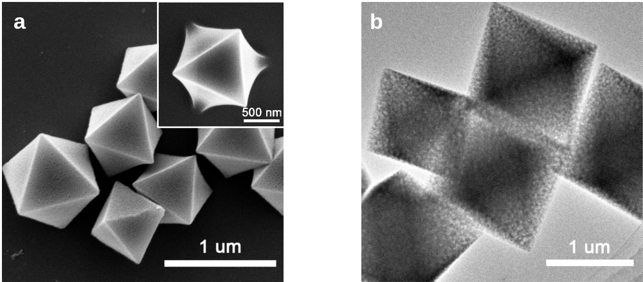

Supplementary Figure 4. SEM (a) and TEM (b) images of the Cu-MOF precursors.

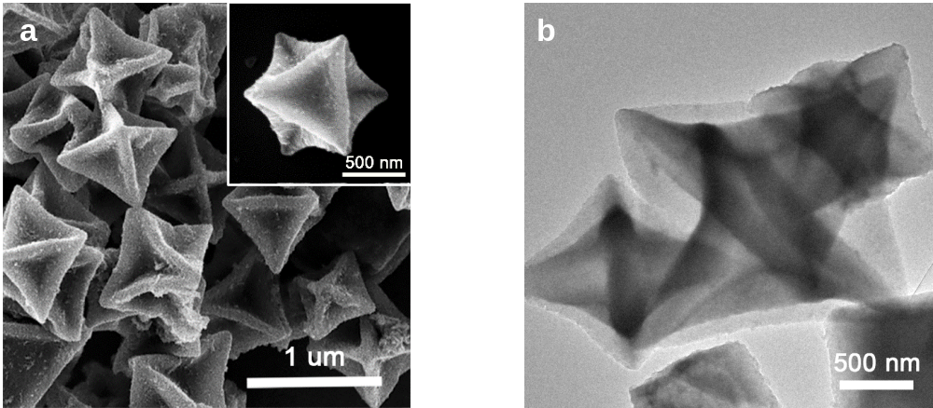
Supplementary Figure 5. SEM (a) and TEM (b) images of the as-prepared Cu-TA (b).
Supplementary Note 2. As shown in the corresponding SEM and TEM images, the plate surface of the Cu-MOF precursors collapsed after etching by TA for 7 h due to the Kirkendall effect.
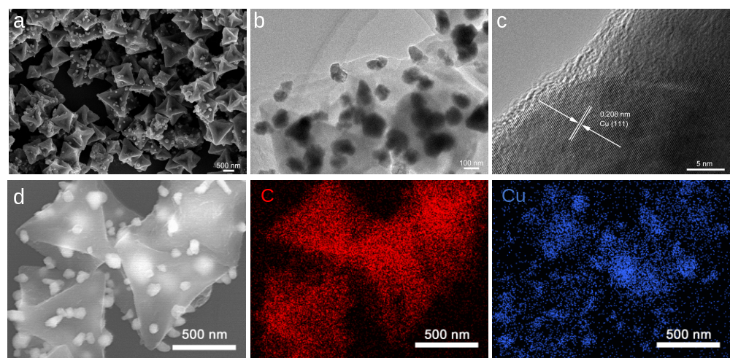
Supplementary Figure 6. SEM, TEM, and HRTEM images of Cu-PCC and the corresponding energy-dispersive X-ray spectroscopy (EDS) elemental mapping images. (a) SEM image. (b) TEM. (c) HRTEM image. (d) The corresponding image of Cu-PCC from scanning transmission electron microscopy under high-angle annular dark-field mode and energy-dispersive X-ray spectroscopy (EDS) elemental mapping images of Cu-PCC.
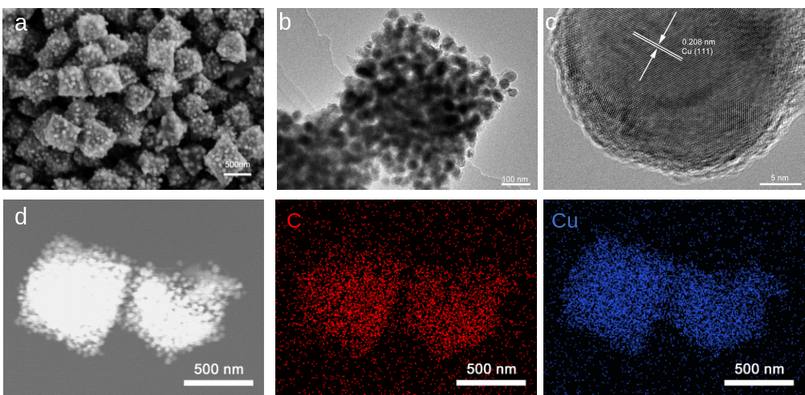
Supplementary Figure 7. SEM, TEM, and HRTEM images of Cu-C and the corresponding energy-dispersive X-ray spectroscopy (EDS) elemental mapping images. (a) SEM. (b) TEM. (c) HRTEM image. (d) The corresponding image of Cu-C from scanning transmission electron microscopy under high-angle annular dark-field mode and energy-dispersive X-ray spectroscopy (EDS) elemental mapping images of Cu-C.

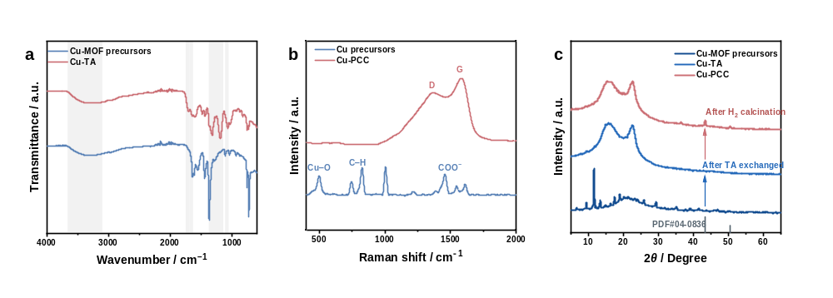
Supplementary Figure 8. The sequential conversion process from Cu-MOF precursors to Cu-PCC. (a) FTIR spectra of Cu-TA and Cu-MOF precursors. (b) Raman spectra of Cu-MOF and the as-prepared Cu-PCC. (c) XRD patterns of Cu-MOF, Cu-TA, and Cu-PCC.
Supplementary Note 3. According to the literature ¹⁻³, the IR data suggest that all the peaks in Supplementary Figure 8a are attributed to the stretching vibration of functional groups from TA, indicating the substitution of H₃BTC by TA and the formation of Cu-TA complexes. As shown in Supplementary Figure 8c, the crystalline structure of the as-prepared Cu-MOF is similar to that reported in the literature ², and these diffraction peaks disappear after the reaction of Cu-MOF with TA due to the amorphous character of the TA-metal complex. Furthermore, diffraction peaks attributed to metallic Cu appear after H₂ calcination, confirming the existence of metallic Cu.

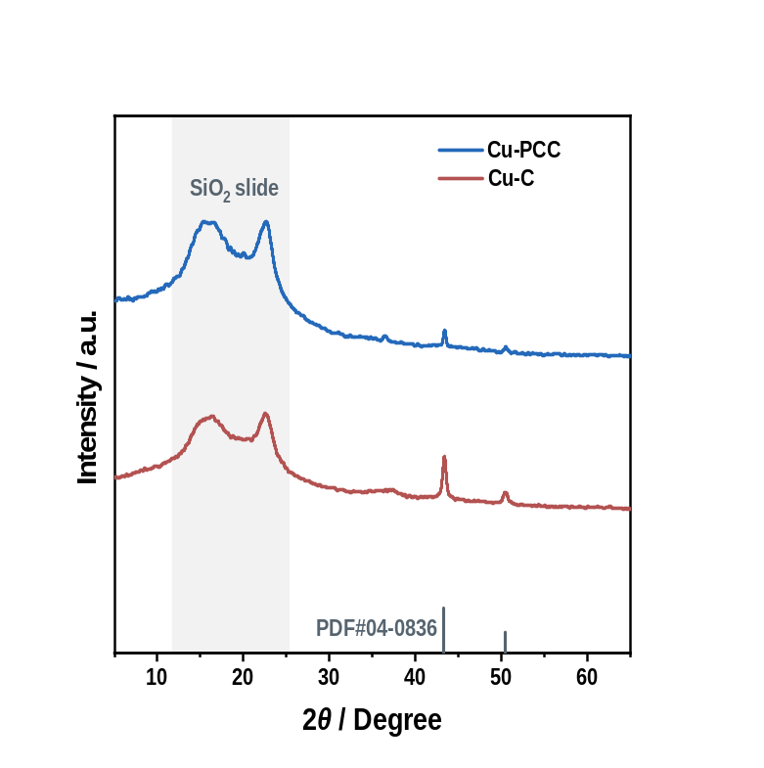
Supplementary Figure 9. XRD patterns of Cu-PCC and Cu-C.

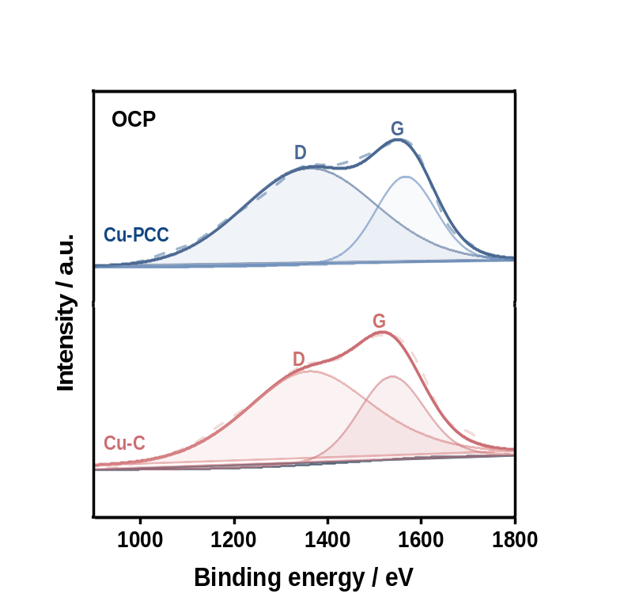
Supplementary Figure 10. Raman spectra of the Cu-PCC and Cu-C under OCP.
Supplementary Note 4. Generally, the relative ratio of the D to G band (I_{D}/I_{G}) values is the descriptor of the carbon defect, as shown in Supplementary Figure 10, the similar I_{D}/I_{G} indicates that there is no obvious difference in the defect concentration between PCC and C ⁴.

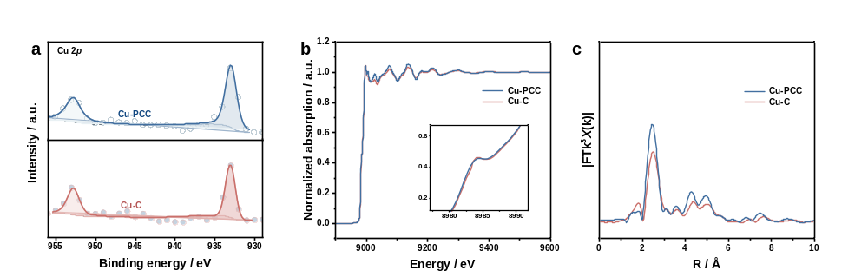
Supplementary Figure 11. The valence state and coordinate environment of Cu. (a) Cu 2p XPS, (b) X-ray absorption near-edge structure spectrum, and (c) EXAFS spectrum of Cu-PCC and Cu-C.
Supplementary Note 5. As shown in Supplementary Figure 11, the valence state and coordinate environment of Cu in Cu-PCC and Cu-C are almost the same.

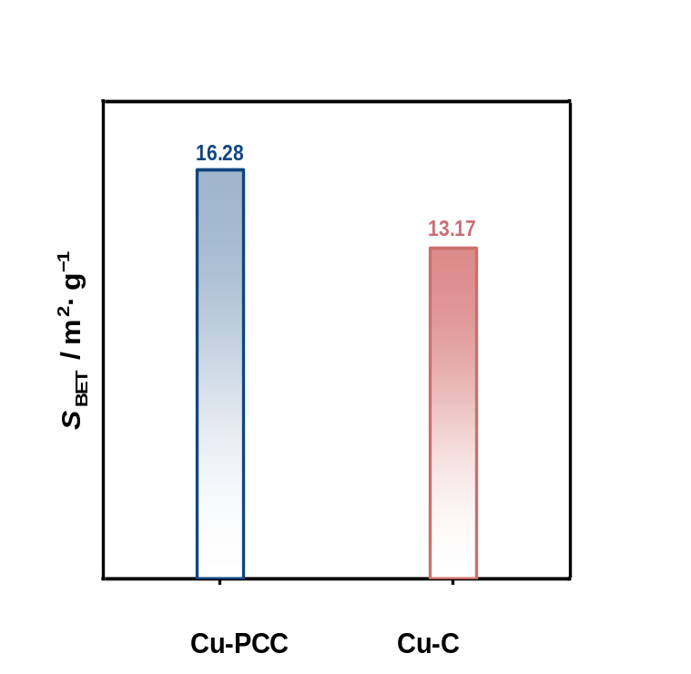
Supplementary Figure 12. Brunauer‒Emmett‒Teller surface area of Cu-PCC and Cu-C.
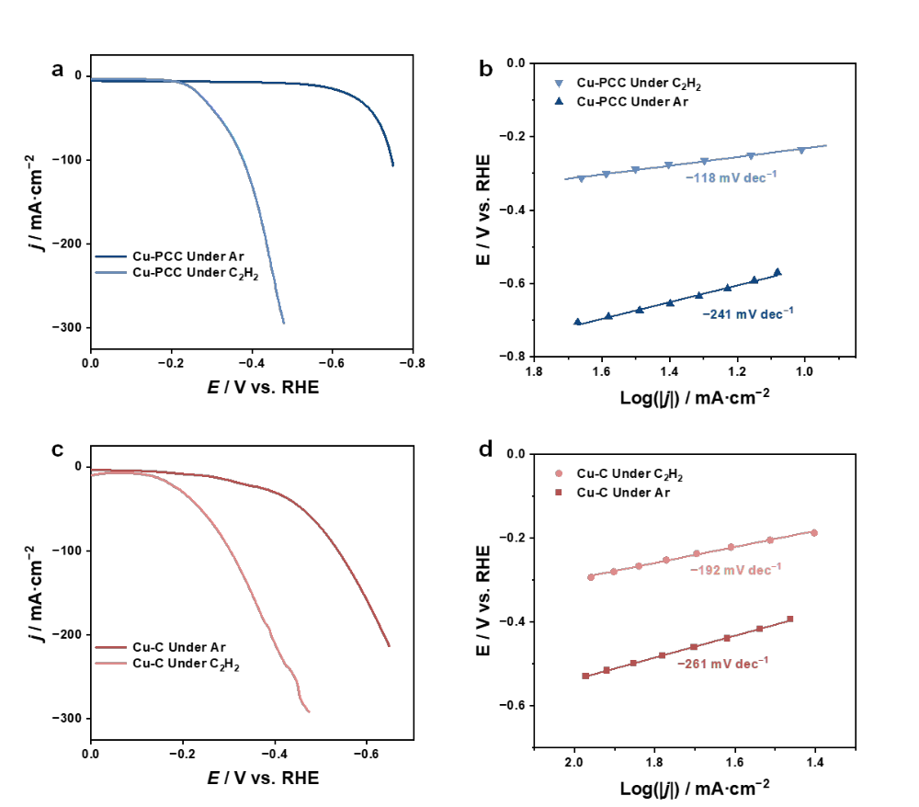
Supplementary Figure 13. The LSV curve and the corresponding Tafel slopes of Cu-PCC and Cu-C. The LSV curves of Cu-PCC under Ar and C₂H₂ atmospheres (a) and the corresponding Tafel slopes (b); the LSV curves of Cu-C under Ar and C₂H₂ atmospheres (c) and the corresponding Tafel slopes (d).
Supplementary Note 6. Supplementary Figure 13a,c clearly shows that the onset potential and current density across the whole potential range under a C₂H₂ atmosphere is much greater than those under an Ar atmosphere both over Cu-PCC and Cu-C. In addition, the difference in the absolute value of the Tafel slope of Cu-PCC (241-118=123 mV dec⁻¹) is much greater than that of Cu-C (261-192=69 mV dec⁻¹) (Supplementary Figure 13b,d), suggesting that the reaction kinetics of C₂H₂ semihydrogenation are enhanced over those of Cu-PCC due to the enrichment effect caused by the concave surface-induced field.

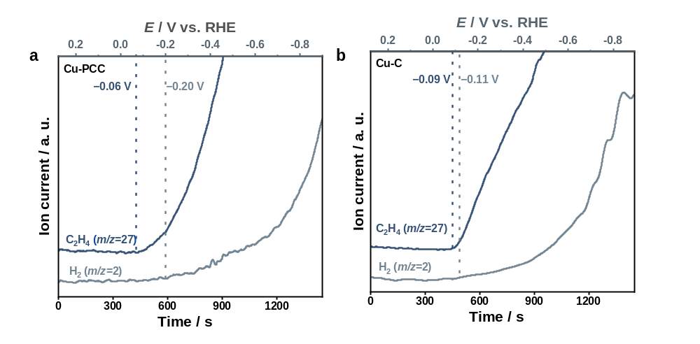
Supplementary Figure 14. Enlarged DEMS in LSV mode of Cu-PCC (a) and Cu-C (b).

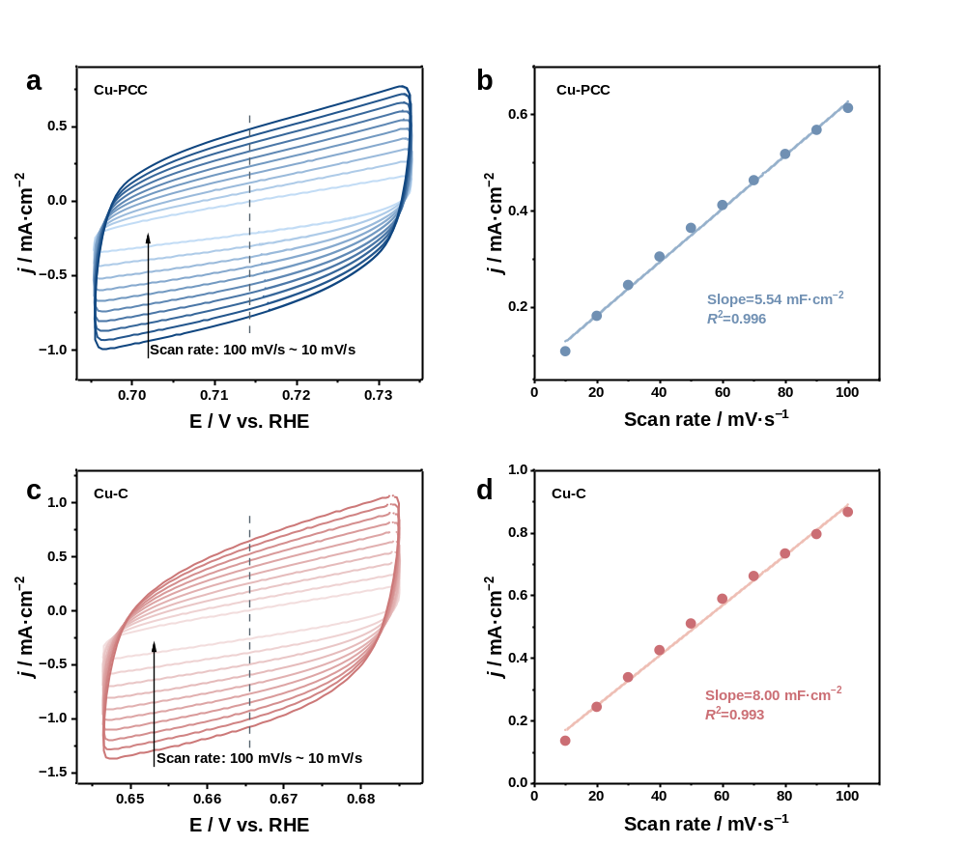
Supplementary Figure 15. Electrochemical capacitance measurements of Cu-PCC and Cu-C. Cyclic voltammogram curves of Cu-PCC at various scan rates (a) and the corresponding fitting (b); cyclic voltammogram curves of Cu-C at various scan rates (c) and the corresponding fitting (d).
Supplementary Note 7.Electrochemical capacitance measurements were used to determine the ECSA of the catalysts. To measure the electrochemical capacitance, the potential was swept at different scan rates ranging from 10-100 mV/s. The specific capacitance for a flat surface is generally found to be in the range of 20-60 µF cm⁻². In the calculations of the ECSA, we assumed a specific capacitance of 40 µF cm⁻².

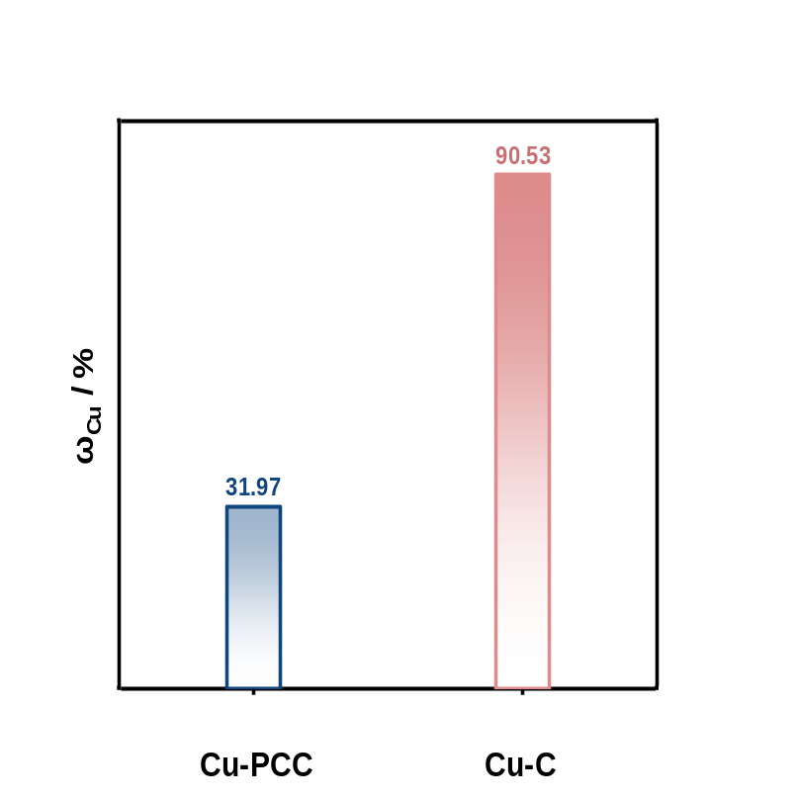
Supplementary Figure 16. Mass fraction of Cu in Cu-PCC and Cu-C from ICP-OES results.

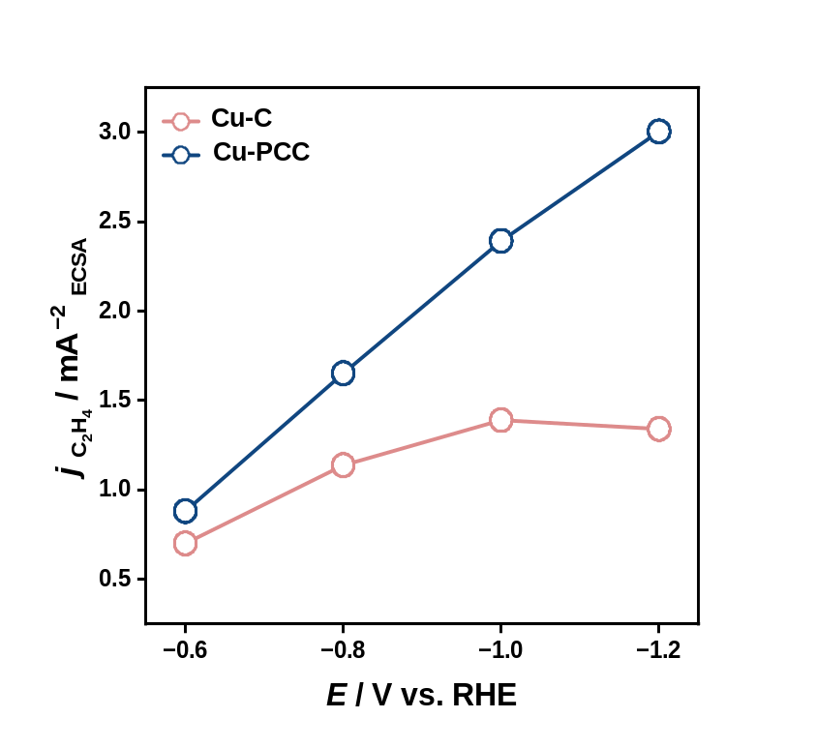
Supplementary Figure 17. The C₂H₄ partial current densities of Cu-PCC and Cu-C after normalization to the ECSA.

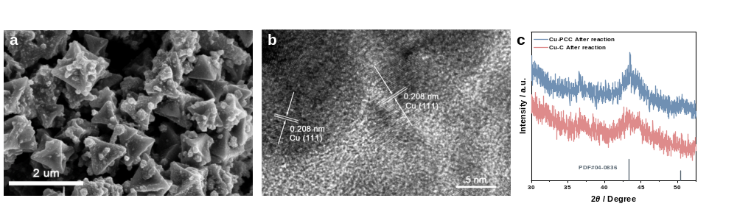
Supplementary Figure 18. The stability of Cu-PCC after 12 h of continuous testing. (a) SEM image. (b) HRTEM image. (c) XRD pattern.
Supplementary Note 8.The SEM images after 12 h of continuous testing indicated that the concave surface and particle size of the Cu-PCC could be maintained. The HRTEM images and XRD patterns confirmed that the crystal phase was unchanged, suggesting the robust stability of the as-prepared catalysts.

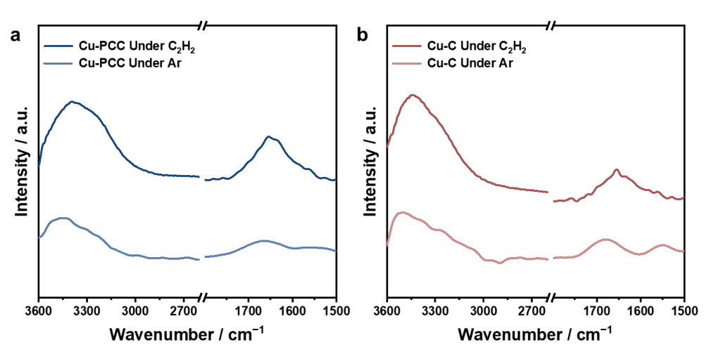
Supplementary Figure 19. The ATR-FTIR spectra of Cu-PCC (a) and Cu-C (b) at OCP under Ar and C₂H₂ atmospheres, respectively.
Supplementary Note 9. As shown in Supplementary Figure 19, the peaks located at 3600~3000 cm⁻¹ and 1750~1550 cm⁻¹ under C₂H₂ are much wider than the corresponding characteristic water peaks under Ar over both Cu-PCC and Cu-C, indicating that the whole peaks under C₂H₂ are attributed to water and C₂H₂. Thus, the relative coverage of water and C₂H₂ could be obtained through peak differentiation and fitting analysis.

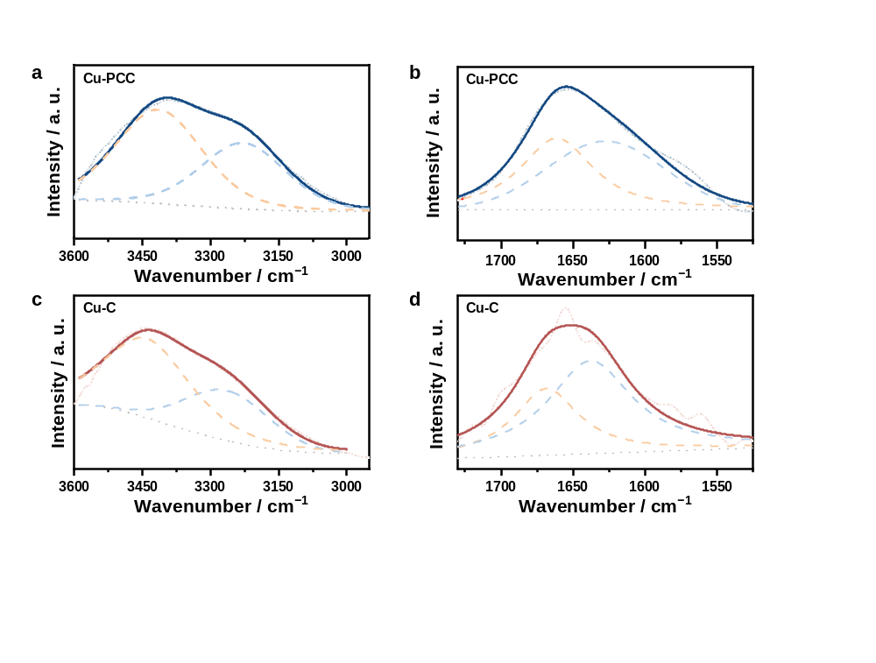
Supplementary Figure 20. Peak-differentiating and fitting analysis of the ATR-FTIR data of Cu-PCC (a, b) and Cu-C (c, d) under a C₂H₂ atmosphere.
Supplementary Note 10. As shown in Supplementary Figure 20, the peak located at 3600~3000 cm⁻¹ at the OCP under a C₂H₂ atmosphere could be divided into two peaks located at ~3410 and ~3200 cm⁻¹, which could be attributed to the ν(O-H) of water and the ν(C-H) of C₂H₂, respectively, both over Cu-PCC and Cu-C. In addition, the peaks in the range of 1750~1550 cm⁻¹ could also be attributed to δ (H-O-H) (~1660 cm⁻¹) and ν(C≡C) (~1620 cm⁻¹) ^{5,6}. Note that both the characteristic peaks of ν(C-H) and ν(C≡C) exhibit a redshift over Cu-PCC compared to their Cu-C counterparts, indicating that the carbon-carbon bonding of C₂H₂ over Cu-PCC has been weakened due to the delocalization of π electrons.

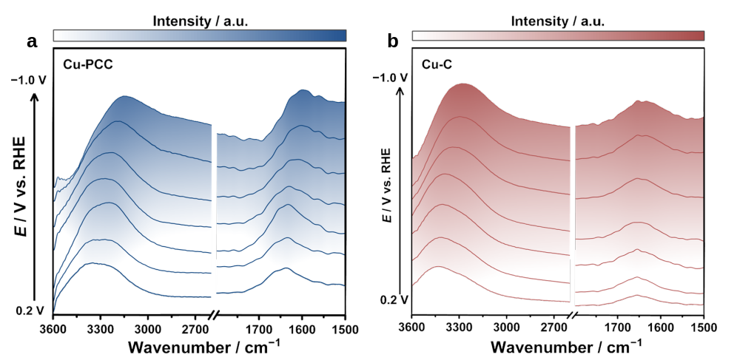
Supplementary Figure 21. Potential-dependent in situ ATR-FTIR results under a C₂H₂ atmosphere over Cu-PCC (a) and Cu-C (b).
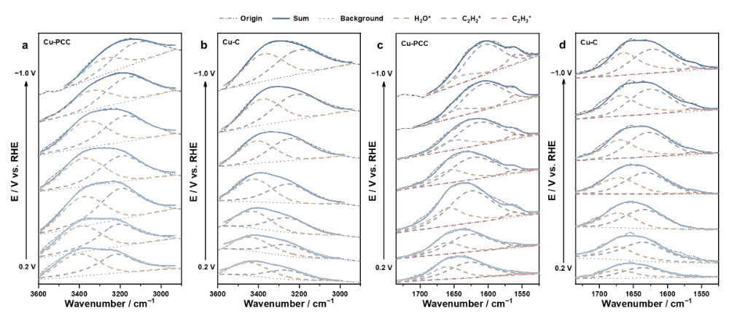
Supplementary Figure 22. Peak-differentiating and fitting analysis of the potential-dependent in situ ATR-FTIR data of Cu-PCC (a,c) and Cu-C (b,d) under a C₂H₂ atmosphere.
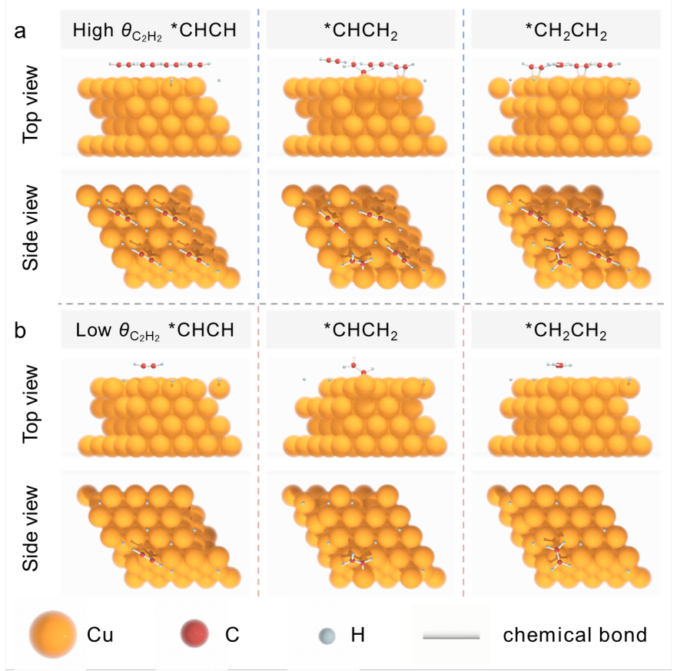

Supplementary Figure 23. Theoretical adsorption models of the hydrogenation process of C₂H₂ over high C₂H₂ coverage and low coverage.

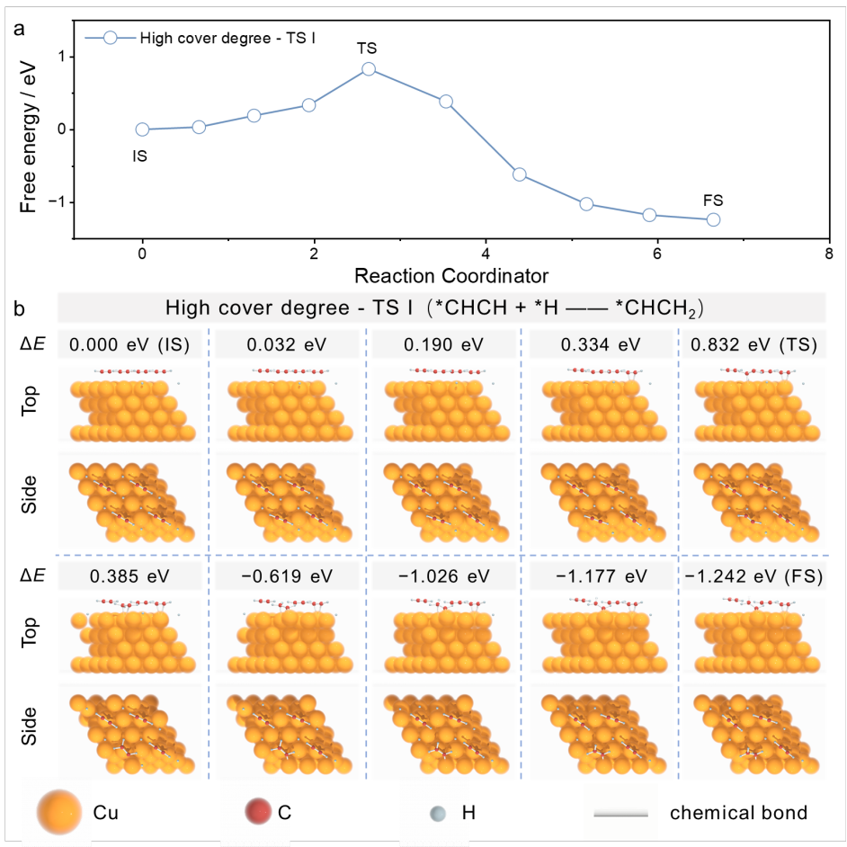
Supplementary Figure 24. The energy change profiles (a) and theoretical adsorption models (b) of the transition states for C₂H₂ hydrogenation to C₂H₃ with high C₂H₂ coverage.

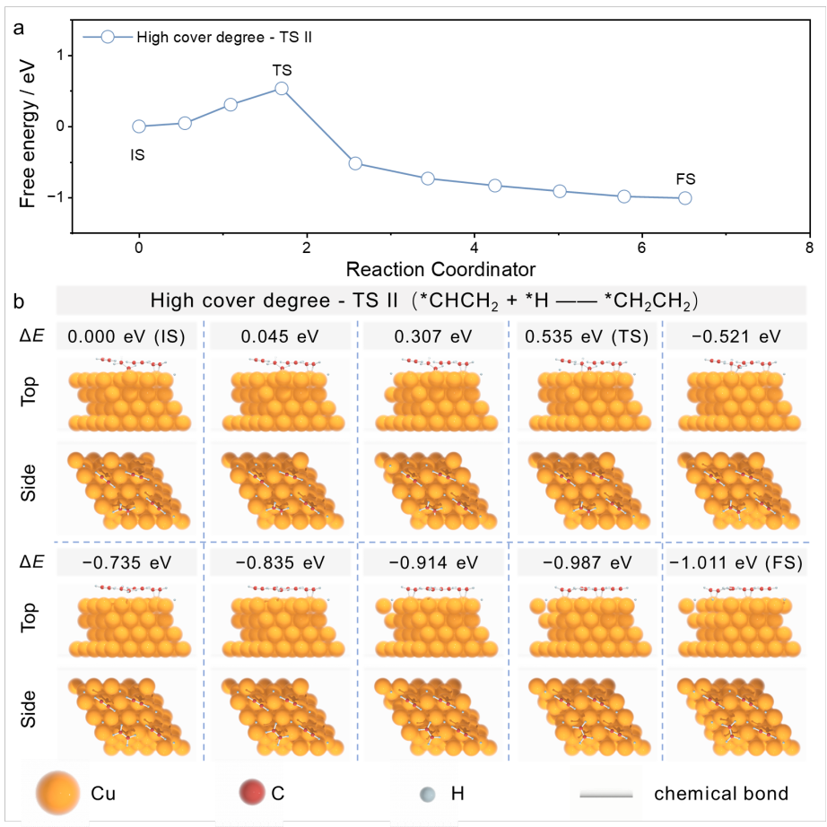
Supplementary Figure 25. The energy change profiles (a) and theoretical adsorption models (b) of the transition states for C₂H₃ hydrogenation to C₂H₄ with high C₂H₂ coverage.

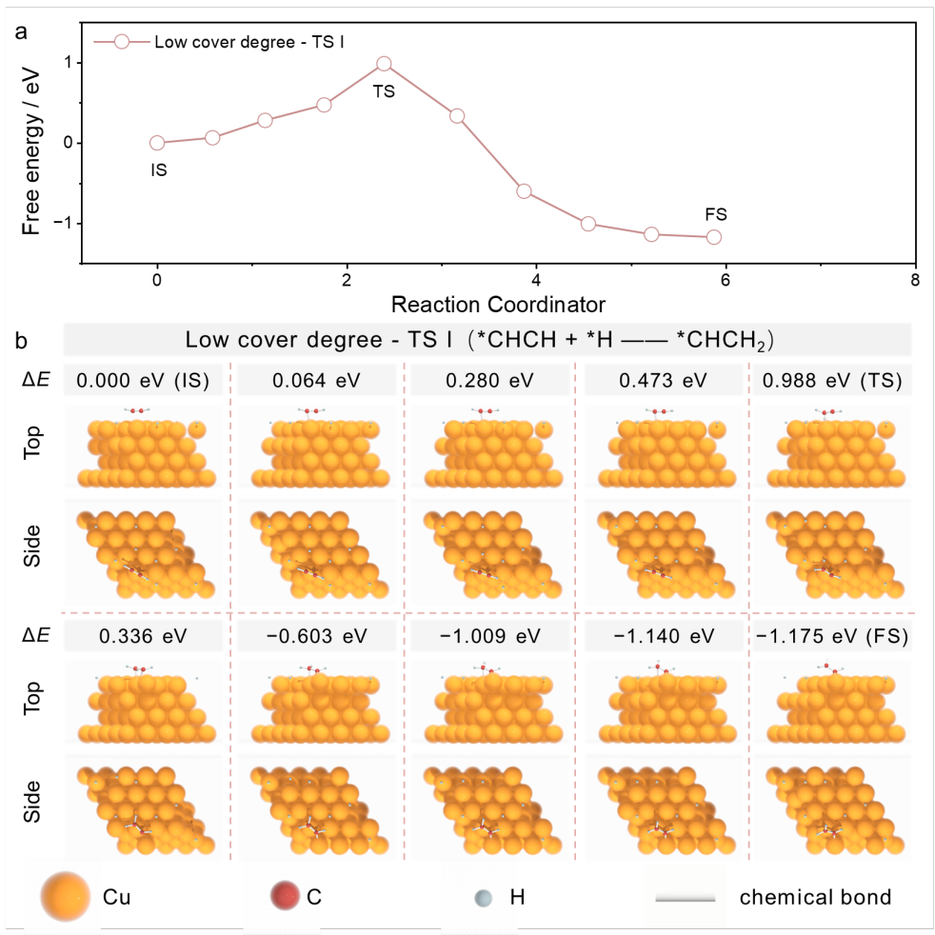
Supplementary Figure 26. The energy change profiles (a) and theoretical adsorption models (b) of the transition states for C₂H₂ hydrogenation to C₂H₃ with low C₂H₂ coverage.

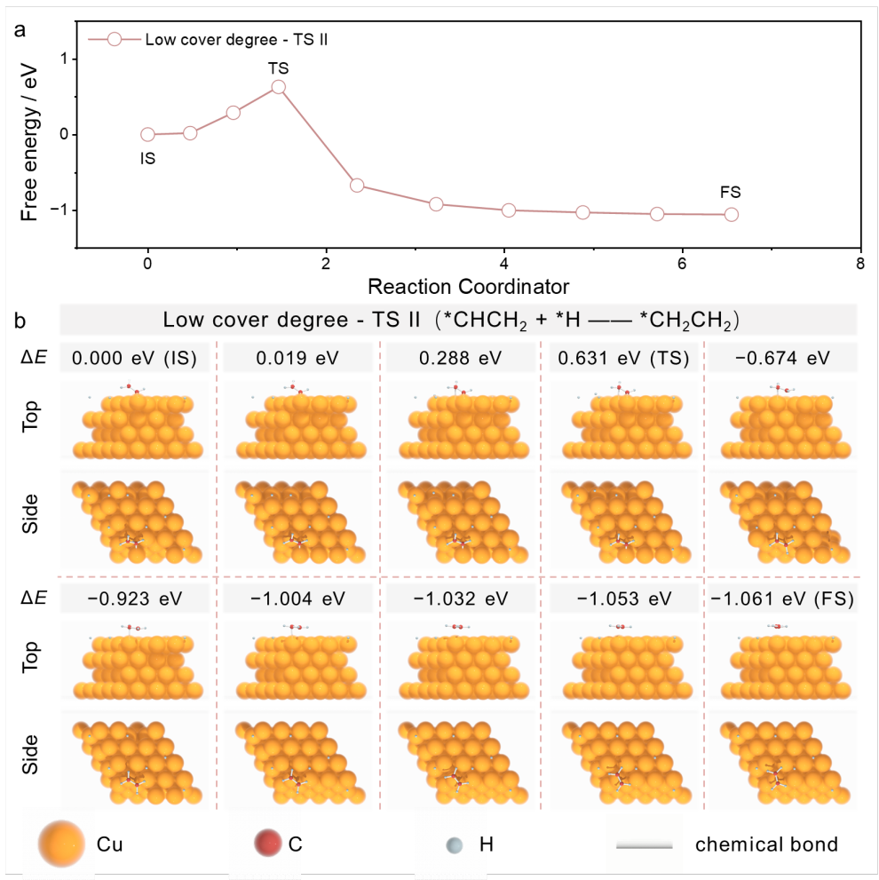
Supplementary Figure 27. The energy change profiles (a) and theoretical adsorption models (b) of the transition states for C₂H₃ hydrogenation to C₂H₄ with low C₂H₂ coverage.

Supplementary References
1. Shi, Y. M., Yu, Y., Liang, Y., Du, Y. H. & Zhang, B. In situ electrochemical conversion of an ultrathin tannin nickel Iron complex film as an efficient oxygen evolution reaction electrocatalyst. Angew. Chem. Int. Ed. 58, 3769-3773, (2019).
2. Wang, M. K. et al. Boosting CO₂-to-CO selectivity and durability by metal-support interaction and encapsulated effect of Ni@C capsules. Chem. Eng. J. 454, 140000, (2023).
3. Shi, Y. M. et al. Unveiling hydrocerussite as an electrochemically stable active phase for efficient carbon dioxide electroreduction to formate. Nat. Commun. 11, 3415, (2020).
4. Liu, H. et al. Curving effects of concave dodecahedral nanocarbons enable enhanced Li-ion storage. J. Mater. Chem. A 6, 14894-14902, (2018).
5. Ma, C. Y. et al. Mesoporous Co₃O₄ and Au/Co₃O₄ catalysts for low-temperature oxidation of trace ethylene. J. Am. Chem. Soc. 132, 2608-2613, (2010).
6. Gu, J. et al. Synergizing metal–support interactions and spatial confinement boosts dynamics of atomic nickel for hydrogenations. Nat. Nanotechnol. 16, 1141-1149, (2021).

