Supplementary Figures

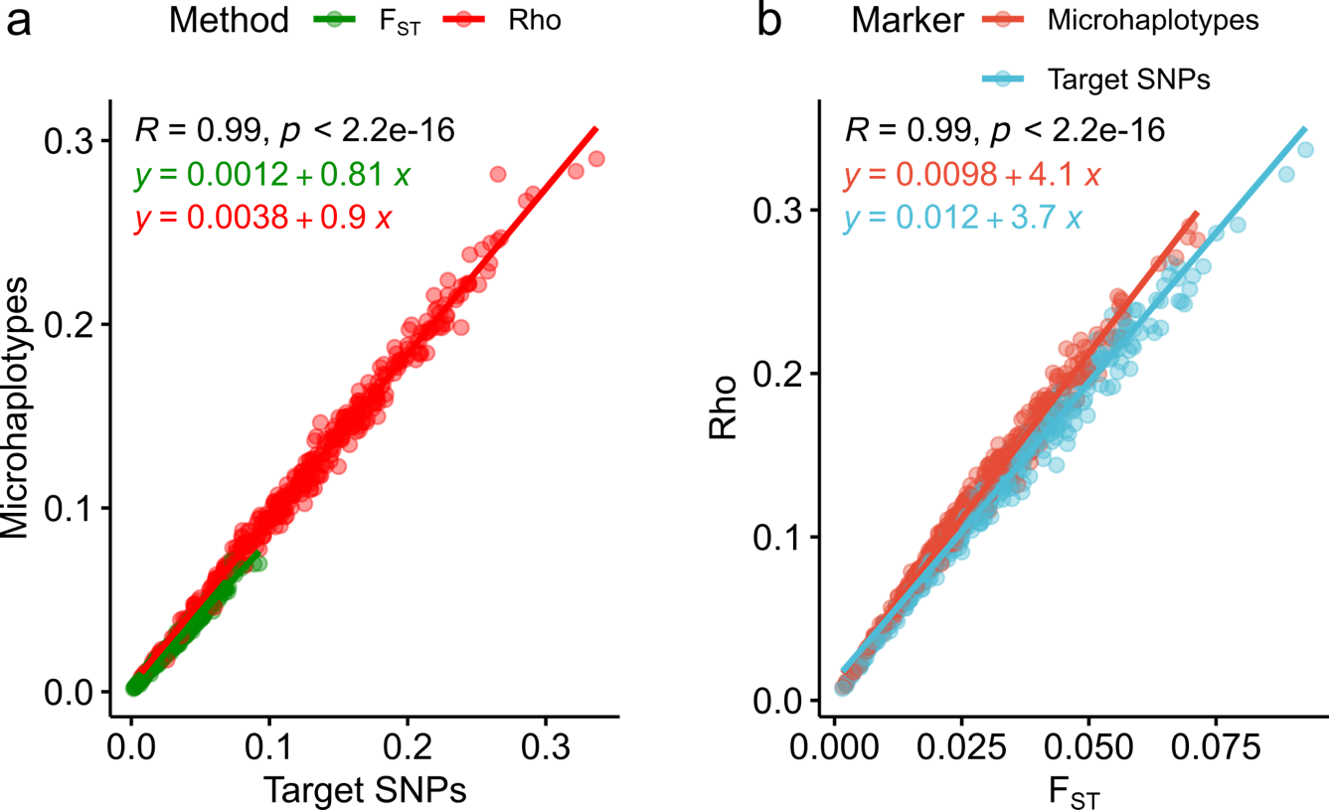

Supplementary Figure 1. Comparison of interpopulation diversity parameters between biallelic and multiallelic (haploblock) markers. a. Linear regression between of F_{ST} (green) and Rho (red) pairwise values in target SNPs and microhaplotypes. b. Linear regression between of target SNPs (Blue) and microhaplotypes (Red) pairwise values using F_{ST} and Rho parameters.

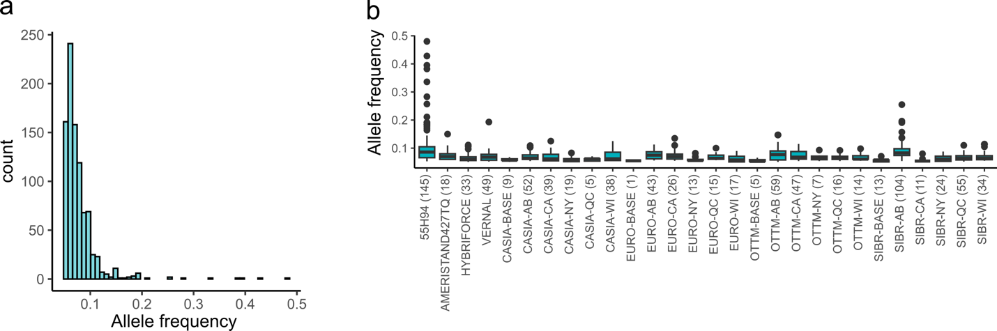

Supplementary Figure 2. Private alleles in microhaplotypes. a. Distribution of frequencies of private alleles (with frequency > 5%) in microhaplotypes. b. Boxplot of private alleles by population. Number in brackets indicates the total of private alleles by population.

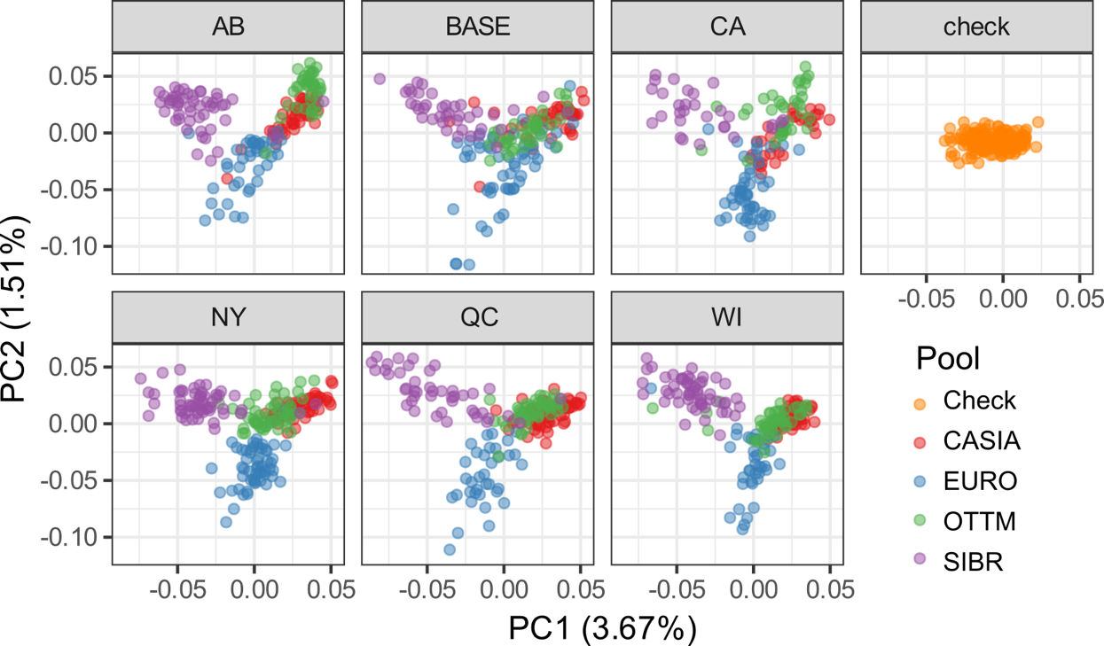

Supplementary Figure 3. Two-dimensional scatter plot from principal component analysis by locations. 1,243 accessions genotyped with target SNPs grouped by check cultivars, base populations, or locations: Lethbridge, Alberta (AB), St-Augustin-de-Desmaures, Quebec (QC), Tulelake, California (CA), Ithaca, New York (NY), and Prairie du Sac, Wisconsin (WI).

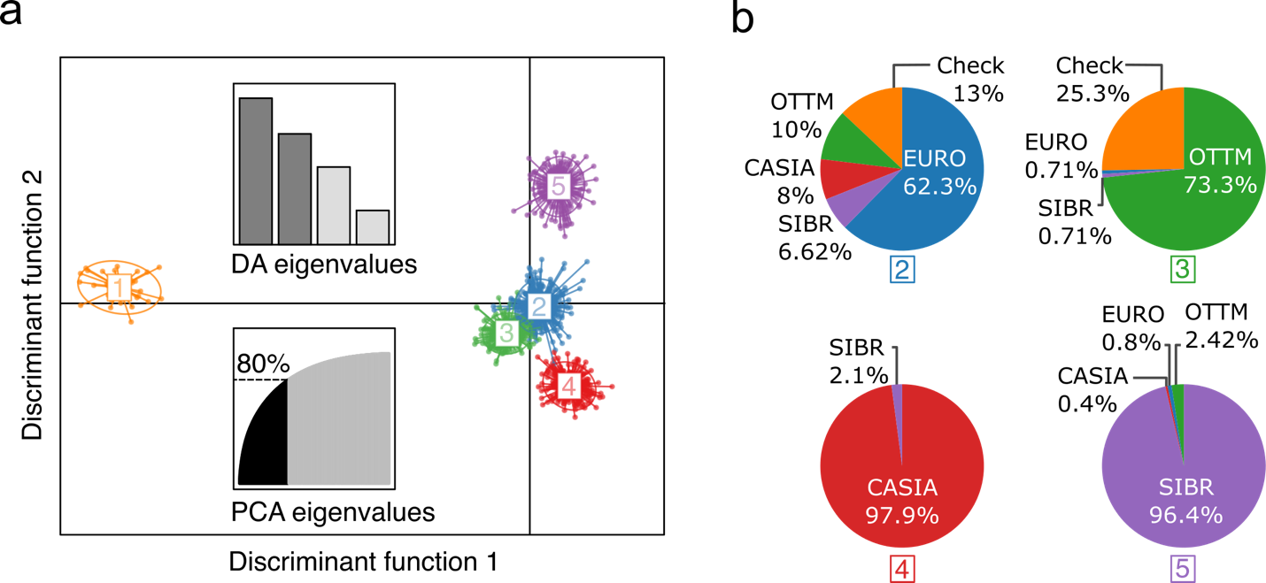

Supplementary Figure 4. Population Structure by Discriminant Analysis of Principal Component (DAPC). a. DAPC scatter plot for 1,243 alfalfa accessions using target SNPs. The axes represent the first two linear discriminants. Each oval represents a numbered cluster, and each dot represents a genotype. The inset charts indicate the number of principal components retained by DAPC (upper bar plot) and the cumulative variation retained during the analysis to describe the relationship between the clusters (lower inset). b. Pie chart of the percentage of pools in clusters generated by DAPC. Cluster one was composed only of the check variety 55H94 and was not included.

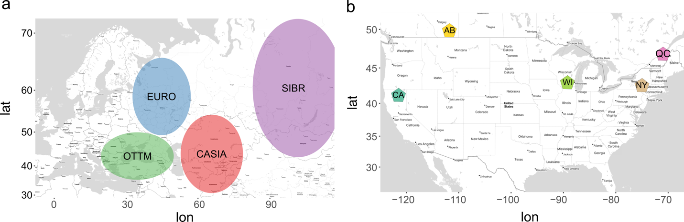

Supplementary Figure 5. Geographical locations of germplasm pools used in this study a. BASE populations were generated by intermating germplasm pools from four defined regions: Central Asia (CASIA), northeastern Europe (EURO), Balkans-Turkey-Black Sea (Ottoman) (OTTM), and Siberia/Mongolia (SIBR) regions b. 20 Cycle 1 (C1) populations were independently developed in five different locations: Lethbridge, Alberta (AB), St-Augustin-de-Desmaures, Quebec (QC), Tulelake, California (CA), Ithaca, New York (NY), and Prairie du Sac, Wisconsin (WI).

Supplementary Tables

Supplementary Table 1. Pairwise F_{ST} values among 28 alfalfa populations calculated with target SNPs (upper diagonal) or with microhaplotypes (lower diagonal). The color scale starts from 0 (blue) low populations differentiation to 1 (red) high population differentiation. All F_{ST} values were significant at p-value < 0.001.
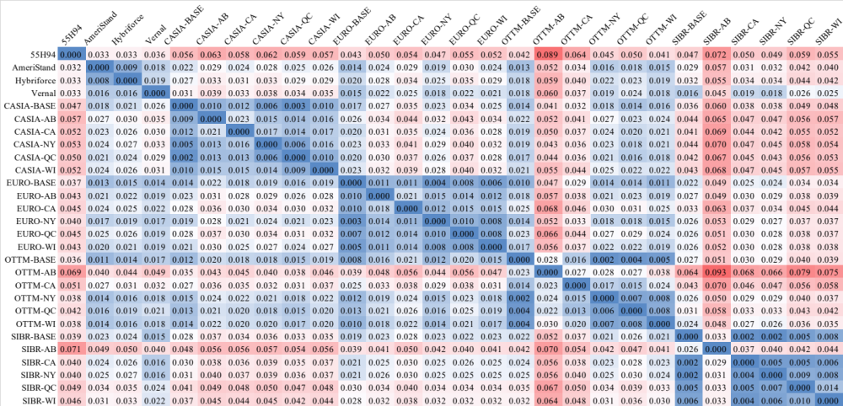

Supplementary Table 2. Pairwise Rho values among 28 alfalfa populations calculated using target SNPs (upper diagonal) and microhaplotypes (lower diagonal). The color scale starts from 0 (blue) low populations differentiation to 1 (red) high population differentiation. All Rho values were significant at p-value < 0.001.
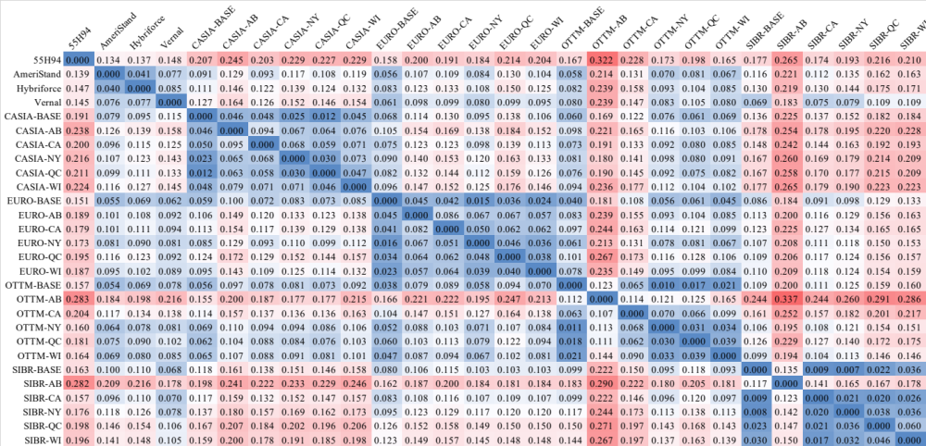

Supplementary Table 3. Allele frequency of loci with F_{ST} values > 0.20. The allele frequency of microhaplotypes was calculated by population. Grey scale color was applied to visualize the differences in allele frequency by locus.
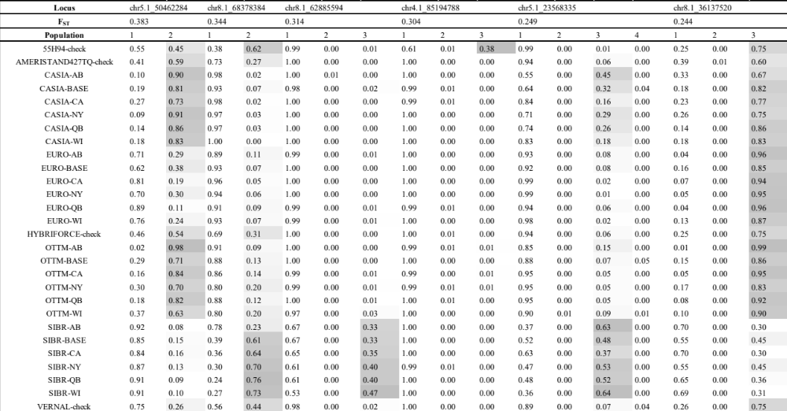

Supplementary Table 4. Population membership generated using Discriminant Analysis of Principal Component (DAPC).

Population | DAPC1 | DAPC2 | DAPC3 | DAPC4 | DAPC5 | Total
55H94 | 37 | 1 | − | − | − | 38
AMERISTAND427TQ | − | − | 25 | − | − | 25
HYBRIFORCE | − | 8 | 46 | − | − | 54
VERNAL | − | 48 | − | − | − | 48
CASIA-BASE | − | 4 | − | 40 | 1 | 45
CASIA-AB | − | 6 | − | 42 | − | 48
CASIA-CA | − | 17 | − | 15 | − | 32
CASIA-NY | − | 2 | − | 46 | − | 48
CASIA-QC | − | 4 | − | 53 | − | 57
CASIA-WI | − | 2 | − | 38 | − | 40
EURO-BASE | − | 54 | 1 | − | − | 55
EURO-AB | − | 39 | − | − | 1 | 40
EURO-CA | − | 50 | − | − | − | 50
EURO-NY | − | 57 | 1 | − | − | 58
EURO-QC | − | 35 | − | − | − | 35
EURO-WI | − | 38 | − | − | 1 | 39
OTTM-BASE | − | 6 | 32 | − | − | 38
OTTM-AB | − | 2 | 37 | − | − | 39
OTTM-CA | − | 3 | 33 | − | 1 | 37
OTTM-NY | − | 9 | 41 | − | 1 | 51
OTTM-QC | − | 17 | 29 | − | − | 46
OTTM-WI | − | 7 | 34 | − | 4 | 45
SIBR-BASE | − | 4 | − | 1 | 34 | 39
SIBR-AB | − | 1 | 1 | 1 | 48 | 51
SIBR-CA | − | 7 | − | 1 | 21 | 29
SIBR-NY | − | 6 | − | 2 | 49 | 57
SIBR-QC | − | 4 | 1 | − | 39 | 44
SIBR-WI | − | 7 | − | − | 48 | 55
Total | 37 | 438 | 281 | 239 | 248 | 1,243

Supplementary Table 5. Genome-wide linkage disequilibrium (LD) decay was calculated for 28 populations. The values represent the LD decay distance in kb at $r^{2}=0.1$ in check cultivars, BASE populations, and cycle 1 populations by locations: Lethbridge, Alberta (AB), St-Augustin-de-Desmaures, Quebec (QC), Tulelake, California (CA), Ithaca, New York (NY), and Prairie du Sac, Wisconsin (WI).
Cultivar |  | Pool | BASE | AB | CA | NY | QC | WI | Mean
55H94 | 592 | CASIA | 717 | 617 | 863 | 386 | 322 | 647 | 592
AmeriStand 427TQ | 469 | EURO | 293 | 654 | 740 | 380 | 584 | 584 | 539
Hybriforce-4400 | 370 | OTTM | 740 | 847 | 1,308 | 388 | 390 | 697 | 728
Vernal | 358 | SIBR | 695 | 740 | 760 | 722 | 575 | 614 | 684
Mean | 447 | − | 611 | 714 | 918 | 469 | 468 | 636 | −

