Supplementary material

Metrics
Multiclass classification accuracy does not give an accurate estimate of performance in class imbalanced data settings as the majority classes dominate the performance. We instead evaluate all models on precision, recall, and F1-score that are all defined using a fixed classification threshold of 0.5. For a given class, we consider all examples and count the number of correct and incorrectly classified ones like in a binary one-vs-rest classification setting. We further report Area Under the Precision-Recall Curve (AUC-PR) as it provides a comprehensive measure of the model's overall precision-recall trade-off at various thresholds. We also show the confusion matrices that give us a glimpse into which pairs of classes are harder for the model to disambiguate. Since it is infeasible to define “confusion” for examples with multiple labels, we restrict the confusion matrix analysis to structures with a single homo-oligomer symmetry label. These examples comprise roughly 6% of the structures in our dataset, 10% of the labels in the test set.

Table S1. Class-wise AUC-PR on the validation set
 |  | AUC-PR on validation set
Labels | Num of samples | Template- based (HHsearch) | ESM-MSA pretrained | ESM2 pretrained | RF2 finetuned | ESM- MSA finetuned | Seq2Symm (ESM2 finetuned) | Seq2Symm + distillation
C1 | 11107 | 0.640 | 0.734 | 0.783 | 0.831 | 0.735 | 0.725 | 0.746
C2 | 9488 | 0.427 | 0.628 | 0.618 | 0.560 | 0.566 | 0.604 | 0.659
C3 | 1406 | 0.400 | 0.413 | 0.516 | 0.547 | 0.525 | 0.585 | 0.557
C4 | 708 | 0.637 | 0.661 | 0.794 | 0.899 | 0.745 | 0.855 | 0.846
C5 | 95 | 0.127 | 0.535 | 0.793 | 0.651 | 0.631 | 0.793 | 0.793
C6 | 285 | 0.326 | 0.352 | 0.266 | 0.649 | 0.473 | 0.578 | 0.676
C7-C9 | 71 | 0.087 | 0.115 | 0.245 | 0.039 | 0.105 | 0.154 | 0.581
C10-C17 | 149 | 0.890 | 0.559 | 0.764 | 0.651 | 0.907 | 0.964 | 0.967
D2 | 3827 | 0.541 | 0.544 | 0.628 | 0.593 | 0.437 | 0.729 | 0.713
D3 | 1524 | 0.496 | 0.126 | 0.469 | 0.253 | 0.253 | 0.659 | 0.641
D4 | 326 | 0.138 | 0.108 | 0.171 | 0.272 | 0.219 | 0.188 | 0.318
D5 | 145 | 0.161 | 0.223 | 0.028 | 0.007 | 0.057 | 0.021 | 0.189
D6-D12 | 373 | 0.414 | 0.134 | 0.339 | 0.052 | 0.417 | 0.599 | 0.447
H | 277 | 0.347 | 0.044 | 0.037 | 0.101 | 0.022 | 0.080 | 0.178
O | 2 | 0.000 | 0.000 | 0.002 | 0.000 | 0.000 | 0.000 | 0.001
T | 131 | 0.158 | 0.432 | 0.402 | 0.033 | 0.587 | 0.632 | 0.591
I | 238 | 0.536 | 0.969 | 0.870 | 0.965 | 0.978 | 0.759 | 0.990
CX (C3 to C17) | 2714 | 0.500 | 0.579 | 0.694 | 0.706 | 0.711 | 0.726 | 0.686
DX (D3-D12) | 2368 | 0.428 | 0.293 | 0.557 | 0.376 | 0.320 | 0.675 | 0.597
HOTI | 648 | 0.401 | 0.493 | 0.464 | 0.613 | 0.473 | 0.275 | 0.601
Macro Average |  | 0.383 | 0.397 | 0.472 | 0.440 | 0.458 | 0.530 | 0.589
Macro Avg excl. coarse grained classes |  | 0.372 | 0.387 | 0.454 | 0.418 | 0.450 | 0.525 | 0.582

Figure S1. Weighted AUC-PR on the validation and test set, where the number of structures from each class are used to weight the average. Majority classes like C1 which constitute 40% of the dataset dominate the performance metrics. Seq2Symm is shown as ‘ESM2 finetuned’ and ‘ESM2 ft distilled’ is Seq2Symm with distillation.
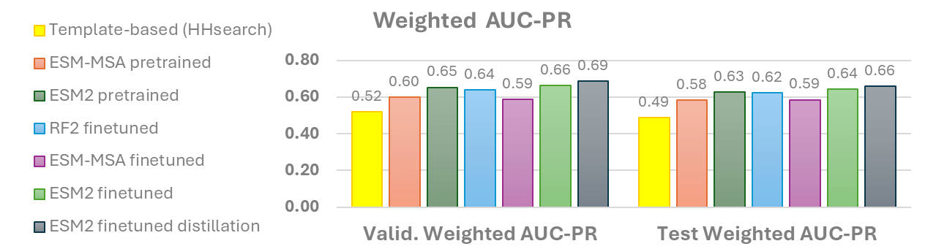

Figure S2. Class-wise precision recall curves on the validation set. Seq2Symm is shown as ‘ESM2 finetuned’ and ‘ESM2 ft distilled’ is Seq2Symm with distillation.
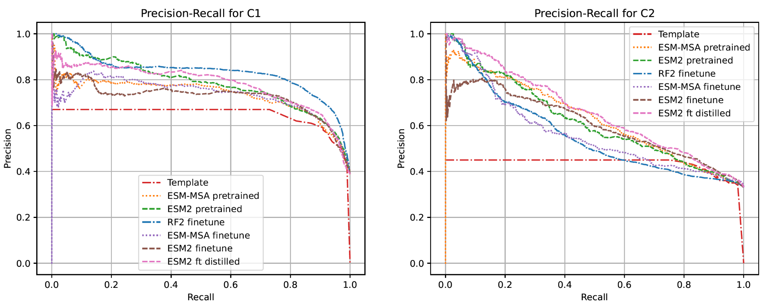
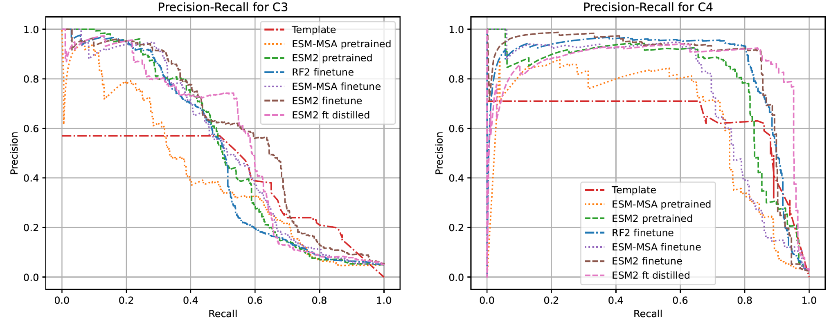
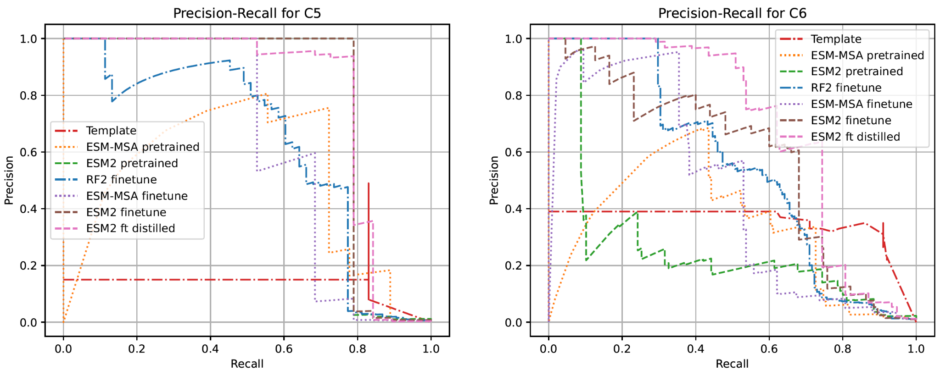
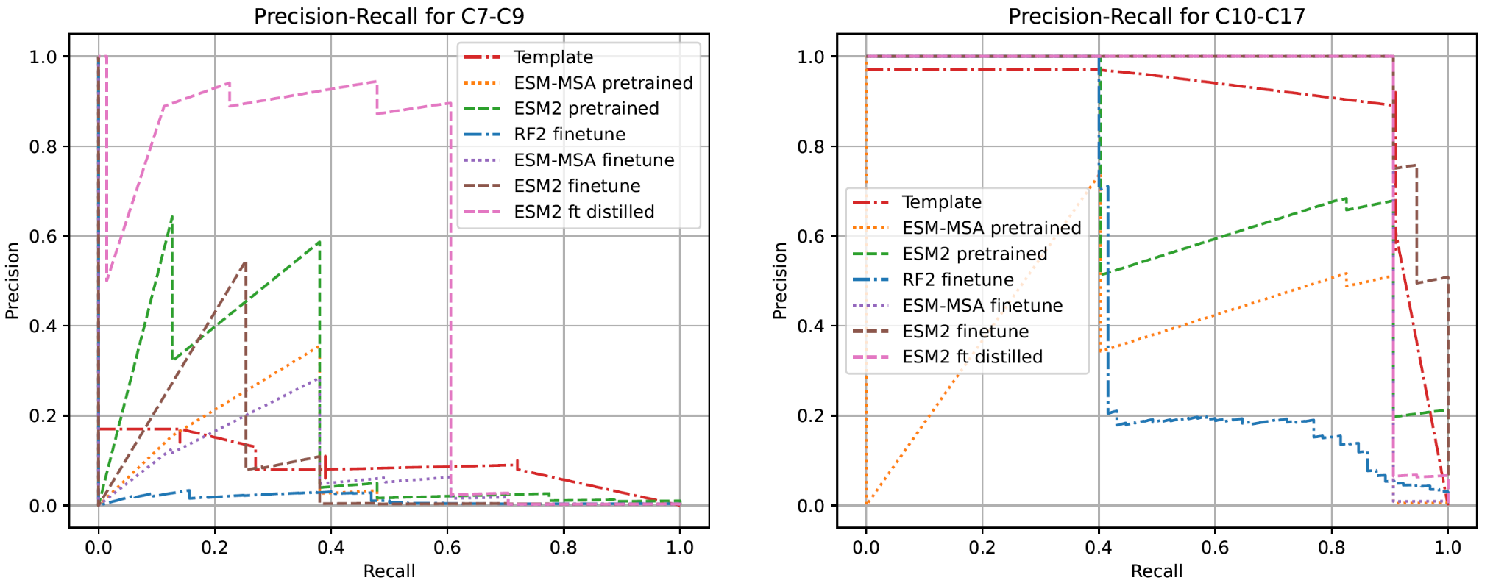
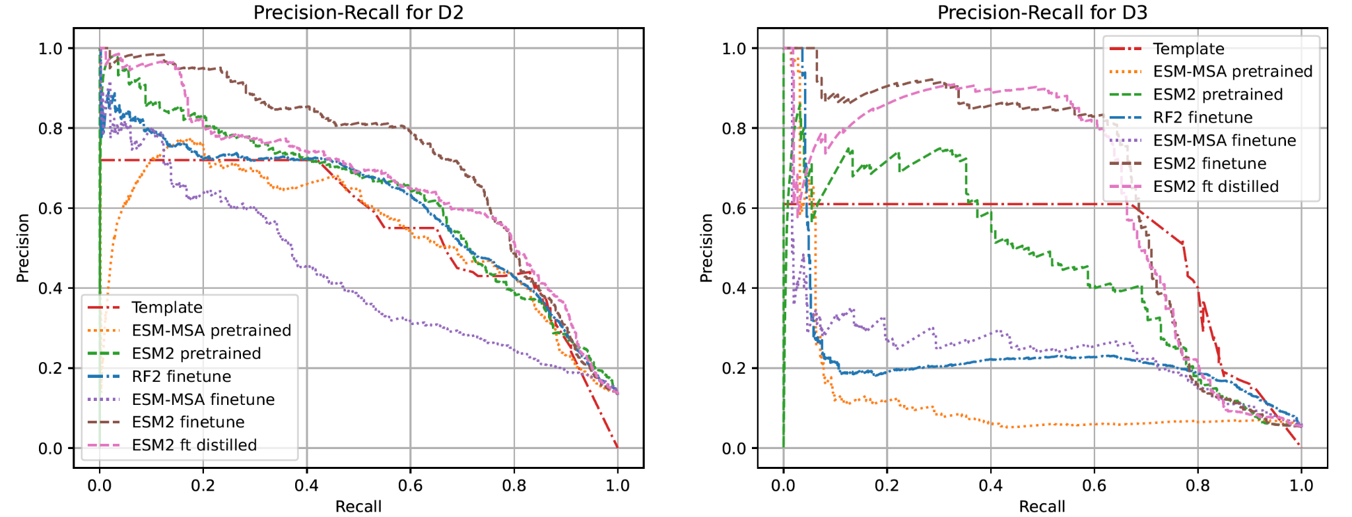
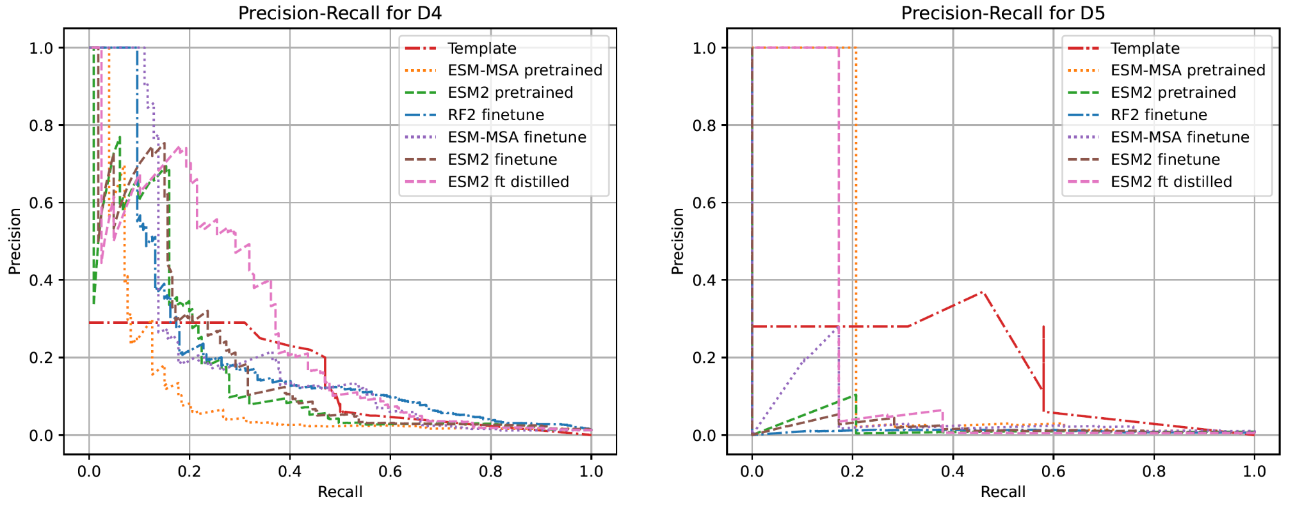
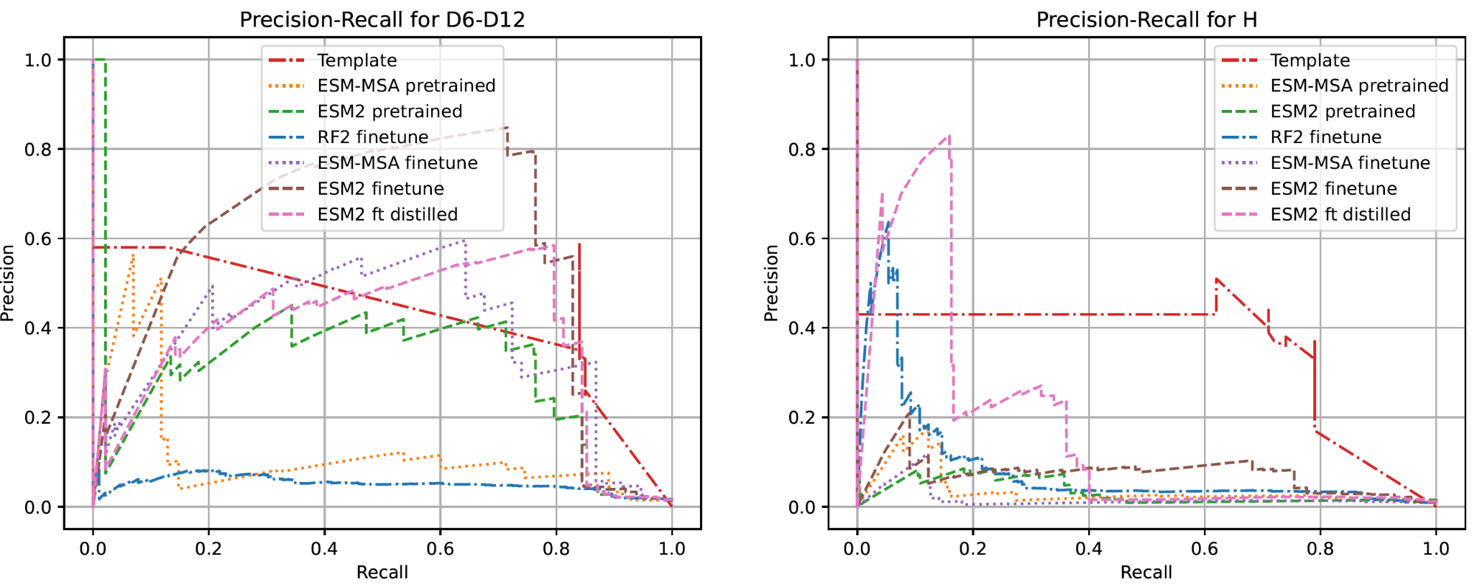
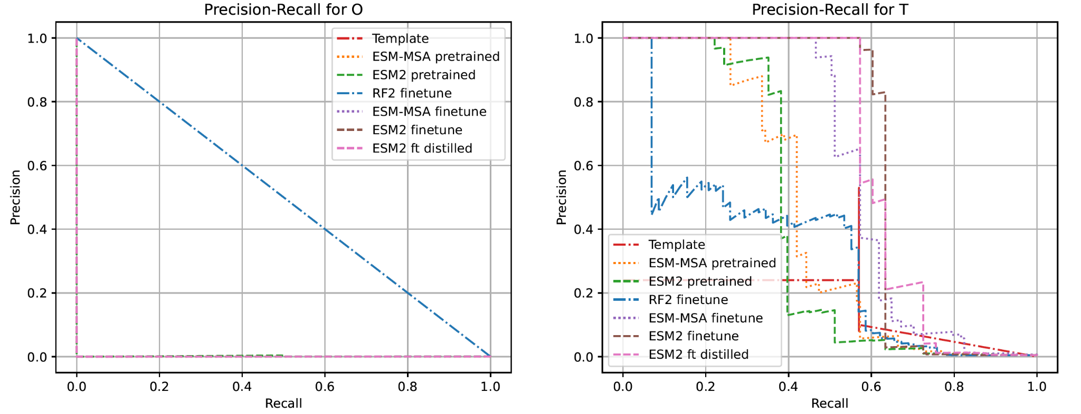
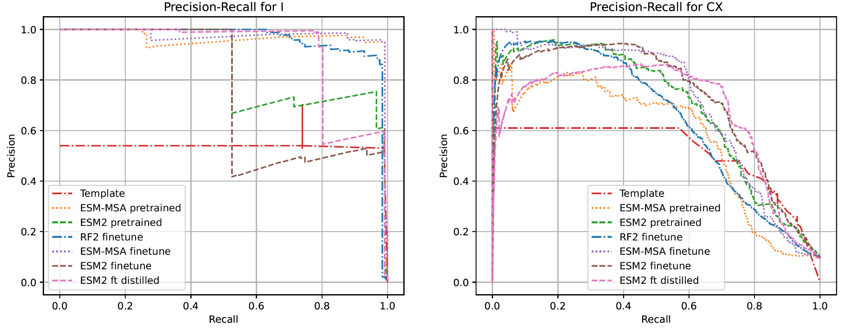
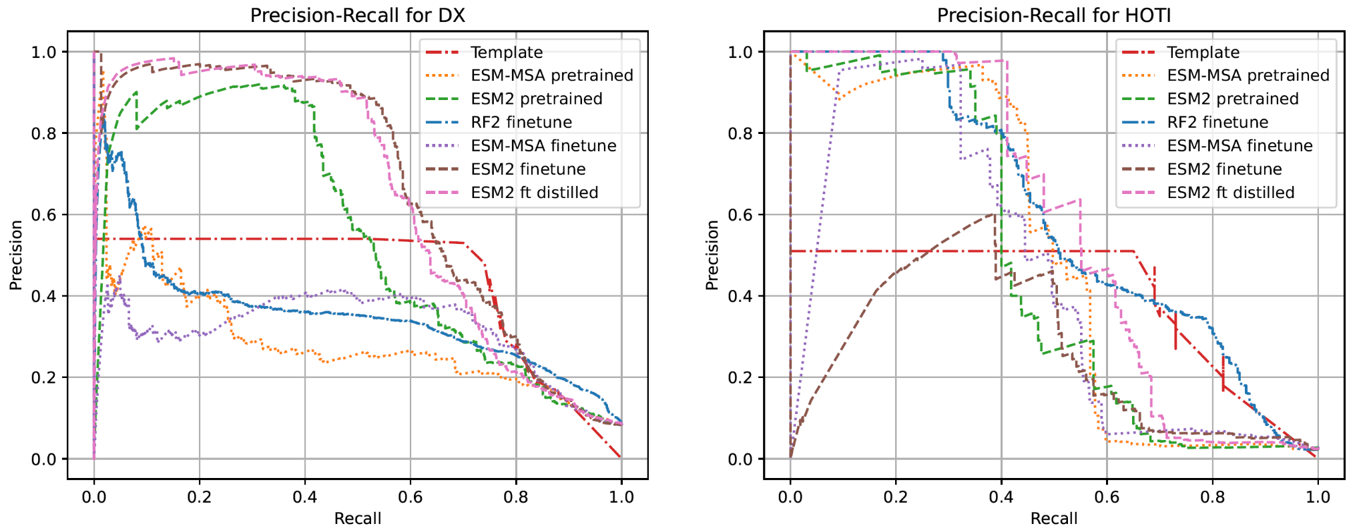

Figure S3. Class-wise precision recall curves on the unseen test dataset. Seq2Symm is shown as ‘ESM2 finetuned’ and ‘ESM2 ft distilled’ is Seq2Symm with distillation.
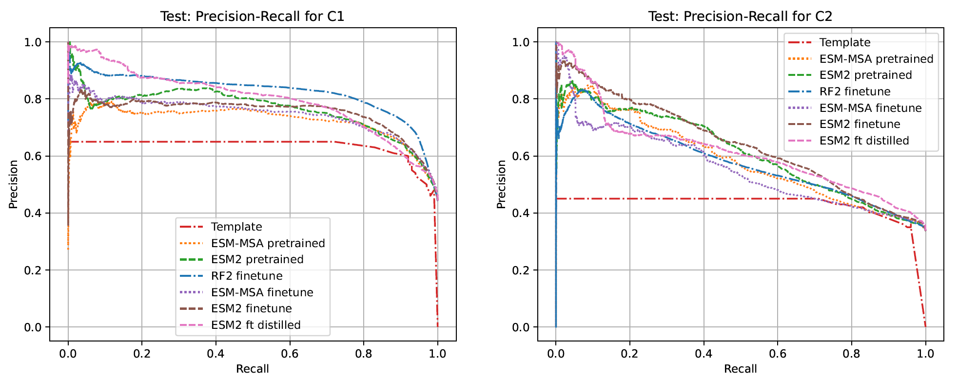
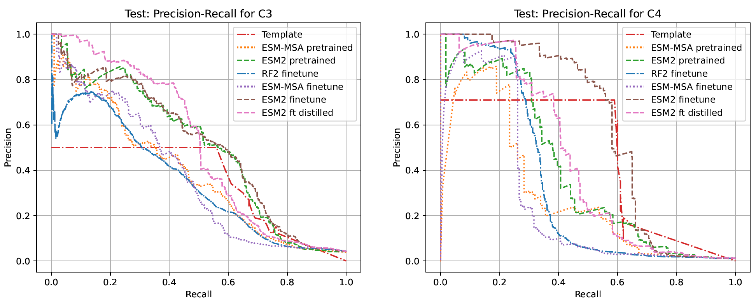
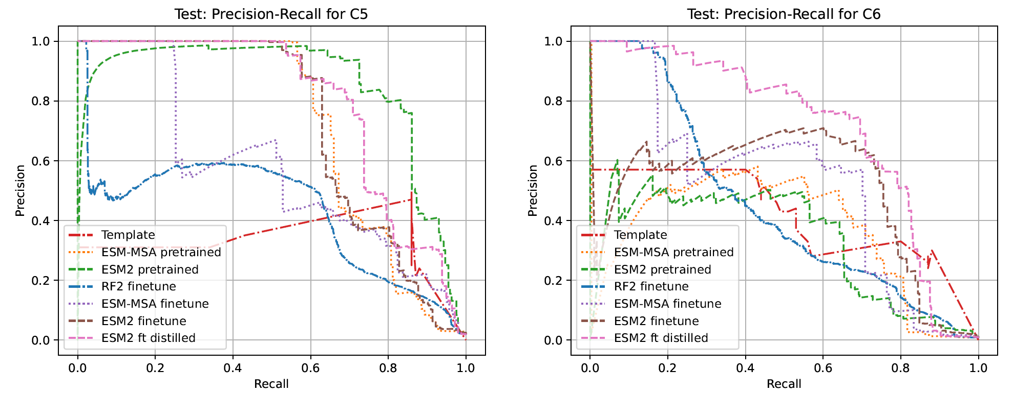
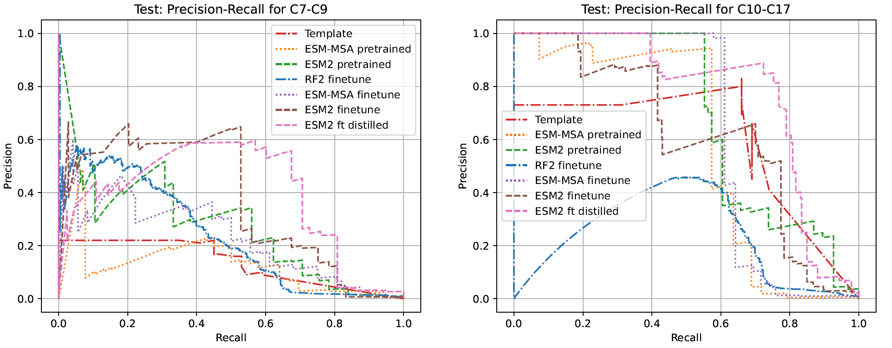
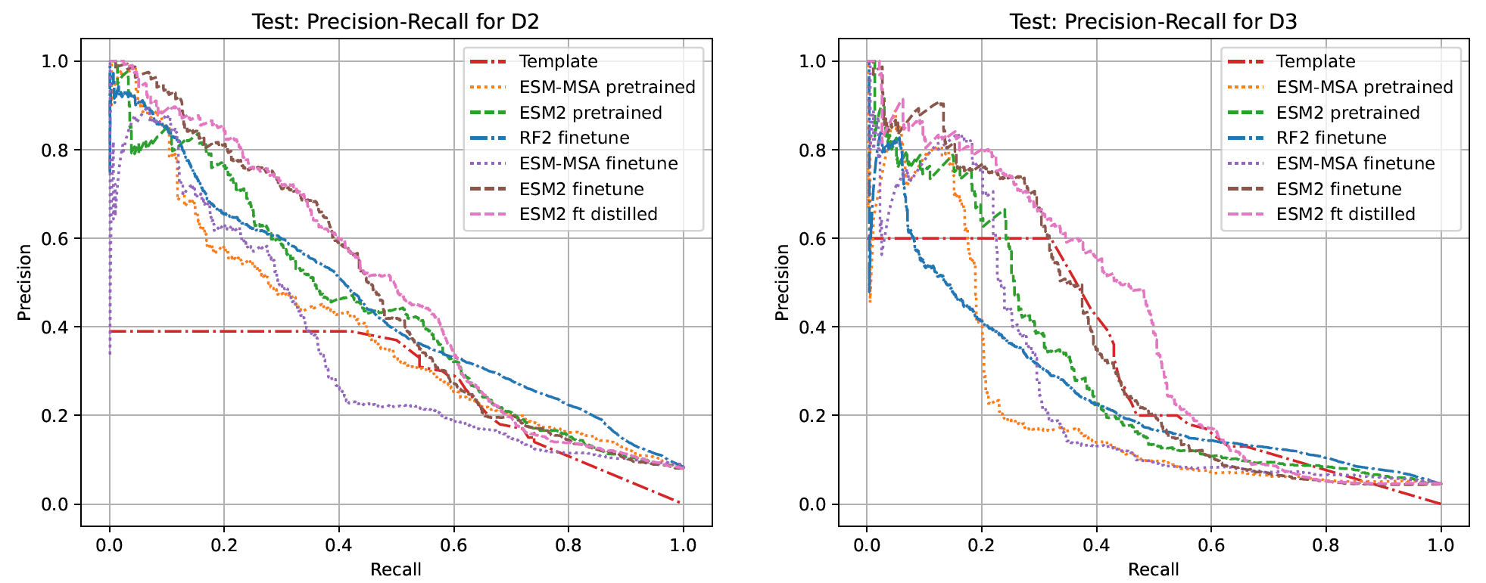
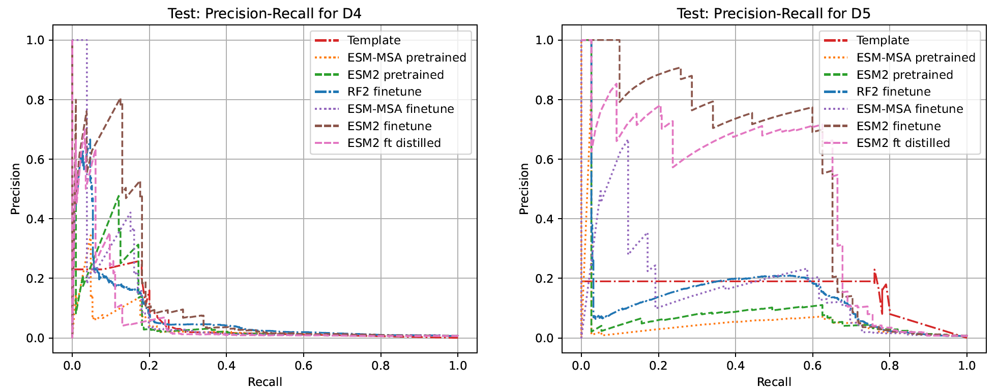
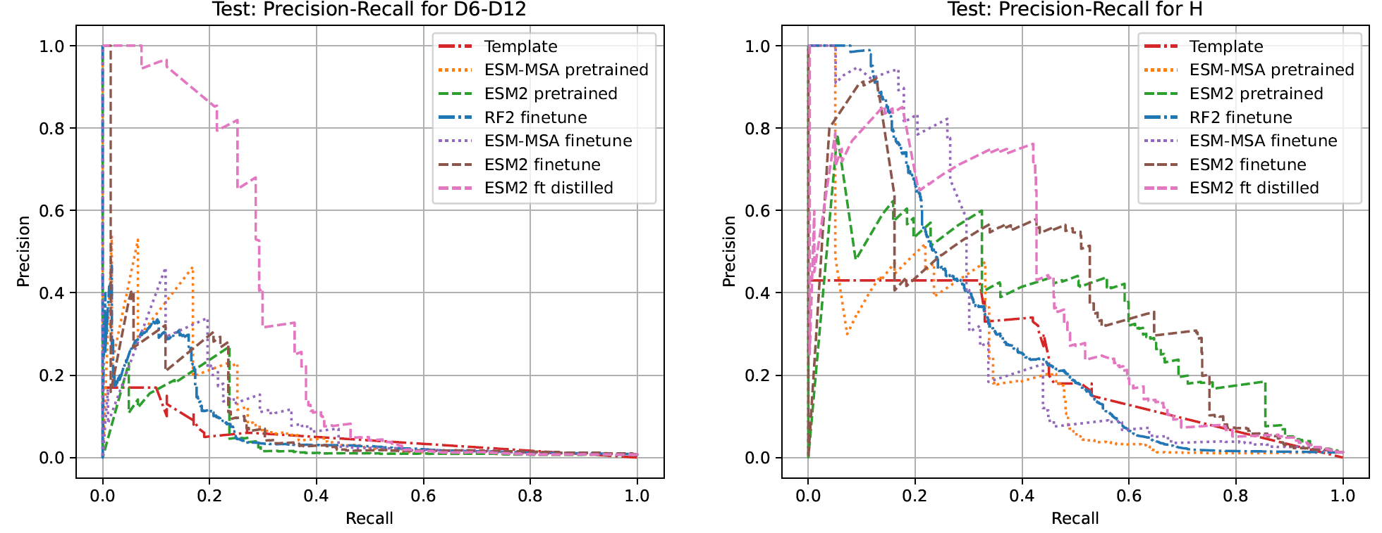
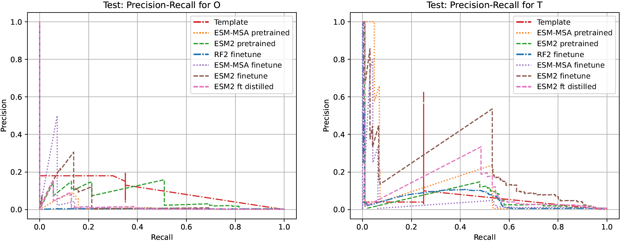
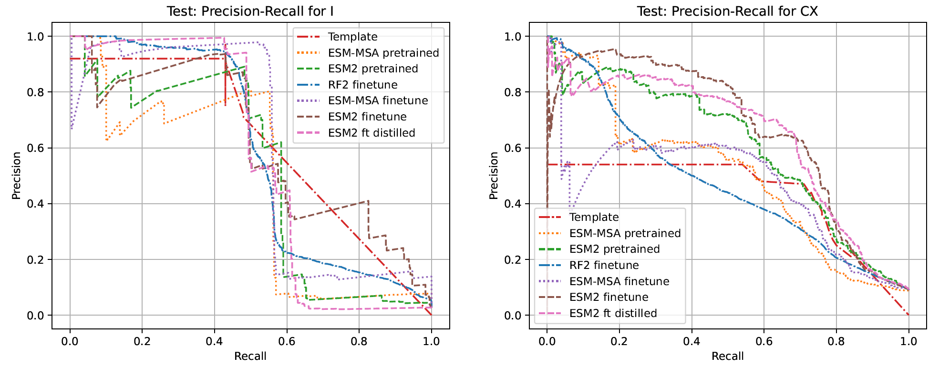
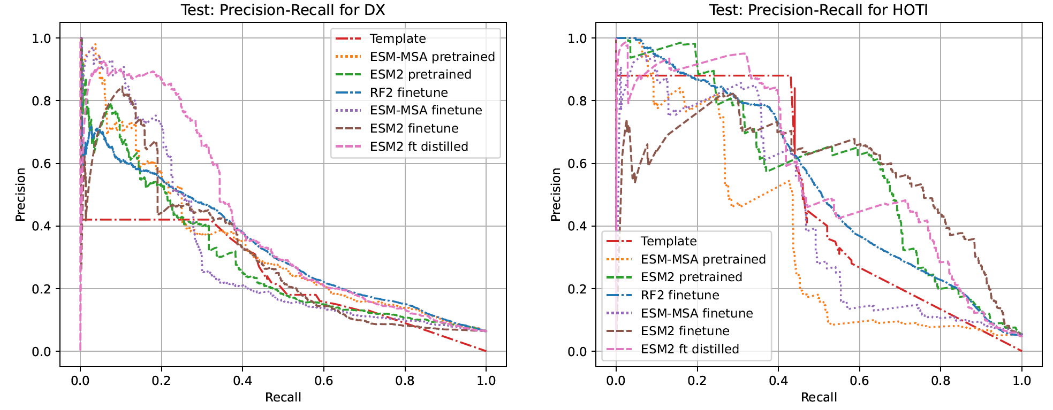

Maximum F1-score of all methods on validation data
Using the precision recall curves on the validation dataset (from Figure S2), we compute the maximum F1-score achieved by each method shown in Table S2. This gives us a sense of the best point on the P-R curves. We record the classification threshold at which the F1-score was maximum on the validation set and use this threshold to classify the held-out test dataset and report the F1-score at this threshold in Table S3. Note that this threshold might not be the one that gives the highest F1-score once we compute the P-R curves in Figure S3.
For the template-based baseline, which can only produce binary predictions (0 or 1 for each class), the “classifier threshold” is varied by varying the value “k” in the top-k hits considered as matches. As expected, smaller values of “k” result in a higher precision (for instance k=1 implies that we only consider the first template-based match that satisfies the sequence-identity cut-off) and higher values of k result in a higher recall at the cost of precision.
We find that the ESM2-based approaches have a higher F1-score overall (F1=0.63), with the finetuned models doing the best. However, the template-based approach has a strong performance too (F1=0.54) that is obtained at a higher recall albeit lower precision. This is in contrast to the fine-tuned models that generally have a higher precision and lower recall at the same or higher F1-scores.

Table S2. Maximum F1-score achieved by the various methods on the validation set, obtained by varying the classifier threshold
 | num of labels | Template- based  HHsearch | ESM- MSA pretrained | ESM2 pre- trained | RF2 fine- tuned | ESM- MSA fine- tuned | Seq2Symm (ESM2 fine- tuned) | Seq2Symm + distillation
C1 | 11107 | 0.714 | 0.748 | 0.745 | 0.801 | 0.750 | 0.753 | 0.759
C2 | 9488 | 0.563 | 0.593 | 0.584 | 0.528 | 0.547 | 0.595 | 0.608
C3 | 1406 | 0.515 | 0.429 | 0.541 | 0.530 | 0.529 | 0.598 | 0.621
C4 | 708 | 0.721 | 0.716 | 0.803 | 0.862 | 0.759 | 0.880 | 0.882
C5 | 95 | 0.605 | 0.739 | 0.882 | 0.660 | 0.690 | 0.882 | 0.857
C6 | 285 | 0.487 | 0.532 | 0.321 | 0.558 | 0.549 | 0.641 | 0.686
C9 | 71 | 0.173 | 0.367 | 0.462 | 0.057 | 0.325 | 0.346 | 0.723
C17 | 149 | 0.915 | 0.654 | 0.776 | 0.571 | 0.951 | 0.951 | 0.951
D2 | 3827 | 0.583 | 0.581 | 0.633 | 0.617 | 0.439 | 0.703 | 0.656
D3 | 1524 | 0.629 | 0.160 | 0.512 | 0.339 | 0.378 | 0.717 | 0.697
D4 | 326 | 0.290 | 0.177 | 0.259 | 0.232 | 0.271 | 0.272 | 0.387
D5 | 145 | 0.389 | 0.343 | 0.138 | 0.027 | 0.214 | 0.082 | 0.294
D12 | 373 | 0.679 | 0.199 | 0.524 | 0.118 | 0.619 | 0.779 | 0.674
H | 277 | 0.556 | 0.145 | 0.123 | 0.156 | 0.121 | 0.180 | 0.292
O | 2 | 0.000 | 0.000 | 0.007 | 0.000 | 0.001 | 0.001 | 0.001
T | 131 | 0.549 | 0.524 | 0.524 | 0.484 | 0.657 | 0.742 | 0.728
I | 238 | 0.747 | 0.971 | 0.847 | 0.932 | 0.971 | 0.689 | 0.879
CX | 2714 | 0.578 | 0.644 | 0.665 | 0.618 | 0.700 | 0.705 | 0.737
DX | 2368 | 0.592 | 0.370 | 0.563 | 0.434 | 0.488 | 0.669 | 0.652
HOTI | 648 | 0.572 | 0.578 | 0.533 | 0.543 | 0.508 | 0.478 | 0.590
Macro Avg. |  | 0.543 | 0.474 | 0.522 | 0.453 | 0.523 | 0.583 | 0.634
Macro Avg. excl. coarse grained classes |  | 0.536 | 0.463 | 0.511 | 0.440 | 0.516 | 0.577 | 0.629

F1-score of all methods on the held-out test dataset
We use the per-class thresholds that give the maximum F1-score on the validation dataset (See Table S2 above) to compute precision, recall and F1-score on the unseen test dataset. The resulting F1-score is shown in Table S3.
Table S3. F1-score on the held-out test dataset, using the “best threshold” to classify, computed on the validation dataset
Test data: F1-score based on thresholds selected using the validation dataset
 | num of labels | Template- based (HHsearch) | ESM- MSA pretrained | ESM2 pretrained | RF2 finetuned | ESM- MSA finetuned | Seq2Symm (ESM2 finetuned) | Seq2Symm + distillation
C1 | 28724 | 0.72 | 0.76 | 0.75 | 0.80 | 0.76 | 0.77 | 0.75
C2 | 21875 | 0.53 | 0.57 | 0.58 | 0.59 | 0.55 | 0.58 | 0.61
C3 | 2670 | 0.53 | 0.42 | 0.51 | 0.38 | 0.37 | 0.54 | 0.55
C4 | 717 | 0.50 | 0.31 | 0.43 | 0.41 | 0.38 | 0.6 | 0.47
C5 | 1220 | 0.32 | 0.71 | 0.77 | 0.31 | 0.50 | 0.59 | 0.74
C6 | 584 | 0.47 | 0.30 | 0.30 | 0.42 | 0.62 | 0.66 | 0.66
C9 | 286 | 0.30 | 0.26 | 0.36 | 0.19 | 0.38 | 0.58 | 0.56
C17 | 382 | 0.72 | 0.40 | 0.45 | 0.49 | 0.67 | 0.44 | 0.52
D2 | 5176 | 0.41 | 0.40 | 0.47 | 0.45 | 0.38 | 0.45 | 0.46
D3 | 2893 | 0.42 | 0.21 | 0.32 | 0.28 | 0.16 | 0.41 | 0.42
D4 | 432 | 0.15 | 0.06 | 0.17 | 0.15 | 0.10 | 0.25 | 0.11
D5 | 384 | 0.29 | 0.02 | 0.04 | 0.07 | 0.24 | 0.33 | 0.05
D12 | 409 | 0.13 | 0.08 | 0.11 | 0.09 | 0.08 | 0.16 | 0.19
H | 813 | 0.37 | 0.34 | 0.42 | 0.34 | 0.24 | 0.49 | 0.42
O | 108 | 0.12 | 0.00 | 0.12 | 0.00 | 0.00 | 0.07 | 0.01
T | 392 | 0.36 | 0.10 | 0.01 | 0.03 | 0.08 | 0.06 | 0.02
I | 1744 | 0.60 | 0.38 | 0.08 | 0.55 | 0.62 | 0.59 | 0.59
CX | 5859 | 0.54 | 0.54 | 0.58 | 0.46 | 0.35 | 0.61 | 0.65
DX | 4118 | 0.36 | 0.32 | 0.30 | 0.36 | 0.23 | 0.34 | 0.41
HOTI | 3385 | 0.58 | 0.39 | 0.42 | 0.46 | 0.49 | 0.45 | 0.51
Macro Average |  | 0.42 | 0.33 | 0.36 | 0.34 | 0.36 | 0.45 | 0.44
Macro Avg. excl. coarse-grained classes |  | 0.41 | 0.31 | 0.35 | 0.33 | 0.36 | 0.45 | 0.42

Figure S4. Confusion matrices of various methods on test set proteins with a single homo-oligomer symmetry label. Singly labeled proteins comprise 90% of the test set with 60,582 structures
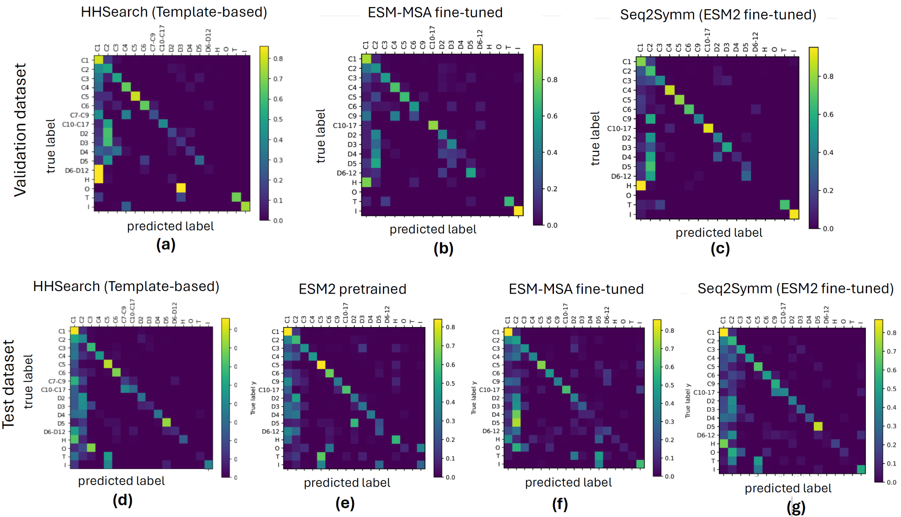
Figure S5. t-SNE representation of 11,952 proteins from the test dataset after dimensionality reduction from the 1280-dimensional embeddings obtained using the Seq2Symm. The largest classes C1, C2 and D2 are not shown as these dominate the plot and are generally dispersed across the 2-dimensional space. Some tighter clusters of points with the same class labels are manually highlighted for visual clarity.
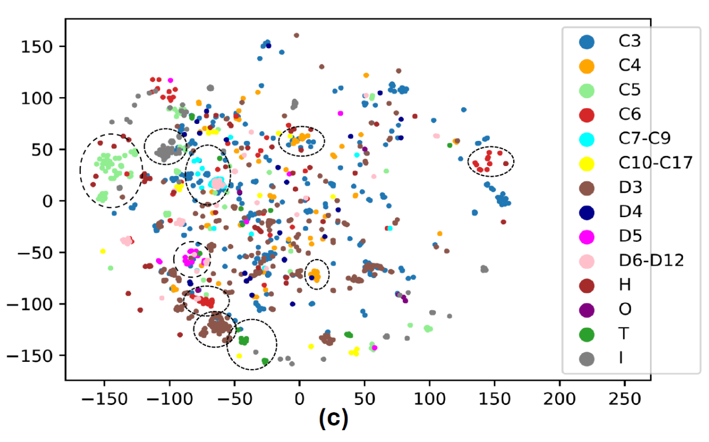

Figure S6. Confusion matrix of Seq2Symm on single-labeled proteins from the UniFold test set
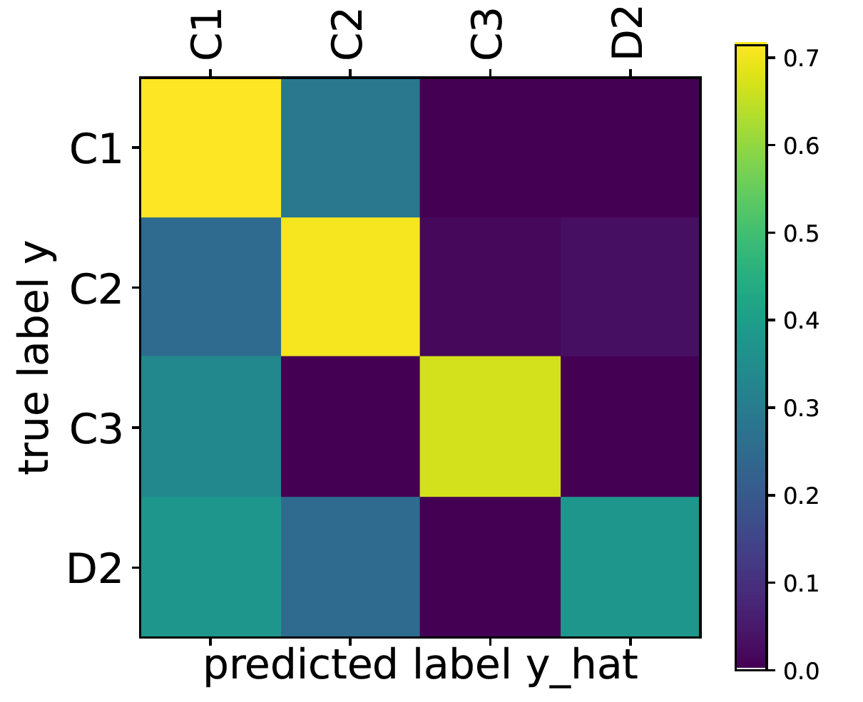

Comparison of the QUEEN model on our dataset
To evaluate the pre-trained QUEEN [6] model which only considers the multiplicity, on our benchmark data, we collapse labels across different symmetry classes -- for example, the multiplicity 24 comprises proteins from C24, D12, and tetrahedral symmetry classes. Some symmetries cannot be mapped at all, such as the helical symmetry which has a variable multiplicity, or classes like C9 for which the pre-trained QUEEN model [6] does not predict. These examples are dropped from the validation data. Additionally, multi-labeled examples have ambiguity in mapping and have been dropped. In total, we keep 88-92% of examples after this initial mapping and filtering step.
To prevent data leakage we removed proteins from our validation and test sets which were highly similar to those used to train the QUEEN model (30% identity and 80% coverage) [22]. We removed 16,403 proteins from validation and 34,575 from testing based on sequence similarity to QUEEN training data, leaving 9,941 and 23,014 proteins respectively in those sets. In Figure 4, we show the performance of the QUEEN model both before and after the filtering step that removes the QUEEN training proteins. As expected, model performance drastically drops after data leakage is accounted for.
In Table S4 (a,b) and Table S5 (a,b) we show various metrics on the validation set, before and after filtering for sequence-similar proteins between our validation set of proteins and the QUEEN training dataset.

Table S4. QUEEN performance showing various metrics on the Validation Set
(a) Before filtering for sequence-similar proteins with QUEEN’s training data.
Class | No. of samples | AUPR | F1 | Precision | Recall
1 | 10196 | 0.778729 | 0.72978 | 0.730354 | 0.729208
2 | 8229 | 0.606769 | 0.592664 | 0.557723 | 0.632276
3 | 2546 | 0.708442 | 0.629968 | 0.600071 | 0.663001
4 | 9881 | 0.784449 | 0.761101 | 0.880048 | 0.670479
5 | 475 | 0.771125 | 0.718016 | 0.945017 | 0.578947
6 | 5482 | 0.855001 | 0.828346 | 0.813908 | 0.843305
7 | 0 | 0 | 0 | 0 | 0
8 | 1350 | 0.853785 | 0.711322 | 0.592885 | 0.888889
10 | 675 | 0.463564 | 0.406032 | 0.935829 | 0.259259
12 | 1950 | 0.898241 | 0.918747 | 0.952643 | 0.887179
14 | 70 | 0.003458 | 0 | 0 | 0
24 | 5 | 0.00139 | 0 | 0 | 0

(b) After filtering for sequence-similar proteins with QUEEN’s training data.
Class | No. of samples | AUPR | F1 | Precision | Recall
1 | 3934 | 0.74621 | 0.692318 | 0.705945 | 0.679207
2 | 2939 | 0.488323 | 0.470228 | 0.411705 | 0.548146
3 | 510 | 0.38704 | 0.301676 | 0.287234 | 0.317647
4 | 1393 | 0.180037 | 0.184211 | 0.312178 | 0.130653
5 | 75 | 0.03539 | 0 | 0 | 0
6 | 415 | 0.05576 | 0.006795 | 0.00641 | 0.007229
7 | 0 | 0 | 0 | 0 | 0
8 | 45 | 0.008711 | 0 | 0 | 0
10 | 400 | 0.346344 | 0 | 0 | 0
12 | 160 | 0.035545 | 0 | 0 | 0
14 | 70 | 0.019932 | 0 | 0 | 0
24 | 0 | 0 | 0 | 0 | 0

Table S5. QUEEN performance showing various metrics on the Test Set
(a) Before filtering for sequence-similar proteins from QUEEN’s training data.
Class | No. of samples | AUPR | F1 | Precision | Recall
1 | 25990 | 0.752065 | 0.736382 | 0.722019 | 0.751327
2 | 18678 | 0.621343 | 0.613754 | 0.582832 | 0.648142
3 | 4276 | 0.545904 | 0.643955 | 0.54393 | 0.789055
4 | 11452 | 0.713551 | 0.694947 | 0.801003 | 0.613692
5 | 5800 | 0.875434 | 0.808162 | 0.975848 | 0.689655
6 | 9982 | 0.821549 | 0.818394 | 0.848071 | 0.790723
7 | 775 | 0.010987 | 0 | 0 | 0
8 | 1305 | 0.33042 | 0.362146 | 0.326757 | 0.40613
10 | 2025 | 0.8415 | 0.804424 | 0.819252 | 0.790123
12 | 1000 | 0.679196 | 0.646445 | 0.642928 | 0.65
14 | 1085 | 0.734068 | 0.692308 | 0.857143 | 0.580645
24 | 430 | 0.64454 | 0.752394 | 0.913621 | 0.639535

(b) After filtering for sequence-similar proteins from QUEEN’s training data.
Class | No. of samples | AUPR | F1 | Precision | Recall
1 | 9075 | 0.598813 | 0.6324 | 0.602293 | 0.665675
2 | 6506 | 0.440828 | 0.48124 | 0.469257 | 0.493852
3 | 836 | 0.166755 | 0.266418 | 0.180059 | 0.511962
4 | 2523 | 0.190438 | 0.131222 | 0.229023 | 0.091954
5 | 1200 | 0.392637 | 0.247875 | 0.825472 | 0.145833
6 | 1199 | 0.181625 | 0.225684 | 0.227891 | 0.22352
7 | 490 | 0.026258 | 0 | 0 | 0
8 | 375 | 0.158518 | 0.161453 | 0.12987 | 0.213333
10 | 125 | 0.004897 | 0 | 0 | 0
12 | 200 | 0.345506 | 0.338983 | 0.328638 | 0.35
14 | 455 | 0.418858 | 0 | 0 | 0
24 | 30 | 0.533333 | 0.75 | 0.6 | 1

Figure S7. Performance of the QUEEN model on our test dataset (a) before excluding proteins that overlap with the training data from QUEEN (b) after excluding proteins that overlap with the training. Once these “easy” examples have been excluded from the test set, the performance drops significantly for all classes except quaternary state 24. There are increases for either precision or recall, but not F1-score or AUPR for quaternary states 5 and 12. There is an anomalous increase in AUPR for quaternary state 24 and it happens since this is a very small class (only 30 examples left after filtering) and so we expect a higher variance in performance.
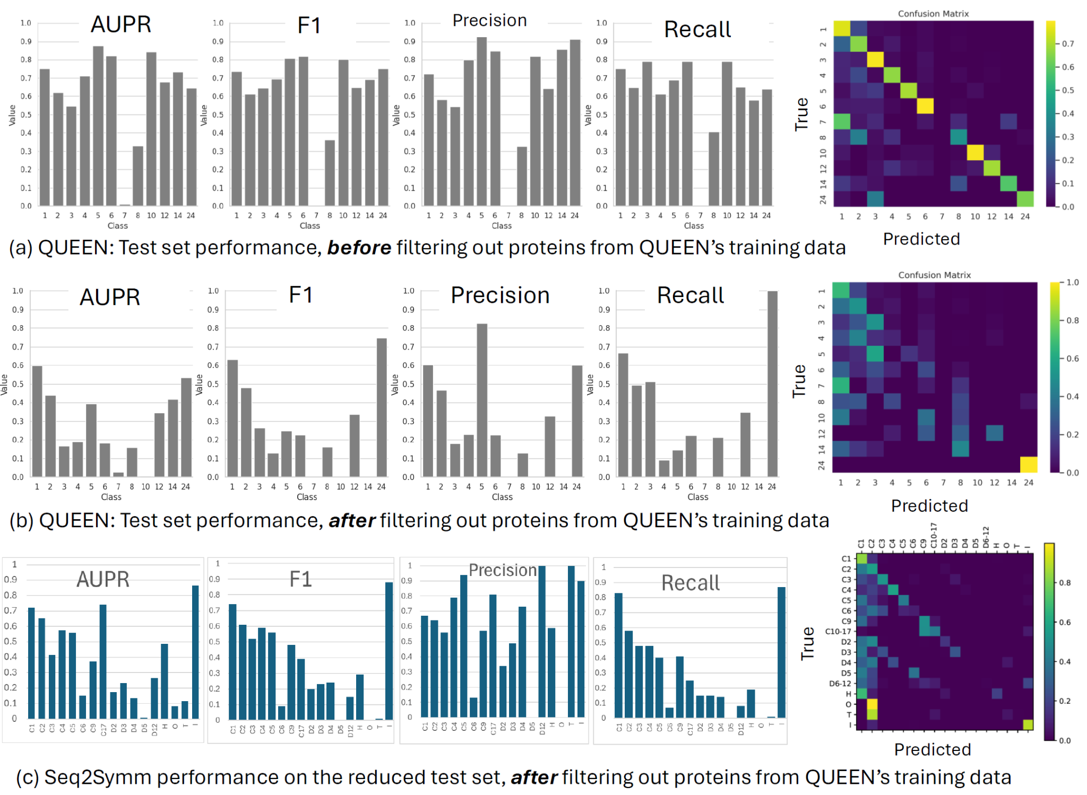

Figure S8. AUC-PR of Seq2Symm on our de novo test set
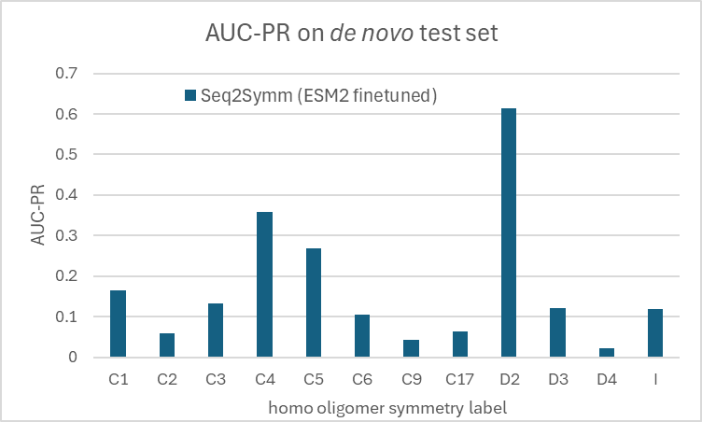

Figure S9. (a) Predicted and true label distributions for a cluster of proteins from the validation set, where the model makes mistakes on the ‘H’ symmetry proteins. (b) Predicted and true label distributions for a cluster of proteins from the validation set, where the model overpredicts ‘C2’ symmetry over ‘D2’, whereas the true prevalence of these symmetries is the reverse.
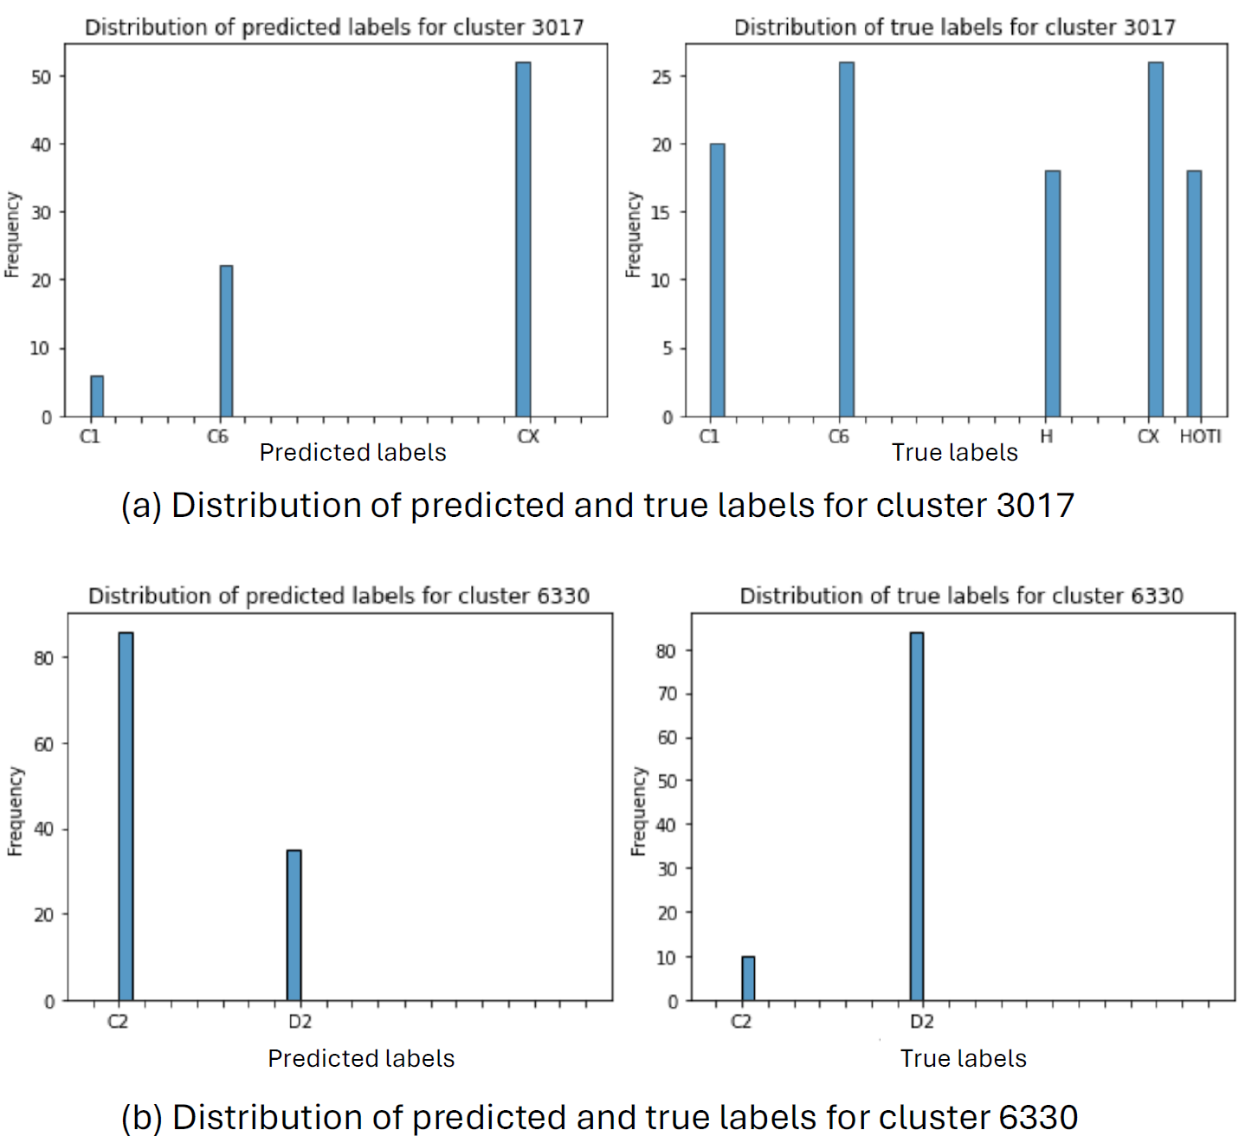
Training
The supervised models that use the pretrained feature embeddings were trained using sklearn’s linear (LogisticRegression) and neural network classifiers (MLPClassifier). Since we operate in a multi-label multi-class classification setting, we use the MultiOutputClassifier wrapper class for converting the base classifiers to multi-output settings. The ESM-MSA and ESM2 models were fine-tuned using the pytorch lightning framework and RoseTTAFold2 was fine-tuned using pytorch’s distributed data parallel framework.

Weighted data sampler for training
In order to prevent overfitting or “memorization” by the neural networks of the larger protein clusters that have thousands of proteins and to ensure that we sample a diverse set of proteins, we use a weighted data sampler where examples are inversely weighted based on cluster size.

Pretrained model hyper-parameter tuning
The hyper-parameters and regularization parameters were tuned on the validation set using GridSearchCV. For the neural network architectures, we try one and two hidden layers of various sizes.

Fine tuned model hyper-parameter tuning
To determine the optimal hyperparameters for the ESM class of models, we performed an iterative search in hyperparameter space to reduce model overfitting and address the challenge of using imbalanced data (i.e., substantially more C1/C2 training examples compared to rare symmetry groups). We assessed models based on Area Under the Precision-Recall Curve (PR-AUC).

We varied the L2 regularization term, the dropout rate used in the final symmetry group prediction layers of the model, the size and number of layers in the final symmetry group prediction head. We experimented with a multiheaded model architecture that had a separate set of trainable weights for each symmetry class or a single head for all symmetry classes. To reduce model overfitting in the MSA-based models, we also tried a random sequence selection step in the MSA construction step, a weighted sampler which assigned a higher weight to rare classes.

The best ESM-MSA model used high dropout and L2 terms (0.5 and 0.2 respectively), a separate prediction head for each symmetry group, and both random sequence selection for MSA construction as well as weighted sampling.

Other training settings
Our homo-oligomer dataset is class imbalanced due to the lack of PDB structures on proteins that have higher-order symmetries, and as such, training machine learning models that can learn most of the oligomer symmetries is challenging for all the models we experimented with (see Methods for how we address class imbalance). We find that the following improves validation set performance: and adding an auxiliary loss term involving a hierarchical loss defined on ‘coarse’ oligomer symmetries, where the higher-order C symmetries (C3 to C17) are grouped into a class ‘CX’ and D symmetries (D3 to D12) are grouped into a class ‘DX’. We sample a training batch based on proteins’ cluster membership (sequence-similar clusters) to increase the heterogeneity of structures seen in each batch.

Dataset information

Table S6. Statistics of the various homo-oligomer label combinations in our dataset, where the labels have been sorted by the number of examples in our dataset, with single labels highlighted for easier perusal.
C1 | 108210 |  | C1 H | 89 |  | C1 C2 T | 17
C2 | 83812 |  | D11 | 88 |  | C2 C5 | 15
D2 | 25861 |  | C1 C4 | 87 |  | C3 C6 | 14
C3 | 11582 |  | C16 | 86 |  | C1 C3 T | 13
I | 9412 |  | C1 C2 D3 | 80 |  | C1 C2 C3 D3 | 13
D3 | 8510 |  | D10 | 80 |  | C2 D2 D6 | 12
C1 C2 | 8315 |  | C3 T | 79 |  | C1 D6 | 12
C5 | 5113 |  | C1 O | 73 |  | C3 D2 | 12
O | 3988 |  | C1 T | 71 |  | C2 D2 D4 | 11
C4 | 3405 |  | C33 | 66 |  | C1 C2 D5 | 10
H | 3382 |  | C2 C3 D3 | 63 |  | C2 D2 D3 | 10
C2 D2 | 2937 |  | C2 C4 | 61 |  | C1 C4 D4 | 9
T | 2889 |  | C1 C2 C3 I | 60 |  | C1 C2 D6 | 9
D5 | 2813 |  | D17 | 53 |  | C9 D9 | 9
C6 | 2547 |  | D9 | 50 |  | C2 D6 | 8
D4 | 2246 |  | C2 I | 50 |  | C1 D8 | 8
C7 | 1303 |  | C1 C7 | 49 |  | C1 C2 D4 | 7
D6 | 1055 |  | C1 C3 D3 | 44 |  | C3 D3 T | 7
D7 | 1051 |  | C22 | 44 |  | C2 C3 D3 O | 6
C11 | 792 |  | D39 | 41 |  | D2 D4 | 6
C1 C3 | 713 |  | D16 | 40 |  | C18 | 6
C1 D2 | 700 |  | C17 | 40 |  | C1 C2 C4 | 5
C2 D3 | 659 |  | C1 C6 | 39 |  | C2 C3 T | 4
C3 D3 | 575 |  | C1 C2 C3 | 35 |  | C2 D2 T | 4
C12 | 401 |  | C1 D5 | 35 |  | C2 D8 | 4
C2 D4 | 397 |  | C2 T | 35 |  | C4 D2 | 4
D8 | 385 |  | C32 | 32 |  | C1 C2 C4 D4 | 4
C8 | 378 |  | C30 | 30 |  | C1 C9 | 3
C1 C2 D2 | 312 |  | D3 O | 29 |  | C12 O | 3
C9 | 300 |  | C1 D7 | 28 |  | C1 C2 H | 3
C10 | 289 |  | C2 C4 D4 | 26 |  | C2 D3 O | 2
C1 D3 | 271 |  | C26 | 26 |  | C2 D2 O | 2
C5 D5 | 265 |  | C1 C5 | 25 |  | C1 C2 D3 T | 2
C4 D4 | 233 |  | C12 D12 | 24 |  | C2 C4 D2 | 2
C15 | 206 |  | C1 C8 | 24 |  | C1 D3 O | 1
C2 C3 | 195 |  | C4 O | 24 |  | C1 C3 C6 | 1
C7 D7 | 189 |  | D12 | 24 |  | O T | 1
C1 D4 | 155 |  | C8 D8 | 22 |  | C3 D3 O | 1
C14 | 146 |  | C21 | 21 |  | C39 | 1
C2 D5 | 135 |  | C5 I | 20 |  | C27 | 1
C13 | 105 |  | C5 D3 | 20 |  | C3 O | 1
C2 H | 102 |  | D2 D5 | 20 |  | D2 D6 | 1
C34 | 102 |  | C2 O | 19 |  | C2 C3 D3 T | 1
C6 D6 | 99 |  | C2 C6 | 18

Table S7. Statistics of the Unifold test set

Class | Counts
C1 | 9
C2 | 60
C3 | 7
C4 | 1
D2 | 7
H | 1

No-homology split
We created another training setup where the training, validation and test splits are based on sequence homology defined by a relaxed sequence similarity threshold: e-value < 0.1. To create this split, we first use BLAST (blastp) to compute pairwise sequence similarity between all proteins in our dataset and then find connected components in this sequence similarity graph that define the “homologous clusters”. We find one large cluster with 233,461 structures and 5,057 smaller clusters over the remaining 65,319 structures. The single large cluster is designated as the training split and we divide the remaining 5,057 clusters randomly into two sets to get the validation and test split. The number of structures and the class-wise distribution of the training / validation and test splits is shown in Table S8.
To characterize this split better and to compare it with the conventional training split that is used to define the main results of this work, we show statistics defined using protein family annotations (PFam database) in Fig S10 (c),(d).
Table S8. No-homology data split (described in the text above): Statistics of data splits generated using a sequence similarity e-value cut-off of 0.1.
 | train | validation | test
C1 | 84421 | 8815 | 11114
C2 | 67111 | 10232 | 8395
C3 | 9270 | 937 | 1421
C4 | 2867 | 194 | 171
C5 | 3360 | 475 | 1271
C6 | 1456 | 662 | 430
C9 | 879 | 671 | 429
C17 | 376 | 601 | 1101
D2 | 23705 | 1353 | 1890
D3 | 7755 | 601 | 919
D4 | 2250 | 142 | 90
D5 | 1793 | 791 | 455
D12 | 1710 | 191 | 934
H | 2081 | 774 | 587
O | 3426 | 129 | 538
T | 2173 | 198 | 562
I | 2980 | 4213 | 2207

Figure S10. (a) Test AUC-PR averaged across classes on the No-homology based splits (b) Class-wise Test AUC-PR on the No-homology split (c) Venn diagram showing overlap of protein families seen in the training and test structures from the 30% cov, 80% id based splits (d) Venn diagram showing overlap of protein families in the training and test structures in the No-homology split
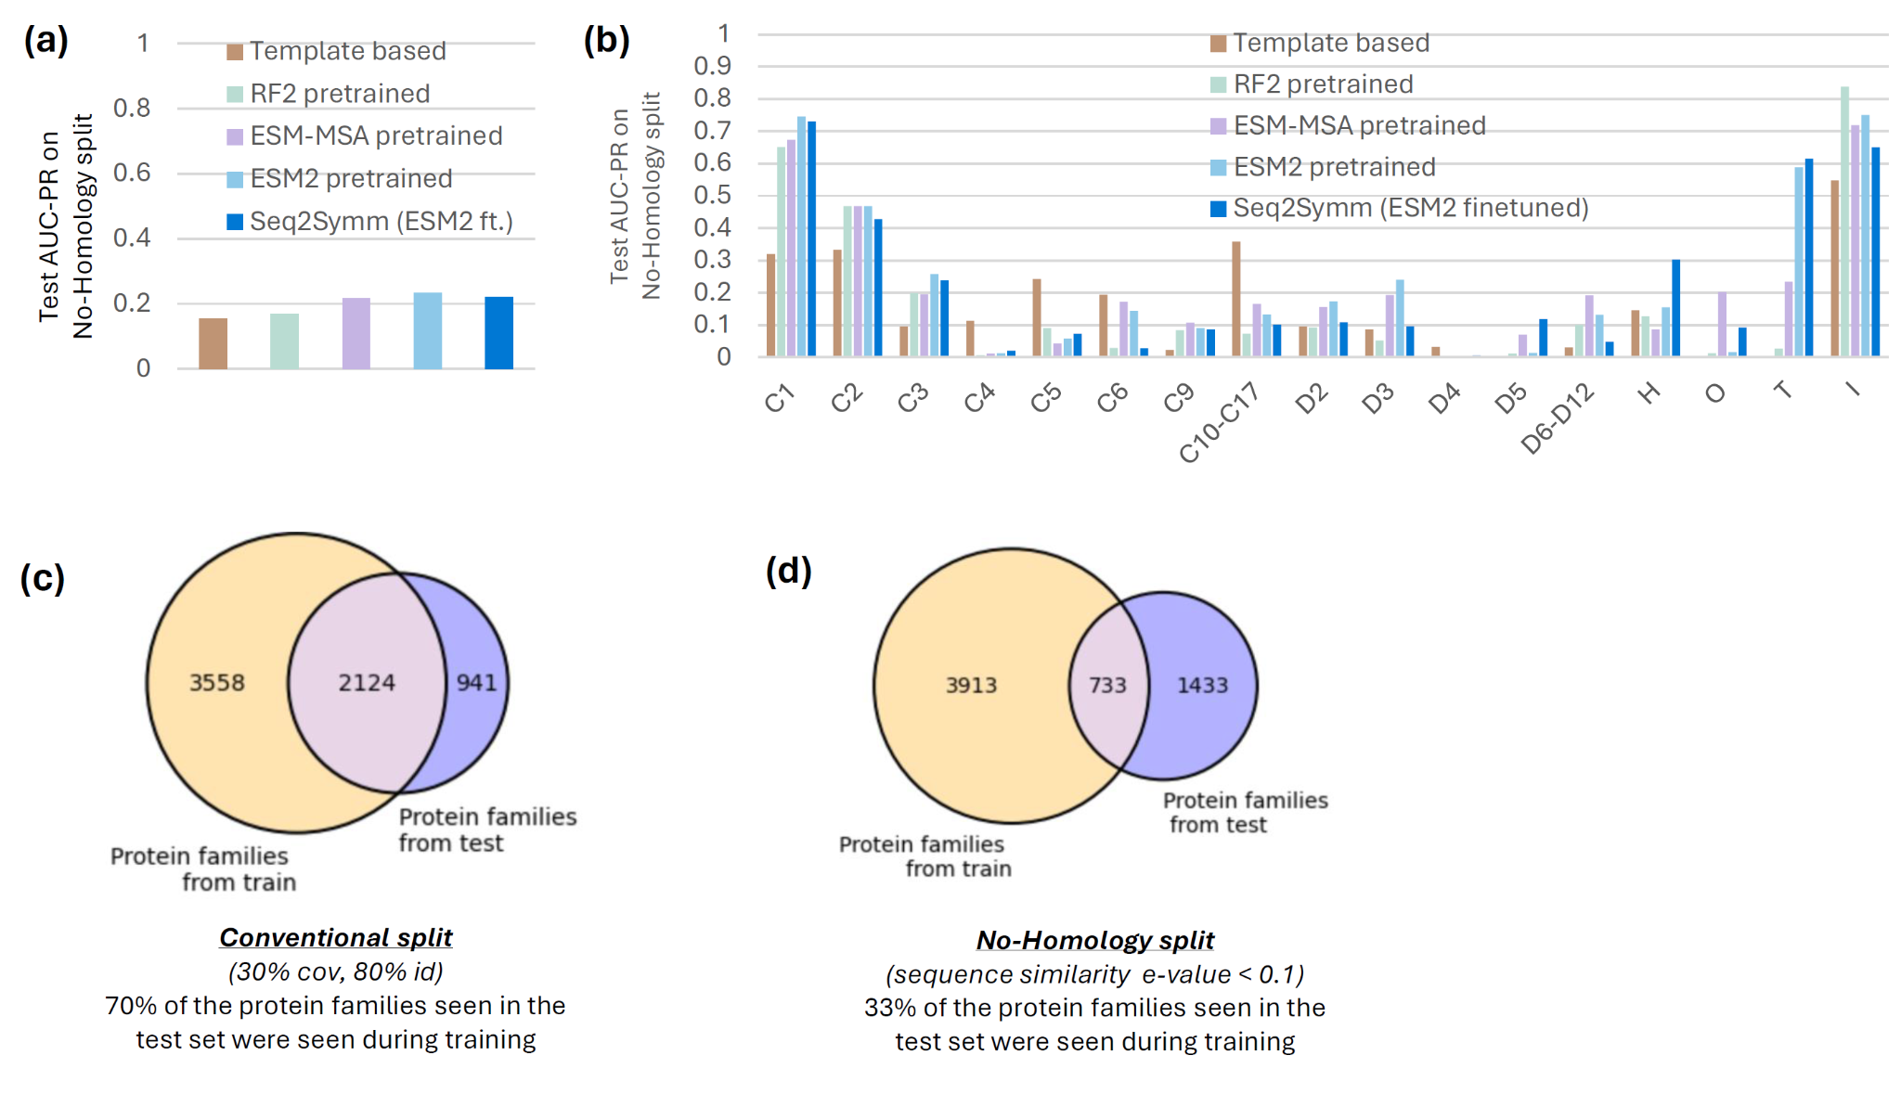

MSA Analysis:
We analyze ~200 randomly selected MSAs from our test split and run inference using our best ESM2-based model on each protein sequence from the MSA. We show the diversity of oligomer symmetries within each MSA in Fig S11(a)-(c). We perform a similar analysis on 300 randomly selected MSAs from our training split, plots for which are shown in Fig S11(d)-(f). Note that the query sequence from the train MSAs (i.e. the top sequence) is seen during training and the model has seen the true label for that sequence. Despite this, the orthologous protein sequences in the train MSA are assigned other labels as can be seen by contrasting Fig S11(d) and Fig S11(e).
Figure S11. (a) Number of unique true homo-oligomer symmetry labels, where available, aggregated over all the proteins from each MSA. The high prevalence of singly-labeled MSAs indicates that we generally have very few labels over the proteins from an MSA. (b) We look at predicted homo-oligomer symmetry labels for the ~200 MSAs and aggregate the labels over all proteins within an MSA. The number of unique oligomer symmetries are shown. (c) As anticipated, the number of unique oligomer symmetries is correlated with the number of protein sequences within an MSA. (d)-(f) Analogous results are shown for 300 randomly selected MSAs from the train split.
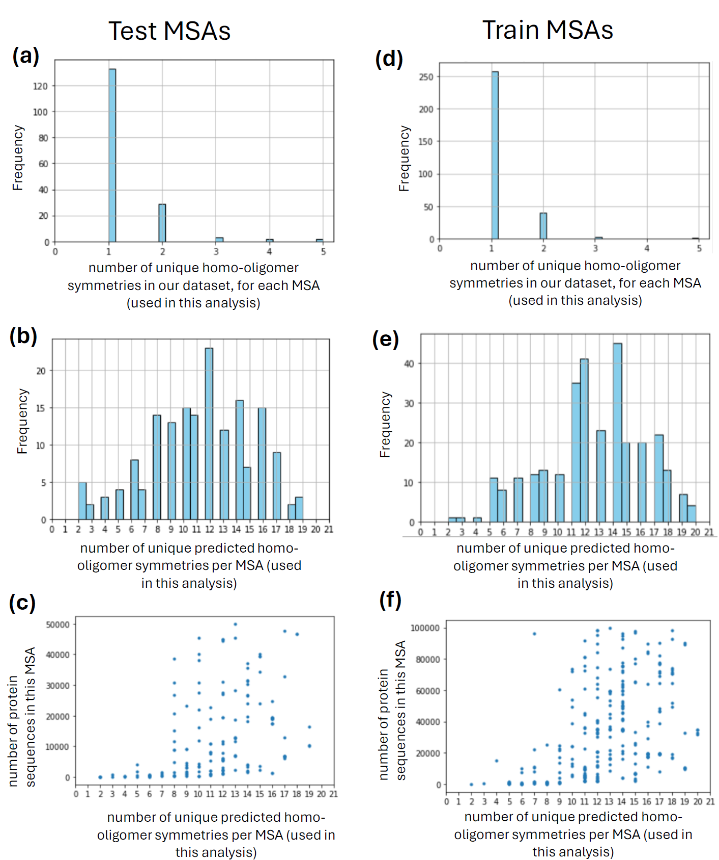
Figure S12. Examples from our dataset showing the diversity of homo-oligomer symmetry labels within an MSA for four different MSAs. Cropped segments of the MSA, both in the length as well as number of sequences, are shown for brevity. We also show how a single protein sequence A0A0C5GTQ from metagenomic data is part of several MSAs, where each MSA has different homo-oligomer symmetry(s).
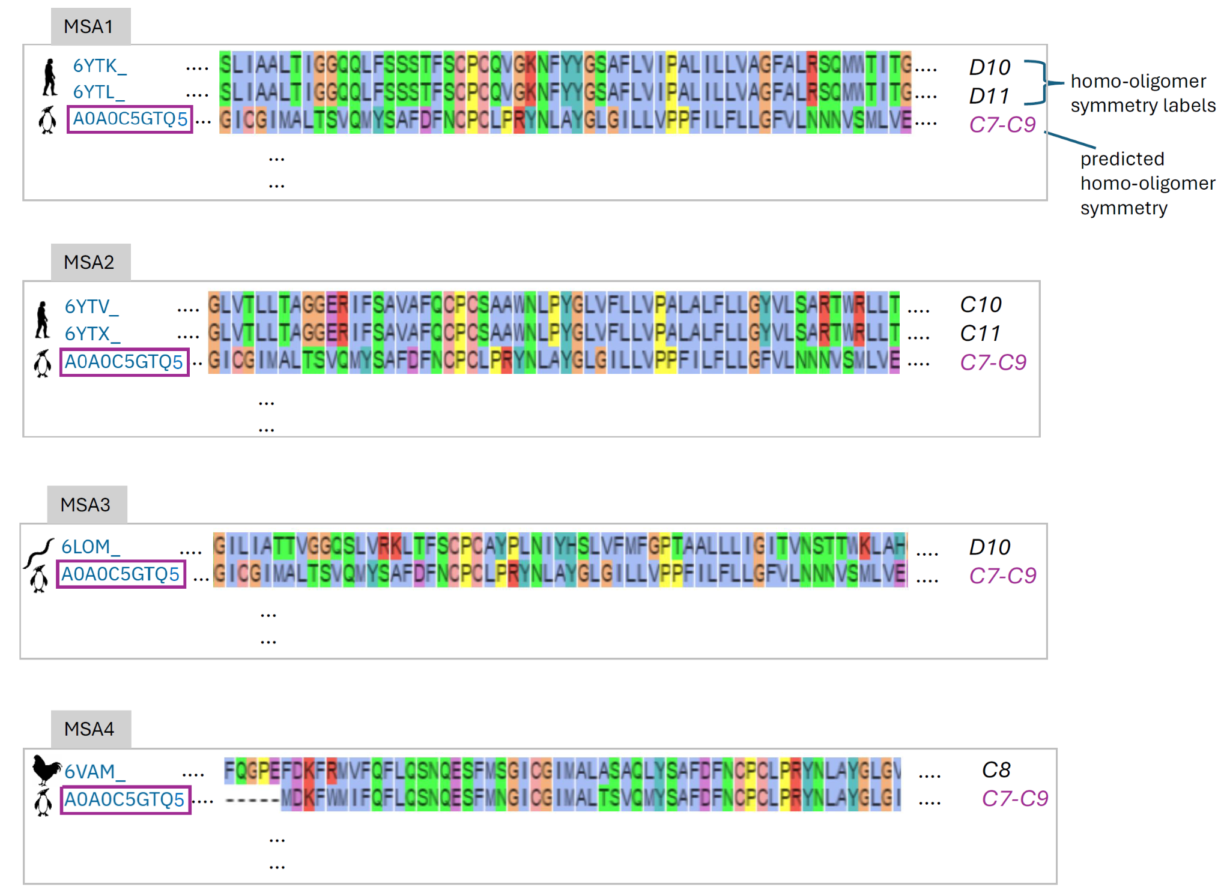

Template-based method using HHSuite
We use the following parameters to run HHSearch while finding template-based matches to a protein of interest. The database used for the search is PDB version 03 March 2021.
hhsearch -hide_cons -hide_pred -hide_dssp -b 50 -B 1000 -z 50 -Z 500 -mact 0.05 -cpu 8 -maxmem 64 -aliw 100000 -e 0.001 -p 5.0 -d <path-to-database>
While assigning labels from the hits to the protein of interest, we restrict to an identity threshold of <30%, as shown in the results in the main text. In Fig S13, we show the AUC-PR averaged over all homo-oligomer symmetries, upon restricting the hits to proteins within the training set, to match with the evaluation setup of the machine-learning models. We call this setup the “Constrained” setup and compare it with the results in the main text, in a <30% identity restricted setup.
Figure S13. Comparison of results from the unconstrained Template-based method (using HHSearch) shown in Fig 1 with a constrained version which only has access to the labels of training proteins.
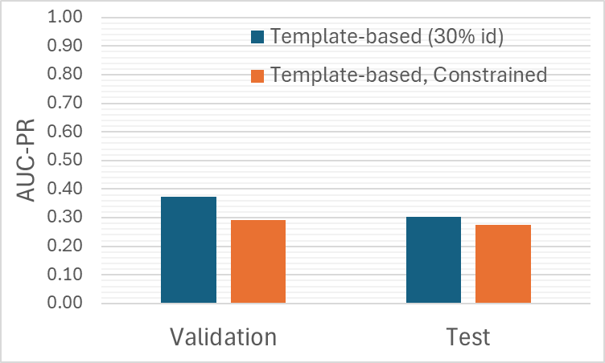

Figure S14 Prevalence of multiple homo-oligomeric symmetries per protein, in the five proteomes shown in main text Fig 4.
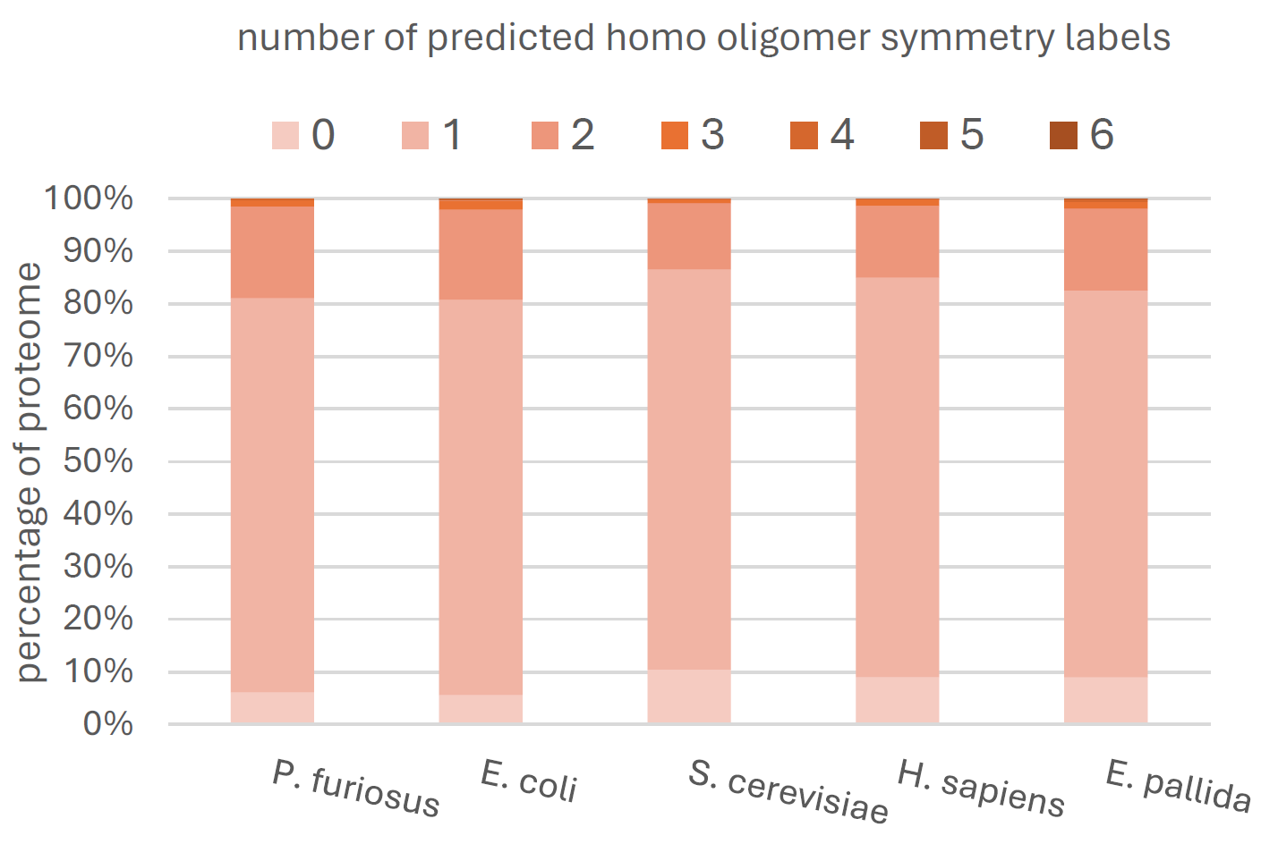

Table S9. Statistics of the five proteomes discussed in Fig 4 in the main text.
 | Proteome | Size
E. coli | UP000000625 | 4,400
S. cerevisiae | UP000002311 | 6,060
H. sapiens | UP000005640 | 20,596
P. furiosus | UP000001013 | 2,044
E. pallida | aiptasia@reefgenomics: sea anemone model for coral biology | 26,042

Generating all atom structures from Seq2Symm predictions:
We modeled 128 confident oligomer state predictions from the E. coli and S. cerevisiae proteomes. These were selected based on no overlap to the training dataset (BLAST e-value < 0.001), a total complex size of ≤ 3,000 residues, AFDB [35] monomeric structure model average pLDDT ≥ 75, and MSA depth ≥ 100 (after 95% identity, 50% coverage redundancy filtering). We find that 24 (19%) are confidently predicted by AlphaFold-multimer with pLDDT ≥ 75 and ipTM ≥ 0.5.

Figure S15. Analysis to estimate how many highly homologous proteins have distinct homo-oligomer symmetry labels. Histograms of average Jaccard similarity computed over all pairs of proteins within a homologous cluster (90% id, 90% cov) are shown.
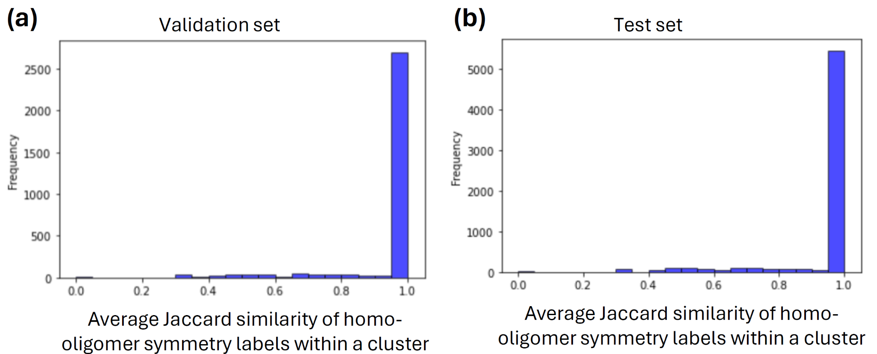

The plots in Fig S15 a,b look at homo-oligomer symmetry labels within homologous clusters of proteins, where we clustered them at 90% identity and 90% coverage. For each cluster of size > 1, we look at the Jaccard similarity between the homo-oligomer symmetry labels of all pairs of proteins within the cluster and compute “average similarity” per cluster. An average similarity of 0 indicates that all proteins in that cluster have different labels and an average similarity of 1 means they have identical labels. The plot is a histogram of the average Jaccard similarity values. We use an average Jaccard similarity of 0.5 to find clusters with very “noisy” labels and count the number of proteins within such clusters to estimate the impact on prediction errors. We find that a total of 2505 proteins from the validation set and 7506 proteins from the test set belong to clusters with highly noisy labels.

Table S10. Statistics and protein sequences from the Denovo test set
Source publication for the protein structures:
HALxxx, PMID: 36108048
HExxx, PMID: 37433327
ID | Protomer sequence | Protomer length | Symm-etry
HALC1_006 | DKIAFFKRLKEELEKDPSDENVEKLIETLNEEEKKILEEIKKEYPNEPLSEIFYKLIEKLLELSE | 65 | C1
HALC2_067 | DKLVRVLSSSMIYYAERMTKGSTDPSDYDKALDDFYNYFLEQPFVDKETLEKAYELARKRLEELL | 65 | C2
HALC3_104 | KRIDEIESKLKHLEEFTTHLIKLMETMLELLKLVSDGKSDSEEYKELLEKAEEYLKQATEAAKKI | 65 | C3
HALC3_110 | LEQILEELTELLERVDEIPLREALKRMLELLVRVTQELKEVKDKVESLEKHLEELDKRVEEIEKK | 65 | C3
HALC5_169 | LLLEVMEKVFDEEQLKLIKEAAEREGNSPVVISSIATLLLLERIEKIVKEIHDEVKKNNEKQEKK | 65 | C5
HALC2_062 | MARVEYSYEKLNDTHYKLKLKVTYEYRKSPEARRLAEDLVQAFVDALSSLPFITVEYEVEEVEVE | 65 | C2
HALC5_176 | MDPKELEREALKNIIKLPKLIQDFKDSVMKELNKIIELLEERRREIDEPLLPIIRKLQEELQKKE | 65 | C5
HALC4_140 | MEEVVLTSHNELHKKLDEVHDKIMSKLDEIHEKLDEIISKLDEIESKLHEILNIVKEIKEILEKK | 65 | C4
HALC4_135 | MEKFKEQLLEEVKKIVLETMTKVMEHLEKWFVTLAEIIITKSEEKLEELKETMEKSIEELRKEAE | 65 | C4
HALC2_068 | MIKVPEDLERIGRELRARGLDTKRLLEEGPKLYPELSIPDLMAIALYDHLNLDPEFLYRLLQQSR | 65 | C2
HALC1_004 | MIVSLEKHPGGVHIITLSSEENLENFVKELKKLGAEVERLPEPNTVRVRAPEEVVEEALKNTKFK | 65 | C1
HALC2_063 | MKVYEFPYPETGKKIIVIQGEKNIVIVVGNTAVVYYEGKWTYKENVTEEDIEKAKTEEGAKELAK | 65 | C2
HALC1_008 | MLTPEELLERLRRHLEEEHGVVVPEERILSVEATPTEVTLTWSRGDGRTGTARYTSDGRFEVEDP | 65 | C1
HALC4_136 | MSPYKKAIEITKRLLELLLSNPELAKKNLGGIATLISLLALISALDGTLDEKDIEPYIKKLEESL | 65 | C4
HALC3_118 | MTRLEQLLAQGVDPFEVLREKIEKLKEIWKKYEEAKGEEKERYRDELLKLMMEVLELMVELLSRR | 65 | C3
HALC2_059 | MVKPITEEDVREAATAASPDYEVGEAKLIDEENNLWFVTLYKGDQKIYALIEDKNGEFTVHQIEL | 65 | C2
HALC1_005 | NEKEFLLQLKEELDKDPSEENVLSLIKTLNEEQKKILEEIKKKYPNLPLSKIFELLIDELLERLE | 65 | C1
HALC6_220 | PPIPPPSFKLEISPAFLELVQLVIDLHPNDEEVRKELIENLISRIGKSDNVPPETISLDISEAALELFEWIFEKFPDDEDVHRRLIESFINKRKFSSSSPLDTPSLDISERFIELVKYILEKYPEDEEIKQKLIDSLLNLLGSY | 144 | C6
HALC3_109 | REEIEEAVKEAELKVLAIVLVALRSVSHYEPLSRLYESFLDALKKALSEEELKEVEKEAERIEKK | 65 | C3
HALC2_065 | SEEEKPIVIDLNKTIERDGRKVKLVRATITVDPETNTITIDIEYEGGPITKEDLLEAFKLAASKL | 65 | C2
HALC2_064 | SKLKEQEELIDEISEKAKEFLLEIKEKYPGELSEERYPGRVVLTYVNEEKGFSITVTIELLNKEK | 65 | C2
HALC3_114 | VDEKEVKERFEEIESRLEELESKVREVEKKVEEVKKESDEKIDQLKTEFETKYNQINNEINTLKN | 65 | C3
HE0368 | SEEEDRKLLKEILAEPEVLELLLEAVKVVEPVYEQFLKALELQNEAWSLILKKFAEKKAK | 60 | D2
HE0370 | DFKEKLKKLQEEMDKLLKKVEETLKEIAKEEENSMIYLAALTTLILAHQAKLNEKLEKANLELLKKEGHKELAKFIEELI | 80 | D2
HE0374 | NEEVKKLLEELKKVSLEKTKEICKLLGLSEEVTELVLKSIEAQNESLEAFIEALEALKKA | 60 | D2
HE0376 | MEKKEKLKKELERELALCETEADKLFILAAVNLMLALLELGREETAKRILKLMEKILELN | 60 | D2
HE0377 | SAALEEAKALLEELAELGLPLSVALLLVALAEELRRLGLPAERAREFVLEVARRIVELLR | 60 | D2
HE0378 | NNSRLENLLLLAKTYVEAALALLRGESPVPHFERAAAELEARGDEESAALVRAAAARERA | 60 | D2
HE0381 | MVKELVDVIIEAQFDLSLRIAKVLGLPEEEAKAIRKRVEEKGDYVEAIAELNQKILKLLE | 60 | D2
HE0384 | MEEKLEKALKFSEEVAEKVKELFKDEPLEKKVLALLVVYNAAKLLLAILSAEDPEKMKKLLKEINEREEKDIEELIKEDK | 80 | D2
HE0385 | MVEKVEEIRKKLLELIEELAKEFLKDPELLELYEKLLKKVEEMRKIIEEKPEYKPLALLLEIQMSTLIFCTILLMAMMME | 80 | D2
HE0386 | SLEEKLAALIAATEKKVAATEEVMKTFGFPESLIEELRAKLAELHTLDPEGQFIQIIEIQGLLNYLEQQALAELYKLLLK | 80 | D2
HE0389 | EVEERLREVEELVDRYRERLLEAIDGPLEEIIALEVDFLREFLELGLPEKALLAAFNILNLLVNIEALMKDEPKEVRKEVREKILDLLEEILKLMIRAEA | 100 | D2
HE0390 | MSKEEKMMEEMMKLCKEMKEKEGLKLSTMNLMMNIVFAYLEGEKVEEIRKACEKTLEMLK | 60 | D2
HE0391 | MRTITVAPEYQEIWDAVDALMKKKGISEMDGLKMFGLMVALIDIYPESHEPIIEMLKSLI | 60 | D2
HE0392 | MLESAKELLELLKKAGDELGLEIAKEYLKLMEKYKEYAPLIANNMLNALMNLCLLEGREELMVEVIEKIAKLMKEILKLK | 80 | D2
HE0393 | MLESAKELLELLEKAGDELGLEIAKEYLKLMEKYKEYAPLIANNMLNALMNLLLKEGRLELAVEVIEKIAKIMKEILKKL | 80 | D2
HE0396 | MEEEIRELTKEALTKLAELWKLALIALGVDKEAVDAAVAELKALLEESKDLPPLEFTKRIVEKCTAITKRFLDQAPLESLLFLAAVNLLLALDLLALQAL | 100 | D2
HE0397 | MKEELKKKLKELLEEFEKLPLETQKLFAESLRVQAKLAGYEKLAKILEELIKLLEEMIKK | 60 | D2
HE0399 | DADIEIDALLLKANLILRKLPLEKQAAFLKAVEALLKEMGLPQEAIDKVKEAAKILEAAI | 60 | D2
HE0400 | SSALEELKEELVRLVEMSVEEILERAEELLKKAKKEGKLLELAKALLTLSLALLKLLLES | 60 | D2
HE0401 | SSALEELKEELLRLVEMSVEEILERAEELLKKAKKEGKLLELAKANLTLNLALLKLLLES | 60 | D2
HE0402 | SLEELREEALEALEELLELLGMSEAERHLARATLLLLLERHPELAPLLLKALRRLLEELK | 60 | D2
HE0409 | ELKELIEKLIKKYKEISEKMLKELESMTSKEKLKEVLLKIIDLQAELDKEMVKTTFEILS | 60 | D2
HE0414 | HKEELLKMVREMSEKIVKKIEELLKYLPEDTRKLVTELLKTLEELLKRAIEEGRVVEAVLALAALLILLALVLQQVEEEA | 80 | D2
HE0415 | MEERVKVVEAAAELCRKRGLEEEAKLLEEAAELIKKGAKIEEITAKLLAAIKEAMKRGDILTAQALLAVHQLLLLLEQLD | 80 | D2
HE0416 | MEERKKVVEALAEVCRKAGREEAAKLMEEAAKLIEEGASIEEITAKLLEAIKELMREGDLLLAQAALAVHQLLLLLELLD | 80 | D2
HE0417 | GEKIKELKEELKKKLEEAKKKVEEAEKEGWTLEKVAEIAELLTEALKIVIELLKLLLEQQ | 60 | D2
HE0419 | SELLERLIKSLRELIELLRKQSKEIQILVIKTLIVNAVFSEEEAEKELERTEKEIKELLE | 60 | D2
HE0420 | SEMKELSLEMLKLAVKMMKNLSVEKVAAILALMLAIAIIMGDEETAELAEEMLRKAIEMKKEGKSTEEVIKEIEKIIEEK | 80 | D2
HE0421 | REKLIEEVTELFKKALEKLSLEEQELLFKALEATLKMAGKEEEAKLMKEAAKLLKEEIEA | 60 | D2
HE0423 | EKVEEILKKIDEIEEKLVAKAKTELEAQAIRALTEATKLLILLNLELAKEAVKEFAKVLE | 60 | D2
HE0424 | MKHNLRVLAKLAALAAVLAVGAMTALLLLAGFEEERKEELEKLKKIIEELEKKETIEEVLKLTLEELEKGLKELKEEVEE | 80 | D2
HE0425 | DKKKLIEAVLETAREISEKLKELAKLFEKAGEKDAYILVLQHLVNSKVNHAAILIKLGAEEEEVEKLVEEAVKAIKEALK | 80 | D2
HE0426 | ELELKLKLLALINAATAKLVAMAKAILEKDLEEAAEEFKKLTAEVEALLKKAEELIKKAL | 60 | D2
HE0427 | MAEERLLALHEERLELYREIGASNKELAIIALLLAVEALILGFEEVAKHYLELAEKLFKE | 60 | D2
HE0428 | SRALQLLKENTCLTLLLLAVEEGAPEEAIEKLEKLLEELRKTGSTEALIAALKLTAEILE | 60 | D2
HE0429 | MLEEILKLLRELEELVKDDPELTIAVLSLRIMIALKYDKEKAKEALEEFVKVVKEMLERE | 60 | D2
HE0432 | MEIVELMAEAVKLLIEAGHYELVAALAETAALTAELVGVPEEAIELFRKAAELAKKRIKE | 60 | D2
HE0433 | EERRRLLLQLAFLLRLARALSEFLDAASRERVEARIAELEARLPEEELAAAEEEVTRRSQTVEGQAELALEAAEALLDAV | 80 | D2
HE0434 | SEKEEKLKKLAEEALELCETVKEKAIVALAFAIIALVLGYLEVAKEYLEKAKELLEKLLA | 60 | D2
HE0443 | MEKLNEAYIKLLELLNEFQLTTTKLLLEGKLEELYKKLEELSKKINEAIEELLKLLKELI | 60 | D2
HE0444 | EQALNDALVKLLELLNEFQLTTVKLYLEGKLEELYKKLEELSKKIQAATQELLALLKALI | 60 | D2
HE0448 | KKVEIAKKAVREVAKVIKELLEELKDDIDFLEFVLALINSIVNKALLEVVESKLLGKSIDEVIKEVEKKEEEAIKRIEEV | 80 | D2
HE0449 | EEAKKAAKEAAEAYKELIKLIDEGAAPEEIRAAVKKAQEKALELDTLIIDLGDPLLRAILRAKAENNLSNTELALEVLEA | 80 | D2
HE0453 | MEEAKEKMSKLLEEIAKIAKKNEDKEKQALIYLELAAIALILGDKELAKKFLEEALKILE | 60 | D2
HE0454 | MKKLVEELAALVREIAKQLSPRDAALLLALLAAICLLVGDLETAEEAVEELKALLAKQKA | 60 | D2
HE0455 | KEERVEELVREEDEYCEELEKEGKKLLAYLRRAAMCLVAALALLGYEEELKRLAEVLKRL | 60 | D2
HE0456 | MVAKLAAAAVVLVLLLVPEEDRPEAVKLLEEILERVKAGESREELLKRAKELLDEALKEL | 60 | D2
HE0461 | MKEAKLEFECGPASAVVATFTACLTTLLLKKPLDETIDIVKEVAKLLEEKLKEEEKVKVSITLKEENGKRTLTITITEEL | 80 | D2
HE0482 | DTKEKAETFAKIVAELVKQGFLETAAAFTREVLAELPEEDKLEVALAMTKAFLEELEKKE | 60 | D4
HE0485 | EEEKQKELYKTIVESAKEISEKYGIDETVAQQQLLQAVALLSLLDEETIKRLTEEVLKMK | 60 | D4
HE0489 | WEEKARRFLRIELIKELLHLYVLARVLGLEETAKLLAKAIKTLIEEDPESEKVLEEVKSLLNETGREILERLLEEVEKEE | 80 | D3
HE0490 | ELKKRVVRYVATRLFTEILSLEPLIGRETALELLLETARILYKASGELELILEVAREEMRRAGVPEEDIEALLAELRAWA | 80 | D3
HE0492 | MEERLEKLNKLETVKEYLKKAVYLGTGDEVLEELLKYVPEEYKELILKVREAAELEKALL | 60 | D3
HE0497 | SEEIAKDLRLMAEISHDNLATLAIILIREGEDIDFLLEIAEDLSELSRLTMRYVAEKLKA | 60 | D3
HE0499 | KLLEVAVLKAIAELLGLAILDPRAIPLAREALEKLRKIHPSEIIKEMCDMGERILELIEE | 60 | D3
HE0501 | KMAEMLVEHVILELERYEERGNAAAMIYTFIERLGKLALLGPEALRLAAAEFAKLPSPLAPELAAACETAAALLERLLAA | 80 | D3
HE0502 | KMAEMLVEHVILELEQYEARGNEAAMIYTFIEHLGKLALLGPEALELAAARLAKLPSPLAPELAAAAEEAAALLKRLLAA | 80 | D3
HE0505 | DLLKEAEELVKKILETDPEANPAALNLYTILKTYVDIGAEKQAKKILELLKVVAEHLEKK | 60 | D3
HE0513 | DAEALVERAAELLLERVRAGVDLEKALTEVLLAVLVRLTEEDAERFVELVVARFAETAELVRTLCEAALLKAKALVEALD | 80 | D3
HE0517 | ERRERARLMMELLAEIAEEAAILQLAAQLAVLMYLSSLVGEDPEELLEIFEEIVLARVQTEFQREVAERVLERLREFVEK | 80 | D3
HE0521 | AEEVLALVAARVMRQLAEDALLAAELGLEEVAAALVELMKALAEEVAKRVSPEVAERVKRVLALLLTRLEKEIAEAKAAE | 80 | D3
HE0537 | SSFQEEAEKTFENLLELLLIATNLDTRVASELAEALVYIMGLLEENKEEFFEKFLKLSKYLNNVTLARAIKTAIELGDKEFTEKLLKEFNKIIEEKKKLV | 100 | D4
HE0620 | MKKIVIEAEMIPENHETILAVVKELVEEGVENLEIVLKVTPETTKEQSVELVKKIIEILK | 60 | C6
HE0621 | AAAEIIKLNLTITENAKFQLLQDYAKFLGDKEELKKITEEANKWFEERMKELEERIKKLE | 60 | C6
HE0625 | MVKRKFTLKLTTGASDDMTEVVPEFLAMIKEAAELFDEVTIKVTTESPEMARAVMEGVGILIKEGVDVTLEIELGSNVKARVEVLKTLAEELKKIKEEIE | 100 | C6
HE0626 | MIKRHFTLKLTTGASDDMKEVVPEFLAMIKEAAELFDEVTLKLTTENPEMARALMEGVGILIKEGVDVHLEVELGSNVKARVEVLKTLAEELKKIKEEIE | 100 | C6
HE0633 | ATTTTTTVTLDSASGERTLTTTTTVPAGTTLAEMVALAEAQLAAASEFDRRTATVTVTEE | 60 | C6
HE0639 | SKAEELAKEMIELLRLVKELLLETTPEFPETTLIALAIVLNAVVTTLNALLDKVPLELLKELVEVMKDTVEGLKEKLKAL | 80 | C6
HE0644 | MVSISLSGKTSEELKVMAKLAEYLGEEKTAEILKKLIPEVKELEAKGETSLEVSVTITFE | 60 | C6
HE0649 | KKSVTIRVTADAAVLAEFTALLLEWLDLDAREVLEAFRKWLEEMKARGIKDDYTVELTVE | 60 | C6
HE0657 | EELIKELKEKQKETQAELEKEYKEYKEKGESESAAIMKATSTQVATKYEIEIAKLKLELL | 60 | C6
HE0662 | MEAILEAIRRLCEAGIKVTVVLAGPISLMEAIVETCIEVGVDEVVIDTSKDHLELIEADK | 60 | C6
HE0690 | MLKVKIKVKDNPAVARGVLRLADKLKKAGVDVEIEIDLYGDEEQALATLAAMEAEVEELA | 60 | C8
HE0897 | SAEALKLARLAALVGLVGAAVATADPANPLFLELLKNPDPFVLQEALTAALVAAILTGEAARCNALALGLAARLSREDAARAALRAAELAYETAALLASL | 100 | I
HE0898 | SFTEEELEKLKEAVKLAVEALLLTPKDFEKALKLLEEVTLKVVEILRRDPLEALKAAFKSTTAIAKLYVAHASKDVSEAQAIAAEAVKALLDLYEKALKE | 100 | I
HE0899 | SFTEEELEELKKAVKLAVEALLLTPDDFEKALKLLEEVTLRVVEILKRDPLEALKAAFYFNTQIAKLYVAHASGDVSEAQKEMAKFVKYLLDLYEKALEE | 100 | I
HE0900 | AFTEEQLKALQESLKLVIEAAELMPDDFEKAIELVEEVARRLVEIFASDPLAALHLAFKFNTAIAKAIVANASKGKEEAMKVLVELAKYVFDLLVAALEA | 100 | I
HE0902 | MFTEEEIKKIRESLKLSVEALEVTPKDFEKALELLEEVAINLMEIFKDDPMKALKIAFKFTNAIAKLYVAHESKDVADAMAIMAEVTKYILEILEKVLEE | 100 | I
HE0908 | ELAEKERLARINIGAVLAGLAMAVVGACKELAEAGMVMAIMSVVAVELAQDPEAAVELAERCIEMAGGLSEEVKKMIKAAVRALKGVVEAEEAKIKKFKA | 100 | I
HE0915 | EEELLEEILEFFEKLSDPKALVAFMLEKAPPDPGLKTALRIALSGPNITVGKALTLGKAIAEVSAGRYGGAGMIAGAAGGFEIGDEEVKRECKLALLKYL | 100 | I
HE0916 | SKEVEEALLKALAAALIAAVAANKAAAVEVLRAIAEEGLDVLVAVVREAMRALADSPLVATLREAAREVAAELPPEERARFLAALEAAAAEVEAEAARAR | 100 | I
HE0917 | SAEVEQALLEALAAALIGAVAASREAAKAVLRAIAELGLDVALAVVRRALRALAESPLVEVLLEAAREVAEELPPEERARFLAALARAAAEVEEEERERR | 100 | I
HE0918 | EEAVKKALIEALAAALIAAVAASKEAAKAVLKAIAELGLDVAVEVVEKALRALADSPLVAVLIEAAKEVAEELPPEERARFLAALAEAVARVEAEAKEAA | 100 | I
HE0919 | MEAVQQALLEALAAALIAAAAASAAAAKAVLRAIAELGLDVLVEVVRRALRALADSPLVATLLAAAREVAAELPPEERAEFLAALERAAAEVEEEAARAK | 100 | I
HE0920 | SEEVRQALLEALAAALIAAAAASREAAVAVLRYLVELGLEVALEVVRLALRALRGSPLRERLLAAAEEVAAELPGEEAARFRAALARAAAEVAEEAAREE | 100 | I
HE0930 | VKELVAELAELAGEADAELRAQIALLLAVIALAPEEQKEELAELALRVVREALEAAASPAVPVALAAAAAAFARSEDPEAVRREAEAIITGLRLAKEGLA | 100 | I
HE0935 | MKELLAEIAELAGEADAELRAQAALLLAVIALAPEEDKEFYAELALRVLRAGLEAAASPAVPVALAKAAAALARGEDREAVERTIEAILTGLELTKKGLA | 100 | I

