Supplementary Material

Supplementary Notes |  | 1
1) X chromosome scaffolds identification and orientation |  | 1
2) Y chromosome scaffolds identification and orientation |  | 2
3) Comparison of X and Y chromosomes in mammals |  | 2
4) Gene annotation of sex chromosomes |  | 3
Supplementary Figures |  | 4
- Alignments of Brahman X against other X chromosomes  a) Brahman X vs Cattle (Hereford: ARS-UCD1.2) X  b) Brahman X vs Cattle (Nelore: Bos indicus 1.0) X  c) Brahman X vs Water Buffalo (UOA_WB_1) X  d) Brahman X vs Goat (ARS1) X  e) Brahman X vs Sheep (Oar_v4.0) X  f) Brahman X vs Pig (Sscrofa11.1) X  g) Brahman X vs Dog (CanFam3.1) X  h) Brahman X vs Horse (EquCab3.0) X  i) Brahman X vs Human (GRCH38.p12) X |  | 4
- Alignments of Angus Y against other Y chromosomes  a) Angus Y vs Cattle (Btau 5.0.1) Y  b) Angus Y vs Human (eMSYv3.1) Y  c) Angus Y vs Horse (MH341179) Y  d) Angus Y vs Pig (Sscrofa11.1) Y |  | 7

Supplementary Tables |  | 8
1) Summary of X and Y chromosome protein-coding genes |  | 8
2) Missing PAR genes from four species listed in figure 3 |  | 10

Supplementary Notes
- X chromosome scaffolds identification and orientation
X chromosome RH and linkage map markers[1-3] were aligned to the maternal (Brahman) contigs using blastn[4] with the following parameters: (-max_hsps 3 -perc_identity 90 -qcov_hsp_perc 80). Contigs were ordered based on the linkage and RH map marker order and then used to assess the concordance with scaffolds based on Hi-C and optical maps. Three Hi-C scaffolds were broken and re-joined based on the RH map order. There was no conflict between optical map and RH map. The Brahman X chromosome was scaffolded by optical mapping (17 scaffolds consisting of 107 contigs) and by Hi-C (14 scaffolds consisting of 57 contigs). The additional optical mapping contigs had a total length of 10 Mb. Hi-C scaffolds were longer, on average, than optical map based scaffolds. As the optical map based scaffolds were in closer agreement with the linkage and RH data, their scaffolds were joined together based on Hi-C scaffolds. This was then polished, gap filled[5] and the consensus sequence rebuilt with ArrowGrid (https://github.com/skoren/ArrowGrid). The final length of the X chromosome was 146,092,946 Mb.

- Y chromosome scaffolds identification and orientation
The Y chromosome contigs were initially identified by the presence of genes reported on the Y chromosomes on the bovine genome assemblies (Bos indicus 1.0, Btau 5.0.1) and a previous cattle Y chromosome gene expression study[6]. We then aligned Y chromosome SNP probes from bovine HD 50k chip and 62 Y-linked RH map markers[7, 8] to paternal contigs and confirmed that 79 contigs originated from cattle Y chromosome. Six contigs with small number of Y chromosome SNP probes were not included as Y sequence because they were in conflict with optical map scaffolding, which placed them on large 4 autosomal scaffolds. The Hi-C and optical map scaffolds were ordered and orientated based on RH map markers to produce scaffolds that were in best agreement. The final length of the Y chromosome was 15,658,480 Mb. This was then subjected to gap filling[5] and consensus sequence rebuilding with ArrowGrid.

- Comparison of X and Y chromosomes in mammals
To facilitate comparison of sex chromosomes across mammalian species representative reference genomes were downloaded from NCBI, these were X (cattle, water buffalo, sheep, human, pig, dog horse) and Y chromosome (cattle, human, pig) were. For the goat X chromosome, we manually joined two X chromosome unplaced scaffolds in the goat genome (NW_017189516.1 and NW_017189517.1) and aligned them to our Brahman X. Horse Y chromosome sequences were obtained from Horse eMSYv3.1 assembly (GenBank MH341179)[9]. Prior to alignments, repeats in the Brahman X and Angus Y chromosomes were masked by Repeatmasker v4-0-7 using cow RepBase23.08[10]. Repeat-masked sex chromosomes from other species were downloaded from the NCBI. Pairwise alignments were generated using the aligner Lastz v1.04[11] with the following parameters.
For intra species: --notransition --step=20 --nogapped --format=maf --ambiguous=iupac\
For inter species: --notransition --step=50 --nogapped --format=maf --ambiguous=iupac\

- Gene annotation of sex chromosomes
To annotate the X chromosome, we downloaded mRNA sequences from the cattle assemblies in NCBI (ARS-UCD 1.2 and Bos indicus 1.0) and lifted these over to the Brahman X using Exonerate v2.4.0[12] with a cut off of 88% (parameters: --model est2genome --querytype dna--targettype dna--showvulgar no --showalignment no --showtargetgff yes --showcigar no --percent 88). A total of 983 genes were annotated on the Brahman X. To annotate the Y chromosome, we downloaded the mRNA from cattle Y chromosome (Btau 5.0.1), previous cattle Y chromosome sequence[6] and other mammalian orthologous sequences (human, pig and horse) and aligned these against the Angus Y assembly. We lifted cattle Y chromosome sequences over using same parameters as we used for Brahman X. In addition to cattle Y genes, other homologous Y genes from human, pig, and horse were used as input to search for Y genes in Angus using 75% sequence identity as cut off. In total, 51 unique genes were annotated in Angus Y including genes on PAR.

Supplementary Figure 1: Alignment of the Brahman X with other mammalian X chromosomes.
The Brahman X chromosome is displayed on the x-axes and the X chromosomes from other species on the y-axes. The panels show alignments with a) Cattle (Hereford) X from ARS-UCD1.2 assembly. Two major inversion blocks (>1 Mb) are highlighted in yellow. b) Cattle (Nelore) X from Bos indicus 1.0 assembly. c) Water Buffalo X from UOA_WB_1 assembly. d) Goat X from ARS1 assembly. e) Sheep X from Oar_v4.0 assembly. f) Pig X from Sscrofa11.1 assembly. g) Dog X from CanFarm3.1 assembly. h) Horse X from EquCab3.0 assembly. i) Human X from GRCH38.p12 assembly.

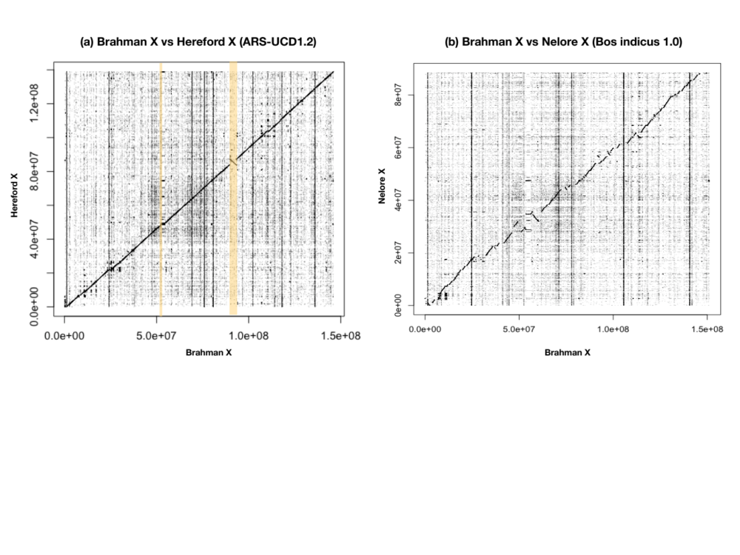
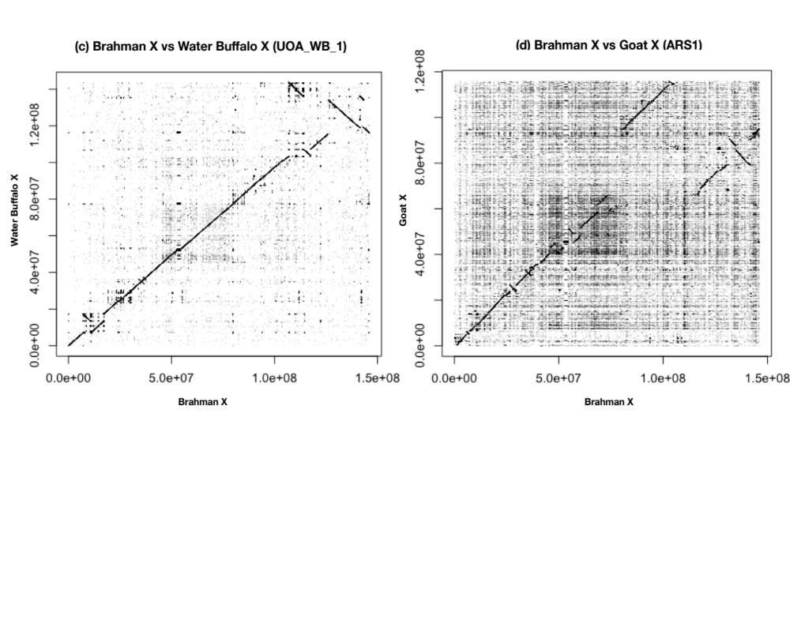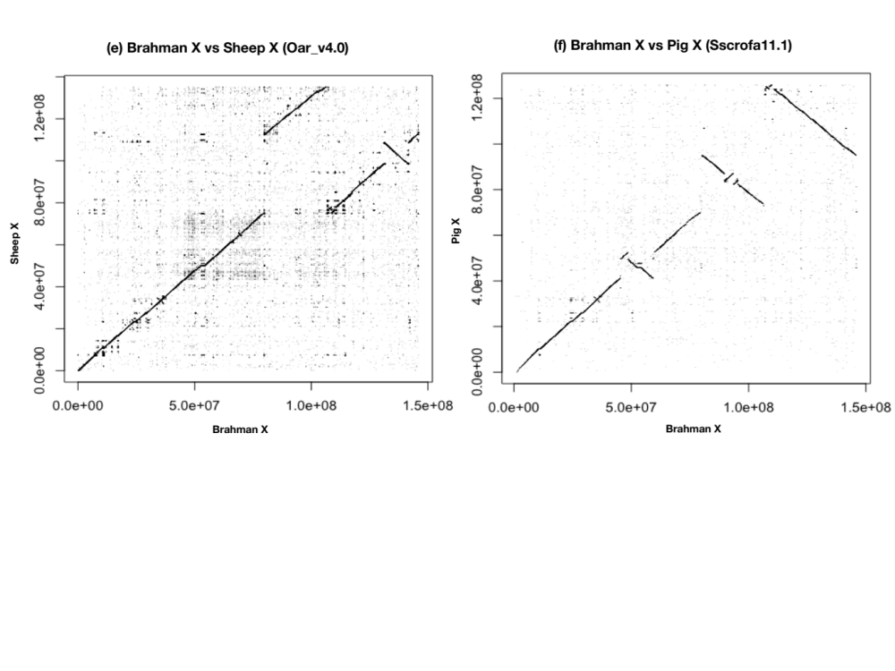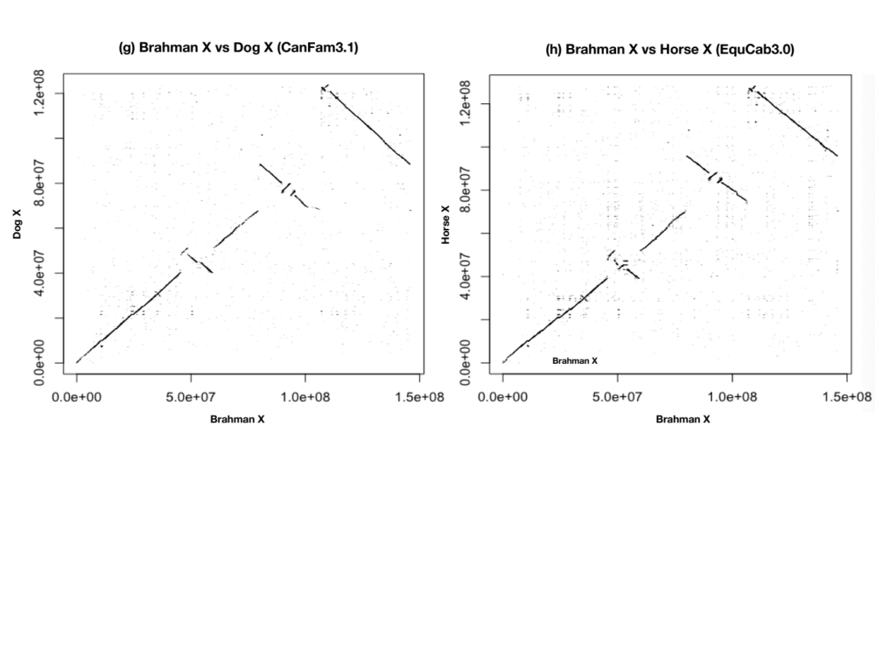
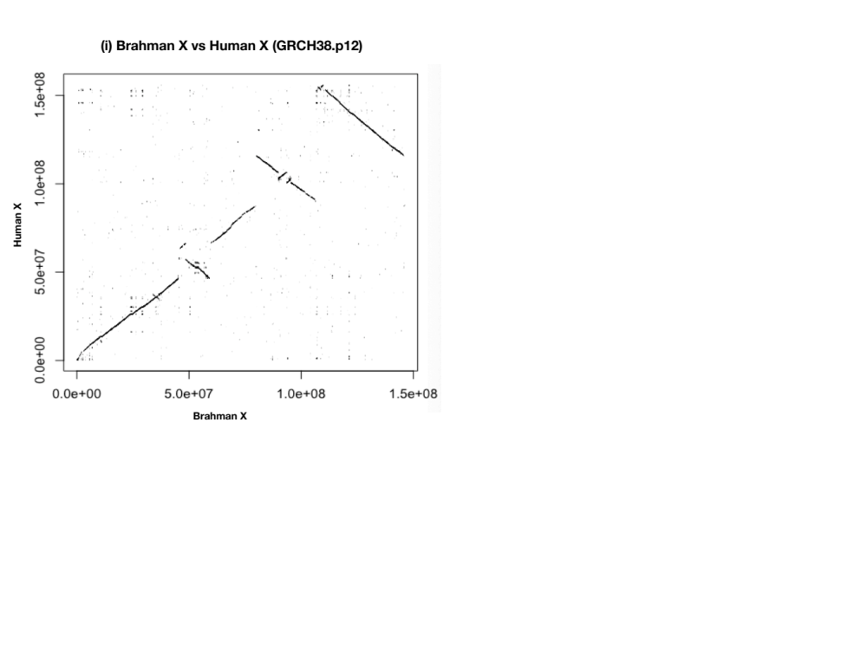

Supplementary Figure 2: Alignment of the Angus cattle Y against other mammalian Y chromosomes
The Angus Y chromosome is on the x-axes and the Y chromosomes from other species on the y-axes. Panels are a) Cattle (Hereford) Y from Btau 5.0.1 assembly. b) Human Y from GRCH38.p12 assembly. c) Horse Y from eMSYv3.1 assembly. d) Pig Y from Sscrofa11.1 assembly.
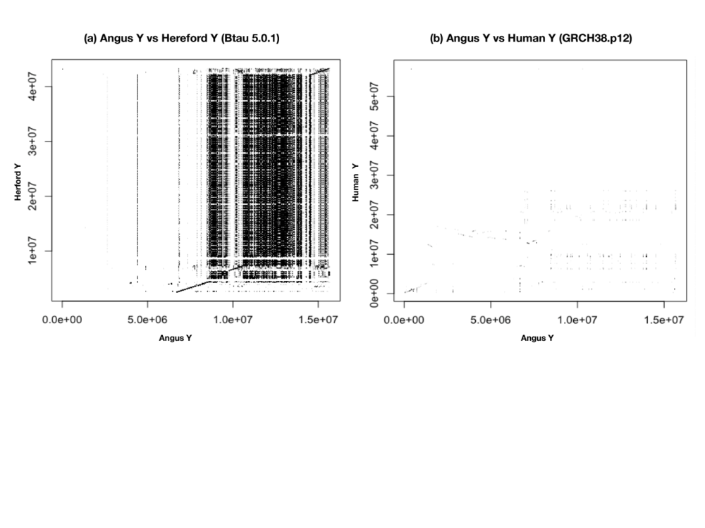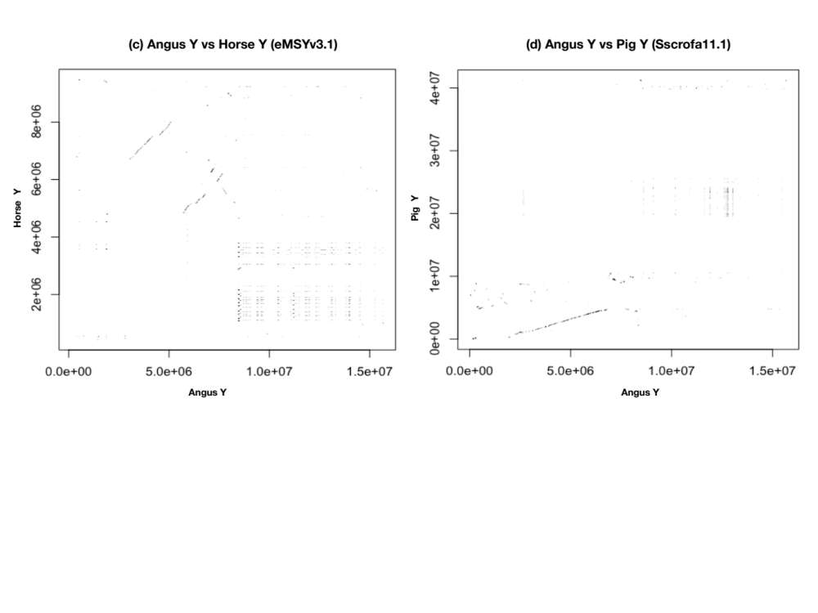

Supplementary Table 1: Summary of X and Y chromosome protein-coding genes

X Genes | Total | Single copy | Multi-copy
X-specific | 936 | 936
PAR | 31 | 29 | 2
X-Y paired outside PAR | 16 | 16 | 0
Total genes | 983 | 981 | 2
Total transcripts | 988 | 981 | 7
Y Genes | Total | Single copy | Multi-copy
Y-specific | 4 | 0 | 4
PAR | 31 | 29 | 2
X-Y paired outside PAR | 16 | 14 | 2
Total genes | 51 | 43 | 6
Total copies | 153 | 43 | 113

A total of 983 genes were annotated on the X chromosome by lift over from three cattle assemblies (ARS-UCD1.2, Bos indicus 1.0 and Btau 5.0.1). These included 936 X-specific single/multiple copy genes, 31 PAR genes and 16 X-Y paired genes. Lift over of Y chromosome annotated genes from previous cattle Y chromosome sequences[6] identified a total of 51 genes including 31 PAR genes, 16 X-Y paired genes and four Y-specific genes without X-homologues. Total number copies on Y including PAR genes are 153. These genes were used as input for Exonerate v2.4.0 to search the Brahman X and Angus Y chromosomes.

Supplemental Table 2: List of PAR genes missing in the current Hereford, sheep, goat and pig assemblies

PAR genes | Hereford |  | Sheep |  | Goat |  | Pig
PAR genes | Chr | Accession version | Chr | Accession version | Chr | Accession version | Chr | Accession version
PLCXD1 | Chr1 | NM_001105044.1 | ChrUn | XM_004022871.2 | ChrUn | XM_018044435.1 | - | -
GTPBP6 | Chr1 | XM_024995411.1 | ChrUn | XM_012107966.1 | ChrUn | XM_018044432.1 | - | -
PPP2R3B | Chr1 | XM_024995403.1 | ChrUn | XM_012107967.1 | ChrUn | XM_018044433.1 | ChrUn | XM_021081364.1
SHOX | Chr2 | NM_001191546.2 | - | - | ChrUn | XM_018045110.1 | ChrUn | XM_021081396.1
CRLF2 | Chr29 | XM_024987475.1 |  |  | ChrUn | XM_005701362.3 | ChrUn | XM_021081383.1
CSF2RA | Chr3 | XM_024990295.1 |  |  | ChrUn | XM_005701352.3 | ChrUn | XM_021081383.1
IL3RA | Chr3 | XM_024990300.1 |  |  | ChrUn | XM_018044557.1 | ChrUn | XR_002341032.1
SLC25A6 | Chr26 | NM_174660.2 |  |  | ChrUn | XM_018044555.1 | ChrUn | NM_214418.2
ASMTL | Chr26 | NM_001035058.1 |  |  | ChrUn | XM_018044443.1 | ChrUn | XM_021081390.1
P2RY8 | Chr3 | XM_005228542.3 |  |  | ChrUn | XM_013976840.2 | ChrUn | XM_021081386.1
AKAP17A | Chr3 | XM_024990316.1 |  |  | ChrUn | XM_018044444.1 | ChrUn | XM_021081363.1
ASMT | Chr1 | NM_177493.2 |  |  | ChrUn | NM_001285598.1 | ChrUn | XM_021081386.1
DHRSX |  |  |  |  | ChrUn | XM_018044442.1 | ChrY | XM_021080887.1
ZBED1 |  |  |  |  | ChrUn | XM_018044439.1 | ChrUn | XM_021082454.1
CD99 |  |  |  |  |  |  | ChrUn | XR_002340897.1
XG
GYG2
ARSD
ARSE
ARSH |  |  |  |  |  |  | - | -

The PAR genes missing from the cattle (Hereford) assembly were found on five autosomes (chromosome 1,2,3,26, 29). Missing PAR genes in the in sheep, goat and pig assemblies were found either in unplaced scaffolds or as follows: sheep SHOX and pig GTPBP6, PPP2R3B and ARSH were not found in their current X chromosome assembly. IL3RA and CD99 are among the non-coding RNA in the current pig assembly.

Supplementary References

1. Jann OC, Aerts J, Jones M, Hastings N, Law A, McKay S, Marques E, Prasad A, Yu J, Moore SS et al: A second generation radiation hybrid map to aid the assembly of the bovine genome sequence. BMC Genomics 2006, 7:283.
2. Ihara N, Takasuga A, Mizoshita K, Takeda H, Sugimoto M, Mizoguchi Y, Hirano T, Itoh T, Watanabe T, Reed KM et al: A comprehensive genetic map of the cattle genome based on 3802 microsatellites. Genome Res 2004, 14(10A):1987-1998.
3. Itoh T, Watanabe T, Ihara N, Mariani P, Beattie CW, Sugimoto Y, Takasuga A: A comprehensive radiation hybrid map of the bovine genome comprising 5593 loci. Genomics 2005, 85(4):413-424.
4. Camacho C, Coulouris G, Avagyan V, Ma N, Papadopoulos J, Bealer K, Madden TL: BLAST+: architecture and applications. BMC Bioinformatics 2009, 10:421.
5. English AC, Richards S, Han Y, Wang M, Vee V, Qu J, Qin X, Muzny DM, Reid JG, Worley KC et al: Mind the gap: upgrading genomes with Pacific Biosciences RS long-read sequencing technology. PLoS One 2012, 7(11):e47768.
6. Chang TC, Yang Y, Retzel EF, Liu WS: Male-specific region of the bovine Y chromosome is gene rich with a high transcriptomic activity in testis development. Proc Natl Acad Sci U S A 2013, 110(30):12373-12378.
7. Liu WS, Mariani P, Beattie CW, Alexander LJ, Ponce De Leon FA: A radiation hybrid map for the bovine Y Chromosome. Mamm Genome 2002, 13(6):320-326.
8. Stafuzza NB, Abbassi H, Grant JR, Rodrigues-Filho EA, Ianella P, Kadri SM, Amarante MV, Stohard P, Womack JE, de Leon FA et al: Comparative RH maps of the river buffalo and bovine Y chromosomes. Cytogenet Genome Res 2009, 126(1-2):132-138.
9. Janecka JE, Davis BW, Ghosh S, Paria N, Das PJ, Orlando L, Schubert M, Nielsen MK, Stout TAE, Brashear W et al: Horse Y chromosome assembly displays unique evolutionary features and putative stallion fertility genes. Nat Commun 2018, 9(1):2945.
10. Bao W, Kojima KK, Kohany O: Repbase Update, a database of repetitive elements in eukaryotic genomes. Mob DNA 2015, 6:11.
11. Harris RS: Improved pairwise alignment of genomic DNA. PhD Thesis, The Pennsylvania State University 2007.
12. Slater GS, Birney E: Automated generation of heuristics for biological sequence comparison. BMC Bioinformatics 2005, 6:31.

