Supplementary Information
Molecular, hierarchical and acoustical cues promote mesenchymal stromal cell differentiation toward tympanic membrane regeneration
Shivesh Anand¹, Claudia Del Toro Runzer², Elizabeth Rosado Balmayor^{2,3}, Martijn van Griensven², Lorenzo Moroni¹, Carlos Mota^{1,*}
¹ Department of Complex Tissue Regeneration, MERLN Institute for Technology-Inspired Regenerative Medicine, Maastricht University, Maastricht, 6229 ER, The Netherlands
² Department of Cell Biology-Inspired Tissue Engineering, MERLN Institute for Technology-Inspired Regenerative Medicine, Maastricht University, 6229 ER Maastricht, The Netherlands
³ Department of Experimental Orthopaedics and Trauma Surgery, RWTH Aachen University Hospital, 52074 Aachen, Germany
* Corresponding author: c.mota@maastrichtuniversity.nl
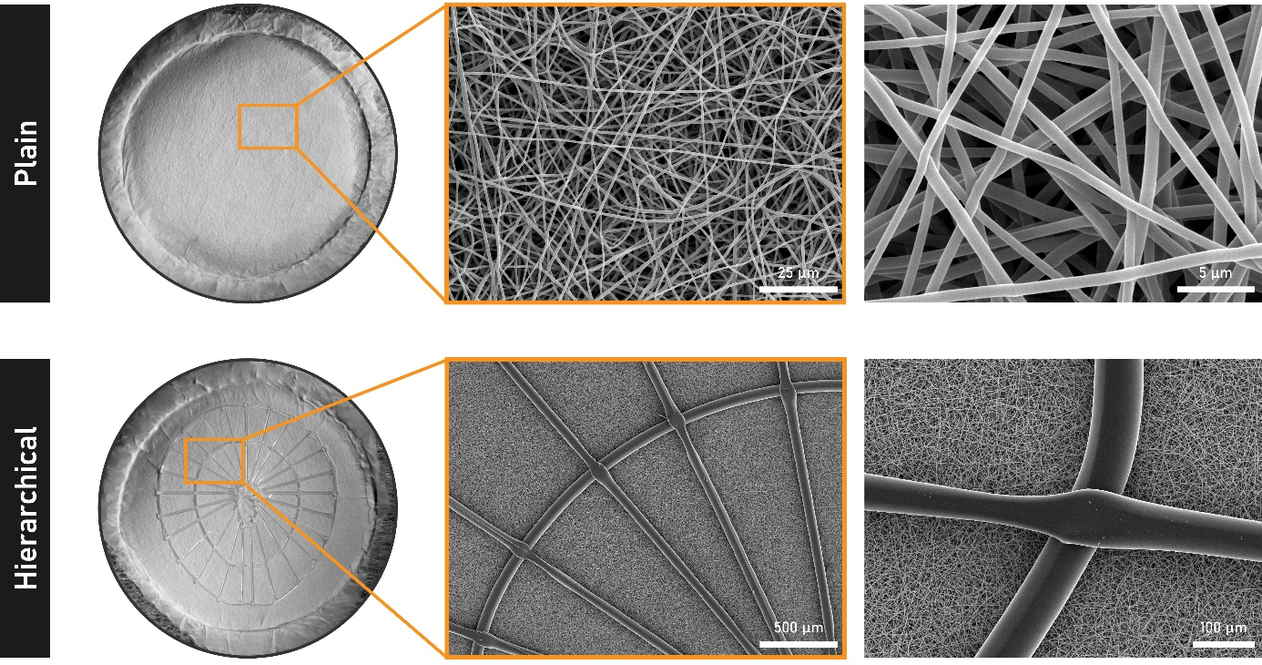
Figure S1. Qualitative assessment of the biofabricated TM scaffolds: plain (ES alone) and hierarchical (ES + FDM). Full constructs were imaged under a stereomicroscope (outer diameter: 15 mm). High magnification micrographs were captured with SEM (scalebar: indicated on each image). The diameter of the electrospun nanofibers was computed to be 715 ± 103 nm (n = 90), and that of the additive-manufactured filaments to be 50.87 ± 5.45 µm (n = 15).
Figure S2. Design and optimization of acoustic bioreactors. (A) Images of the piezoelectric transducer and the acrylic spacers. (B) Detected output voltage (gray) in response to the acoustical waves (red) for h_{SP} = 5 mm. The highlighted blue box presents an example of amplified vibrations at certain frequencies, which are known as the resonant frequencies.

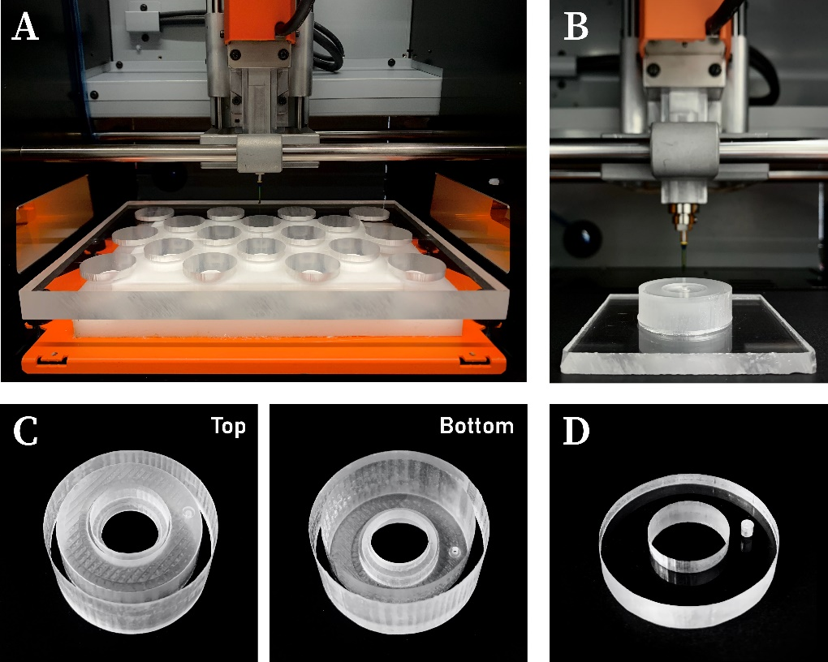
Figure S3. Production of acoustic bioreactors. (A) Mass production of 18 well inserts during each batch of milling. (B) Individual creation of the tweezer hole with a 1 mm bit. (C) Final bioreactor: top and bottom view. (D) Control well inserts for standard cell culture.
Figure S4. Qualitative characterization of sound-induced vibrations in stimulated TM scaffolds. (A) Schematic illustration of the stereomicroscope test bench. (B) Individual frames extracted from the recorded video; the yellow circle marks the region of interest for all the intensity measurements. (C) Graphical representation of the quantified intensity values between the investigated frequency ranges: (Y+X1) to (Y+X2).
Figure S5. Quantitative characterization of sound-induced vibrations in stimulated TM scaffolds. (A) Assembled test bench for: (i) air-air measurements, (ii) air-liquid measurements. OSC: oscilloscope, WFG: waveform generator. (B) COMSOL-computed displacements for the first 50 modes of vibration of plain and hierarchical TM scaffolds when acoustically stimulated at air-air and air-liquid interfaces. The dampening of scaffold vibrations upon transitioning from an air-air interface to an air-liquid interface was estimated with respect to their average displacement during the first 50 modes. (C) Vibrational characterizations conducted with CL-P030 / CL-3000 Series displacement sensor. The amplitude of scaffold oscillation at the air-liquid interface was determined to be below the detection limit of the test bench. The dashed lines mark the extent of the background noise during the displacement measurements with sound.
Figure S6. In vitro validation of acoustic bioreactors. (A) Experimental setup consisting of the waveform generator, oscilloscope, and a dedicated incubator for culturing the dynamic TM scaffolds. (B) Phalloidin-labeled F-actin (yellow), DAPI-labeled nuclei (cyan), and CNA-35-labeled extracellular collagen (magenta) for MSCs cultured on electrospun scaffolds under distinct conditions (control, static and dynamic) for a period of 4 days. (C) Cell metabolic activity of the control, static, and dynamic samples on day 4. (D) Demonstration of monolayer formation over the TM constructs, prior to initiating the differentiation protocol.
Figure S7. Protein secretion by MSCs. Enzyme-linked immunosorbent assay (ELISA) quantifications of collagen type I and type II secreted by the MSCs after 5 weeks of culture on TM scaffolds under control, static, and dynamic conditions (n = 6).
Table S1. Primer sequence of the investigated genes
Genes | Company | Sense | Sequence (5’ 3’)
TUBB2A | Eurofins | Forward | TGCCTAGGCGCATTTCAGTGC
TUBB2A | Eurofins | Reverse | TGAGGTGACTGGCGGGGTGT
COL1A1 | Eurofins | Forward | AGCGGACGCTAACCCCCTCC
COL1A1 | Eurofins | Reverse | CAGACGGGACAGCACTCGCC
COL2A1 | Eurofins | Forward | GGCGGATTTCTTCTAGTGGG
COL2A1 | Eurofins | Reverse | GCAGCAGCAGGGGATGAATA
FGF7 | Sigma | Forward | TCCTGCCAACTTTGCTCTACA
FGF7 | Sigma | Reverse | CAGGGCTGGAACAGTTCACAT
FGF10 | Sigma | Forward | ATCGGCAGGCACCACTAAAA
FGF10 | Sigma | Reverse | ACAAAACCCAAGGGAGGTGG

