Extended figures
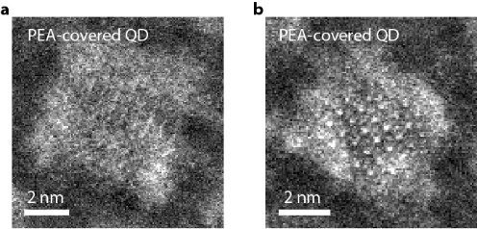
Extended Figure 1. STEM images of strongly confined PEA-covered CsPbBr₃ QDs after solid-state ligand exchange. a, b, PEA-covered QDs maintained their cubical shape after solid-state ligands exchange using PEABr.

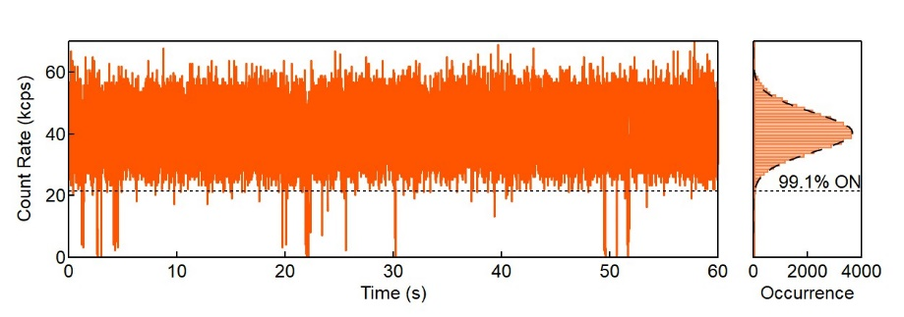
Extended Figure 2. PL blinking trace and intensity distribution histogram of the PEA-covered QD shown in Fig. 2 with a 1 ms bin time. The ON fraction time remains high (> 99%), and the PL intensity distribution remains shot-noise limited.

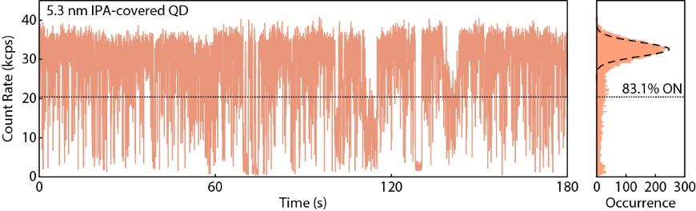
Extended Figure 3. PL blinking trace and intensity distribution histogram of an IPA-covered CsPbBr₃ QD. Despite exhibiting suppressed blinking, the OFF time fraction of IPA-covered QD is higher than that of PEA-covered QDs.

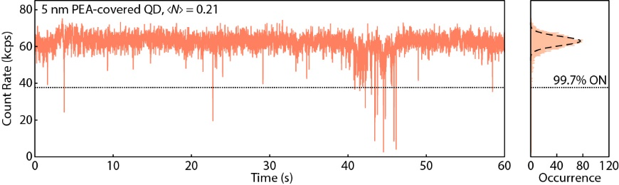
Extended Figure 4. PEA-covered QD under intense excitation. PL blinking trace and intensity distribution histogram of a PEA-covered CsPbBr₃ QD (~ 5 nm), excited by a 405 nm laser running at pulsed mode with an average excitation number of 0.21 and a repetition rate of 5 MHz.

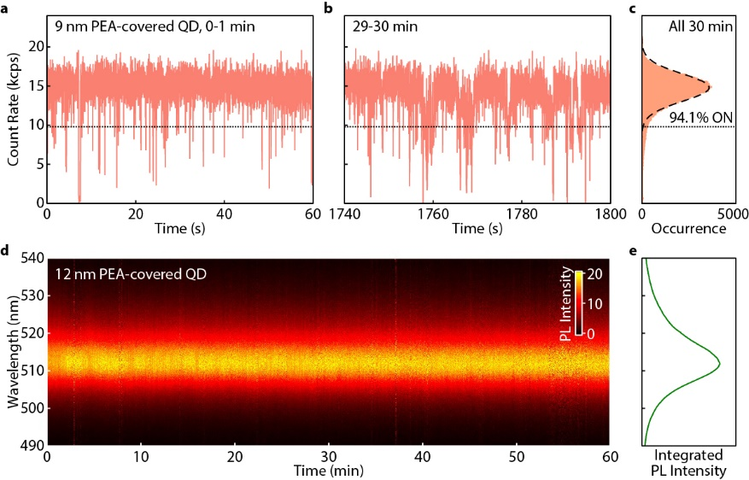
Extended Figure 5. Suppressed blinking and spectral diffusion of single weakly confined PEA-covered CsPbBr₃ QD. a, b, PL blinking traces of a weakly confined PEA-covered CsPbBr₃ QD (9 nm) in a 1-miunte window at a the first and b the last minute of a 30-minute continuous measurement. c, PL intensity distribution histogram built using the entire 30-minute measurements. d, Normalized time-dependent PL spectra of a weakly confined PEA-covered CsPbBr₃ QD (12 nm) measured continuously for 1 h. No spectral diffusion or shifting are observed. e, Integrated PL spectrum from d. Its FWHM remains small (69 ± 1 meV) and comparable to that (69 ± 2 meV) of the PL spectrum measured in a short time window (60 s), suggesting the PL of the QD was stable.

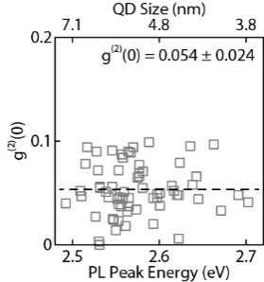
Extended Figure 6. Summary of g⁽²⁾(0) extracted from 60 non-blinking strongly confined PEA-covered CsPbBr₃ QDs. The dashed line marks the average g⁽²⁾(0) value of 0.054.

