Supplementary Information for

Towards non-blinking perovskite quantum dots
Chenjia Mi, Gavin C. Gee, Chance W. Lander, Matthew L. Atteberry, Novruz G. Akhmedov, Lamia Hidayatova, Jesse D. DiCenso, Wai Tak Yip, Yihan Shao, Yitong Dong*

Table of Contents:
Section 1: DFT modelling 3
Supplementary Note 1: Surface ligand configurations used in the DFT calculation 3
Supplementary Fig. 1 | The CsPbBr₃ slabs with a single bonded ligand. 3
Supplementary Fig. 2 | The CsPbBr₃ slab with its surface fully covered by PEA. 3
Supplementary Fig. 3 | The CsPbBr₃ slab with its surface fully covered by truncated DDA. 3
Supplementary Fig. 4 | Schemes of the surface ligand configurations for the PEA-covered CsPbBr₃ slabs. 4
Supplementary Fig. 5 | Schemes of surface ligand configurations for the truncated DDA-covered CsPbBr₃ slabs. 4
Supplementary Note 2: Entropy considerations 5
Supplementary Note 3: Intermolecular interactions 5
Section 2: Additional QD characterizations 6
Supplementary Fig. 6 | Absorption spectra and STEM images of CsPbBr₃ QDs. 6
Supplementary Fig. 7 | ¹H NMR spectra of CsPbBr₃ QDs after solution ligand exchange using PEABr. 6
Supplementary Fig. 8 | ¹H NMR spectra of CsPbBr₃ QDs after solution ligand exchange using a mixture of PEABr and MPEABr. 7
Supplementary Fig. 9 | 2D NOESY of CsPbBr₃ QDs after solution ligand exchange using a mixture of PEABr and MPEABr. 7
Supplementary Fig. 10 | XRD pattern of solid-state ligand exchanged CsPbBr₃ QDs. 8
Supplementary Fig. 11 | ¹H NMR spectra of digested CsPbBr₃ QDs after solid-state ligand exchange using PEABr. 8
Section 3: Single QD PL data analyses 9
Supplementary Note 4: Mandel Q parameter 9
Supplementary Note 5: Average excitation number 9
Section 4: Additional single QD spectroscopic measurements 10
Supplementary Fig. 12 | PL spectra diffusion in a DDA-covered CsPbBr₃ QD. 10
Supplementary Fig. 13 | Blinking trace of a PEA-covered QD after storing it at ambient conditions for about one month. 10
Supplementary Fig. 14 | Additional single QD spectroscopic measurements. 11
Supplementary Fig. 15 | Reported g⁽²⁾(0) values of single CsPbBr₃ QDs. 12
Supplementary Fig. 16 | Reported single CsPbBr₃ QD PL linewidths. 12
Supplementary Fig. 17 | Spectral independent PL decay dynamics. 12
Section 5: Instrumentation 13
Supplementary Fig. 18 | Schematic illustrations of the single particle microscope setup. 13
References 14

Section 1: DFT modelling

Supplementary Note 1: Surface ligand configurations used in the DFT calculation
The energy of PEA or truncated DDA covered 2×2×1 (100) CsPbBr₃ slabs were calculated as a function of ligand numbers. The ligand binding energies were estimated by putting only one ligand on the slab (Supplementary Fig. 1, all other 7 sites are filled with Cs⁺ to maintain charge neutrality). The resultant binding energy of 2.37 eV (for DDA) and 2.00 eV (for PEA) are comparable to that of similar compounds reported in other works.^{1,2}

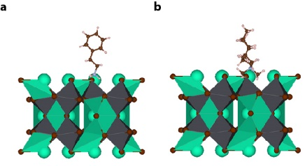
Supplementary Fig. 1 | The CsPbBr₃ slabs with a single bonded ligand. a, PEA and b, truncated DDA. The other surface sites were filled by Cs⁺.

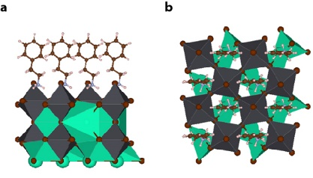
Supplementary Fig. 2 | The CsPbBr₃ slab with its surface fully covered by PEA. a, Side-view. b, Top-view.

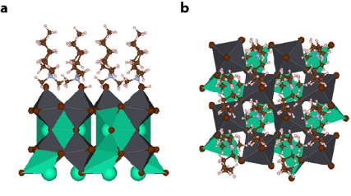
Supplementary Fig. 3 | The CsPbBr₃ slab with its surface fully covered by truncated DDA. a, Side-view. b, Top-view.

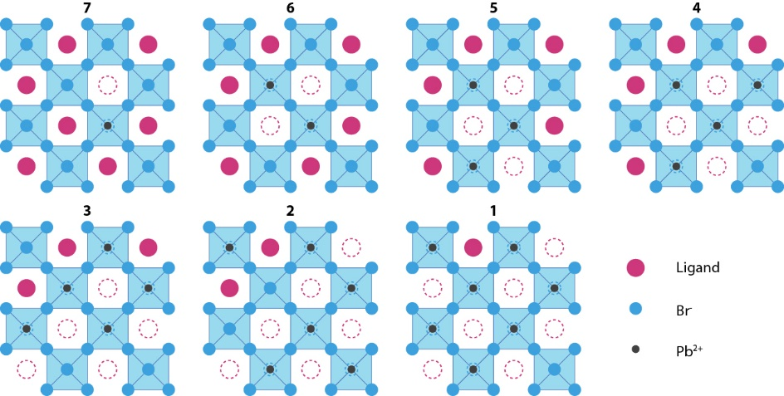
Supplementary Fig. 4 | Schemes of the surface ligand configurations for the PEA-covered CsPbBr₃ slabs. Dashed hollow circles represent vacant sites. PEA⁺ and Br⁻ was removed together when reducing ligand coverage.

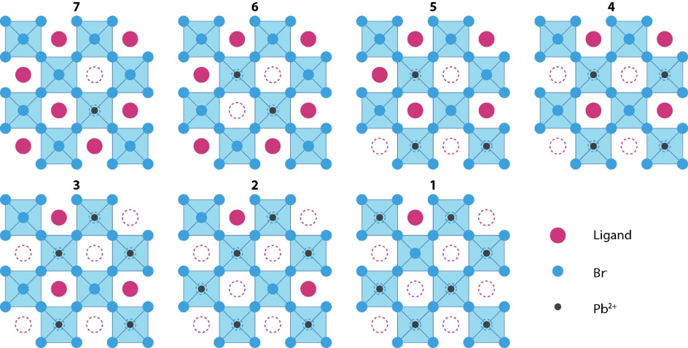
Supplementary Fig. 5 | Schemes of surface ligand configurations for the truncated DDA-covered CsPbBr₃ slabs. Dashed hollow circles represent vacant sites. DDA⁺ and Br⁻ were removed together when reducing ligand coverage.

Supplementary Note 2: Entropy considerations
The above calculations yielded surface enthalpies. Entropy contributions from the structurally distinct DDA and PEA should be included for calculating the free energy of the system. The entropy difference between bound (solid-state) and free (gas-phase) ligands were calculated with the assumptions that the chemical bond vibration modes do not change significantly. Entropies were assumed to be negligible in the solid states. The gas-phase ligand entropies were calculated using the Q-Chem 6.1 software package.³ At room temperature, the total entropies for a gas-phase PEA and DDA (full length) were 0.95 eV and 1.05 eV, respectively.

Supplementary Note 3: Intermolecular interactions
The distance between two closest carbon atoms in different PEAs on a fully passivated CsPbBr₃ surface is 4.41 Å. According to reported potential energy curves for benzene dimers, π-π interactions between phenyl rings are attractive when they are spaced by 4.41 Å.⁴ The intermolecular interaction between two PEAs was also calculated with wB97x-D/6-311++G** basis set to be – 0.08 eV. This suggests that the intermolecular interaction is attractive.
On the contrary, in the case that the CsPbBr₃ surface is fully covered by DDAs (Supplementary Fig. 3), the distance between two closest carbon atoms from different DDAs is less than 4 Å. According to the reported energy curves, the inter-ligand tail interaction would be repulsive.⁵ Our calculation showed that the intermolecular interaction between a ligand tail of DDA and all three neighbour carbon chains are repulsive, with an average interaction energy of 0.09 eV. This suggests that DDAs on a fully covered CsPbBr₃ surface suffer from steric repulsions, agreeing with previous studies.¹

Section 2: Additional QD characterizations

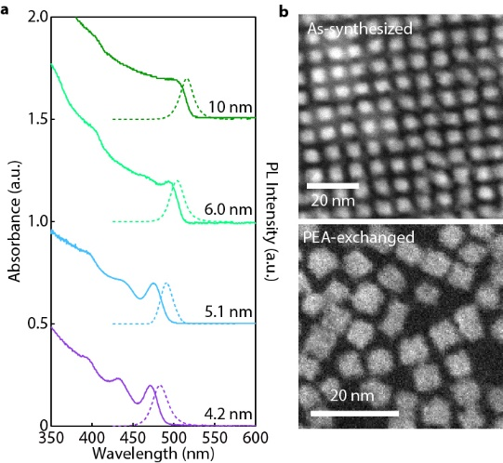
Supplementary Fig. 6 | Absorption spectra and STEM images of CsPbBr₃ QDs. a, Absorption (solid curves) and PL (dotted curves) spectra of the CsPbBr₃ QDs of various sizes. b, HAADF-STEM images of as-synthesized CsPbBr₃ QDs (top) and PEA-exchanged QDs (bottom). Both the as-synthesized QDs and PEA-covered QDs are cubical, suggesting that the solid-state ligand exchange did not change the shape of QDs.

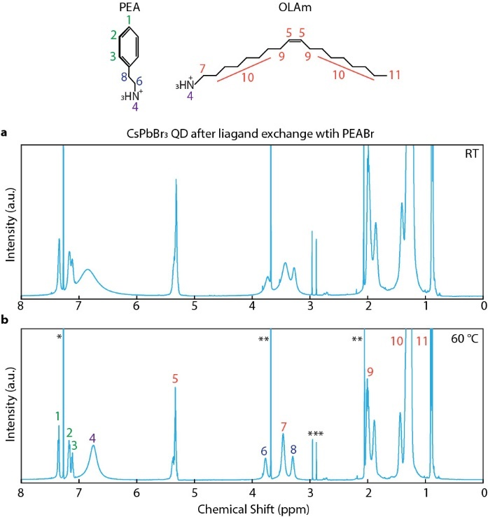
Supplementary Fig. 7 | ¹H NMR spectra of CsPbBr₃ QDs after solution ligand exchange using PEABr. a, b, ¹H NMR spectra of QDs in CDCl₃ at a, room temperature (RT) and b, 60 ˚C.

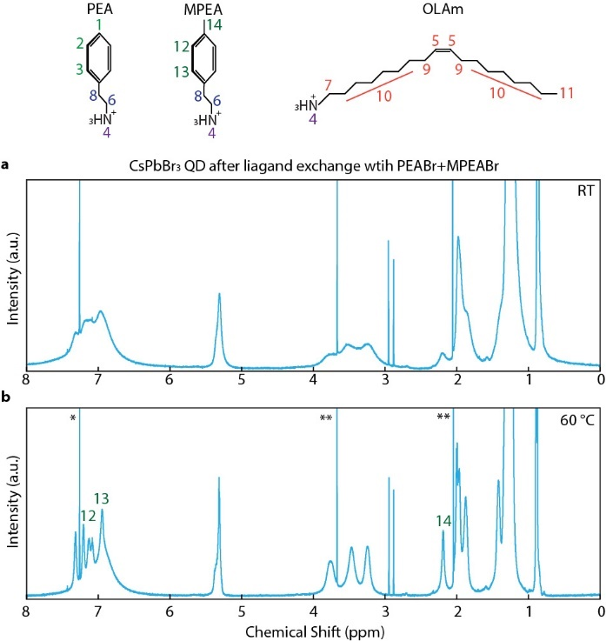
Supplementary Fig. 8 | ¹H NMR spectra of CsPbBr₃ QDs after solution ligand exchange using a mixture of PEABr and MPEABr. a, b, ¹H NMR spectra of QDs in CDCl₃ a, at room temperature (RT) and b, at 60 ˚C.
NMR peak assignments: 1. p-phenyl (1H); 2. m-phenyl (2H); 3. o-phenyl (2H); 6. α-methylene (2H); 8. β-methylene (2H); 5. olefine (2H); 7. α-methylene (2H); 9. allylic methylene (4H); 10. aliphatic methylene (28H); 11. methyl (3H); 12. m-phenyl (2H); 13. o-phenyl (2H); 14. methyl (3H); the chemical shifts of α- and β-methylene protons are similar to that of PEABr; and 4. ammonium. All the sharp peaks labelled with *(chloroform), **(methyl acetate) and ***(N,N-dimethylformamide) are solvent residues introduced during the ligand exchange.
The broadening of the ¹H NMR peaks at room temperature suggests that the PEA⁺ moieties are bound to the QD surface. To better resolve the phenyl protons in PEA and MPEA, the samples were heated to 60 °C. The QD samples showed no signs of degradation after heating.

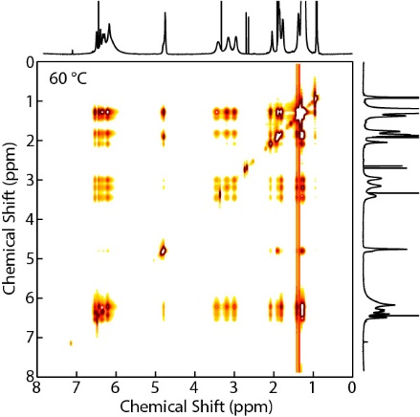
Supplementary Fig. 9 | 2D NOESY of CsPbBr₃ QDs after solution ligand exchange using a mixture of PEABr and MPEABr. The spectrum was collected at 60 °C.

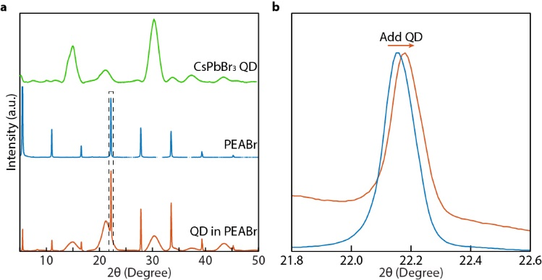
Supplementary Fig. 10 | XRD pattern of solid-state ligand exchanged CsPbBr₃ QDs. a, XRD patterns of pristine CsPbBr₃ QDs (green), pristine PEABr thin-film (blue) and PEABr thin-film with high concentrations of solid-state ligand exchanged QDs (red). b, When QDs are added, the PEABr peaks exhibit a small shift towards a higher angle, indicating potential intermolecular spacing change induced by forming epitaxial interfaces with CsPbBr₃ QDs.

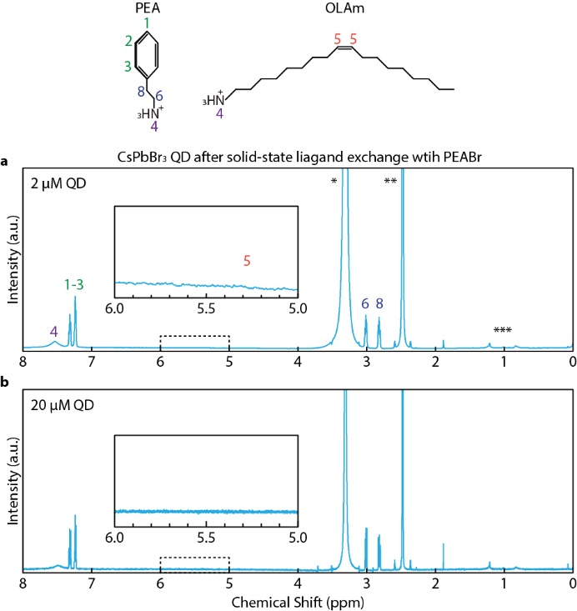
Supplementary Fig. 11 | ¹H NMR spectra of digested CsPbBr₃ QDs after solid-state ligand exchange using PEABr. a, b, The solid-state ligand exchanges were using a, 2 μM and b, 20 μM of QD colloids, which are ~ 10⁴× and ~ 10⁵× more concentrated than that used for single QD sample preparations, respectively. The sample film was digested using deuterated dimethyl sulfoxide (DMSO-d₆) for ¹H NMR measurements. The insets show zoom-in views of the NMR spectra between 5 and 6 ppm, where the olefin proton signals of oleylammonium is expected. No olefin proton signal is observed even with the significantly higher QD concentration used in this experiment. Peaks labelled with * (water), ** (DMSO) and *** (octane) are solvent residues.

Section 3: Single QD PL data analyses

Supplementary Note 4: Mandel Q parameter
The distribution of the PL ON state is characterized using normalized second factorial moment minus one (Mandel Q parameter):
$$Q=\frac{〈C^{2}〉-{〈C〉}^{2}}{〈C〉}-1$$
where C is the photon counts per bin in the blinking trace and the bracket denotes the mean value over the measurement time. The Q value is zero for a Poisson distribution, the characteristic of a shot-noise limited PL ON state distribution. The Q typically rises above 1 if the PL ON state intensity is fluctuating (i.e. multiple emissive states are mixed).⁶

Supplementary Note 5: Average excitation number
For single QDs excited using a pulsed mode laser, the average excitation number per pulse, $〈N〉$, is calculated using the following equation:
$$〈N〉=\frac{fP}{Rπr^{2}}\frac{λ}{hc}σ$$
where P is the average laser power, R is the pulse repetition rate (typically 4 – 5 MHz), and r is the Gaussian beam spot radius (140 ~ 180 nm), f is a beam position factor with the value of 2 (assuming QD is at the centre of the Gaussian laser beam spot), λ is the laser wavelength (405 nm), h is Planck’s constant, c is the speed of light, and σ is the optical cross section of the QD using literature values.⁷

Section 4: Additional single QD spectroscopic measurements

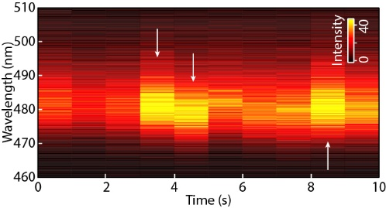
Supplementary Fig. 12 | PL spectra diffusion in a DDA-covered CsPbBr₃ QD. The integration time of PL spectrum collection is 1 s. The arrows indicates when spectral diffusion happens.

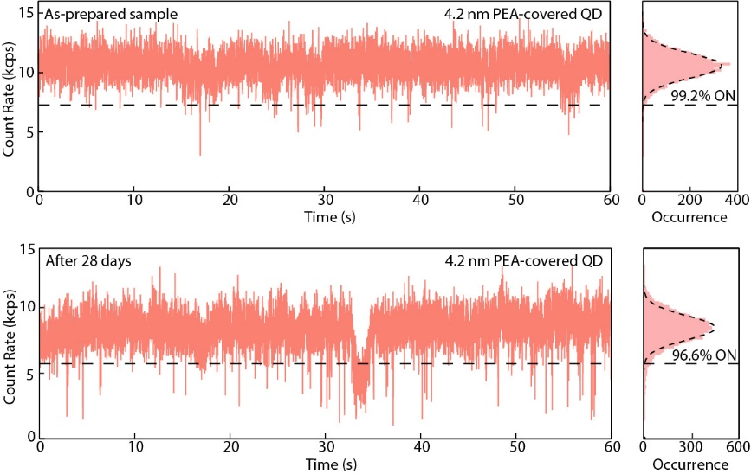
Supplementary Fig. 13 | Blinking trace of a PEA-covered QD after storing it at ambient conditions for about one month. The PEA-covered QD remained nearly non-blinking with a > 96% ON time fraction.

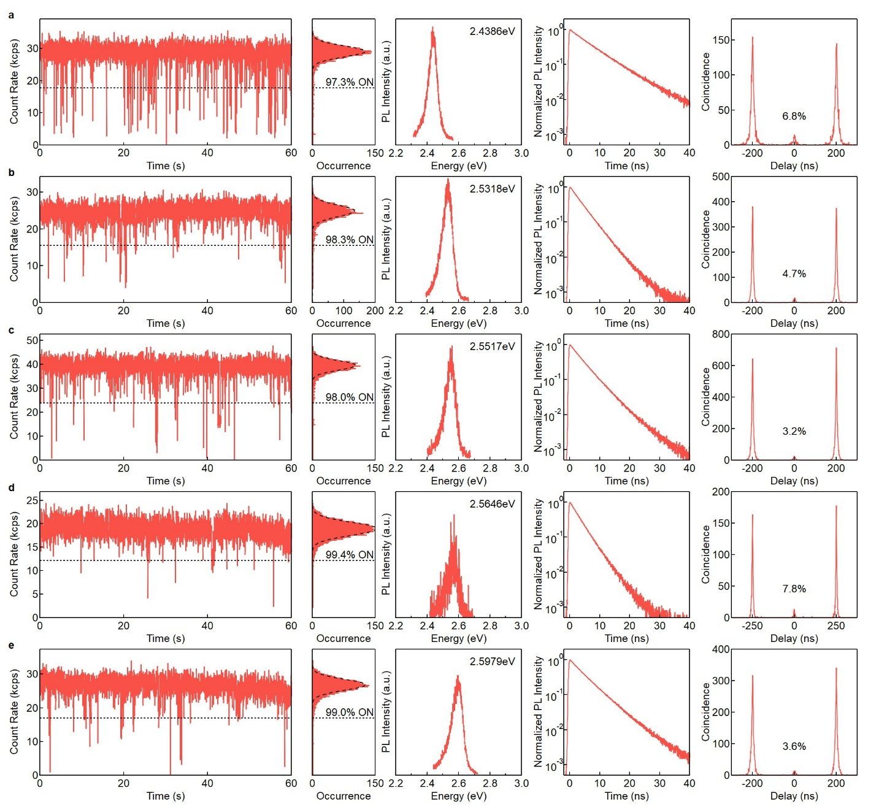
Supplementary Fig. 14 | Additional single QD spectroscopic measurements. a – e, PL blinking traces (first column), PL intensity distribution histograms (second column), PL spectra (third column), time-resolved PL intensity decay traces (fourth column), and second-order correlation plots (fifth column) of different PEA-covered CsPbBr₃ QDs.

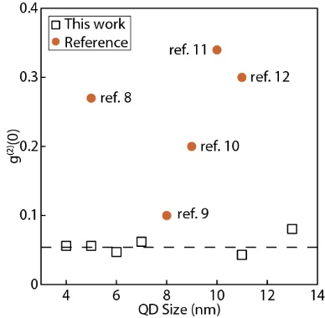
Supplementary Fig. 15 | Reported g⁽²⁾(0) values of single CsPbBr₃ QDs.^{8–12} Each open square represents a group of QDs with similar size measured in this work. The dashed line is a visual guide that marks the average g⁽²⁾(0) value of 0.054 for our strongly confined QDs (< 7 nm).

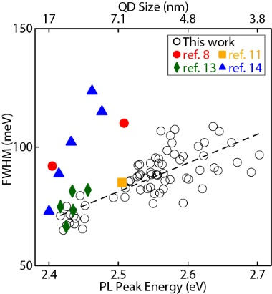
Supplementary Fig. 16 | Reported single CsPbBr₃ QD PL linewidths.^{8,11,13,14} The full-width half-maximum (FWHM) values are plotted for comparison. The dashed line is a linear fit of the linewidths measured in this work.

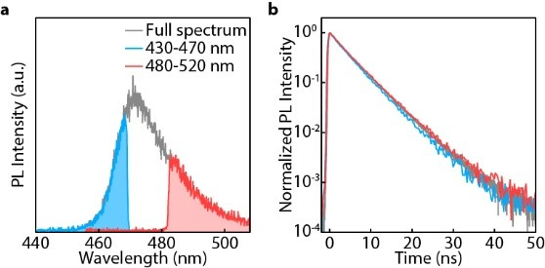
Supplementary Fig. 17 | Spectral independent PL decay dynamics. a, PL spectrum of a PEA-covered single CsPbBr₃ QD. b, Time-resolved PL intensity decay measured at different spectral windows (color-coded) selected using bandpass filters.

Section 5: Instrumentation

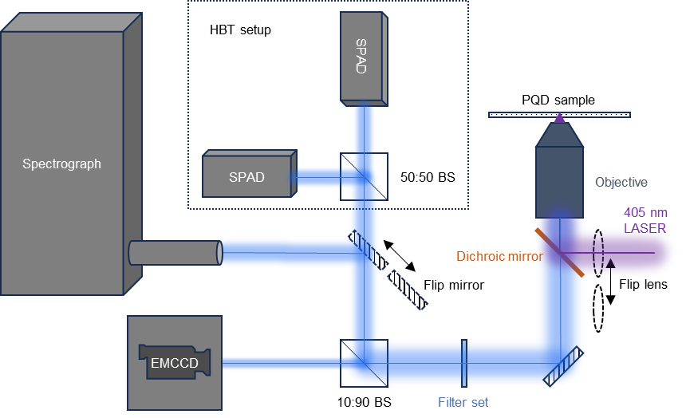
Supplementary Fig. 18 | Schematic illustrations of the single particle microscope setup. Stages, mirrors and focusing lenses are omitted. The filter set consists of a 405 nm notch filter, a 425 nm long pass filter, and a selected bandpass filter when needed.
The 405 nm laser (pulsed/cw) was attenuated with a set of reflective/absorptive neutral density filters, and then sent to a single-mode optical fibre. Only the TEM00 mode was allowed to pass through the fibre and then collimated. The average laser power is typically measured after this point and calibrated using a microscope slide power meter sensor head (Thorlabs, S171C) measuring after the objective. In confocal mode, the collimated TEM00 mode laser was sent through the objective and focused to a Gaussian spot on the sample plane. The spot diameter (where the irradiance > 1/e² of the maximum) is measured to be 280 ~ 360 nm using a fluorescence standard. Due to the QD size (a few nm) being significantly smaller than the beam size, the QD is considered a dimensionless point when calculating the power density of the focused beam. At the peak of the Gaussian beam profile, the power density is twice of the average power density of the entire beam spot area. When imaging QDs in wide-field mode, the flip lens is set to intercept the beam path, de-collimating the laser beam and focusing it near the back focal plane of the objective.

References
1. Imran, M. et al. Simultaneous cationic and anionic ligand exchange for colloidally stable CsPbBr₃ nanocrystals. ACS Energy Lett. 4, 819–824 (2019).
2. Quarta, D. et al. Stable ligand coordination at the surface of colloidal CsPbBr₃ nanocrystals. J. Phys. Chem. Lett. 10, 3715–3726 (2019).
3. Epifanovsky, E. et al. Software for the frontiers of quantum chemistry: an overview of developments in the Q-Chem 5 package. J. Chem. Phys. 155, 084801 (2021).
4. Sherrill, C. D., Takatani, T. & Hohenstein, E. G. An assessment of theoretical methods for nonbonded interactions: comparison to complete basis set limit coupled-cluster potential energy curves for the benzene dimer, the methane dimer, benzene−methane, and benzene−H₂S. J. Phys. Chem. A 113, 10146–10159 (2009).
5. Bursch, M., Grimme, S. & Hansen, A. Influence of steric and dispersion interactions on the thermochemistry of crowded (fluoro)alkyl compounds. Acc. Chem. Res. 57, 153–163 (2024).
6. Malko, A. V. et al. Pump-intensity- and shell-thickness-dependent evolution of photoluminescence blinking in individual core/shell CdSe/CdS nanocrystals. Nano Lett. 11, 5213–5218 (2011).
7. Puthenpurayil, J., Cheng, O. H.-C., Qiao, T., Rossi, D. & Son, D. H. On the determination of absorption cross section of colloidal lead halide perovskite quantum dots. J. Chem. Phys. 151, 154706 (2019).
8. Boehme, S. C. et al. Strongly confined CsPbBr₃ quantum dots as quantum emitters and building blocks for rhombic superlattices. ACS Nano 17, 2089–2100 (2023).
9. Rainò, G. et al. Underestimated effect of a polymer matrix on the light emission of single CsPbBr₃ nanocrystals. Nano Lett. 19, 3648–3653 (2019).
10. Krieg, F. et al. Stable ultraconcentrated and ultradilute colloids of CsPbX₃ (X = Cl, Br) nanocrystals using natural lecithin as a capping ligand. J. Am. Chem. Soc. 141, 19839–19849 (2019).
11. Zhu, C. et al. Room-temperature, highly pure single-photon sources from all-Inorganic lead halide perovskite quantum dots. Nano Lett. 22, 3751–3760 (2022).
12. Li, B. et al. Excitons and biexciton dynamics in single CsPbBr₃ perovskite quantum dots. J. Phys. Chem. Lett. 9, 6934–6940 (2018).
13. Utzat, H. et al. Probing linewidths and biexciton quantum yields of single cesium lead halide nanocrystals in solution. Nano Lett. 17, 6838–6846 (2017).
14. Rainò, G. et al. Ultra-narrow room-temperature emission from single CsPbBr₃ perovskite quantum dots. Nat. Commun. 13, 2587 (2022).

