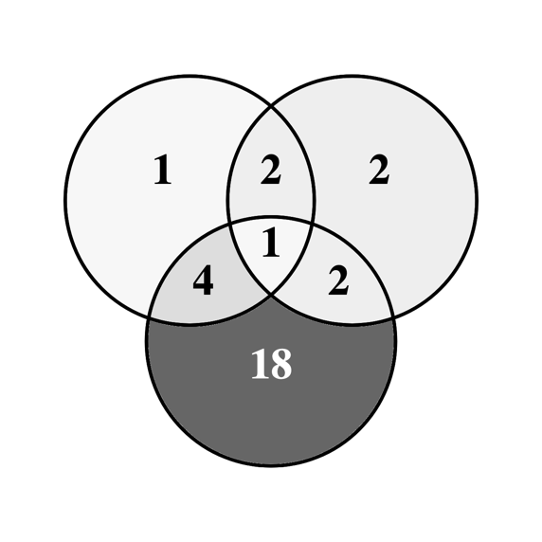
Supplemental figure 1. Adverse event distribution
Benign tumors n=25
BCC n=7
SCC n=8

Supplemental figure 2. Sex distribution

Supplemental figure 3. FA gene association

