REV3L gene variants rs1002481, rs462779, and rs465646 lead to increased susceptibility towards non-small cell lung cancer in the population of Jammu and Kashmir.
Rajeshwer Singh Jamwal¹, Nikita Mahajan¹, Gh. Rasool Bhat¹, Amrita Bhat¹, Bhanu Sharma¹, Minerva Sharma¹, Ruchi Shah², Sonali Verma³, Divya Bakshi¹, Rahul Sharma⁴, Deepak Abrol⁵, Audesh Bhat⁶*, Rakesh Kumar^{1,3}*
- School of Biotechnology, Shri Mata Vaishno Devi University, Katra, India.
Email: rsjamwal0@gmail.com, mahajannikita22@gmail.com, amritabhatt88@gmail.com, seithbhat11@gmail.com, bhanugaur91@gmail.com, Sharmamanii1322@gmail.com and divya.bakshi09@gmail.com.
- Department of Biotechnology, Kashmir University, Jammu & Kashmir, India, Email: scientistdobt@gmail.com
- Indian Council of Medical Research-Centre for Advance Research, Shri Mata Vaishno Devi University -Katra J&K, India, Email: Sonali.verma@smvdu.ac.in.
- Department of Radiotherapy, GMC Jammu. Email: drrahulsharma2002@yahoo.com
- Department of Radiotherapy, GMC Kathua. Email: deepakabrol2003@gmail.com
- Centre for Molecular Biology, Central University of Jammu, J&K, India:
- Email: audeshs2002@gmail.com.
*Corresponding Author
Dr. Audesh Bhat
Assistant Professor
Centre for Molecular Biology, Central University of Jammu, J&K, India.
Email: audeshs2002@gmail.com
And
Dr. Rakesh Kumar.
Assistant Professor and Principal Investigator
Indian Council of Medical Research-Centre for Advance Research
Shri Mata Vaishno Devi University -Katra J&K, India,
Email: kumar.rakesh@smvdu.ac.in

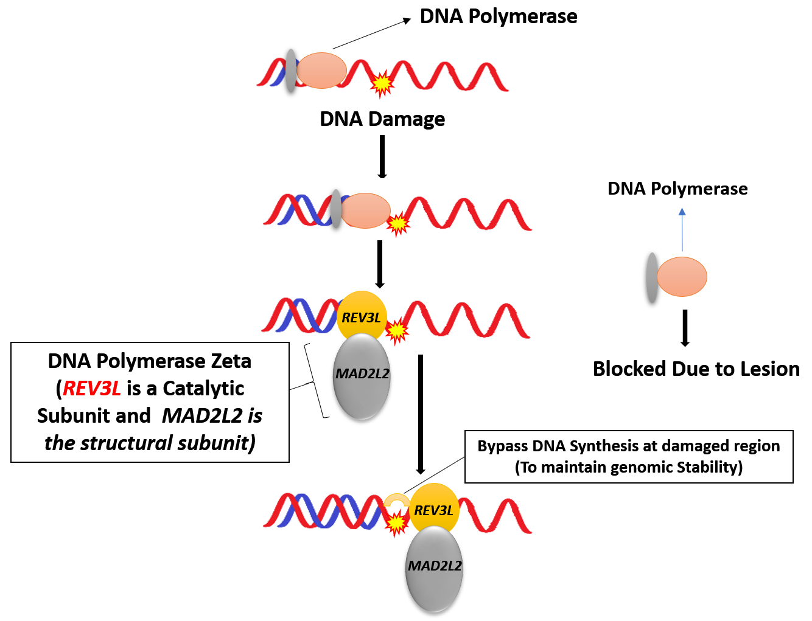

Supplementary Figure S1: Representing Translesion DNA synthesis by DNA polymerase (pol) ζ.


Supplementary Figure S2: Showing the interaction of REV3L with other genes by string tool software. More the thickness of nodes more is the relationship among the genes, less the thickness of nodes less will be the relationship among these genes.
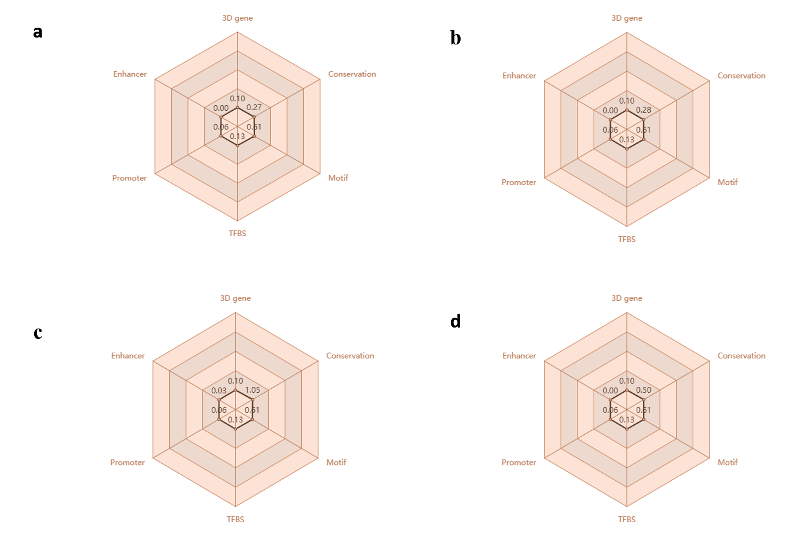

Supplementary Figure S3: Showing interacting elements along with important epigenetic marks, and a comprehensive functionality score (Source:3DSNP). (a) Showing important epigenetic marks of rs1002481 with a total functionality score of 1.16. (b) Showing important epigenetic marks of rs462779 with a total functionality score of 1.18. (c) Showing important epigenetic marks of rs465646 with a total functionality score of 1.97. (d) Showing important epigenetic marks of rs11153292 with a total functionality score of 1.40.

