Supplementary information

Novel precise separation technology will significantly improve the circulation of critical materials in automotive Lithium-ion batteries

Yi Dou¹, Aya Heiho², Chiharu Tokoro³, Yasunori Kikuchi^{1,4,5}

¹ Institute for Future Initiatives, The University of Tokyo, 7-3-1 Hongo Bunkyo-ku, Tokyo 113-8654, Japan
² Faculty of Environmental Studies, Tokyo City University, 3-3-1 Ushikubo-Nishi, Tsuzuki-Ku, Yokohama, Kanagawa 224-8551 ,Japan
³ Department of Resources and Environmental Engineering, Faculty of Science and Engineering, Waseda University, 3-4-1 Okubo Shinjuku-ku, Tokyo 169-8555, Japan
⁴ Presidential Endowed Chair for “Platinum Society”, Organization for Interdisciplinary Research Project, The University of Tokyo, 7-3-1 Hongo, Bunkyo-ku, Tokyo 113-8656, Japan
⁵ Department of Chemical System Engineering, The University of Tokyo, 7-3-1 Hongo, Bunkyo-ku, Tokyo 113-8654, Japan

Contents
Acronyms and abbreviations 3
Supplementary Fig. S1 Positioning of a precise separation technology in recycling spent automotive LIBs. 4
Supplementary Fig. S2 Image of a pilot equipment using high-voltage pulsed discharge. 5
Supplementary Fig. S3 Projection of population and the number of people per household in Japan (2020-2050). 6
Supplementary Fig. S4 The ownership of various vehicles in Japan (1970-2020)(AIRIA, 2021). 7
Supplementary Fig. S5 The ownership of passenger vehicles in Japan (1970-2020) and its projection (2020-2050). 8
Supplementary Fig. S6 The past records and future prediction on the sharing of each type of passenger vehicles in Japanese new passenger cars sales market. 9
Supplementary Fig. S7 The past records and future projection of passenger car market and the share of EVs in Japan. 10
Supplementary Fig. S8 Market sharing of different Li-ion batteries in annual new battery sales in the future. 11
Supplementary Fig. S9 Actual survival rate of passenger cars in Japan (2019) and its fitted curve by Weibull distribution. 12
Supplementary Fig. S10 Actual passenger car ownership (1993-2019) and the comparison to the calculation result backwards from 2019. 13
Supplementary Fig. S11 The past records (1993-2020) and future prediction (2021-2050) on the number of registration cancellations and new car sales in Japan. 14
Supplementary Fig. S12 Capacity of the LIBs in use in the EVs and spent LIBs in secondary usage as stationary energy storage. 15
Supplementary Fig. S13 Sensitivity analysis: the annual stocks and flows of critical metals relating to automotive LIBs in Japan. 16
Supplementary Fig. S14 Sensitivity analysis: life cycle GHG emissions in cases. 17
Supplementary Fig. S15 Sensitivity analysis: life cycle RCP in cases. 18
Supplementary Table S1 Statistical data collected from national statistics and reports of Japan 19
Supplementary Table S2 Parameters setting regarding the future socio-economic changes of Japan 20
Supplementary Table S3 Target setting regarding the sales market share of each type of passenger vehicles according to the Carbon Neutral Target declared in Japan (METIJ, 2020) 21
Supplementary Table S4 Survival rate of passenger vehicles (vehicle fleets in the year 2019) 22
Supplementary Table S5 Calculation of sales-weighted average capacity of BEVs and PHEVs. 23
Supplementary Table S6 Lifetime parameters setting for LIBs. 24
Supplementary Table S7 Parameters setting: sales-weighted average battery wight and critical metals included (unit: kg). 25
Supplementary Table S8 The changes of GHG emission factors and resource consumption potential by years according to the decarbonization target in electricity supply. 26
Supplementary Table S9 Sensitivity analysis: life cycle GHG emissions in cases. 27
Supplementary Table S10 Sensitivity analysis: life cycle RCP in cases. 28
Reference: 29

Acronyms and abbreviations

EV | Electric vehicle
HEV | Hybrid electric vehicle
BEV | Battery electric vehicle
PHEV | Plug-in hybrid electric vehicle
ICEV | Internal-combustion engine vehicle
FCV | Fuel cell vehicle
LIB | Lithium-ion battery
LFP | Lithium iron phosphate
NCA | Lithium Nickel Cobalt Aluminum Oxide
NCM | Lithium Nickel Manganese Cobalt Oxide
LMO | Lithium manganese oxide
Li-S | Lithium-sulfur battery
Li-Air | Lithium-air battery
MFA | Material flow analysis
LCA | Life-cycle assessment
GHG | Greenhouse Gas
RCP | Resource consumption potential
PE | Positive electrode
PEAM | Positive electrode active materials

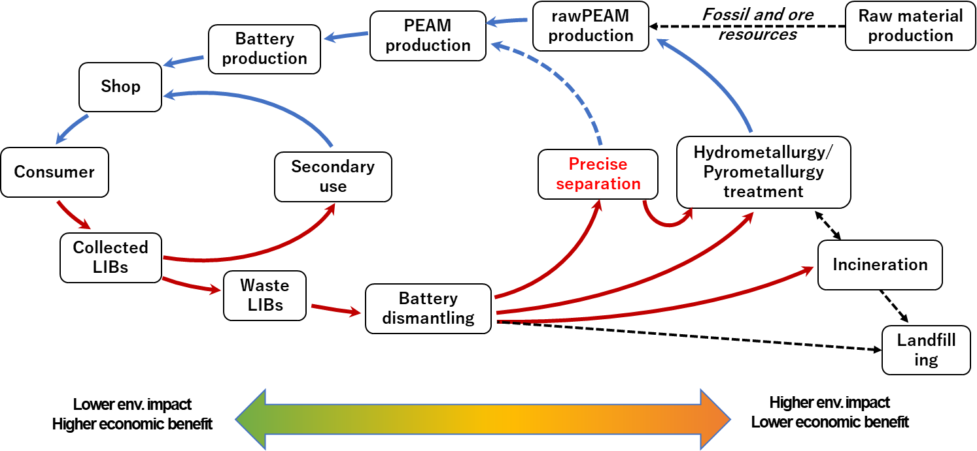

Supplementary Fig. S1 Positioning of a precise separation technology in recycling spent automotive LIBs.
A precise separation technique is firstly developed to pretreat the dismantled battery cells for the following metals recovery by hydrometallurgy, but it has potential to directly recycle the PEAMs if the separation is “precise enough” to extract and remain the properties of recovered PEAMs.

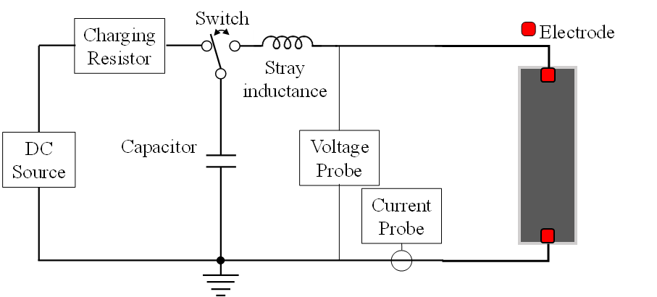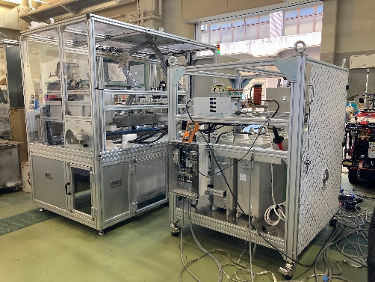
a b

Supplementary Fig. S2 Diagram of the experimental circuit for a wire explosion caused by a high-voltage pulsed discharge in case of separating PEAMs from the cathode (a), and a picture of the pilot equipment (b).
The similar application to spent solar panels can refer to Lim et al., 2021¹.

Supplementary Fig. S3 Projection of population and the number of people per household in Japan (2020-2050).
The population of Japan was predicted to keep decreasing from 2020 ², while the number of people per household appeared the same tendency of a long-term decrement ³.

Supplementary Fig. S4 The ownership of various vehicles in Japan (1970-2020)⁴.
Our study took the passenger cars into consideration, where shared-ride cars (e.g., buses), cargo vehicles, and the others were excluded. Cargo vehicles possess a part of the whole car ownership, but may adopt hydrogen fuels because of the longer transport distance supported by hydrogen fuels.

Supplementary Fig. S5 The ownership of passenger vehicles in Japan (1970-2020) and its projection (2020-2050).
Based on the ownership of passenger vehicles in the past years ⁴, our study predicted the future ownership of passenger vehicles using the formula supported by ⁵. Additionally, we improved the formula by adding the effect of car-sharing to the car ownership ⁶. Here, ECOMO ⁷ reported that the car-sharing service will decrease the rate of car ownership by 62% among car-sharing members.

Supplementary Fig. S6 The past records and future prediction on the sharing of each type of passenger vehicles in Japanese new passenger cars sales market.
According to the ambitious targets carried out by the Japanese government and automobile associations, the sales of ICEs will be stopped in domestic by the early of 2030s while the transport sector should be decarbonized by 2050⁸. Thus, we assumed that the ICEs will gradually quit the new sales market by 2035 and the HEVs will gradually quit the new sales market by 2050.

Supplementary Fig. S7 The past records and future projection of passenger car market and the share of EVs in Japan.
The past records are referred to ⁹, and future projection is the simulation result of this study.

Supplementary Fig. S8 Market sharing of different Li-ion batteries in annual new battery sales in the future.
Xu, et al. ¹⁰ set three scenarios to simulate the model changes of LIBs in the future, including (1) LFP remains the major in a long term due to its advantage in cost and technical maturity; (2) NCM gradually becomes the major in the market share because of its relatively low cost and high energy density; (3) Li-S, Li-Air are penetrated and fast diffused in the future due to the lower resource dependence. The scenario (2) has the highest probability to become the truth, thus we adopted the same scenario in our simulation.

Supplementary Fig. S9 Actual survival rate of passenger cars in Japan (2019) and its fitted curve by Weibull distribution.
According to the survey on survival rate of passenger cars in Japan in 2019¹¹, we fitted a curve by Weibull distribution to predict the number of abandoned passenger cars in the future.

Supplementary Fig. S10 Actual passenger car ownership (1993-2019) and the comparison to the calculation result backwards from 2019.
Because of the data lack on the cars’ years in service, we firstly used the calibrated Weibull distribution to calculate backwards from 2019, but found it underestimated than the actual data. Thus, we adjusted the underestimated number to the actual data in proportion before the following material flow analysis.

Supplementary Fig. S11 The past records (1993-2020) and future prediction (2021-2050) on the number of registration cancellations and new car sales in Japan.
Generally, the number of abandoned passenger cars (cancelled the registration, including the second-hand cars exported to the overseas) increased from 1993 to 2020, but will decrease gradually while the new car sales are becoming less in the future (estimated in this study).

a | b

Supplementary Fig. S12 Capacity of the LIBs in use in the EVs and spent LIBs in secondary usage as stationary energy storage.
a: assumed that the capacity of the spent LIBs in secondary usage as stationary energy storage will not over 25% of it of the LIBs in use in the EVs, referred to ¹². b: assumed that the capacity of the spent LIBs in secondary usage as stationary energy storage will not have limit.

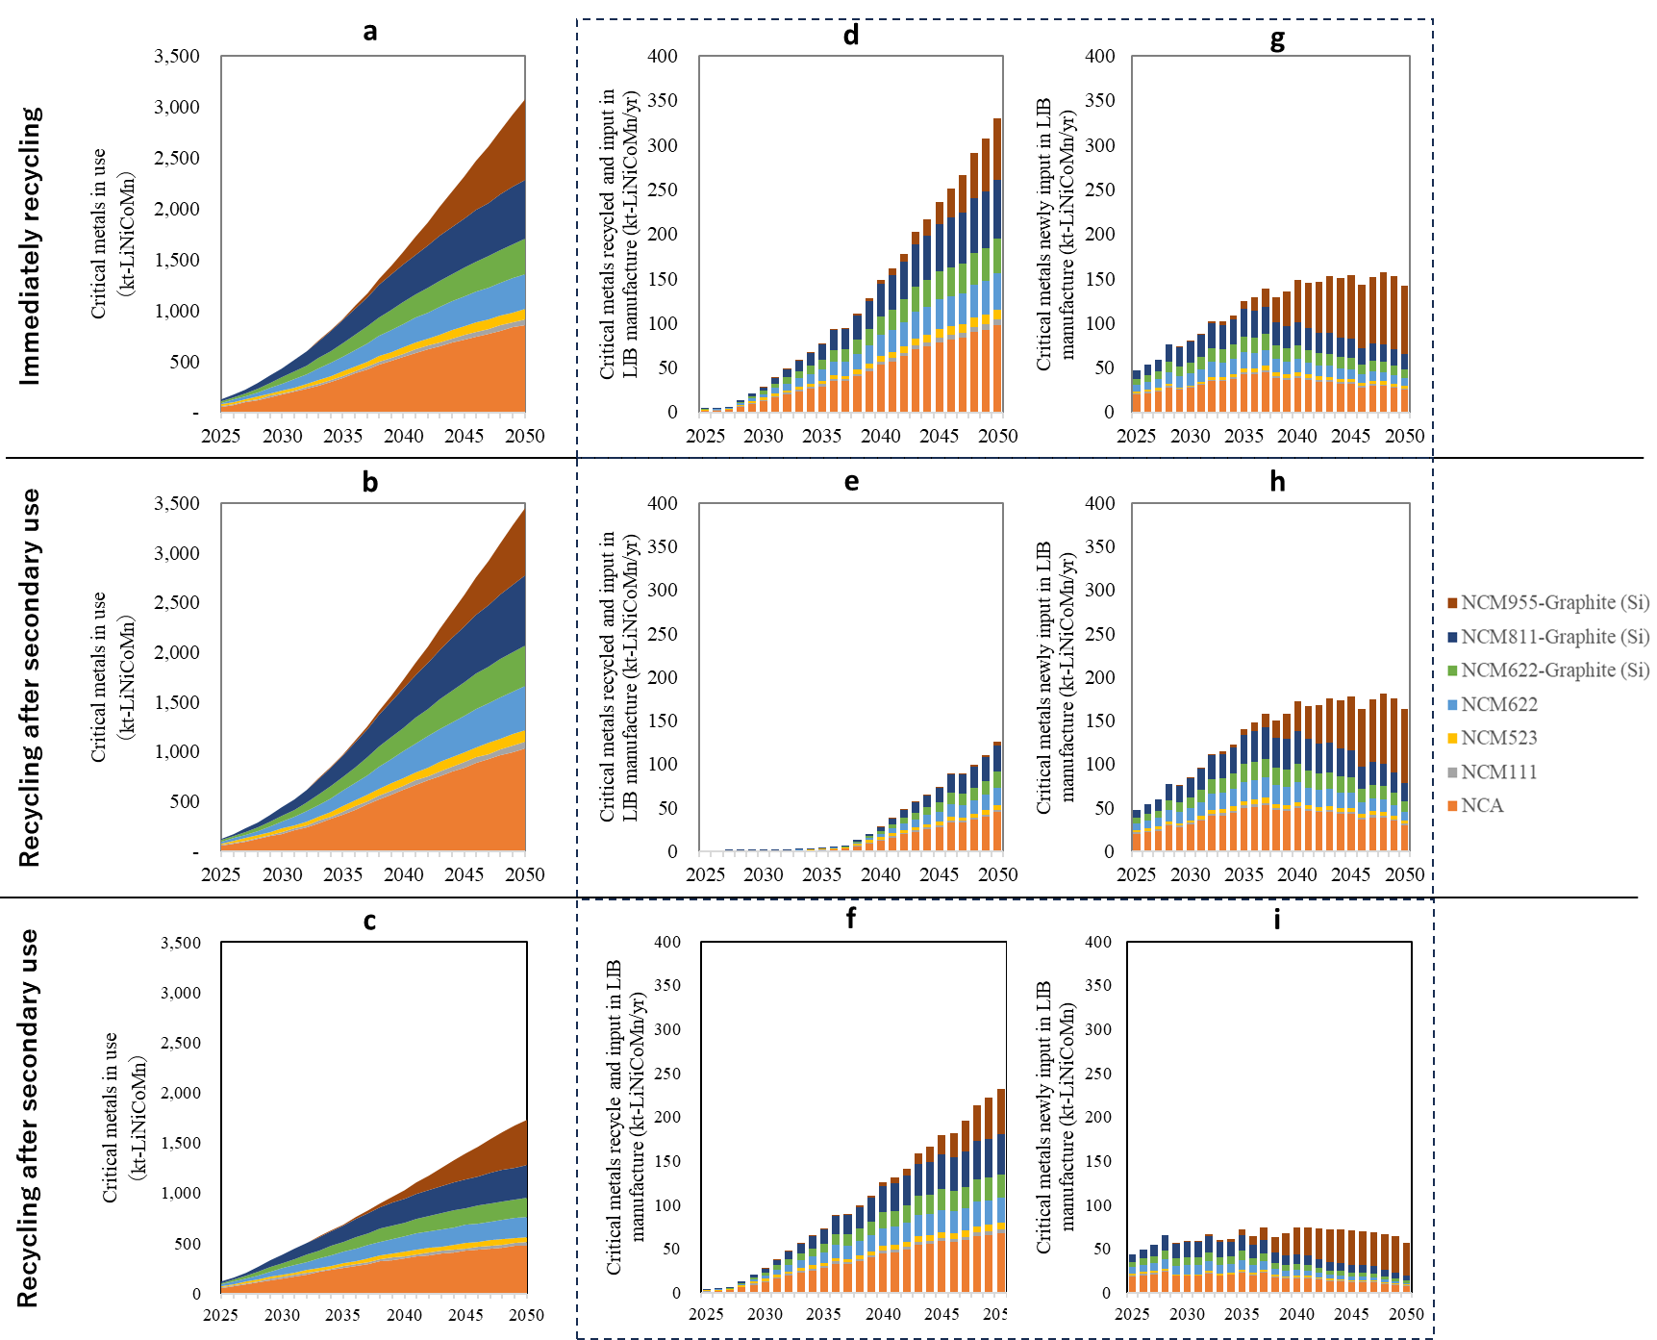

Supplementary Fig. S13 Sensitivity analysis: the annual stocks and flows of critical metals relating to automotive LIBs in Japan.
a, b, c: critical metals in use, d, e, f: critical metals recycled and input in LIB manufacture, g, h, i: critical metals newly input in LIB manufacture. Upper figures belong to the case of immediately recycling with unlimited stationary energy storage market to accept the spent LIBs, medium figures belong to the case of recycling after secondary use with unlimited stationary energy storage market to accept the spent LIBs, lower figures belong to the case of immediately recycling with no stationary energy storage market to accept the spent LIBs.

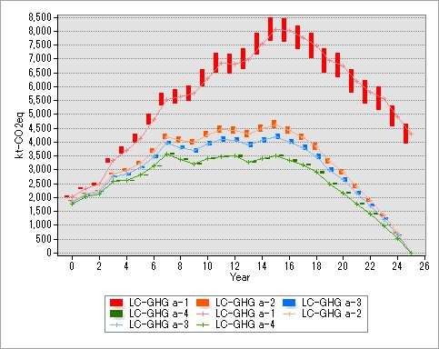  - Immediately recycling | 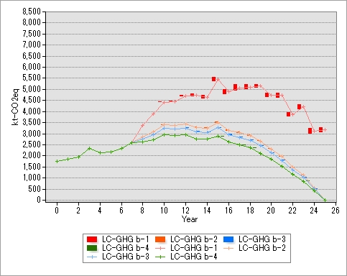  - Recycling after secondary use

Supplementary Fig. S14 Sensitivity analysis: life cycle GHG emissions in cases.
Collection ratio of spent LIBs =100% ±10%, capacity of spent LIBs in secondary use <= 25% capacity of automotive LIBs in use in EVs.

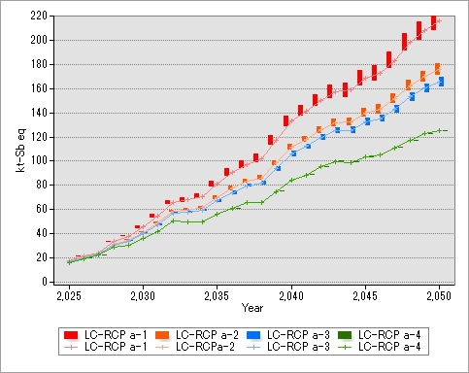  - Immediately recycling | 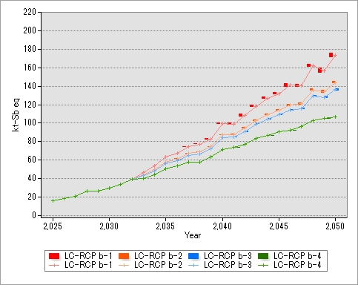  - Recycling after secondary use
Supplementary Fig. S9 Sensitivity analysis on resource consumption potential of all cases (collection ratio of spent LIBs =100% ±10%)

Supplementary Fig. S15 Sensitivity analysis: life cycle RCP in cases.
Collection ratio of spent LIBs =100% ±10%, capacity of spent LIBs in secondary use <= 25% capacity of automotive LIBs in use in EVs.

Supplementary Table S1 Statistical data collected from national statistics and reports of Japan
Statistics | Period | Reference | Status
Ownership of passenger vehicles | 1966-2020 | Automobile Inspection & Registration Information Association ⁴ | Statistic value
Population; Number of households | 1970-2020 | National census of Japan ¹³ | Statistic value
Average household income | 2005‐2018 | Comprehensive Survey of Living Conditions ¹⁴ | Statistic value
Average purchase price of passenger vehicles | 2005-2019 | Current Survey of Production ¹⁵ | Statistic value
Number of car-sharing members | 2002‐2020 | Survey by Foundation for Promoting Personal Mobility and Ecological Transportation ⁶ | Statistic value
Fleet composition of passenger vehicles | 2019.3 | Automobile Inspection & Registration Information Association ⁹ | Statistic value
Prospects of number of households | 2021-2040 | “Future prospection of number of households in Japan” by National Institute of Population and Social Security Research ³ | Estimated value
Prospects of population | 2021-2065 | “Future prospection of population in Japan” by National Institute of Population and Social Security Research ² | Estimated value

Supplementary Table S2 Parameters setting regarding the future socio-economic changes of Japan
Socio-economic prospection | Period | Value | Reference | Status
Ownership reduce due to car sharing | Constant | 62% | “Report on the environmental load reduction due to car-sharing” by Foundation for Promoting Personal Mobility and Ecological Transportation ⁷ | Referential value
Annual increase rate of car-sharing members | Constant | 0.19% | Average increase rate during period 2014-2019 ⁶ | Referential value
Average purchase price of passenger vehicles | 2021-50 | - | Assume to follow the changes of CPI ¹⁶ | Referential value
Annual increase of employees' income | 2021-30 | 1.6% | “Initiative of Future Society 2050” by Mitsubishi Research Institute ¹⁶ | Referential value
Annual increase of employees' income | 2031-40 | 1% |  | Referential value
Annual increase of employees' income | 2041-50 | 0.9% |  | Referential value
Consumer Price Index | 2021-30 | 1.6% |  | Referential value
Consumer Price Index | 2031-40 | 1.7% |  | Referential value
Consumer Price Index | 2041-50 | 1.9% |  | Referential value

Supplementary Table S3 Target setting regarding the sales market share of each type of passenger vehicles according to the Carbon Neutral Target declared in Japan ¹⁷
Vehicle type | Year | Value | Reference | Status
ICEV | 2035 | 0% | Green Growth Strategy by the cabinet office of Japan | Target value
ICEV | 2050 | 0% | Must for achieving Carbon Neutral Declaration by 2050 | Target value
HEV | 2035 | 0% | Must for achieving Carbon Neutral Declaration by 2050 | Assumption
HEV | 2050 | 0% | Must for achieving Carbon Neutral Declaration by 2050 | Assumption
PHEV | 2030 | 3% | Next-generation vehicle strategy by Ministry of Economy, Trade and Industry of Japan (2010) | Target value
PHEV | 2050 | 0% | Possible target for achieving Carbon Neutral Declaration by 2050 | Assumption
BEV | 2030 | 22% | Next-generation vehicle strategy by Ministry of Economy, Trade and Industry of Japan (2010) | Target value
BEV | 2050 | 90% | Possible target for achieving Carbon Neutral Declaration by 2050 | Assumption
FCV | 2030 | 3% | Next-generation vehicle strategy by Ministry of Economy, Trade and Industry of Japan (2010) | Target value
FCV | 2050 | 10% | Possible target for achieving Carbon Neutral Declaration by 2050 | Assumption
Others | 2030 | 0% | Possible target for achieving Carbon Neutral Declaration by 2050 | Assumption
Others | 2050 | 0% | Possible target for achieving Carbon Neutral Declaration by 2050 | Assumption

Supplementary Table S4 Survival rate of passenger vehicles (vehicle fleets in the year 2019)
Years in service | 1 | 2 | 3 | 4 | 5 | 6 | 7 | 8 | 9 | 10
Survival ratio (%) | 98.75 | 98.23 | 96.58 | 92.93 | 91.57 | 89.16 | 88.40 | 83.59 | 80.77 | 77.55
Years in service | 11 | 12 | 13 | 14 | 15 | 16 | 17 | 18 | 19 | 20
Survival ratio (%) | 70.31 | 61.90 | 57.54 | 47.54 | 41.10 | 30.78 | 24.74 | 17.05 | 14.55 | 11.04
Years in service | 21 | 22 | 23 | 24 | 25 | 26 | 27 | 28 | 29
Survival ratio (%) | 9.05 | 7.17 | 6.19 | 5.22 | 4.56 | 4.28 | 3.61 | 3.66 | 2.93

Supplementary Table S5 Calculation of sales-weighted average capacity of BEVs and PHEVs.
BEVs | Sales maeket share | Required battery capacity (kWh) | Sales-weighted average capacity (kWh) | PHEVs | Sales maeket share | Required battery capacity (kWh) | Sales-weighted average capacity (kWh)
Small BEV | 19% | 33 | 72 | Small PHEV | 23% | 17 | 11
Mid-size BEV | 48% | 66 | 72 | Mid-size PHEV | 45% | 8 | 11
Large BEV | 34% | 100 | 72 | Large PHEV | 32% | 12 | 11
Parameters of various type of EVs are referred from Xu, et al. ¹⁰. The authors calculate the average capacity per vehicle in the simulation.

Supplementary Table S6 Lifetime parameters setting for LIBs.
Li-ion battery lifetime | Years
Primary use in EVs | 8
Secondary use in stationary energy storage | 10
Parameters are set referred to Xu, et al. ¹⁰, Zeng, et al. ¹⁸.

Supplementary Table S7 Parameters setting: sales-weighted average battery wight and critical metals included (unit: kg).
 | LFP | NCA | NCM111 | NCM523 | NCM622 | NCM622-Graphite (Si) | NCM811-Graphite (Si) | NCM955-Graphite (Si)
Pack level
BEV average | 558.90 | 405.74 | 450.24 | 442.30 | 415.87 | 387.32 | 374.37 | 356.81
PHEV average | 138.42 | 92.36 | 101.04 | 99.45 | 93.55 | 88.88 | 86.75 | 83.95
BEV average
Li | 7.14 | 7.38 | 10.16 | 9.86 | 8.56 | 8.69 | 8.08 | 7.24
Ni | 0.00 | 47.72 | 24.99 | 36.35 | 37.74 | 38.52 | 47.72 | 47.99
Co | 0.00 | 8.98 | 25.09 | 14.60 | 12.63 | 12.89 | 5.99 | 2.82
Mn | 0.00 | 0.00 | 23.39 | 20.41 | 11.77 | 12.02 | 5.58 | 2.50
Al | 116.74 | 91.23 | 96.07 | 94.96 | 92.04 | 87.97 | 86.42 | 84.38
Cu | 63.47 | 55.03 | 56.08 | 55.45 | 54.48 | 54.96 | 54.28 | 53.65
Steel | 4.20 | 2.73 | 2.98 | 2.95 | 2.80 | 2.51 | 2.43 | 2.32
Graphite | 85.08 | 76.58 | 78.57 | 77.59 | 75.83 | 51.16 | 50.26 | 49.19
Electrolyte | 98.44 | 46.75 | 52.04 | 51.08 | 48.01 | 42.23 | 40.73 | 38.71
Separator | 6.45 | 5.79 | 5.83 | 5.77 | 5.69 | 5.83 | 5.76 | 5.71
Si | 0.00 | 0.00 | 0.00 | 0.00 | 0.00 | 5.06 | 4.97 | 4.86
PHEVs average
Li | 1.15 | 1.18 | 1.62 | 1.57 | 1.36 | 1.38 | 1.29 | 1.16
Ni | 0.00 | 7.58 | 3.97 | 5.77 | 5.99 | 6.11 | 7.57 | 7.62
Co | 0.00 | 1.43 | 3.98 | 2.32 | 2.01 | 2.05 | 0.95 | 0.45
Mn | 0.00 | 0.00 | 3.71 | 3.24 | 1.87 | 1.91 | 0.89 | 0.40
Al | 29.88 | 18.15 | 19.97 | 19.72 | 18.20 | 16.69 | 16.45 | 16.19
Cu | 35.73 | 24.31 | 24.85 | 24.56 | 23.95 | 24.70 | 24.54 | 24.41
Steel | 1.07 | 0.64 | 0.70 | 0.69 | 0.66 | 0.61 | 0.59 | 0.57
Graphite | 13.44 | 12.17 | 12.48 | 12.33 | 12.05 | 8.13 | 7.98 | 7.81
Electrolyte | 18.17 | 8.22 | 9.15 | 8.97 | 8.40 | 7.55 | 7.31 | 7.00
Separator | 2.90 | 1.49 | 1.57 | 1.54 | 1.46 | 1.53 | 1.52 | 1.52
Si | 0.00 | 0.00 | 0.00 | 0.00 | 0.00 | 0.80 | 0.79 | 0.77
Parameters are set based on Xu, et al. ¹⁰. The authors calculate the average value due to the market share of small, medium, and large EVs and their individual components’ weight.

Supplementary Table S8 The changes of GHG emission factors and resource consumption potential by years according to the decarbonization target in electricity supply.
Scenario | Year | 2025 | 2030 | 2035 | 2040 | 2045 | 2050
Reference value
All | GHG emissions factor (electricity) | 0.366 | 0.250 | 0.188 | 0.125 | 0.063 | 0.000
LIB manufacture
All | GHG unit (kg-CO₂ eq/kg-PE sheet) | 16.09 | 11.00 | 8.25 | 5.50 | 2.75 | 0.00
All | RCP unit (kg-Sb eq/kg-PE sheet) | 0.149 | 0.149 | 0.149 | 0.149 | 0.149 | 0.149
LIB remanufacture
a-1, b-2 | GHG unit (kg-CO₂ eq/kg-PE sheet) | 16.09 | 11.00 | 8.25 | 5.50 | 2.75 | 0.00
a-2, b-2 | GHG unit (kg-CO₂ eq/kg-PE sheet) | 7.48 | 5.12 | 3.84 | 2.56 | 1.28 | 0.00
a-3, b-3 | GHG unit (kg-CO₂ eq/kg-PE sheet) | 7.74 | 5.29 | 3.97 | 2.65 | 1.32 | 0.00
a-4, b-4 | GHG unit (kg-CO₂ eq/kg-PE sheet) | 3.61 | 2.47 | 1.85 | 1.23 | 0.62 | 0.00
a-1, b-1 | RCP unit (kg-Sb eq/kg-PE sheet) | 0.149 | 0.149 | 0.149 | 0.149 | 0.149 | 0.149
a-2, b-2 | RCP unit (kg-Sb eq/kg-PE sheet) | 0.078 | 0.078 | 0.078 | 0.078 | 0.078 | 0.078
a-3, b-3 | RCP unit (kg-Sb eq/kg-PE sheet) | 0.063 | 0.063 | 0.063 | 0.063 | 0.063 | 0.063
a-4, b-4 | RCP unit (kg-Sb eq/kg-PE sheet) | 0.008 | 0.008 | 0.008 | 0.008 | 0.008 | 0.008
LIB recycling
a-1, b-2 | GHG unit (kg-CO₂ eq/kg-PE sheet) | 13.84 | 11.58 | 10.35 | 9.13 | 7.91 | 6.68
a-2, b-2 | GHG unit (kg-CO₂ eq/kg-PE sheet) | 6.28 | 4.30 | 3.22 | 2.15 | 1.07 | 0.00
a-3, b-3 | GHG unit (kg-CO₂ eq/kg-PE sheet) | 2.41 | 1.65 | 1.23 | 0.82 | 0.41 | 0.00
a-4, b-4 | GHG unit (kg-CO₂ eq/kg-PE sheet) | 0.60 | 0.41 | 0.31 | 0.20 | 0.10 | 0.00
a-1, b-1 | RCP unit (kg-Sb eq/kg-PE sheet) | 4.5.E-05 | 4.5.E-05 | 4.5.E-05 | 4.5.E-05 | 4.5.E-05 | 4.5.E-05
a-2, b-2 | RCP unit (kg-Sb eq/kg-PE sheet) | 8.6.E-03 | 8.6.E-03 | 8.6.E-03 | 8.6.E-03 | 8.6.E-03 | 8.6.E-03
a-3, b-3 | RCP unit (kg-Sb eq/kg-PE sheet) | 7.9.E-03 | 7.9.E-03 | 7.9.E-03 | 7.9.E-03 | 7.9.E-03 | 7.9.E-03
a-4, b-4 | RCP unit (kg-Sb eq/kg-PE sheet) | 2.7.E-05 | 2.7.E-05 | 2.7.E-05 | 2.7.E-05 | 2.7.E-05 | 2.7.E-05

Supplementary Table S9 Sensitivity analysis: life cycle GHG emissions in cases.

Scenario | Secondary use | Collection ratio | 2025 | 2030 | 2035 | 2040 | 2045 | 2050
a-1 | No | 90% | 1860.47 | 3317.15 | 5372.72 | 6589.37 | 6526.48 | 4852.88
a-1 | No | 100% | 1873.93 | 3394.97 | 5546.37 | 6856.38 | 6859.87 | 5220.76
a-1 | No | 110% | 1887.40 | 3472.78 | 5720.01 | 7123.39 | 7193.26 | 5588.65
a-2 | No | 90% | 1718.96 | 2513.22 | 3527.89 | 3432.54 | 2261.64 | 0.00
a-2 | No | 100% | 1716.70 | 2501.72 | 3506.35 | 3407.50 | 2243.59 | 0.00
a-2 | No | 110% | 1714.45 | 2490.21 | 3484.81 | 3382.47 | 2225.55 | 0.00
a-3 | No | 90% | 1687.26 | 2367.82 | 3242.13 | 3052.66 | 1954.22 | 0.00
a-3 | No | 100% | 1681.48 | 2340.15 | 3190.35 | 2992.48 | 1910.84 | 0.00
a-3 | No | 110% | 1675.70 | 2312.48 | 3138.58 | 2932.31 | 1867.46 | 0.00
a-4 | No | 90% | 1635.25 | 2125.34 | 2765.62 | 2419.21 | 1441.59 | 0.00
a-4 | No | 100% | 1623.69 | 2070.74 | 2663.43 | 2300.43 | 1355.97 | 0.00
a-4 | No | 110% | 1612.14 | 2016.13 | 2561.24 | 2181.66 | 1270.36 | 0.00
b-1 | Yes | 90% | 1739.29 | 2167.23 | 2857.17 | 3143.39 | 2829.76 | 1759.47
b-1 | Yes | 100% | 1739.29 | 2167.23 | 2867.25 | 3204.77 | 2962.39 | 1954.97
b-1 | Yes | 110% | 1739.29 | 2167.23 | 2877.32 | 3266.14 | 3095.02 | 2150.47
b-2 | Yes | 90% | 1739.29 | 2167.23 | 2755.27 | 2539.20 | 1571.45 | 0.00
b-2 | Yes | 100% | 1739.29 | 2167.23 | 2754.02 | 2533.45 | 1564.27 | 0.00
b-2 | Yes | 110% | 1739.29 | 2167.23 | 2752.77 | 2527.69 | 1557.09 | 0.00
b-3 | Yes | 90% | 1739.29 | 2167.23 | 2739.48 | 2466.50 | 1480.74 | 0.00
b-3 | Yes | 100% | 1739.29 | 2167.23 | 2736.48 | 2452.66 | 1463.49 | 0.00
b-3 | Yes | 110% | 1739.29 | 2167.23 | 2733.47 | 2438.83 | 1446.23 | 0.00
b-4 | Yes | 90% | 1739.29 | 2167.23 | 2713.16 | 2345.26 | 1329.50 | 0.00
b-4 | Yes | 100% | 1739.29 | 2167.23 | 2707.23 | 2317.96 | 1295.44 | 0.00
b-4 | Yes | 110% | 1739.29 | 2167.23 | 2701.30 | 2290.65 | 1261.37 | 0.00
Collection ratio of spent LIBs =100% ±10%, capacity of spent LIBs in secondary use <= 25% capacity of automotive LIBs in use in EVs.

Supplementary Table S10 Sensitivity analysis: life cycle RCP in cases.
Scenario | Secondary use | Collection ratio | 2025 | 2030 | 2035 | 2040 | 2045 | 2050
a-1 | No | 90% | 16.13 | 35.49 | 67.48 | 100.45 | 134.59 | 165.26
a-1 | No | 100% | 16.13 | 35.49 | 67.48 | 100.46 | 134.59 | 165.26
a-1 | No | 110% | 16.13 | 35.49 | 67.48 | 100.46 | 134.59 | 165.27
a-2 | No | 90% | 15.58 | 31.70 | 57.54 | 80.64 | 102.52 | 119.76
a-2 | No | 100% | 15.52 | 31.28 | 56.49 | 78.81 | 99.88 | 116.32
a-2 | No | 110% | 15.46 | 30.86 | 55.44 | 76.98 | 97.24 | 112.87
a-3 | No | 90% | 15.44 | 30.72 | 54.98 | 75.54 | 94.26 | 108.04
a-3 | No | 100% | 15.36 | 30.19 | 53.66 | 73.23 | 90.93 | 103.70
a-3 | No | 110% | 15.28 | 29.66 | 52.34 | 70.93 | 87.61 | 99.37
a-4 | No | 90% | 14.89 | 26.92 | 45.03 | 55.69 | 62.14 | 62.47
a-4 | No | 100% | 14.75 | 25.97 | 42.66 | 51.55 | 56.17 | 54.68
a-4 | No | 110% | 14.61 | 25.02 | 40.28 | 47.41 | 50.21 | 46.89
b-1 | Yes | 90% | 16.13 | 29.39 | 50.02 | 70.28 | 88.76 | 103.02
b-1 | Yes | 100% | 16.13 | 29.39 | 50.02 | 70.28 | 88.76 | 103.02
b-1 | Yes | 110% | 16.13 | 29.39 | 50.02 | 70.28 | 88.76 | 103.02
b-2 | Yes | 90% | 16.13 | 29.39 | 49.48 | 66.49 | 79.30 | 86.52
b-2 | Yes | 100% | 16.13 | 29.39 | 49.41 | 66.07 | 78.25 | 84.69
b-2 | Yes | 110% | 16.13 | 29.39 | 49.35 | 65.64 | 77.19 | 82.86
b-3 | Yes | 90% | 16.13 | 29.39 | 49.33 | 65.51 | 76.86 | 82.27
b-3 | Yes | 100% | 16.13 | 29.39 | 49.26 | 64.98 | 75.54 | 79.97
b-3 | Yes | 110% | 16.13 | 29.39 | 49.18 | 64.45 | 74.21 | 77.66
b-4 | Yes | 90% | 16.13 | 29.39 | 48.78 | 61.71 | 67.38 | 65.75
b-4 | Yes | 100% | 16.13 | 29.39 | 48.65 | 60.76 | 65.01 | 61.61
b-4 | Yes | 110% | 16.13 | 29.39 | 48.51 | 59.81 | 62.63 | 57.47
Collection ratio of spent LIBs =100% ±10%, capacity of spent LIBs in secondary use <= 25% capacity of automotive LIBs in use in EVs.

Reference:

1 Lim, S. et al. Recovery of Silver From Waste Crystalline Silicon Photovoltaic Cells by Wire Explosion. Ieee T Plasma Sci 49, 2857-2865 (2021). https://doi.org:10.1109/TPS.2021.3106307
2 IPSS. Population Projections for Japan (2021-2070). (National Institute of Population and Social Security Research (IPSS), Tokyo, 2023).
3 IPSS. Household Projection for Japan : 2015-2050. (National Institute of Population and Social Security Research, Tokyo, 2018).
4 AIRIA. The ownership of automobiles in Japan (1966-2020). (Automobile Inspection & Registration Information Association (AIRIA), Tokyo, 2021).
5 Nakamura, K., Kato, H. & Hayashi, Y. Forecast of Motorization Progress Considering Railway Improvement Timing In Asian Developing Mega-Cities. Journal of Japan Society of Civil Engineers, Ser. D3 (Infrastructure Planning and Management) 68, I_823-I_830 (2012). https://doi.org:10.2208/jscejipm.68.I_823
6 ECOMO. Number of car-sharing members in Japan (2002-2020). (Foundation for Promoting Personal Mobility and Ecological Transportation (ECOMO), Tokyo, 2021).
7 ECOMO. Verification of the eco effects brought about from car-sharing. (Foundation for Promoting Personal Mobility and Ecological Transportation (ECOMO), Tokyo, 2013).
8 METI. Green Growth Strategy Through Achieving Carbon Neutrality in 2050. (The Ministry of Economy, Trade and Industry (METI), Tokyo, 2021).
9 AIRIA. Fleet composition of the passenger vehicles in Japan. (Automobile Inspection & Registration Information Association, Tokyo, 2019).
10 Xu, C. J. et al. Future material demand for automotive lithium-based batteries. Commun Mater 1 (2020). https://doi.org:10.1038/s43246-020-00095-x
11 AIRIA. Survey on vehicles average age by the end of fiscal year 2018. (Automobile Inspection & Registration Information Association (AIRIA), Tokyo, 2019).
12 IRENA. Global Renewables Outlook: Energy transformation 2050. (The International Renewable Energy Agency (IRENA), Abu Dhabi, 2020).
13 SBJ. 2020 Population Census. (Statistics Bureau of Japan (SBJ), Tokyo, 2021).
14 MHLWJ. Comprehensive Survey of Living Conditions (2005-2018). (Ministry of Health, Labour and Welfare of Japan (MHLWJ), Tokyo, 2019).
15 METI. Current Survey of Production 2005-2019. (Ministry of Economy, Trade and Industry of Japan (METI), Tokyo, 2020).
16 MRI. Social and Economic Impacts of Carbon Neutrality in 2050. (Mitsubishi Research Institute (MRI), Tokyo, 2022).
17 METIJ. Japan’s Roadmap to “Beyond-Zero” Carbon. (Ministry of Economy, Trade and Industry (METI) of Japan, Tokyo, 2020).
18 Zeng, A. et al. Battery technology and recycling alone will not save the electric mobility transition from future cobalt shortages. Nature Communications 13, 1341 (2022). https://doi.org:10.1038/s41467-022-29022-z

