Additional File 2
To build the antioxidant QSAR model, a library of 70 di(hetero)aryl amines and amides belonging to 3 different families (A, B and C), which differ in the constitution of their linker, was used. Family A (Figure S1, Figure S2, Figure S3, Table S1, Table S2 and Table S3) presents an amine group (NH) linker. Family B (Figure S4, Figure S5 and Table S4) presents a methanimine group (CH₂NH) linker. Family C (Figure S6, Figure S7, Figure S8, Figure S9, Figure S10, Table S5 and Table S6) presents an amide group (CONH) linker. Within each family, the compounds were grouped into classes according to the similarity in their base structure for a better perception of the results. The classes obtained were:
Family A – Consists of 26 compounds divided into 3 classes: A-I (6 compounds), A-II (14 compounds) and A-III (6 compounds), as represented in Figures S1, S2 and S3, respectively. Tables S1, S2 and S3 show the constituents of the various R groups that make up each compound in each class.
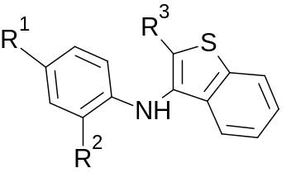
Figure S1. The base structure of compounds belonging to Class A-I.
Table S1. R groups of each compound belonging to Class A-I.
COMPOUND | R¹ | R² | R³
A1^{[18]} | OCH₃ | OCH₃ | H
A2^{[18]} | OCH₃ | OCH₃ | COOH
A3^{[18]} | OCH₃ | OCH₃ | COOCH₂CH₃
A4^{[18]} | OH | OH | COOCH₂CH₃
A5^{[18]} | H | OH | COOCH₂CH₃
A6^{[18]} | H | F | H

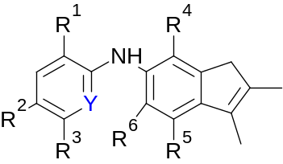
Figure S2. The base structure of compounds belonging to Class A-II.
Table S2. R groups of each compound belonging to Class A-II.
COMPOUND | R¹ | R² | R³ | R⁴ | R⁵ | R⁶ | Y
A7^{[18]} | OCH₃ | OCH₃ | H | H | H | CH₃ | C
A8^{[18]} | H | OCH₃ | OCH₃ | H | H | CH₃ | C
A9^{[18]} | H | OCH₃ | H | CH₃ | CH₃ | H | C
A10^{[18]} | H | OCH₃ | H | H | H | CH₃ | C
A11^{[18]} | H | H | OCH₃ | H | H | CH₃ | C
A12^{[18]} | H | CH=O | H | H | H | CH₃ | C
A13^{[18]} | H | C≡N | H | CH₃ | CH₃ | H | C
A14^{[18]} | Br | OCH₃ | OCH₃ | H | H | CH₃ | C
A15^{[18]} | Br | OCH₃ | H | CH₃ | CH₃ | H | C
A16^{[18]} | Br | OCH₃ | H | H | H | CH₃ | C
A17^{[18]} | Br | H | H | H | H | CH₃ | C
A18^{[18]} | Br | H | H | CH₃ | CH₃ | H | C
A19^{[18]} | I | H | H | H | H | CH₃ | C
A20^{[18]} | H | H | H | CH₃ | CH₃ | H | N
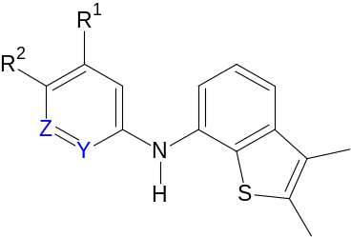
Figure S3. The base structure of compounds belonging to Class A-III.
Table S3. R groups of each compound belonging to Class A-III.
COMPOUND | R¹ | R² | Z | Y
A21^{[18]} | OCH₃ | OCH₃ | CH | CH
A22^{[18]} | OCH₃ | H | CH | CH
A23^{[18]} | H | OCH₃ | CH | CH
A24^{[18]} | C≡N | H | CH | CH
A25^{[18]} | H | H | N | CH
A26^{[18]} | H | H | CH | N

Family B – Consists of 24 compounds divided into 3 classes: B-I (22 compounds), B-II (1 compound) and B-III (1 compound), as represented in Figures S4 and S5. Table S4 shows the constituents of the various R groups that comprise each class B-I compound.

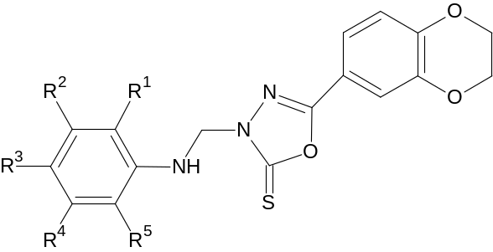
Figure S4. The base structure of compounds belonging to Class B-I.
Table S4. R groups of each compound belonging to Class B-I.
COMPOUND | R¹ | R² | R³ | R⁴ | R⁵ | COMPOUND | R¹ | R² | R³ | R⁴ | R⁵
B1^{[25]} | H | F | F | F | H | B12^{[25]} | H | Cl | Cl | H | H
B2^{[25]} | H | H | H | H | H | B13^{[25]} | H | H | H | H | Br
B3^{[25]} | H | H | H | H | F | B14^{[25]} | H | H | Br | H | H
B4^{[25]} | H | H | F | H | H | B15^{[25]} | Br | H | Br | H | H
B5^{[25]} | F | H | H | H | F | B16^{[25]} | H | H | H | H | NO₂
B6^{[25]} | H | H | H | H | CF₃ | B17^{[25]} | H | NO₂ | H | H | H
B7^{[25]} | H | H | H | CF₃ | H | B18^{[25]} | Cl | H | NO₂ | H | H
B8^{[25]} | H | CF₃ | H | CF₃ | H | B19^{[25]} | CH₃ | H | H | H | H
B9^{[25]} | H | H | H | H | Cl | B20^{[25]} | H | H | CH₃ | H | H
B10^{[25]} | Cl | H | Cl | H | H | B21^{[25]} | H | H | OCH₃ | H | H
B11^{[25]} | Cl | H | H | Cl | H | B22^{[25]} | CH₃CH₂O | H | H | H | H

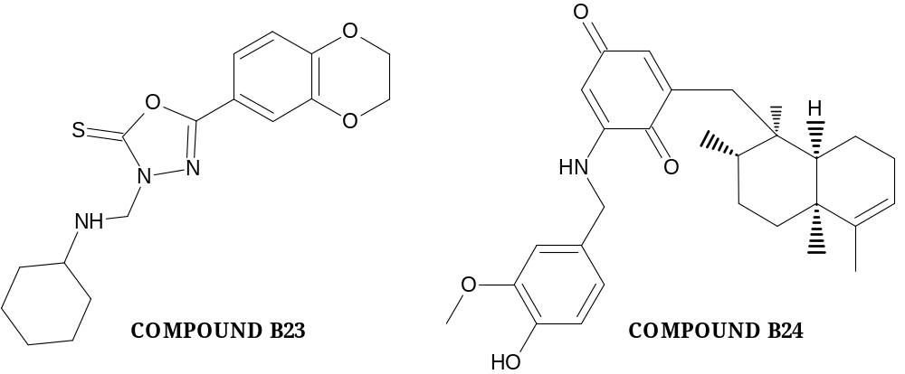

Figure S5. Structure of compound B23^{[25]} (only Class B-II compound) and B24^{[26]} (only Class B-III compound).
Family C – Consists of 20 compounds divided into 10 classes: C-I (1 compound), C-II (7 compounds), C-III (1 compound), C-IV (1 compound), C-V (1 compound), C-VI (1 compound), C-VII (2 compounds), C-VIII (1 compound), C-IX (3 compounds) and C-X (2 compounds) as shown in Figures S6, S7, S8, S9 and S10. Tables S5 and S6 show the constituents of the various R groups comprising each compound from class C-II to C-VII. Table S7 shows the constituents of the various R groups comprising each compound from classes C-IX and C-X. Classes C-I, C-III, C-IV, C-V, C-VI, and C-VIII comprise only 1 compound.

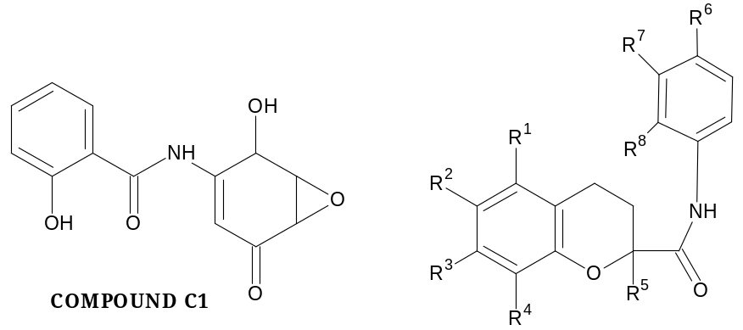
Figure S6. Structure of compound C1^{[27]} (only 1 compound belonging to Class C-I) and the base structure of compounds belonging to Class C-II.
Table S5. R groups for each compound belonging to Class C-II: W–NHCO(CH₂)₄CHC₃H₅S₂; X–NHCO(CH₂)₄CHSH₂(CH₂)SH; Y – OC₆H₄NHCO(CH₂)₄C₃H₅S₂; Z – NHCO(CH₂)₂C₃H₅S₂.
COMPOUND | R¹ | R² | R³ | R⁴ | R⁵ | R⁶ | R⁷ | R⁸
C2^{[28]} | CH₃ | OH | CH₃ | CH₃ | CH₃ | H | H | W
C3^{[28]} | CH₃ | OH | CH₃ | CH₃ | CH₃ | NH₂ | H | H
C4^{[28]} | CH₃ | OH | CH₃ | CH₃ | CH₃ | H | H | X
C5^{[28]} | CH₃ | OH | CH₃ | CH₃ | CH₃ | Y | H | H
C6^{[28]} | CH₃ | OH | CH₃ | CH₃ | CH₃ | Z | H | H
C14^{[31]} | H | OCH₃ | OH | H | H | H | H | H
C15^{[31]} | H | OCH₃ | OH | H | H | NO₂ | H | H
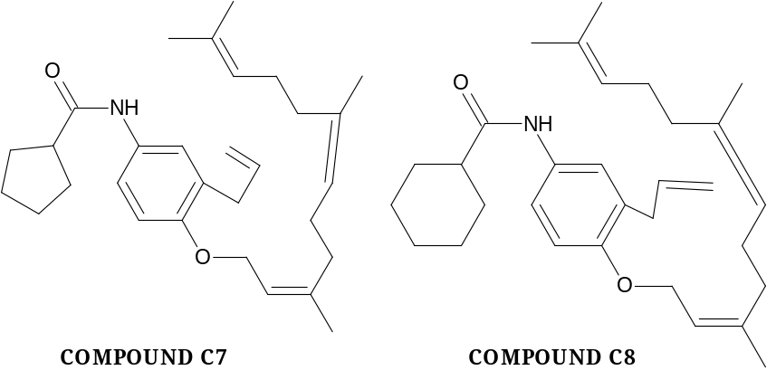
Figure S7. Base structure of compound C7^{[29]} (only compound belonging to Class C-III) and C8^{[29]} (only compound belonging to Class C-IV).

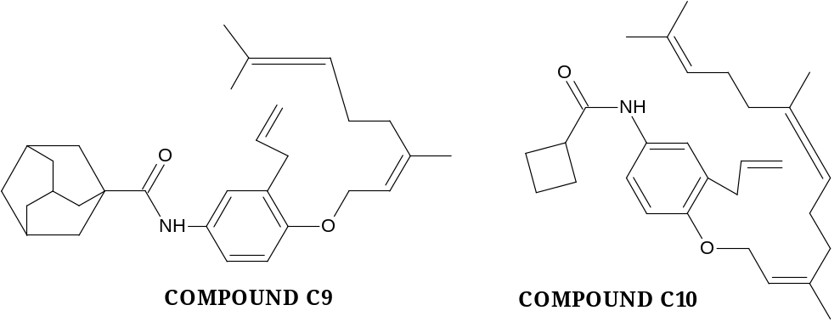
Figure S8. Base structure of compound C9^{[29]} (only compound belonging to Class C-V) and C10^{[29]} (only compound belonging to Class C-VI).
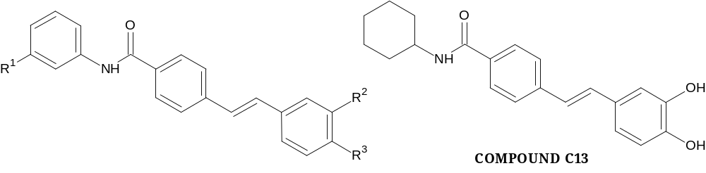
Figure S9. The base structure of compounds belonging to Class C-VII and compound C13^{[30]} (only compound belonging to Class C-VIII).
Table S6. R groups of each compound belonging to Class C-VII.
COMPOUND | R1 | R2 | R3
C11^{[30]} | COOCH₂CH₃ | OH | OH
C12^{[30]} | H | OH | OH

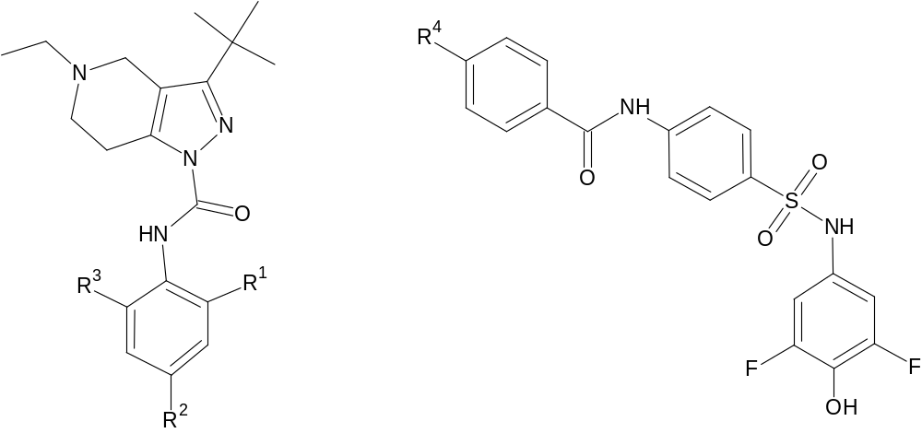
Figure S10. The base structure of compounds belonging to Class C-IX and C-X
Table S7. R groups of each compound belonging to Class C-IX and C-X.
COMPOUND | R1 | R2 | R3 | R4
C16^{[32]} | H | Br | H | -
C17^{[32]} | CH₃ | CH₃ | H | -
C18^{[32]} | CH₃ | H | CH₃ | -
C19^{[33]} | - | - | - | H
C20^{[33]} | - | - | - | OCH

